Network Lab 3
Abhiraj Tiwari (180905422)

Question 1
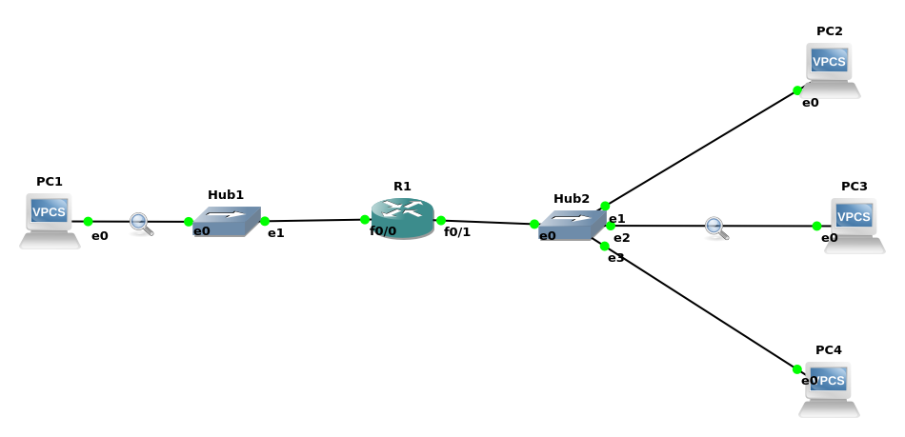
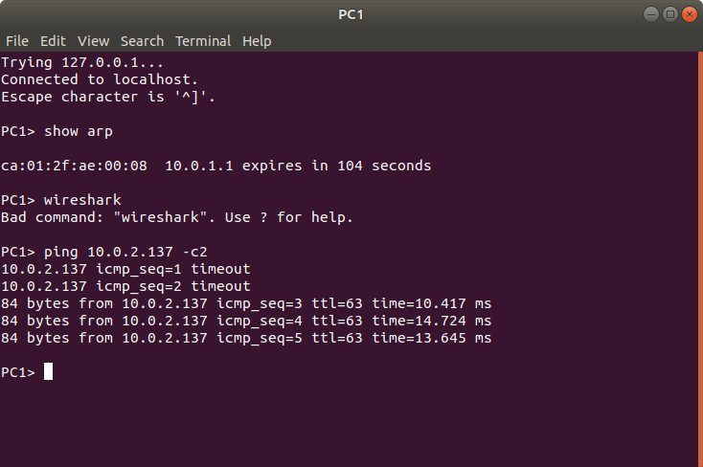
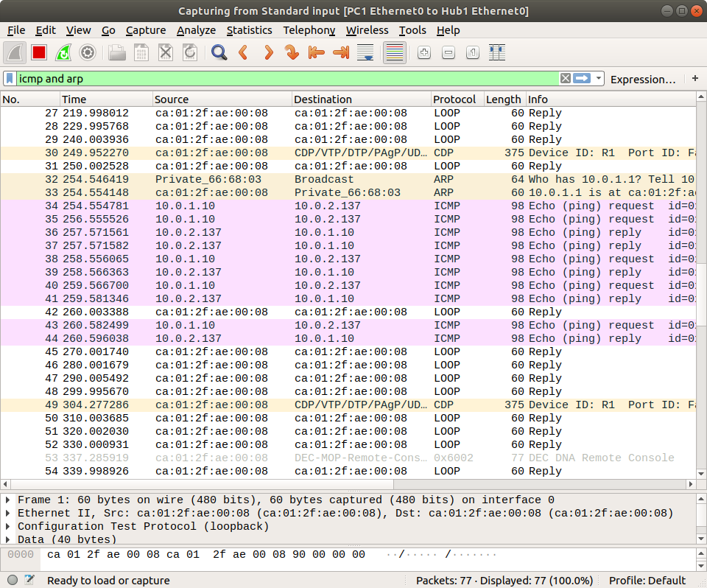
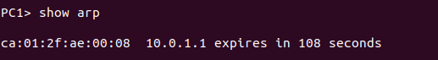
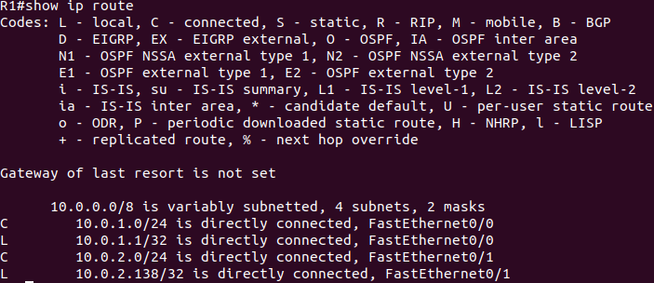

Question 2
There are 256 addresses in this block. the first address is 14.24.74.0/24; The last address is 14.24.74.255/24.
The number of addresses in the largest subblock ,which requires 120 addresses, is not power of 2, we allocate 128 addresses .The subnet mask for this subnet can be found as 32 -log₂128 =25. The first address in this block is 14.24.74.0/25 ; the last address is 14.24.74.127/25.

The number of addresses in the second largest subblock , which requires 60 addresses , is not a power of 2 either, we allocate 64 addresses .The subnet mask for this subnet can be found as 32 - log₂64 = 26.The first address in this block is 14.24.74.128/26;The last address is 14.24.74.191/26

The number of addresses in the smallest subblock ,which requires 10 addresses, is not a power of 2 either.we allocate 16 addresses.The subnet mask for this subnet can be found as 32-log₂16 = 28. The first address in this block is 14.24.74.192/28; The last address is 14.24.74.207/28

Question 3
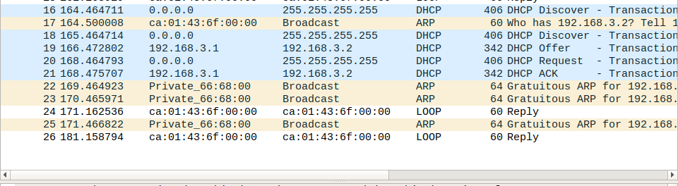

Question 4

