OS Lab 3
Abhiraj Tiwari (180905422)

Question 1

Code
#include <sys/types.h>
#include <stdlib.h>
#include <sys/wait.h>
#include <stdio.h>
#include <unistd.h>

void main() {
int status;
pid_t pid;
pid = fork();
if (pid == -1){
printf("ERROR child not created\n");
}
else if (pid == 0) {
printf("I'm the child\n");
for (int i = 0; i < 10000; ++i);
exit(0);
}
else {
wait(&status);
printf("I'm the parent!\n");
printf("Child returned %d\n", status);
}
}

Screenshot
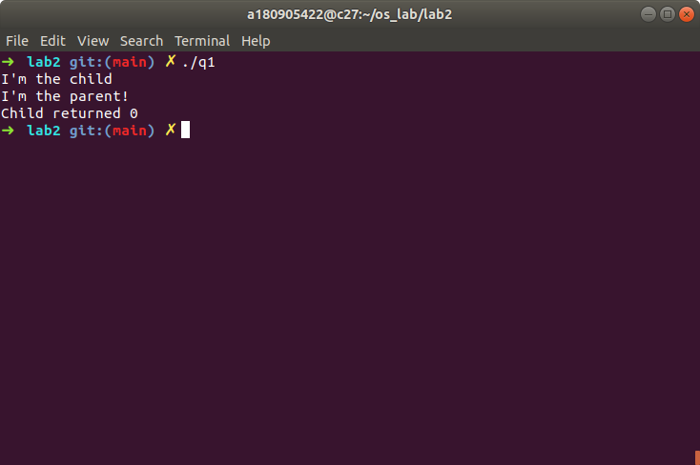

Question 2

Code
#include <sys/types.h>
#include <stdlib.h>
#include <sys/wait.h>
#include <stdio.h>
#include <unistd.h>

void main() {
pid_t pid;
int status;
pid = fork();
if (pid==0)
{
execvp("./q1",NULL);
}
else if (pid == -1) {
perror("Fork unsuccessfull");
}
else {
wait(&status);
exit(0);
}
}

Screenshot
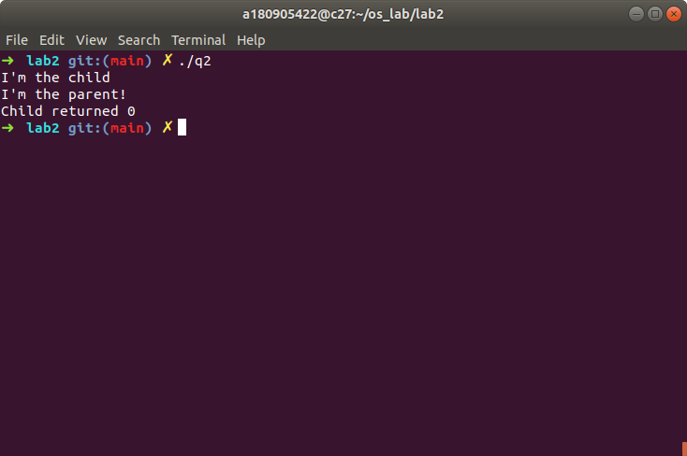

Question 3

Code
#include <sys/types.h>
#include <stdlib.h>
#include <sys/wait.h>
#include <stdio.h>
#include <unistd.h>

void main() {
pid_t pid;
int status;
pid = fork();
if (pid == -1) {
perror("Fork unsuccessfull");
}
else if (pid == 0) {
printf("I'm child and my process id is %d\n", getpid());
}
else {
printf("I'm the parent process and my process id is %d\n", getpid());
wait(&status);
}
}

Screenshot
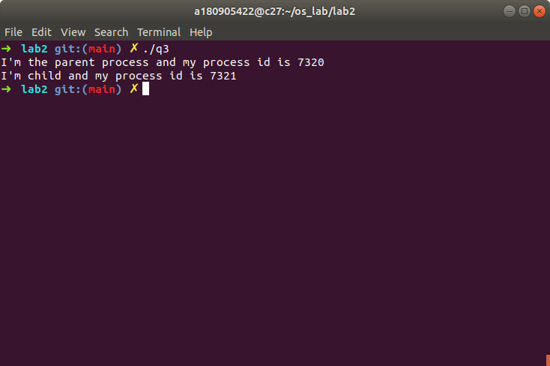

Question 4

Code
#include <sys/types.h>
#include <stdlib.h>
#include <sys/wait.h>
#include <stdio.h>
#include <unistd.h>
#include <time.h>

void main() {
pid_t pid;
pid = fork();
if (pid == 0) {
printf("I'm child\n");
printf("child end\n");
exit(0);
}
else if (pid == -1) {
perror("fork unsuccessfull");
}
else {
printf("parent\n");
clock_t start = clock();
while (clock() < start+(10*1000000));
printf("parent end\n");
exit(0);
}
}

Screenshot
