OS Lab 4
Abhiraj Tiwari (180905422)

Question 1

Code
#include <sys/stat.h>
#include <stdio.h>
#include <unistd.h>
#include <sys/types.h>

int main(int argc, char** argv)
{
struct stat sb;
int ret;
ret = stat(argv[1], &sb);
if (ret) {
perror("unable to fetch stat");
return 1;
}
printf("Inode: %ld\n", sb.st_ino);
return 0;
}

Screenshot
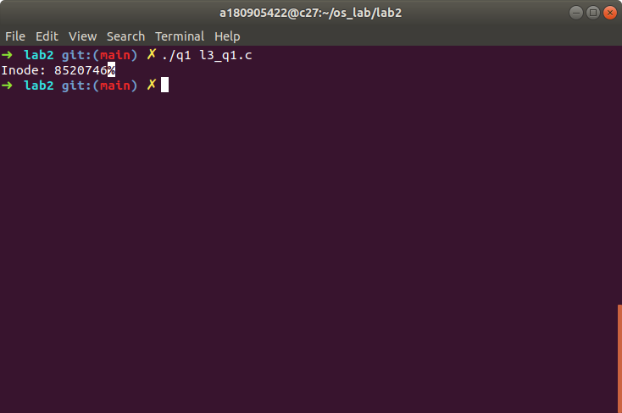

Question 2

Code
#include <stdio.h>
#include <sys/types.h>
#include <sys/stat.h>
#include <unistd.h>
#include <stdlib.h>

int main(int argc, char* argv[]) {
struct stat sb;
int ret;
if(argc < 2){
fprintf(stderr, "usage: %s <file>\n", argv[0]);
return 1;
}
ret = stat(argv[1], &sb);
if(ret) {
perror("stat");
return 1;
}
printf("st_dev: %ld\n", sb.st_dev);
printf("st_ino: %ld\n", sb.st_ino);
printf("st_size: %ld\n", sb.st_size);
printf("st_uid: %d\n", sb.st_uid);
printf("st_nlink: %ld\n", sb.st_nlink);
return 0;
}

Screenshot
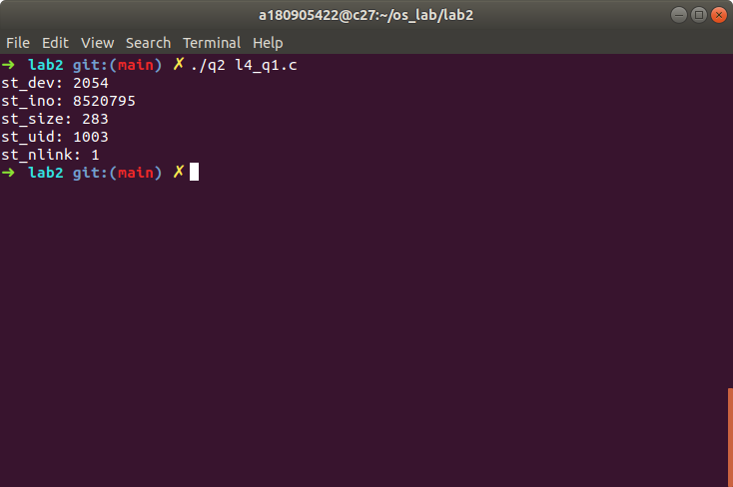

Question 3

Code
#include <stdio.h>
#include <sys/types.h>
#include <sys/stat.h>
#include <unistd.h>
#include <stdlib.h>

int main(int argc, char const *argv[])
{
link(argv[1], argv[2]);
printf("new path is %s", argv[2]);
getchar();
unlink(argv[2]);
printf("file unlinked");
return 0;
}

Screenshot
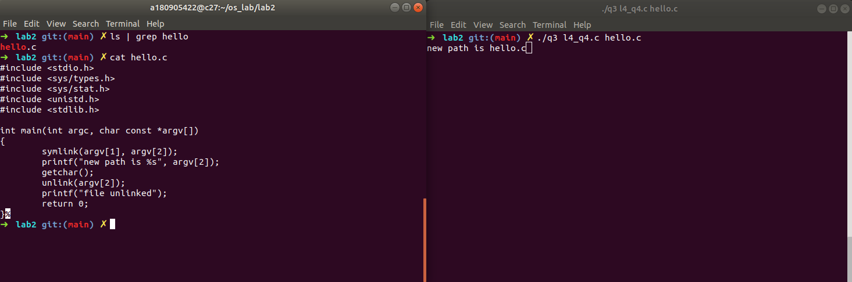
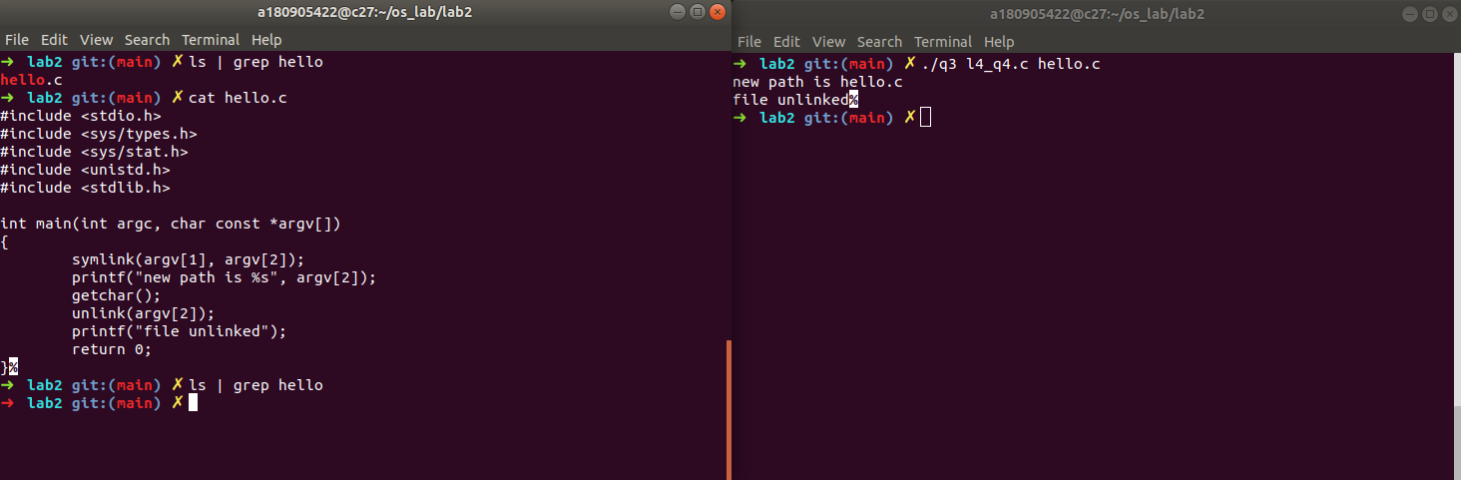

Question 4

Code
#include <stdio.h>
#include <sys/types.h>
#include <sys/stat.h>
#include <unistd.h>
#include <stdlib.h>

int main(int argc, char const *argv[])
{
symlink(argv[1], argv[2]);
printf("new path is %s", argv[2]);
getchar();
unlink(argv[2]);
printf("file unlinked");
return 0;
}

Screenshot
