Project Structure

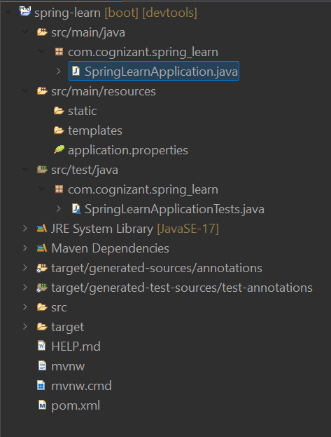

src/main/java -> contains java codes and the main class in SpringLearnApplication.java file

src/main/resources -> contains application.properties and resource files

src/test/java -> contains all the test classes

SpringLearnApplication.java

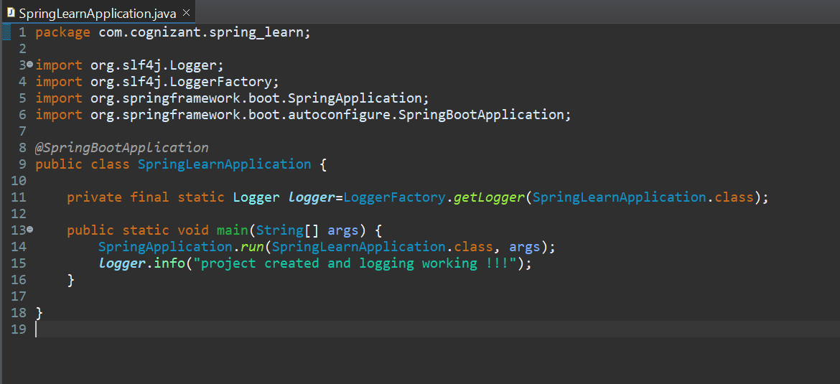

This is the main class of the application where the project execution starts

@SpringBootApplication annotation combines the @SpringBootConfiguration , @EnableAutoConfiguration, @ComponentScan annotations for spring boot auto-configuration

There is also a logger(slf4j) object created for logging features

POM.xml

<?xml version="1.0" encoding="UTF-8"?>

<project xmlns="http://maven.apache.org/POM/4.0.0" xmlns:xsi="http://www.w3.org/2001/XMLSchema-instance"

xsi:schemaLocation="http://maven.apache.org/POM/4.0.0 https://maven.apache.org/xsd/maven-4.0.0.xsd">

<modelVersion>4.0.0</modelVersion>

<parent>

<groupId>org.springframework.boot</groupId>

<artifactId>spring-boot-starter-parent</artifactId>

<version>3.5.3</version>

<relativePath/> <!-- lookup parent from repository -->

</parent>

<groupId>com.cognizant</groupId>

<artifactId>spring-learn</artifactId>

<version>0.0.1-SNAPSHOT</version>

<name>spring-learn</name>

<description>Demo project for Spring Boot</description>

<url/>

<licenses>

<license/>

</licenses>

<developers>

<developer/>

</developers>

<scm>

<connection/>

<developerConnection/>

<tag/>

<url/>

</scm>

<properties>

<java.version>17</java.version>

</properties>

<dependencies>

<dependency>

<groupId>org.springframework.boot</groupId>

<artifactId>spring-boot-starter-web</artifactId>

</dependency>

<dependency>

<groupId>org.springframework.boot</groupId>

<artifactId>spring-boot-devtools</artifactId>

<scope>runtime</scope>

<optional>true</optional>

</dependency>

<dependency>

<groupId>org.springframework.boot</groupId>

<artifactId>spring-boot-starter-test</artifactId>

<scope>test</scope>

</dependency>

</dependencies>

<build>

<plugins>

<plugin>

<groupId>org.springframework.boot</groupId>

<artifactId>spring-boot-maven-plugin</artifactId>

</plugin>

</plugins>

</build>

</project>

* <modelVersion> – Defines the version of the POM model use
* <groupId> – Specifies the base package name (com.cognizant)
* <artifactId> – Defines the project name (spring-learn)
* <version> – Sets the current version of the project (0.0.1-SNAPSHOT)
* <parent> – Inherits settings from spring-boot-starter-parent
* <properties> – Contains global properties like Java version
* <dependencies> – Lists required libraries like Spring Web, DevTools, and Test
* <build> – Configures how the project should be packaged and built
* spring-boot-maven-plugin – Creates an executable JAR with embedded server

Dependency Hierarchy:

