* <bean> tag:

bean tag is used in the xml configuration file and it allows us to define beans with properties

ex:

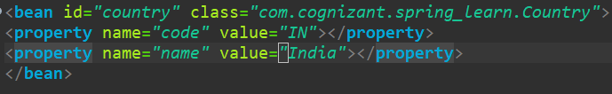

This will create a bean and this bean will be stored in the spring IOC container

* Id : id attribute will specify the id of the bean which will be required to access that bean from the IOC container
* Class : class attribute will specify which class the bean is created for i.e., when we access this bean a Country object is created
* <property> tag:

Property tag allows us to specify the values of attributes which are a part of the class mentioned in the class attribute

* Name : name attribute specifies the name of field in the class
* Value : value provides value for the field which is specified in the name attribute
* ApplicationContext : application context is an implementation of IOC container. This allows us to fetch and store the configuration of the application
* ClassPathXmlApplicationContext: this is an implementation of ApplicationContext which is used for loading an xml configuration file
* Context.getBean(): whenever this method is invoked it looks for the required bean in the configuration file that is loaded by the above two. This takes two parameters :

1. bean id : we have to pass the id of the bean

2. type: by default getBean() will return an object type and we have to type cast it to work with our required class