* 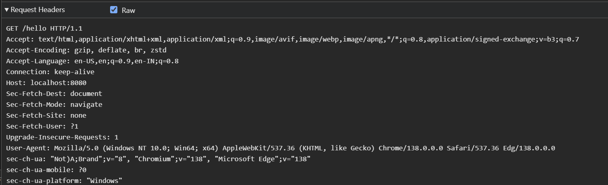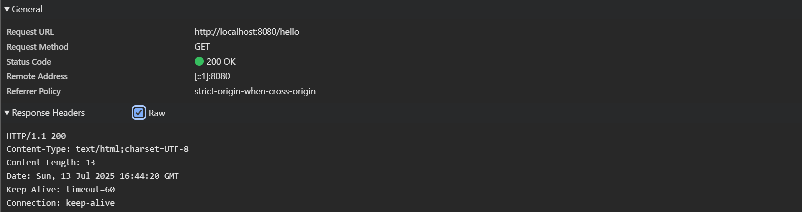Network Tab of developers Tools:
* Postman :

