* What happens in the controller method?

In the controller method for the url mapping “/country” we load the application context and load our country bean.

We return this bean as the response to the request

* How the bean is converted into JSON reponse?

The bean is converted to the JSON response with the help of serialization. In this process the country bean is converted to a JSON response by spring using Jackson

* Network Tab:

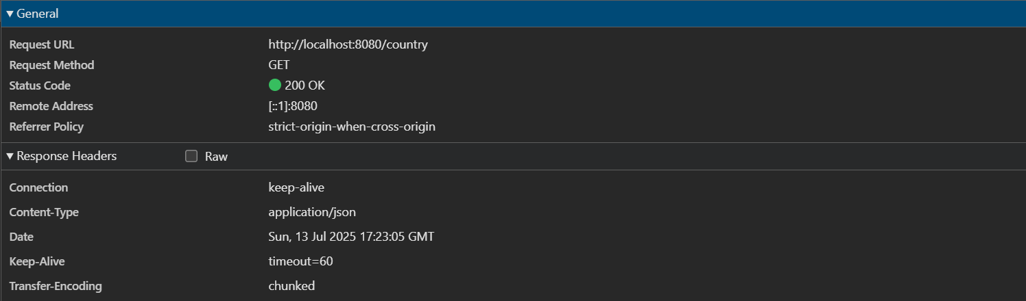

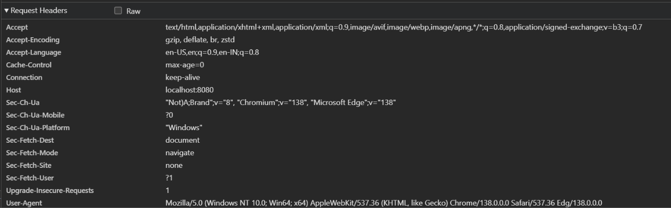

* Postman:

