**Pyspark Coding Assessment:** **Abhiram Basa - 27-12-23**

**Questions:**

1. Implement Processing JSON and CSV data with PySpark
2. Explain ETL (Extract, Transform, Load) with PySpark
3. Using Spark SQL - Creating databases, tables
4. Using Spark SQL - Transformations such as Filter, Join, Simple Aggregations, GroupBy.

**Answers:**

1. **Implement Processing JSON and CSV data with PySpark**

**Solution for 1** : We can read the csv files using the below syntax

**Syntax:** Data1 = data1.read.csv(“filename.csv”)

**Csv file processing:**

**Data1.show() :** It will print the output

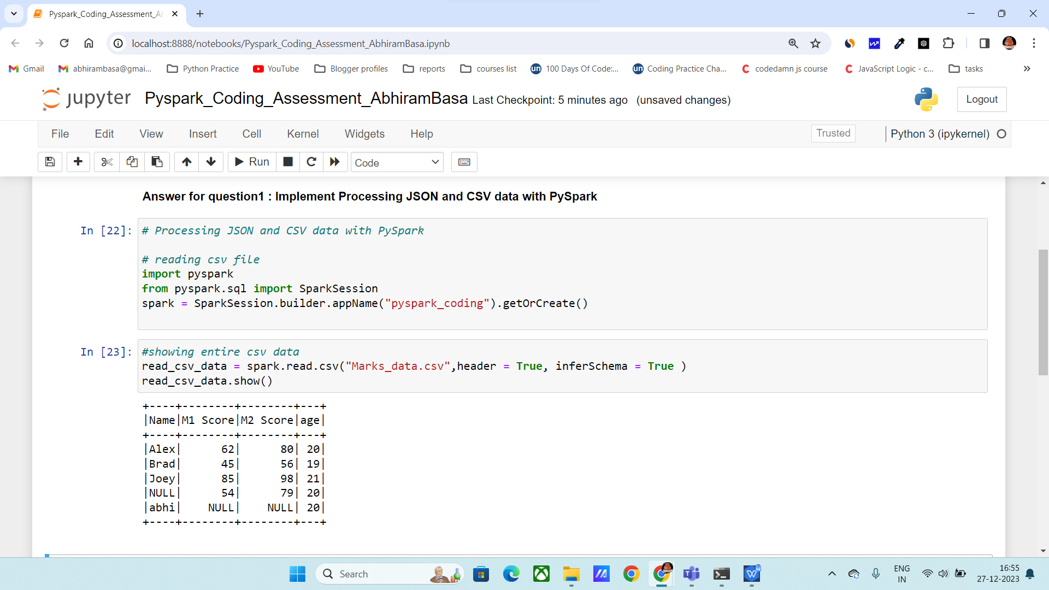

**Json file processing:**

**Syntax:** Data2 = data1.read.json(“filename.json”)

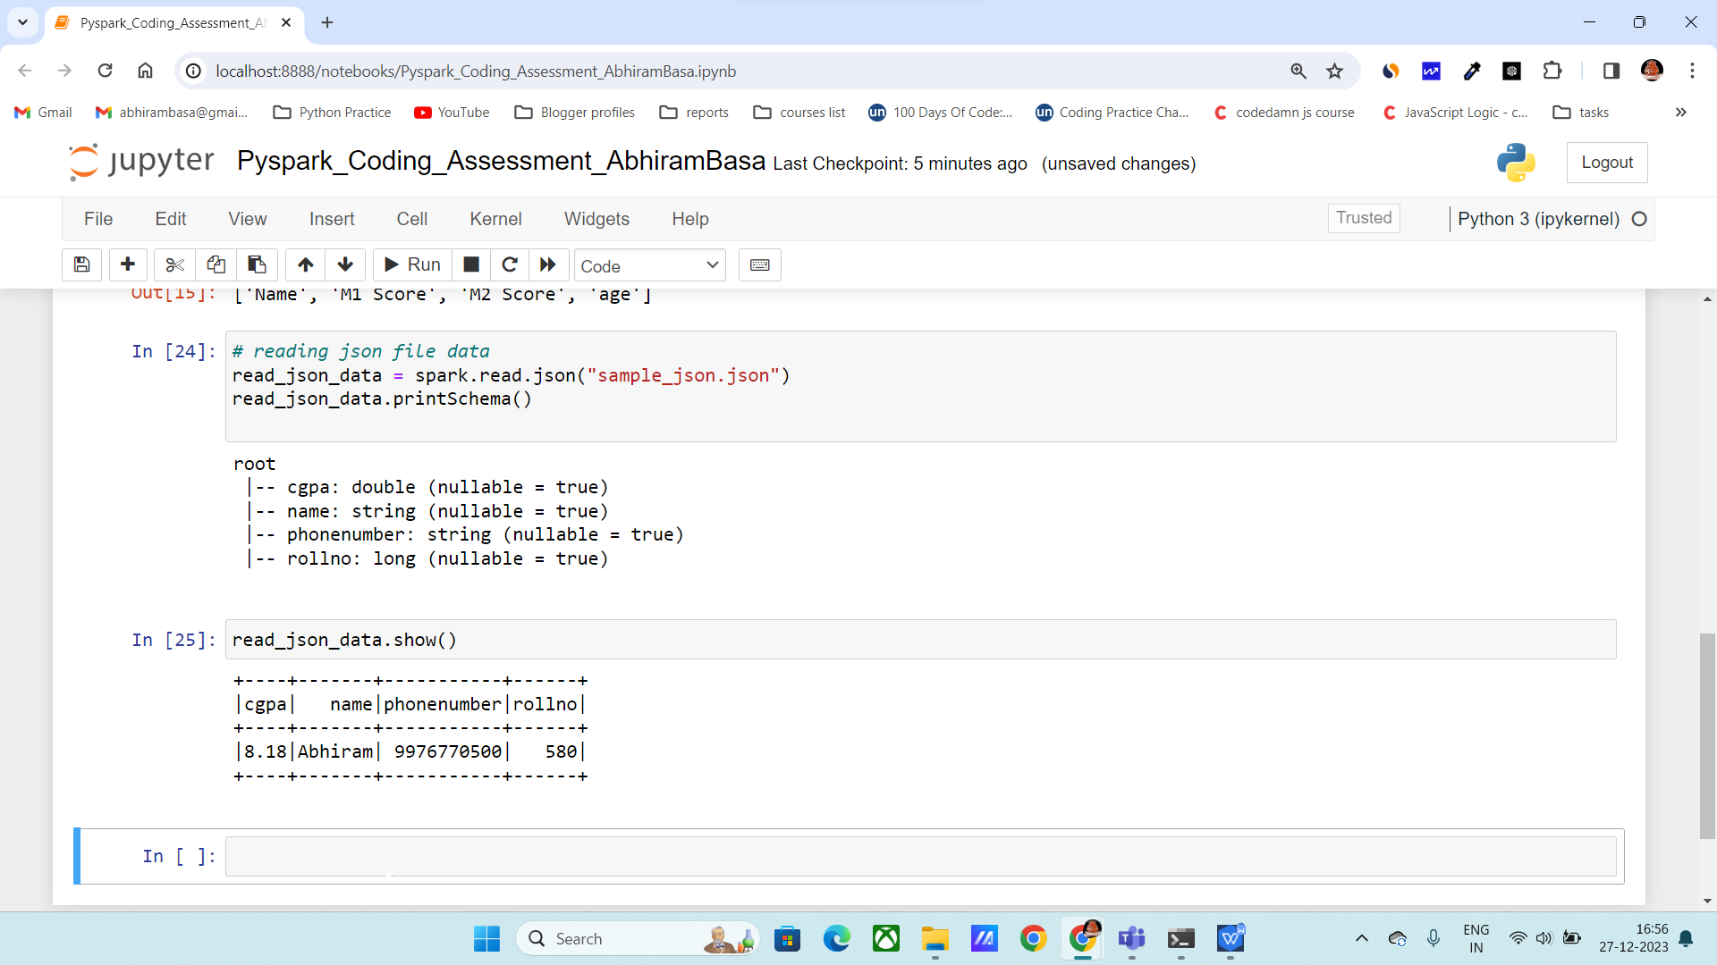

1. **Explain ETL (Extract, Transform, Load) with PySpark**

**Solution 2 :**

ETL stands for

**Extract**: extract the data from the different sources

**Transform**: Transform the unstructured data into structured data. Transformations like cleaning, manipulation, etc.

**Load**: Load the transformed data into a location or date warehouse.

Below we performed ETL on sample **CSV** data.

we will load the spark session using **from pyspark.sql import SparkSession.**

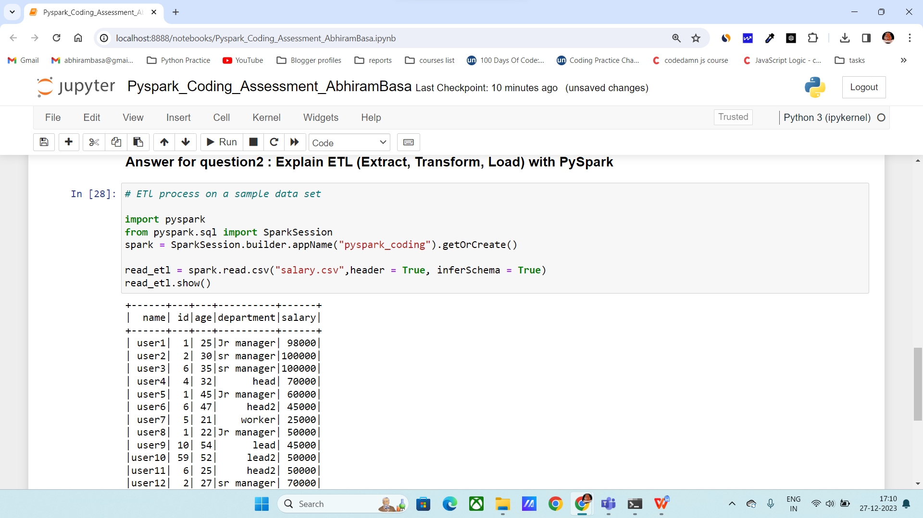

**Creating new columns:**

Syntax: data1.withcolumn(“new_column_name”, condition)

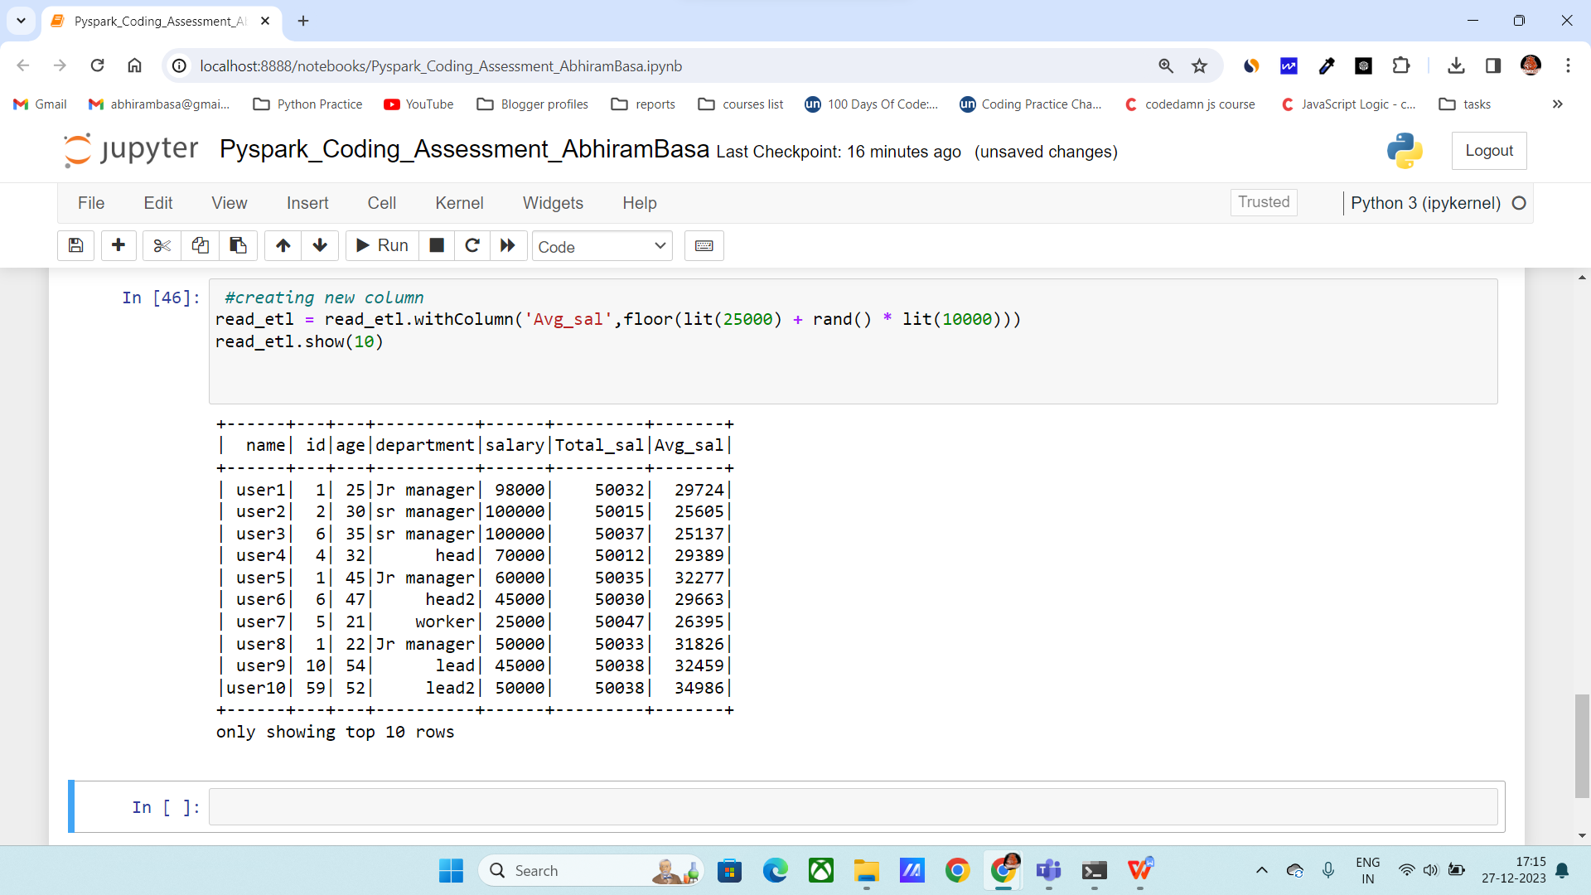

**Filter():**

Syntax: data1. filter(condition)

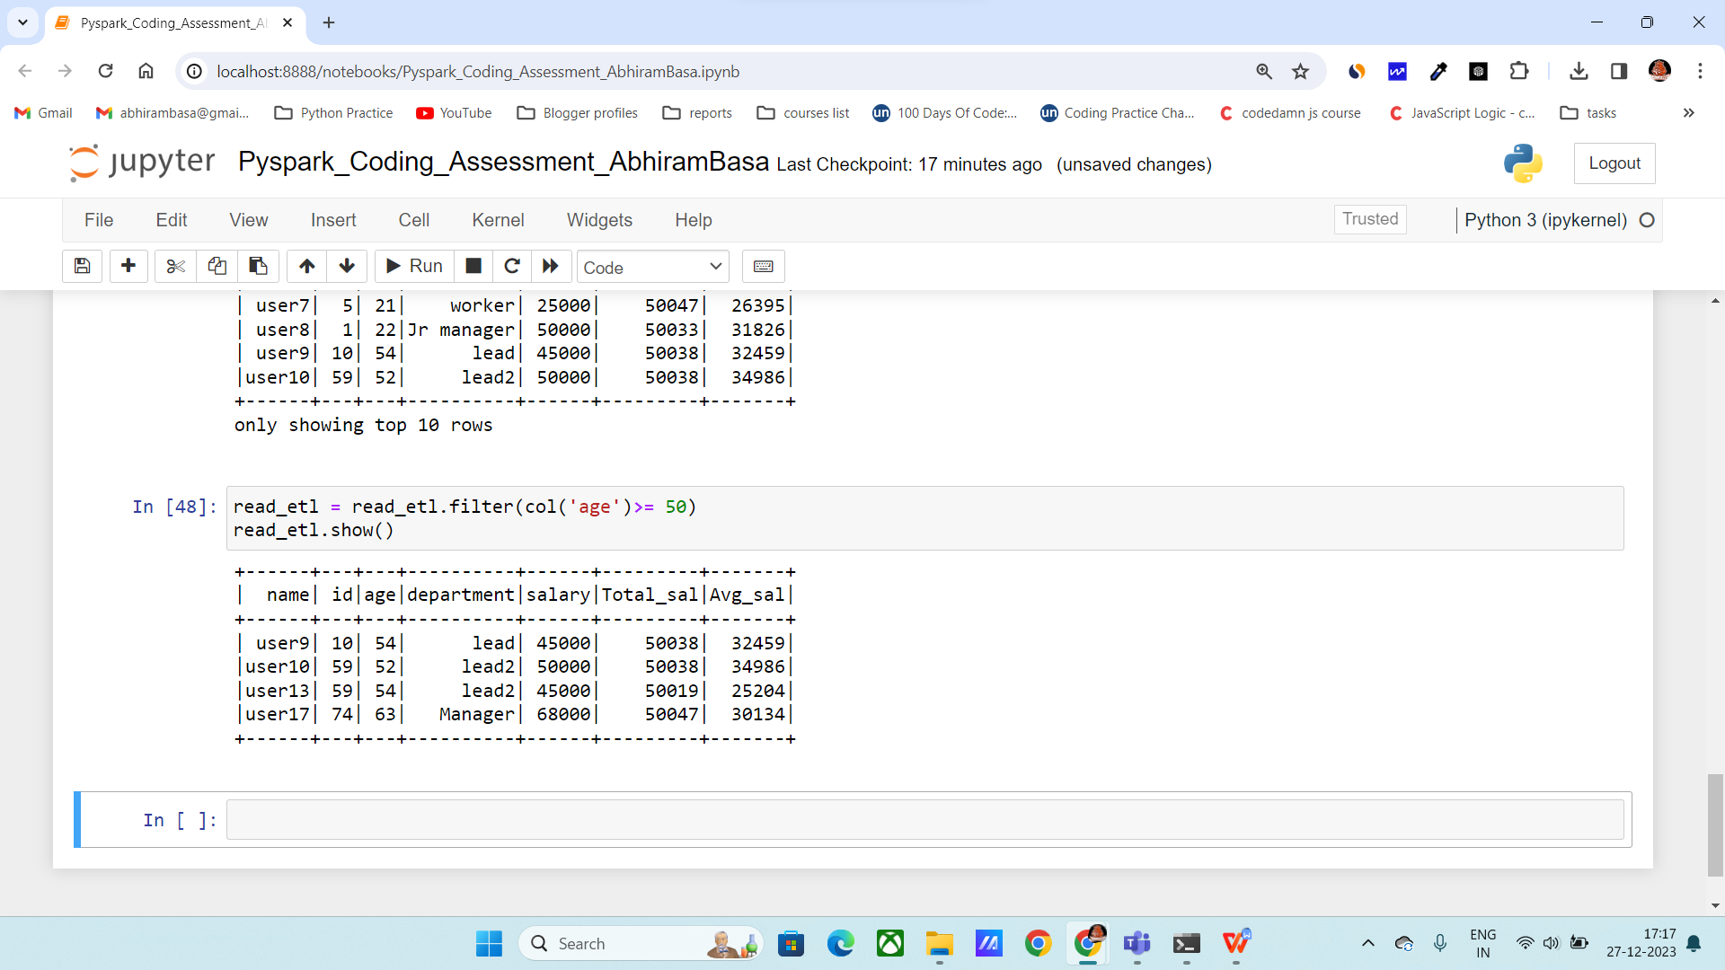

**Orderby:**

Syntax: data1.orderBy(“column_name”)

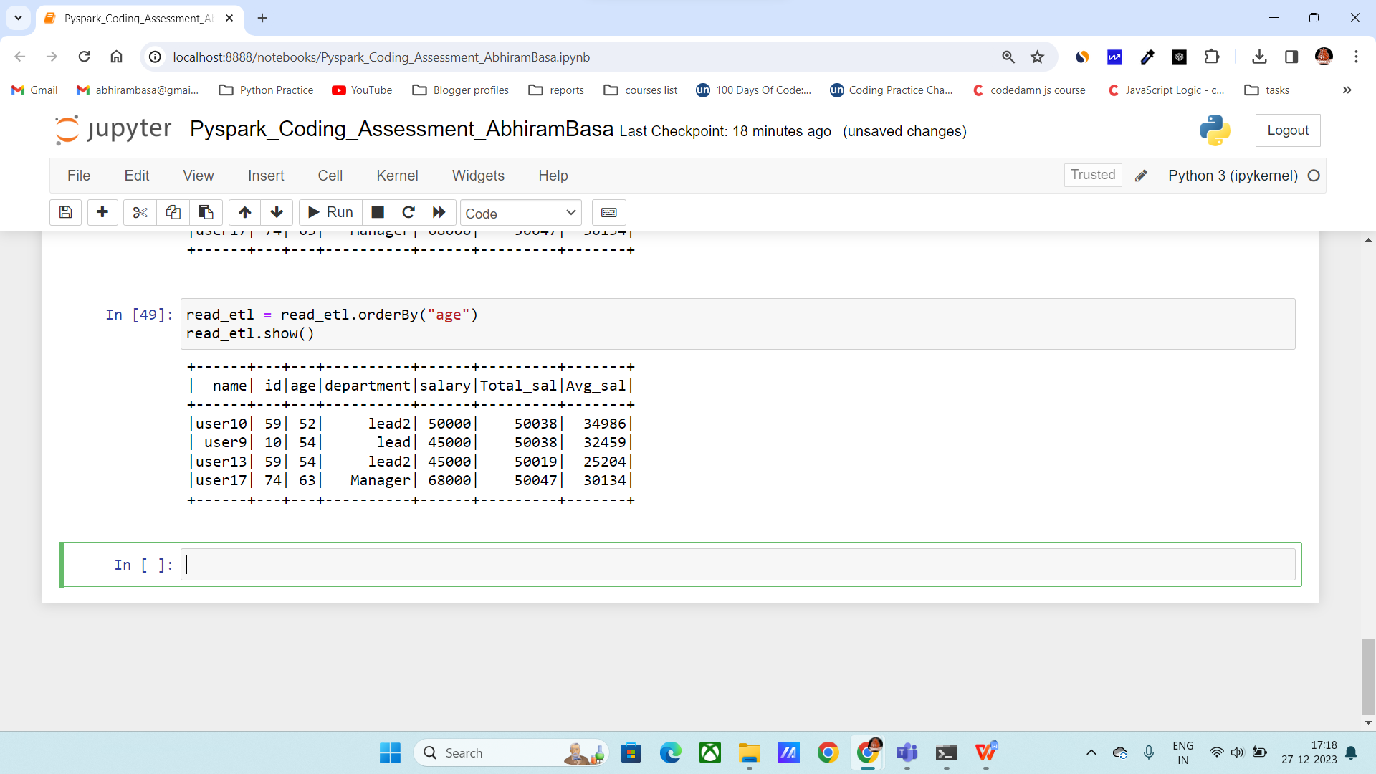

**Loaded into another csv file:**

We can load the data into another csv file using

Syntax: data1.write.csv(target_path, mode='overwrite', header=True)

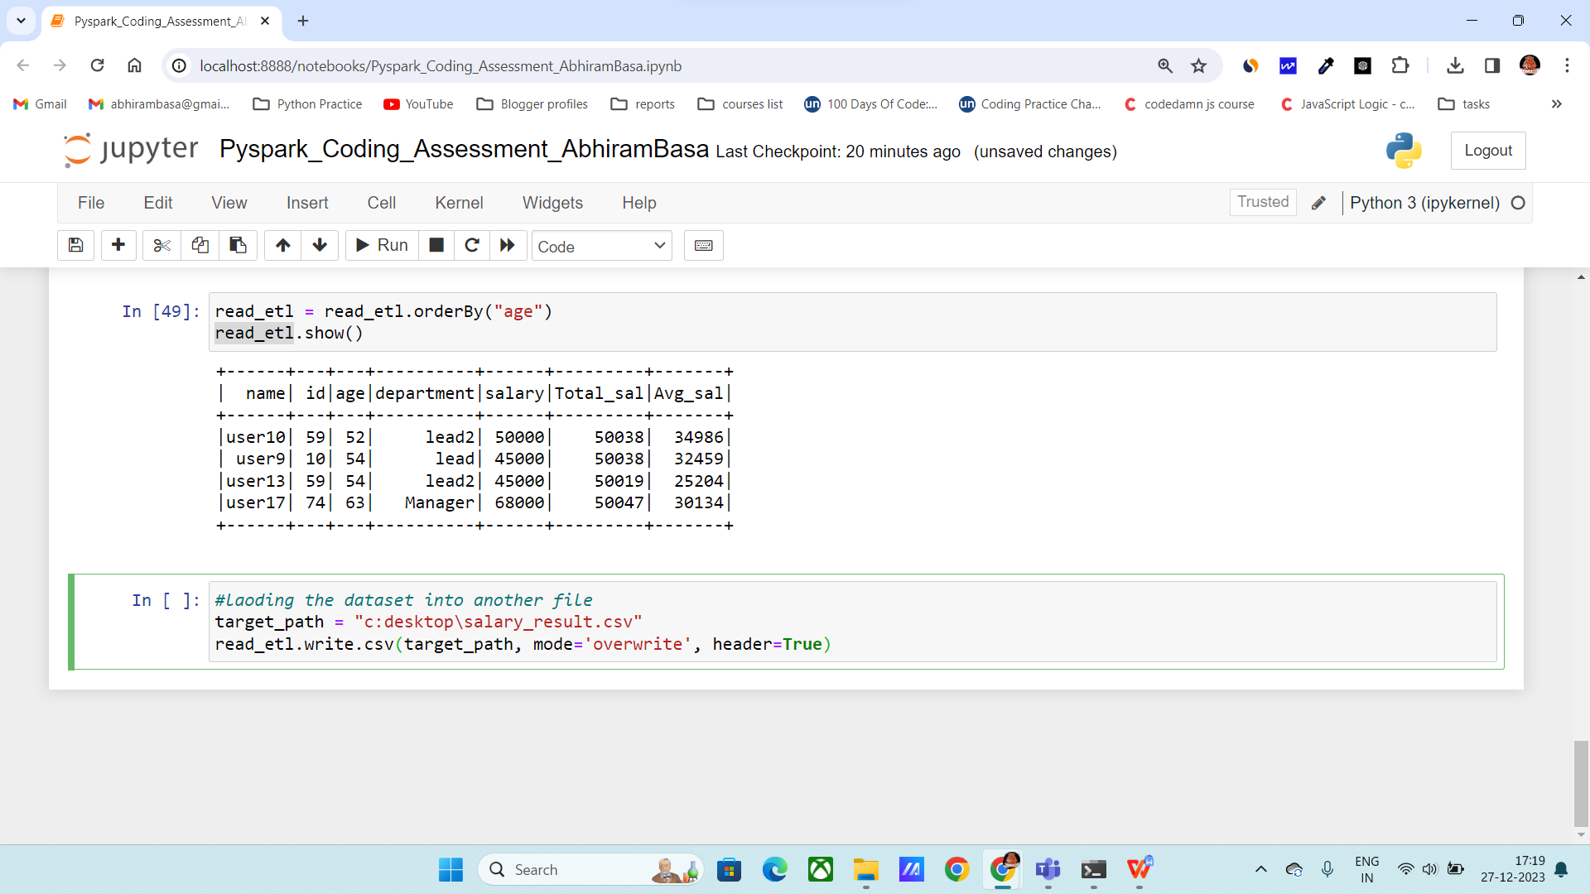

1. **Using Spark SQL - Creating databases, tables**

**Solution 3 :**

**Creating a database :**

Syntax:

database_name = "new_database"

spark.sql(f” {database_name}")

The above command will use the database specified

**Creating a table in pyspark:**

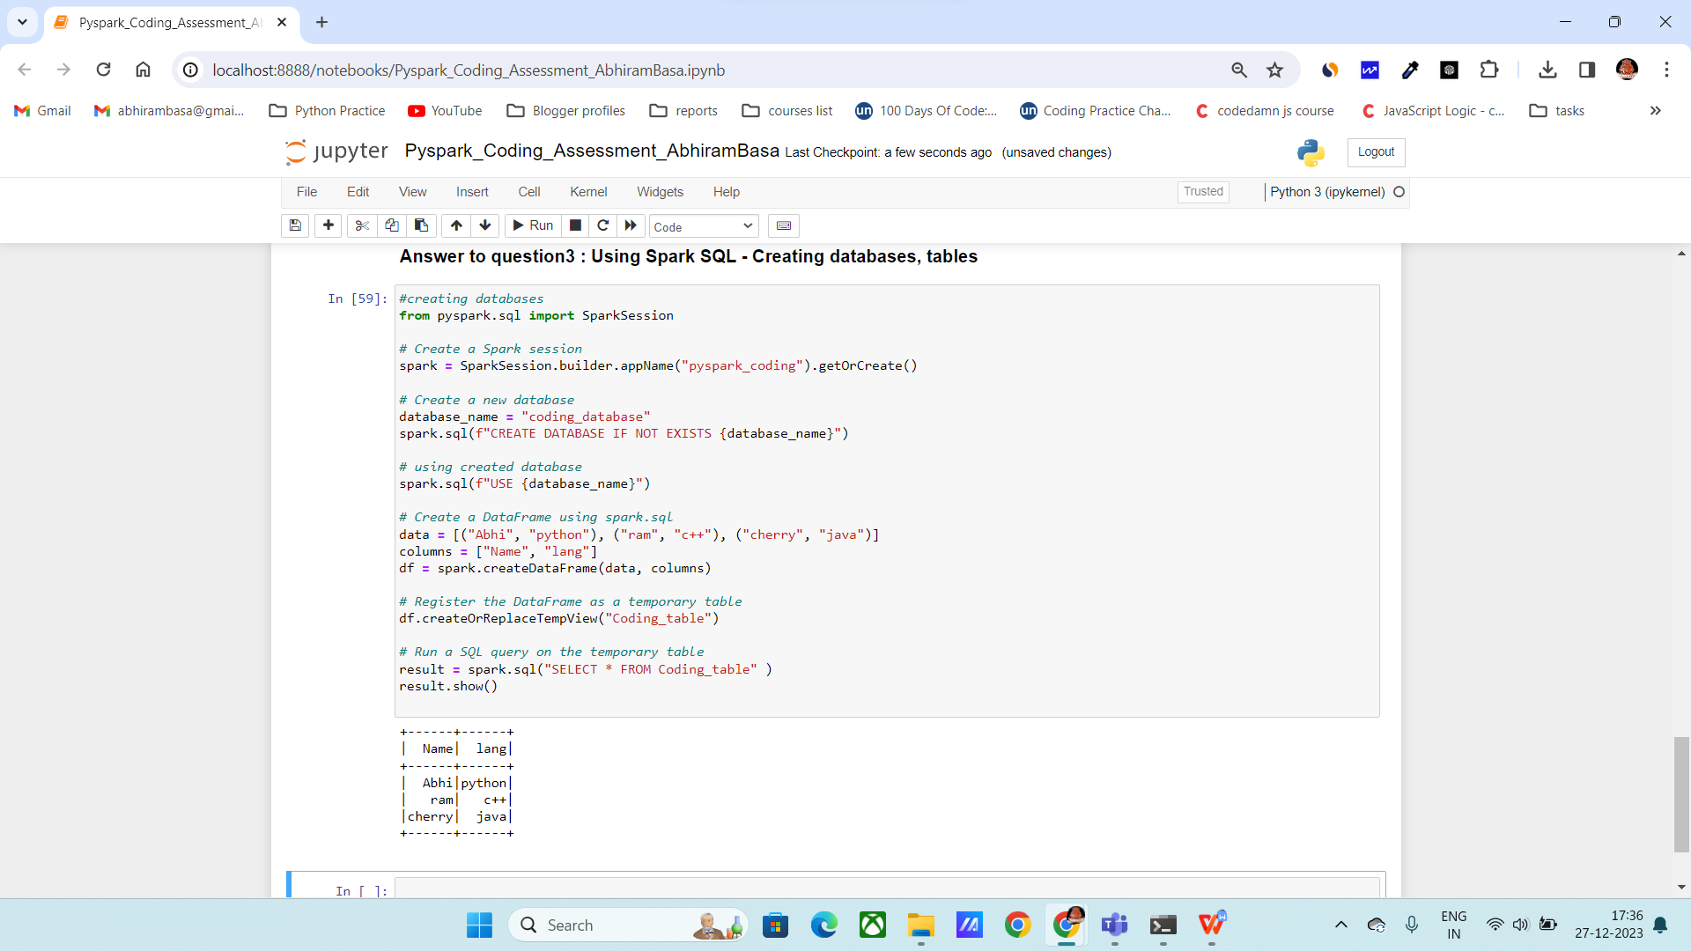

1. **Transformations such as Filter, Join, Simple Aggregations, GroupBy.**

**Solution 4:**

**Filter:** it will filter the data based on the specified condition.

Syntax: data1.filter(condition)

Performing filter ()

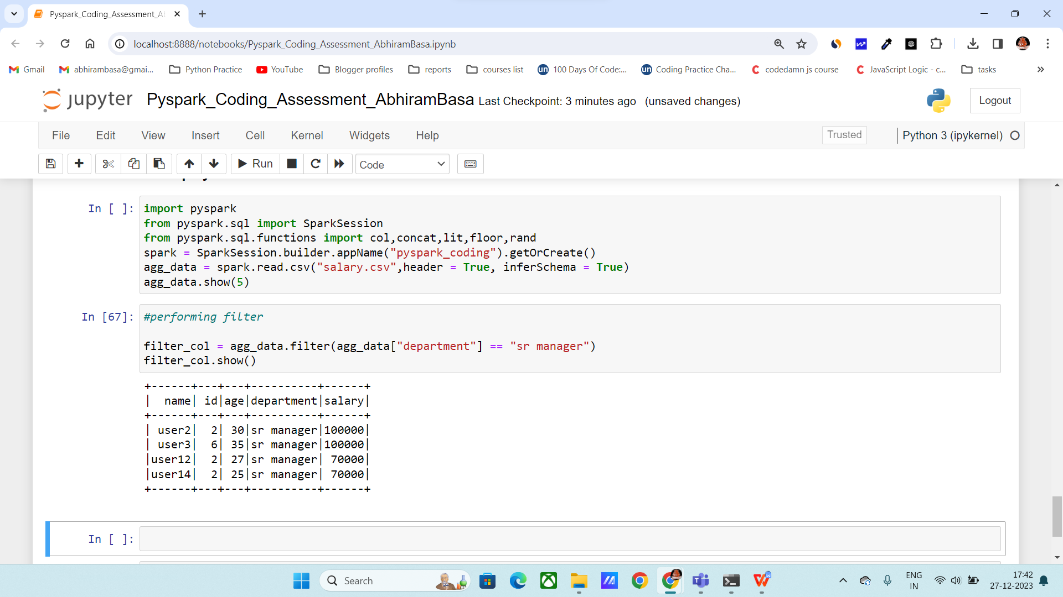

**Performing joins:**

Below I am performing inner join

Inner join: It will gives the data which is matching in both the tables

**Syntax:** df1. join(df2, "Name", "inner")

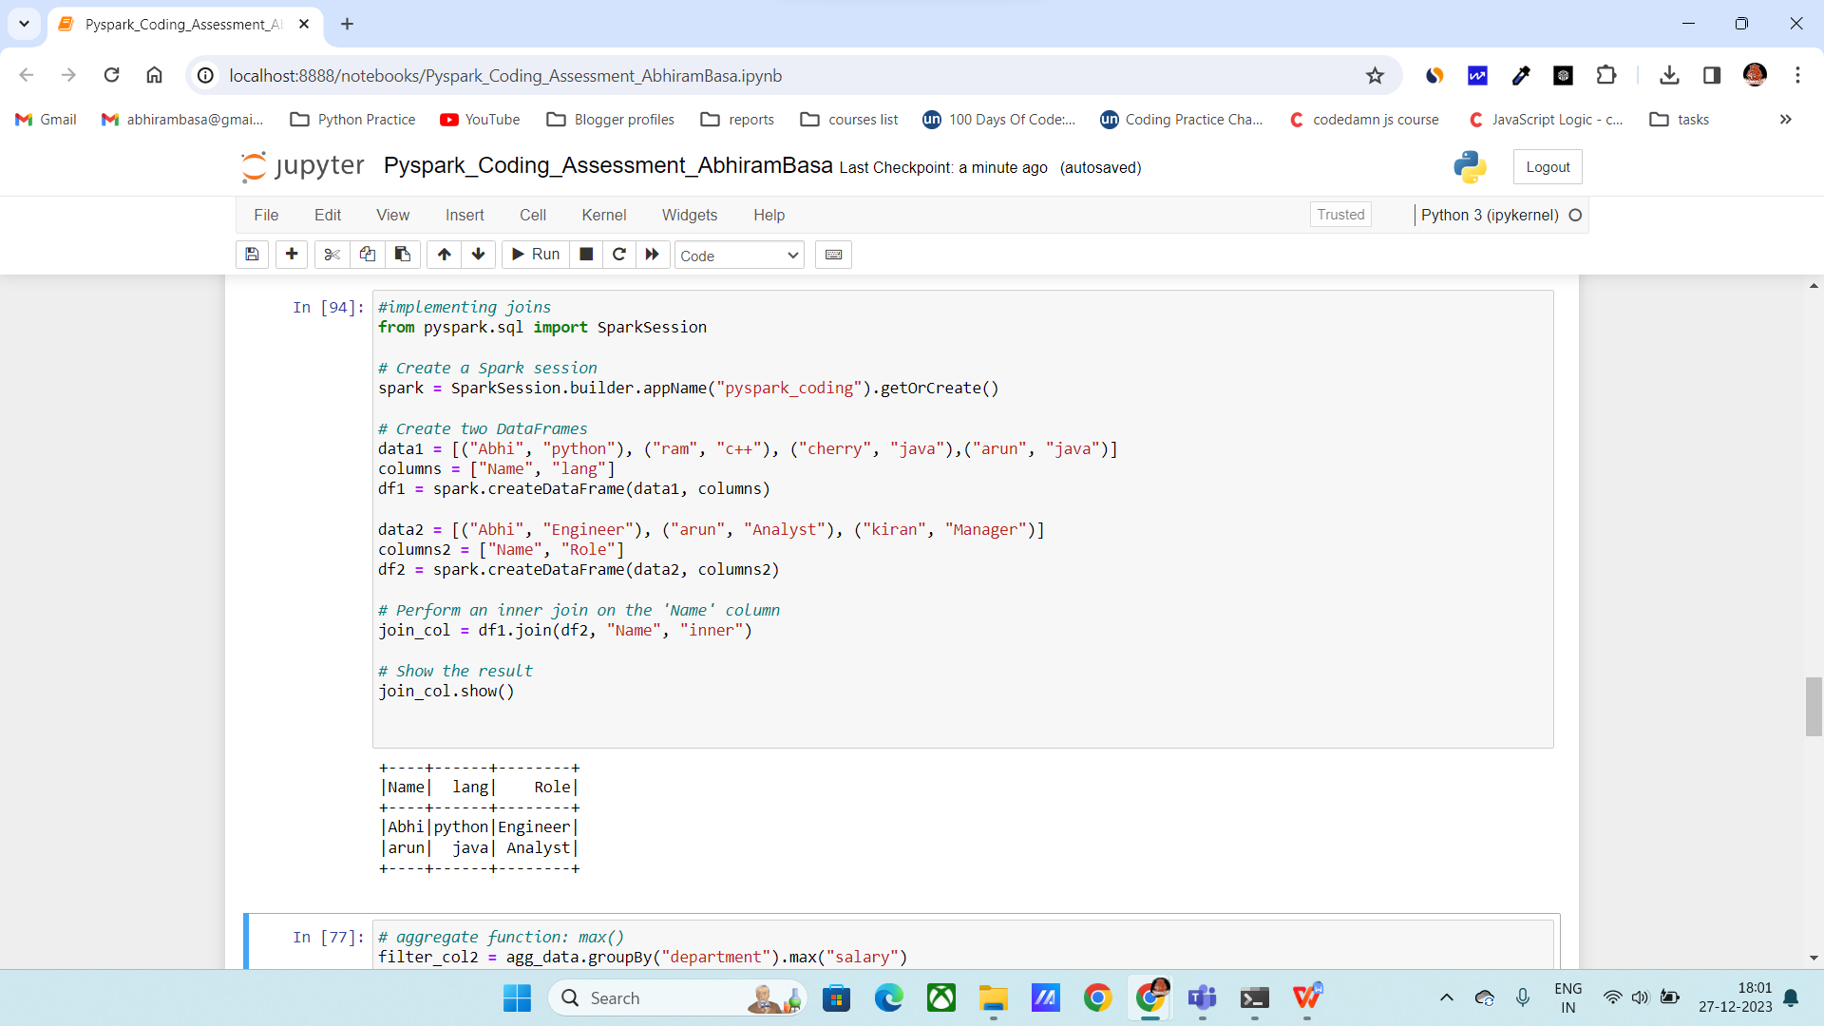

**Aggregate fun:**

**max():** It will return the max of the salary column in below code.

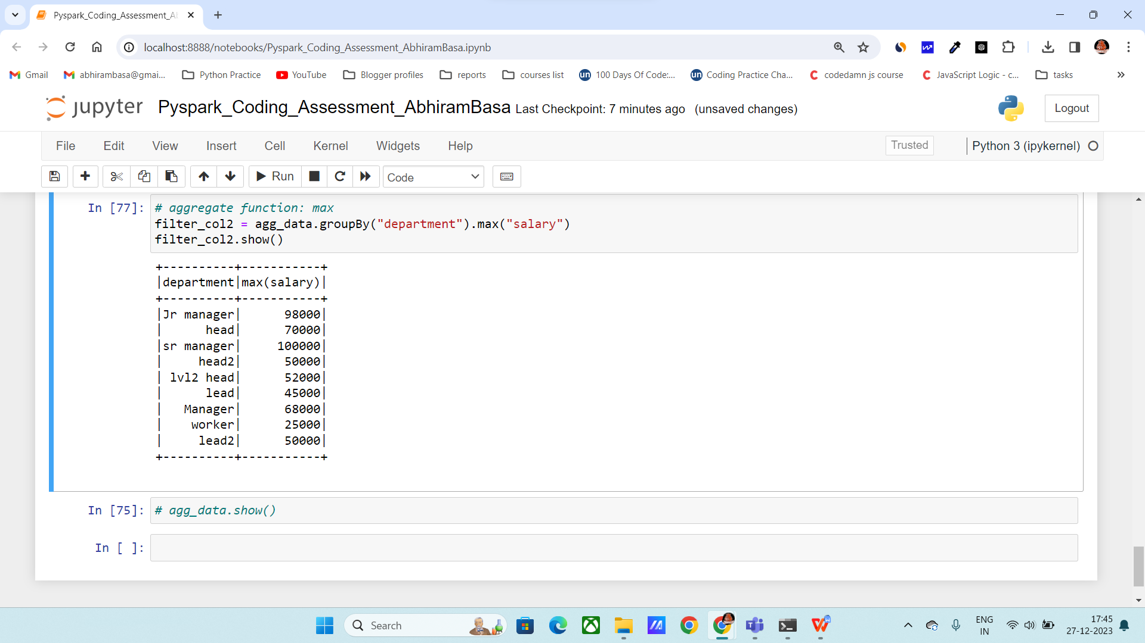

**Min() :** It will return the min of the salary column in below code.

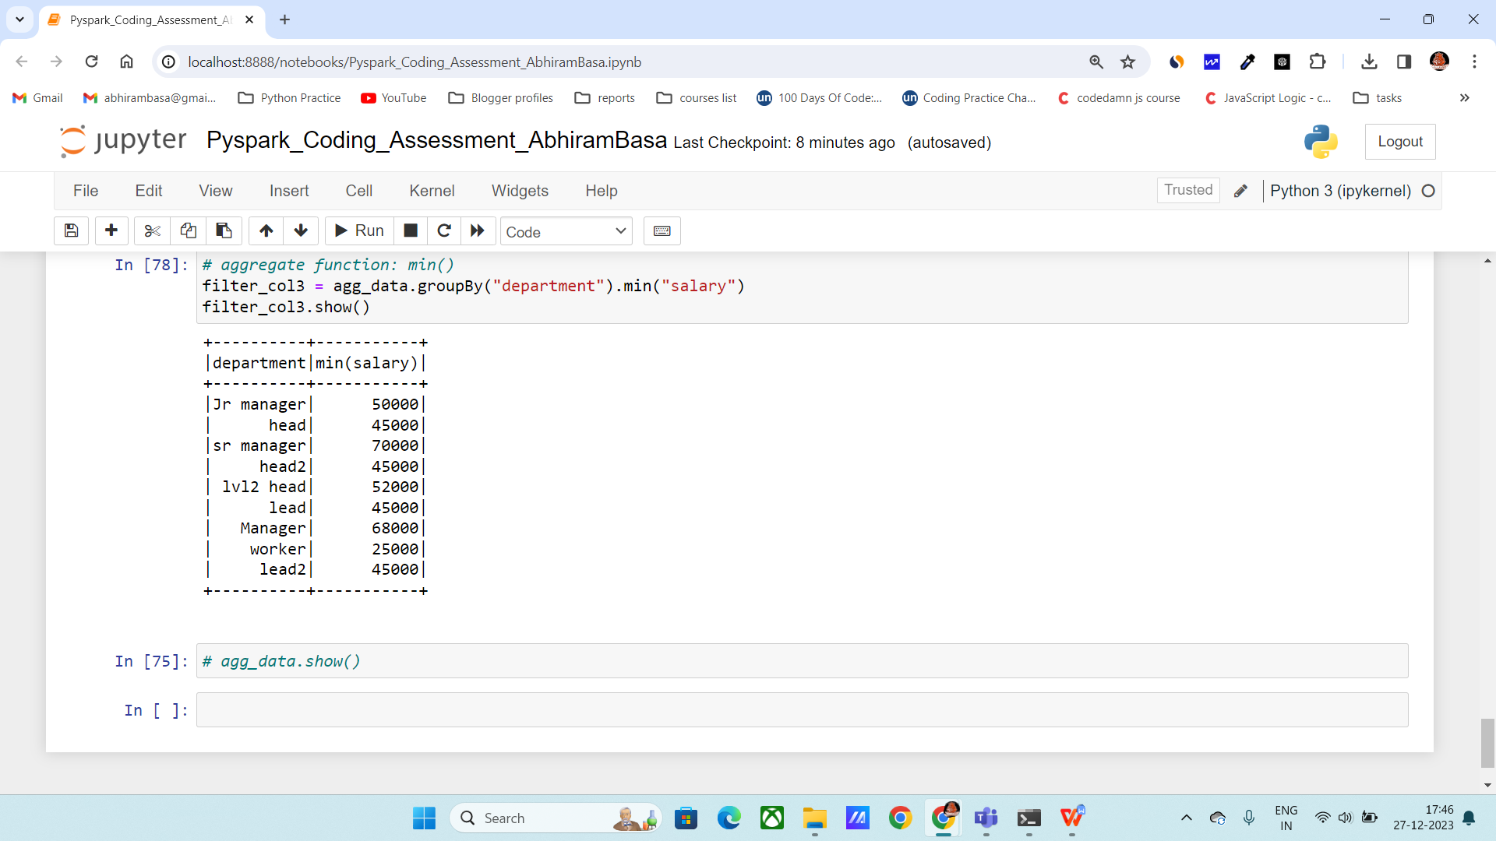

**Avg() :** It will return the avg of the salary column in below code.

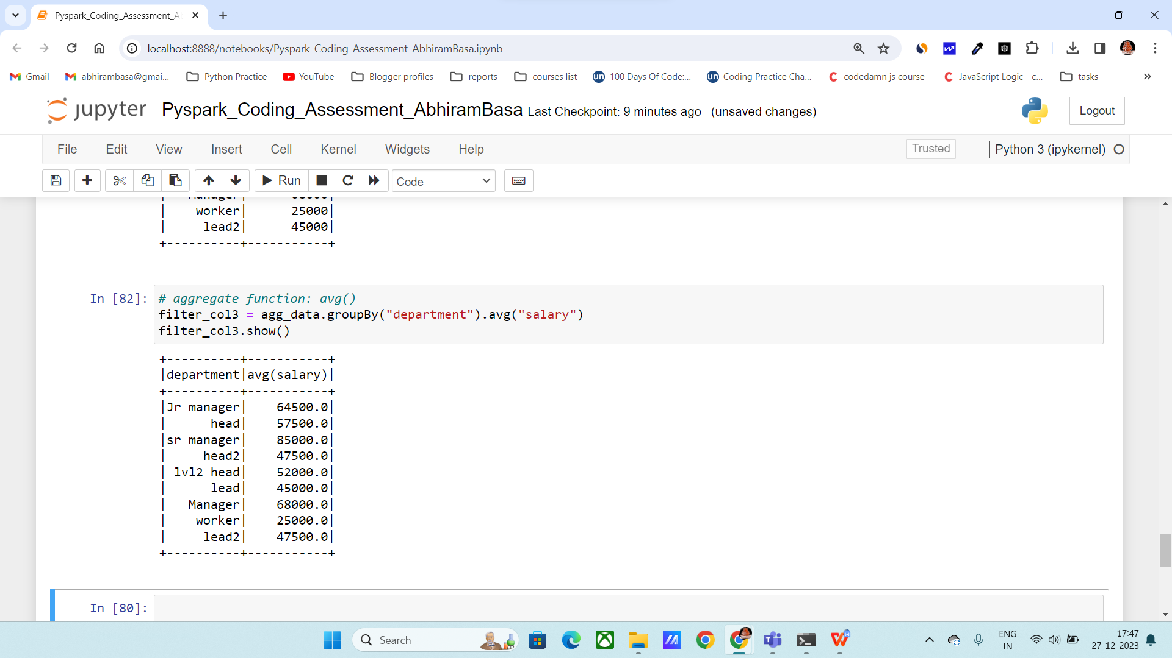

**Sum() :** It will return the sum of the salary column in below code.

Here it will group by department

