**CO5 PYTHON**

**1.Write a Python program to read a file line by line and store it into a list.**

f1=open("secfile.txt","w")

f1.write("This is my first file in python.\n want to work with files \n This is my third line")

f1=open("secfile.txt","r")

ff=f1.readlines()

print(ff)

output

['This is my first file in python.\n', ' want to work with files \n', ' This is my third line']

**2. Python program to copy odd lines of one file to other**

f1=open("secfile.txt","r")

ff=f1.readlines()

with open("odd.txt","w") as f2:

for x in range(0,len(ff)):

if(x%2!=0):

f2.write(ff[x])

output

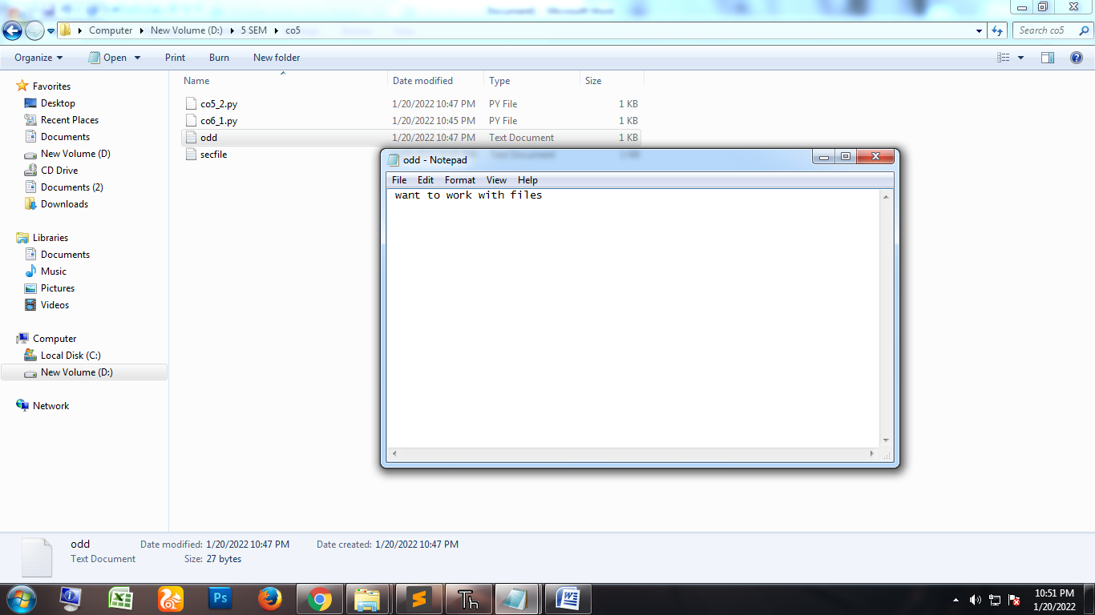

**3. Write a Python program to read each row from a given csv file and print a list of strings.**

import csv

with open('departments.csv', newline='') as csvfile:

data = csv.reader(csvfile, delimiter=' ', quotechar='|')

for row in data:

print(', '.join(row))

output

department_id,department_name,manager_id,location_id

10,Administration,200,1700

20,Marketing,201,1800

30,Purchasing,114,1700

File content

department_id,department_name,manager_id,location_id

10,Administration,200,1700

20,Marketing,201,1800

30,Purchasing,114,1700

**4. Write a Python program to read specific columns of a given CSV file and print the content of the columns.**

import csv

with open('departments.csv', newline='') as csvfile:

data = csv.DictReader(csvfile)

print("id Department")

print("---------------------------------")

for r in data:

print(r['department_id']," ",r['department_name'])

output

id Department

---------------------------------

10 Administration

20 Marketing

30 Purchasing

**5. Write a Python program to write a Python dictionary to a csv file. After writing the CSV file read the CSV file and display the content.**

import csv

field_names = ['No', 'Company', 'Model']

cars = [

{'No': 1, 'Company': 'Ferrari', 'Model': '488 GTB'},

{'No': 2, 'Company': 'Porsche', 'Model': '918 Spyder'},

{'No': 3, 'Company': 'Bugatti', 'Model': 'La Voiture Noire'},

]

with open('cars.csv', 'w') as csvfile:

writer = csv.DictWriter(csvfile, fieldnames=field_names)

writer.writeheader()

writer.writerows(cars)

with open('cars.csv', newline='') as csvfile:

data = csv.reader(csvfile, delimiter=' ', quotechar='|')

for r in data:

print(', '.join(r))

output

No,Company,Model

1,Ferrari,488, GTB

2,Porsche,918, Spyder

3,Bugatti,La, Voiture, Noire

Cars.csv

No,Company,Model

1,Ferrari,488 GTB

2,Porsche,918 Spyder

3,Bugatti,La Voiture Noire