VVA Technical Documentation

finally finished
Repository: vva-cli | Branch: main | Generated by VVA

1. Executive Summary & Purpose
Analyzed Git commit fff2ec3: finally finished. Verified 1 changed file(s) across project subsystems.
Strategic Rationale: Implements targeted architectural and technical enhancements in vva-cli.

2. System Architecture & Intelligence Workflow
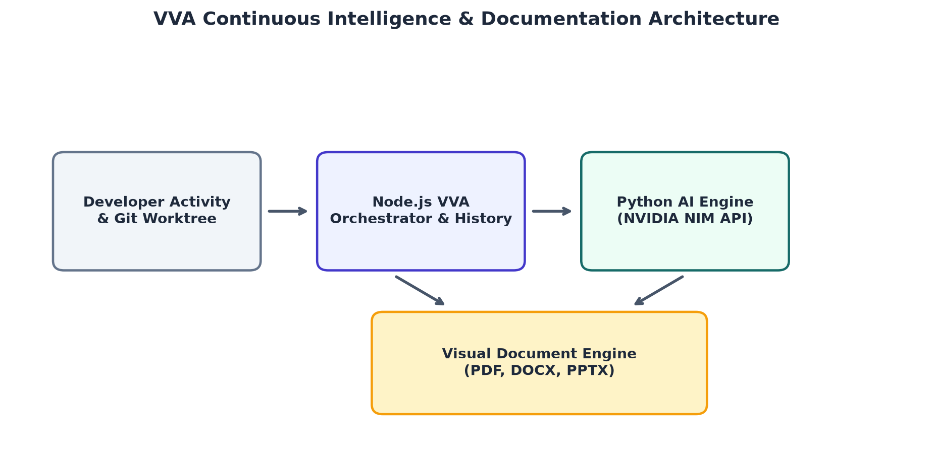
Figure 1: VVA Continuous Workflow Architecture & Subsystem Diagram

3. Development Activity & Evolution Metrics
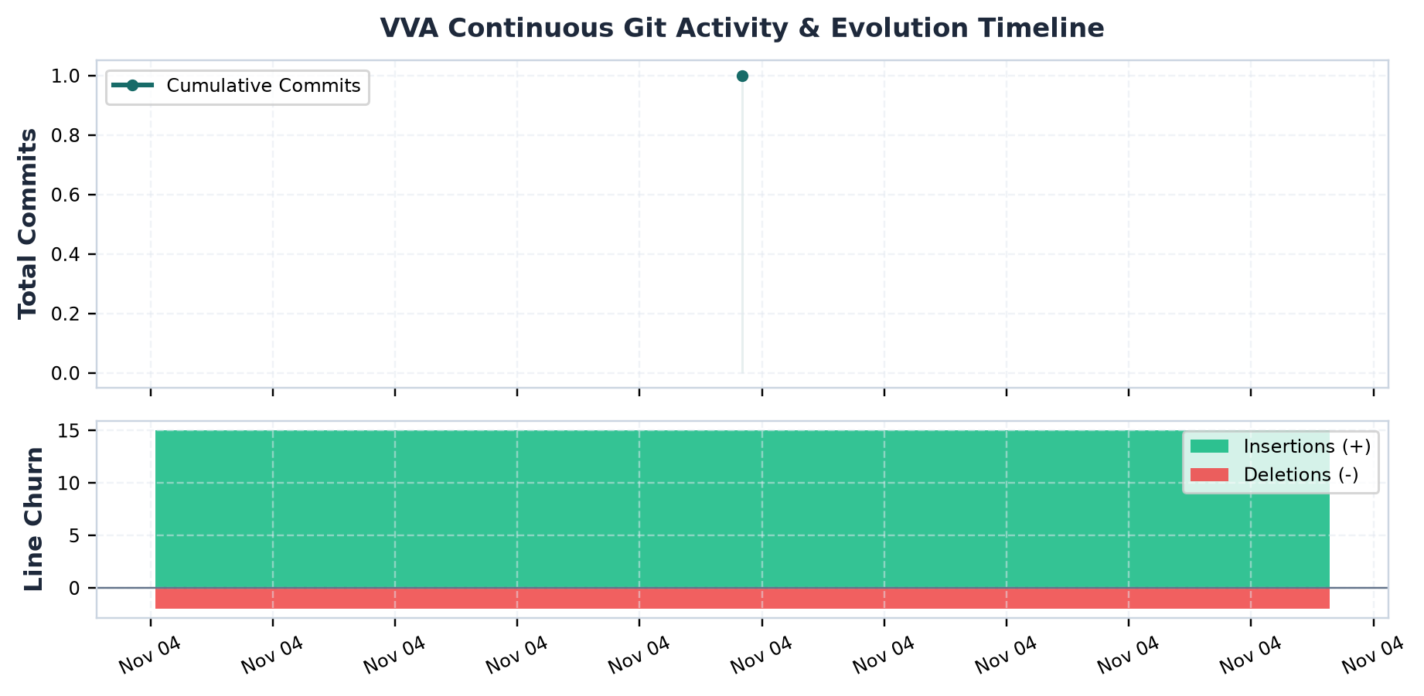
Figure 2: Cumulative Commit Progress & Code Volume Churn

4. Historical Development Milestones
Commit | Author | Milestone | Commit Message
fff2ec3 | abhirambinil-08 | Active Working Tree State | finally finished

5. Technical Implementation Details
- Updated .vva/config.json (A) with +None / -0 lines.

6. Architectural Impact & Limitations
Refines modular boundaries and ensures deterministic execution across repository workflows.
- Facts verified directly from committed diff hunk without speculative assumptions.
- Changes verified against active runtime and schema specifications.

