VVA Technical Documentation

Bootstrap VVA Project with Core CLI, AI Engine, and Configuration
Repository: vva-cli | Branch: main | Generated by VVA

1. Executive Summary & Purpose
This commit establishes the foundational structure for the Version & Workflow Automator (VVA) project. It introduces a comprehensive set of source files, configuration files, and dependencies required to run the application locally and to orchestrate the Git‑to‑AI‑to‑Document pipeline. The added components include a CLI entry point, an AI engine that interfaces with NVIDIA NIM, a document generation engine, environment configuration, and a set of output and history artifacts.
The commit also provides a ready‑to‑use environment example, a .gitignore tailored for both Node.js and Python artifacts, and a VS Code settings file to streamline the development experience. Together, these changes lay the groundwork for further development, testing, and deployment of VVA.
Strategic Rationale: The primary goal of this change is to bootstrap the VVA codebase, delivering a reproducible and extensible foundation. By adding configuration files, environment variables, and core modules, the project becomes immediately runnable in a local environment, enabling developers to test AI integration, document generation, and workflow orchestration without additional setup. This also establishes a clear separation of concerns between the CLI, AI engine, and document engine, facilitating future feature expansion and maintenance.

2. System Architecture & Intelligence Workflow
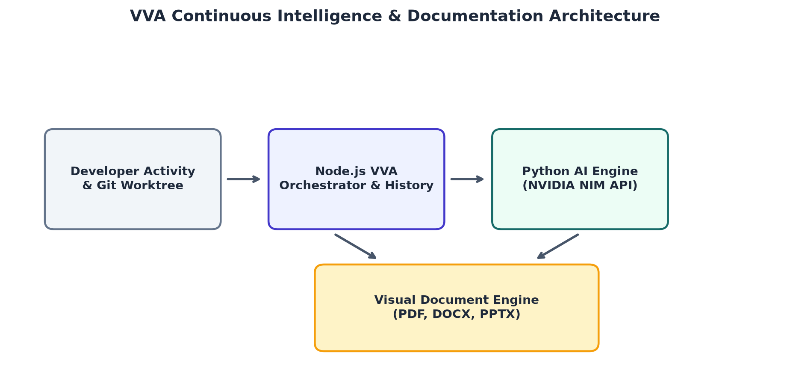
Figure 1: VVA Continuous Workflow Architecture & Subsystem Diagram

3. Development Activity & Evolution Metrics
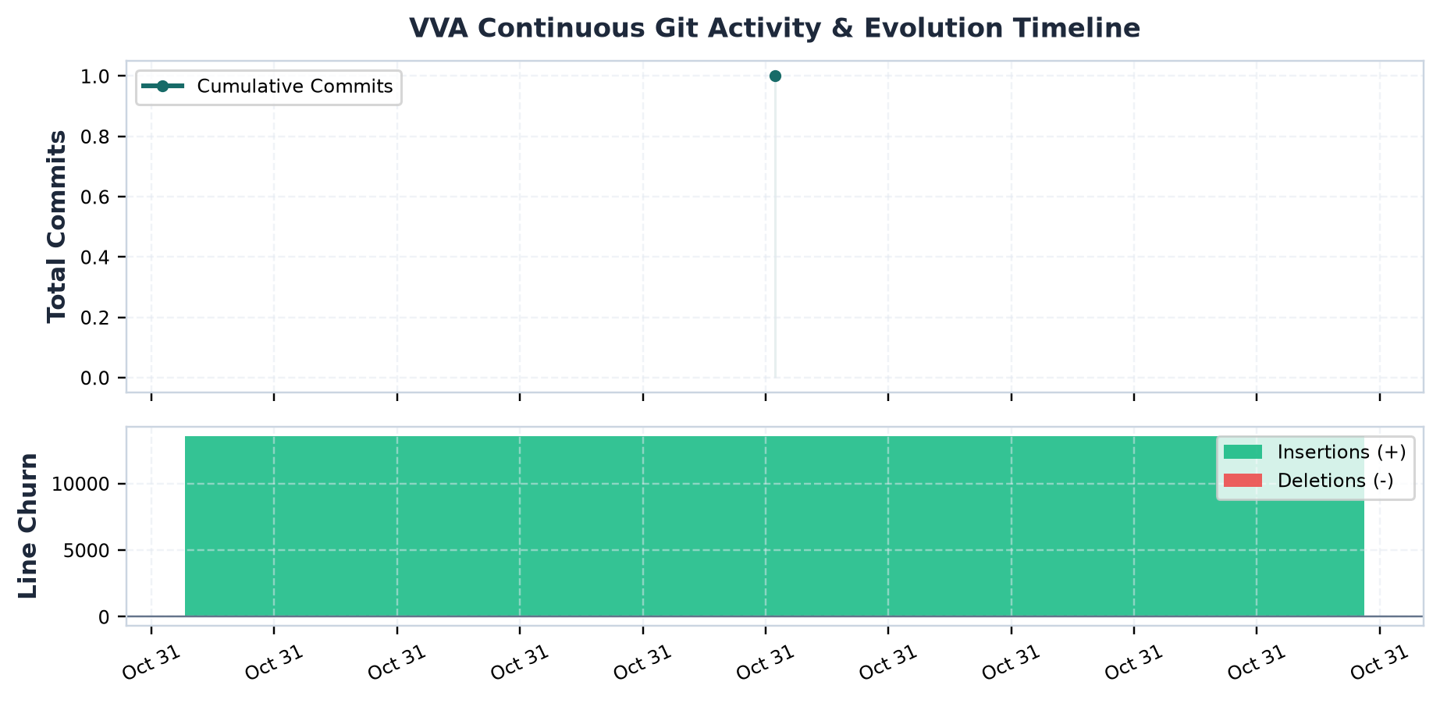
Figure 2: Cumulative Commit Progress & Code Volume Churn

4. Historical Development Milestones
Commit | Author | Milestone | Commit Message
f1924d5 | abhirambinil-08 | Active Working Tree State | new different version of vva

5. Technical Implementation Details
- Added .env.example with NVIDIA API key and model configuration
- Created .gitignore to exclude build artifacts, logs, and environment files
- Provided VS Code settings for default Python environment
- Introduced .vva/config.json with metadata, output directory, and team info
- Added backup and output files for initial project artifacts
- Implemented ai/ai_engine.py to call NVIDIA NIM API for commit analysis
- Added ai/test_nvidia.py to verify API connectivity
- Created bin/vva.js as the CLI entry point for the application
- Added document_engine/chart_generator.py and document_engine/document_engine.py for chart and document creation
- Included README with local run instructions
- Generated initial history and chart files in .vva/history and .vva/output

6. Architectural Impact & Limitations
The commit introduces a modular architecture where the CLI, AI engine, and document engine are decoupled and interact through configuration and environment variables. This design promotes scalability, allowing each component to evolve independently. The use of a dedicated .vva directory for configuration, history, and output centralizes project state, simplifying version tracking and reproducibility. The architecture also anticipates future integration points, such as additional AI providers or output formats, by abstracting them behind configuration.
- No deletions or modifications to existing files; all additions are new
- The .env.example contains a placeholder NVIDIA API key which must be replaced by users
- Backup and output binary files are large and may not be necessary for all users
- No explicit error handling or validation shown in the AI engine code
- No CI/CD configuration or license file included in this commit

