Name: ABHIRAM CHANDIKA
Section: CSM 06
Roll No: 26001198

Task 1: Design and Development of a Responsive Hotel Website with Integrated Booking System
Aim: To design and develop a responsive, single-page hotel website featuring room categories, room images, facilities, tariffs, check-in and check-out fields, and reservation forms using HTML and CSS.
Question: Design a hotel website containing room categories, room images, facilities, tariffs, check-in and check-out fields, and reservation forms. Create attractive room cards and responsive booking sections.
Source Code:
<!DOCTYPE html>
<html lang="en">
<head>
<meta charset="UTF-8">
<meta name="viewport" content="width=device-width, initial-scale=1.0">
<title>Dream Stay Hotel</title>
<style>
* {
margin: 0;
padding: 0;
box-sizing: border-box;
}
body {
font-family: Arial, sans-serif;
background: #f4f4f4;
color: #333;
}
header {
background: #123b50;
color: white;
padding: 20px;
text-align: center;
}
nav {
background: #1c536b;
padding: 12px;
text-align: center;
}
nav a {
color: white;
text-decoration: none;
margin: 15px;
}
.hero {
background: linear-gradient(
rgba(0,0,0,0.4),
rgba(0,0,0,0.4)
), url("https://images.unsplash.com/photo-1566073771259-6a8506099945");
background-size: cover;
background-position: center;
height: 350px;
display: flex;
align-items: center;
justify-content: center;
text-align: center;
color: white;
}
.hero h2 {
font-size: 40px;
}
.booking {
background: white;
padding: 25px;
margin: 25px auto;
max-width: 900px;
border-radius: 10px;
box-shadow: 0 2px 10px #ccc;
}
.booking form {
display: grid;
grid-template-columns: repeat(
auto-fit, minmax(150px, 1fr)
);
gap: 15px;
}
input, select, button {
padding: 12px;
border: 1px solid #ccc;
border-radius: 5px;
width: 100%;
}
button {
background: #e69b35;
color: white;
border: none;
cursor: pointer;
font-weight: bold;
}
button:hover {
background: #c77d1d;
}
.rooms {
padding: 30px;
text-align: center;
}
.room-container {
display: grid;
grid-template-columns: repeat(
auto-fit, minmax(250px, 1fr)
);
gap: 25px;
margin-top: 25px;
}
.room-card {
background: white;
border-radius: 10px;
overflow: hidden;
box-shadow: 0 2px 10px #ccc;
text-align: left;
}
.room-card img {
width: 100%;
height: 200px;
object-fit: cover;
}
.room-info {
padding: 20px;
}
.room-info h3 {
color: #123b50;
margin-bottom: 10px;
}
.room-info p {
margin: 8px 0;
}
.price {
color: #e69b35;
font-size: 20px;
font-weight: bold;
}
.facilities {
background: #e8f0f3;
padding: 30px;
text-align: center;
}
.facilities p {
margin-top: 15px;
line-height: 2;
}
footer {
background: #123b50;
color: white;
text-align: center;
padding: 20px;
}
@media (max-width: 600px) {
.hero h2 {
font-size: 28px;
}
nav a {
margin: 5px;
font-size: 14px;
}
.rooms {
padding: 15px;
}
}
</style>
</head>
<body>
<header>
<h1>Dream Stay Hotel</h1>
<p>Your comfort is our priority</p>
</header>
<nav>
<a href="#home">Home</a>
<a href="#rooms">Rooms</a>
<a href="#facilities">Facilities</a>
<a href="#booking">Booking</a>
</nav>
<section class="hero" id="home">
<div>
<h2>Welcome to Dream Stay</h2>
<p>Experience luxury and comfort</p>
</div>
</section>
<section class="booking" id="booking">
<h2>Book Your Stay</h2>
<br>
<form onsubmit="alert('Reservation submitted successfully!'); return false;">
<div>
<label>Check-in</label>
<input type="date" required>
</div>
<div>
<label>Check-out</label>
<input type="date" required>
</div>
<div>
<label>Guests</label>
<select required>
<option>1 Guest</option>
<option>2 Guests</option>
<option>3 Guests</option>
<option>4 Guests</option>
</select>
</div>
<div>
<label>Room Type</label>
<select required>
<option>Standard Room</option>
<option>Deluxe Room</option>
<option>Suite Room</option>
</select>
</div>
<div>
<label>Your Name</label>
<input type="text" placeholder="Enter your name" required>
</div>
<div>
<label>Email</label>
<input type="email" placeholder="Enter your email" required>
</div>
<div>
<label> </label>
<button type="submit">Reserve Now</button>
</div>
</form>
</section>
<section class="rooms" id="rooms">
<h2>Our Rooms</h2>
<p>Choose the perfect room for your stay</p>
<div class="room-container">
<div class="room-card">
<img src="https://images.unsplash.com/photo-1611892440504-42a792e24d32" alt="Standard Room">
<div class="room-info">
<h3>Standard Room</h3>
<p>Comfortable room for two guests.</p>
<p>Facilities: Wi-Fi, TV, AC</p>
<p class="price">₹2,000 / Night</p>
<button onclick="location.href='#booking'">Book Room</button>
</div>
</div>
<div class="room-card">
<img src="https://images.unsplash.com/photo-1590490360182-c33d57733427" alt="Deluxe Room">
<div class="room-info">
<h3>Deluxe Room</h3>
<p>Luxury room with beautiful interiors.</p>
<p>Facilities: Wi-Fi, AC, TV, Balcony</p>
<p class="price">₹4,000 / Night</p>
<button onclick="location.href='#booking'">Book Room</button>
</div>
</div>
<div class="room-card">
<img src="https://images.unsplash.com/photo-1582719478250-c89cae4dc85b" alt="Suite Room">
<div class="room-info">
<h3>Suite Room</h3>
<p>Premium room with spacious interiors.</p>
<p>Facilities: Wi-Fi, AC, TV, Pool</p>
<p class="price">₹7,000 / Night</p>
<button onclick="location.href='#booking'">Book Room</button>
</div>
</div>
</div>
</section>
<section class="facilities" id="facilities">
<h2>Hotel Facilities</h2>
<p>
🏊 Swimming Pool | 🍽 Restaurant | 📶 Free Wi-Fi | 🚗 Parking | ❄ Air Conditioning | 🏋 Gym
</p>
</section>
<footer>
<p>© 2026 Dream Stay Hotel</p>
<p>Contact: dreamstay@example.com</p>
</footer>
</body>
</html>

Output

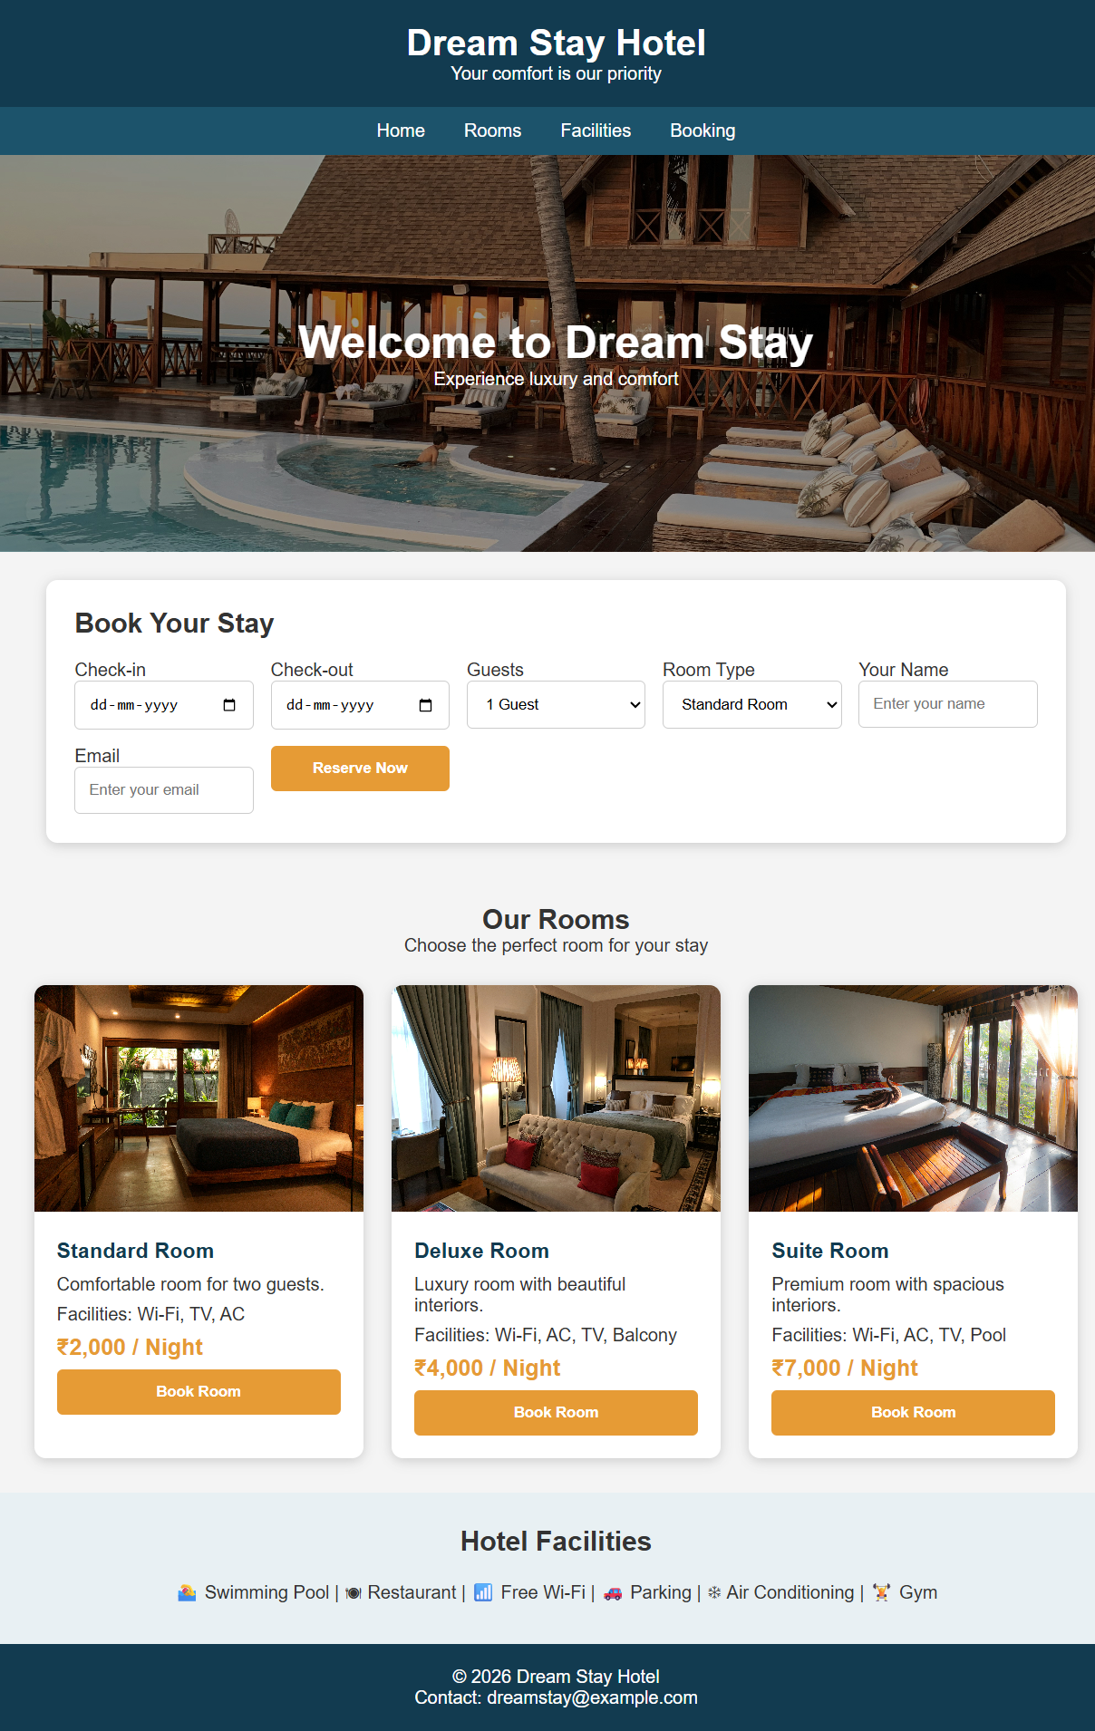
Conclusion:The hotel website was successfully developed using standard web technologies. By combining semantic HTML structuring and CSS grid layouts, an elegant and functional hotel booking webpage was achieved. The final design successfully meets the requirements by integrating a responsive room card section, room tariffs, facility showcases, and a full reservation form.

Task 2: Design and Implementation of an Online Food Ordering Interface
Aim: To design and develop a responsive food ordering interface featuring restaurant details, menu categories, food items, pricing, promotional offers, customer reviews, and interactive ordering features using HTML, CSS, and JavaScript.
Question: Design a food ordering interface with restaurant details, menu categories, food images, prices, special offers, customer reviews, and order buttons. Use card layouts, attractive backgrounds, and mobile-friendly navigation.
Source Code:
<!DOCTYPE html>
<html lang="en">
<head>
<meta charset="UTF-8">
<meta name="viewport" content="width=device-width, initial-scale=1.0">
<title>Foodie - Online Food Ordering</title>
<style>
* {
margin: 0;
padding: 0;
box-sizing: border-box;
}
body {
font-family: Arial, sans-serif;
background: #fffaf5;
color: #333;
}
header {
background: #ff5722;
color: white;
padding: 20px;
display: flex;
justify-content: space-between;
align-items: center;
flex-wrap: wrap;
}
header h1 {
font-size: 28px;
}
nav a {
color: white;
text-decoration: none;
margin: 10px;
font-weight: bold;
}
.hero {
background: linear-gradient(
rgba(0,0,0,0.5),
rgba(0,0,0,0.5)
), url("https://images.unsplash.com/photo-1504674900247-0877df9cc836");
background-size: cover;
background-position: center;
padding: 100px 20px;
text-align: center;
color: white;
}
.hero h2 {
font-size: 40px;
margin-bottom: 15px;
}
.hero button {
background: #ff5722;
color: white;
border: none;
padding: 12px 25px;
border-radius: 5px;
margin-top: 20px;
cursor: pointer;
}
.offer {
background: #ffe0b2;
text-align: center;
padding: 25px;
margin: 25px;
border-radius: 10px;
}
.offer h2 {
color: #e64a19;
}
.categories {
text-align: center;
padding: 25px;
}
.category-list {
display: flex;
justify-content: center;
flex-wrap: wrap;
gap: 15px;
margin-top: 20px;
}
.category-list button {
padding: 12px 25px;
border: none;
border-radius: 25px;
background: #ff5722;
color: white;
cursor: pointer;
}
.menu {
padding: 30px;
text-align: center;
}
.food-container {
display: grid;
grid-template-columns: repeat(
auto-fit, minmax(230px, 1fr)
);
gap: 25px;
margin-top: 25px;
}
.food-card {
background: white;
border-radius: 12px;
overflow: hidden;
box-shadow: 0 3px 10px #ddd;
transition: 0.3s;
}
.food-card:hover {
transform: translateY(-5px);
}
.food-card img {
width: 100%;
height: 190px;
object-fit: cover;
}
.food-info {
padding: 20px;
text-align: left;
}
.food-info h3 {
color: #e64a19;
margin-bottom: 10px;
}
.food-info p {
margin: 10px 0;
}
.price {
font-size: 20px;
font-weight: bold;
color: #333;
}
.food-info button {
width: 100%;
padding: 12px;
background: #ff5722;
color: white;
border: none;
border-radius: 5px;
cursor: pointer;
}
.food-info button:hover {
background: #e64a19;
}
.reviews {
background: #fff0e6;
padding: 40px 20px;
text-align: center;
}
.review-container {
display: grid;
grid-template-columns: repeat(
auto-fit, minmax(200px, 1fr)
);
gap: 20px;
margin-top: 25px;
}
.review-card {
background: white;
padding: 20px;
border-radius: 10px;
}
footer {
background: #333;
color: white;
text-align: center;
padding: 20px;
}
#cart {
font-weight: bold;
}
@media (max-width: 600px) {
header {
flex-direction: column;
gap: 15px;
}
nav {
text-align: center;
}
nav a {
display: inline-block;
margin: 6px;
}
.hero h2 {
font-size: 28px;
}
.menu {
padding: 15px;
}
}
</style>
</head>
<body>
<header>
<h1>Foodie</h1>
<nav>
<a href="#home">Home</a>
<a href="#menu">Menu</a>
<a href="#reviews">Reviews</a>
<a href="#contact">Contact</a>
<span id="cart">🛒 Cart: 0</span>
</nav>
</header>
<section class="hero" id="home">
<h2>Delicious Food Delivered</h2>
<p>Fresh food, fast delivery, and amazing taste!</p>
<button onclick="location.href='#menu'">Order Now</button>
</section>
<section class="offer">
<h2> Special Offer!</h2>
<p>Get 20% OFF on your first order.</p>
<p>Use Coupon Code: FOOD20</p>
</section>
<section class="categories">
<h2>Food Categories</h2>
<div class="category-list">
<button onclick="filterFood('All')">All</button>
<button onclick="filterFood('Pizza')">Pizza</button>
<button onclick="filterFood('Burger')">Burgers</button>
<button onclick="filterFood('Biryani')">Biryani</button>
<button onclick="filterFood('Dessert')">Desserts</button>
</div>
</section>
<section class="menu" id="menu">
<h2>Our Popular Menu</h2>
<div class="food-container">
<div class="food-card" data-category="Pizza">
<img src="https://images.unsplash.com/photo-1513104890138-7c749659a591" alt="Pizza">
<div class="food-info">
<h3>Cheese Pizza</h3>
<p>Delicious cheesy pizza with fresh toppings.</p>
<p class="price">₹249</p>
<button onclick="addToCart('Cheese Pizza',249)">Add to Cart</button>
</div>
</div>
<div class="food-card" data-category="Burger">
<img src="https://images.unsplash.com/photo-1568901346375-23c9450c58cd" alt="Burger">
<div class="food-info">
<h3>Classic Burger</h3>
<p>Juicy burger with cheese and vegetables.</p>
<p class="price">₹149</p>
<button onclick="addToCart('Classic Burger',149)">Add to Cart</button>
</div>
</div>
<div class="food-card" data-category="Biryani">
<img src="https://images.unsplash.com/photo-1563379091339-03246963d96c" alt="Biryani">
<div class="food-info">
<h3>Chicken Biryani</h3>
<p>Authentic spicy biryani with rich flavors.</p>
<p class="price">₹299</p>
<button onclick="addToCart('Chicken Biryani',299)">Add to Cart</button>
</div>
</div>
<div class="food-card" data-category="Dessert">
<img src="https://images.unsplash.com/photo-1551024506-0bccd828d307" alt="Donuts">
<div class="food-info">
<h3>Chocolate Dessert</h3>
<p>Sweet and delicious chocolate treat.</p>
<p class="price">₹99</p>
<button onclick="addToCart('Chocolate Dessert',99)">Add to Cart</button>
</div>
</div>
</div>
</section>
<section class="reviews" id="reviews">
<h2>Customer Reviews</h2>
<div class="review-container">
<div class="review-card">
<h3>⭐⭐⭐⭐⭐</h3>
<p>"Amazing food and fast delivery!"</p>
<h4>Rahul</h4>
</div>
<div class="review-card">
<h3>⭐⭐⭐⭐⭐</h3>
<p>"The biryani was delicious. Loved it!"</p>
<h4>Priya</h4>
</div>
<div class="review-card">
<h3>⭐⭐⭐⭐</h3>
<p>"Great taste and affordable prices."</p>
<h4>Arjun</h4>
</div>
</div>
</section>
<footer id="contact">
<h3>Foodie Restaurant</h3>
<p>Address: Vijayawada, Andhra Pradesh</p>
<p>Contact: 9876543210</p>
<p>© 2026 Foodie. All Rights Reserved.</p>
</footer>
<script>
let cartCount = 0;
let totalAmount = 0;
function addToCart(name, price) {
cartCount++;
totalAmount += price;
document.getElementById("cart").innerHTML =
"🛒 Cart: " + cartCount;
alert(name + " added to cart!\n" +
"Total Amount: ₹" + totalAmount);
}
function filterFood(category) {
let foods = document.querySelectorAll(".food-card");
foods.forEach(function(food) {
if (category === "All" ||
food.dataset.category === category) {
food.style.display = "block";
} else {
food.style.display = "none";
}
});
}
</script>
</body>
</html>

Output
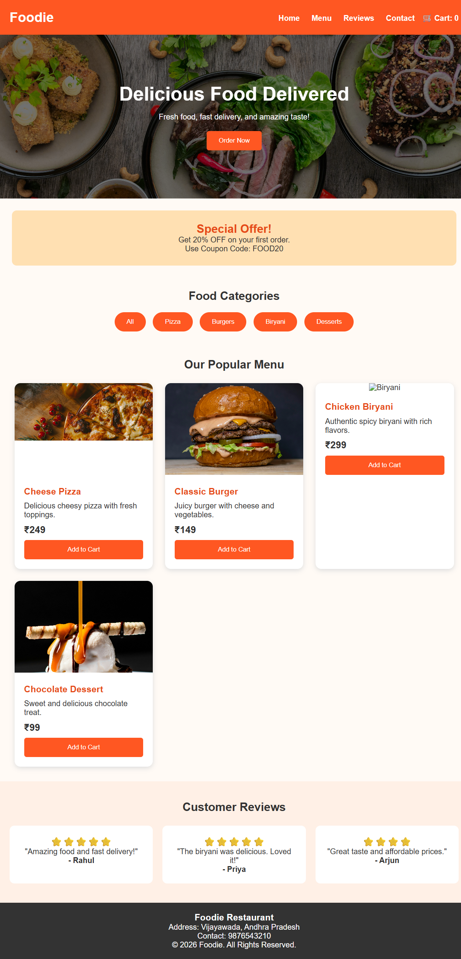
Conclusion:The online food ordering interface was successfully developed using HTML, CSS, and basic JavaScript. The dynamic cart functionality, dynamic category filtering, customer review display, and grid-based menu layout allow for a seamless user experience across desktop and mobile browsers.

Task 3: Creation of an Interactive Personal Portfolio and Professional Resume Website
Aim: To create a responsive personal portfolio website displaying educational qualifications, technical skills, hobbies, projects, achievements, resume, and contact information, utilizing CSS animations and interactive layout management.
Question: Create a personal website displaying a profile, educational qualifications, technical skills, hobbies, projects, achievements, resume, and contact information. Use CSS animations, responsive layouts, and interactive navigation effects.
Source Code:
<!DOCTYPE html>
<html lang="en">
<head>
<meta charset="UTF-8">
<meta name="viewport" content="width=device-width, initial-scale=1.0">
<title>My Portfolio</title>
<style>
* {
margin: 0;
padding: 0;
box-sizing: border-box;
scroll-behavior: smooth;
}
body {
font-family: Arial, sans-serif;
background: #f4f7fc;
color: #333;
}
nav {
background: #222;
padding: 15px;
text-align: center;
position: sticky;
top: 0;
}
nav a {
color: white;
text-decoration: none;
margin: 12px;
}
nav a:hover {
color: #00c3ff;
}
header {
background: linear-gradient(120deg, #007bff, #00c3ff);
color: white;
text-align: center;
padding: 60px 20px;
animation: fade 2s;
}
header img {
width: 120px;
height: 120px;
border-radius: 50%;
margin-bottom: 15px;
}
header h1 {
margin-bottom: 10px;
}
section {
max-width: 900px;
margin: auto;
padding: 35px 20px;
}
h2 {
color: #007bff;
text-align: center;
margin-bottom: 20px;
}
.card {
background: white;
padding: 20px;
margin: 15px 0;
border-radius: 10px;
box-shadow: 0 3px 10px #ddd;
transition: 0.3s;
}
.card:hover {
transform: translateY(-5px);
}
.skills {
display: flex;
justify-content: center;
flex-wrap: wrap;
gap: 15px;
}
.skills span {
background: #007bff;
color: white;
padding: 12px 20px;
border-radius: 20px;
}
.btn {
display: inline-block;
background: #007bff;
color: white;
padding: 12px 20px;
text-decoration: none;
border-radius: 5px;
margin-top: 15px;
}
.btn:hover {
background: #0056b3;
}
footer {
background: #222;
color: white;
text-align: center;
padding: 20px;
}
@keyframes fade {
from {
opacity: 0;
transform: translateY(30px);
}
to {
opacity: 1;
transform: translateY(0);
}
}
@media (max-width: 600px) {
nav a {
display: inline-block;
margin: 7px;
}
header h1 {
font-size: 25px;
}
}
</style>
</head>
<body>
<nav>
<a href="#home">Home</a>
<a href="#education">Education</a>
<a href="#skills">Skills</a>
<a href="#projects">Projects</a>
<a href="#contact">Contact</a>
</nav>
<header id="home">
<img src="https://via.placeholder.com/120" alt="Profile Photo">
<h1>Hello, I'm Your Name</h1>
<p>Student | Web Developer</p>
<a href="#contact" class="btn">Contact Me</a>
</header>
<section>
<h2>About Me</h2>
<div class="card">
<p>
I am a student interested in programming,
web development, and learning new technologies.
</p>
</div>
</section>
<section id="education">
<h2>Education</h2>
<div class="card">
<h3>B.Tech</h3>
<p>College: Your College Name</p>
<p>Year: 2026 - 2030</p>
</div>
<div class="card">
<h3>Intermediate</h3>
<p>College: Your College Name</p>
<p>Year: 2024 - 2026</p>
</div>
<div class="card">
<h3>SSC</h3>
<p>School: Your School Name</p>
<p>Year: 2024</p>
</div>
</section>
<section id="skills">
<h2>Technical Skills</h2>
<div class="skills">
<span>HTML</span>
<span>CSS</span>
<span>Python</span>
<span>C</span>
</div>
</section>
<section>
<h2>Hobbies</h2>
<div class="card">
<p>Reading Books, Playing Cricket, Listening to Music</p>
</div>
</section>
<section id="projects">
<h2>Projects</h2>
<div class="card">
<h3>Personal Portfolio</h3>
<p>A website to display my profile and skills.</p>
</div>
<div class="card">
<h3>Food Ordering Website</h3>
<p>A simple online food ordering interface.</p>
</div>
</section>
<section>
<h2>Achievements</h2>
<div class="card">
<p>Completed HTML and CSS course.</p>
<p>Participated in college technical events.</p>
</div>
</section>
<section>
<h2>Resume</h2>
<div class="card" style="text-align:center">
<a href="resume.pdf" download class="btn">Download Resume</a>
</div>
</section>
<section id="contact">
<h2>Contact Information</h2>
<div class="card">
<p>Email: yourname@gmail.com</p>
<p>Phone: 9876543210</p>
<p>Location: Vijayawada</p>
</div>
</section>
<footer>
<p>© 2026 My Personal Portfolio</p>
</footer>
</body>
</html>

Output
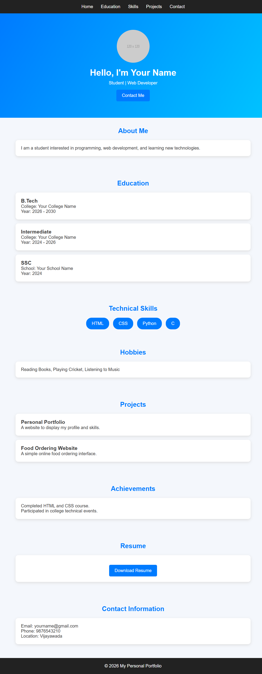
Conclusion:The personal portfolio website was successfully developed using HTML and CSS. By utilizing semantic structuring, smooth scrolling, CSS hover effects, and animation Keyframes, a responsive, visually appealing online portfolio was achieved. The website effectively highlights educational qualifications, technical skill tags, interactive project cards, achievements, and resume download capabilities.

