SQL> SET SERVEROUTPUT ON;

SQL> DECLARE

2 message varchar2(20):='Hello World!';

3 BEGIN

4 dbms_output.put_line(message);

5 END;

6 /

Hello World!

PL/SQL procedure successfully completed.

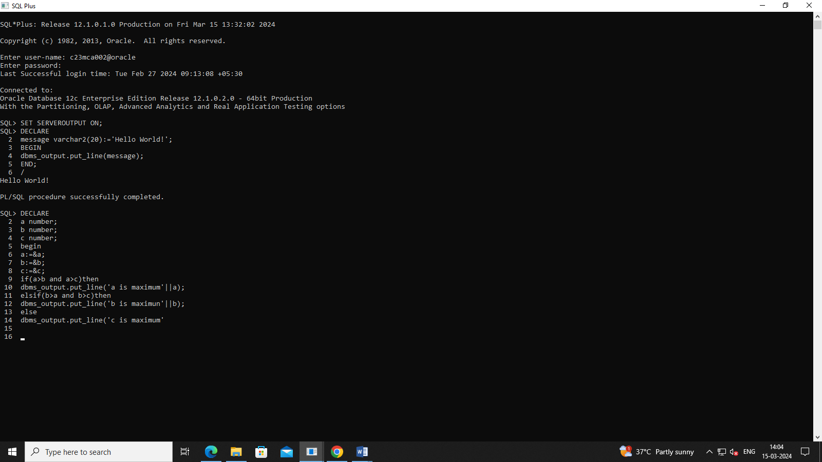

SQL> create table employee(ssn number(3),fname varchar(20),lname varchar(20),salaruy number(38));

Table created.

SQL> insert into employee values(101,'amrutha','biju',75000);

1 row created.

SQL> insert into employee values(102,'anite','jose',75000);

1 row created.

SQL> insert into employee values(103,'anna','maria',75000);

1 row created.

SQL> insert into employee values(104,'bharathi','s',75000);

1 row created.

