

DATA STRUCTURE LAB

**(20MCA135)**

**LAB RECORD**

Submitted in partial fulfilment of the requirements for the award of the degree of Master of Computer Applications of A P J Abdul Kalam Technological University, Kerala.

**Submitted by:**

**ABHIRAMI VINOD (SJC23MCA-2001)**

**MASTER OF COMPUTER APPLICATIONS**

**ST.JOSEPH’S COLLEGE OF ENGINEERING AND TECHNOLOGY, PALAI**

**CHOONDACHERRY P.O, KOTTAYAM**

**KERALA**

**December 2023**



**ST. JOSEPH’ S COLLEGE OF ENGINEERING AND TECHNOLOGY, PALAI**

**(An ISO 9001: 2015 Certified College)**

**CHOONDACHERRY P.O, KOTTAYAM, KERALA**

**CERTIFICATE**

This is to certify that the Data Structure Lab Record (20MCA135) submitted by Abhirami Vinod, student of First semester MCA at ST. JOSEPH’S COLLEGE OF ENGINEERING AND TECHNOLOGY, PALAI in partial fulfilment for the award of Master of Computer Applications is a bonafide record of the lab work carried out by her under our guidance and supervision. This record in any form has not been submitted to any other University or Institute for any purpose.

|  |  |
| --- | --- |
| **Prof. Anish Augustine K** | **Dr. Rahul Shajan** |
| **Faculty In- Charge** | **(Head of the Department)** |

Submitted for the End Semester Examination held on

**Examiner 1:**

**Examiner 2:**

**DECLARATION**

I Abhirami Vinod, do hereby declare that the Data Structure Lab Record (20 MCA 135) is a record of work carried out under the guidance of Mr. Anish Augustine, Asst. Professor, Department of Computer Applications, SJCET, Palai as per the requirement of the curriculum of Master of Computer Applications Programme of A P J Abdul Kalam Technology University, Thiruvananthapuram. Further, I also declare that this record has not been submitted, full or part thereof, in any University / Institution for the award of any Degree / Diploma.

Place: Choondacherry ABHIRAMI VINOD

Date : (SJC23MCA-2001)

**CONTENT**

|  |  |  |
| --- | --- | --- |
| **Sl. No.** | **Program List** | **Page No.** |
| 1 | Array Operation (Insertion, Deletion, Sorting, Merging). | 1 |
| 2 | Searching an array element (Linear Search, Binary Search). | 6 |
| 3 | Matrix Operations (Addition, Multiplication,  Transpose). | 9 |
| 4 | Using Structure, add two distances in the inch-feet  system. | 14 |
| 5 | Implement Stack Operations. | 16 |
| 6 | String Operations (Searching, Concatenation,  Substring). | 19 |
| 7 | Sorting an Array (Bubble Sort, Selection Sort, Insertion  Sort). | 21 |
| 8 | Implement Queue operations (Insert, delete, display front &amp; rear values). | 25 |
| 9 | Implement Circular Queue operations (Insert, delete, display front &amp; rear values). | 28 |
| 10 | Implement singly linked list (Insert at the head, insert at tail, insert at a position, delete at the  head, delete at tail, delete form a position, search an  element). | 31 |
| 11 | Implement doubly linked list (Insert at the head, insert at tail, insert at a position, delete at the  head, delete at tail, delete form a position, search an  element). | 38 |
| 12 | Implement circular linked list (Insert at the head, insert at tail, insert at a position, delete at the  head, delete at tail, delete form a position, search an  element). | 45 |
| 13 | Implement binary search tree. | 51 |
| 14 | Implement balanced-binary-search tree. | 56 |

|  |  |  |
| --- | --- | --- |
| 15 | Implement set operations (union, intersection,  difference). | 61 |
| 16 | Implement disjoint set operations. | 66 |
| 17 | Implement tree traversal methods DFS (In-order, Pre-  Order, Post-Order), and BFS. | 69 |
| 18 | Implement Binomial Heaps and operations (Create, Insert, Delete). | 74 |
| 19 | Implement B Trees and its operations. | 86 |
| 20 | Implement Red Black Trees and its operations. | 97 |
| 21 | Graph Traversal techniques (DFS and BFS) and  Topological Sorting. | 103 |
| 22 | Finding the Strongly connected Components in a  directed graph. | 108 |
| 23 | Prim’s Algorithm for finding the minimum cost  spanning tree. | 112 |
| 24 | Kruskal’s algorithm using the Disjoint set data  structure. | 115 |
| 25 | Single Source shortest path algorithm using any heap structure that supports mergeable heap  operations. | 118 |

1. **Array Operation (Insertion, Deletion, Sorting, Merging). Program:**

#include <stdio.h>

int a[50], n, choice, i, x, j; void insert(){

int pos;

printf("Enter the position :"); scanf("%d", &pos);

if (pos < 0 || pos > n)

{

printf("Invalid position"); return;

}

else

{

printf("Enter the element to insert: "); scanf("%d", &x);

for (i = n; i > pos; i--)

{

a[i] = a[i - 1];

}

a[pos] = x; n++;

}

}

void delete(){ int pos;

printf("Enter the position of element to delete: "); scanf("%d", &pos);

if (pos < 0 || pos > n)

{

printf("Ivalid position"); return;

}

else

{

if (pos >= n + 1)

{

printf("Deletion is not possible");

}

else

{

for (i = pos; i < n - 1; i++)

{

a[i] = a[i + 1];

}

n--;

}

}

}

void display(){

printf("Array Elements:\n"); for (i = 0; i < n; i++)

{

printf("%d\n", a[i]);

}

}

void sort(){ int temp;

for (i = 0; i < n - 1; i++)

{

for (j = 0; j < n - i - 1; j++)

{

if (a[j] > a[j + 1])

{

temp = a[j]; a[j] = a[j + 1]; a[j + 1] = temp;

}

}

}

}

void merge(){

int n2, n3, b[50], c[50];

printf("Enter the size of second array: "); scanf("%d", &n2);

printf("Enter the array of second elements: "); for (i = 0; i < n2; i++)

{

scanf("%d", &b[i]);

}

n3 = n + n2;

for (i = 0; i < n; i++)

{

c[i] = a[i];

}

for (i = 0; i < n2; i++)

{

c[i + n] = b[i];

}

n=n3;

for(i = 0; i< n3; i++){ a[i] = c[i];

}

printf("The merged array: "); for (i = 0; i < n3; i++)

{

printf("%d ", a[i]);

}

}

int main(){

printf("Enter the size of array: "); scanf("%d", &n);

printf("Enter the elements: "); for (i = 0; i < n; i++)

{

scanf("%d", &a[i]);

}

while (choice != 6)

{

printf("\nEnter the choice (1.Insert 2.Delete 3.Sort 4.Merge 5.Display 6.Exit): "); scanf("%d", &choice);

switch (choice){ case 1:

insert(); break;

case 2:

delete(); break;

case 3:

sort(); break;

case 4:

merge(); break;

case 5:

display(); break;

case 6:

printf("\nExit\n"); break;

default:

printf("Enter the invalid option");

}

}

return 0;

}

**Output:**

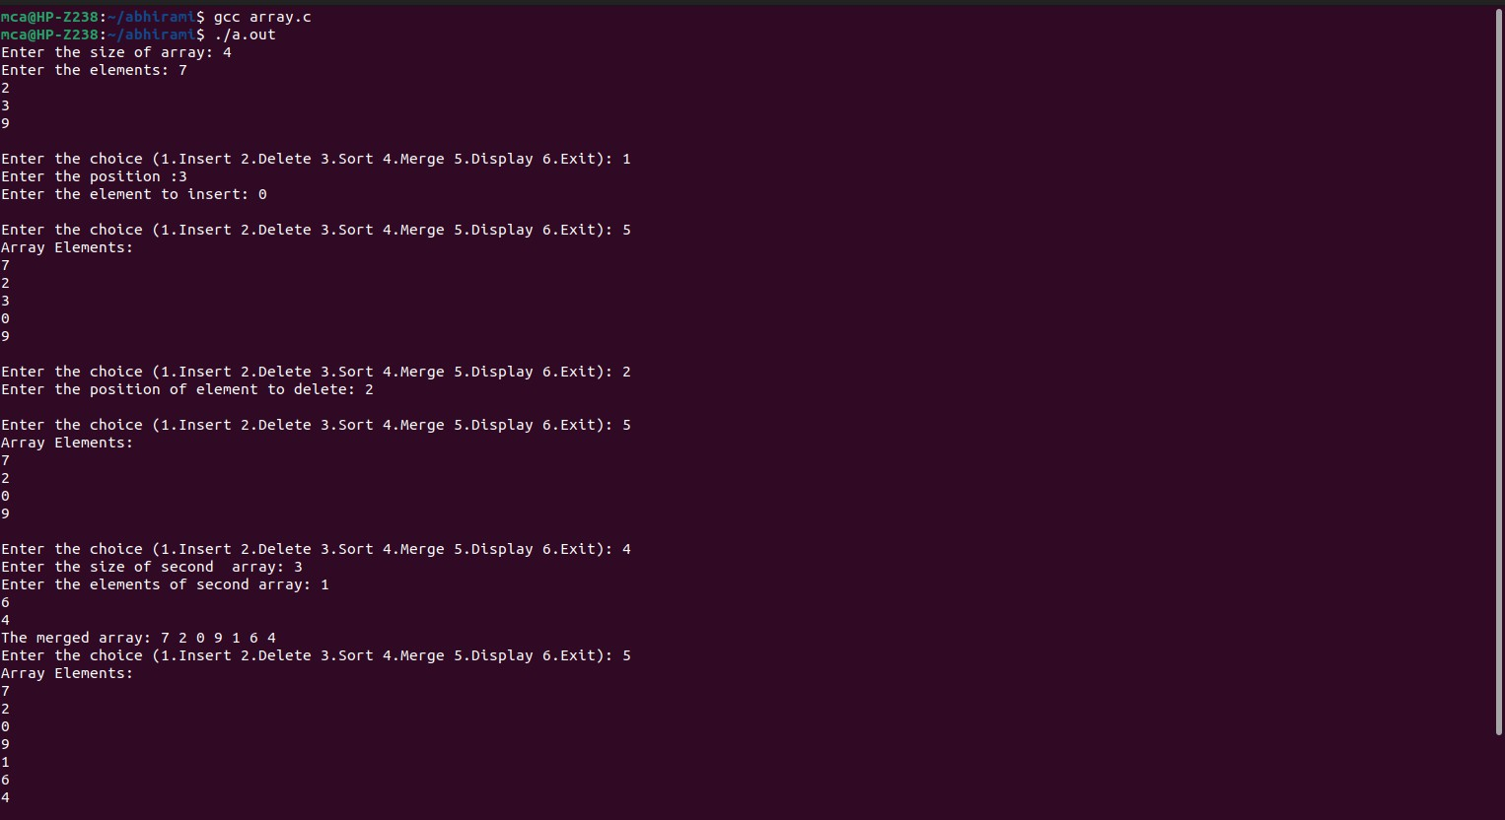

1. **Searching an array element (Linear Search, Binary Search). Program:**

#include <stdio.h>

int linearSearch(int arr[], int n, int key) { for (int i = 0; i < n; i++) {

if (arr[i] == key) { return i;

}

}

return -1;

}

int binarySearch(int arr[], int n, int key) { int left = 0;

int right = n - 1; while (left <= right) {

int mid = left + (right - left) / 2; if (arr[mid] == key) {

return mid;

} else if (arr[mid] < key) { left = mid + 1;

} else {

right = mid - 1;

}

}

return -1;

}

int main() {

int n, choice, key, result;

printf("Enter the number of elements in the array: "); scanf("%d", &n);

int arr[n];

printf("Enter the elements of the array in sorted order:\n"); for (int i = 0; i < n; i++) {

scanf("%d", &arr[i]);

}

while (1) {

printf("\nMenu:\n"); printf("1. Linear Search\n"); printf("2. Binary Search\n"); printf("3. Exit\n"); printf("Enter your choice: "); scanf("%d", &choice);

switch (choice) { case 1:

printf("Enter the element to search: "); scanf("%d", &key);

result = linearSearch(arr, n, key); if (result != -1) {

printf("Element found at index %d.\n", result);

} else {

printf("Element not found.\n");

}

break; case 2:

printf("Enter the element to search: "); scanf("%d", &key);

result = binarySearch(arr, n, key);

if (result != -1) {

printf("Element found at index %d.\n", result);

} else {

printf("Element not found.\n");

}

break; case 3:

printf("Exiting program.\n"); return 0;

default:

printf("Invalid choice. Please select a valid option.\n");

}

}

return 0;

}

**Output:**

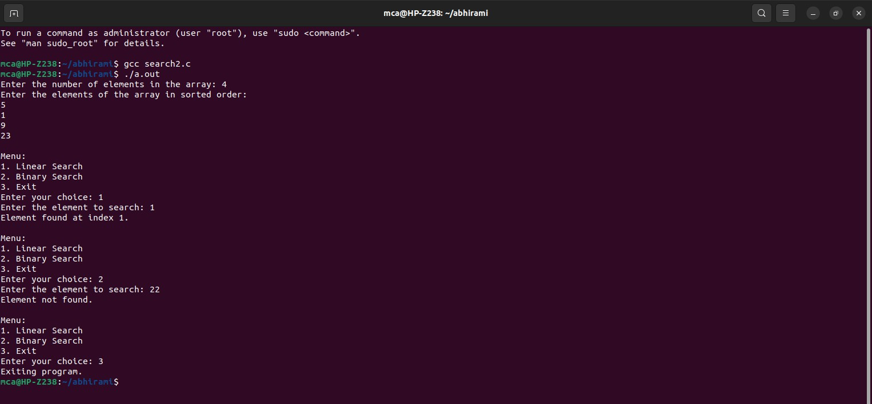

1. **Matrix Operations (Addition, Multiplication, Transpose) Program:**

#include <stdio.h>

int a[10][10], b[10][10], c[10][10], d[10][10], i, j, row, col, choice; void add()

{

for (i = 0; i < row; i++)

{

for (j = 0; j < col; j++)

{

c[i][j] = a[i][j] + b[i][j];

}

}

printf("\nMatrix: \n"); for (i = 0; i < row; i++)

{

for (j = 0; j < col; j++)

{

printf("%d\t", c[i][j]);

}

printf("\n");

}

}

void multiply()

{

for (i = 0; i < row; i++)

{

for (j = 0; j < col; j++)

{

d[i][j] = a[i][j] * b[i][j];

}

}

printf("\nMatrix: \n"); for (i = 0; i < row; i++)

{

for (j = 0; j < col; j++)

{

printf("%d\t", d[i][j]);

}

printf("\n");

}

}

void transpose()

{

printf("Transpose of First Matix: \n"); for (i = 0; i < row; i++)

{

for (j = 0; j < col; j++)

{

printf("%d\t", a[j][i]);

}

printf("\n");

}

printf("Transpose of Second Matix: \n"); for (i = 0; i < row; i++)

{

for (j = 0; j < col; j++)

{

printf("%d\t", a[j][i]);

}

printf("\n");

}

}

int main()

{

printf("Enter the no of rows: "); scanf("%d", &row);

printf("Enter the no of columns: "); scanf("%d", &col);

printf("Enter the elements of first matrix:\n "); for (i = 0; i < row; i++)

{

for (j = 0; j < col; j++)

{

printf("a[%d][%d]: ", i, j);

scanf("%d", &a[i][j]);

}

}

printf("Enter the elements of second matrix:\n "); for (i = 0; i < row; i++)

{

for (j = 0; j < col; j++)

{

printf("b[%d][%d]: ", i, j);

scanf("%d", &b[i][j]);

}

}

printf("\nFirst Matrix: \n"); for (i = 0; i < row; i++)

{

for (j = 0; j < col; j++)

{

printf("%d\t", a[i][j]);

}

printf("\n");

}

printf("\nSecond Matrix: \n"); for (i = 0; i < row; i++)

{

for (j = 0; j < col; j++)

{

printf("%d\t", b[i][j]);

}

printf("\n");

}

while (choice != 4)

{

printf("\nEnter the choice (1.Add 2.Multiply 3.Transpose 4.Exit): "); scanf("%d", &choice);

switch (choice)

{

case 1:

{

add(); break;

}

case 2:

{

multiply(); break;

}

case 3:

{

transpose(); break;

}

case 4:

{

printf("\nExit\n"); break;

}

default:

{

printf("Enter the invalid option");

}}}

return 0;

}

**Output:**

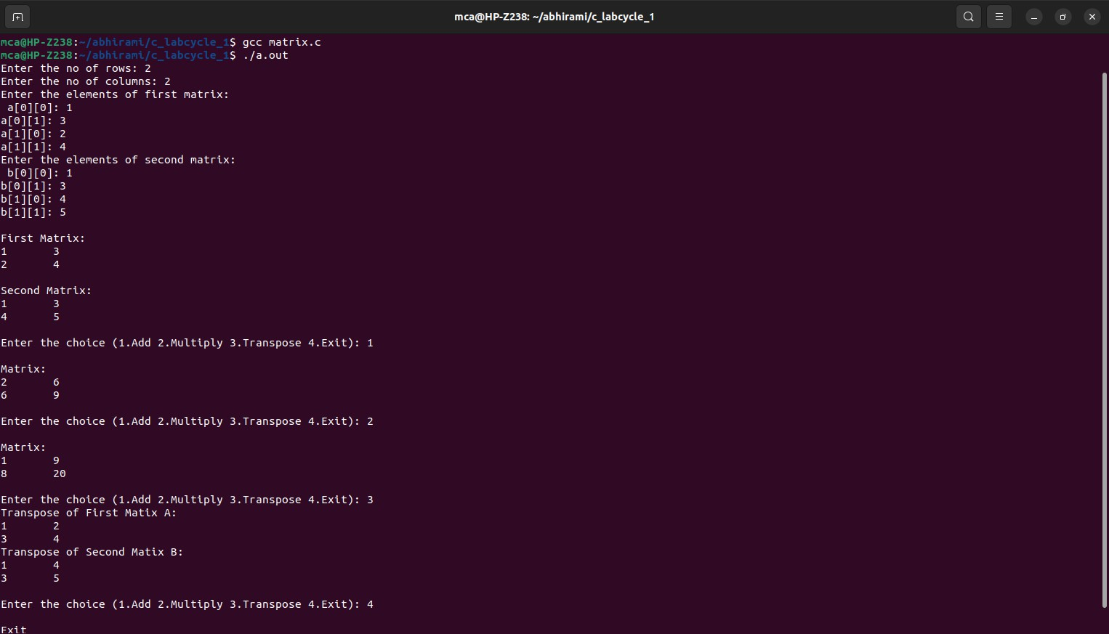

1. **Using Structure, add two distances in the inch-feet system. Program:**

#include <stdio.h> struct Distance { int feet;

float inches;

};

struct Distance addDistances(struct Distance d1, struct Distance d2) { struct Distance result;

result.inches = d1.inches + d2.inches; result.feet = d1.feet + d2.feet;

if (result.inches >= 12.0) { result.feet++;

result.inches -= 12.0;

}

return result;

}

int main() {

struct Distance distance1, distance2, sum;

printf("Enter distance 1:\n");

printf("Feet: ");

scanf("%d", &distance1.feet);

printf("Inches: ");

scanf("%f", &distance1.inches);

printf("Enter distance 2:\n");

printf("Feet: ");

scanf("%d", &distance2.feet); printf("Inches: ");

scanf("%f", &distance2.inches);

sum = addDistances(distance1, distance2);

printf("Sum of distances: %d feet %.2f inches\n", sum.feet, sum.inches); return 0;

}

**Output:**

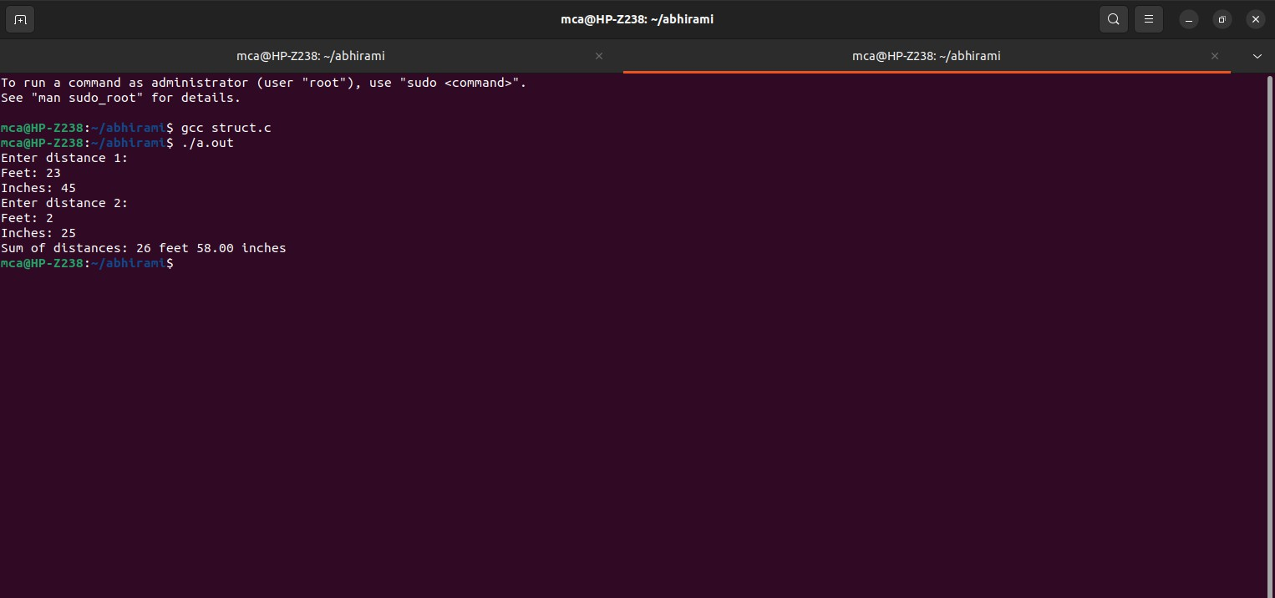

1. **Implement Stack Operations. Program:**

#include<stdio.h> #include<stdlib.h> #define max 20

int top=-1,s[max],n; void push(int n)

{

if(top==max-1)

{

printf("Stack is overflow"); return;

}

else

{

top=top+1; s[top]=n;

}

}

void pop()

{

int del; if(top==-1)

{

printf("stack is underflow"); return;

}

else

{

del=s[top]; top=top-1;

}

}

void traverse()

{

int i; if(top==-1)

printf("Stack is underflow"); else

{

for(i=top;i>=0;i--)

printf("%d",s[i]);

}

}

int main()

{

int op,n; do

{

printf("\n 1.push\n 2.pop \n 3.traverse \n 4.exit\n Enter your choice\n"); scanf("%d",&op);

switch(op)

{

case 1:

printf("\n Enter any element to push :: "); scanf("%d",&n);

push(n); break;

case 2:

pop(); break;

case 3:

traverse(); break;

case 4:

exit(0);

break;

}

}

while(1); return 0;

}

**Output:**

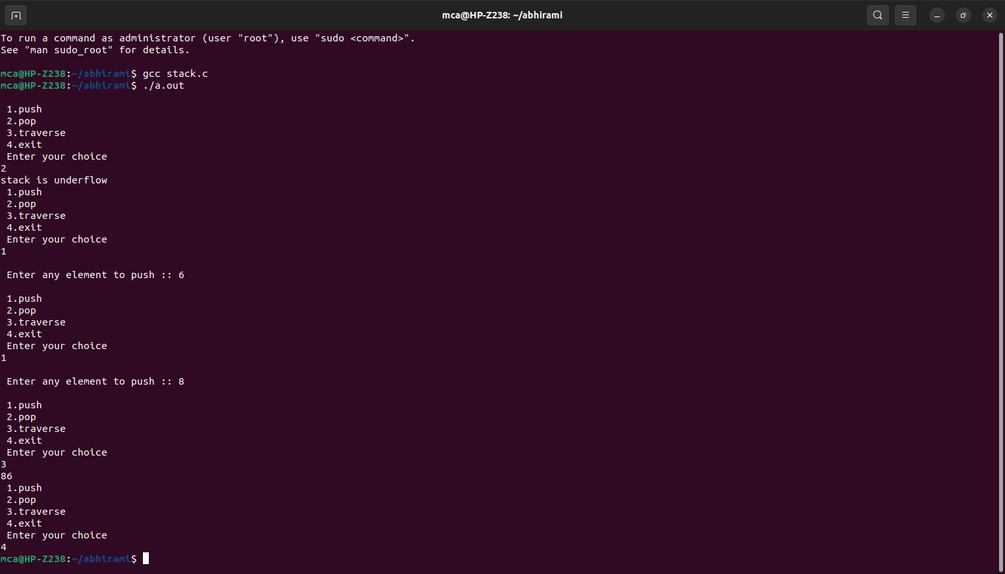

1. **String Operations (Searching, Concatenation, Substring). Program:**

#include <stdio.h> #include <string.h> int main()

{

char str1[100], str2[100]; int choice=0;

printf("Enter the first string: "); scanf("%s", str1);

printf("Enter the second string: "); scanf("%s", str2);

while (choice != 4){

printf("\nSelect a String Operation\n");

printf("1. Search\n2. Concatenate\n 3. Substring\n4. Exit\n "); printf("\nEnter your choice: ");

scanf("%d", &choice); switch (choice)

{

case 1:

if (strstr(str1, str2) != NULL){ printf("'%s' found in '%s'\n", str2, str1);

}

else{

printf("'%s' not found in '%s'\n", str2, str1);

case 2:

}

break;

strcat(str1, str2);

printf("Concatenated string: %s\n", str1);

case 3:

break;

if (strstr(str1, str2) != NULL){

printf("'%s' is a substring of '%s'\n", str2, str1);

}

else{

printf("'%s' is not a substring of '%s'\n", str2, str1);

case 4:

}

break;

printf("Exiting the program.\n"); break;

default:

printf("Invalid choice.\n");

}}

return 0;

}

**Output:**

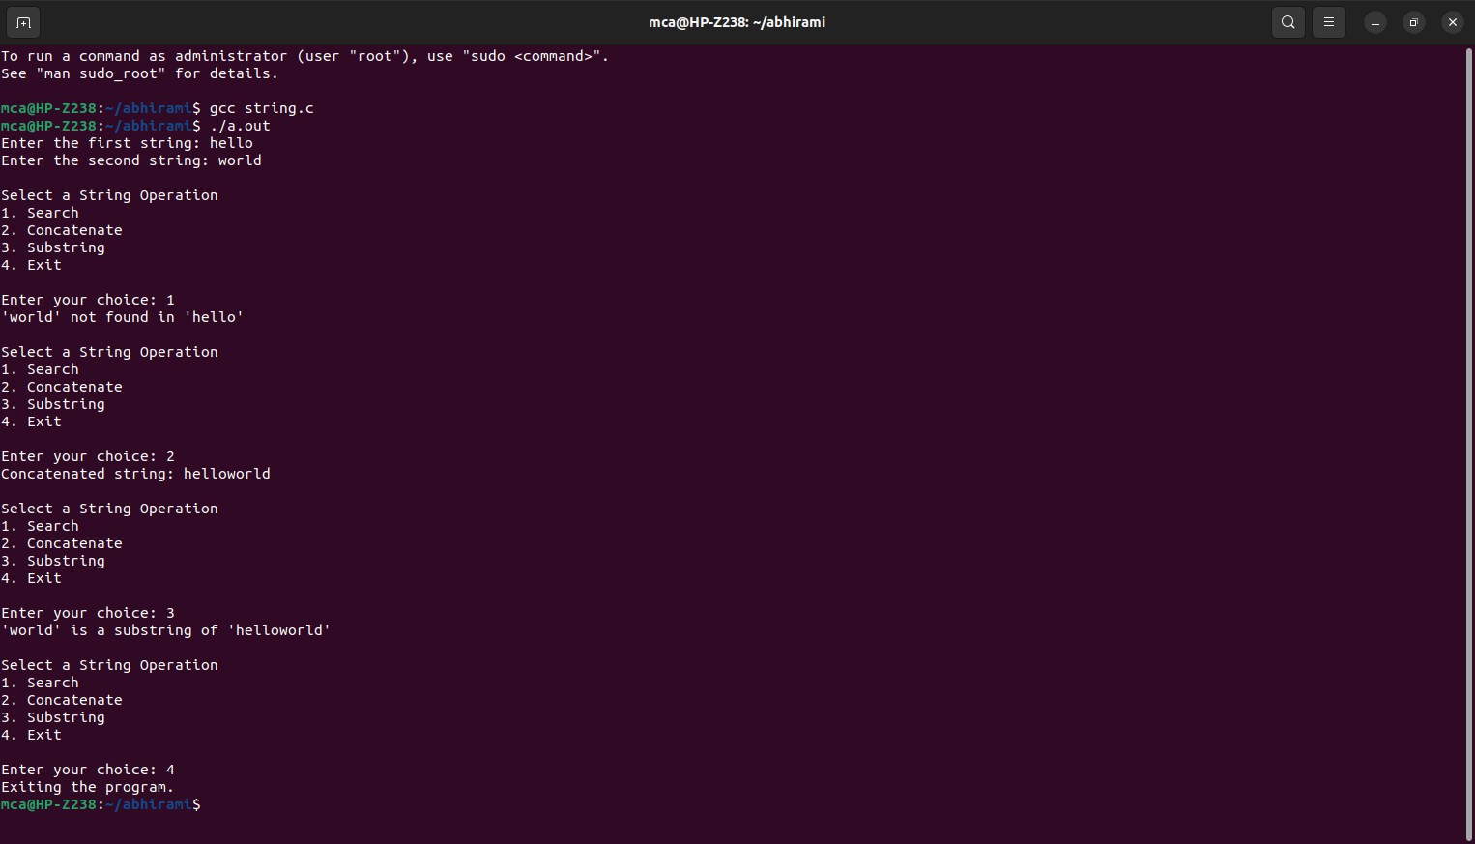

1. **Sorting an Array (Bubble Sort, Selection Sort, Insertion Sort). Program:**

#include<stdio.h> #include<stdlib.h>

void display(int a[],int n); void bubble_sort(int a[],int n);

void selection_sort(int a[],int n); void insertion_sort(int a[],int n); int main()

{

int n,choice,i; char ch[20];

printf("Enter no. of elements u want to sort : "); scanf("%d",&n);

int arr[n]; for(i=0;i<n;i++)

{

printf("Enter %d Element : ",i+1); scanf("%d",&arr[i]);

}

printf("Please select any option Given Below for Sorting : \n");

while(1)

{

printf("\n1. Bubble Sort\n2. Selection Sort\n3. Insertion Sort\n4. Display Array.\n5.

Exit the Program.\n"); printf("\nEnter your Choice : "); scanf("%d",&choice);

switch(choice)

{

case 1:

bubble_sort(arr,n); break;

case 2:

selection_sort(arr,n); break;

case 3:

insertion_sort(arr,n); break;

case 4:

display(arr,n); break;

case 5:

return 0; default:

printf("\nPlease Select only 1-5 option \n");

}

}

return 0;

}

void display(int arr[],int n)

{

for(int i=0;i<n;i++)

{

printf(" %d ",arr[i]);

}

}

void bubble_sort(int arr[],int n)

{

int i,j,temp; for(i=0;i<n;i++)

{

for(j=0;j<n-i-1;j++)

{

if(arr[j]>arr[j+1])

{

temp=arr[j]; arr[j]=arr[j+1]; arr[j+1]=temp;

}

}

}

printf("After Bubble sort Elements are : "); display(arr,n);

}

void selection_sort(int arr[],int n)

{

int i,j,temp; for(i=0;i<n-1;i++)

{

for(j=i+1;j<n;j++)

{

if(arr[i]>arr[j])

{

temp=arr[i]; arr[i]=arr[j]; arr[j]=temp;

}

}

}

printf("After Selection sort Elements are : "); display(arr,n);

}

void insertion_sort(int arr[],int n)

{

int i,j,min; for(i=1;i<n;i++)

{

min=arr[i]; j=i-1;

while(min<arr[j] && j>=0)

{

arr[j+1]=arr[j]; j=j-1;

}

arr[j+1]=min;

}

printf("After Insertion sort Elements are : "); display(arr,n);

}

**Output:**

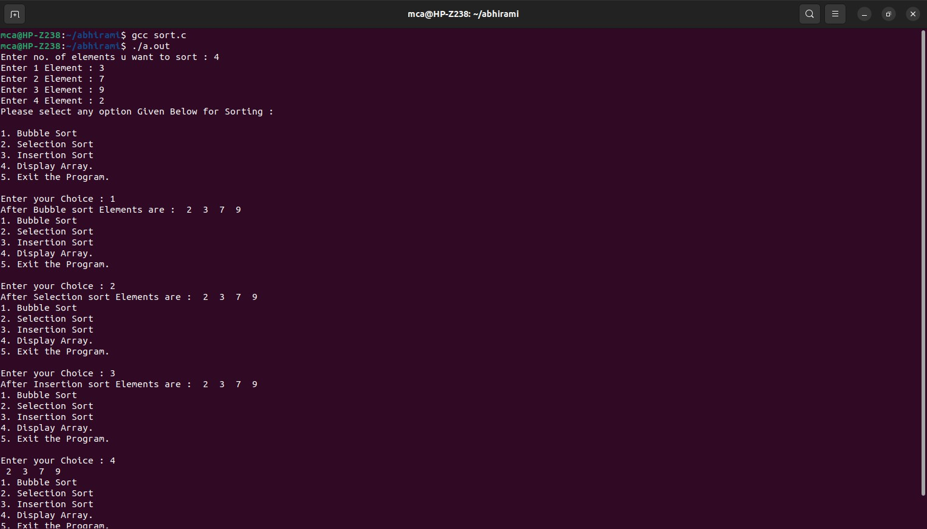

1. **Implement Queue operations (Insert, delete, display front &amp; rear values). Program:**

#include<stdio.h> #define MAX 5

int q[20],choice,n,rear=-1,front=-1,x,i; void insert(){

int item;

if (rear==MAX-1){ printf("Queue Overflow \n");

}else{

if (front==-1) front=0;

printf("Inset the element in queue: "); scanf("%d",&item);

rear=rear+1; q[rear]=item;

}

}

void delete(){

if(front==-1||front>rear){ printf("Queue Underflow \n"); return ;

}else{

printf("Element deleted from queue is : %d\n", q[front]); front=front+1;

}

}

void display(){ int i;

if (front== -1)

printf("Queue is empty \n"); else

{

printf("Queue is : ");

for (i=front;i<=rear;i++) printf("%d ", q[i]);

printf("\nFront element is %d ", q[front]); printf("\nRear element is %d ", q[rear]); printf("\n");

}

}

int main()

{

while(choice != 4)

{

printf("\nEnter the choice(1.Insert 2.Delete 3.Display 4.Exit): ");

scanf("%d",&choice); switch(choice)

{

case 1:

{

insert(); break;

}

case 2:

{

delete(); break;

}

case 3:{

display(); break;

}

case 4:

{

printf("Exit\n"); break;

}

default:{

printf("Enter valid option");

}

}

}

return 0;

}

**Output:**

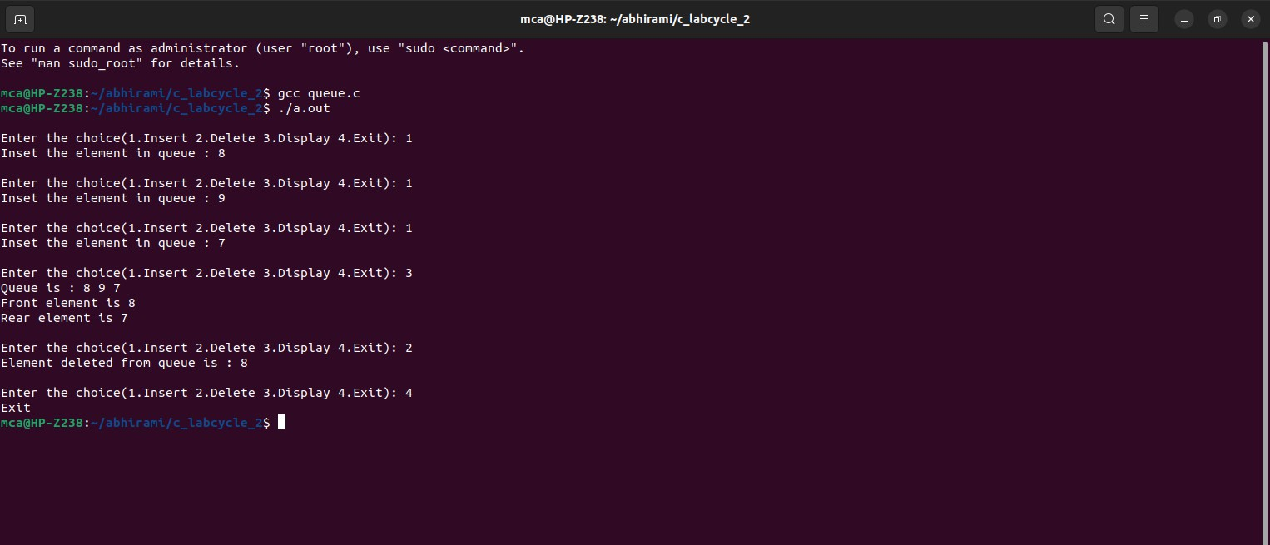

1. **Implement Circular Queue operations (Insert, delete, display front &amp; rear values).**

**Program:**

#include<stdio.h> #define MAX 10

int q[10],n,choice,front=-1,rear=-1; void insert()

{

int x;

if((front==0 &&rear==MAX-1)||(front==rear+1)){ printf("queue is full");

return;

}else {

printf("Enter the element: "); scanf("%d", &x);

if (front == -1) { front = 0;

}

rear=(rear+1)%MAX; q[rear] = x;

}}

void delete()

{

if (front==-1){

printf("Queue is empty ");

}else {

int removed =q[front]; if (front == rear){ front = rear = -1;

}else{

front = (front + 1) % MAX;

}

printf("Element deleted is %d.\n", removed);

}}

void display()

{

int i;

if(rear==-1 && front==-1){ printf("Queue is empty");

}else if (front > rear){ for (i = front;i<n;i++){ printf("%d ", q[i]);

}

for(i=0;i<=rear;i++) printf("%d ", q[i]);

}else{ printf("Elements: ");

for (i = front; i <= rear; i++) printf("%d ", q[i]);

printf("\nFront element is %d ", q[front]); printf("\nRear element is %d ", q[rear]);

}}

int main()

{

while(choice != 4)

{

printf("\nEnter the choice(1.Insert 2.Delete 3.Display 4.Exit): "); scanf("%d",&choice);

switch(choice) { case 1:

insert();

break; case 2:

delete(); break;

case 3:

display(); break;

case 4:

printf("Exit\n"); break;

default:

printf("Enter valid option");

}}

return 0;

}

**Output:**

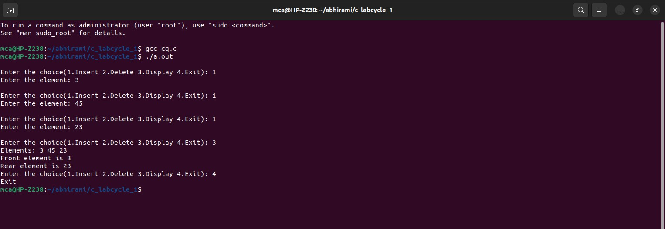

1. **Implement singly linked list (Insert at the head, insert at tail, insert at a position, delete at the head, delete at tail, delete form a position, search an element).**

**Program:**

#include <stdio.h> #include <stdlib.h>

struct Node { int data;

struct Node* next;

};

struct Node* createNode(int data) {

struct Node* newNode = (struct Node*)malloc(sizeof(struct Node)); newNode->data = data;

newNode->next = NULL; return newNode;

}

void insertAtHead(struct Node** head, int data) { struct Node* newNode = createNode(data); newNode->next = *head;

*head = newNode;

}

void insertAtTail(struct Node** head, int data) { struct Node* newNode = createNode(data); struct Node* current = *head;

if (*head == NULL) {

*head = newNode; return;

}

while (current->next != NULL) { current = current->next;

}

current->next = newNode;

}

void insertAtPosition(struct Node** head, int data, int position) { if (position < 0) {

printf("Invalid position\n"); return;

}

if (position == 0 || *head == NULL) {

insertAtHead(head, data); return;

}

struct Node* newNode = createNode(data); struct Node* current = *head;

int currentPosition = 0;

while (currentPosition < position - 1 && current->next != NULL) { current = current->next;

currentPosition++;

}

newNode->next = current->next; current->next = newNode;

}

void deleteAtHead(struct Node** head) { if (*head == NULL) {

printf("List is empty\n"); return;

}

struct Node* temp = *head;

*head = (*head)->next; free(temp);

}

void deleteAtTail(struct Node** head) { if (*head == NULL) {

printf("List is empty\n"); return;

}

if ((*head)->next == NULL) { free(*head);

*head = NULL; return;

}

struct Node* current = *head;

while (current->next->next != NULL) { current = current->next;

}

free(current->next); current->next = NULL;

}

void deleteAtPosition(struct Node** head, int position) {

if (*head == NULL) { printf("List is empty\n"); return;

}

if (position < 0) { printf("Invalid position\n"); return;

}

if (position == 0) { deleteAtHead(head); return;

}

struct Node* current = *head; int currentPosition = 0;

while (currentPosition < position - 1 && current->next != NULL) { current = current->next;

currentPosition++;

}

if (current->next == NULL || current->next->next == NULL) { printf("Invalid position\n");

return;

}

struct Node* temp = current->next; current->next = current->next->next; free(temp);

}

int searchElement(struct Node* head, int key) { struct Node* current = head;

int position = 0;

while (current != NULL) {

if (current->data == key) { return position;

}

current = current->next; position++;

}

return -1;

}

void printList(struct Node* head) { struct Node* current = head; while (current != NULL) {

printf("%d -> ", current->data); current = current->next;

}

printf("NULL\n");

}

int main() {

struct Node* head = NULL; int choice, data, position, key; while (1) {

printf("\nMenu:\n1. Insert at head\n2. Insert at tail\n3. Insert at a position\n”); printf(“4. Delete at head\n5. Delete at tail\n6. Delete at a position\n”); printf(“7. Search \n8. Dispaly\n9. Exit\n");

printf("Enter your choice: "); scanf("%d", &choice);

switch (choice) { case 1:

printf("Enter data to insert at head: "); scanf("%d", &data); insertAtHead(&head, data);

break; case 2:

printf("Enter data to insert at tail: "); scanf("%d", &data); insertAtTail(&head, data);

break; case 3:

printf("Enter data to insert: "); scanf("%d", &data);

printf("Enter position to insert at: "); scanf("%d", &position); insertAtPosition(&head, data, position); break;

case 4:

deleteAtHead(&head); break;

case 5:

deleteAtTail(&head); break;

case 6:

printf("Enter position to delete from: ");

scanf("%d", &position); deleteAtPosition(&head, position); break;

case 7:

printf("Enter element to search for: "); scanf("%d", &key);

position = searchElement(head, key); if (position != -1) {

printf("%d found at position %d\n", key, position);

} else {

printf("%d not found in the linked list\n", key);

}

break; case 8:

printf("Linked List: "); printList(head);

break; case 9:

printf("\nExit\n"); exit(0);

default:

printf("Invalid choice\n");

}

}

return 0;

}

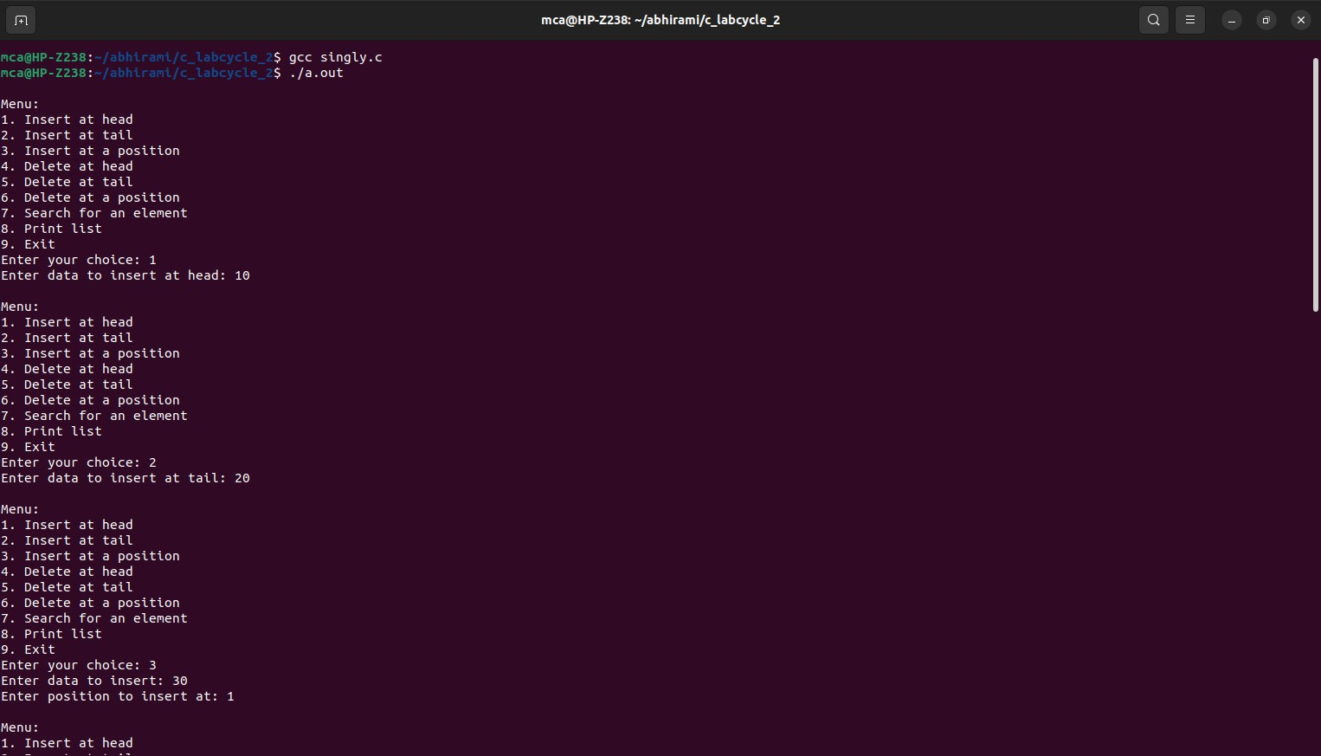**Output:**

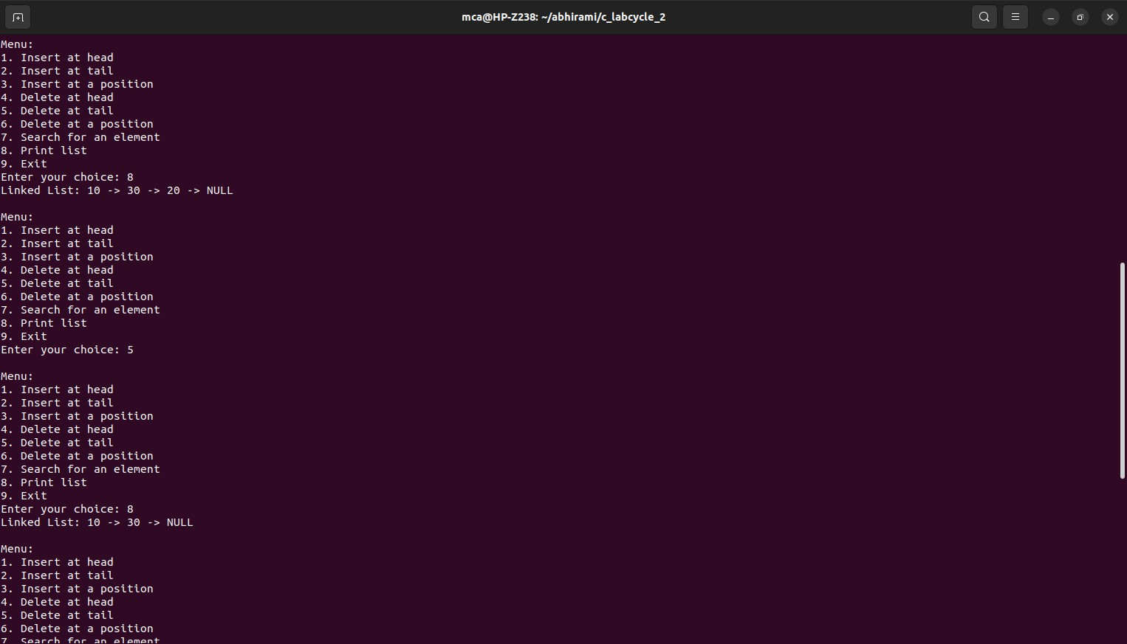

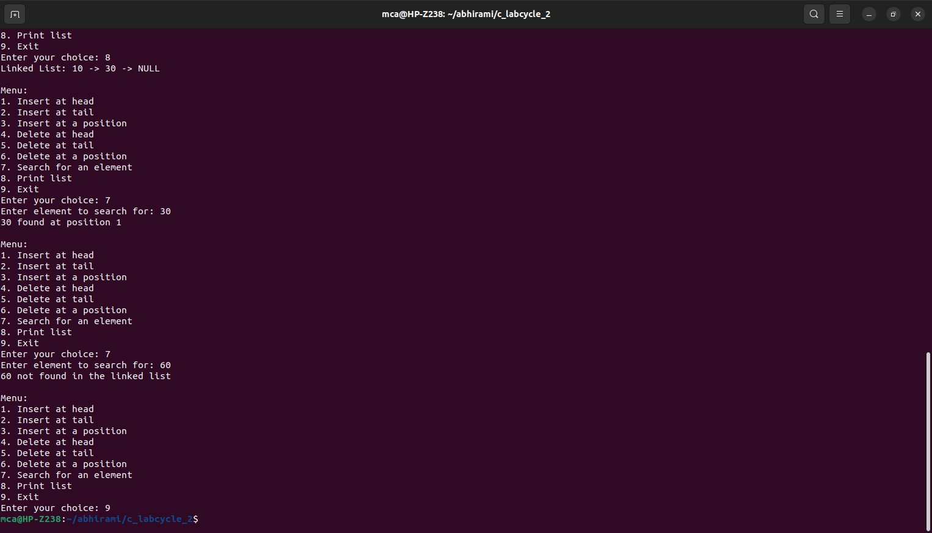

1. **Implement doubly linked list (Insert at the head, insert at tail, insert at a position, delete at the head, delete at tail, delete form a position, search an element).**

**Program:**

#include <stdio.h> #include <stdlib.h> struct Node {

int data;

struct Node* prev; struct Node* next;

};

struct Node* createNode(int data) {

struct Node* newNode = (struct Node*)malloc(sizeof(struct Node)); if (newNode == NULL) {

printf("Memory allocation failed.\n"); exit(1);

}

newNode->data = data; newNode->prev = NULL; newNode->next = NULL; return newNode;

}

void insertAtHead(struct Node** head, int data) { struct Node* newNode = createNode(data);

if (*head != NULL) { (*head)->prev = newNode;

}

newNode->next = *head;

*head = newNode;

}

void insertAtTail(struct Node** head, int data) { struct Node* newNode = createNode(data);

if (*head == NULL) {

*head = newNode; return;

}

struct Node* current = *head; while (current->next != NULL) {

current = current->next;

}

current->next = newNode; newNode->prev = current;

}

void insertAtPosition(struct Node** head, int data, int position) { if (position < 0) {

printf("Invalid position. Position must be non-negative.\n");

return;

}

if (position == 0) { insertAtHead(head, data); return;

}

struct Node* newNode = createNode(data); struct Node* current = *head;

int currentPosition = 0;

while (current != NULL && currentPosition < position - 1) { current = current->next;

currentPosition++;

}

if (current == NULL) {

printf("Position exceeds the length of the list.\n"); return;

}

newNode->prev = current; newNode->next = current->next; if (current->next != NULL) {

current->next->prev = newNode;

}

current->next = newNode;

}

void deleteAtHead(struct Node** head) { if (*head == NULL) {

printf("List is empty. Cannot delete.\n"); return;

}

struct Node* temp = *head;

*head = (*head)->next; if (*head != NULL) {

(*head)->prev = NULL;

}

free(temp);

}

void deleteAtTail(struct Node** head) { if (*head == NULL) {

printf("List is empty. Cannot delete.\n"); return;

}

if ((*head)->next == NULL) { free(*head);

*head = NULL; return;

}

struct Node* current = *head; while (current->next != NULL) {

current = current->next;

}

current->prev->next = NULL; free(current);

}

void deleteAtPosition(struct Node** head, int position) { if (*head == NULL) {

printf("List is empty. Cannot delete.\n"); return;

}

if (position < 0) {

printf("Invalid position. Position must be non-negative.\n"); return;

}

if (position == 0) { deleteAtHead(head); return;

}

struct Node* current = *head; int currentPosition = 0;

while (current != NULL && currentPosition < position) { current = current->next;

currentPosition++;

}

if (current == NULL) {

printf("Position exceeds the length of the list.\n"); return;

}

current->prev->next = current->next; if (current->next != NULL) {

current->next->prev = current->prev;

}

free(current);

}

int search(struct Node* head, int key) { struct Node* current = head;

int position = 0;

while (current != NULL) {

if (current->data == key) { return position;

}

current = current->next; position++;

}

return -1;

}

void displayForward(struct Node* head) { struct Node* current = head;

while (current != NULL) { printf("%d -> ", current->data); current = current->next;

}

printf("NULL\n");

}

void displayBackward(struct Node* head) { struct Node* current = head;

while (current != NULL && current->next != NULL) { current = current->next;

}

while (current != NULL) { printf("%d -> ", current->data); current = current->prev;

}

printf("NULL\n");

}

int main()

{

struct Node* head = NULL; int choice, data, position;

while (1) {

printf("\nDoubly Linked List Operations:\n")

printf("1. Insert at the Head\n2. Insert at the Tail\n3. Insert at a Position\n”); printf("4. Delete at the Head\n5. Delete at the Tail\n6. Delete at a Position\n”); printf("7. Search for an Element\n8. Display Forward\n9. Display Backward\n”); printf("10. Exit\n");

printf("Enter your choice: "); scanf("%d", &choice);

switch (choice) { case 1:

printf("Enter data to insert at the head: "); scanf("%d", &data); insertAtHead(&head, data);

break; case 2:

printf("Enter data to insert at the tail: "); scanf("%d", &data); insertAtTail(&head, data);

break;

case 3:

printf("Enter data to insert: "); scanf("%d", &data);

printf("Enter position to insert at: "); scanf("%d", &position); insertAtPosition(&head, data, position); break;

case 4:

deleteAtHead(&head); break;

case 5:

deleteAtTail(&head); break;

case 6:

printf("Enter position to delete: "); scanf("%d", &position); deleteAtPosition(&head, position); break;

case 7:

printf("Enter element to search: "); scanf("%d", &data);

position = search(head, data); if (position != -1) {

printf("Element %d found at position %d\n", data, position);

} else {

printf("Element %d not found in the linked list\n", data);

}

break;

case 8:

printf("Doubly Linked List (Forward): "); displayForward(head);

break;

case 9:

printf("Doubly Linked List (Backward): "); displayBackward(head);

break;

case 10:

printf("\nExit\n"); exit(0);

break;

default:

printf("Invalid choice. Please enter a valid option.\n");

}

}

return 0;

}

**Output:**

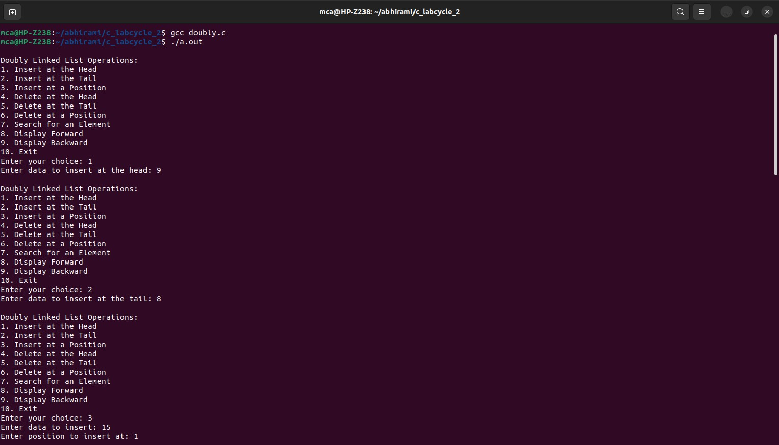

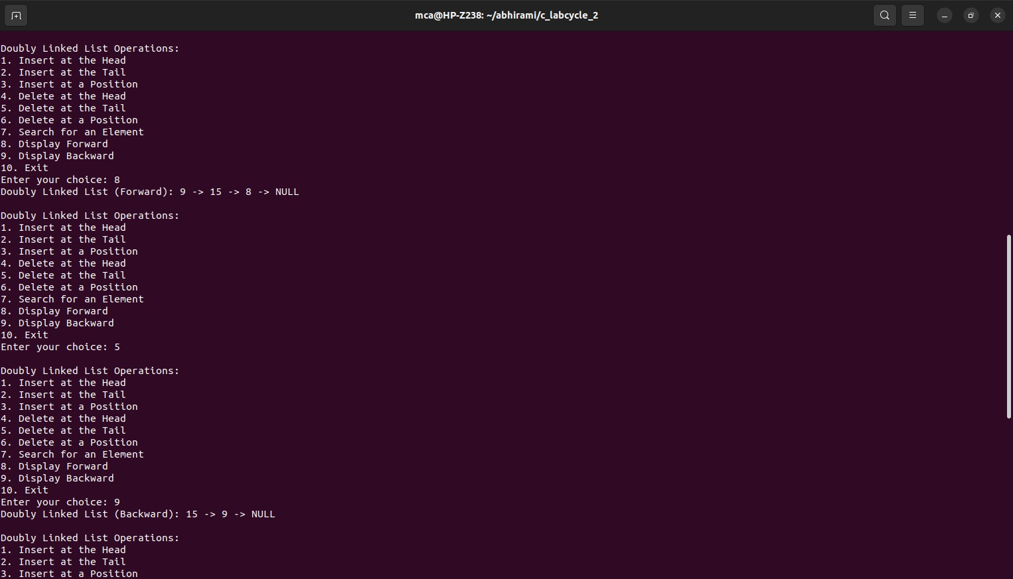

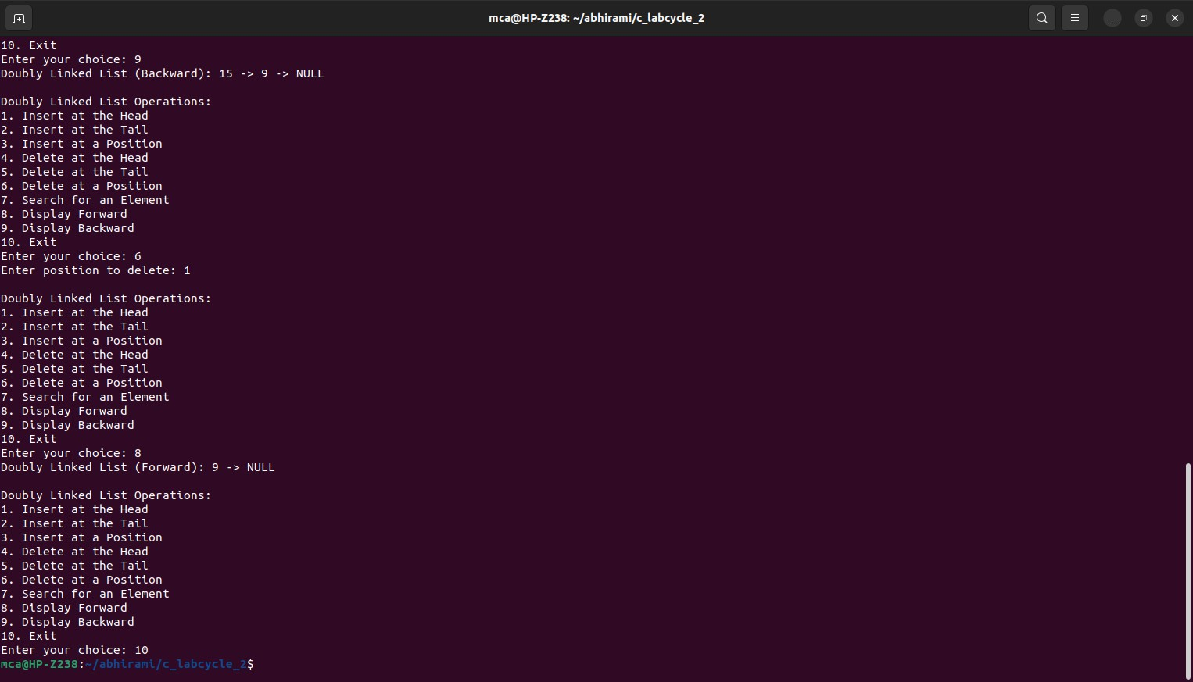

1. **Implement circular linked list (Insert at the head, insert at tail, insert at a position, delete at the head, delete at tail, delete form a position, search an element).**

**Program:**

#include <stdio.h> #include <stdlib.h> struct Node {

int data;

struct Node* next;

};

struct Node* head = NULL; void insertAtHead(int value) {

struct Node* newNode = (struct Node*)malloc(sizeof(struct Node)); newNode->data = value;

if (head == NULL) {

newNode->next = newNode; head = newNode;

return;

}

struct Node* temp = head; while (temp->next != head)

temp = temp->next;

temp->next = newNode; newNode->next = head; head = newNode;

}

void insertAtTail(int value) {

struct Node* newNode = (struct Node*)malloc(sizeof(struct Node)); newNode->data = value;

if (head == NULL) {

newNode->next = newNode; head = newNode;

return;

}

struct Node* temp = head; while (temp->next != head)

temp = temp->next; temp->next = newNode; newNode->next = head;

}

void insertAtPosition(int value, int position) {

if (position == 1) { insertAtHead(value); return;

}

struct Node* newNode = (struct Node*)malloc(sizeof(struct Node)); newNode->data = value;

struct Node* temp = head;

for (int i = 1; i < position - 1 && temp->next != head; i++) temp = temp->next;

newNode->next = temp->next; temp->next = newNode;

}

void deleteAtHead() { if (head == NULL) {

printf("List is empty. Cannot delete.\n"); return;

}

if (head->next == head) { free(head);

head = NULL; return;

}

struct Node* temp = head; while (temp->next != head)

temp = temp->next; temp->next = head->next;

struct Node* toDelete = head; head = head->next; free(toDelete);

}

void deleteAtTail() {

if (head == NULL) {

printf("List is empty. Cannot delete.\n"); return;

}

if (head->next == head) { free(head);

head = NULL; return;

}

struct Node* temp = head;

while (temp->next->next != head) temp = temp->next;

struct Node* toDelete = temp->next; temp->next = head;

free(toDelete);

}

void deleteAtPosition(int position) { if (head == NULL) {

printf("List is empty. Cannot delete.\n"); return;

}

if (position == 1) { deleteAtHead(); return;

}

struct Node* temp = head;

for (int i = 1; i < position - 1 && temp->next != head; i++) temp = temp->next;

if (temp->next == head) { printf("Invalid position.\n"); return;

}

struct Node* toDelete = temp->next; temp->next = temp->next->next; free(toDelete);

}

void search(int value) { struct Node* temp = head; int position = 1;

do {

if (temp->data == value) {

printf("%d found at position %d.\n", value, position); return;

}

temp = temp->next; position++;

} while (temp != head);

printf("%d not found in the list.\n", value);

}

void display() {

if (head == NULL) { printf("List is empty.\n"); return;

}

struct Node* temp = head; do {

printf("%d ", temp->data); temp = temp->next;

} while (temp != head); printf("\n");

}

int main() {

int choice, value, position; do {

printf("\nCircular Linked List Operations:\n");

printf("1. Insert at Head\n2. Insert at Tail\n3. Insert at Position\n4. Delete at Head\n5. Delete at Tail\n6. Delete at Position\n7. Search\n8. Display\n9. Quit\n");

printf("Enter your choice: "); scanf("%d", &choice);

switch (choice) { case 1:

printf("Enter value to insert: "); scanf("%d", &value); insertAtHead(value);

break;

case 2:

printf("Enter value to insert: "); scanf("%d", &value); insertAtTail(value);

break;

case 3:

printf("Enter value to insert: "); scanf("%d", &value); printf("Enter position: "); scanf("%d", &position); insertAtPosition(value, position); break;

case 4:

deleteAtHead(); break;

case 5:

deleteAtTail(); break;

case 6:

printf("Enter position: "); scanf("%d", &position); deleteAtPosition(position); break;

case 7:

printf("Enter value to search: "); scanf("%d", &value); search(value);

break; case 8:

display(); break;

case 9:

printf("Exiting...\n"); break;

default:

printf("Invalid choice. Please try again.\n"); break;

}} while (choice != 9); return 0;

}

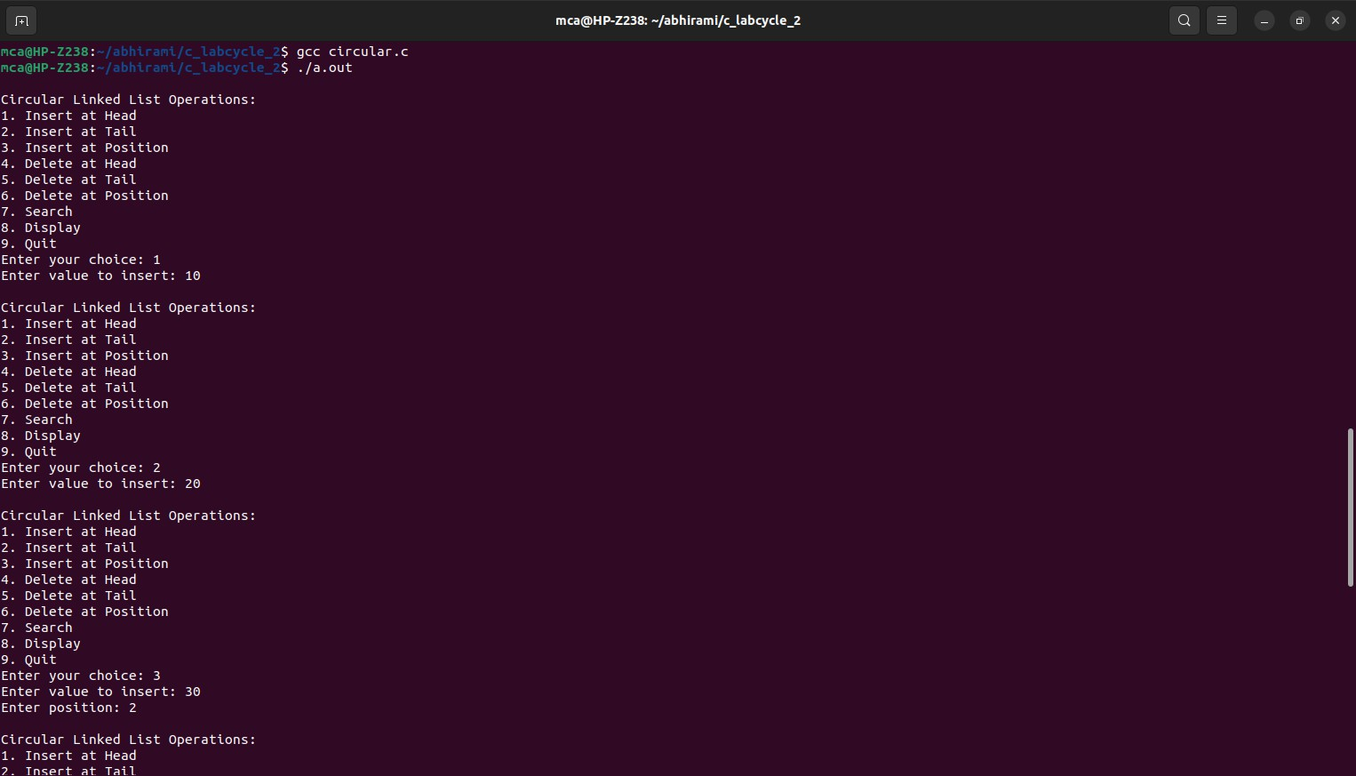**Output:**

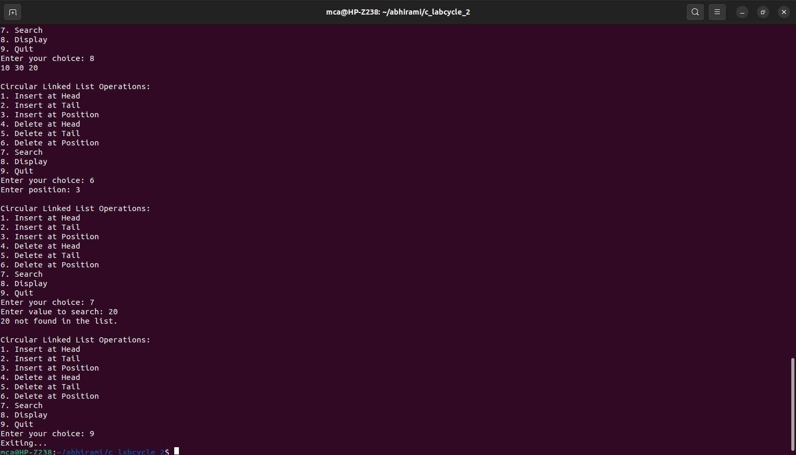

1. **Implement binary search tree. Program:**

#include <stdio.h> #include <stdlib.h>

struct Node { int data;

struct Node* left; struct Node* right;

};

struct Node* createNode(int value) {

struct Node* newNode = (struct Node*)malloc(sizeof(struct Node)); newNode->data = value;

newNode->left = newNode->right = NULL; return newNode;

}

struct Node* insert(struct Node* root, int value) { if (root == NULL)

return createNode(value); if (value < root->data)

root->left = insert(root->left, value); else if (value > root->data)

root->right = insert(root->right, value); return root;

}

struct Node* findMin(struct Node* node) { struct Node* current = node;

while (current && current->left != NULL) current = current->left;

return current;

}

struct Node* deleteNode(struct Node* root, int value) { if (root == NULL)

return root;

if (value < root->data)

root->left = deleteNode(root->left, value); else if (value > root->data)

root->right = deleteNode(root->right, value); else {

if (root->left == NULL) {

struct Node* temp = root->right; free(root);

return temp;

} else if (root->right == NULL) { struct Node* temp = root->left; free(root);

return temp;

}

struct Node* temp = findMin(root->right); root->data = temp->data;

root->right = deleteNode(root->right, temp->data);

}

return root;

}

struct Node* search(struct Node* root, int value) { if (root == NULL || root->data == value)

return root;

if (value < root->data)

return search(root->left, value); return search(root->right, value);

}

void inOrderTraversal(struct Node* root) { if (root != NULL) {

inOrderTraversal(root->left); printf("%d ", root->data); inOrderTraversal(root->right);

}

}

int main() {

struct Node* root = NULL; int choice, value;

do {

printf("\nBinary Search Tree Operations:\n");

printf("1. Insert\n2. Delete\n3. Search\n4. In-order Traversal\n5. Quit\n"); printf("Enter your choice: ");

scanf("%d", &choice); switch (choice) {

case 1:

printf("Enter value to insert: "); scanf("%d", &value);

root = insert(root, value); break;

case 2:

printf("Enter value to delete: ");

scanf("%d", &value);

root = deleteNode(root, value); break;

case 3:

printf("Enter value to search: "); scanf("%d", &value);

struct Node* result = search(root, value); if (result != NULL)

printf("%d found in the tree.\n", value); else

printf("%d not found in the tree.\n", value); break;

case 4:

printf("In-order Traversal: "); inOrderTraversal(root); printf("\n");

break; case 5:

printf("Exiting...\n"); break;

default:

printf("Invalid choice. Please try again.\n"); break;

}

} while (choice != 5);

return 0;

}

**Output:**

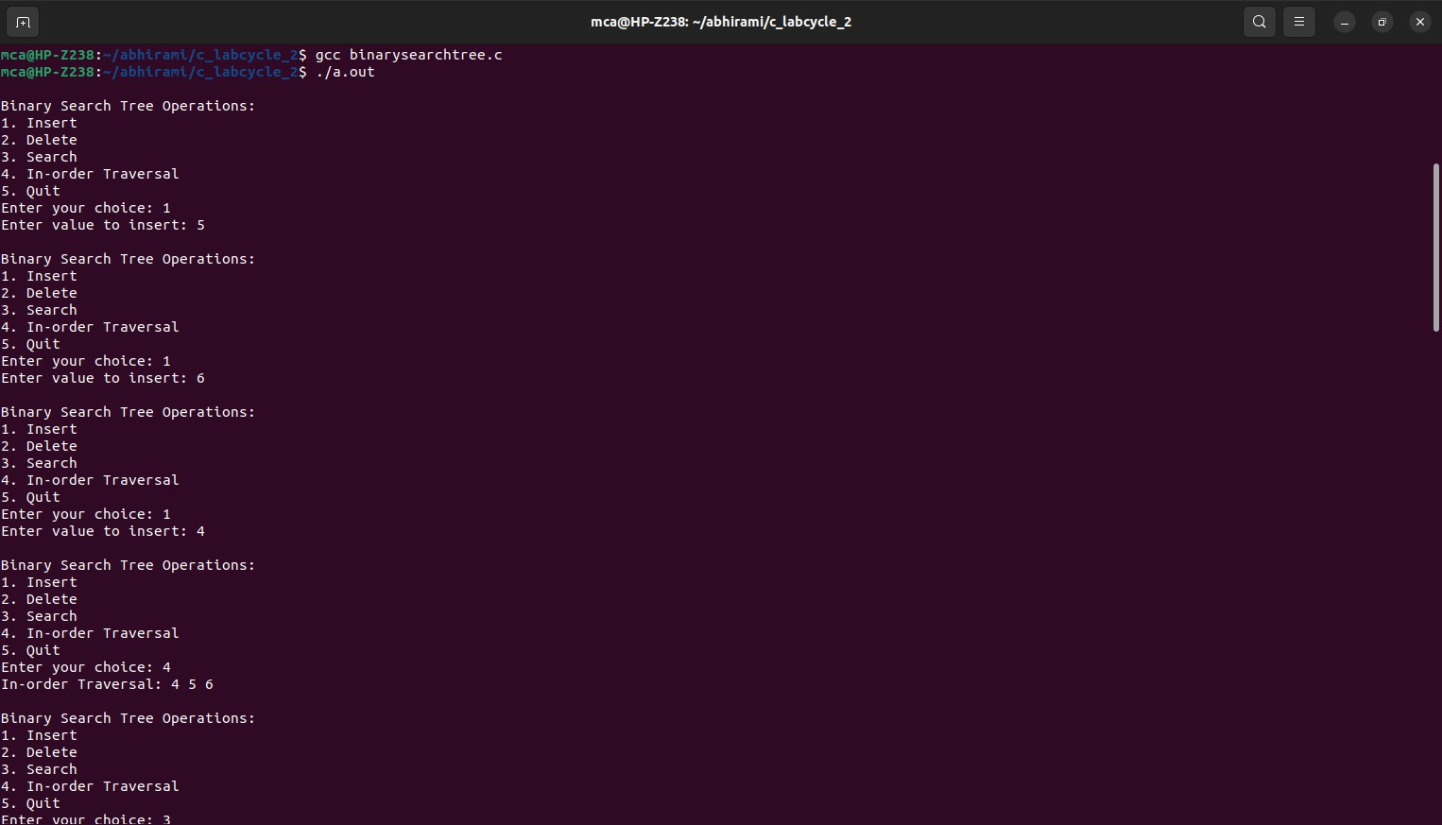

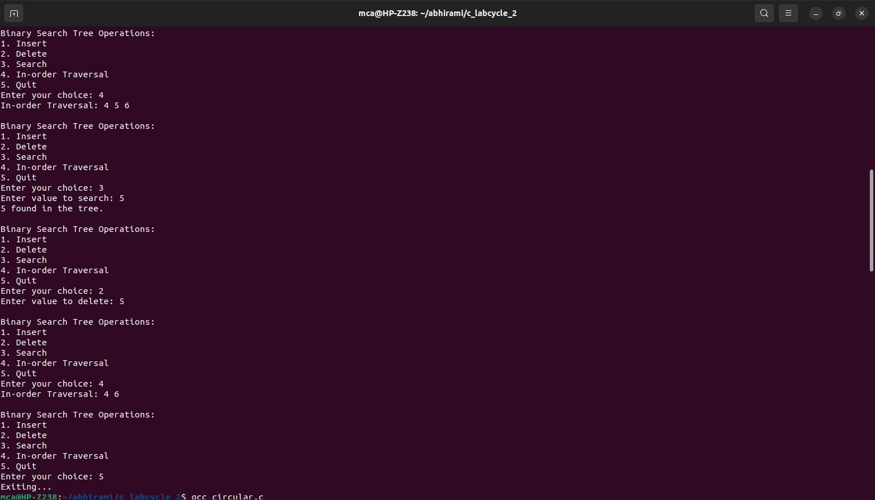

1. **Implement balanced-binary-search tree. Program:**

#include <stdio.h> #include <stdlib.h> #define MAX_SIZE 100 struct Node {

int data; int height;

struct Node* left; struct Node* right;

};

struct Node* createNode(int value) {

struct Node* newNode = (struct Node*)malloc(sizeof(struct Node)); newNode->data = value;

newNode->height = 1;

newNode->left = newNode->right = NULL; return newNode;

}

int calculateHeight(struct Node* node) {

int leftHeight = (node->left) ? node->left->height : 0;

int rightHeight = (node->right) ? node->right->height : 0;

return (leftHeight > rightHeight) ? leftHeight + 1 : rightHeight + 1;

}

void updateHeight(struct Node* node) { node->height = calculateHeight(node);

}

struct Node* rightRotate(struct Node* y) { struct Node* x = y->left;

struct Node* T = x->right; x->right = y;

y->left = T; updateHeight(y); updateHeight(x); return x;

}

struct Node* leftRotate(struct Node* x) { struct Node* y = x->right;

struct Node* T = y->left; y->left = x;

x->right = T; updateHeight(x); updateHeight(y); return y;

}

struct Node* balanceNode(struct Node* node) {

int balance = (node->left ? node->left->height : 0) - (node->right ? node->right->height

: 0);

if (balance > 1) {

if (node->left->left) { return rightRotate(node);

} else {

node->left = leftRotate(node->left); return rightRotate(node);

}

}

if (balance < -1) {

if (node->right->right) { return leftRotate(node);

} else {

node->right = rightRotate(node->right); return leftRotate(node);

}

}

return node;

}

struct Node* insert(struct Node* root, int value) { if (root == NULL) {

struct Node* newNode = createNode(value); return newNode;

}

if (value < root->data)

root->left = insert(root->left, value); else if (value > root->data)

root->right = insert(root->right, value); updateHeight(root);

return balanceNode(root);

}

struct Node* findMin(struct Node* node) { struct Node* current = node;

while (current && current->left != NULL) current = current->left;

return current;

}

struct Node* deleteNode(struct Node* root, int value) { if (root == NULL)

return root;

if (value < root->data)

root->left = deleteNode(root->left, value); else if (value > root->data)

root->right = deleteNode(root->right, value);

else {

if (root->left == NULL) {

struct Node* temp = root->right; free(root);

return temp;

} else if (root->right == NULL) { struct Node* temp = root->left; free(root);

return temp;

}

struct Node* temp = findMin(root->right); root->data = temp->data;

root->right = deleteNode(root->right, temp->data);

}

updateHeight(root); return balanceNode(root);

}

struct Node* search(struct Node* root, int value) { if (root == NULL || root->data == value)

return root;

if (value < root->data)

return search(root->left, value); return search(root->right, value);

}

void inOrderTraversal(struct Node* root) { if (root != NULL) {

inOrderTraversal(root->left); printf("%d ", root->data); inOrderTraversal(root->right);

}

}

int main() {

struct Node* root = NULL; int choice, value;

do {

printf("\nBalanced Binary Search Tree Operations:\n"); printf("1. Insert\n");

printf("2. Delete\n"); printf("3. Search\n");

printf("4. In-order Traversal\n"); printf("5. Quit\n");

printf("Enter your choice: "); scanf("%d", &choice); switch (choice) {

case 1:

printf("Enter value to insert: "); scanf("%d", &value);

if (search(root, value) == NULL) root = insert(root, value);

else

printf("%d is already in the tree.\n", value); break;

case 2:

printf("Enter value to delete: "); scanf("%d", &value);

if (search(root, value) != NULL) root = deleteNode(root, value);

else

printf("%d not found in the tree.\n", value); break;

case 3:

printf("Enter value to search: "); scanf("%d", &value);

struct Node* result = search(root, value); if (result != NULL)

printf("%d found in the tree.\n", value); else

printf("%d not found in the tree.\n", value); break;

case 4:

printf("In-order Traversal: "); inOrderTraversal(root); printf("\n");

break; case 5:

printf("Exiting...\n"); break;

default:

printf("Invalid choice. Please try again.\n"); break;

}

} while (choice != 5); while (root != NULL) {

struct Node* temp = root;

root = deleteNode(root, temp->data);

}

return 0;

}

**Output:**

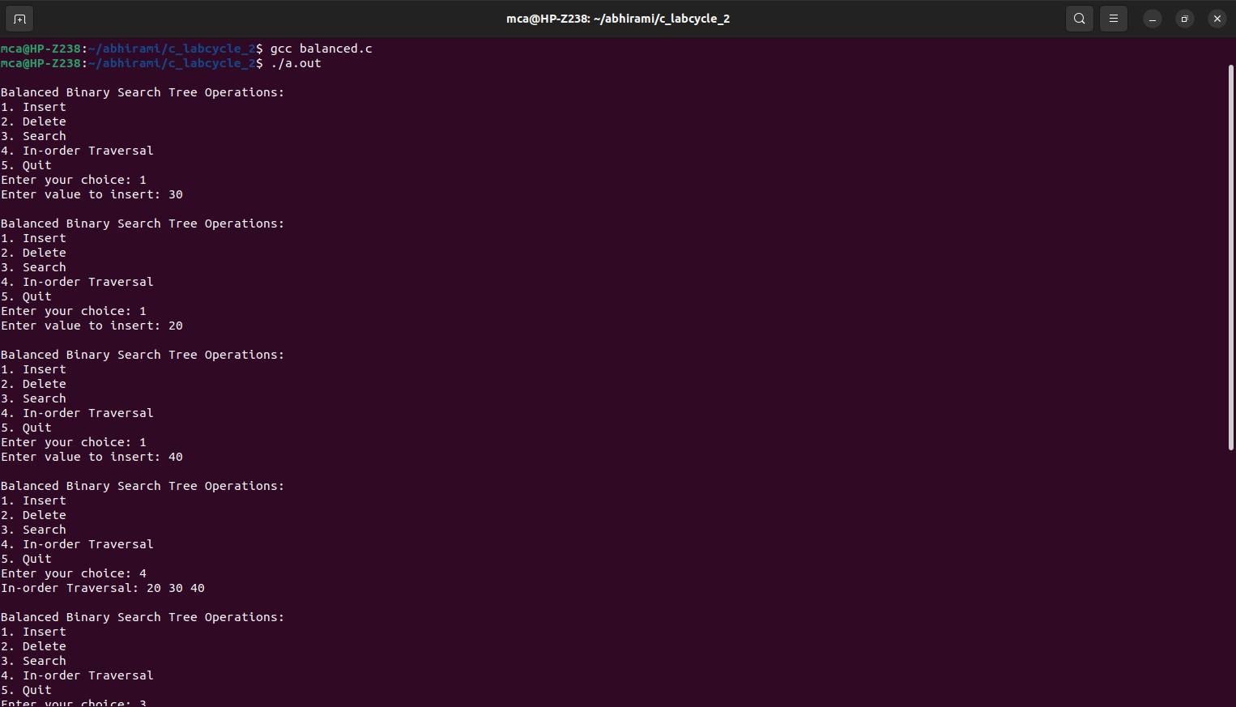

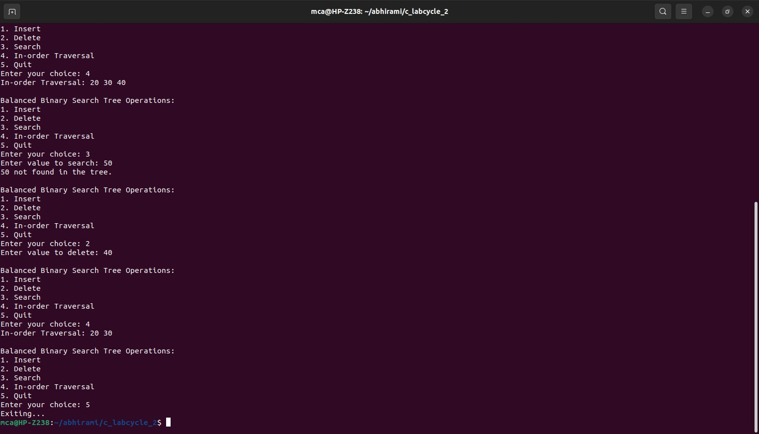

1. **Implement set operations (union, intersection, difference). Program:**

#include <stdio.h> #define MAX_SIZE 100 int readSet(int set[]) {

int size, i;

printf("Enter the size of the set: "); scanf("%d", &size);

printf("Enter elements of the set:\n"); for (i = 0; i < size; i++) {

scanf("%d", &set[i]);

}

return size;

}

void displaySet(int set[], int size) { int i;

printf("Set: { ");

for (i = 0; i < size; i++) { printf("%d ", set[i]);

}

printf("}\n");

}

int setUnion(int set1[], int size1, int set2[], int size2, int result[]) { int i, j, k = 0;

for (i = 0; i < size1; i++) { result[k++] = set1[i];

}

for (i = 0; i < size2; i++) { int found = 0;

for (j = 0; j < size1; j++) { if (set2[i] == set1[j]) {

found = 1; break;

}

}

if (!found) { result[k++] = set2[i];

}

}

return k;

}

int setIntersection(int set1[], int size1, int set2[], int size2, int result[]) { int i, j, k = 0;

for (i = 0; i < size1; i++) { for (j = 0; j < size2; j++) {

if (set1[i] == set2[j]) { result[k++] = set1[i]; break;

}

}

}

return k;

}

int setDifference(int set1[], int size1, int set2[], int size2, int result[]) { int i, j, k = 0;

for (i = 0; i < size1; i++) {

int found = 0;

for (j = 0; j < size2; j++) { if (set1[i] == set2[j]) {

found = 1; break;

}

}

if (!found) { result[k++] = set1[i];

}

}

return k;

}

int main() {

int set1[MAX_SIZE], set2[MAX_SIZE], result[MAX_SIZE]; int size1, size2, resultSize;

int choice;

size1 = readSet(set1); size2 = readSet(set2); do {

printf("\nSet Operations:\n"); printf("1. Union\n"); printf("2. Intersection\n");

printf("3. Difference (set1 - set2)\n"); printf("4. Display Sets\n");

printf("5. Quit\n"); printf("Enter your choice: "); scanf("%d", &choice); switch (choice) {

case 1:

resultSize = setUnion(set1, size1, set2, size2, result); displaySet(result, resultSize);

break; case 2:

resultSize = setIntersection(set1, size1, set2, size2, result); displaySet(result, resultSize);

break; case 3:

resultSize = setDifference(set1, size1, set2, size2, result); displaySet(result, resultSize);

break; case 4:

printf("\nSets:\n"); printf("Set 1: "); displaySet(set1, size1); printf("Set 2: "); displaySet(set2, size2); break;

case 5:

printf("Exiting...\n"); break;

default:

printf("Invalid choice. Please try again.\n"); break;

}

} while (choice != 5); return 0;

}

**Output:**

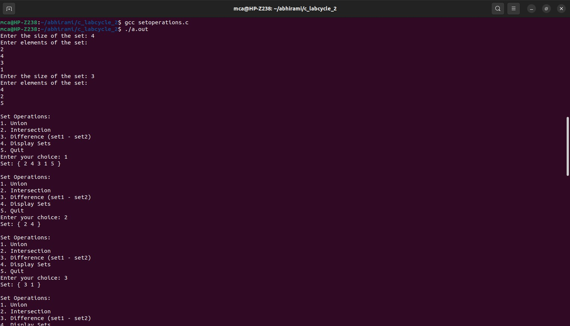

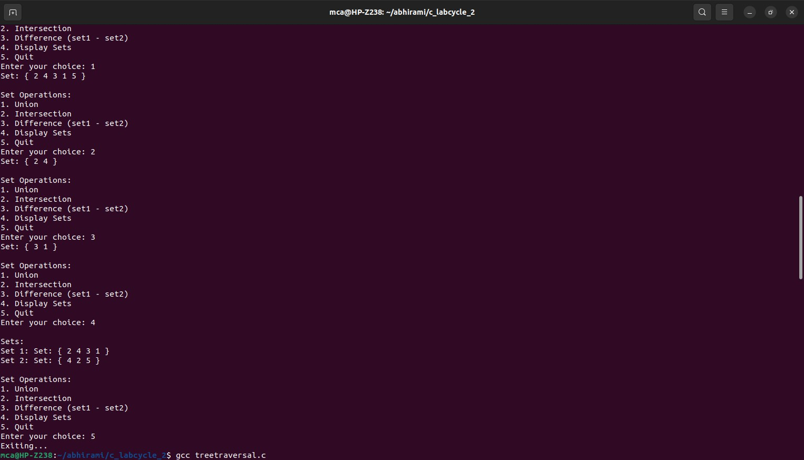

1. **Implement disjoint set operations. Program:**

#include <stdio.h> #define MAX 100

int parent[MAX], rank[MAX], n;

// Function to find the representative of the set containing element x int find(int x) {

if (x != parent[x])

parent[x] = find(parent[x]); // Path Compression return parent[x];

}

int main() {

printf("Enter the number of elements: ");

if (scanf("%d", &n) != 1 || n <= 0 || n > MAX) {

printf("Invalid input. Please enter a positive integer less than or equal to %d.\n", MAX);

return 1;

}

for (int i = 0; i < n; i++) { parent[i] = i;

rank[i] = 0;

}

int choice, x, y; while (1) {

printf("\nOperations:\n1. Union\n2. Find\n3. Display Set Representatives\n4.

Exit\nEnter your choice: ");

if (scanf("%d", &choice) != 1) {

printf("Invalid input. Please enter an integer.\n"); continue;

}

switch (choice) {

case 1:

// Union operation

printf("Enter elements to perform union: ");

if (scanf("%d %d", &x, &y) != 2 || x < 0 || x >= n || y < 0 || y >= n) { printf("Invalid input. Please enter valid elements.\n");

} else {

int rootX = find(x); int rootY = find(y); if (rootX == rootY) {

printf("%d and %d are already in the same set.\n", x, y);

} else {

// Merge sets

if (rank[rootX] > rank[rootY]) { parent[rootY] = rootX;

} else if (rank[rootX] < rank[rootY]) { parent[rootX] = rootY;

} else {

parent[rootY] = rootX; rank[rootX]++;

}

printf("Union of %d and %d is performed.\n", x, y);

}

}

break; case 2:

// Find operation

printf("Enter element to find its set: ");

if (scanf("%d", &x) != 1 || x < 0 || x >= n) { printf("Invalid input. Please enter a valid element.\n");

} else {

printf("Set representative of %d is %d\n", x, find(x));

}

break; case 3:

// Display set representatives printf("Set Representatives:\n"); for (int i = 0; i < n; i++) {

printf("Element %d belongs to set with representative %d\n", i, find(i));

}

break; case 4:

return 0; default:

printf("Invalid choice. Please enter a valid option.\n"); break;

}

}

}

**Output:**

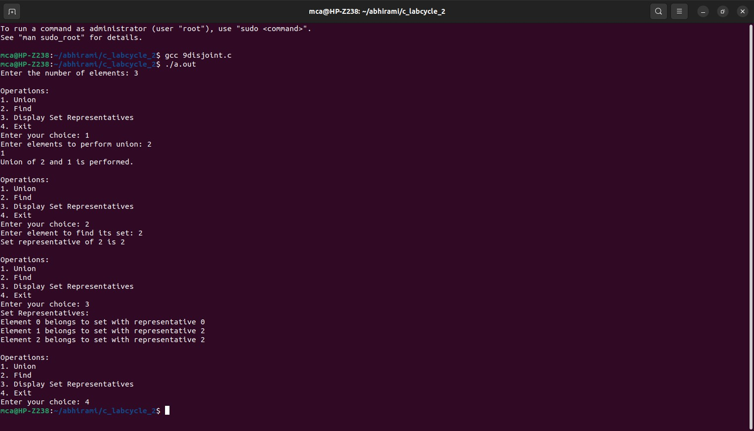

1. **Implement tree traversal methods DFS (In-order, Pre-Order, Post-Order), and BFS. Program:**

#include <stdio.h> #include <stdlib.h> struct Node {

int data;

struct Node* left; struct Node* right;

};

struct Node* createNode(int value) {

struct Node* newNode = (struct Node*)malloc(sizeof(struct Node)); newNode->data = value;

newNode->left = newNode->right = NULL; return newNode;

}

struct Node* insert(struct Node* root, int value) { if (root == NULL)

return createNode(value); if (value < root->data)

root->left = insert(root->left, value); else if (value > root->data)

root->right = insert(root->right, value); return root;

}

void inOrderTraversal(struct Node* root) { if (root != NULL) {

inOrderTraversal(root->left); printf("%d ", root->data); inOrderTraversal(root->right);

}

}

void preOrderTraversal(struct Node* root) { if (root != NULL) {

printf("%d ", root->data); preOrderTraversal(root->left); preOrderTraversal(root->right);

}

}

void postOrderTraversal(struct Node* root) { if (root != NULL) {

postOrderTraversal(root->left); postOrderTraversal(root->right); printf("%d ", root->data);

}

}

void breadthFirstSearch(struct Node* root) { if (root == NULL)

return;

struct Node* queue[100]; int front = -1, rear = -1; queue[++rear] = root; while (front < rear) {

struct Node* current = queue[++front]; printf("%d ", current->data);

if (current->left != NULL) queue[++rear] = current->left;

if (current->right != NULL) queue[++rear] = current->right;

}

}

int main() {

struct Node* root = NULL; int choice, value;

do {

printf("\nTree traversal Operations:\n1. Insert\n2. In-order Traversal\n3. Pre-order Traversal\n4. Post-order Traversal\n5. Breadth-First Search (BFS)\n6. Quit\n");

printf("Enter your choice: "); scanf("%d", &choice); switch (choice) {

case 1:

printf("Enter value to insert: "); scanf("%d", &value);

root = insert(root, value); break;

case 2:

printf("In-order Traversal: "); inOrderTraversal(root); printf("\n");

break; case 3:

printf("Pre-order Traversal: "); preOrderTraversal(root); printf("\n");

break; case 4:

printf("Post-order Traversal: "); postOrderTraversal(root); printf("\n");

break;

case 5:

printf("Breadth-First Search (BFS): "); breadthFirstSearch(root);

printf("\n"); break;

case 6:

printf("Exiting...\n"); break;

default:

printf("Invalid choice. Please try again.\n"); break;

}

} while (choice != 6); return 0;

}

**Output:**

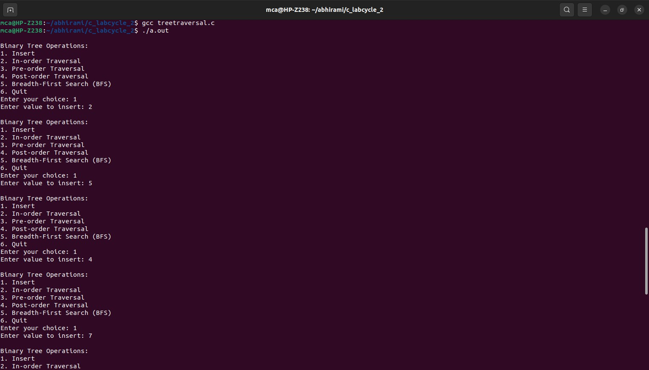

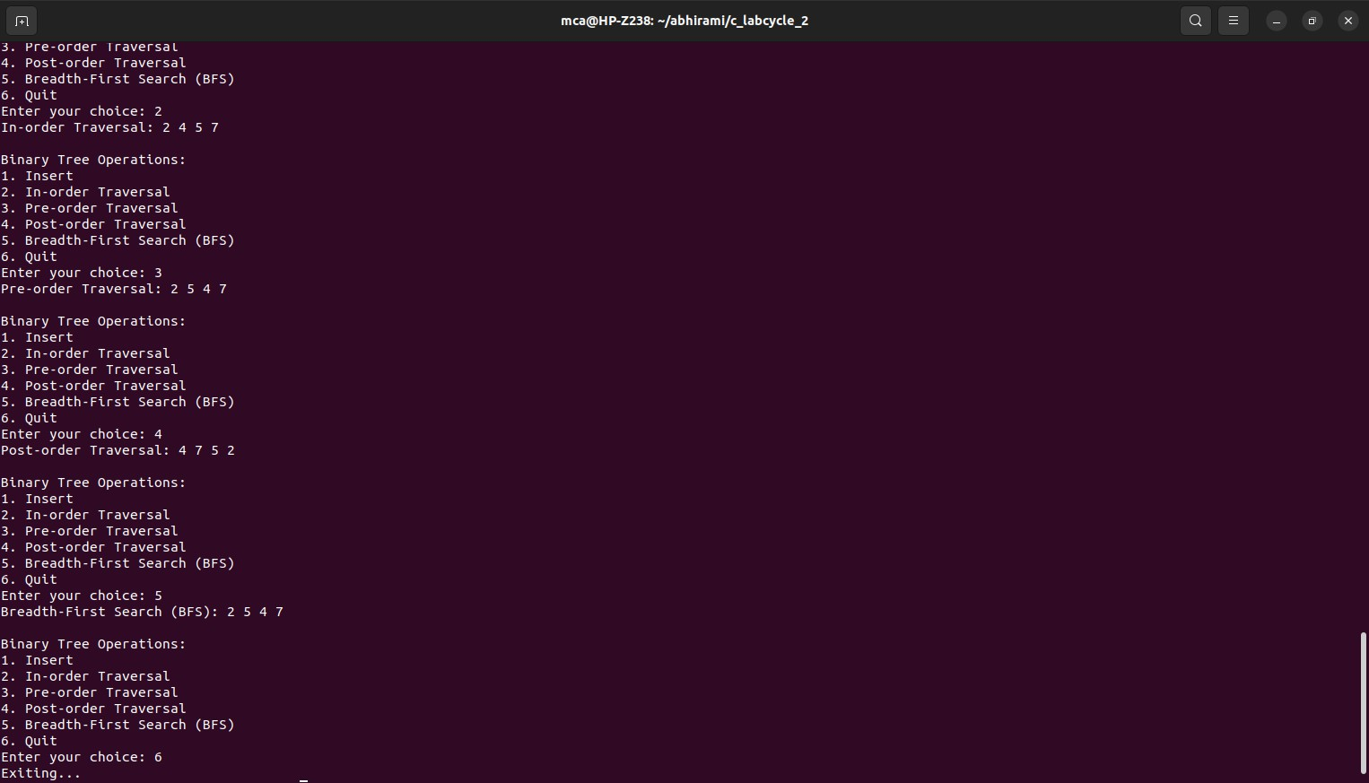

1. **Implement Binomial Heaps and operations (Create, Insert, Delete). Program:**

#include<stdio.h> #include<malloc.h> struct node {

int n;

int degree;

struct node* parent; struct node* child; struct node* sibling;

};

struct node* MAKE_bin_HEAP();

int bin_LINK(struct node*, struct node*); struct node* CREATE_NODE(int);

struct node* bin_HEAP_UNION(struct node*, struct node*); struct node* bin_HEAP_INSERT(struct node*, struct node*); struct node* bin_HEAP_MERGE(struct node*, struct node*); struct node* bin_HEAP_EXTRACT_MIN(struct node*);

int REVERT_LIST(struct node*); int DISPLAY(struct node*);

struct node* FIND_NODE(struct node*, int);

int bin_HEAP_DECREASE_KEY(struct node*, int, int); int bin_HEAP_DELETE(struct node*, int);

int count = 1;

struct node* MAKE_bin_HEAP() { struct node* np;

np = NULL;

return np;

}

struct node * H = NULL;

struct node *Hr = NULL;

int bin_LINK(struct node* y, struct node* z) { y->parent = z;

y->sibling = z->child;

z->child = y;

z->degree = z->degree + 1;

}

struct node* CREATE_NODE(int k) { struct node* p;//new node;

p = (struct node*) malloc(sizeof(struct node)); p->n = k;

return p;

}

struct node* bin_HEAP_UNION(struct node* H1, struct node* H2) { struct node* prev_x;

struct node* next_x; struct node* x;

struct node* H = MAKE_bin_HEAP(); H = bin_HEAP_MERGE(H1, H2);

if (H == NULL)

return H; prev_x = NULL; x = H;

next_x = x->sibling;

while (next_x != NULL) {

if ((x->degree != next_x->degree) || ((next_x->sibling != NULL) && (next_x->sibling)->degree == x->degree)) {

prev_x = x; x = next_x;

}

else {

if (x->n <= next_x->n) {

x->sibling = next_x->sibling; bin_LINK(next_x, x);

}

else {

if (prev_x == NULL) H = next_x;

else

prev_x->sibling = next_x; bin_LINK(x, next_x);

x = next_x;

}

}

next_x = x->sibling;

}

return H;

}

struct node* bin_HEAP_INSERT(struct node* H, struct node* x) { struct node* H1 = MAKE_bin_HEAP();

x->parent = NULL; x->child = NULL; x->sibling = NULL; x->degree = 0;

H1 = x;

H = bin_HEAP_UNION(H, H1);

return H;

}

struct node* bin_HEAP_MERGE(struct node* H1, struct node* H2) { struct node* H = MAKE_bin_HEAP();

struct node* y; struct node* z; struct node* a; struct node* b;

y = H1;

z = H2;

if (y != NULL) {

if (z != NULL && y->degree <= z->degree) H = y;

else if (z != NULL && y->degree > z->degree)

/* need some modifications here;the first and the else conditions can be merged together!!!! */

H = z;

else

H = y;

} else

H = z;

while (y != NULL && z != NULL) { if (y->degree < z->degree) {

y = y->sibling;

}

else if (y->degree == z->degree) { a = y->sibling;

y->sibling = z; y = a;

} else {

b = z->sibling; z->sibling = y; z = b;

}

}

return H;

}

int DISPLAY(struct node* H) { struct node* p;

if (H == NULL) {

printf("\nHEAP EMPTY"); return 0;

}

printf("\nTHE ROOT NODES ARE:-\n"); p = H;

while (p != NULL) { printf("%d", p->n);

if (p->sibling != NULL) printf("-->");

p = p->sibling;

}

printf("\n");

}

struct node* bin_HEAP_EXTRACT_MIN(struct node* H1) { int min;

struct node* t = NULL; struct node* x = H1; struct node *Hr;

struct node* p; Hr = NULL;

if (x == NULL) {

printf("\nNOTHING TO EXTRACT");

return x;

}

// int min=x->n; p = x;

while (p->sibling != NULL) { if ((p->sibling)->n < min) {

min = (p->sibling)->n; t = p;

x = p->sibling;

}

p = p->sibling;

}

if (t == NULL && x->sibling == NULL) H1 = NULL;

else if (t == NULL) H1 = x->sibling;

else if (t->sibling == NULL) t = NULL;

else

t->sibling = x->sibling; if (x->child != NULL) {

REVERT_LIST(x->child); (x->child)->sibling = NULL;

}

H = bin_HEAP_UNION(H1, Hr);

return x;

}

int REVERT_LIST(struct node* y){ if (y->sibling != NULL) {

REVERT_LIST(y->sibling); (y->sibling)->sibling = y;

} else {

Hr = y;

}

}

struct node* FIND_NODE(struct node* H, int k) { struct node* x = H;

struct node* p = NULL; if (x->n == k) {

p = x; return p;

}

if (x->child != NULL && p == NULL) { p = FIND_NODE(x->child, k);

}

if (x->sibling != NULL && p == NULL){ p = FIND_NODE(x->sibling, k);

}

return p;

}

int bin_HEAP_DECREASE_KEY(struct node* H, int i, int k) { int temp;

struct node* p; struct node* y; struct node* z;

p = FIND_NODE(H, i); if (p == NULL){

printf("\nINVALID CHOICE OF KEY TO BE REDUCED");

return 0;

}

if (k > p->n){

printf("\nSORY!THE NEW KEY IS GREATER THAN CURRENT ONE");

return 0;

}

p->n = k;

y = p;

z = p->parent;

while (z != NULL && y->n < z->n) { temp = y->n;

y->n = z->n;

z->n = temp;

y = z;

z = z->parent;

}

printf("\nKEY REDUCED SUCCESSFULLY!");

}

int bin_HEAP_DELETE(struct node* H, int k){ struct node* np;

if (H == NULL){

printf("\nHEAP EMPTY"); return 0;

}

bin_HEAP_DECREASE_KEY(H, k, -1000); np = bin_HEAP_EXTRACT_MIN(H);

if (np != NULL)

printf("\nNODE DELETED SUCCESSFULLY");

}

int main(){

int i, n, m, l; struct node* p; struct node* np; char ch;

printf("\nENTER THE NUMBER OF ELEMENTS:");

scanf("%d", &n);

printf("\nENTER THE ELEMENTS:\n"); for (i = 1; i <= n; i++){

scanf("%d", &m);

np = CREATE_NODE(m);

H = bin_HEAP_INSERT(H, np);

} DISPLAY(H);

do{

printf("\nMENU:-\n");

printf("\n1)INSERT AN ELEMENT\n2)EXTRACT THE MINIMUM KEY NODE\n3)DECREASE A NODE KEY\n4)DELETE A NODE\n5)QUIT\n");

scanf("%d", &l); switch (l) {

case 1: do{

printf("\nENTER THE ELEMENT TO BE INSERTED:");

scanf("%d", &m);

p = CREATE_NODE(m);

H = bin_HEAP_INSERT(H, p);

printf("\nNOW THE HEAP IS:\n"); DISPLAY(H);

printf("\nINSERT MORE(y/Y)= \n"); fflush(stdin);

scanf("%c", &ch);

} while (ch == 'Y' || ch == 'y'); break;

case 2: do{

printf("\nEXTRACTING THE MINIMUM KEY NODE");

p = bin_HEAP_EXTRACT_MIN(H); if (p != NULL)

printf("\nTHE EXTRACTED NODE IS %d", p->n);

printf("\nNOW THE HEAP IS:\n"); DISPLAY(H);

printf("\nEXTRACT MORE(y/Y)\n"); fflush(stdin);

scanf("%c", &ch);

} while (ch == 'Y' || ch == 'y'); break;

case 3: do{

printf("\nENTER THE KEY OF THE NODE TO BE DECREASED:");

scanf("%d", &m);

printf("\nENTER THE NEW KEY : ");

scanf("%d", &l); bin_HEAP_DECREASE_KEY(H, m, l);

printf("\nNOW THE HEAP IS:\n"); DISPLAY(H);

printf("\nDECREASE MORE(y/Y)\n"); fflush(stdin);

scanf("%c", &ch);

} while (ch == 'Y' || ch == 'y'); break;

case 4: do{

printf("\nENTER THE KEY TO BE DELETED: ");

scanf("%d", &m); bin_HEAP_DELETE(H, m);

printf("\nDELETE MORE(y/Y)\n");

fflush(stdin); scanf("%c", &ch);

} while (ch == 'y' || ch == 'Y'); break;

case 5:

printf("\nExiting. \n");

break; default:

printf("\nINVALID ENTRY...TRY AGAIN. \n");

}

} while (l != 5);

}

**Output:**

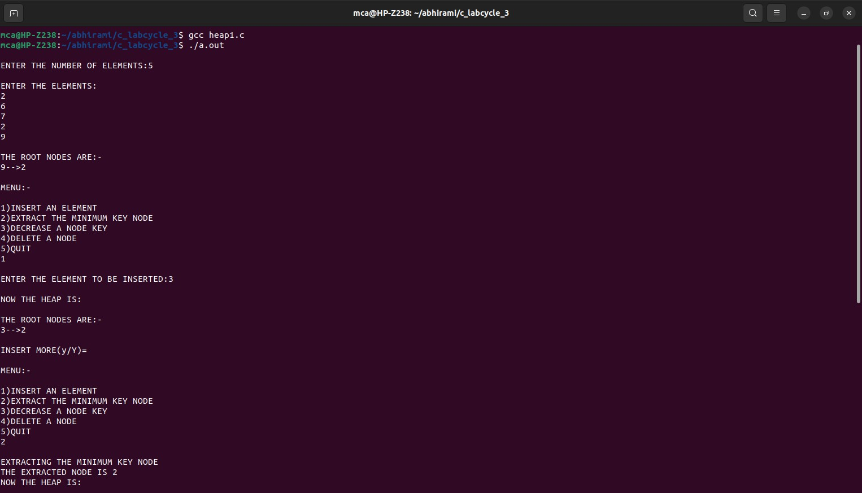

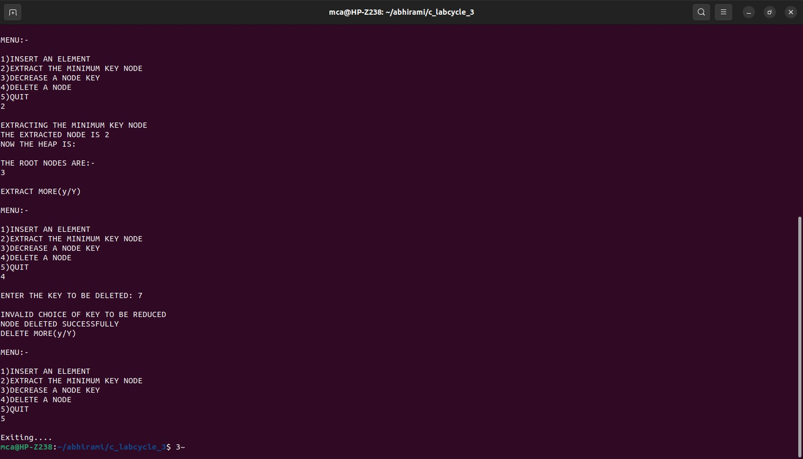

1. **Implement B Trees and its operations**. **Program:**

#include <stdio.h> #include <stdlib.h> #define MAX 4

#define MIN 2 struct btreeNode{

int val[MAX + 1], count;

struct btreeNode *link[MAX + 1];

};

struct btreeNode *root;

struct btreeNode * createNode(int val, struct btreeNode *child) { struct btreeNode *newNode;

newNode = (struct btreeNode *)malloc(sizeof(struct btreeNode)); newNode->val[1] = val;

newNode->count = 1; newNode->link[0] = root; newNode->link[1] = child; return newNode;

}

void addValToNode(int val, int pos, struct btreeNode *node,struct btreeNode *child){ int j = node->count;

while (j > pos){

node->val[j + 1] = node->val[j]; node->link[j + 1] = node->link[j]; j--;

}

node->val[j + 1] = val; node->link[j + 1] = child; node->count++;

}

void splitNode (int val, int *pval, int pos, struct btreeNode *node, struct btreeNode *child, struct btreeNode **newNode) {

int median, j; if (pos > MIN)

median = MIN + 1;

else

median = MIN;

*newNode = (struct btreeNode *)malloc(sizeof(struct btreeNode)); j = median + 1;

while (j <= MAX){

(*newNode)->val[j - median] = node->val[j]; (*newNode)->link[j - median] = node->link[j]; j++;

}

node->count = median;

(*newNode)->count = MAX - median; if (pos <= MIN) {

addValToNode(val, pos, node, child);

}

else{

}

addValToNode(val, pos - median, *newNode, child);

*pval = node->val[node->count];

(*newNode)->link[0] = node->link[node->count]; node->count--;

}

int setValueInNode(int val, int *pval,struct btreeNode *node, struct btreeNode **child){ int pos;

if (!node){

*pval = val;

*child = NULL; return 1;

}

if (val < node->val[1]){ pos = 0;

}

else{

for (pos = node->count;

(val < node->val[pos] && pos > 1); pos--); if (val == node->val[pos]){

printf("Duplicates not allowed\n"); return 0;

}

}

if (setValueInNode(val, pval, node->link[pos], child)){ if (node->count < MAX){

addValToNode(*pval, pos, node, *child);

} else{

splitNode(*pval, pval, pos, node, *child, child); return 1;

}

}

return 0;

}

void insertion(int val){ int flag, i;

struct btreeNode *child;

flag = setValueInNode(val, &i, root, &child); if (flag)

root = createNode(i, child);

}

void copySuccessor(struct btreeNode *myNode, int pos){ struct btreeNode *dummy;

dummy = myNode->link[pos]; for (;dummy->link[0] != NULL;)

dummy = dummy->link[0]; myNode->val[pos] = dummy->val[1];

}

void removeVal(struct btreeNode *myNode, int pos){ int i = pos + 1;

while (i <= myNode->count) {

myNode->val[i - 1] = myNode->val[i]; myNode->link[i - 1] = myNode->link[i]; i++;

}

myNode->count--;

}

void doRightShift(struct btreeNode *myNode, int pos){ struct btreeNode *x = myNode->link[pos];

int j = x->count; while (j > 0) {

x->val[j + 1] = x->val[j]; x->link[j + 1] = x->link[j];

}

x->val[1] = myNode->val[pos]; x->link[1] = x->link[0];

x->count++;

x = myNode->link[pos - 1];

myNode->val[pos] = x->val[x->count];

myNode->link[pos] = x->link[x->count]; x->count--;

return;

}

void doLeftShift(struct btreeNode *myNode, int pos){ int j = 1;

struct btreeNode *x = myNode->link[pos - 1]; x->count++;

x->val[x->count] = myNode->val[pos];

x->link[x->count] = myNode->link[pos]->link[0]; x = myNode->link[pos];

myNode->val[pos] = x->val[1]; x->link[0] = x->link[1];

x->count--;

while (j <= x->count) {

x->val[j] = x->val[j + 1]; x->link[j] = x->link[j + 1]; j++;

}

return;

}

void mergeNodes(struct btreeNode *myNode, int pos){ int j = 1;

struct btreeNode *x1 = myNode->link[pos], *x2 = myNode->link[pos - 1]; x2->count++;

x2->val[x2->count] = myNode->val[pos]; x2->link[x2->count] = myNode->link[0]; while (j <= x1->count){

x2->count++;

x2->val[x2->count] = x1->val[j];

x2->link[x2->count] = x1->link[j]; j++;

}

j = pos;

while (j < myNode->count){

myNode->val[j] = myNode->val[j + 1]; myNode->link[j] = myNode->link[j + 1]; j++;

}

myNode->count--; free(x1);

}

void adjustNode(struct btreeNode *myNode, int pos){ if (!pos) {

if (myNode->link[1]->count > MIN){ doLeftShift(myNode, 1);

} else{

mergeNodes(myNode, 1);

}

} else{

if (myNode->count != pos){

if(myNode->link[pos - 1]->count > MIN){ doRightShift(myNode, pos);

} else{

if (myNode->link[pos + 1]->count > MIN){ doLeftShift(myNode, pos + 1);

} else{

mergeNodes(myNode, pos);

}

}

} else{

if (myNode->link[pos - 1]->count > MIN) doRightShift(myNode, pos);

}}}

else

mergeNodes(myNode, pos);

int delValFromNode(int val, struct btreeNode *myNode){ int pos, flag = 0;

if (myNode) {

if (val < myNode->val[1]) { pos = 0;

flag = 0;

} else{

for (pos = myNode->count;

(val < myNode->val[pos] && pos > 1); pos--); if (val == myNode->val[pos]){

flag = 1;

}

else{

flag = 0;

}}

if (flag){

if (myNode->link[pos - 1]){ copySuccessor(myNode, pos);

flag = delValFromNode(myNode->val[pos], myNode->link[pos]); if (flag == 0){

printf("Given data is not present in B-Tree\n");

}

} else{

removeVal(myNode, pos);

}

} else{

flag = delValFromNode(val, myNode->link[pos]);

}

if (myNode->link[pos]){

if (myNode->link[pos]->count < MIN) adjustNode(myNode, pos);

}}

return flag;

}

void deletion(int val, struct btreeNode *myNode){ struct btreeNode *tmp;

if (!delValFromNode(val, myNode)){

printf("Given value is not present in B-Tree\n"); return;

} else{

if (myNode->count == 0){ tmp = myNode;

myNode = myNode->link[0]; free(tmp);

}}

root = myNode; return;

}

void searching(int val, int *pos, struct btreeNode *myNode){ if (!myNode){

return;

}

if (val < myNode->val[1])

{

*pos = 0;

} else{

for (*pos = myNode->count;

(val < myNode->val[*pos] && *pos > 1); (*pos)--); if (val == myNode->val[*pos]) {

printf("Given data %d is present in B-Tree", val); return;

}}

searching(val, pos, myNode->link[*pos]); return;

}

/* B-Tree Traversal */

void traversal(struct btreeNode *myNode){ int i;

if (myNode){

for (i = 0; i < myNode->count; i++){ traversal(myNode->link[i]); printf("%d ", myNode->val[i + 1]);

}

traversal(myNode->link[i]);

}}

int main(){

int val, ch; while (1){

printf("\n1. Insertion\n2. Deletion\n3. Searching\n4. Traversal\n5. Exit\n”); printf(“Enter your choice:\n");

scanf("%d", &ch); switch (ch){

case 1:

printf("Enter your element:");

scanf("%d", &val); insertion(val); break;

case 2:

printf("Enter the element to delete:"); scanf("%d", &val);

deletion(val, root); break;

case 3:

printf("Enter the element to search:"); scanf("%d", &val);

searching(val, &ch, root); break;

case 4:

traversal(root); break;

case 5:

exit(0); default:

printf("U have entered wrong option!!\n"); break;

}

printf("\n");

}

}

**Output:**

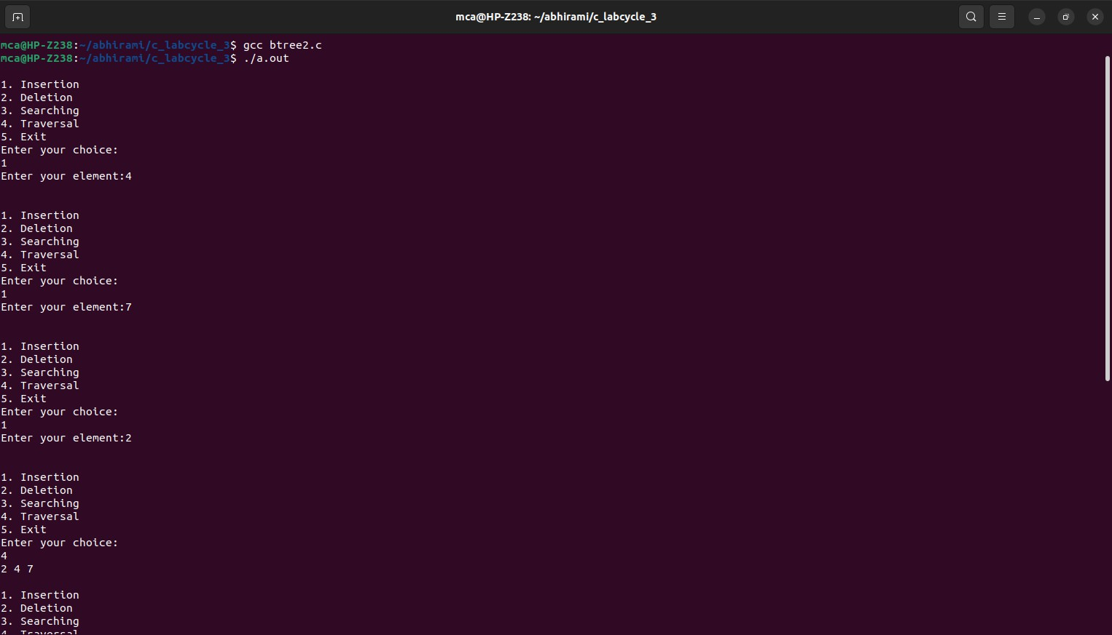

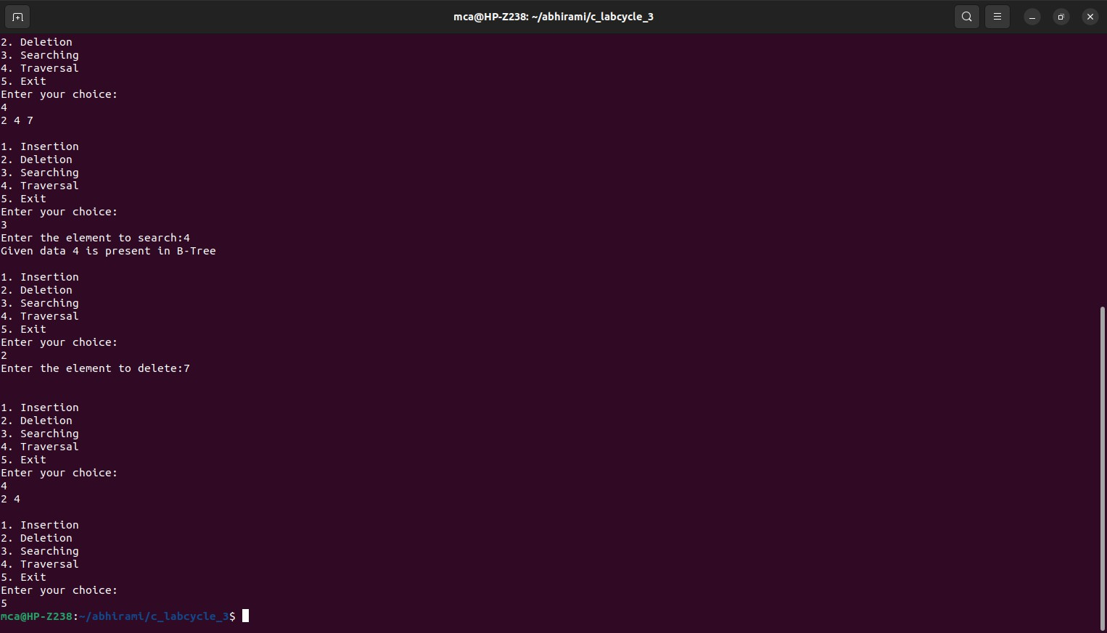

1. **Implement Red Black Trees and its operations. Program:**

#include <stdio.h> #include <stdlib.h>

// Node structure for Red-Black Tree typedef struct Node {

int key;

int color; // 0 for black, 1 for red struct Node* parent;

struct Node* left; struct Node* right;

} Node;

// Sentinel node to represent NULL (external nodes in the tree) Node* NIL;

// Function to create a new node with given key and color Node* createNode(int key, int color) {

Node* newNode = (Node*)malloc(sizeof(Node)); newNode->key = key;

newNode->color = color; newNode->parent = NIL; newNode->left = NIL; newNode->right = NIL; return newNode;

}

// Function to perform left rotation on the given node void leftRotate(Node** root, Node* x) {

Node* y = x->right; x->right = y->left;

if (y->left != NIL)

y->left->parent = x;

y->parent = x->parent;

if (x->parent == NIL)

*root = y;

else if (x == x->parent->left) x->parent->left = y;

else

x->parent->right = y;

y->left = x;

x->parent = y;

}

// Function to perform right rotation on the given node void rightRotate(Node** root, Node* y) {

Node* x = y->left; y->left = x->right;

if (x->right != NIL)

x->right->parent = y;

x->parent = y->parent;

if (y->parent == NIL)

*root = x;

else if (y == y->parent->left) y->parent->left = x;

else

y->parent->right = x;

x->right = y; y->parent = x;

}

// Function to fix the Red-Black Tree after insertion void insertFixup(Node** root, Node* z) {

while (z->parent->color == 1) {

if (z->parent == z->parent->parent->left) { Node* y = z->parent->parent->right;

if (y->color == 1) {

z->parent->color = 0;

y->color = 0;

z->parent->parent->color = 1; z = z->parent->parent;

} else {

if (z == z->parent->right) { z = z->parent; leftRotate(root, z);

}

z->parent->color = 0;

z->parent->parent->color = 1; rightRotate(root, z->parent->parent);

}

} else {

Node* y = z->parent->parent->left; if (y->color == 1) {

z->parent->color = 0;

y->color = 0;

z->parent->parent->color = 1; z = z->parent->parent;

} else {

if (z == z->parent->left) { z = z->parent; rightRotate(root, z);

}

z->parent->color = 0;

z->parent->parent->color = 1; leftRotate(root, z->parent->parent);

}

}

}

(*root)->color = 0;

}

// Function to insert a key into the Red-Black Tree void insert(Node** root, int key) {

Node* z = createNode(key, 1); Node* y = NIL;

Node* x = *root;

while (x != NIL) { y = x;

if (z->key < x->key) x = x->left;

else

x = x->right;

}

z->parent = y;

if (y == NIL)

*root = z;

else if (z->key < y->key) y->left = z;

else

y->right = z;

z->left = NIL; z->right = NIL;

z->color = 1; // Red

insertFixup(root, z);

}

// Function to print the Red-Black Tree (in-order traversal) void inOrderTraversal(Node* root) {

if (root != NIL) { inOrderTraversal(root->left);

printf("%d (%s) ", root->key, root->color == 0 ? "Black" : "Red"); inOrderTraversal(root->right);

}

}

int main() {

NIL = createNode(0, 0); Node* root = NIL;

int choice, key; do {

printf("\n1. Insert\n2. Display\n3. Exit\n"); printf("Enter your choice: ");

scanf("%d", &choice);

switch (choice) { case 1:

printf("Enter key to insert: "); scanf("%d", &key); insert(&root, key);

break; case 2:

printf("Red-Black Tree (in-order traversal): \n"); inOrderTraversal(root);

printf("\n"); break;

case 3:

exit(0); default:

printf("Invalid choice!\n");

}

} while (1);

return 0;

}

**Output:**

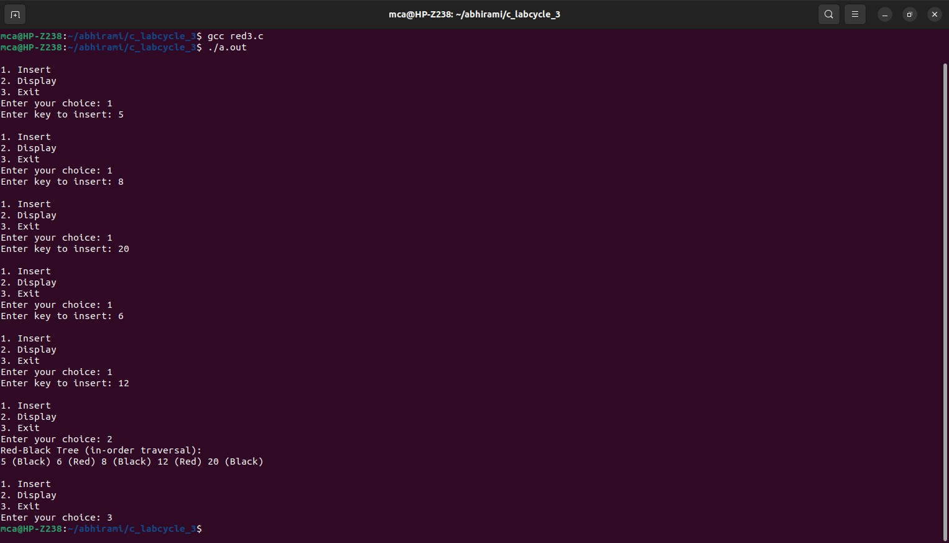

1. **Graph Traversal techniques (DFS and BFS) and Topological Sorting**. **Program:**

#include <stdio.h> #include <stdlib.h> #include <stdbool.h>

#define MAX_VERTICES 5 typedef struct Node {

int vertex;

struct Node* next;

} Node;

typedef struct Graph {

Node* adjList[MAX_VERTICES]; int numVertices;

} Graph;

Graph* createGraph(int numVertices) {

if (numVertices <= 0 || numVertices > MAX_VERTICES) { printf("Invalid number of vertices. Exiting...\n"); exit(EXIT_FAILURE);

}

Graph* graph = (Graph*)malloc(sizeof(Graph)); graph->numVertices = numVertices;

for (int i = 0; i < numVertices; ++i) graph->adjList[i] = NULL;

return graph;

}

void addEdge(Graph* graph, int src, int dest) {

if (src < 0 || src >= graph->numVertices || dest < 0 || dest >= graph->numVertices) { printf("Invalid source or destination vertex. Ignoring edge...\n");

return;

}

Node* newNode = (Node*)malloc(sizeof(Node)); newNode->vertex = dest;

newNode->next = graph->adjList[src]; graph->adjList[src] = newNode;

}

void DFS(Graph* graph, int vertex, bool visited[]) { visited[vertex] = true;

printf("%d ", vertex);

Node* adjNode = graph->adjList[vertex]; while (adjNode != NULL) {

int adjVertex = adjNode->vertex; if (!visited[adjVertex])

DFS(graph, adjVertex, visited); adjNode = adjNode->next;

}

}

void BFS(Graph* graph, int start) {

if (start < 0 || start >= graph->numVertices) { printf("Invalid starting vertex. Exiting...\n"); exit(EXIT_FAILURE);

}

bool visited[MAX_VERTICES] = { false }; int queue[MAX_VERTICES];

int front = 0, rear = -1; visited[start] = true; queue[++rear] = start; while (front <= rear) {

int vertex = queue[front++]; printf("%d ", vertex);

Node* adjNode = graph->adjList[vertex]; while (adjNode != NULL) {

int adjVertex = adjNode->vertex; if (!visited[adjVertex]) {

visited[adjVertex] = true;

queue[(++rear) % MAX_VERTICES] = adjVertex

}

adjNode = adjNode->next;

}

}

}

void topologicalSortUtil(Graph* graph, int vertex, bool visited[], int stack[], int* stackIndex) {

visited[vertex] = true;

Node* adjNode = graph->adjList[vertex]; while (adjNode != NULL) {

int adjVertex = adjNode->vertex; if (!visited[adjVertex])

topologicalSortUtil(graph, adjVertex, visited, stack, stackIndex); adjNode = adjNode->next;

}

stack[++(*stackIndex)] = vertex;

}

void topologicalSort(Graph* graph) {

bool visited[MAX_VERTICES] = { false }; int stack[MAX_VERTICES];

int stackIndex = -1;

for (int i = 0; i < graph->numVertices; ++i) { if (!visited[i])

topologicalSortUtil(graph, i, visited, stack, &stackIndex);

}

printf("Topological Sorting: "); while (stackIndex >= 0)

printf("%d ", stack[stackIndex--]);

}

int main() {

Graph* graph = createGraph(MAX_VERTICES); addEdge(graph, 0, 1);

addEdge(graph, 0, 3);

addEdge(graph, 1, 2);

addEdge(graph, 2, 3);

addEdge(graph, 3, 4); int choice;

printf("Choose a technique to demonstrate:\n");

printf("1. DFS\n2. BFS\n3. Topological Sort\n4. Exit\n"); while (1) {

printf("Enter your choice (1-4): "); scanf("%d", &choice);

switch (choice) { case 1:

printf("DFS Traversal: ");

DFS(graph, 0, (bool[MAX_VERTICES]){ false }); printf("\n");

break; case 2:

printf("BFS Traversal: "); BFS(graph, 0);

printf("\n"); break;

case 3:

topologicalSort(graph); printf("\n");

break; case 4:

exit(EXIT_SUCCESS);

default:

printf("Invalid choice!\n");

}

}

return 0;

}

**Output:**

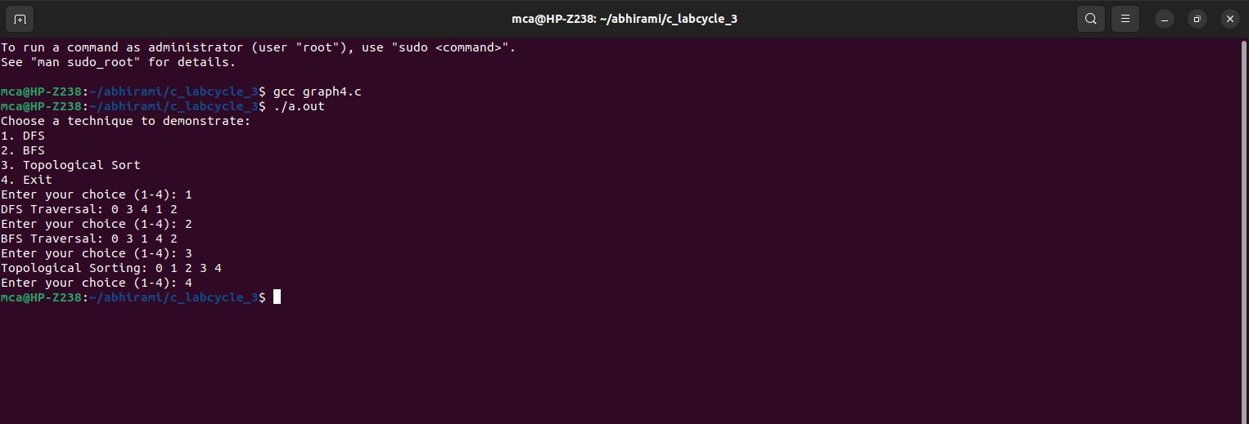

1. **Finding the Strongly connected Components in a directed graph**. **Program:**

#include <stdio.h> #include <stdlib.h> #include <stdbool.h>

#define MAX_VERTICES 100 typedef struct Node {

int vertex;

struct Node* next;

} Node;

typedef struct Graph {

Node* adjList[MAX_VERTICES]; Node* revAdjList[MAX_VERTICES]; int numVertices;

} Graph;

Graph* createGraph(int numVertices) {

if (numVertices <= 0 || numVertices > MAX_VERTICES) { printf("Invalid number of vertices. Exiting...\n"); exit(EXIT_FAILURE);

}

Graph* graph = (Graph*)malloc(sizeof(Graph)); graph->numVertices = numVertices;

for (int i = 0; i < numVertices; ++i) { graph->adjList[i] = NULL;

graph->revAdjList[i] = NULL;

}

return graph;

}

void addEdge(Graph* graph, int src, int dest) {

if (src < 0 || src >= graph->numVertices || dest < 0 || dest >= graph->numVertices) {

printf("Invalid source or destination vertex. Ignoring edge...\n"); return;

}

Node* newNode = (Node*)malloc(sizeof(Node)); newNode->vertex = dest;

newNode->next = graph->adjList[src]; graph->adjList[src] = newNode;

// Reverse graph for Kosaraju's algorithm newNode = (Node*)malloc(sizeof(Node)); newNode->vertex = src;

newNode->next = graph->revAdjList[dest]; graph->revAdjList[dest] = newNode;

}

void DFSUtil(Graph* graph, int vertex, bool visited[]) { visited[vertex] = true;

printf("%d ", vertex);

Node* adjNode = graph->adjList[vertex]; while (adjNode != NULL) {

int adjVertex = adjNode->vertex; if (!visited[adjVertex])

DFSUtil(graph, adjVertex, visited); adjNode = adjNode->next;

}

}

void fillOrder(Graph* graph, int vertex, bool visited[], int stack[], int* stackIndex) { visited[vertex] = true;

Node* adjNode = graph->revAdjList[vertex]; while (adjNode != NULL) {

int adjVertex = adjNode->vertex; if (!visited[adjVertex])

fillOrder(graph, adjVertex, visited, stack, stackIndex); adjNode = adjNode->next;

}

stack[++(*stackIndex)] = vertex;

}

Graph* getTranspose(Graph* graph) {

Graph* transposedGraph = createGraph(graph->numVertices); for (int i = 0; i < graph->numVertices; ++i) {

Node* current = graph->adjList[i]; while (current != NULL) {

addEdge(transposedGraph, current->vertex, i); current = current->next;

}

}

return transposedGraph;

}

void printSCCs(Graph* graph) { int stack[MAX_VERTICES]; int stackIndex = -1;

bool visited[MAX_VERTICES] = { false }; for (int i = 0; i < graph->numVertices; ++i) {

if (!visited[i])

fillOrder(graph, i, visited, stack, &stackIndex);

}

Graph* transposedGraph = getTranspose(graph); for (int i = 0; i < graph->numVertices; ++i)

visited[i] = false; while (stackIndex >= 0) {

int vertex = stack[stackIndex--]; if (!visited[vertex]) {

DFSUtil(transposedGraph, vertex, visited); printf("\n");

}

}

free(transposedGraph);

}

int main() {

Graph* graph = createGraph(8);

// Define edges for demonstration addEdge(graph, 0, 1);

addEdge(graph, 1, 2);

addEdge(graph, 2, 0);

addEdge(graph, 2, 3);

addEdge(graph, 3, 4);

addEdge(graph, 4, 5);

addEdge(graph, 5, 3);

addEdge(graph, 6, 5);

addEdge(graph, 6, 7);

addEdge(graph, 7, 6);

printf("Strongly Connected Components:\n"); printSCCs(graph);

return 0;

}

**Output:**

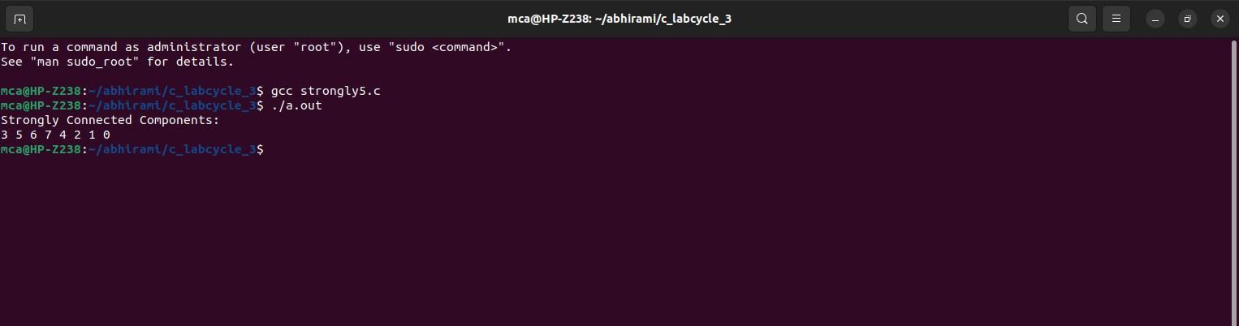

1. **Prim’s Algorithm for finding the minimum cost spanning tree. Program:**

#include <stdio.h> #include <stdlib.h> #include <stdbool.h>

#define MAX_VERTICES 100

#define INF 999999 typedef struct {

int parent; int key;

bool inMST;

} Vertex;

typedef struct Graph { int numVertices;

int adjacencyMatrix[MAX_VERTICES][MAX_VERTICES]; Vertex vertices[MAX_VERTICES];

} Graph;

Graph* createGraph(int numVertices) {

if (numVertices <= 0 || numVertices > MAX_VERTICES) { printf("Invalid number of vertices. Exiting...\n"); exit(EXIT_FAILURE);

}

Graph* graph = (Graph*)malloc(sizeof(Graph)); graph->numVertices = numVertices;

for (int i = 0; i < numVertices; ++i) { graph->vertices[i].parent = -1; graph->vertices[i].key = INF; graph->vertices[i].inMST = false; for (int j = 0; j < numVertices; ++j)

graph->adjacencyMatrix[i][j] = INF;

}

return graph;

}

void addEdge(Graph* graph, int src, int dest, int weight) {

if (src >= 0 && src < graph->numVertices && dest >= 0 && dest < graph-

>numVertices) {

graph->adjacencyMatrix[src][dest] = weight; graph->adjacencyMatrix[dest][src] = weight;

} else {

printf("Invalid source or destination vertex. Ignoring edge...\n");

}

}

int findMinKeyVertex(Graph* graph) { int minKey = INF;

int minIndex = -1;

for (int i = 0; i < graph->numVertices; ++i) {

if (!graph->vertices[i].inMST && graph->vertices[i].key < minKey) { minKey = graph->vertices[i].key;

minIndex = i;

}}

return minIndex;

}

void primMST(Graph* graph) { graph->vertices[0].key = 0;

for (int count = 0; count < graph->numVertices - 1; ++count) { int u = findMinKeyVertex(graph);

graph->vertices[u].inMST = true;

for (int v = 0; v < graph->numVertices; ++v) {

if (graph->adjacencyMatrix[u][v] != INF && !graph->vertices[v].inMST && graph->adjacencyMatrix[u][v] < graph->vertices[v].key) {

graph->vertices[v].key = graph->adjacencyMatrix[u][v];

graph->vertices[v].parent = u;

}

}

}

printf("Minimum Cost Spanning Tree (Prim's Algorithm):\n"); for (int i = 1; i < graph->numVertices; ++i)

printf("Edge: %d - %d, Weight: %d\n", graph->vertices[i].parent, i, graph

>vertices[i].key); int main() {

Graph* graph = createGraph(5);

// Define edges for demonstration addEdge(graph, 0, 1, 2);

addEdge(graph, 0, 3, 6);

addEdge(graph, 1, 2, 3);

addEdge(graph, 1, 3, 8);

addEdge(graph, 1, 4, 5);

addEdge(graph, 2, 4, 7);

addEdge(graph, 3, 4, 9); primMST(graph); return 0;

}

**Output:**

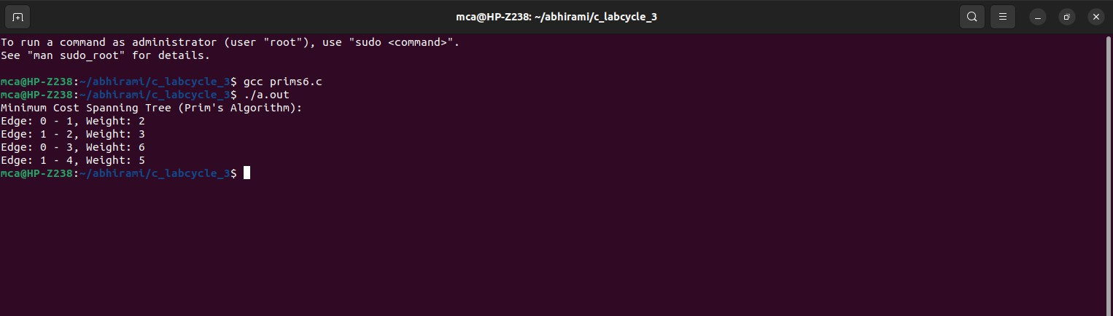

1. **Kruskal’s algorithm using the Disjoint set data structure**. **Program:**

#include <stdio.h> #include <stdlib.h>

#define MAX_VERTICES 100 typedef struct Edge {

int src, dest, weight;

} Edge; typedef struct {

int parent, rank;

} Subset; typedef struct {

int numVertices, numEdges;

Edge edges[MAX_VERTICES * MAX_VERTICES];

} Graph;

Graph* createGraph(int numVertices, int numEdges) {

if (numVertices <= 0 || numVertices > MAX_VERTICES || numEdges <= 0 || numEdges > MAX_VERTICES * MAX_VERTICES) {

printf("Invalid number of vertices or edges. Exiting...\n"); exit(EXIT_FAILURE);

}

Graph* graph = (Graph*)malloc(sizeof(Graph)); graph->numVertices = numVertices;

graph->numEdges = numEdges; return graph;

}

void addEdge(Graph* graph, int index, int src, int dest, int weight) {

if (index >= 0 && index < graph->numEdges && src >= 0 && src < graph-

>numVertices &&

dest >= 0 && dest < graph->numVertices) { graph->edges[index].src = src;

graph->edges[index].dest = dest; graph->edges[index].weight = weight;

} else {

printf("Invalid edge information. Exiting...\n"); exit(EXIT_FAILURE);

}}

int compareEdges(const void* a, const void* b) { return ((Edge*)a)->weight - ((Edge*)b)->weight; }

int find(Subset subsets[], int i) { if (subsets[i].parent != i)

subsets[i].parent = find(subsets, subsets[i].parent); return subsets[i].parent;}

void unionSets(Subset subsets[], int x, int y) { int xroot = find(subsets, x);

int yroot = find(subsets, y);

if (subsets[xroot].rank < subsets[yroot].rank) subsets[xroot].parent = yroot;

else if (subsets[xroot].rank > subsets[yroot].rank) subsets[yroot].parent = xroot;

else {

subsets[yroot].parent = xroot; subsets[xroot].rank++;

}}

void kruskalMST(Graph* graph) { Edge result[graph->numVertices]; int e = 0;

int i = 0;

qsort(graph->edges, graph->numEdges, sizeof(graph->edges[0]), compareEdges); Subset subsets[graph->numVertices];

for (i = 0; i < graph->numVertices; ++i) {

subsets[i].parent = i; subsets[i].rank = 0;

}

i = 0;

while (e < graph->numVertices - 1 && i < graph->numEdges) { Edge nextEdge = graph->edges[i++];

int x = find(subsets, nextEdge.src); int y = find(subsets, nextEdge.dest); if (x != y) {

result[e++] = nextEdge; unionSets(subsets, x, y);

}}

printf("Minimum Cost Spanning Tree (Kruskal's Algorithm):\n"); for (i = 0; i < e; ++i)

printf("Edge: %d - %d, Weight: %d\n", result[i].src, result[i].dest, result[i].weight); } int main() {

Graph* graph = createGraph(4, 5); addEdge(graph, 0, 0, 1, 10);

addEdge(graph, 1, 0, 2, 6);

addEdge(graph, 2, 0, 3, 5);

addEdge(graph, 3, 1, 3, 15);

addEdge(graph, 4, 2, 3, 4); kruskalMST(graph); return 0;

}

Output:

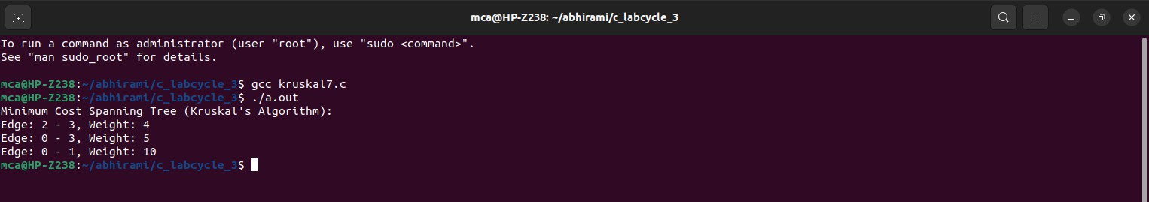

1. **Single Source shortest path algorithm using any heap structure that supports mergeable heap operations.**

**Program:**

#include <stdio.h> #include <stdlib.h> #include <stdbool.h> #include <time.h>

#define MAX_VERTICES 5

#define MAX_DISTANCE 50 // Adjust this based on the expected maximum distance between nodes

typedef struct {

int vertex, distance;

} Node; typedef struct {

Node* heap;

int capacity, size;

} MinHeap; typedef struct {

int numVertices;

int adjacencyMatrix[MAX_VERTICES][MAX_VERTICES];

} Graph;

Graph* createGraph(int numVertices) {

if (numVertices <= 0 || numVertices > MAX_VERTICES) { printf("Invalid number of vertices. Exiting...\n"); exit(EXIT_FAILURE);

}

Graph* graph = (Graph*)malloc(sizeof(Graph)); graph->numVertices = numVertices;

for (int i = 0; i < numVertices; ++i) { for (int j = 0; j < numVertices; ++j) {

if (i == j) {

graph->adjacencyMatrix[i][j] = 0; // Distance from a vertex to itself is 0

} else {

graph->adjacencyMatrix[i][j] = rand() % MAX_DISTANCE + 1; // Random distance between 1 and MAX_DISTANCE

}

}

}

return graph;

}

MinHeap* createMinHeap(int capacity) {

MinHeap* heap = (MinHeap*)malloc(sizeof(MinHeap)); heap->capacity = capacity;

heap->size = 0;

heap->heap = (Node*)malloc(capacity * sizeof(Node)); return heap;

}

void swap(Node* a, Node* b) { Node temp = *a;

*a = *b;

*b = temp;

}

void minHeapify(MinHeap* heap, int idx) { int smallest = idx;

int left = 2 * idx + 1; int right = 2 * idx + 2;

if (left < heap->size && heap->heap[left].distance < heap->heap[smallest].distance) smallest = left;

if (right < heap->size && heap->heap[right].distance < heap->heap[smallest].distance) smallest = right;

if (smallest != idx) {

swap(&heap->heap[idx], &heap->heap[smallest]); minHeapify(heap, smallest);

}

}

bool isEmpty(MinHeap* heap) { return heap->size == 0;

}

Node extractMin(MinHeap* heap) { if (isEmpty(heap))

exit(EXIT_FAILURE);

Node root = heap->heap[0];

heap->heap[0] = heap->heap[heap->size - 1]; heap->size--;

minHeapify(heap, 0); return root;

}

void decreaseKey(MinHeap* heap, int vertex, int distance) { int i;

for (i = 0; i < heap->size; ++i) {

if (heap->heap[i].vertex == vertex) { heap->heap[i].distance = distance; break;

}}

while (i != 0 && heap->heap[i].distance < heap->heap[(i - 1) / 2].distance) { swap(&heap->heap[i], &heap->heap[(i - 1) / 2]);

i = (i - 1) / 2;

}}

void dijkstra(Graph* graph, int src, int dest) {

MinHeap* heap = createMinHeap(graph->numVertices);

Node* result = (Node*)malloc(graph->numVertices * sizeof(Node)); for (int i = 0; i < graph->numVertices; ++i) {

heap->heap[i].vertex = i;

heap->heap[i].distance = MAX_DISTANCE * graph->numVertices + 1; // A value larger than the sum of all possible distances

result[i].vertex = -1;

result[i].distance = MAX_DISTANCE * graph->numVertices + 1; } heap->heap[src].distance = 0;

result[src].distance = 0; clock_t start_time = clock(); while (!isEmpty(heap)) {

Node current = extractMin(heap); int u = current.vertex;

for (int v = 0; v < graph->numVertices; ++v) {

if (graph->adjacencyMatrix[u][v] != 0) { // Consider only non-zero distances int alt = result[u].distance + graph->adjacencyMatrix[u][v];

if (alt < result[v].distance) { result[v].distance = alt; result[v].vertex = u; decreaseKey(heap, v, alt);

}}

}}

clock_t end_time = clock();

double execution_time = ((double)(end_time - start_time)) / CLOCKS_PER_SEC; printf("Paths from source %d to destination %d:\n", src, dest);

printf("Shortest Distance: %d\n", result[dest].distance); printf("Execution Time: %f seconds\n", execution_time); printf("Path: ");

int temp = dest; while (temp != -1) {

printf("%d ", temp);

temp = result[temp].vertex; } printf("\n");

printf("All Paths Traversed:\n");

for (int i = 0; i < graph->numVertices; ++i) { if (i == src) continue;

printf("To vertex %d: Distance = %d, Path = ", i, result[i].distance); temp = i;

while (temp != -1) {

printf("%d ", temp);

temp = result[temp].vertex;

}

printf("\n"); } free(heap->heap);

free(heap); free(result);

}

int main() { srand(time(NULL));

Graph* graph = createGraph(5); printf("Random Distance Matrix:\n");

for (int i = 0; i < graph->numVertices; ++i) { for (int j = 0; j < graph->numVertices; ++j) {

printf("%2d ", graph->adjacencyMatrix[i][j]);

}

printf("\n");

}

int sourceVertex, destVertex;

printf("\nEnter source vertex (0-%d): ", graph->numVertices - 1); scanf("%d", &sourceVertex);

printf("Enter destination vertex (0-%d): ", graph->numVertices - 1); scanf("%d", &destVertex);

if (sourceVertex < 0 || sourceVertex >= graph->numVertices || destVertex < 0 || destVertex >= graph->numVertices) { printf("Invalid source or destination vertex. Exiting...\n"); return EXIT_FAILURE;

}

dijkstra(graph, sourceVertex, destVertex);

free(graph); return 0;

}

**Output:**

