VeridaX

Social Impact Platform Report

Abhirami Nair- 23070122012

Aditi Bansal- 23070122013

Aparna Nair- 23070122040

# Problem Statement and Objectives

## Problem Statement

Communities often struggle with mobilizing volunteers for local initiatives and events. While many individuals are willing to volunteer, there is no centralized, user-friendly platform to connect them with organizations in need of assistance. Current methods—such as social media posts, word-of-mouth, and outdated websites—are fragmented and inefficient, making it difficult for volunteers to find opportunities that align with their skills and availability.

Additionally, funding for social causes is another major challenge. Many nonprofit initiatives lack access to adequate crowdfunding platforms tailored to their needs. Moreover, while social media can be used for spreading awareness, there is no dedicated social media platform specifically designed to promote good causes and enable meaningful engagement.

Furthermore, sustainable products often struggle to find the right audience due to a lack of visibility in conventional e-commerce platforms.

This inefficiency results in missed opportunities for volunteers, organizations, and social entrepreneurs alike. A digital ecosystem is required that integrates volunteering, crowdfunding, social awareness, and sustainable commerce into a single, effective platform.

## Objectives

* Develop a centralized web and mobile application integrating volunteering, crowdfunding, social media for good causes, and sustainable e-commerce.
* Implement a smart matching algorithm to recommend volunteering opportunities based on user profiles.
* Create a crowdfunding platform to support social initiatives.
* Design a social media space dedicated to promoting and supporting good causes.
* Establish an e-commerce platform to promote sustainable products.
* Ensure user security and authentication while maintaining a seamless experience.
* Improve engagement through real-time notifications, feedback mechanisms, and gamification.

# Engineering Systems, Variables, and Parameters

## Engineering Systems Involved

The platform will integrate the following key systems:

|  |  |
| --- | --- |
| **System** | **Function** |
| Web and Mobile Application System | Centralized platform for volunteers, donors, social activists, and sustainable product sellers. |
| Database Management System (DBMS) | Stores user data, volunteer profiles, fundraising campaigns, product listings, and participation history. |
| Matching Algorithm & Recommendation System | Uses AI/ML or rule-based filtering to match volunteers with opportunities, donors with causes, and consumers with sustainable products. |
| Geolocation System | Matches volunteers with nearby events and highlights local fundraising campaigns and sustainable businesses. |
| Communication & Notification System | Sends email, SMS, or push notifications for new opportunities, fundraising updates, and product deals. |
| User Authentication & Security System | Ensures secure logins and role-based access. |
| Feedback & Rating System | Allows users to rate events, fundraising campaigns, and products, improving the platform’s credibility. |

## Key Variables and Parameters

Volunteer Variables

* + Skills (V_s): List of abilities (e.g., teaching, event management).
  + Availability (V_a): Preferred volunteering dates and times.
  + Location (V_l): Volunteer’s home or preferred area for volunteering.
  + Experience Level (V_e): Number of past volunteering activities. Event Variables
  + Event Type (E_t): Category of volunteering needed (e.g., fundraising, logistics).
  + Location (E_l): Event location.
  + Required Skills (E_s): Skills necessary for participation.
  + Time & Duration (E_ti): Event schedule and duration. Crowdfunding Variables
  + Campaign Goal (C_g): Target amount for a fundraising initiative.
  + Donor Contribution (D_c): Amount donated by a contributor.
  + Campaign Duration (C_d): Time period for which the campaign is active.
  + Impact Score (I_s): Measures the potential impact of a campaign based on donor interest and past success.

Social Media Variables

* + Engagement Rate (S_e): Measures user interaction (likes, shares, comments) on a post.
  + Cause Popularity (S_p): Tracks trending causes based on user engagement.
  + Influencer Reach (S_r): Measures the extent of social impact influencers on the platform.

E-commerce Variables

* + Product Category (P_c): Type of sustainable product (e.g., eco-friendly clothing, biodegradable packaging).
  + Seller Reputation (S_r): Rating of a seller based on past transactions.
  + Customer Reviews (C_r): Feedback provided by buyers.
  + Sales Volume (S_v): Number of products sold.

# Existing Processes and Solution Methods

**Traditional Approaches**

|  |  |  |
| --- | --- | --- |
| Method | Description | Limitations |
| Word-of-Mouth & Community Networking | Volunteers and donors learn about opportunities through informal discussions. | Limited reach, difficult to scale. |
| Physical Notice Boards & Flyers | Organizations post volunteering and donation opportunities in public spaces. | No real-time updates, restricted local reach. |

**Digital & Social Media-Based Solutions**

|  |  |  |
| --- | --- | --- |
| Method | Description | Limitations |
| Social Media Groups (Facebook, WhatsApp, etc.) | Organizations post opportunities in online groups. | No structured way to match users, requires manual effort. |
| General Crowdfunding Websites | Platforms like GoFundMe allow fundraising for various causes. | Lacks dedicated features for social initiatives. |
| E-commerce for Sustainable Goods | Platforms like Etsy allow eco-friendly products. | Lacks exclusive focus on sustainability, difficult for small sellers to gain visibility. |

**Existing Platforms for Social Causes**

|  |  |  |
| --- | --- | --- |
| Platform | Features | Limitations |
| VolunteerMatch | Matches volunteers based on interests. | Lacks integration with crowdfunding and social commerce. |
| GoFundMe | General crowdfunding for various needs. | No targeted features for nonprofits and sustainability. |
| Eco-friendly E-commerce (Etsy, Green Marketplace) | Sells sustainable products. | Sellers struggle with visibility among non-sustainable products. |

**Proposed Solution Method**

To address these challenges, a comprehensive digital ecosystem should:

* + Integrate volunteering, crowdfunding, social networking, and e-commerce into a single platform.
  + Use AI-powered filtering to connect users with relevant opportunities.
  + Enable real-time notifications and geolocation-based searches.
  + Provide crowdfunding tools designed specifically for social initiatives.
  + Include a dedicated marketplace for sustainable products.
  + Incorporate gamification features (certifications, badges, incentives) to encourage participation.

By implementing these strategies, the platform can create a more effective, engaging, and scalable solution for driving social impact.

# Comparative Analysis: VeridaX vs. Existing Platforms

|  |  |  |  |  |  |
| --- | --- | --- | --- | --- | --- |
| **Criteria / Features** | **VeridaX** | **VolunteerMatch** | **GoFundMe** | **Kiva** | **Benevity** |
| Skill-Based Volunteering & Micro- Tasking | C Virtual mentoring, micro-tasks  (design, coding, translation),  gamified with badges and leaderboards | C Skill-based volunteering, but no micro-tasking | ❌ No volunteering | ❌ No volunteering | C  Corporate volunteering, limited  micro-tasks |
| AI-Powered Volunteer & Fundraiser Matching | C Personalized AI-driven recommendations for both volunteering and fundraising, dynamic urgent cause alerts | ❌ Manual search-based matching | ❌ No AI- powered matching | ❌ No AI- powered matching | C AI  matches employees to corporate volunteer events |
| Volunteer-to- Employment Pipeline | C Volunteering resumes,  partnerships with companies for socially responsible  hiring, AI-driven resume builder | ❌ No employment integration | ❌ No employment integration | ❌ No employment integration | C  Indirectly supports employee recognition |
| AI-Powered Good Deeds Reminder | C AI nudges for volunteering opportunities based on free time and location | ❌ No reminders | ❌ No reminders | ❌ No reminders | ❌ No reminders |

|  |  |  |  |  |  |
| --- | --- | --- | --- | --- | --- |
| **Criteria / Features** | **VeridaX** | **VolunteerMatch** | **GoFundMe** | **Kiva** | **Benevity** |
| Blockchain- Based  Transparency | C Blockchain ensures donation tracking, public ledgers, and transparency reports | ❌ No  blockchain transparency | ❌ Limited transparency, no  blockchain | C  Transparent loan  tracking, but no  blockchain | C  Corporate transparency, no  blockchain |
| AI-Powered Impact Forecasting | C AI models predict long-term impact, personal dashboards show environmental and social contributions,  gamified tracking | ❌ No forecasting | ❌ No forecasting | ❌ No forecasting | ❌ No forecasting |
| Sustainable Marketplace | C Eco-friendly, authentic  products integrated with crowdfunding and volunteering | ❌ | ❌ | ❌ | ❌ |
| Technology & UX/UI | 🚀 Modern, interactive UI, smooth transitions, dynamic  dashboards | Simple,  traditional UI | Basic UI, focused on donations | Streamlined, functional UI | Corporate, enterprise- level UI |
| Community Engagement & Global Collaboration | C Real-time global collaboration tools, forums, and live events | C Volunteer forums | ❌ No community features | C Donor stories, community projects | C  Employee engagement tools |

## Key Differentiators of VeridaX:

* + AI-Driven Personalization: Unlike platforms like GoFundMe or VolunteerMatch, VeridaX leverages AI for personalized volunteer and fundraiser matching, urgent cause alerts, and good deeds reminders.
  + Blockchain Transparency: Ensuring unmatched transparency for donations and impact tracking through blockchain, setting it apart from platforms like Kiva and Benevity.
  + Volunteering to Employment Pipeline: Unique AI-powered resume builder and partnerships with socially responsible employers to bridge volunteering with professional growth.
  + Impact Forecasting & Gamification: AI models forecast the tangible impacts of donations and volunteer work, with a gamified dashboard to keep users engaged and motivated.
  + All-in-One Platform: Combining volunteering, crowdfunding, global collaboration, and a sustainable marketplace in a seamless, user-friendly environment.

# Non-Technical and Technical Information

## Non-Technical Information

**Target Audience:**

* + Individual volunteers seeking meaningful opportunities.
  + Non-profits and NGOs looking for skilled volunteers.
  + Donors interested in transparent crowdfunding projects.
  + Entrepreneurs and businesses promoting sustainable products.

## Key Features:

1. Skill-Based Volunteering: Match volunteers with opportunities based on their unique skill sets.
2. AI-Powered Matching: Utilize AI algorithms to connect users with the most relevant opportunities.
3. Blockchain Transparency: Ensure transparent transactions and project progress tracking through blockchain technology.
4. Impact Forecasting: Use data analytics to predict the potential impact of projects before execution.

## Competitor Analysis:

* + GoFundMe: Focuses on crowdfunding but lacks volunteering integration and blockchain transparency.
  + Benevity: Offers corporate volunteering solutions but doesn't cater to individual volunteers and lacks a sustainable marketplace.
  + VolunteerMatch: Connects volunteers with opportunities but lacks crowdfunding features and blockchain transparency.
  + Kiva: Specializes in microloans for social impact but doesn't integrate volunteering opportunities or AI-powered matching.

## Business Model:

* + Revenue Streams: Transaction fees from crowdfunding, premium features for advanced project analytics, partnerships with NGOs and corporations.
  + Sustainability: A portion of the revenue will be reinvested into platform development and community initiatives.

## Technical Information Technology Stack:

* + Frontend: React for dynamic and responsive UI.
  + Backend: Node.js with Express for API development.
  + Blockchain: Ethereum or similar blockchain platforms for transparent transactions.
  + AI Tools: Python-based machine learning libraries (e.g., TensorFlow, Scikit-learn) for intelligent matching and impact forecasting.
  + Database: MongoDB or PostgreSQL for data storage.

## Architecture Overview:

* + User Interface Layer: Built with React, offering a smooth and interactive user experience.
  + Application Layer: Node.js handles API requests, integrates AI models, and interacts with the blockchain.
  + Data Layer: Blockchain for transaction records, traditional databases for user and project data.
  + AI Layer: Processes user data to provide personalized recommendations and predict project impacts.

## Security & Privacy:

* + Blockchain Integration: Provides immutable and transparent transaction records.
  + Data Encryption: Secure storage and transmission of user data.
  + User Authentication: Multi-factor authentication to protect user accounts.

## Scalability:

* + Microservices Architecture: Allows independent scaling of platform components.
  + Cloud Deployment: Use of cloud services (e.g., AWS, Azure) for flexible scaling and high availability.

## Challenges & Solutions:

* + Real-Time Data Handling: Implementing efficient data pipelines to manage real-time updates.
  + AI Integration: Ensuring AI models are accurate and continuously learning from new data.
  + Blockchain Costs: Managing transaction fees by optimizing smart contract interactions.

**UML Diagrams**

1. **Usecase**

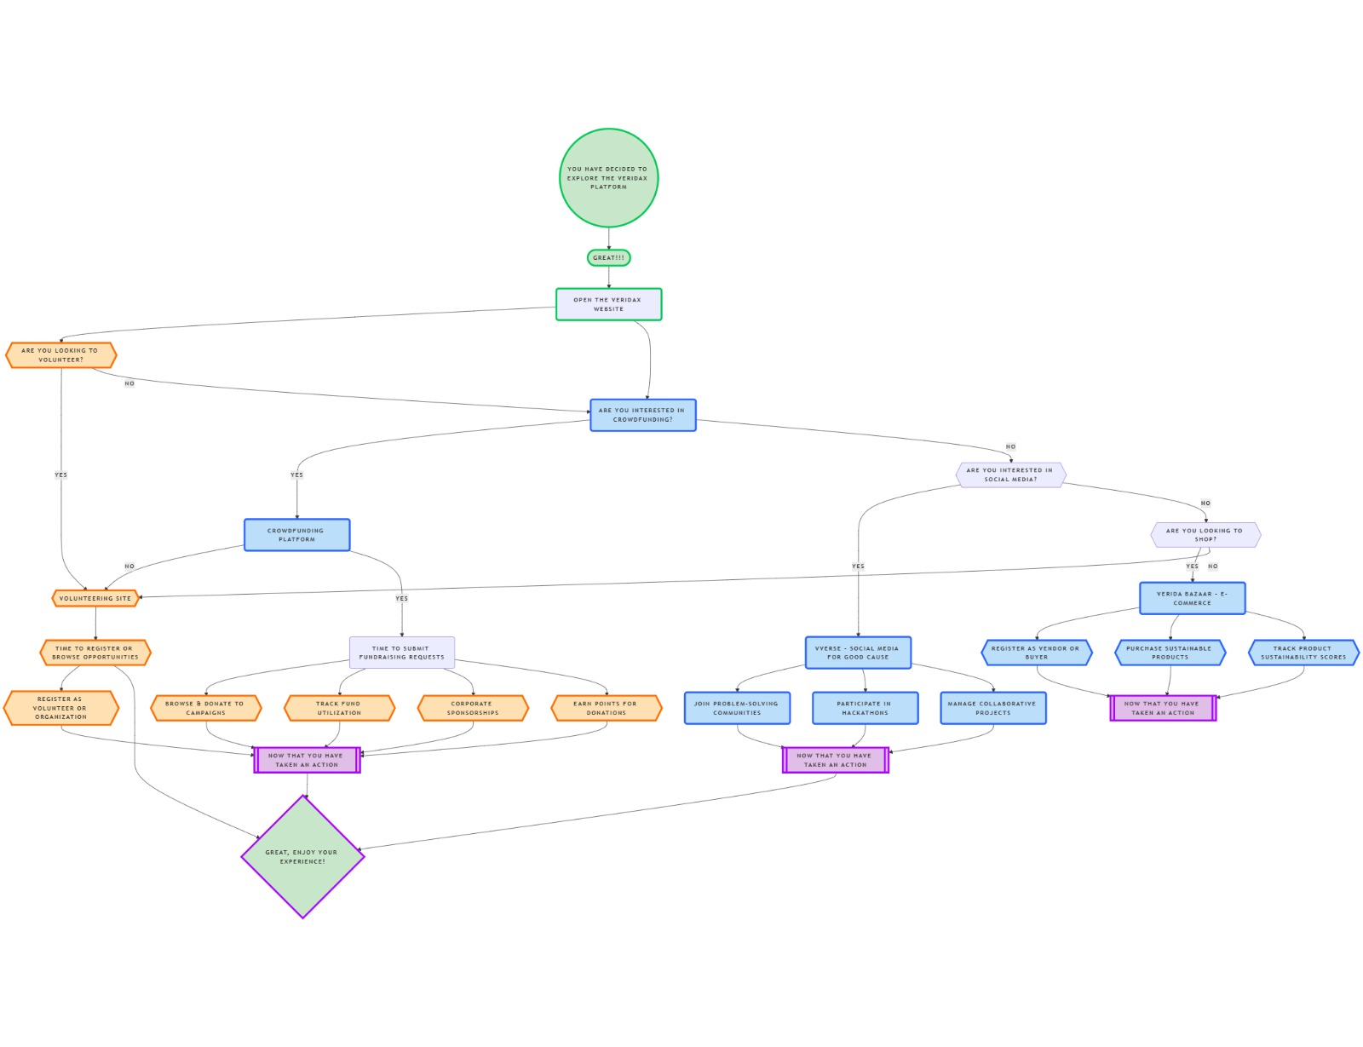

1. **Sequence**

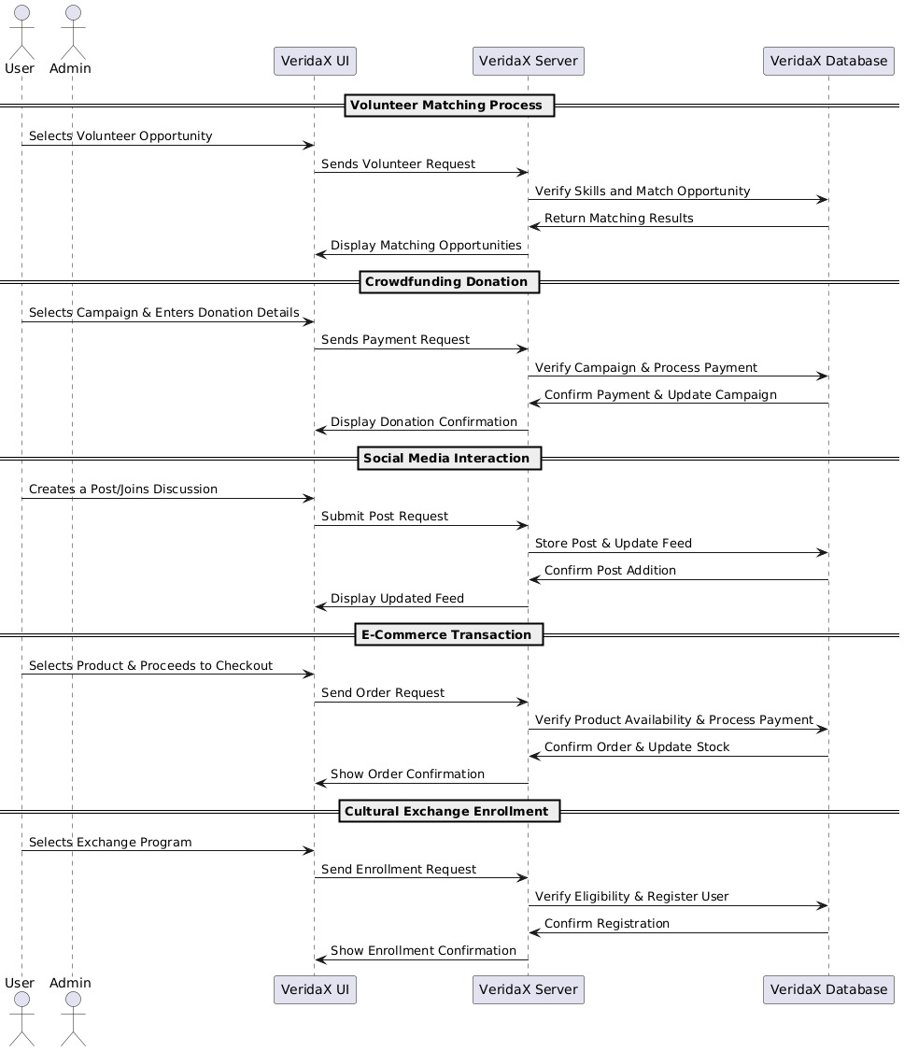

1. **Activity**

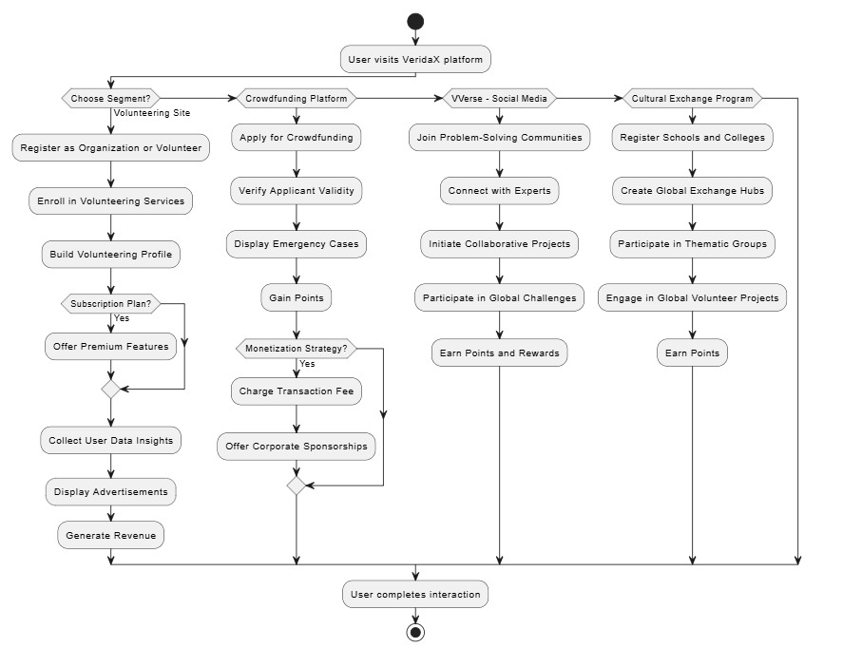

**Timeline**

