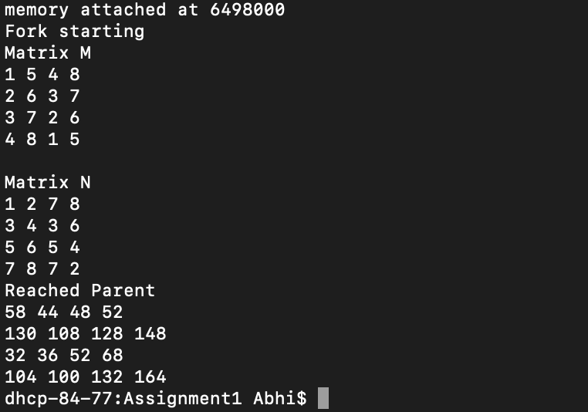

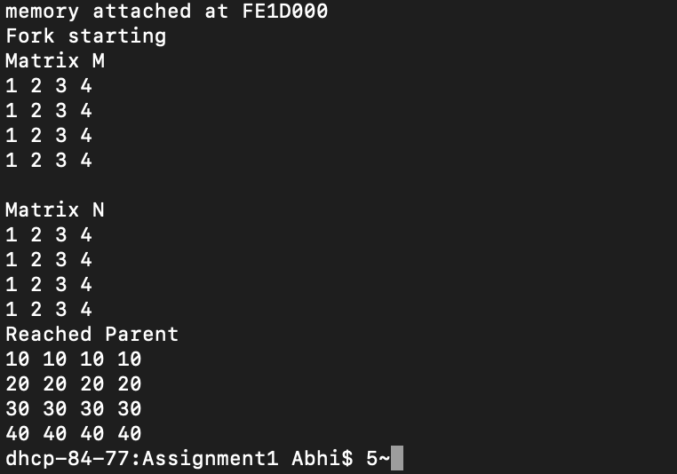

Using the test cases given (in the first screenshot), the multiplication of matrices M and N result in the matrix Q displayed in the first screenshot. Using my own test case, presented in the screenshot above, the multiplication of matrices M and N result in the matrix Q displayed in the second screenshot. These results are achieved by forking the main program a variable amount of times. Each child of the parent process computes one row of the matrix, concurrently. The parent program waits, by using a flag, for the children to finish computing. The result is then displayed.