**FLOW CHARTS**

1. **Main Function Flow Chart**

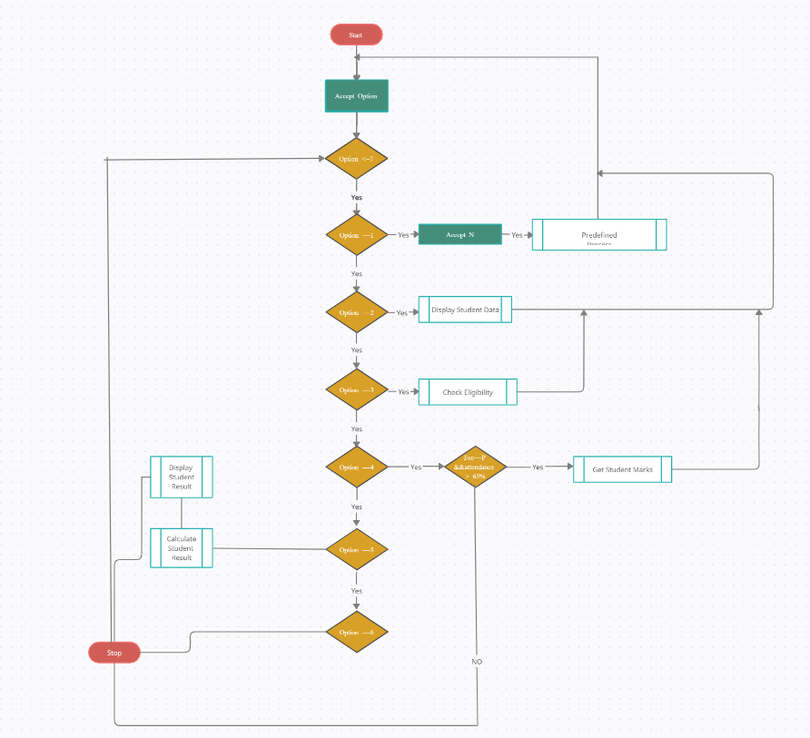

1. **Get Student Data Function Flow Chart**

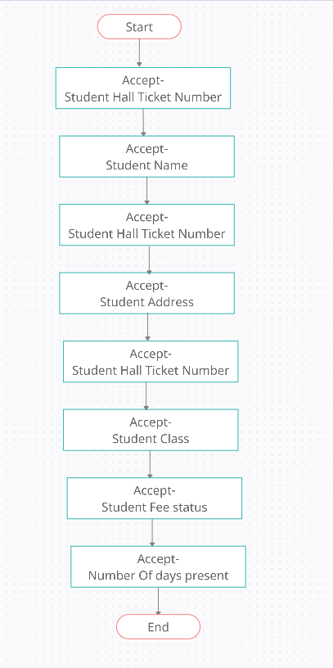

1. **Display Student Data Flow Chart**

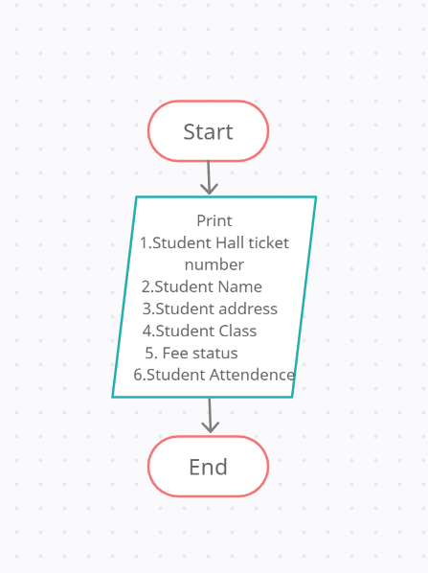

1. **Check Eligibility Function Flow Chart**

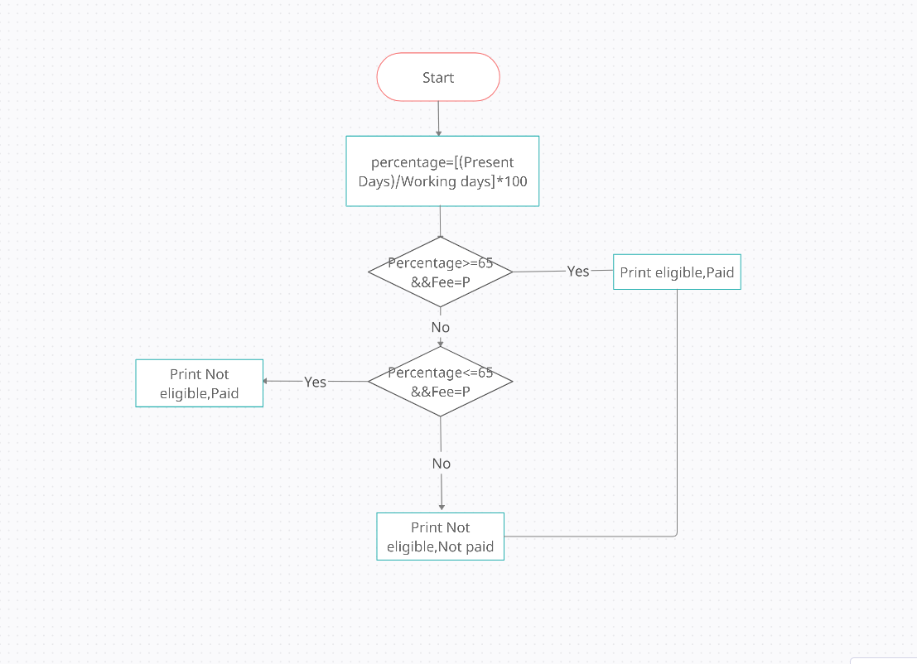

1. **Get Student Result Function Flow Chart**

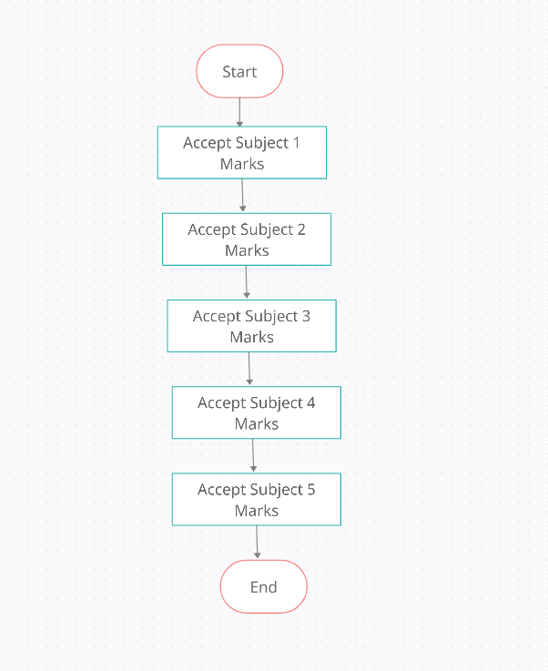

1. **Calculate Student Result Flow Chart**

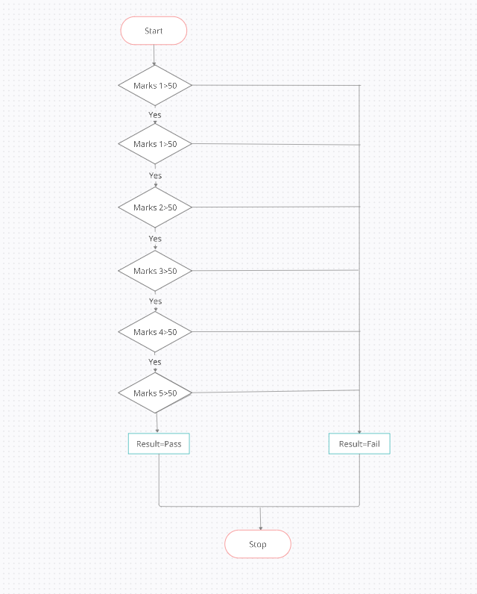

1. **Display Student Result Flow Chart**

