
Department of Electronics & Communication Engineering
KONERU LAKSHMAIAH EDUCATION FOUNDATION
(K L Deemed to be University)
Green Fields, Vaddeswaram, Andhra Pradesh - 522302, India
DEPARTMENT OF ELECTRONICS AND COMMUNICATION ENGINEERING
A MINI-PROJECT REPORT ON
INTERRUPT CONTROLLER WITH PRIORITY AND MASKING
Submitted in partial fulfilment of the requirements for the award of the degree of
BACHELOR OF TECHNOLOGY
in
ELECTRONICS AND COMMUNICATION ENGINEERING
Submitted by
M Abhiram Manikanta Reddy | – 2400040026
B Lokesh | – 2400040120
N Shashi Kiran Reddy | – 2400040132
A Charan Teja Reddy | – 2400040133

Team: T028
Academic Year: 2024 – 2028

CERTIFICATE
This is to certify that the mini-project report entitled "Interrupt Controller with Priority and Masking" is a bonafide record of the work carried out by M Abhiram Manikanta Reddy, B Lokesh, N Shashi Kiran Reddy and A Charan Teja Reddy in partial fulfilment of the requirements for the award of the degree of Bachelor of Technology in Electronics and Communication Engineering at Koneru Lakshmaiah Education Foundation during the academic year 2024–2028.
The work embodied in this report has not been submitted to any other university or institution for the award of any degree or diploma.
Dr. S Vamsee Krishna
Project Guide, Dept. of ECE
Dr. Govardhini I
Head of the Department, Dept. of ECE
Date: 11/10/2026
Place: K L University

ACKNOWLEDGEMENT
We express our sincere gratitude to our project guide, Dr. S Vamsee Krishna, Department of Electronics and Communication Engineering, for the valuable guidance, encouragement and constructive feedback provided throughout this mini-project. The discussions with the guide helped us understand arbitration, priority selection and RTL verification.
We are thankful to the Head of the Department and all faculty members for providing the laboratory facilities, software tools and academic support required to complete this project.
We also acknowledge the cooperation and teamwork of all team members in system design, System Verilog coding, simulation, verification and documentation. Finally, we thank our families and friends for their continuous support and motivation.
M Abhiram Manikanta Reddy
B Lokesh
N Shashi Kiran Reddy
A Charan Teja Reddy
ABSTRACT
An interrupt controller is an essential component of a processor-based system that manages interrupt requests from multiple peripheral devices and ensures that they are serviced according to their priority. This project focuses on the design and implementation of a 16-source Interrupt Controller with Priority and Masking using Verilog HDL. The controller collects interrupt requests from 16 independent sources, selects the highest-priority eligible request, and generates the corresponding interrupt output for the processor.
The proposed design incorporates priority-based interrupt selection and interrupt masking, allowing individual interrupt sources to be enabled or disabled as required. It also aims to support nested priority handling, enabling higher-priority interrupts to be serviced while a lower-priority interrupt is being processed. Special attention is given to interrupt acknowledgment, simultaneous requests, and the handling of level-triggered and edge-triggered interrupts to ensure reliable operation.
The design is described at the Register Transfer Level (RTL) using Verilog HDL and verified through simulation with a testbench. The verification process covers interrupt request generation, priority selection, masking functionality, nested interrupt handling, acknowledgment behavior, and edge-triggered and level-triggered interrupt conditions. Simulation waveforms are used to examine the controller's functionality and identify potential design issues.
The proposed interrupt controller can be used in embedded systems, System-on-Chip (SoC) architectures, and processor-based digital systems that require efficient and reliable management of multiple interrupt sources.
Keywords: Interrupt Controller, Priority Arbitration, Interrupt Masking, Nested Interrupts, Verilog HDL, RTL Design, Interrupt Acknowledgment, Edge-Triggered Interrupts, Level-Triggered Interrupts.

TABLE OF CONTENTS
- Introduction
- Problem Statement
- Aim and Objectives
- Literature Survey
- System Requirements
- System Architecture
- Design Methodology
- RTL Design
- Working Principle
- Verilog Implementation
- Simulation and Verification
- Simulation Results and Analysis
- Challenges and Bottlenecks
- Applications, Advantages and Future Scope
- Conclusion
References

1. INTRODUCTION
An interrupt controller is a digital hardware component that manages interrupt requests from multiple peripheral devices and determines which interrupt should be serviced by the processor. This project focuses on designing an interrupt controller that supports 16 interrupt sources with priority selection and masking.
The controller uses priority logic to select the most important active interrupt and masking to enable or disable individual interrupt sources. It also supports nested priority handling, allowing higher-priority interrupts to be serviced before lower-priority ones. Proper interrupt acknowledgement and consistent edge- and level-triggered handling are essential to prevent missed or repeated interrupts.
The proposed design aims to improve interrupt management and provide reliable communication between the processor and peripheral devices.

2. PROBLEM STATEMENT
In digital systems, multiple peripheral devices may generate interrupt requests simultaneously, requiring an efficient mechanism to determine which request should be serviced first. Without proper priority selection and masking, important interrupts may be delayed, and unnecessary interrupts may affect processor performance.
The objective of this project is to design an interrupt controller that manages 16 interrupt sources using priority selection and interrupt masking. The design must handle interrupt acknowledgement correctly, support nested priority handling, and ensure consistent operation of edge-triggered and level-triggered interrupts while preventing missed or repeated requests.

3. AIM AND OBJECTIVES
3.1 Aim
To design and implement a 16-source interrupt controller with priority selection, interrupt masking, and nested interrupt handling for efficient and reliable processor interrupt management.
3.2 Objectives
- To manage 16 independent interrupt sources.
- To select interrupts based on priority.
- To implement masking to enable or disable individual interrupt sources.
- To support nested priority handling.
- To handle interrupt acknowledgement without losing pending requests.
- To ensure consistent edge-triggered and level-triggered interrupt operation.
- To verify the design through RTL simulation and functional testing.

4. LITERATURE SURVEY
Existing interrupt controllers use priority-based selection to handle important interrupt requests first. Interrupt masking allows individual sources to be enabled or disabled, while nested interrupt handling supports the servicing of higher-priority interrupts before lower-priority ones. Proper acknowledgement and trigger handling help prevent missed or repeated interrupts. These concepts form the foundation of the proposed 16-source interrupt controller.

5. SYSTEM REQUIREMENTS
5.1 Hardware Requirements
- Computer or laptop for design, simulation, and synthesis.
5.2 Software Requirements
- Cadence: For RTL simulation and verification.
- Xilinx Vivado: For RTL design, simulation, and synthesis.
- Verilog/SystemVerilog: For hardware description and implementation.
- Waveform viewer: For analyzing interrupt requests, priorities, and responses.
5.3 Functional Requirements
- Support 16 interrupt sources.
- Implement priority selection and interrupt masking.
- Support nested interrupt handling.
- Handle interrupt acknowledgement correctly.
- Support edge-triggered and level-triggered interrupts.

6. SYSTEM ARCHITECTURE
The proposed interrupt controller consists of 16 interrupt inputs, a priority selection unit, an interrupt mask register, pending interrupt logic, and a processor interface. The priority selection unit identifies the highest-priority eligible interrupt, while the mask register enables or disables individual interrupt sources. The pending logic tracks interrupt requests, and the acknowledgement mechanism coordinates interrupt servicing with the processor. The architecture also supports nested priority handling and edge-triggered or level-triggered interrupts.
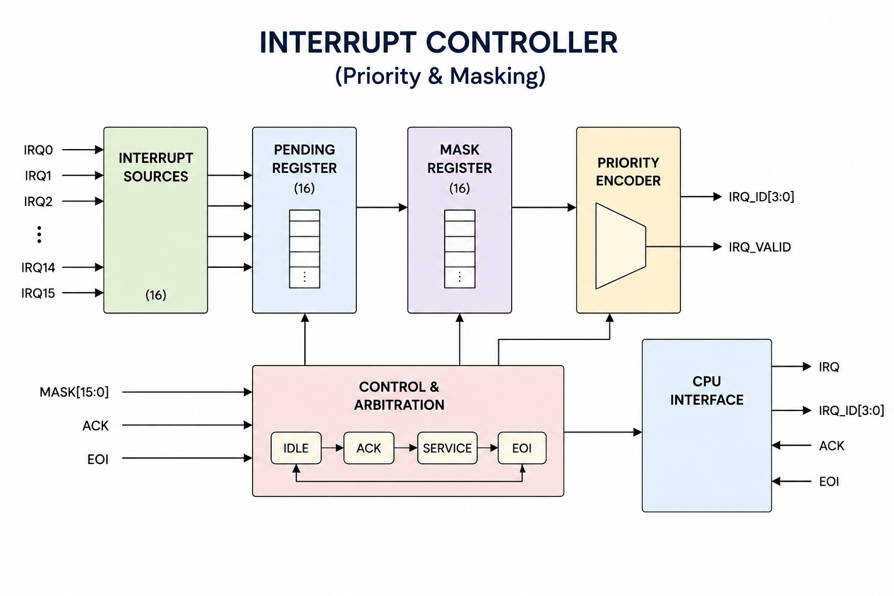
Fig. 1. System Architecture of the Interrupt Controller with Priority and Masking
Main functional blocks:
- Interrupt Inputs: Receive requests from 16 sources.
- Mask Register: Enables or disables individual interrupts.
- Priority Encoder: Selects the highest-priority eligible request.
- Pending Register: Tracks requests awaiting service.
- Acknowledgement Logic: Handles processor acknowledgement.
- Processor Interface: Provides the interrupt signal and interrupt identification.

7. DESIGN METHODOLOGY
7.1 Interrupt Request Handling
The controller receives interrupt requests from 16 independent sources. The pending register stores requests that require processor attention.

7.2 Priority Selection
The priority encoder selects the highest-priority eligible interrupt and generates its 4-bit interrupt ID along with a valid signal.
7.3 Interrupt Masking
The 16-bit mask register enables or disables individual interrupt sources. Only unmasked requests are considered for priority selection.
7.4 Nested Interrupt Handling
The controller supports higher-priority interrupts preempting lower-priority interrupts during servicing, based on the active priority and system configuration.
7.5 Interrupt Acknowledgment
The acknowledgement (ACK) signal indicates that the processor has accepted an interrupt. The end-of-interrupt (EOI) signal indicates completion of interrupt servicing.
7.6 Edge-Triggered and Level-Triggered Interrupts
Edge-triggered interrupts are detected from signal transitions, while level-triggered interrupts remain active as long as the specified logic level persists. Both require appropriate handling to avoid missed or repeated requests.
7.7 Design Flow
The design flow consists of RTL coding, functional simulation, waveform analysis, and synthesis using Cadence and Xilinx Vivado. The results are checked to verify correct priority selection, masking, acknowledgement, and interrupt handling.

8. RTL DESIGN
8.1 Interrupt Request Logic
The interrupt request logic receives signals from 16 interrupt sources and records pending requests. These requests are passed to the masking and priority selection stages for processing.
8.2 Priority Encoder
The priority encoder examines eligible interrupt requests and selects the highest-priority source. It generates a 4-bit interrupt ID and a valid signal to indicate a selected interrupt.

8.3 Interrupt Masking Logic
The masking logic uses a 16-bit mask register to enable or disable individual interrupt sources. Masked requests are excluded from priority selection.
8.4 Nested Priority Control
The nested priority control tracks the currently serviced interrupt and allows a higher-priority request to preempt a lower-priority interrupt when permitted.
8.5 Interrupt Acknowledgment Logic
The acknowledgement logic processes the CPU's ACK signal and the EOI signal to coordinate interrupt servicing. It must handle new requests arriving during acknowledgement without losing pending interrupts or generating unintended repeated requests.

9. WORKING PRINCIPLE
- The controller receives interrupt requests from 16 sources.
- The pending register records requests that require servicing.
- The mask register enables or disables individual interrupt sources.
- The priority encoder selects the highest-priority eligible interrupt and generates its interrupt ID.
- The CPU receives the interrupt signal and acknowledges the request using ACK.
- The controller manages nested interrupts according to their priority levels.
- After servicing is completed, the CPU sends an EOI signal, allowing the controller to update its service state and handle subsequent requests.

10. VERILOG IMPLEMENTATION
10.1 Verilog RTL Implementation
The interrupt controller is implemented using Verilog/SystemVerilog RTL. The design consists of interrupt request handling, a priority encoder, masking logic, nested priority control, and acknowledgement logic. These modules work together to manage 16 interrupt sources and provide the selected interrupt information to the processor. The design is simulated using Cadence and Xilinx Vivado to verify its functionality.
`timescale 1ns / 1ps

// ============================================================
// Interrupt Controller with Priority, Masking and Nesting
// 16 interrupt sources; IRQ0 has the highest priority.
// Verilog-2001 compatible RTL.
// ============================================================
module interrupt_controller #(
parameter IRQ_COUNT = 16,
parameter STACK_DEPTH = 4,
parameter IRQ_WIDTH = 4
) (
input wire clk,
input wire reset,

input wire [IRQ_COUNT-1:0] irq,
input wire [IRQ_COUNT-1:0] mask,
// trigger_type[i] = 0: level-triggered
// trigger_type[i] = 1: rising-edge-triggered
input wire [IRQ_COUNT-1:0] trigger_type,

input wire cpu_ack,
input wire cpu_eoi,

output wire cpu_irq,
output wire [IRQ_WIDTH-1:0] irq_id,
output wire active,
output wire stack_full,
output wire stack_empty
);

localparam PTR_WIDTH = (STACK_DEPTH < 2) ? 1 : $clog2(STACK_DEPTH + 1);

reg [IRQ_COUNT-1:0] irq_previous;
reg [IRQ_COUNT-1:0] pending;

reg [IRQ_WIDTH-1:0] active_irq_id;
reg active_valid;

reg [IRQ_WIDTH-1:0] irq_stack [0:STACK_DEPTH-1];
reg [PTR_WIDTH-1:0] stack_pointer;

wire [IRQ_COUNT-1:0] irq_request;
wire [IRQ_COUNT-1:0] enabled;

reg candidate_valid;
reg [IRQ_WIDTH-1:0] candidate_id;

wire accept_irq;
wire finish_irq;
wire [IRQ_COUNT-1:0] clear_vector;

integer i;
integer j;

// --------------------------------------------------------
// Trigger detection:
// - Level request follows the input level.
// - Edge request is asserted for one clock after a rising
// transition, independently for each interrupt input.
// --------------------------------------------------------
assign irq_request =
(irq & ~trigger_type) |
(irq & ~irq_previous & trigger_type);

always @(posedge clk or posedge reset) begin
if (reset)
irq_previous <= {IRQ_COUNT{1'b0}};
else
irq_previous <= irq;
end

// --------------------------------------------------------
// Masking and fixed-priority encoder.
// IRQ0 is checked first and therefore has highest priority.
// --------------------------------------------------------
assign enabled = pending & ~mask;

always @(*) begin
candidate_valid = 1'b0;
candidate_id = {IRQ_WIDTH{1'b0}};

for (i = IRQ_COUNT-1; i >= 0; i = i-1) begin
if (enabled[i]) begin
candidate_valid = 1'b1;
candidate_id = i;
end
end
end

// A new interrupt may be offered if no interrupt is active,
// or if it has higher priority (smaller ID) than the active one.
assign cpu_irq = candidate_valid &&
(!active_valid ||
((candidate_id < active_irq_id) && !stack_full));

// irq_id presents the currently offered interrupt; otherwise
// it presents the active interrupt ID, or zero when idle.
assign irq_id = cpu_irq ? candidate_id :
(active_valid ? active_irq_id : {IRQ_WIDTH{1'b0}});

assign active = active_valid;
assign stack_empty = (stack_pointer == 0);
assign stack_full = (stack_pointer == STACK_DEPTH);

assign accept_irq = cpu_irq && cpu_ack;
assign finish_irq = active_valid && cpu_eoi;

// Clear the selected pending bit on acknowledgement.
// New requests take precedence in the pending update below,
// so a simultaneous request is not lost.
assign clear_vector = accept_irq
? ({{(IRQ_COUNT-1){1'b0}}, 1'b1} << candidate_id)
: {IRQ_COUNT{1'b0}};

// --------------------------------------------------------
// Pending bits:
// pending_next = (pending & ~clear) | new_request
// Request wins over clear if both happen in the same cycle.
// --------------------------------------------------------
always @(posedge clk or posedge reset) begin
if (reset)
pending <= {IRQ_COUNT{1'b0}};
else
pending <= (pending & ~clear_vector) | irq_request;
end

// --------------------------------------------------------
// Active interrupt and nesting stack.
//
// On acknowledgement of a higher-priority interrupt, save
// the previous active interrupt and activate the new one.
// On EOI, restore the most recently saved interrupt; if the
// stack is empty, return to the idle/no-active state.
//
// If ACK and EOI occur together, ACK is given priority.
// Stack overflow prevents accepting a nested interrupt.
// --------------------------------------------------------
always @(posedge clk or posedge reset) begin
if (reset) begin
active_irq_id <= {IRQ_WIDTH{1'b0}};
active_valid <= 1'b0;
stack_pointer <= {PTR_WIDTH{1'b0}};

for (j = 0; j < STACK_DEPTH; j = j + 1)
irq_stack[j] <= {IRQ_WIDTH{1'b0}};
end
else begin
if (accept_irq) begin
// Nested acceptance: preserve the currently active IRQ.
if (active_valid) begin
if (candidate_id < active_irq_id &&
stack_pointer < STACK_DEPTH) begin
irq_stack[stack_pointer] <= active_irq_id;
stack_pointer <= stack_pointer + 1'b1;
active_irq_id <= candidate_id;
end
// If stack is full, do not replace the active IRQ.
// The pending request remains available for later.
end
else begin
active_irq_id <= candidate_id;
active_valid <= 1'b1;
end
end
else if (finish_irq) begin
if (stack_pointer != 0) begin
active_irq_id <= irq_stack[stack_pointer - 1'b1];
stack_pointer <= stack_pointer - 1'b1;
active_valid <= 1'b1;
end
else begin
active_irq_id <= {IRQ_WIDTH{1'b0}};
active_valid <= 1'b0;
end
end
end
end

endmodule

10.2 Important Design Considerations
- Priority Selection: Select the highest-priority eligible interrupt.
- Interrupt Masking: Prevent disabled sources from being selected.
- Pending Requests: Ensure requests are not lost during interrupt servicing.
- Nested Handling: Allow higher-priority interrupts to preempt lower-priority interrupts when permitted.
- Acknowledgement: Handle ACK and EOI signals correctly.
- Verification: Test simultaneous requests, masking, priority selection, and interrupt handling through simulation.

11. Simulation and Verification
11.1 Testbench Architecture
A Verilog testbench is used to verify the 16-source interrupt controller. It generates interrupt requests, controls masking and acknowledgement signals, and observes the selected interrupt ID and valid output. The testbench is simulated using Cadence and Xilinx Vivado tools.
11.2 Verification Test Cases
The following test cases are considered:
- Single Interrupt: Verify correct selection when one source requests an interrupt.
- Multiple Interrupts: Check priority selection when multiple sources request interrupts simultaneously.
- Interrupt Masking: Verify that masked sources are excluded from selection.
- Nested Interrupts: Check whether a higher-priority interrupt can preempt a lower-priority interrupt.
- Acknowledgement: Verify correct handling of ACK and EOI signals.
- Pending Requests: Check that new requests arriving during interrupt servicing are not lost.
- Edge and Level Triggers: Verify correct handling of edge-triggered and level-triggered requests.

Waveform:

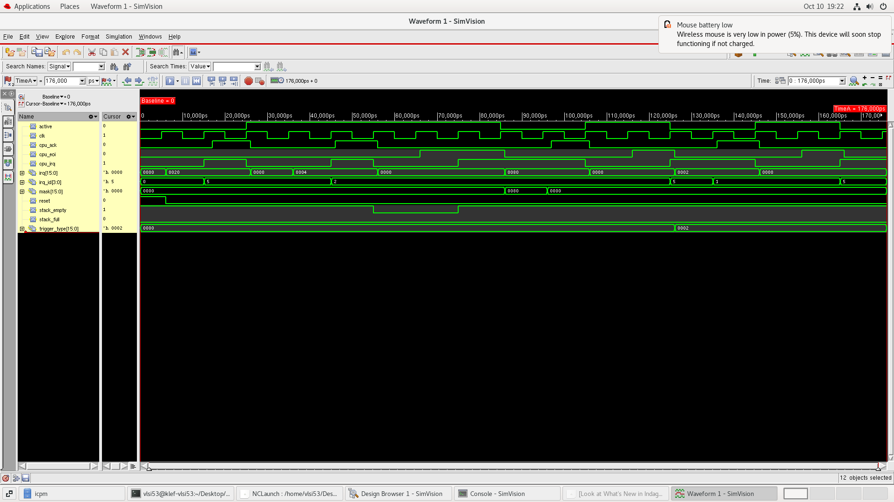
Fig. 2. RTL Simulation Waveforms of the Interrupt Controller in Cadence SimVision.
11.3 Verification Checks
The simulation waveforms are checked to confirm correct priority selection, interrupt masking, interrupt ID generation, pending-request handling, nested interrupt behavior, and acknowledgement operation. The results should demonstrate that the controller responds correctly to the test cases without losing or repeatedly servicing requests unintentionally.

12. Simulation Results and Analysis
The interrupt controller is simulated using Cadence and Xilinx Vivado. The simulation waveforms are analyzed to evaluate interrupt request handling, priority selection, masking, acknowledgement, and nested interrupt behavior.
The expected results are:
- Priority Selection: The highest-priority eligible interrupt is selected.
- Interrupt Masking: Masked interrupt sources are excluded from selection.
- Pending Requests: New requests are retained while another interrupt is being serviced.
- Acknowledgement: ACK and EOI signals coordinate interrupt servicing.
- Nested Interrupts: Higher-priority interrupts can preempt lower-priority interrupts when permitted.
- Trigger Handling: Edge-triggered and level-triggered requests are handled according to their respective behavior.
The simulation results should be confirmed using the actual waveforms and testbench outputs before reporting the design as successfully verified.
Sythesis:
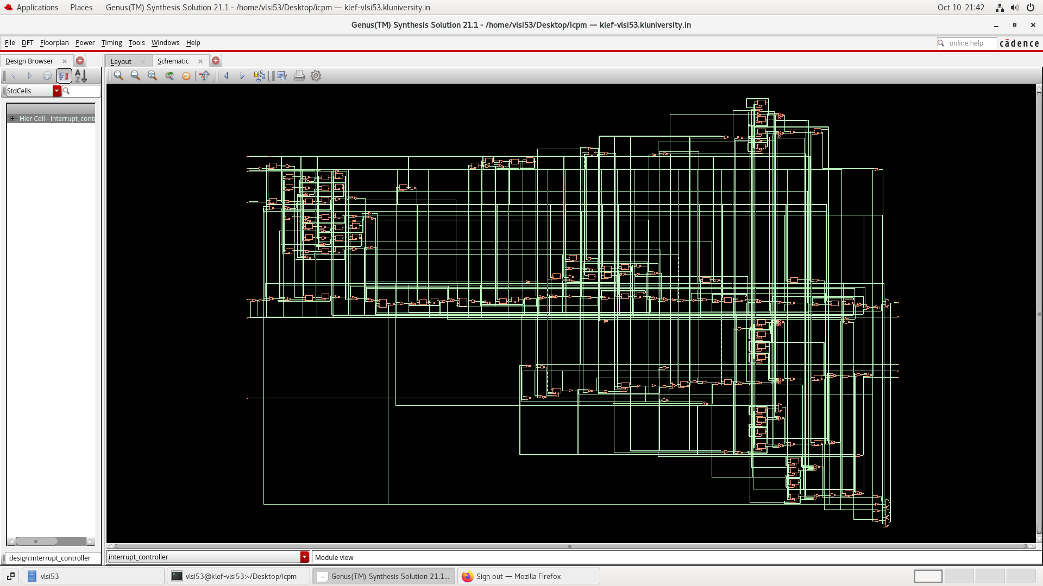
Fig. 3. Synthesized RTL Schematic of the Interrupt Controller Using Cadence Genus.

Layout:
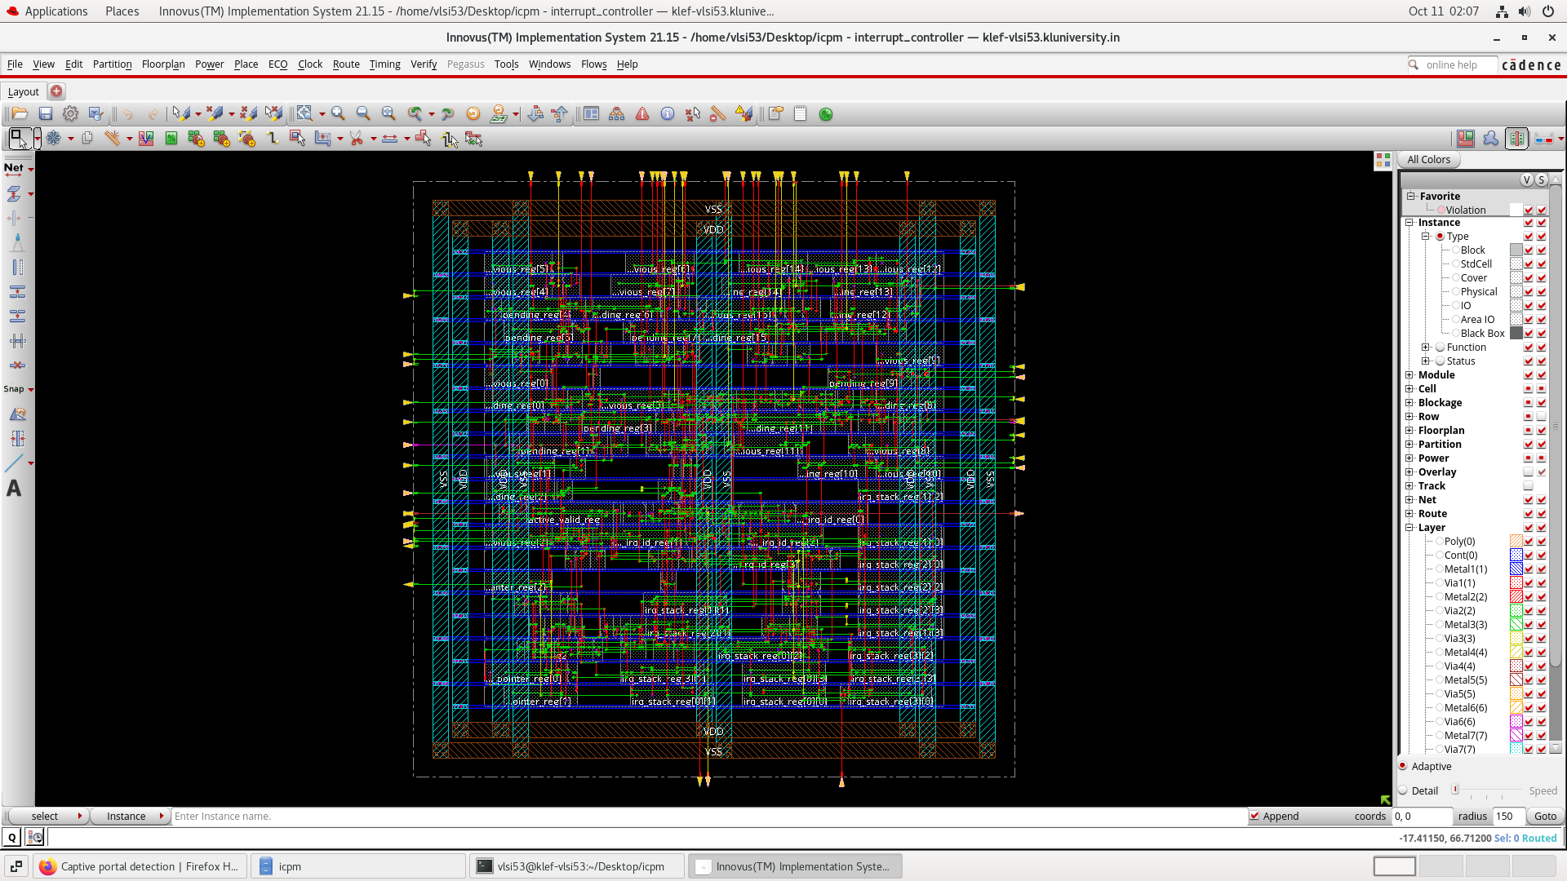

GDSII:
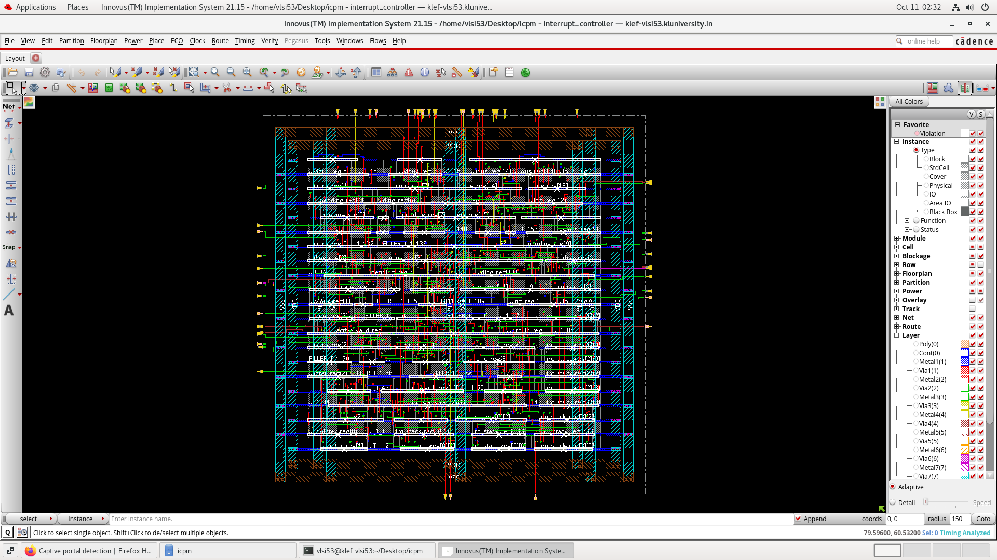

13. Challenges and Bottlenecks
The main challenges in designing the 16-source interrupt controller are:
- Priority Conflicts: Selecting the correct interrupt when multiple requests arrive simultaneously.
- Acknowledgement Races: Handling new interrupt requests that arrive during the ACK process without losing pending requests.
- Interrupt Masking: Ensuring masked sources do not interfere with priority selection.
- Nested Interrupt Handling: Managing higher-priority interrupts while a lower-priority interrupt is being serviced.
- Edge and Level Triggering: Handling both trigger types correctly to avoid missed or repeated interrupts.
- Verification Complexity: Testing simultaneous requests, masking, acknowledgement, and nested interrupt scenarios through simulation.
These challenges require careful RTL design and thorough testbench verification to ensure reliable interrupt handling.

14. Applications, Advantages and Future Scope
14.1 Applications
- Processor and microcontroller interrupt management.
- Embedded systems with multiple peripheral devices.
- Real-time systems requiring priority-based interrupt handling.
- System-on-Chip (SoC) designs with multiple interrupt sources.
14.2 Advantages
- Handles 16 independent interrupt sources.
- Provides priority-based interrupt selection.
- Supports interrupt masking for individual sources.
- Enables nested interrupt handling based on priority.
- Improves interrupt management and helps prevent lost requests when correctly implemented.
14.3 Future Scope
- Increase the number of supported interrupt sources.
- Implement programmable priority levels.
- Add configurable edge-triggered and level-triggered modes.
- Improve power and area efficiency through RTL optimization.
- Extend verification for complex interrupt and nested-servicing scenarios.

Screenshot:
Design Rule Check (DRC):
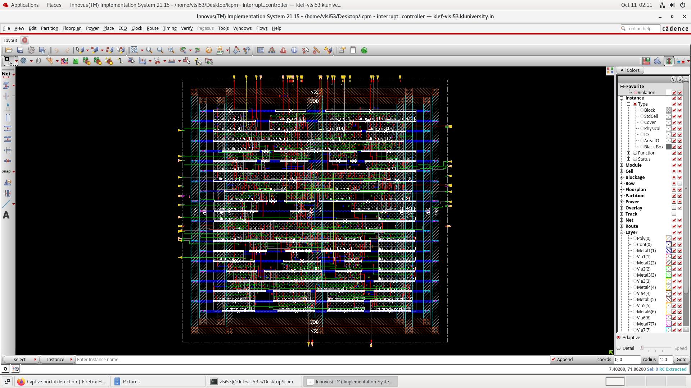

Power Analysis:
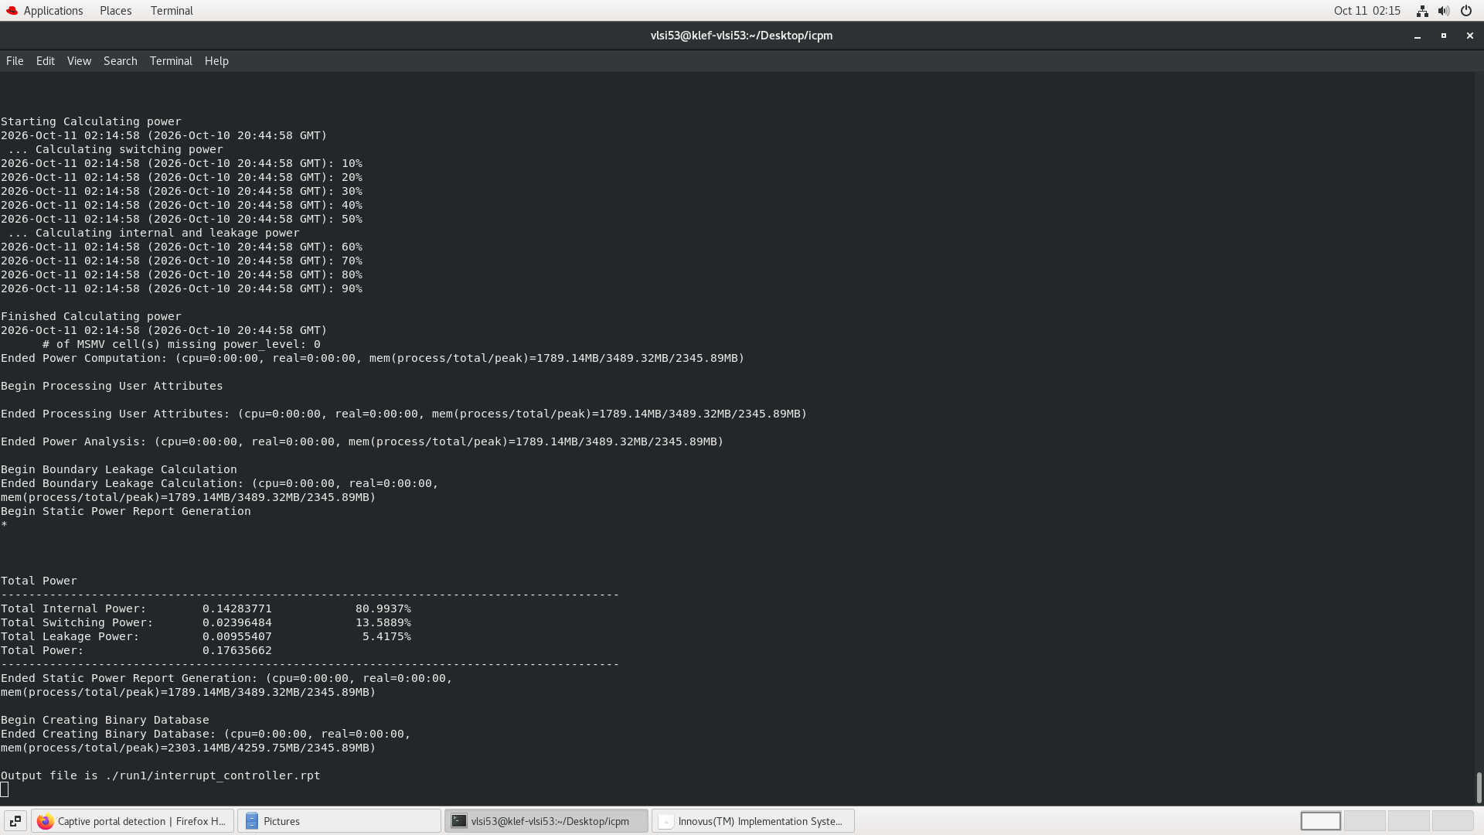
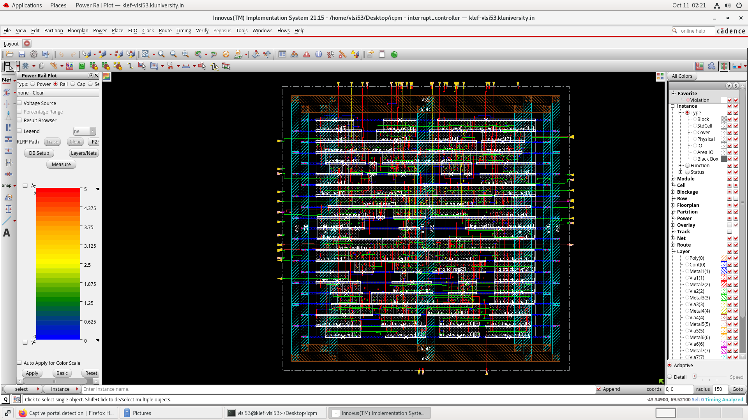

Filler:
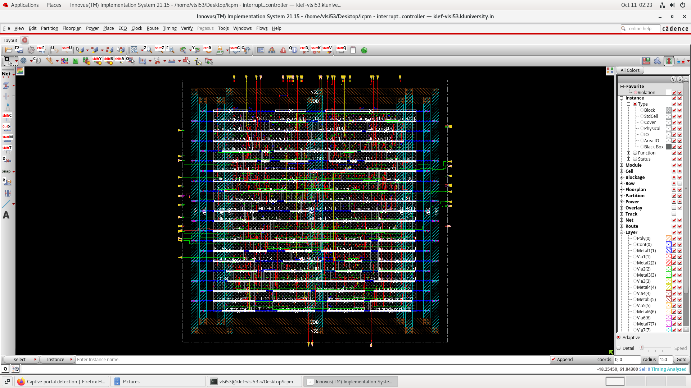

Verify Connectivity:
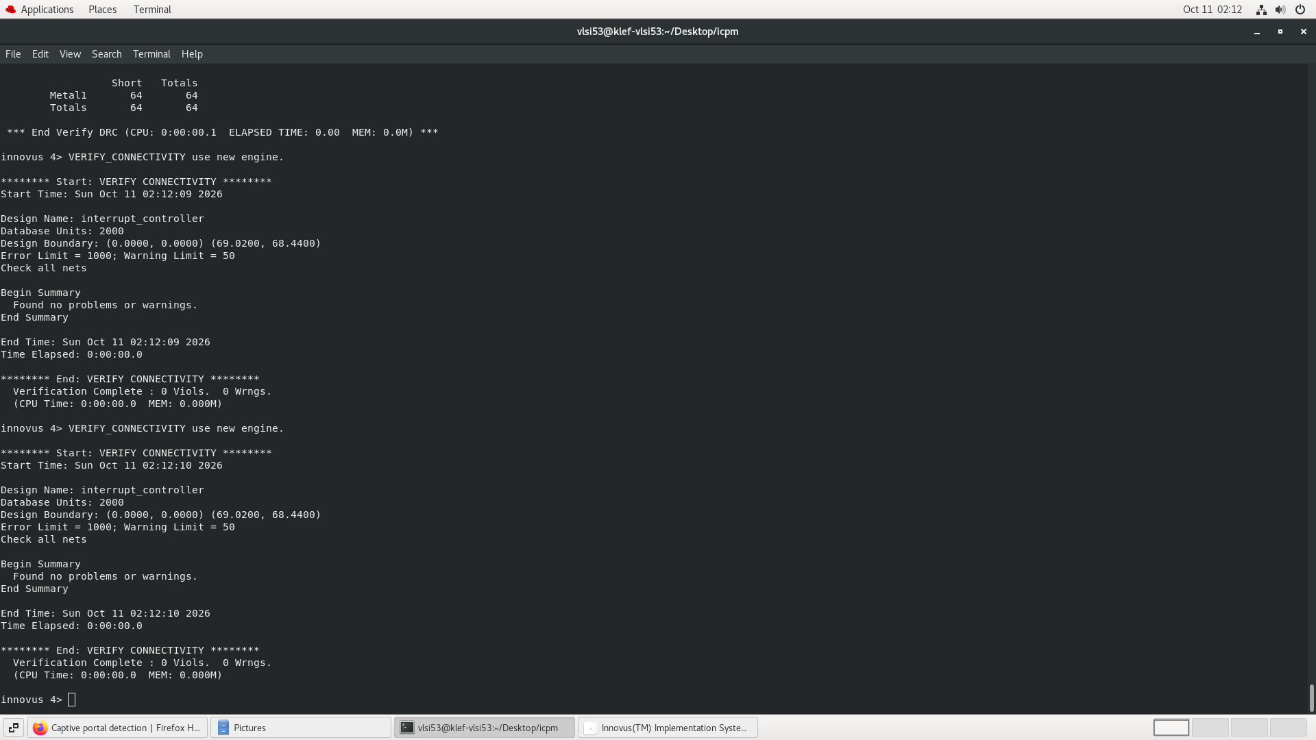

Verification:
Waveform:
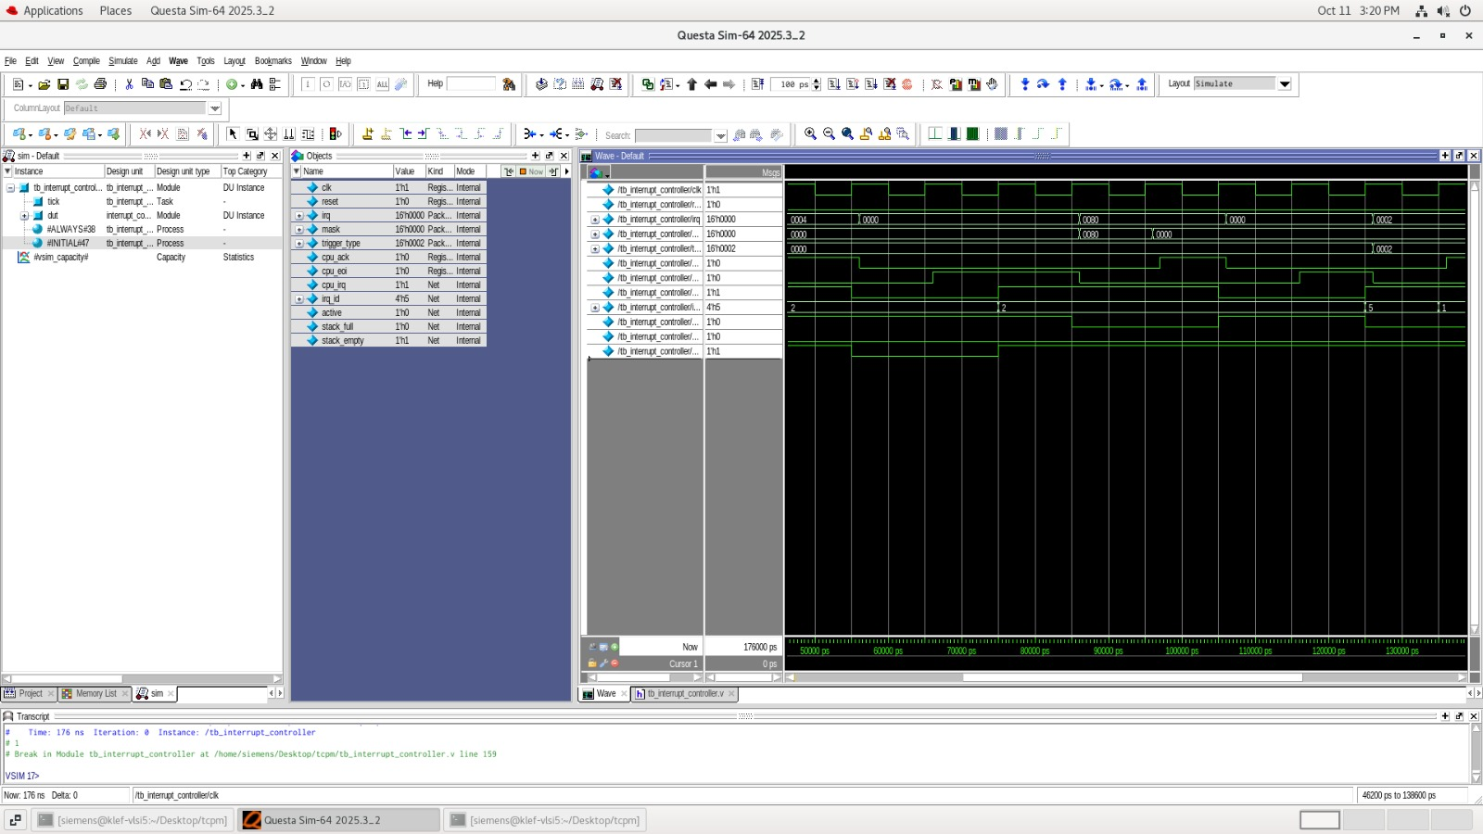
NetList:
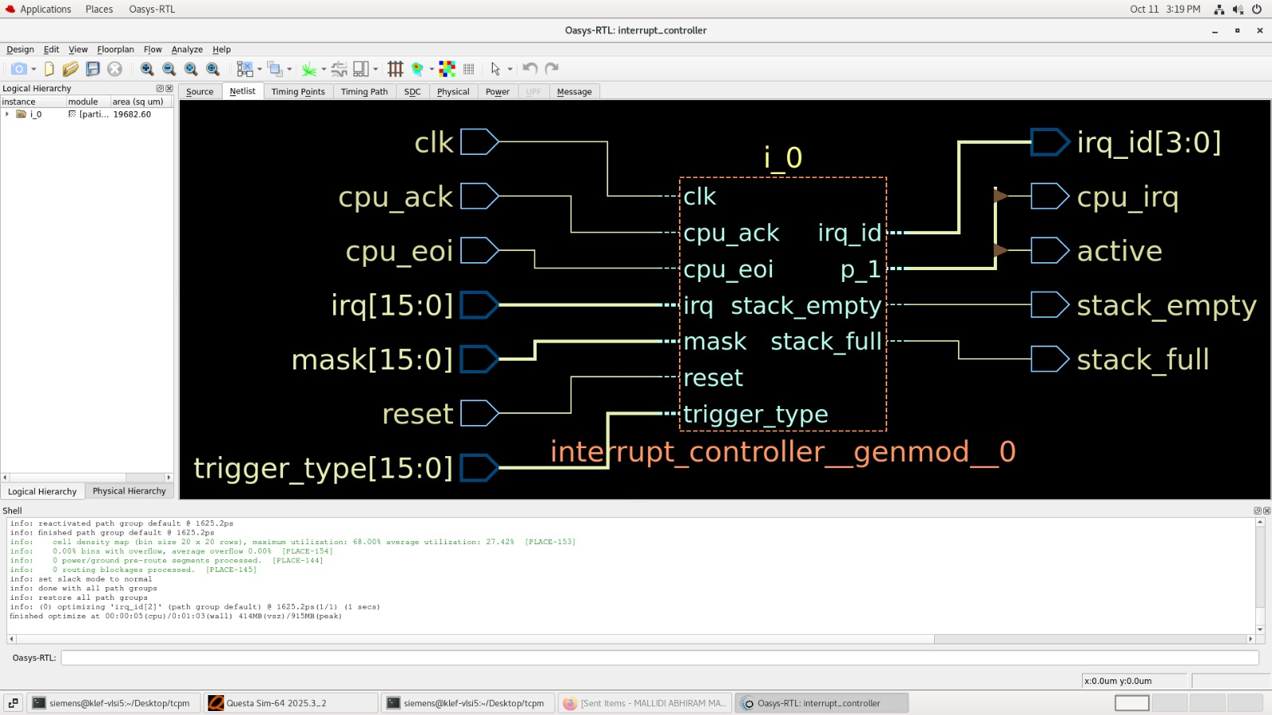

Timing Point:
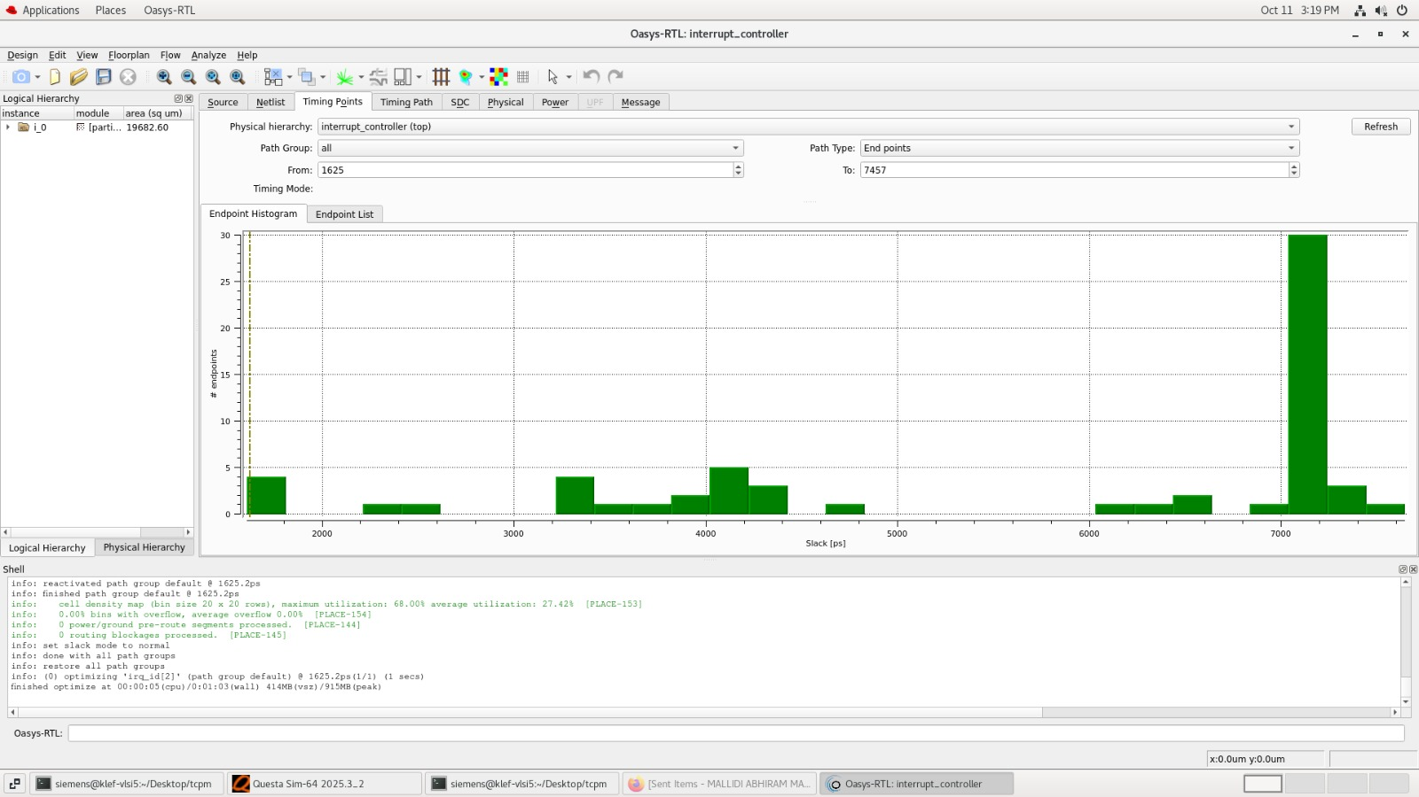
Timing Path:
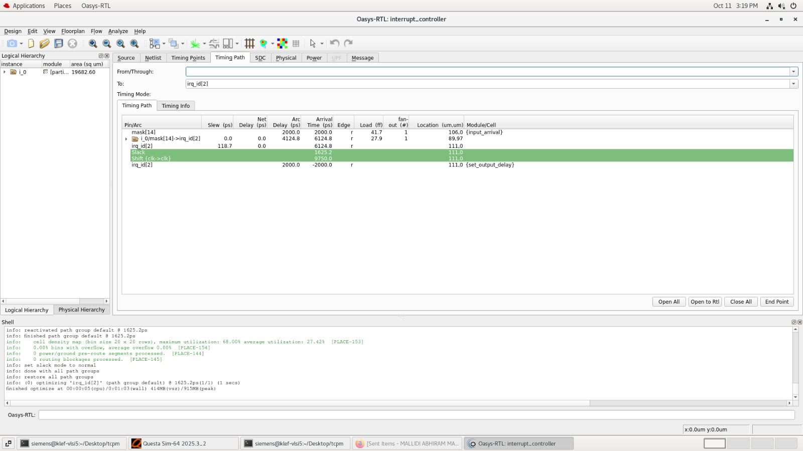

Physical Design:
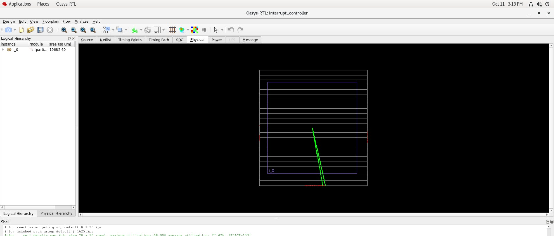
Power:
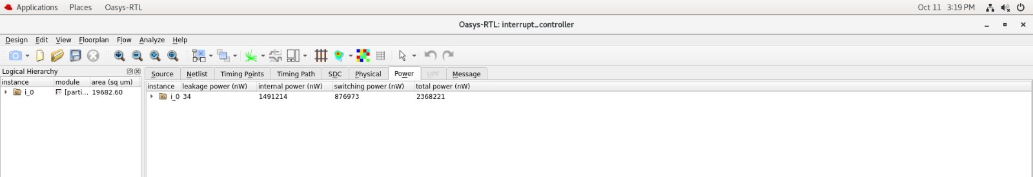

15. Conclusion
The project focuses on designing a 16-source interrupt controller with priority selection, interrupt masking, and nested interrupt handling. The design also addresses acknowledgement coordination, pending requests, and edge- and level-triggered interrupts. Cadence and Xilinx Vivado are used for design and simulation activities. Functional correctness is assessed through testbench scenarios and waveform analysis. The project provides a foundation for reliable interrupt management in processor-based and embedded systems.

