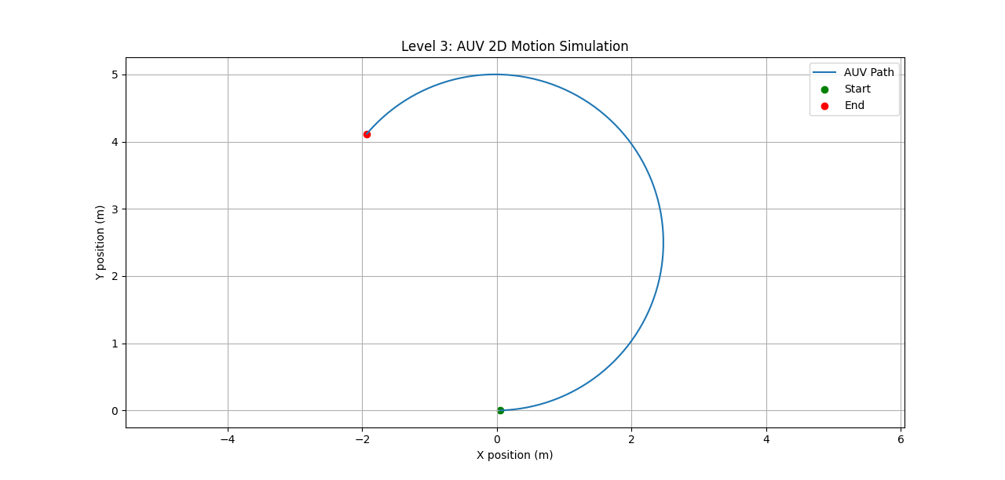
Level 3: 2D Circular / Arc Motion
Fish-inspired turning and cruising behavior
This motion represents smooth, continuous turning observed in many fast-swimming fish such as tuna, mackerel, and carp. During steady swimming, these fish execute banking turns by gradually adjusting the curvature of their bodies, allowing them to change heading while maintaining nearly constant speed.
From a biological perspective, the fish alters its body stiffness and curvature distribution to generate a constant turning radius without abrupt maneuvers. The resulting trajectory is a smooth arc with constant curvature.
In robotics, this behavior corresponds to constant yaw-rate motion, a fundamental locomotion primitive used in mobile robots and AUVs. It is commonly employed for trajectory generation, path smoothing, and low-level motion planning.
This model is highly realistic for representing steady, energy-efficient swimming and gentle turns.
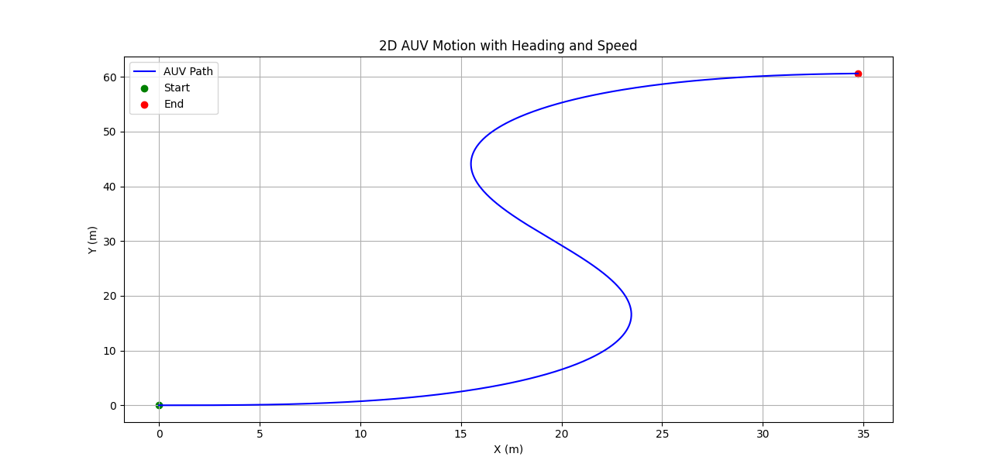
Level 3: 2D S-shaped Motion (Heading and Speed Variation)
Carangiform swimming pattern
This motion captures the characteristic S-shaped trajectory produced by carangiform swimmers such as salmon and trout. In this mode of swimming, thrust is generated primarily by lateral oscillations of the rear body and tail, while the head remains relatively stable.
Biologically, propulsion arises from a traveling sinusoidal wave that propagates from the fish’s body toward the tail. This wave motion produces alternating lateral forces, resulting in a sinusoidal or S-shaped path when projected onto the horizontal plane.
In robotic systems, this behavior is analogous to sinusoidal heading modulation and is widely used in bio-inspired propulsion models for robotic fish and underwater vehicles.
This representation is considered textbook fish swimming behavior and closely matches real biological locomotion.
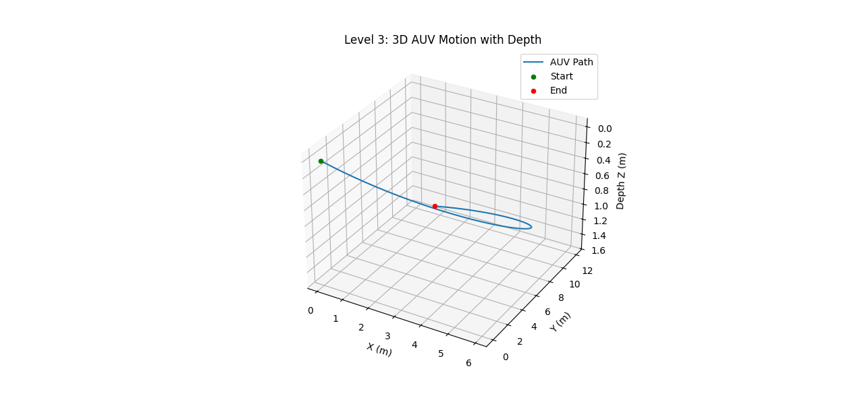
Level 3: 3D Motion with Depth Change
Diving and ascending glide motion
This motion models three-dimensional swimming with gradual depth variation, as seen in sharks, rays, and other large pelagic fish. These animals often change depth smoothly while minimizing energy expenditure.
From a biological standpoint, depth control is achieved through a combination of buoyancy regulation (e.g., swim bladder or body density) and fin angle adjustment, allowing fish to glide upward or downward with minimal active thrust.
In underwater robotics, this behavior corresponds to helical or 3D glide paths, commonly used in underwater gliders such as Slocum and Seaglider vehicles.
This model is highly representative of energy-efficient underwater motion used for long-duration missions.
Level 4: 3D Motion with Sensor Noise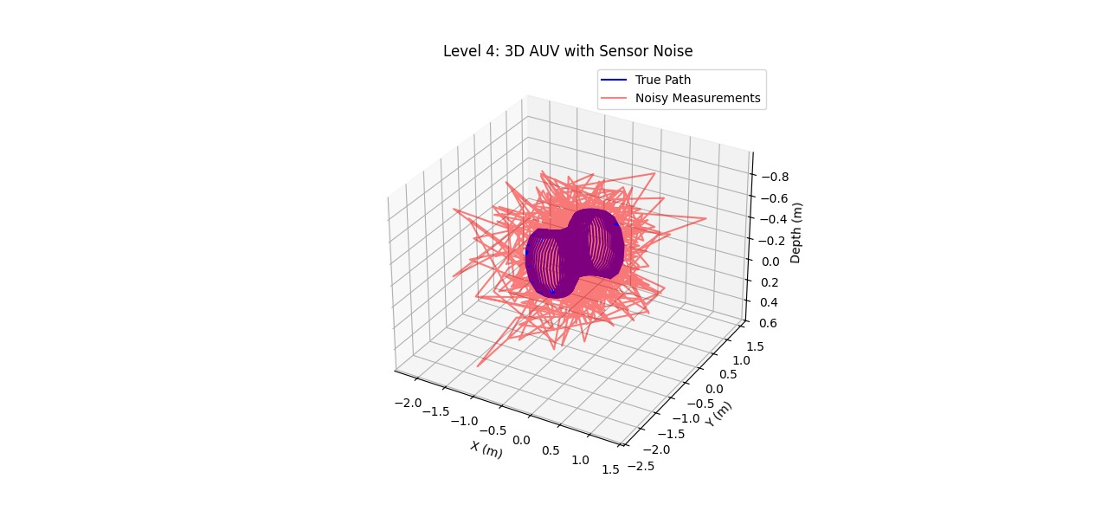
Perception-uncertain swimming
This motion incorporates random deviations caused by imperfect sensing, similar to how fish behave in environments with limited visibility, such as murky water or low-light conditions during night hunting.
Biologically, fish rely on noisy sensory inputs from vision and the lateral line system, which can introduce uncertainty in motion estimation. As a result, their trajectories exhibit small fluctuations and continuous corrections.
In robotics, this is modeled as sensor noise and stochastic motion, reflecting realistic uncertainties in underwater perception systems.
This behavior closely matches real underwater navigation conditions, where perfect state information is unavailable.
EKF State Estimation
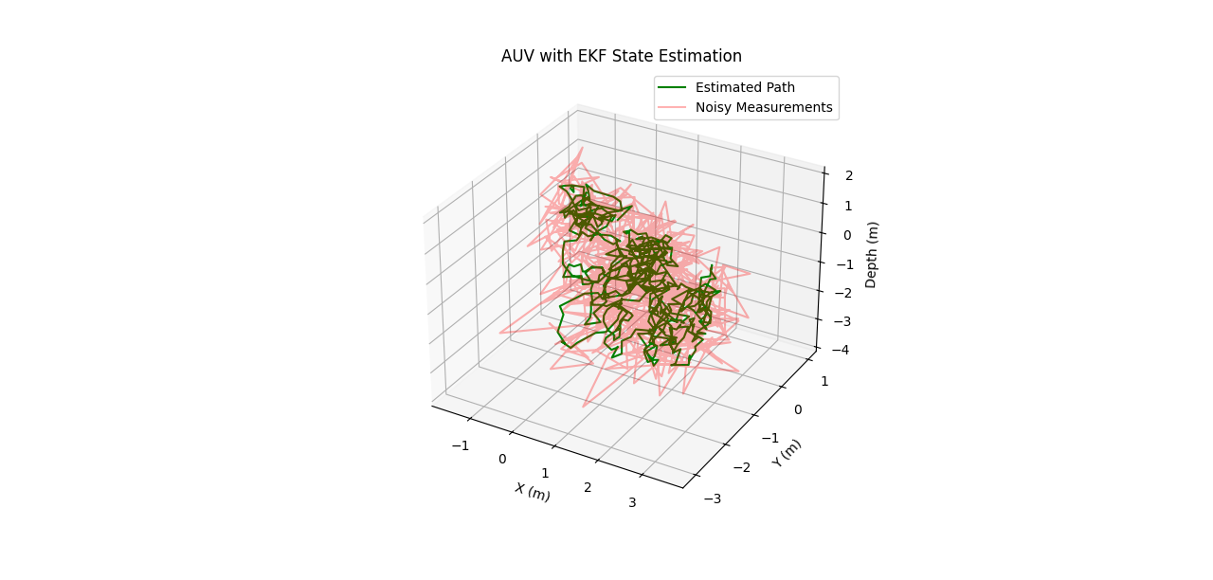

Neural filtering and sensory fusion
This component does not represent a physical swimming pattern but rather the internal processing performed by the fish’s nervous system. When tracking prey or navigating complex environments, fish continuously filter noisy sensory information to estimate their own motion and the motion of external objects.
Biologically, this resembles neural sensor fusion, where multiple imperfect sensory inputs are combined to form a stable internal estimate of state.
In robotics, this process is mathematically represented by the Extended Kalman Filter (EKF), which fuses noisy measurements with a motion model to produce improved state estimates.
This level represents fish brain logic rather than physical motion.
Level 6: Depth Control using PID
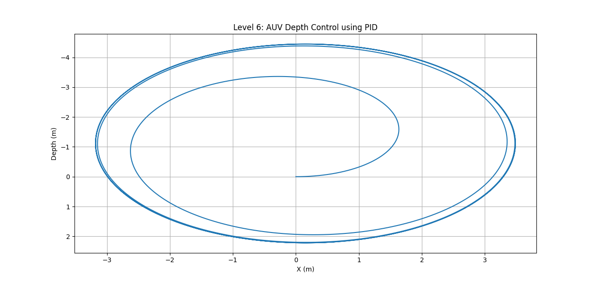

Buoyancy stabilization behavior
This motion models how fish maintain or adjust depth using feedback mechanisms. Many fish regulate depth through swim bladder inflation/deflation combined with fin movements, leading to transient oscillations before settling at a desired depth.
From a control perspective, this behavior closely resembles a feedback control loop, where pressure or depth sensing is used to correct deviations.
In underwater robotics, this is implemented using a PID controller for depth regulation. The characteristic overshoot and settling behavior observed in the trajectory closely matches biological depth stabilization.
This model is highly realistic for representing vertical control dynamics.
Level 7: Waypoint Navigation
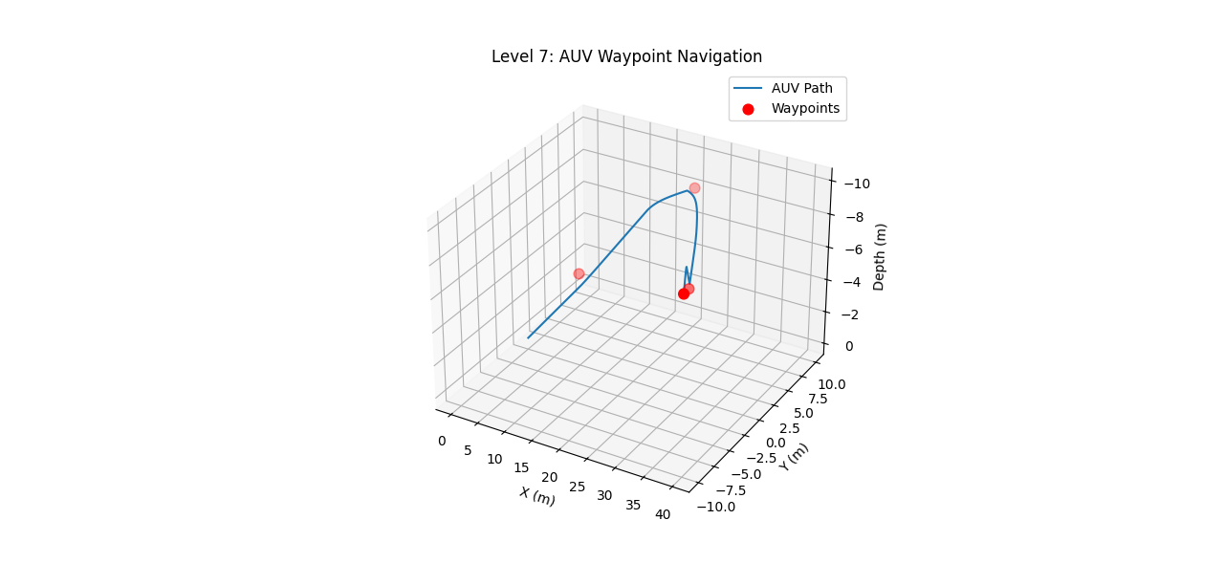

Goal-directed swimming behavior
This motion represents intentional navigation toward specific targets, as observed in migratory fish and reef-dwelling species. Fish use environmental cues, memory, and landmarks to move between feeding, breeding, or shelter locations.
Biologically, this behavior involves higher-level decision-making and spatial memory, leading to sharper turns and deliberate trajectory changes near targets.
In robotics, this corresponds to waypoint-based navigation, a standard approach in autonomous vehicle guidance systems.
The resulting motion strongly resembles purposeful, goal-oriented swimming.

Level 8: Waypoint Navigation with Ocean Currents
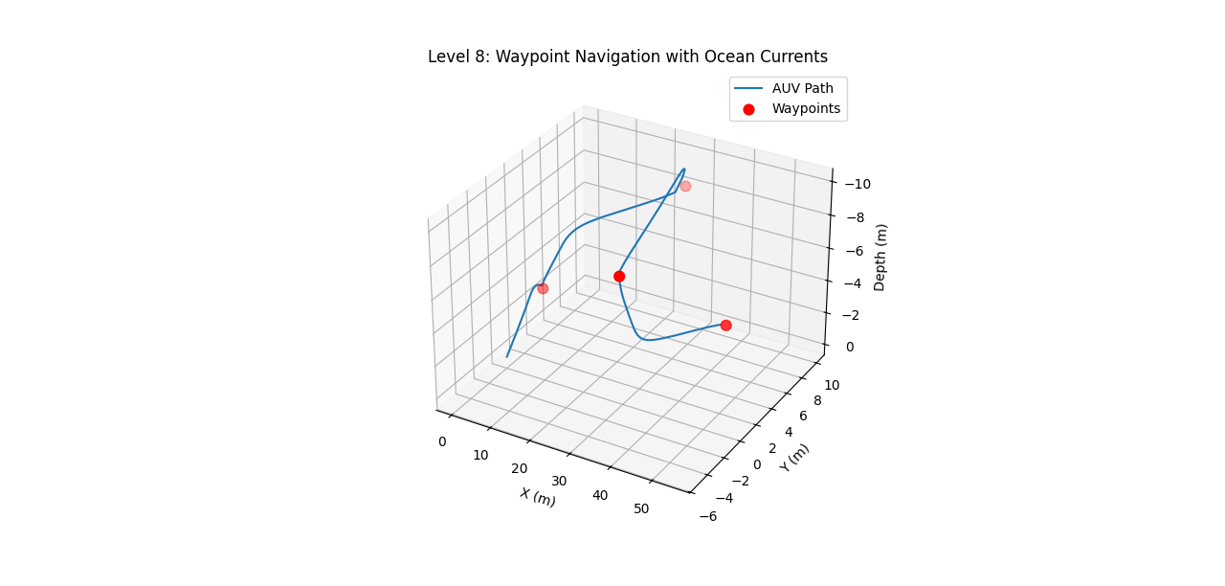

Drift-compensated swimming
This motion captures how fish swim in the presence of ocean currents. Species such as sharks and tuna do not swim directly toward their destination relative to the ground; instead, they adjust their heading to compensate for water flow, resulting in crab-angle swimming.
Biologically, fish sense flow direction and speed, adapting their orientation to maintain a desired ground-relative trajectory.
In robotics, this is known as the current compensation problem, where vehicle motion is controlled relative to the surrounding fluid rather than the Earth-fixed frame.
This behavior is extremely realistic and accurately reflects true ocean swimming dynamics.

