Programming for Problem Solving

ASSIGNMENT – 3

Prepared By:

Abhiram Sreekar V Iruvanti

Dharmavarapu Lalitha Sowjanya

Project Title : Cricket Mania

~: Introduction :~

This is a mini cricket simulation in which you will be playing against the computer. This is very similar to the real cricket and the experience is truly worth it. It has many unique patterns to follow and everyone can experience immense fun after playing this.

The rules for this game are as follows:

#1 You get to enter your name

#2 Whoever wins the toss, chooses either to bat or bowl

#3 You need to choose one number from 1,2,4 and 6 **only**.

#4 If the number you choose and the computer choose are the same, then the batsman gets out

#5 If numbers are different then the number you throw gets added to the score

#6 After the batsman gets out, the first innings will be done

#7 The total score will be set as the target and the opponent will have to chase that score

#8 If the target is achieved, that player will win the game.

The main aspect of the game lies in random number generation which will explained in detail later. Each and every permutation results in a completely different game, so it is worth to get entertained from this program that we designed.

~: Description :~

The libraries used in this program are:

1. **stdio.h** – for standard input and output commands

2. **time.h** – for the time changing constraints

3. **string.h** – for the string handling functions

4. **stdlib.h** – for some in-built functions like rand()

This program consists of many functions in order to simplify things.

The **user-functions** used in this program are:

1. **void display()** : This function is used to display the rules of the game before it starts to let the user understand the structure of the game.

2. **int cc()** : This function is used to take the random choice of numbers (1,2,4 and 6) for the computer while playing the game .

3. **int toss()** : This function is used for making the decision of toss.

4. **int compchoice()** : This function helps the computer to choose either to bowl or bat in case if the user lost the toss.

5. **int start()** : This function allows the user to choose either to go for heads or tails.

6. **int inp()** : This function takes the input of the numbers (1,2,4 and 6) when the innings are going on.

7. **int batorbowl()** : This function allows the user to choose either to bowl or bat in case if the user won the toss.

8. **int webatinn1()** : This function follows the innings 1 of the match where the user gets to bat first.

9. **int compbatinn1()** : This function follows the innings 1 of the match where the computer gets to bat first.

10. **int webatinn2(int)**: This function follows the innings 2 of the match where the user gets to bat and chase the target the computer hit.

11. **int compbatinn2(int)** : This function follows the innings 2 of the match where the computer gets to bat and chase the target the user hit.

The important **pre-defined** functions in this program :

1. **rand()** : This pre-defined function is the key to the entire program and helps in generating random numbers.

2. **srand(time(NULL))** : This pre-defined function helps in changing the random numbers for every individual input.

3. **fopen()** : This function is used to open the file mentioned.

4. **fprintf()** : This function is used to print the details given in the file mentioned.

5**. fclose()** : This function closes the file.

6. **strcpy()** : This string function helps in copying one string to another.

~: Project Code :~

#include<stdio.h>

#include<stdlib.h>

#include<time.h>

#include<string.h>

struct score

{

char name[15];

char status[20];

int ourscore;

int compscore;

};

void blue();

void green();

void red();

void purple();

void yellow();

void reset();

void display()

{

purple();

printf("\n\t*********\n");

printf("\n\t* *\n");

printf("\n\t* WELCOME TO CRICKET MANIA *\n");

printf("\n\t* *\n");

printf("\n\t*********\n");

printf("\n\t------This is a fascinating cricket game simulator-------\n");

printf("\n\t-------------------------RULES---------------------------\n");

printf("\n\t#1 You get to enter your name\n");

printf("\n\t#2 Whoever wins the toss, chooses either to bat or bowl\n");

printf("\n\t#3 You need to choose one number from 1,2,4 and 6 only\n");

printf("\n\t#4 If the number you choose and the computer choose are the same\n");

printf("\n\t!!!!!!!!Then the batsman gets OUT!!!!!!!!\n");

printf("\n\t#5 If numbers are different then the number you throw gets added to the score\n");

printf("\n\t#6 After the batsman gets out, the first innings will be done\n");

printf("\n\t#7 The total score will be set as the target and the opponent will chase that score\n");

printf("\n\t#8 If the target is achieved, that player will win the GAME\n");

printf("\n\t*I HOPE YOU ARE CLEAR WITH THE RULES\n");

reset();

}

int cc()

{

int num=rand()%4;

switch(num)

{

case 0:{return 1;break;}

case 1:{return 2;break;}

case 2:{return 4;break;}

case 3:{return 6;break;}

}

}

int toss()

{

int num=rand()%2;

return num;

}

int compchoice()

{

int num=rand()%2;

return num;

}

int start()

{

int ch,*ptr;

printf("\n*Lets start with the toss*\n");

printf("\nEnter 0 for heads (OR) 1 for tails : ");

scanf("%d",&ch);

ptr=&ch;

if(*ptr==0)

return 0;

else if(*ptr==1)

return 1;

else

{

printf("\nINVALID INPUT!!\n");

start();

}

}

int inp()

{

int ch;

printf("\nEnter a number (1/2/4/6) : ");

scanf("%d",&ch);

if(ch==1||ch==2||ch==4||ch==6)

return ch;

else

{

printf("\nINVALID INPUT!!\n");

inp();

}

}

int batorbowl()

{

int c;

printf("\nEnter 0 to Bat (OR) 1 to Bowl\n");

scanf("%d",&c);

if(c==0)

return 0;

else if(c==1)

return 1;

else

{

printf("\nINVALID INPUT!!!!\n");

batorbowl();

}

}

void red() {

printf("\033[1;31m");

}

void yellow() {

printf("\033[1;33m");

}

void blue() {

printf("\033[1;34m");

}

void green() {

printf("\033[1;32m");

}

void purple() {

printf("\033[1;35m");

}

void reset() {

printf("\033[0m");

}

int webatinn1();

int webatinn2(int t);

int compbatinn1();

int compbatinn2(int t);

int main()

{

struct score s;

FILE *fp;

int temp=0,temp2=0,temp3=0,check;

char choice,target1=0,target2=0;

display();

do{

target1=0,target2=0;

printf("\nEnter your name : ");

scanf("%s",s.name);

srand(time(0));

temp=start();

srand(time(0));

temp2=toss();

if(temp==temp2)

{

if(temp2==0)

{

blue();

printf("\nIT IS HEADS!!! So what are you gonna do?\n");

reset();

}

else if(temp2==1)

{

blue();

printf("\nIT IS TAILS!!! So what are you gonna do?\n");

reset();

}

choice=batorbowl();

if(choice==0)

{

printf("\nYou chose to bat, all the very best for that\n");

target1=webatinn1();

}

else if(choice==1)

{

printf("\nYou chose to bowl, all the very best for that\n");

target1=compbatinn1();

}

printf("\nCongrats!! The First Innings end now\n");

if(choice==0)

{

printf("\nYour performance was brilliant all the while\n");

printf("\nThe target for computer to chase is %d\n",target1);

printf("\n*GOOD LUCK!!!\n");

target2=compbatinn2(target1);

printf("\nWOW!! That was a thrilling game\n");

if(target1>target2)

{

strcpy(s.status,"Victory");

s.ourscore=target1;

s.compscore=target2;

green();

printf("\n**SCORE-BOARD*\n");

printf("\nName of the Player : %s\n",s.name);

printf("\nStatus of the Match : %s\n",s.status);

printf("\nOur Score : %d\n",s.ourscore);

printf("\nComputer's Score : %d\n",s.compscore);

reset();

fp=fopen("Stats.txt","w");

fprintf(fp,"\n**SCORE-BOARD*\n");

fprintf(fp,"\nName of the Player : %s\n",s.name);

fprintf(fp,"\nStatus of the Match : %s\n",s.status);

fprintf(fp,"\nOur Score : %d\n",s.ourscore);

fprintf(fp,"\nComputer's Score : %d\n",s.compscore);

fclose(fp);

printf("\nWOHOOOO!!!!!!! YOU WON THE GAME\n");

printf("\nYOU BET COMPUTER WITH A DIFFERENCE OF %d, AMAZING SHOWW!!!!\n",target1-target2);

printf("\nEnter 0 to Play again (OR) any other number to exit : ");

scanf("%d",&check);

}

else

{

strcpy(s.status,"Lost");

s.ourscore=target1;

s.compscore=target2;

green();

printf("\n**SCORE-BOARD*\n");

printf("\nName of the Player : %s\n",s.name);

printf("\nStatus of the Match : %s\n",s.status);

printf("\nOur Score : %d\n",s.ourscore);

printf("\nComputer's Score : %d\n",s.compscore);

reset();

fp=fopen("Stats.txt","w");

fprintf(fp,"\n**SCORE-BOARD*\n");

fprintf(fp,"\nName of the Player : %s\n",s.name);

fprintf(fp,"\nStatus of the Match : %s\n",s.status);

fprintf(fp,"\nOur Score : %d\n",s.ourscore);

fprintf(fp,"\nComputer's Score : %d\n",s.compscore);

fclose(fp);

printf("\nYOUR PERFORMANCE WAS FABULOUS!!!!!!\n");

printf("\nBut unfortunately you LOST to computer\n");

printf("\nBetter luck next time!!!!\n");

printf("\nEnter 0 to Play again (OR) any other number to exit : ");

scanf("%d",&check);

}

}

else if(choice==1)

{

printf("\nYour bowling was AMAZING!!!\n");

printf("\nThe target for you to chase is %d\n",target1);

printf("\n*GOOD LUCK\n");

target2=webatinn2(target1);

printf("\nWOW!! That was a fantastic game\n");

if(target1>target2)

{

strcpy(s.status,"Lost");

s.ourscore=target2;

s.compscore=target1;

green();

printf("\n**SCORE-BOARD*\n");

printf("\nName of the Player : %s\n",s.name);

printf("\nStatus of the Match : %s\n",s.status);

printf("\nOur Score : %d\n",s.ourscore);

printf("\nComputer's Score : %d\n",s.compscore);

reset();

fp=fopen("Stats.txt","w");

fprintf(fp,"\n**SCORE-BOARD*\n");

fprintf(fp,"\nName of the Player : %s\n",s.name);

fprintf(fp,"\nStatus of the Match : %s\n",s.status);

fprintf(fp,"\nOur Score : %d\n",s.ourscore);

fprintf(fp,"\nComputer's Score : %d\n",s.compscore);

fclose(fp);

printf("\nYOUR BATTING WAS OUTSTANDING!!!!!!\n");

printf("\nBut unfortunately you LOST to computer\n by %d runs",target1-target2);

printf("\nBetter luck next time!!!!\n");

printf("\nEnter 0 to Play again (OR) any other number to exit : ");

scanf("%d",&check);

printf("\n");

}

else

{

strcpy(s.status,"Victory");

s.ourscore=target2;

s.compscore=target1;

green();

printf("\n**SCORE-BOARD*\n");

printf("\nName of the Player : %s\n",s.name);

printf("\nStatus of the Match : %s\n",s.status);

printf("\nOur Score : %d\n",s.ourscore);

printf("\nComputer's Score : %d\n",s.compscore);

reset();

fp=fopen("Stats.txt","w");

fprintf(fp,"\n**SCORE-BOARD*\n");

fprintf(fp,"\nName of the Player : %s\n",s.name);

fprintf(fp,"\nStatus of the Match : %s\n",s.status);

fprintf(fp,"\nOur Score : %d\n",s.ourscore);

fprintf(fp,"\nComputer's Score : %d\n",s.compscore);

fclose(fp);

printf("\nWOHOOOO!!!YOU WON THE GAME\n");

printf("\nYou BET computer, you stole the show!!!!!\n");

printf("\nEnter 0 to Play again (OR) any other number to exit : ");

scanf("%d",&check);

printf("\n");

}

}

}

else

{

printf("\nBad luck!! The computer won the toss\n");

srand(time(0));

printf("\nThe computer chooses to ");

srand(time(0));

temp3=compchoice();

switch(temp3)

{

case 0:

{

printf("bat\n");

target1=compbatinn1();break;

}

case 1:

{

printf("bowl\n");

target1=webatinn1();break;

}

}

printf("\nThat was an incredible 1st innings!!\n");

if(temp3==1)

{

printf("\nYour performance was brilliant all the while\n");

printf("\nThe target for computer to chase is %d\n",target1);

printf("\n*GOOD LUCK!!!\n");

target2=compbatinn2(target1);

printf("\nWOW!! That was a thrilling game\n");

if(target1>target2)

{

strcpy(s.status,"Victory");

s.ourscore=target1;

s.compscore=target2;

green();

printf("\n**SCORE-BOARD*\n");

printf("\nName of the Player : %s\n",s.name);

printf("\nStatus of the Match : %s\n",s.status);

printf("\nOur Score : %d\n",s.ourscore);

printf("\nComputer's Score : %d\n",s.compscore);

reset();

fp=fopen("Stats.txt","w");

fprintf(fp,"\n**SCORE-BOARD*\n");

fprintf(fp,"\nName of the Player : %s\n",s.name);

fprintf(fp,"\nStatus of the Match : %s\n",s.status);

fprintf(fp,"\nOur Score : %d\n",s.ourscore);

fprintf(fp,"\nComputer's Score : %d\n",s.compscore);

fclose(fp);

printf("\nWOHOOOO!!!!!!! YOU WON THE GAME\n");

printf("\nYOU BET computer WITH A DIFFERENCE OF %d, AMAZING SHOWW!!!!\n",target1-target2);

printf("\nEnter 0 to Play again (OR) any other number to exit : ");

scanf("%d",&check);

printf("\n");

}

else

{

strcpy(s.status,"Lost");

s.ourscore=target1;

s.compscore=target2;

green();

printf("\n**SCORE-BOARD*\n");

printf("\nName of the Player : %s\n",s.name);

printf("\nStatus of the Match : %s\n",s.status);

printf("\nOur Score : %d\n",s.ourscore);

printf("\nComputer's Score : %d\n",s.compscore);

reset();

fp=fopen("Stats.txt","w");

fprintf(fp,"\n**SCORE-BOARD*\n");

fprintf(fp,"\nName of the Player : %s\n",s.name);

fprintf(fp,"\nStatus of the Match : %s\n",s.status);

fprintf(fp,"\nOur Score : %d\n",s.ourscore);

fprintf(fp,"\nComputer's Score : %d\n",s.compscore);

fclose(fp);

printf("\nYOUR PERFORMANCE WAS FABULOUS!!!!!!\n");

printf("\nBut unfortunately you LOST to computer\n");

printf("\nBetter luck next time!!!!\n");

printf("\nEnter 0 to Play again (OR) any other number to exit : ");

scanf("%d",&check);

printf("\n");

}

}

else if(temp3==0)

{

printf("\nYour bowling was AMAZING!!!\n");

printf("\nThe target for you to chase is %d\n",target1);

printf("\n*GOOD LUCK\n");

target2=webatinn2(target1);

printf("\nWOW!! That was a fantastic game\n");

if(target1>target2)

{

strcpy(s.status,"Lost");

s.ourscore=target2;

s.compscore=target1;

green();

printf("\n**SCORE-BOARD*\n");

printf("\nName of the Player : %s\n",s.name);

printf("\nStatus of the Match : %s\n",s.status);

printf("\nOur Score : %d\n",s.ourscore);

printf("\nComputer's Score : %d\n",s.compscore);

reset();

fp=fopen("Stats.txt","w");

fprintf(fp,"\n**SCORE-BOARD*\n");

fprintf(fp,"\nName of the Player : %s\n",s.name);

fprintf(fp,"\nStatus of the Match : %s\n",s.status);

fprintf(fp,"\nOur Score : %d\n",s.ourscore);

fprintf(fp,"\nComputer's Score : %d\n",s.compscore);

fclose(fp);

printf("\nYOUR BATTING WAS OUTSTANDING!!!!!!\n");

printf("\nBut unfortunately you LOST to computer by %d runs\n",target1-target2);

printf("\nBetter luck next time!!!!");

printf("\nEnter 0 to Play again (OR) any other number to exit : ");

scanf("%d",&check);

printf("\n");

}

else

{

strcpy(s.status,"Victory");

s.ourscore=target2;

s.compscore=target1;

green();

printf("\n**SCORE-BOARD*\n");

printf("\nName of the Player : %s\n",s.name);

printf("\nStatus of the Match : %s\n",s.status);

printf("\nOur Score : %d\n",s.ourscore);

printf("\nComputer's Score : %d\n",s.compscore);

reset();

fp=fopen("Stats.txt","w");

fprintf(fp,"\n**SCORE-BOARD*\n");

fprintf(fp,"\nName of the Player : %s\n",s.name);

fprintf(fp,"\nStatus of the Match : %s\n",s.status);

fprintf(fp,"\nOur Score : %d\n",s.ourscore);

fprintf(fp,"\nComputer's Score : %d\n",s.compscore);

fclose(fp);

printf("\nWOHOOOO!!!YOU WON THE GAME\n");

printf("\nYou BET computer, you stole the show!!!!!");

printf("\nEnter 0 to Play again (OR) any other number to exit : ");

scanf("%d",&check);

printf("\n");

}

}

}}while(check==0);

printf("Thank you for playing!!\n");

return 0;

}

int webatinn1()

{

int r,total=0,v,temp=0,fours=0,sixes=0,arr[2];

printf("\n-----INNINGS 1-----\n");

printf("\nYou are batting\n");

do

{

srand(time(0));

v=cc();

temp=v;

r=inp();

yellow();

printf("\nYour input = %d \t Computer's input = %d\n",r,temp);

reset();

if(r!=temp)

{

switch(r)

{

case 1:{blue();printf("\nA simple single run!\n");reset();break;}

case 2:{blue();printf("\nGood run! 2 runs from that ball\n");reset();break;}

case 4:{blue();printf("\nPOWW!!! a wonderful four\n");reset();fours++;arr[0]=fours;printf("No.of fours=%d\n",arr[0]);break;}

case 6:{blue();printf("\nWOAHHH!!! That's a sixerrr\n");reset();sixes++;arr[1]=sixes;printf("No.of sixes=%d\n",arr[1]);break;}

}

total=total+r;

}

else

{

red();

printf("\n**OUTTT!!!!\n");

reset();

printf("\n*TARGET=%d*\n",total);

break;

}

printf("\n->TOTAL=%d",total);

}while(r!=temp);

printf("\n*INNINGS 1 ENDS*\n");

return total;

}

int compbatinn1()

{

int r,total=0,v,temp=0;

printf("\n-----INNINGS 1-----\n");

printf("\n You are bowling\n");

do

{

srand(time(0));

v=cc();

temp=v;

r=inp();

yellow();

printf("\nComputer's input = %d\tYour input = %d \n",temp,r);

reset();

if(r!=temp)

{

switch(temp)

{

case 1:{blue();printf("\nGood ball! Only a single\n");reset();break;}

case 2:{blue();printf("\nComputer goes for a two \n");reset();break;}

case 4:{blue();printf("\nA fourrr!!! You should be careful with your bowling\n");reset();break;}

case 6:{blue();printf("\nThats a massive six by computer!! Check on the fielding\n");reset();break;}

}

total=total+temp;

}

else

{

red();

printf("\n**OUTTT!!!!\n");

reset();

printf("\n*TARGET=%d*\n",total);

break;

}

printf("\n->TOTAL=%d",total);

}while(r!=temp);

printf("\n*INNINGS 1 ENDS*\n");

return total;

}

int webatinn2(int t)

{

int r,total=0,v,temp=0,fours=0,sixes=0,arr[2];

printf("\n-----INNINGS 2-----\n");

printf("\n You are batting\n");

do

{

srand(time(0));

v=cc();

temp=v;

r=inp();

yellow();

printf("\nYour input = %d \t Computer's input = %d\n",r,temp);

reset();

if(r!=temp)

{

switch(r)

{

case 1:{blue();printf("\nA simple single run!\n");reset();break;}

case 2:{blue();printf("\nGood run! 2 runs from that ball\n");reset();break;}

case 4:{blue();printf("\nPOWW!!! a wonderful four\n");reset();fours++;arr[0]=fours;printf("No.of fours=%d\n",arr[0]);break;}

case 6:{blue();printf("\nWOAHHH!!! That's a sixerrr\n");reset();sixes++;arr[1]=sixes;printf("No.of sixes=%d\n",arr[1]);break;}

}

total=total+r;

}

else if(r==temp)

{

red();

printf("\nOUT!!!\n");

reset();

break;

}

else if(total>t)

break;

printf("\n -> TOTAL=%d\n",total);

}while(total<=t);

printf("\n*MATCH IS OVER\n");

return total;

}

int compbatinn2(int t)

{

int r,total=0,v,temp=0;

printf("\n-----INNINGS 2-----\n");

printf("\n You are bowling\n");

do

{

srand(time(0));

v=cc();

temp=v;

r=inp();

yellow();

printf("\nComputer's input = %d\tYour input = %d \n",temp,r);

reset();

if(r!=temp)

{

switch(temp)

{

case 1:{blue();printf("\nGood ball! Only a single\n");reset();break;}

case 2:{blue();printf("\nComputer goes for a two \n");reset();break;}

case 4:{blue();printf("\nA fourrr!!! You should be careful with your bowling\n");reset();break;}

case 6:{blue();printf("\nThats a massive six by computer!! Check on the fielding\n");reset();break;}

}

total=total+temp;

}

else if(r==temp)

{

red();

printf("\nOUT!!!\n");

reset();

break;

}

else if(total>t)

break;

printf("\n -> TOTAL=%d\n",total);

}while(total<=t);

printf("\n*MATCH IS OVER\n");

return total;

}

~: Test Cases :~

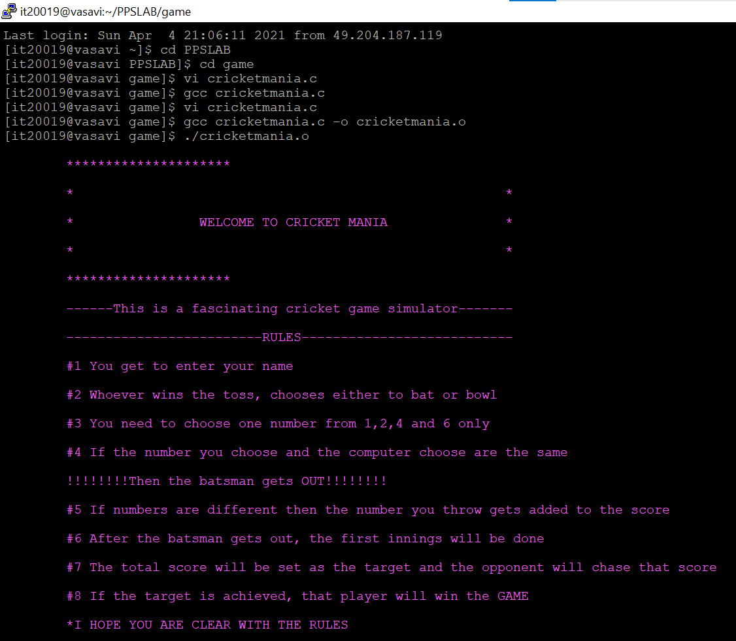

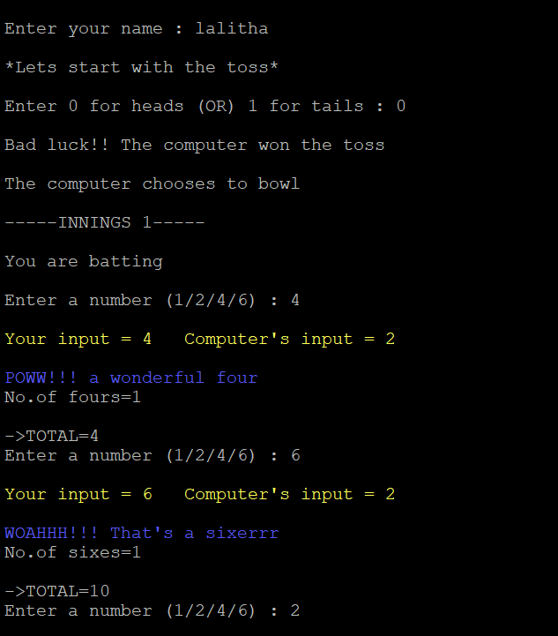

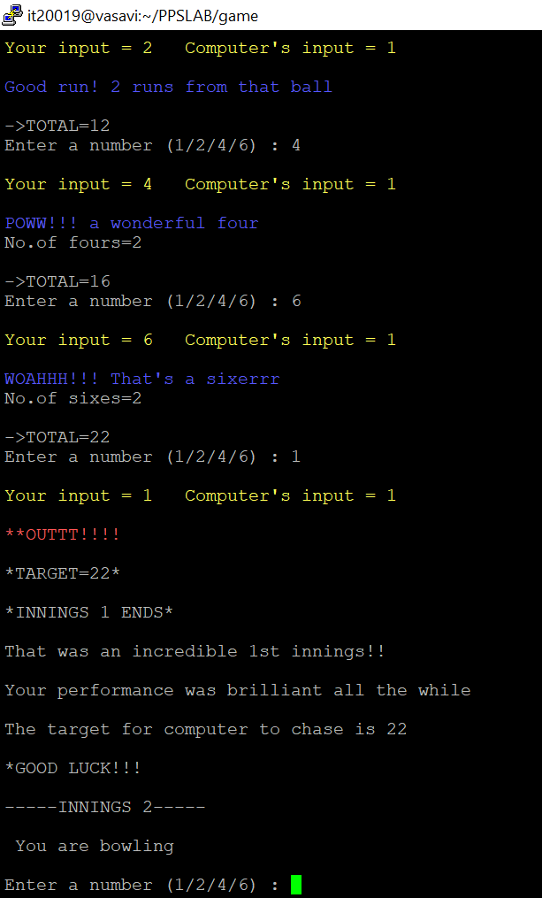

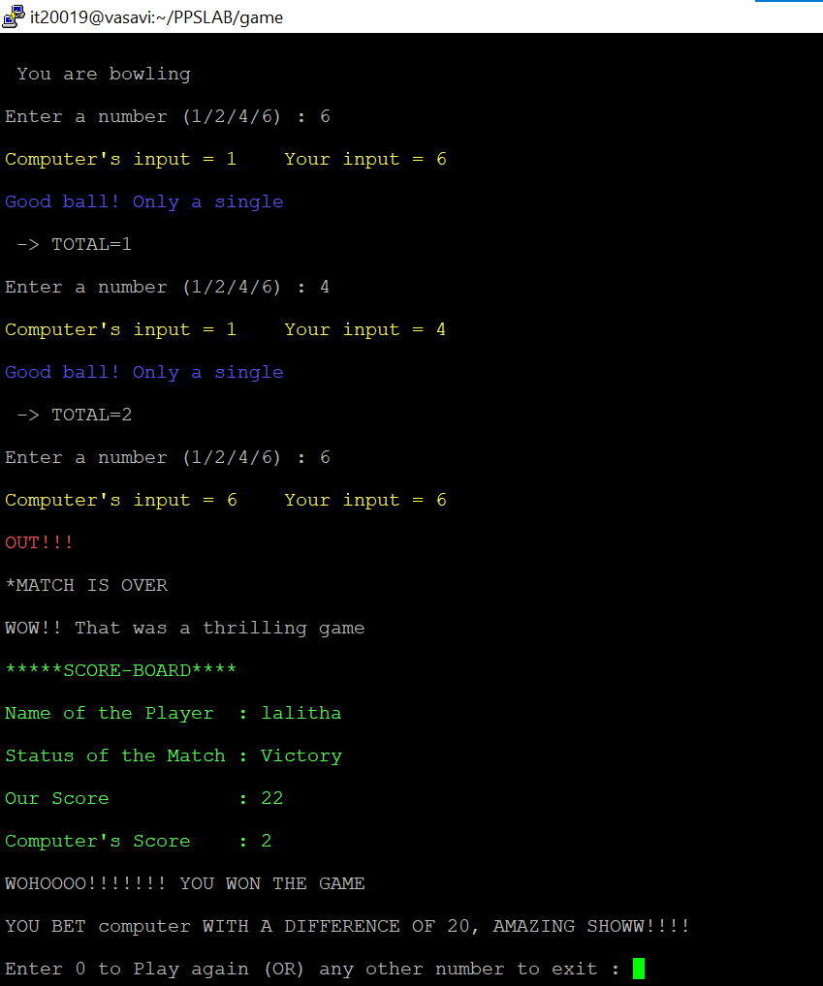

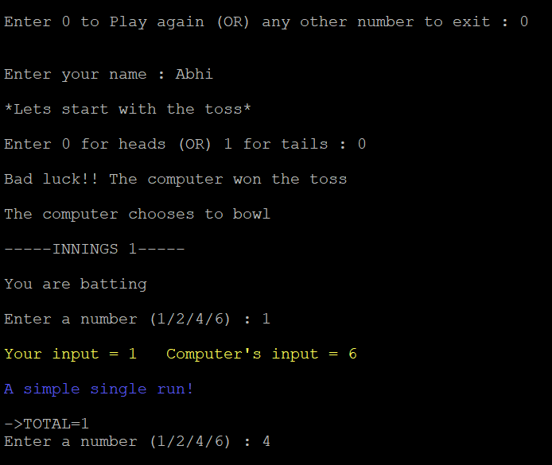

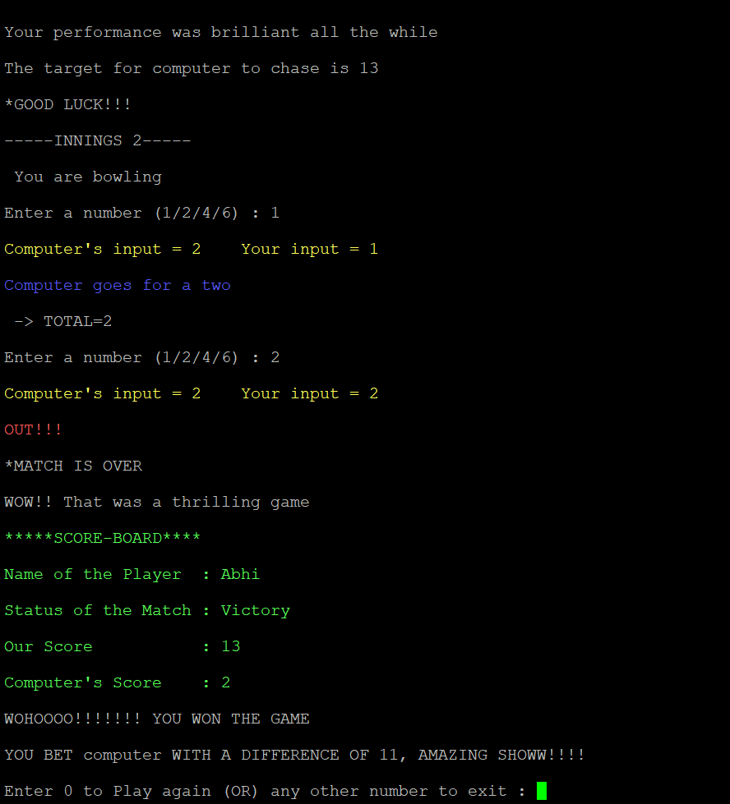

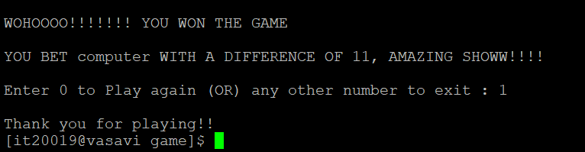

~: Inference :~

This project helped us grasp the concepts that we have learnt during the C language course. We were able to understand the importance of using functions. Since this program primarily focuses on random number generations, we were able to exhibit different cases possible and enjoy the process.

The concepts of structures and files come handy to accept and store the data. In our program, the use of score structure made it easy to store the data of the score card.

We used the concept of files to store the data in them to create a database of different games played by different players to analyse the performance and scores.

~: Conclusion :~

This program is very similar to **hand cricket.** This is a project for an entertainment purpose highlighting the concepts of C programming. We thoroughly enjoyed and learnt the basic fundamentals.

The program gets compiled successfully and passes all the test cases.

~: Future scope :~

This program can be improved extensively with the use of more features of C programming and more information can be added like run rate, strike rate, number of overs, etc.

With the new programming languages coming up and the object-oriented approach, this program can be simplified with small code and enhanced with more graphics and statistics.