**JAVA SWING BASED - HealthCounselling - SQL CONNECTIVITY USING JDBC**

*A*

*Report*

*Submitted in partial fulfilment of the*

*Requirements for the award of the Degree of*

**BACHELOR OF ENGINEERING**

**IN**

**INFORMATION TECHNOLOGY**

**By**

**I. Abhiram Sreekar <1602-20-737-001>**

**Under the guidance of Ms B. Leelavathy**



**Department of Information Technology**

**Vasavi College of Engineering (Autonomous)**

**(Affiliated to Osmania University)**

**Ibrahimbagh, Hyderabad-31**

**2021-2022**

**BONAFIDE CERTIFICATE**

This is to certify that this project report titled

‘***MOOC Database***’

is a project work of ***I. Abhiram Sreekar***

bearing roll no. 1602-20-737-001

who carried out

this project under my supervision

in the IV semester

of the academic year 2020- 2021

Signature Signature

External Examiner Internal Examiner

**ABSTRACT**

Learning online is now the next big thing. This is majorly achieved by various MOOC platform (Massive Open Online Courses). The engineering colleges are encouraging the students to take these courses online by partnering with some MOOC platforms and in return achieve certificates and grade points which will be added to their semester grades. But what if the student wants to obtain the details of his/her courses and grades? This is where my DBMS project comes into action. This project is an application which helps the students access their highest-grade points from all the courses they have been certified for.

**Requirement Analysis**

**List of Tables:**

1. Students

2. MOOCs

3. Certificate

4. Scores

**List of attributes with their domain types:**

Students:

* student_name varchar2(20)
* year_of_study number(4)
* roll_number varchar2(15)

MOOCs:

* course_id number(10)
* course_name varchar2(40)
* date_of_registration date
* date_of_examination date
* number_of_weeks number(2)
* platform_name varchar2(10)

Enrolls:

* roll_number varchar2(15)
* course_id number(10)
* enroll_id number(10)

Certificate:

* percentage_achieved number(3)
* certificate_id number(10)
* roll_number varchar2(15)
* issue_date date

Scores:

* percentage_achieved number(3)
* score_id number(10)
* student_highest_grade number(2)
* roll_number varchar2(15)

**DATABASE DESIGN**

**Mapping Cardinality and Participation Constraints**

Firstly, many courses enroll many students. Therefore, the relationship between student and MOOC is many-to-many (N-N).

Every course has to make certificates for each student, hence it is one-to-one relationship (1-1) between students and certificate

Every student has their respective scores in the course. So, they have one-to-many (N-N) relationship.

**DESIGN**

**Entity Relationship Diagram**

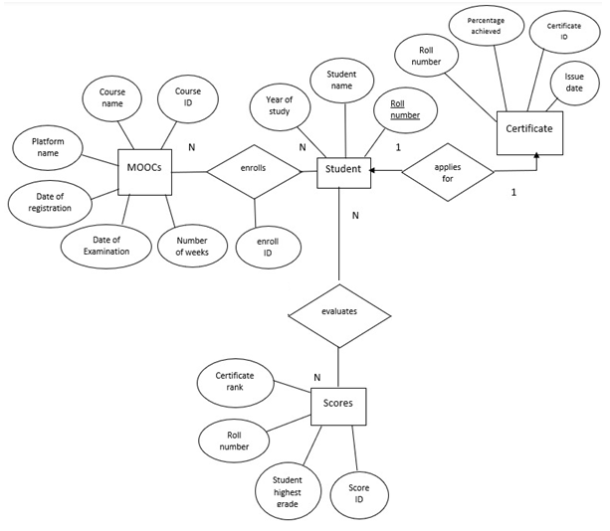

**DDL Commands:**

SQL> create table students(

2 student_name varchar2(20),

3 year_of_study number(2),

4 roll_number varchar2(15),

5 CONSTRAINT pkey_students_rno PRIMARY KEY (roll_number));

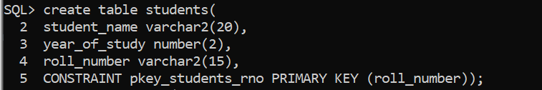

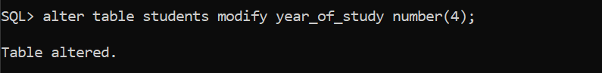

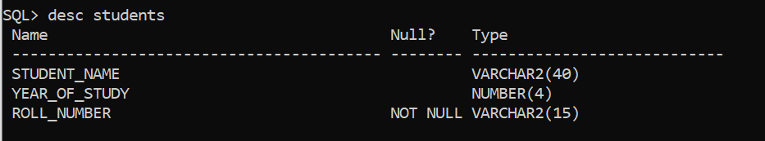

SQL> create table MOOCs(

2 course_id number(10),

3 course_name varchar2(40),

4 date_of_registration date,

5 date_of_examination date,

6 no_of_weeks number(2),

7 platform_name varchar2(10),

8 certificate_id number(10),

9 CONSTRAINT pkey_MOOCs_cid PRIMARY KEY (course_id));

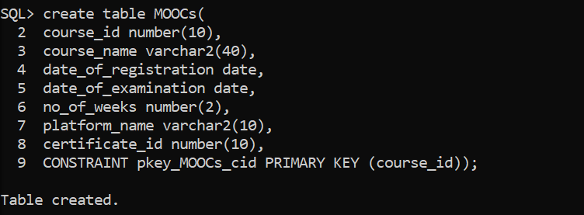

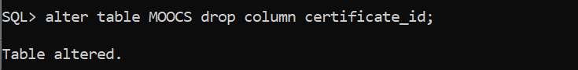



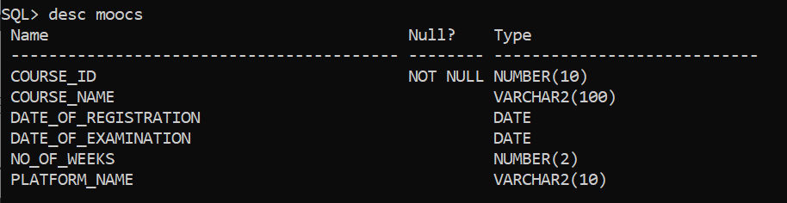

SQL> create table enrolls(

2 roll_number varchar2(15),

3 course_id number(10),

4 enroll_id number(10),

5 CONSTRAINT fkey_enrolls_rno FOREIGN KEY (roll_number) REFERENCES

6 students (roll_number) ON DELETE CASCADE,

7 CONSTRAINT fkey_enrolls_cid FOREIGN KEY (course_id) REFERENCES

8 MOOCS (course_id) ON DELETE CASCADE);

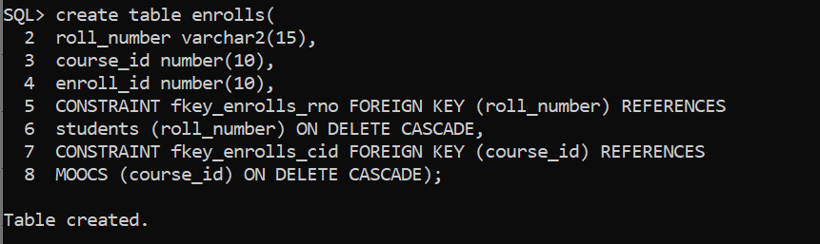

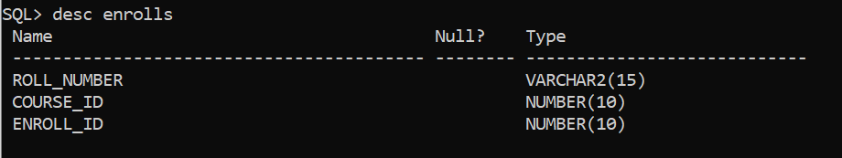

SQL> create table certificate(

2 percentage_achieved number(3),

3 certificate_id number(10),

4 roll_number varchar2(15),

5 issue_date date,

6 CONSTRAINT pkey_certificate_cid PRIMARY KEY (certificate_id),

7 CONSTRAINT fkey_certificate_rno FOREIGN KEY (roll_number) REFERENCES

8 students (roll_number) ON DELETE CASCADE);

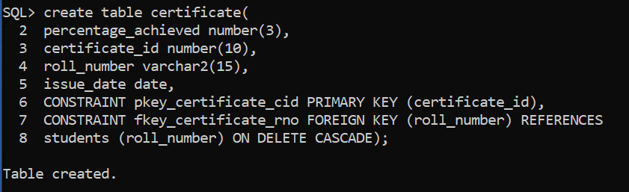

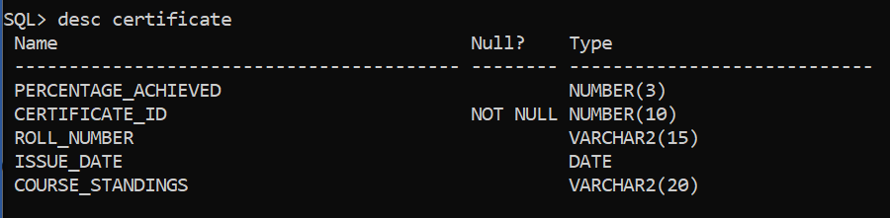

SQL> create table scores(

2 percentage_achieved number(3),

3 score_id number(10),

4 student_highest_grade number(2),

5 roll_number varchar2(15),

6 CONSTRAINT pkey_scores_sid PRIMARY KEY (score_id),

7 CONSTRAINT fkey_scores_rno FOREIGN KEY (roll_number) REFERENCES

8 students (roll_number) ON DELETE CASCADE);

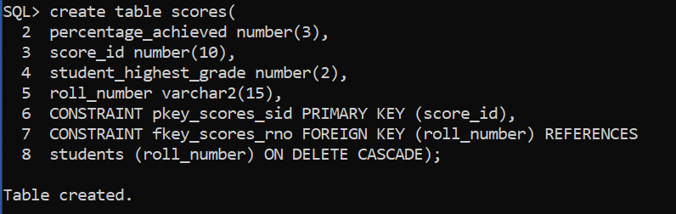

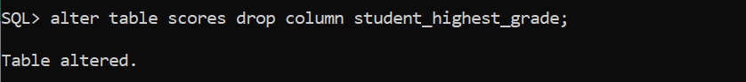

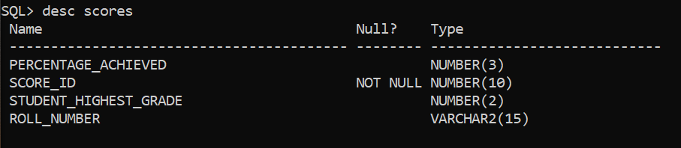

**DML Commands:**

SQL> insert into students values (‘&student_name’,&year_of_study,’&roll_number’);

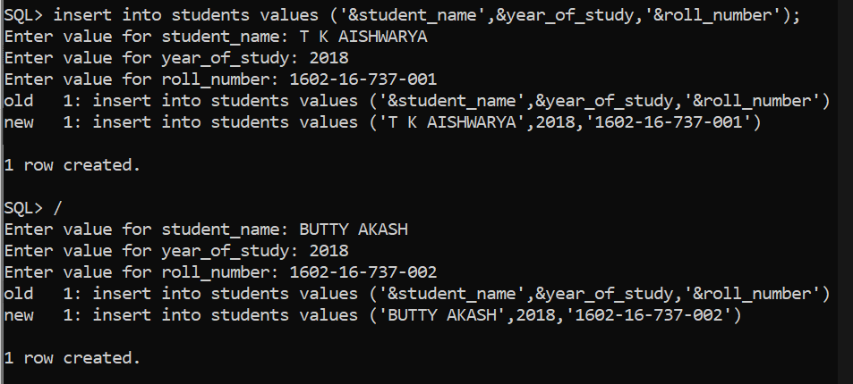

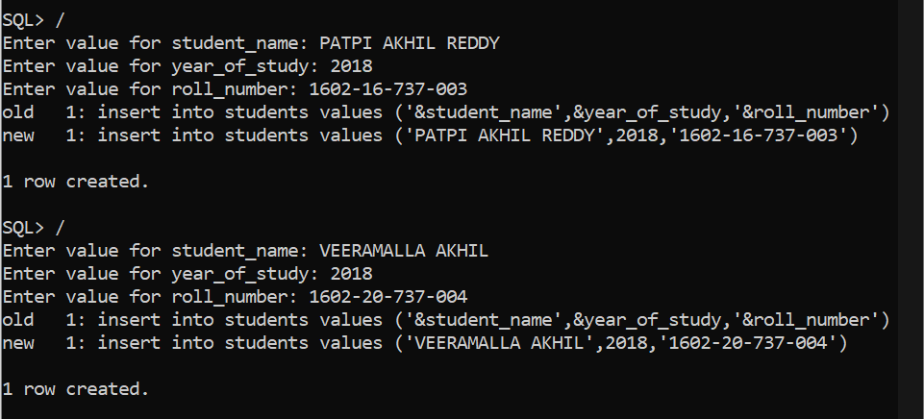

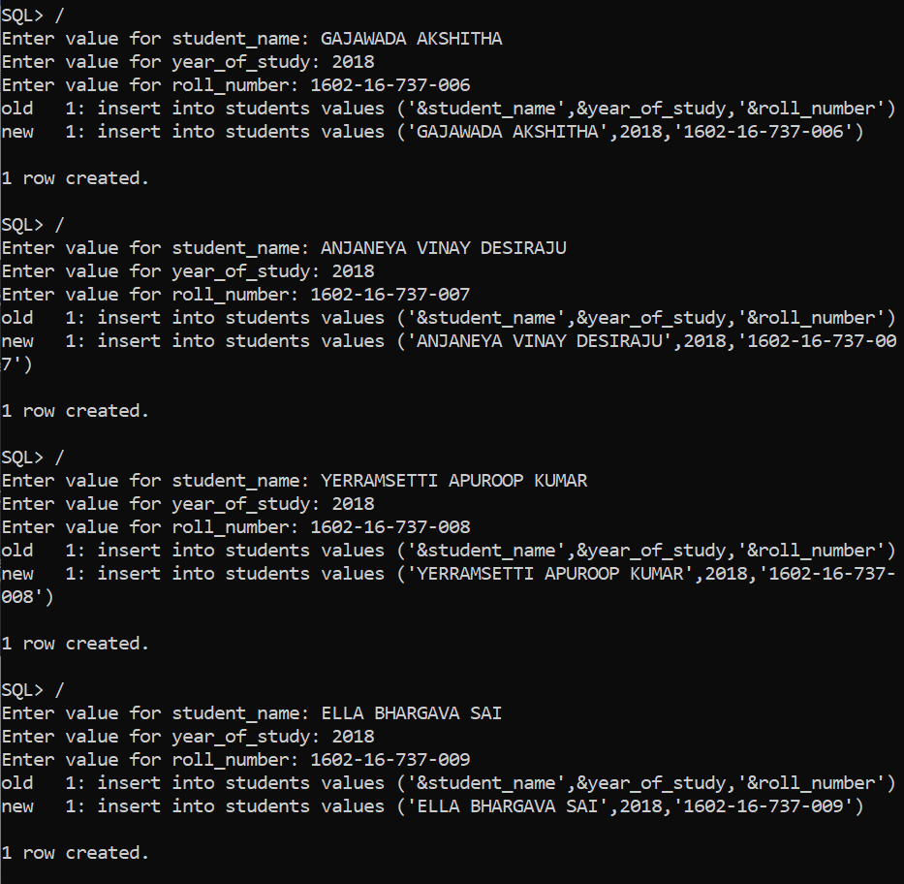

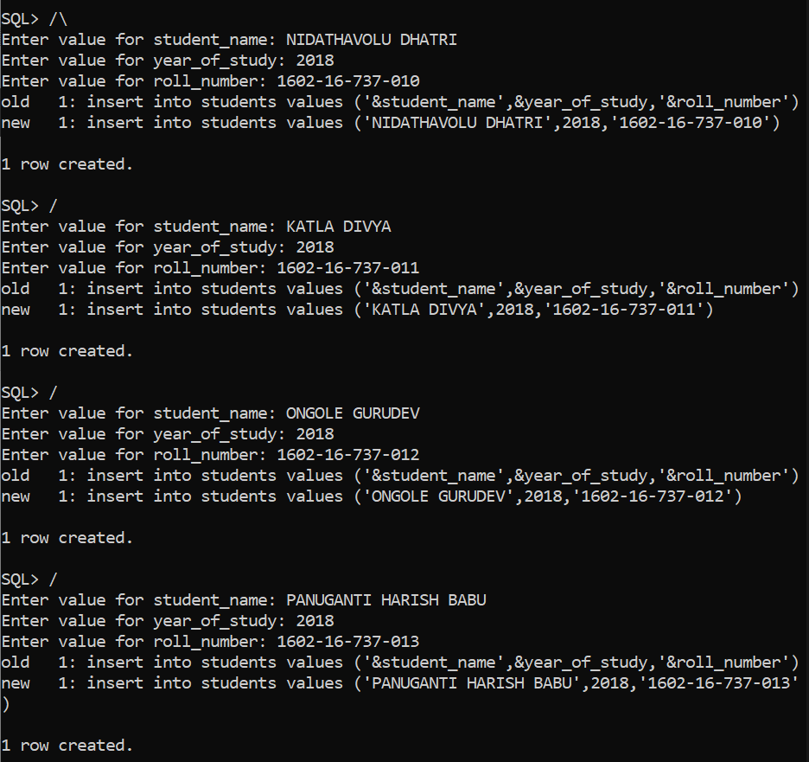

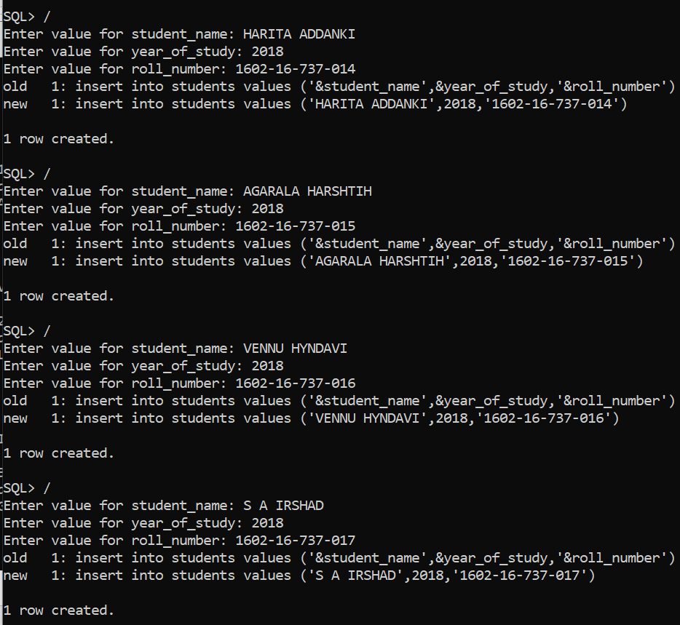

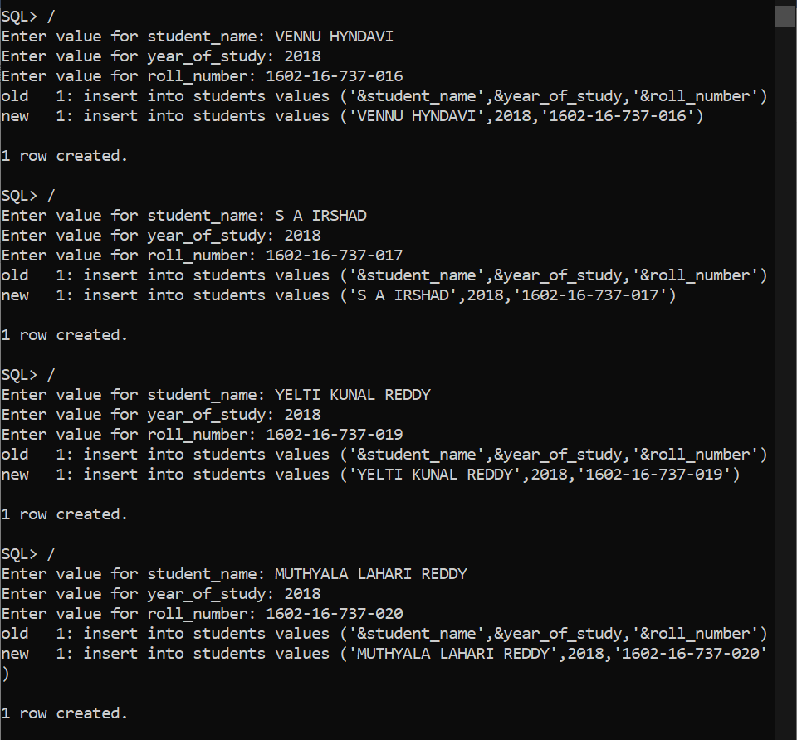

SQL> select * from students;

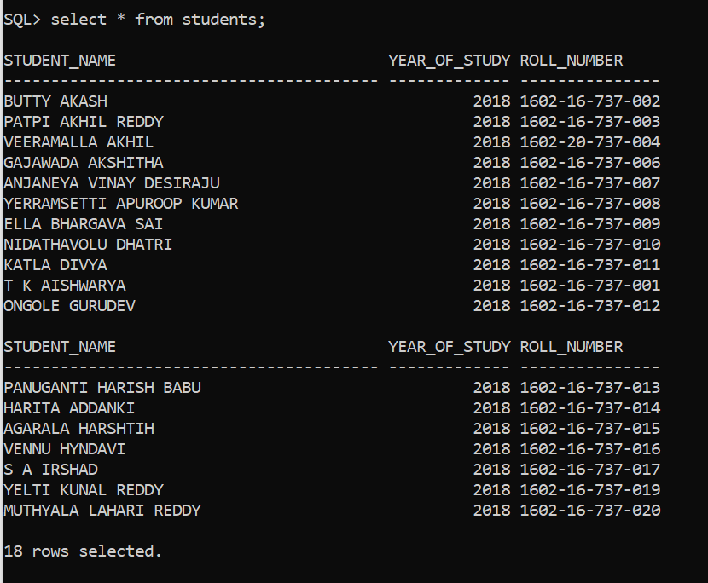

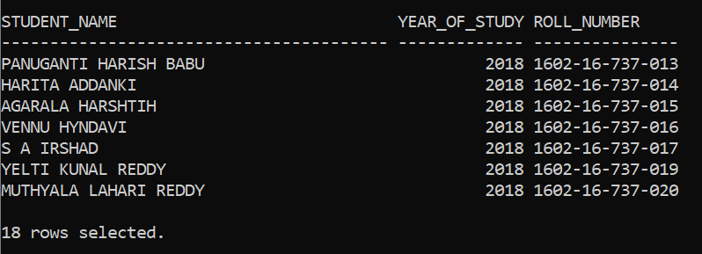

SQL> insert into moocs values (&course_id,'&course_name',DATE '&date_of_registration',DATE '&date_of_examination',&no_of_weeks,'&platform_name');

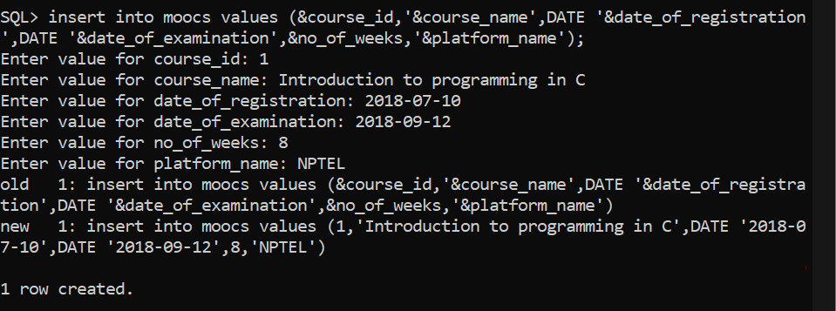

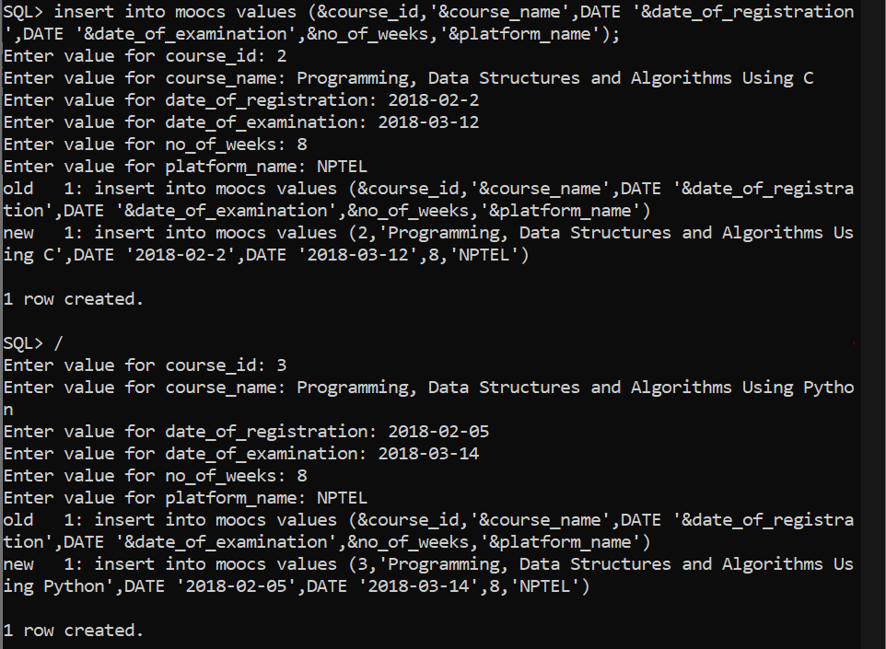

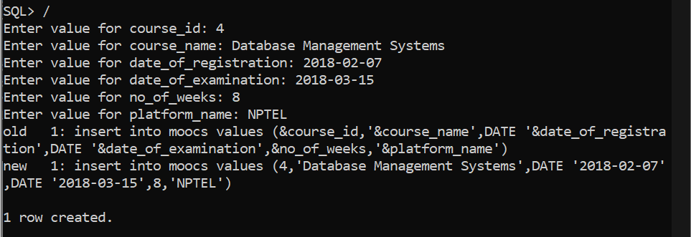

SQL> select * from moocs;

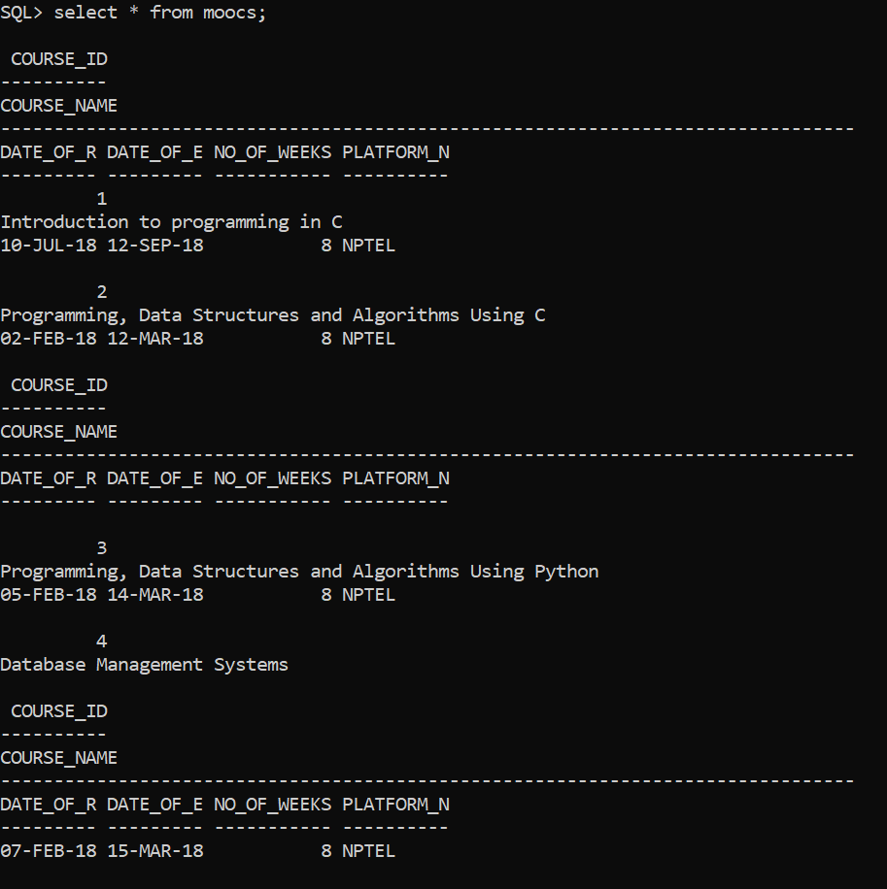

SQL> insert into enrolls values (‘&roll_number’,&course_id,&enroll_id);

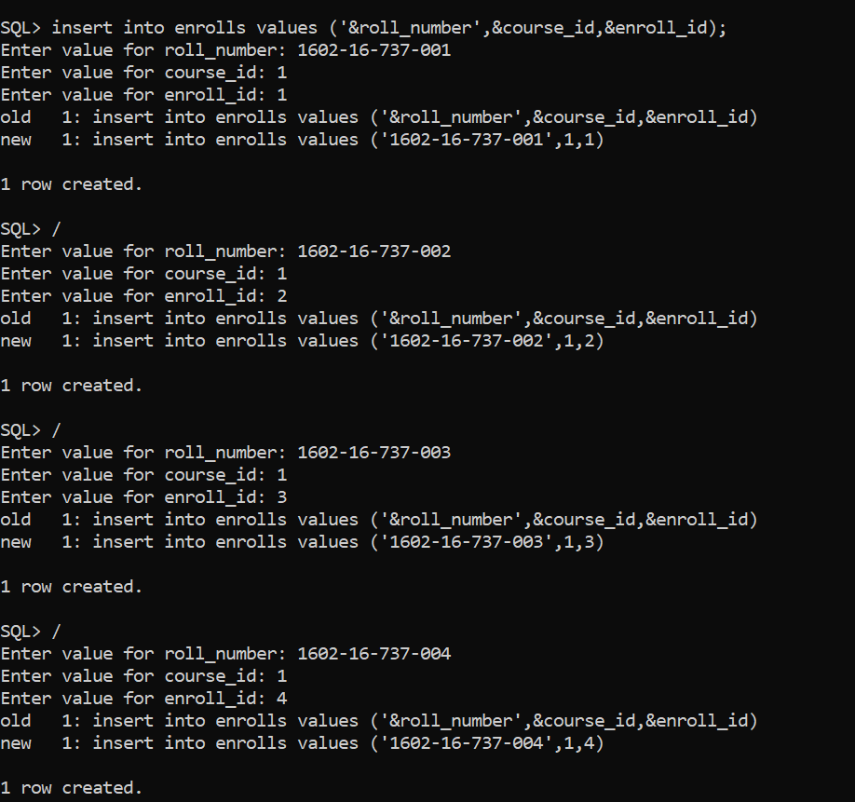

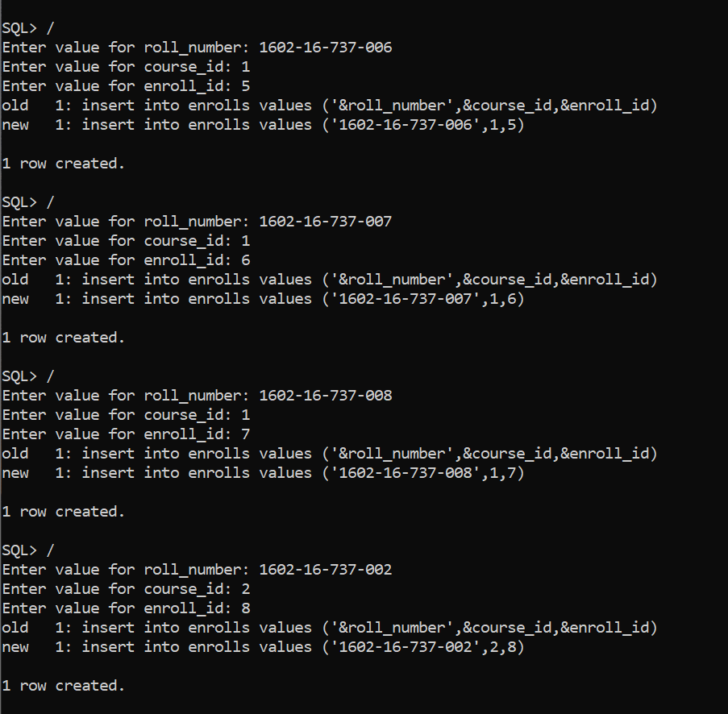

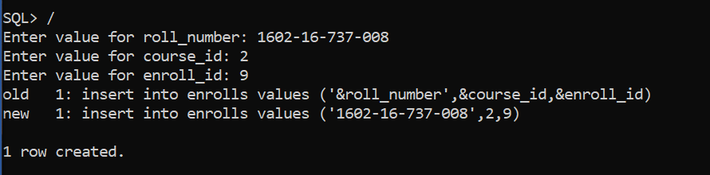

SQL> select * from enrolls;

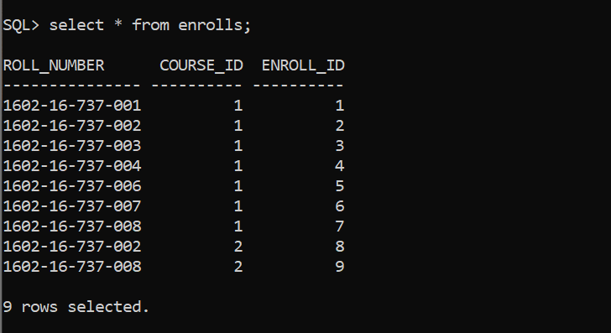

**IMPLEMENTATION**

**JAVA-SQL Connectivity using JDBC:**

**Java Database Connectivity (JDBC)** is an application programming interface (API) for the programming language Java, which defines how a client may access a database. It is a Java-based data access technology used for Java database connectivity. It is part of the Java Standard Edition platform, from Oracle Corporation. It provides methods to query and update data in a database and is oriented towards relational databases.

The connection to the database can be performed using Java programming (JDBC API) as:

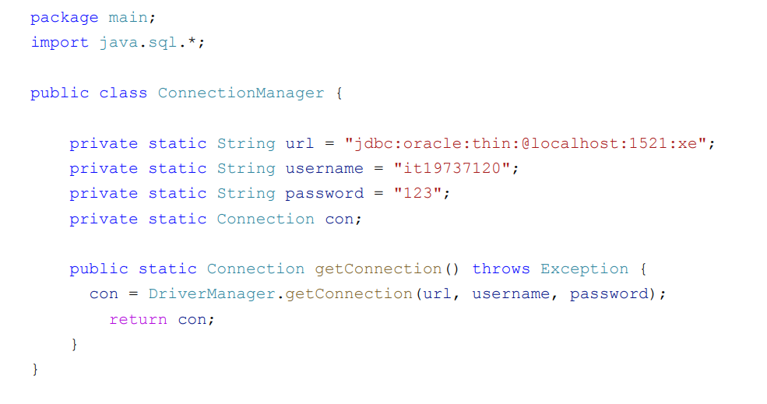

**Front-end Programs (User Interfaces):**

**Home Page:**

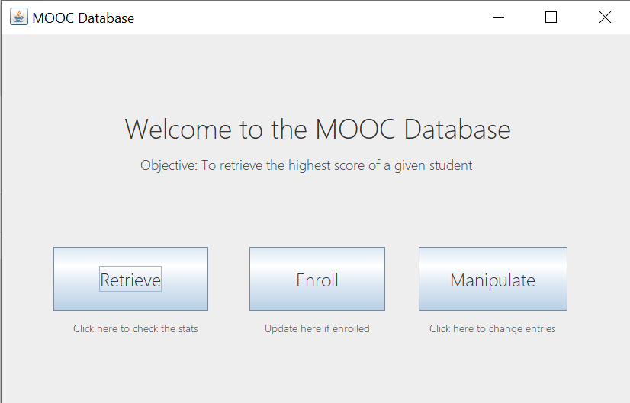

package moocdbase;

public class TheMainPage extends javax.swing.JFrame {

public TheMainPage() {

initComponents();

}

private void initComponents() {

jLabel1 = new javax.swing.JLabel();

jButton1 = new javax.swing.JButton();

jButton2 = new javax.swing.JButton();

jLabel2 = new javax.swing.JLabel();

jButton3 = new javax.swing.JButton();

jLabel3 = new javax.swing.JLabel();

jLabel4 = new javax.swing.JLabel();

jLabel5 = new javax.swing.JLabel();

setDefaultCloseOperation(javax.swing.WindowConstants.EXIT_ON_CLOSE);

setTitle("MOOC Database");

jLabel1.setFont(new java.awt.Font("Yu Gothic UI Light", 0, 36));

jLabel1.setText("Welcome to the MOOC Database");

jButton1.setFont(new java.awt.Font("Yu Gothic UI Light", 0, 24));

jButton1.setText("Retrieve");

jButton1.addActionListener(new java.awt.event.ActionListener() {

public void actionPerformed(java.awt.event.ActionEvent evt) {

jButton1ActionPerformed(evt);

}

});

jButton2.setFont(new java.awt.Font("Yu Gothic UI Light", 0, 24));

jButton2.setText("Manipulate");

jButton2.addActionListener(new java.awt.event.ActionListener() {

public void actionPerformed(java.awt.event.ActionEvent evt) {

jButton2ActionPerformed(evt);

}

});

jLabel2.setFont(new java.awt.Font("Yu Gothic UI Light", 0, 18));

jLabel2.setText("Objective: To retrieve the highest score of a given student");

jButton3.setFont(new java.awt.Font("Yu Gothic UI Light", 0, 24));

jButton3.setText("Enroll");

jButton3.addActionListener(new java.awt.event.ActionListener() {

public void actionPerformed(java.awt.event.ActionEvent evt) {

jButton3ActionPerformed(evt);

}

});

jLabel3.setFont(new java.awt.Font("Yu Gothic UI Light", 0, 14));

jLabel3.setText("Update here if enrolled");

jLabel4.setFont(new java.awt.Font("Yu Gothic UI Light", 0, 14));

jLabel4.setText("Click here to check the stats");

jLabel5.setFont(new java.awt.Font("Yu Gothic UI Light", 0, 14));

jLabel5.setText("Click here to change entries");

javax.swing.GroupLayout layout = new javax.swing.GroupLayout(getContentPane());

getContentPane().setLayout(layout);

layout.setHorizontalGroup(

layout.createParallelGroup(javax.swing.GroupLayout.Alignment.LEADING)

.addGroup(javax.swing.GroupLayout.Alignment.TRAILING, layout.createSequentialGroup()

.addContainerGap(javax.swing.GroupLayout.DEFAULT_SIZE, Short.MAX_VALUE)

.addGroup(layout.createParallelGroup(javax.swing.GroupLayout.Alignment.LEADING)

.addGroup(layout.createSequentialGroup()

.addGap(21, 21, 21)

.addComponent(jLabel2))

.addComponent(jLabel1))

.addGap(158, 158, 158))

.addGroup(javax.swing.GroupLayout.Alignment.TRAILING, layout.createSequentialGroup() .addGroup(layout.createParallelGroup(javax.swing.GroupLayout.Alignment.LEADING) .addGroup(layout.createSequentialGroup().addGap(68, 68, 68)

.addComponent(jButton1, javax.swing.GroupLayout.PREFERRED_SIZE, 203, javax.swing.GroupLayout.PREFERRED_SIZE)

.addGap(54, 54, 54) .addComponent(jButton3, javax.swing.GroupLayout.PREFERRED_SIZE, 178, javax.swing.GroupLayout.PREFERRED_SIZE))

.addGroup(layout.createSequentialGroup()

.addGap(94, 94, 94)

.addComponent(jLabel4)

.addGap(88, 88, 88)

.addComponent(jLabel3, javax.swing.GroupLayout.PREFERRED_SIZE, 148, javax.swing.GroupLayout.PREFERRED_SIZE))) .addPreferredGap(javax.swing.LayoutStyle.ComponentPlacement.RELATED, 44, Short.MAX_VALUE) .addGroup(layout.createParallelGroup(javax.swing.GroupLayout.Alignment.LEADING)

.addComponent(jButton2, javax.swing.GroupLayout.Alignment.TRAILING, javax.swing.GroupLayout.PREFERRED_SIZE, 195, javax.swing.GroupLayout.PREFERRED_SIZE)

.addComponent(jLabel5, javax.swing.GroupLayout.Alignment.TRAILING, javax.swing.GroupLayout.PREFERRED_SIZE, 181, javax.swing.GroupLayout.PREFERRED_SIZE))

.addGap(84, 84, 84))

);

layout.setVerticalGroup(

layout.createParallelGroup(javax.swing.GroupLayout.Alignment.LEADING)

.addGroup(layout.createSequentialGroup()

.addGap(98, 98, 98)

.addComponent(jLabel1)

.addPreferredGap(javax.swing.LayoutStyle.ComponentPlacement.UNRELATED)

.addComponent(jLabel2)

.addGap(96, 96, 96) .addGroup(layout.createParallelGroup(javax.swing.GroupLayout.Alignment.LEADING) .addGroup(layout.createParallelGroup(javax.swing.GroupLayout.Alignment.BASELINE) .addComponent(jButton1, javax.swing.GroupLayout.PREFERRED_SIZE, 84, javax.swing.GroupLayout.PREFERRED_SIZE)

.addComponent(jButton2, javax.swing.GroupLayout.PREFERRED_SIZE, 84, javax.swing.GroupLayout.PREFERRED_SIZE))

.addComponent(jButton3, javax.swing.GroupLayout.Alignment.TRAILING, javax.swing.GroupLayout.PREFERRED_SIZE, 84, javax.swing.GroupLayout.PREFERRED_SIZE))

.addPreferredGap(javax.swing.LayoutStyle.ComponentPlacement.UNRELATED) .addGroup(layout.createParallelGroup(javax.swing.GroupLayout.Alignment.LEADING) .addGroup(layout.createParallelGroup(javax.swing.GroupLayout.Alignment.BASELINE)

.addComponent(jLabel4)

.addComponent(jLabel3))

.addComponent(jLabel5))

.addContainerGap(90, Short.MAX_VALUE))

);

pack();

}

private void jButton2ActionPerformed(java.awt.event.ActionEvent evt) {

dispose();

MainFrame mf=new MainFrame();

mf.show();

}

private void jButton1ActionPerformed(java.awt.event.ActionEvent evt) {

dispose();

Retrieval r=new Retrieval();

r.show()}

private void jButton3ActionPerformed(java.awt.event.ActionEvent evt) {

dispose();

enroll e=new enroll();

e.show();

}

public static void main(String args[]) {

java.awt.EventQueue.invokeLater(new Runnable() {

public void run() {

new TheMainPage().setVisible(true);

}

});

}

private javax.swing.JButton jButton1;

private javax.swing.JButton jButton2;

private javax.swing.JButton jButton3;

private javax.swing.JLabel jLabel1;

private javax.swing.JLabel jLabel2;

private javax.swing.JLabel jLabel3;

private javax.swing.JLabel jLabel4;

private javax.swing.JLabel jLabel5;

}

**Manipulate Interface:**

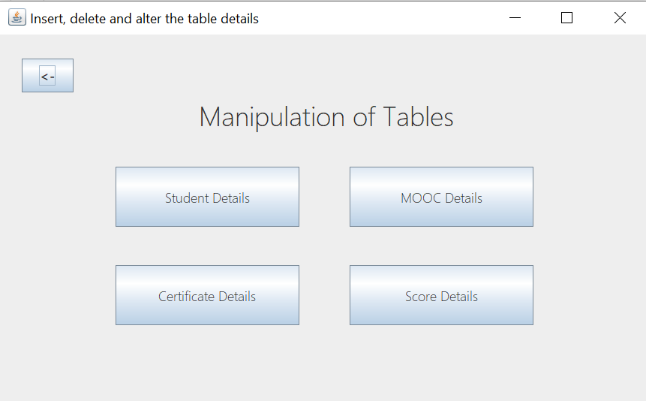

package moocdbase;

public class MainFrame extends javax.swing.JFrame {

public MainFrame() {

initComponents();

}

private void initComponents() {

jLabel1 = new javax.swing.JLabel();

jButton1 = new javax.swing.JButton();

jButton2 = new javax.swing.JButton();

jButton3 = new javax.swing.JButton();

jButton4 = new javax.swing.JButton();

jButton7 = new javax.swing.JButton();

setDefaultCloseOperation(javax.swing.WindowConstants.EXIT_ON_CLOSE);

setTitle("Insert, delete and alter the table details");

jLabel1.setFont(new java.awt.Font("Yu Gothic UI Light", 0, 36));

jLabel1.setText("Manipulation of Tables");

jButton1.setFont(new java.awt.Font("Yu Gothic UI Light", 0, 18));

jButton1.setText("MOOC Details");

jButton1.addActionListener(new java.awt.event.ActionListener() {

public void actionPerformed(java.awt.event.ActionEvent evt) {

jButton1ActionPerformed(evt);

}

});

jButton2.setFont(new java.awt.Font("Yu Gothic UI Light", 0, 18));

jButton2.setText("Certificate Details");

jButton2.addActionListener(new java.awt.event.ActionListener() {

public void actionPerformed(java.awt.event.ActionEvent evt) {

jButton2ActionPerformed(evt);

}

});

jButton3.setFont(new java.awt.Font("Yu Gothic UI Light", 0, 18));

jButton3.setText("Score Details");

jButton3.addActionListener(new java.awt.event.ActionListener() {

public void actionPerformed(java.awt.event.ActionEvent evt) {

jButton3ActionPerformed(evt);

}

});

jButton4.setFont(new java.awt.Font("Yu Gothic UI Light", 0, 18));

jButton4.setText("Student Details");

jButton4.addActionListener(new java.awt.event.ActionListener() {

public void actionPerformed(java.awt.event.ActionEvent evt) {

jButton4ActionPerformed(evt);

}

});

jButton7.setFont(new java.awt.Font("Yu Gothic UI", 1, 18));

jButton7.setText("<-");

jButton7.addActionListener(new java.awt.event.ActionListener() {

public void actionPerformed(java.awt.event.ActionEvent evt) {

jButton7ActionPerformed(evt);

}

});

javax.swing.GroupLayout layout = new javax.swing.GroupLayout(getContentPane());

getContentPane().setLayout(layout);

layout.setHorizontalGroup(

layout.createParallelGroup(javax.swing.GroupLayout.Alignment.LEADING)

.addGroup(layout.createSequentialGroup()

.addContainerGap(154, Short.MAX_VALUE) .addGroup(layout.createParallelGroup(javax.swing.GroupLayout.Alignment.LEADING)

.addGroup(javax.swing.GroupLayout.Alignment.TRAILING, layout.createSequentialGroup()

.addGroup(layout.createParallelGroup(javax.swing.GroupLayout.Alignment.TRAILING)

.addGroup(layout.createSequentialGroup()

.addComponent(jButton2, javax.swing.GroupLayout.PREFERRED_SIZE, 245, javax.swing.GroupLayout.PREFERRED_SIZE).addGap(67, 67, 67) .addComponent(jButton3, javax.swing.GroupLayout.PREFERRED_SIZE, 245, javax.swing.GroupLayout.PREFERRED_SIZE))

.addGroup(layout.createSequentialGroup()

.addComponent(jButton4, javax.swing.GroupLayout.PREFERRED_SIZE, 245, javax.swing.GroupLayout.PREFERRED_SIZE)

.addGap(67, 67, 67)

.addComponent(jButton1, javax.swing.GroupLayout.PREFERRED_SIZE, 245, javax.swing.GroupLayout.PREFERRED_SIZE)))

.addGap(150, 150, 150))

.addGroup(javax.swing.GroupLayout.Alignment.TRAILING, layout.createSequentialGroup()

.addComponent(jLabel1)

.addGap(256, 256, 256))))

.addGroup(layout.createSequentialGroup()

.addGap(29, 29, 29)

.addComponent(jButton7, javax.swing.GroupLayout.PREFERRED_SIZE, 69, javax.swing.GroupLayout.PREFERRED_SIZE)

.addGap(0, 0, Short.MAX_VALUE))

);

layout.setVerticalGroup(

layout.createParallelGroup(javax.swing.GroupLayout.Alignment.LEADING)

.addGroup(layout.createSequentialGroup()

.addGap(32, 32, 32)

.addComponent(jButton7, javax.swing.GroupLayout.PREFERRED_SIZE, 45, javax.swing.GroupLayout.PREFERRED_SIZE) .addPreferredGap(javax.swing.LayoutStyle.ComponentPlacement.RELATED)

.addComponent(jLabel1)

.addGap(45, 45, 45) .addGroup(layout.createParallelGroup(javax.swing.GroupLayout.Alignment.BASELINE)

.addComponent(jButton1, javax.swing.GroupLayout.PREFERRED_SIZE, 80, javax.swing.GroupLayout.PREFERRED_SIZE)

.addComponent(jButton4, javax.swing.GroupLayout.PREFERRED_SIZE, 80, javax.swing.GroupLayout.PREFERRED_SIZE))

.addGap(51, 51, 51) .addGroup(layout.createParallelGroup(javax.swing.GroupLayout.Alignment.BASELINE)

.addComponent(jButton2, javax.swing.GroupLayout.PREFERRED_SIZE, 80, javax.swing.GroupLayout.PREFERRED_SIZE)

.addComponent(jButton3, javax.swing.GroupLayout.PREFERRED_SIZE, 80, javax.swing.GroupLayout.PREFERRED_SIZE))

.addContainerGap(102, Short.MAX_VALUE))

);

pack();

}

private void jButton2ActionPerformed(java.awt.event.ActionEvent evt) {

dispose();

CertificateModify cf=new CertificateModify();

cf.show();

}

private void jButton4ActionPerformed(java.awt.event.ActionEvent evt) {

dispose();

StudentModify sf=new StudentModify();

sf.show();

}

private void jButton1ActionPerformed(java.awt.event.ActionEvent evt) {

dispose();

MOOCModify mf=new MOOCModify();

mf.show();

}

private void jButton3ActionPerformed(java.awt.event.ActionEvent evt) {

dispose();

ScoreModify sf=new ScoreModify();

sf.show();

}

private void jButton7ActionPerformed(java.awt.event.ActionEvent evt) {

dispose();

TheMainPage mp=new TheMainPage();

mp.show();

}

public static void main(String args[]) {

java.awt.EventQueue.invokeLater(new Runnable() {

public void run() {

new MainFrame().setVisible(true);

}

});

}

private javax.swing.JButton jButton1;

private javax.swing.JButton jButton2;

private javax.swing.JButton jButton3;

private javax.swing.JButton jButton4;

private javax.swing.JButton jButton7;

private javax.swing.JLabel jLabel1;

}

**Students Details:**

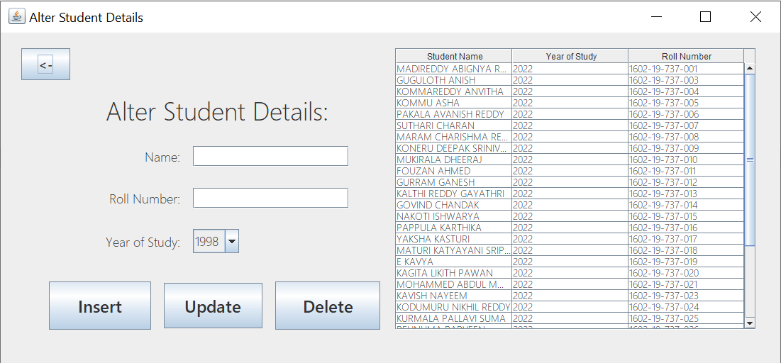

package moocdbase;

import java.sql.*;

import javax.swing.JOptionPane;

import javax.swing.table.DefaultTableModel;

public class StudentModify extends javax.swing.JFrame {

public StudentModify() {

initComponents();

action();

}

private void initComponents() {

jLabel1 = new javax.swing.JLabel();

jLabel5 = new javax.swing.JLabel();

year = new javax.swing.JComboBox<>();

jLabel2 = new javax.swing.JLabel();

jLabel3 = new javax.swing.JLabel();

name = new javax.swing.JTextField();

jLabel4 = new javax.swing.JLabel();

rno = new javax.swing.JTextField();

jButton2 = new javax.swing.JButton();

RnoBox = new javax.swing.JButton();

jScrollPane1 = new javax.swing.JScrollPane();

mainTable = new javax.swing.JTable();

jButton3 = new javax.swing.JButton();

JButton = new javax.swing.JButton();

jLabel1.setText("jLabel1");

setDefaultCloseOperation(javax.swing.WindowConstants.EXIT_ON_CLOSE);

setTitle("Alter Student Details");

jLabel5.setFont(new java.awt.Font("Yu Gothic UI Light", 0, 18));

jLabel5.setText("Year of Study:");

year.setFont(new java.awt.Font("Yu Gothic UI Light", 0, 18));

year.setModel(new javax.swing.DefaultComboBoxModel<>(new String[] { "1998", "1999", "2000", "2001", "2002", "2003", "2004", "2005", "2006", "2007", "2008", "2009", "2010", "2011", "2012", "2013", "2014", "2015", "2016", "2017", "2018", "2019", "2020", "2021", "2022" }));

jLabel2.setFont(new java.awt.Font("Yu Gothic UI Light", 0, 36));

jLabel2.setText("Alter Student Details:");

jLabel3.setFont(new java.awt.Font("Yu Gothic UI Light", 0, 18));

jLabel3.setText("Name:");

name.setFont(new java.awt.Font("Yu Gothic UI Light", 0, 18));

name.addActionListener(new java.awt.event.ActionListener() {

public void actionPerformed(java.awt.event.ActionEvent evt) {

nameActionPerformed(evt);

}

});

jLabel4.setFont(new java.awt.Font("Yu Gothic UI Light", 0, 18));

jLabel4.setText("Roll Number:");

rno.setFont(new java.awt.Font("Yu Gothic UI Light", 0, 18));

rno.addActionListener(new java.awt.event.ActionListener() {

public void actionPerformed(java.awt.event.ActionEvent evt) {

rnoActionPerformed(evt);

}

});

jButton2.setFont(new java.awt.Font("Yu Gothic UI", 1, 18));

jButton2.setText("<-");

jButton2.addActionListener(new java.awt.event.ActionListener() {

public void actionPerformed(java.awt.event.ActionEvent evt) {

jButton2ActionPerformed(evt);

}

});

RnoBox.setFont(new java.awt.Font("Yu Gothic UI", 1, 24));

RnoBox.setText("Update");

RnoBox.addActionListener(new java.awt.event.ActionListener() {

public void actionPerformed(java.awt.event.ActionEvent evt) {

RnoBoxActionPerformed(evt);

}

});

mainTable.setFont(new java.awt.Font("Yu Gothic UI Light", 0, 14));

mainTable.setModel(new javax.swing.table.DefaultTableModel(

new Object [][] {

{null, null, null},

{null, null, null},

{null, null, null},

{null, null, null},

{null, null, null},

{null, null, null},

{null, null, null},

{null, null, null},

{null, null, null},

{null, null, null}

},

new String [] {

"Student Name", "Year of Study", "Roll Number"

}

));

mainTable.addMouseListener(new java.awt.event.MouseAdapter() {

public void mouseClicked(java.awt.event.MouseEvent evt) {

mainTableMouseClicked(evt);

}

});

jScrollPane1.setViewportView(mainTable);

jButton3.setFont(new java.awt.Font("Yu Gothic UI", 1, 24));

jButton3.setText("Insert");

jButton3.addActionListener(new java.awt.event.ActionListener() {

public void actionPerformed(java.awt.event.ActionEvent evt) {

jButton3ActionPerformed(evt);

}

});

JButton.setFont(new java.awt.Font("Yu Gothic UI", 1, 24));

JButton.setText("Delete");

JButton.addActionListener(new java.awt.event.ActionListener() {

public void actionPerformed(java.awt.event.ActionEvent evt) {

JButtonActionPerformed(evt);

}

});

javax.swing.GroupLayout layout = new javax.swing.GroupLayout(getContentPane());

getContentPane().setLayout(layout);

layout.setHorizontalGroup(

layout.createParallelGroup(javax.swing.GroupLayout.Alignment.LEADING)

.addGroup(layout.createSequentialGroup()

.addGroup(layout.createParallelGroup(javax.swing.GroupLayout.Alignment.LEADING)

.addGroup(layout.createSequentialGroup()

.addGap(29, 29, 29)

.addComponent(jButton2, javax.swing.GroupLayout.PREFERRED_SIZE, 69, javax.swing.GroupLayout.PREFERRED_SIZE) .addPreferredGap(javax.swing.LayoutStyle.ComponentPlacement.RELATED, 50, Short.MAX_VALUE) .addGroup(layout.createParallelGroup(javax.swing.GroupLayout.Alignment.LEADING)

.addGroup(layout.createSequentialGroup() .addGroup(layout.createParallelGroup(javax.swing.GroupLayout.Alignment.TRAILING)

.addComponent(jLabel4)

.addComponent(jLabel3)

.addComponent(jLabel5))

.addGap(18, 18, 18) .addGroup(layout.createParallelGroup(javax.swing.GroupLayout.Alignment.LEADING) .addGroup(layout.createParallelGroup(javax.swing.GroupLayout.Alignment.TRAILING, false)

.addComponent(name, javax.swing.GroupLayout.Alignment.LEADING)

.addComponent(rno, javax.swing.GroupLayout.PREFERRED_SIZE, 220, javax.swing.GroupLayout.PREFERRED_SIZE))

.addComponent(year, javax.swing.GroupLayout.PREFERRED_SIZE, javax.swing.GroupLayout.DEFAULT_SIZE, javax.swing.GroupLayout.PREFERRED_SIZE)))

.addComponent(jLabel2, javax.swing.GroupLayout.PREFERRED_SIZE, 387, javax.swing.GroupLayout.PREFERRED_SIZE)))

.addGroup(layout.createSequentialGroup()

.addContainerGap(javax.swing.GroupLayout.DEFAULT_SIZE, Short.MAX_VALUE)

.addComponent(jButton3, javax.swing.GroupLayout.PREFERRED_SIZE, 144, javax.swing.GroupLayout.PREFERRED_SIZE)

.addGap(18, 18, 18)

.addComponent(RnoBox, javax.swing.GroupLayout.PREFERRED_SIZE, 139, javax.swing.GroupLayout.PREFERRED_SIZE)

.addGap(18, 18, 18)

.addComponent(JButton, javax.swing.GroupLayout.PREFERRED_SIZE, 148, javax.swing.GroupLayout.PREFERRED_SIZE))) .addPreferredGap(javax.swing.LayoutStyle.ComponentPlacement.RELATED, 21, Short.MAX_VALUE)

.addComponent(jScrollPane1, javax.swing.GroupLayout.PREFERRED_SIZE, 509, javax.swing.GroupLayout.PREFERRED_SIZE)

.addContainerGap(34, Short.MAX_VALUE))

);

layout.setVerticalGroup(

layout.createParallelGroup(javax.swing.GroupLayout.Alignment.LEADING)

.addGroup(layout.createSequentialGroup()

.addGap(22, 22, 22)

.addGroup(layout.createParallelGroup(javax.swing.GroupLayout.Alignment.LEADING, false)

.addComponent(jScrollPane1, javax.swing.GroupLayout.PREFERRED_SIZE, 0, Short.MAX_VALUE)

.addGroup(layout.createSequentialGroup() .addGroup(layout.createParallelGroup(javax.swing.GroupLayout.Alignment.LEADING)

.addGroup(layout.createSequentialGroup()

.addComponent(jButton2, javax.swing.GroupLayout.PREFERRED_SIZE, 45, javax.swing.GroupLayout.PREFERRED_SIZE)

.addGap(284, 284, 284))

.addGroup(javax.swing.GroupLayout.Alignment.TRAILING, layout.createSequentialGroup()

.addComponent(jLabel2, javax.swing.GroupLayout.PREFERRED_SIZE, 66, javax.swing.GroupLayout.PREFERRED_SIZE)

.addGap(18, 18, 18) .addGroup(layout.createParallelGroup(javax.swing.GroupLayout.Alignment.BASELINE)

.addComponent(jLabel3)

.addComponent(name, javax.swing.GroupLayout.PREFERRED_SIZE, javax.swing.GroupLayout.DEFAULT_SIZE, javax.swing.GroupLayout.PREFERRED_SIZE))

.addGap(30, 30, 30) .addGroup(layout.createParallelGroup(javax.swing.GroupLayout.Alignment.BASELINE)

.addComponent(jLabel4)

.addComponent(rno, javax.swing.GroupLayout.PREFERRED_SIZE, javax.swing.GroupLayout.DEFAULT_SIZE, javax.swing.GroupLayout.PREFERRED_SIZE))

.addGap(29, 29, 29)

.addGroup(layout.createParallelGroup(javax.swing.GroupLayout.Alignment.BASELINE)

.addComponent(jLabel5)

.addComponent(year, javax.swing.GroupLayout.PREFERRED_SIZE, javax.swing.GroupLayout.DEFAULT_SIZE, javax.swing.GroupLayout.PREFERRED_SIZE))

.addGap(40, 40, 40))) .addGroup(layout.createParallelGroup(javax.swing.GroupLayout.Alignment.BASELINE)

.addComponent(JButton, javax.swing.GroupLayout.PREFERRED_SIZE, 68, javax.swing.GroupLayout.PREFERRED_SIZE)

.addComponent(jButton3, javax.swing.GroupLayout.PREFERRED_SIZE, 68, javax.swing.GroupLayout.PREFERRED_SIZE)

.addComponent(RnoBox, javax.swing.GroupLayout.PREFERRED_SIZE, 64, javax.swing.GroupLayout.PREFERRED_SIZE))))

.addContainerGap(47, Short.MAX_VALUE))

);

pack();

}

private void nameActionPerformed(java.awt.event.ActionEvent evt) {

}

private void rnoActionPerformed(java.awt.event.ActionEvent evt) {

}

private void jButton2ActionPerformed(java.awt.event.ActionEvent evt) {

dispose();

MainFrame cf=new MainFrame();

cf.show();

}

public void action(){

try{

Class.forName("oracle.jdbc.OracleDriver");

Connection con = DriverManager.getConnection("jdbc:oracle:thin:@localhost:1521:xe","abhiram","iruvanti");

Statement stmt=con.createStatement();

ResultSet rs=stmt.executeQuery("select * from students");

DefaultTableModel tm=(DefaultTableModel)mainTable.getModel();

tm.setRowCount(0);

while(rs.next()) {

Object o[]={rs.getString("student_name"),rs.getInt("year_of_study"),rs.getString("roll_number")};

tm.addRow(o);

}

}

catch(ClassNotFoundException | SQLException e)

{

JOptionPane.showMessageDialog(this,e);

}

}

private void RnoBoxActionPerformed(java.awt.event.ActionEvent evt) {

String nam=name.getText();

String roll=rno.getText();

String y=year.getSelectedItem().toString();

try{

Class.forName("oracle.jdbc.OracleDriver");

Connection con = DriverManager.getConnection("jdbc:oracle:thin:@localhost:1521:xe","abhiram","iruvanti");

Statement stmt=con.createStatement();

stmt.executeQuery("update students set student_name='"+nam+"',year_of_study="+y+" where roll_number='"+roll+"'");

JOptionPane.showMessageDialog(this,"Update Successful!");

}

catch(ClassNotFoundException | SQLException e)

{

JOptionPane.showMessageDialog(this,"There must be some problem!");

}

action();

name.setText("");

rno.setText("");

year.setSelectedItem("1998");

}

private void mainTableMouseClicked(java.awt.event.MouseEvent evt) {

try{

Class.forName("oracle.jdbc.OracleDriver");

Connection con = DriverManager.getConnection("jdbc:oracle:thin:@localhost:1521:xe","abhiram","iruvanti");

Statement stmt=con.createStatement();

int row=mainTable.getSelectedRow();

String Rno=(mainTable.getModel().getValueAt(row,2)).toString();

ResultSet rs=stmt.executeQuery("select * from students where roll_number='"+Rno+"'");

while(rs.next()){

name.setText(rs.getString("student_name"));

year.setSelectedItem(rs.getString("year_of_study"));

rno.setText(rs.getString("roll_number"));

}

con.close();

}

catch(ClassNotFoundException | SQLException e){

JOptionPane.showMessageDialog(this,e);

}

}

private void jButton3ActionPerformed(java.awt.event.ActionEvent evt) {

String nam=name.getText();

String roll=rno.getText();

String y=year.getSelectedItem().toString();

String nm="";

try{

Class.forName("oracle.jdbc.OracleDriver");

Connection con = DriverManager.getConnection("jdbc:oracle:thin:@localhost:1521:xe","abhiram","iruvanti");

Statement stmt=con.createStatement();

stmt.executeQuery("insert into students values('"+nam+"',"+y+",'"+roll+"')");

JOptionPane.showMessageDialog(this,"Insert Successful!");

}

catch(ClassNotFoundException | SQLException e)

{

JOptionPane.showMessageDialog(this,"There must be some problem!");

}

action();

name.setText("");

rno.setText("");

year.setSelectedItem("1998");

}

private void JButtonActionPerformed(java.awt.event.ActionEvent evt) {

String roll=rno.getText();

try{

Class.forName("oracle.jdbc.OracleDriver");

Connection con = DriverManager.getConnection("jdbc:oracle:thin:@localhost:1521:xe","abhiram","iruvanti");

Statement stmt=con.createStatement();

stmt.executeQuery("delete from students where roll_number='"+roll+"'");

JOptionPane.showMessageDialog(this,"Delete Successful!");

}

catch(ClassNotFoundException | SQLException e)

{

JOptionPane.showMessageDialog(this,"There must be some problem!");

}

action();

rno.setText("");

}

public static void main(String args[]) {

java.awt.EventQueue.invokeLater(new Runnable() {

public void run() {

new StudentModify().setVisible(true);

}

});

}

private javax.swing.JButton JButton;

private javax.swing.JButton RnoBox;

private javax.swing.JButton jButton2;

private javax.swing.JButton jButton3;

private javax.swing.JLabel jLabel1;

private javax.swing.JLabel jLabel2;

private javax.swing.JLabel jLabel3;

private javax.swing.JLabel jLabel4;

private javax.swing.JLabel jLabel5;

private javax.swing.JScrollPane jScrollPane1;

private javax.swing.JTable mainTable;

private javax.swing.JTextField name;

private javax.swing.JTextField rno;

private javax.swing.JComboBox<String> year;

}

**MOOC Details:**

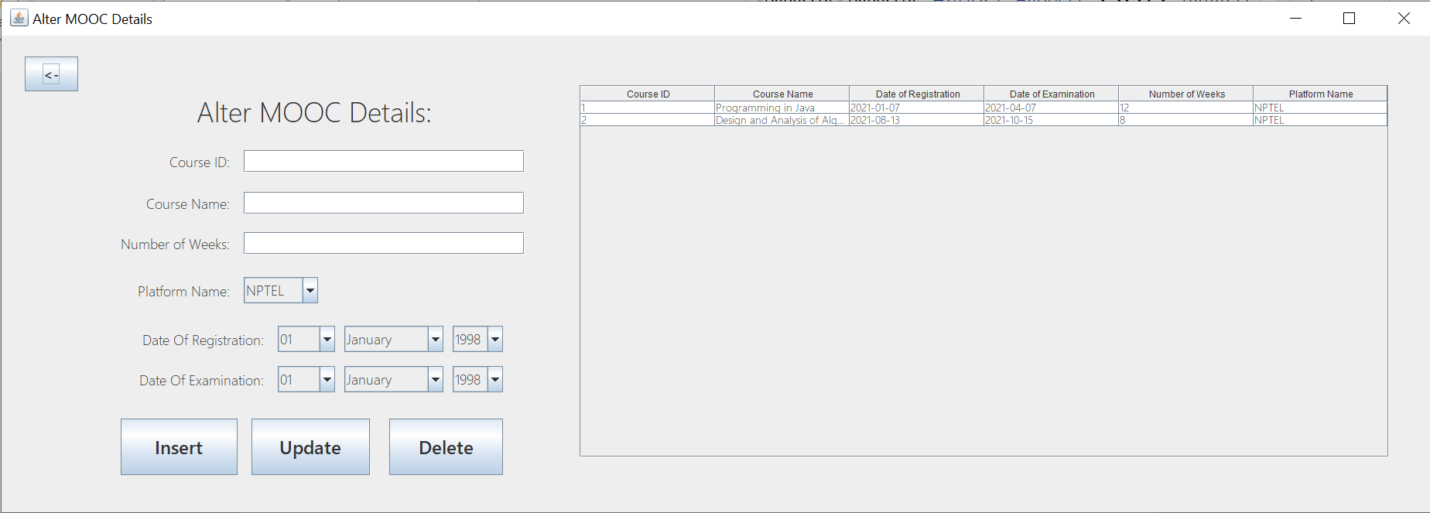

package moocdbase;

import java.sql.Connection;

import java.sql.DriverManager;

import java.sql.ResultSet;

import java.sql.SQLException;

import java.sql.Statement;

import java.util.StringTokenizer;

import javax.swing.JOptionPane;

import javax.swing.table.DefaultTableModel;

public class MOOCModify extends javax.swing.JFrame {

public MOOCModify() {

initComponents();

action();

}

private void initComponents() {

cname = new javax.swing.JTextField();

jLabel8 = new javax.swing.JLabel();

monthe = new javax.swing.JComboBox<>();

monthr = new javax.swing.JComboBox<>();

platform = new javax.swing.JComboBox<>();

yeare = new javax.swing.JComboBox<>();

yearr = new javax.swing.JComboBox<>();

jLabel7 = new javax.swing.JLabel();

jLabel2 = new javax.swing.JLabel();

dayr = new javax.swing.JComboBox<>();

jLabel3 = new javax.swing.JLabel();

cid = new javax.swing.JTextField();

jLabel4 = new javax.swing.JLabel();

week = new javax.swing.JTextField();

jLabel6 = new javax.swing.JLabel();

jLabel5 = new javax.swing.JLabel();

daye = new javax.swing.JComboBox<>();

jButton1 = new javax.swing.JButton();

jButton2 = new javax.swing.JButton();

jScrollPane1 = new javax.swing.JScrollPane();

mainTable = new javax.swing.JTable();

jButton3 = new javax.swing.JButton();

jButton4 = new javax.swing.JButton();

setDefaultCloseOperation(javax.swing.WindowConstants.EXIT_ON_CLOSE);

setTitle("Alter MOOC Details");

cname.setFont(new java.awt.Font("Yu Gothic UI Light", 0, 18));

cname.addActionListener(new java.awt.event.ActionListener() {

public void actionPerformed(java.awt.event.ActionEvent evt) {

cnameActionPerformed(evt);

}

});

jLabel8.setFont(new java.awt.Font("Yu Gothic UI Light", 0, 18));

jLabel8.setText("Platform Name:");

monthe.setFont(new java.awt.Font("Yu Gothic UI Light", 0, 18));

monthe.setModel(new javax.swing.DefaultComboBoxModel<>(new String[] { "January", "February", "March", "April", "May", "June", "July", "August", "September", "October", "November", "December" }));

monthr.setFont(new java.awt.Font("Yu Gothic UI Light", 0, 18));

monthr.setModel(new javax.swing.DefaultComboBoxModel<>(new String[] { "January", "February", "March", "April", "May", "June", "July", "August", "September", "October", "November", "December" }));

platform.setFont(new java.awt.Font("Yu Gothic UI Light", 0, 18));

platform.setModel(new javax.swing.DefaultComboBoxModel<>(new String[] { "NPTEL", "eDx", "Coursera" }));

platform.addActionListener(new java.awt.event.ActionListener() {

public void actionPerformed(java.awt.event.ActionEvent evt) {

platformActionPerformed(evt);

}

});

yeare.setFont(new java.awt.Font("Yu Gothic UI Light", 0, 18));

yeare.setModel(new javax.swing.DefaultComboBoxModel<>(new String[] { "1998", "1999", "2000", "2001", "2002", "2003", "2004", "2005", "2006", "2007", "2008", "2009", "2010", "2011", "2012", "2013", "2014", "2015", "2016", "2017", "2018", "2019", "2020", "2021", "2022" }));

yearr.setFont(new java.awt.Font("Yu Gothic UI Light", 0, 18));

yearr.setModel(new javax.swing.DefaultComboBoxModel<>(new String[] { "1998", "1999", "2000", "2001", "2002", "2003", "2004", "2005", "2006", "2007", "2008", "2009", "2010", "2011", "2012", "2013", "2014", "2015", "2016", "2017", "2018", "2019", "2020", "2021", "2022" }));

jLabel7.setFont(new java.awt.Font("Yu Gothic UI Light", 0, 18));

jLabel7.setText("Date Of Registration:");

jLabel2.setFont(new java.awt.Font("Yu Gothic UI Light", 0, 36));

jLabel2.setText("Alter MOOC Details:");

dayr.setFont(new java.awt.Font("Yu Gothic UI Light", 0, 18));

dayr.setModel(new javax.swing.DefaultComboBoxModel<>(new String[] { "01", "02", "03", "04", "05", "06", "07", "08", "09", "10", "11", "12", "13", "14", "15", "16", "17", "18", "19", "20", "21", "22", "23", "24", "25", "26", "27", "28", "29", "30", "31" }));

dayr.addActionListener(new java.awt.event.ActionListener() {

public void actionPerformed(java.awt.event.ActionEvent evt) {

dayrActionPerformed(evt);

}

});

jLabel3.setFont(new java.awt.Font("Yu Gothic UI Light", 0, 18));

jLabel3.setText("Course ID:");

cid.setFont(new java.awt.Font("Yu Gothic UI Light", 0, 18));

cid.addActionListener(new java.awt.event.ActionListener() {

public void actionPerformed(java.awt.event.ActionEvent evt) {

cidActionPerformed(evt);

}

});

jLabel4.setFont(new java.awt.Font("Yu Gothic UI Light", 0, 18));

jLabel4.setText("Course Name:");

week.setFont(new java.awt.Font("Yu Gothic UI Light", 0, 18));

week.addActionListener(new java.awt.event.ActionListener() {

public void actionPerformed(java.awt.event.ActionEvent evt) {

weekActionPerformed(evt);

}

});

jLabel6.setFont(new java.awt.Font("Yu Gothic UI Light", 0, 18));

jLabel6.setText("Number of Weeks:");

jLabel5.setFont(new java.awt.Font("Yu Gothic UI Light", 0, 18));

jLabel5.setText("Date Of Examination:");

daye.setFont(new java.awt.Font("Yu Gothic UI Light", 0, 18));

daye.setModel(new javax.swing.DefaultComboBoxModel<>(new String[] { "01", "02", "03", "04", "05", "06", "07", "08", "09", "10", "11", "12", "13", "14", "15", "16", "17", "18", "19", "20", "21", "22", "23", "24", "25", "26", "27", "28", "29", "30", "31" }));

daye.addActionListener(new java.awt.event.ActionListener() {

public void actionPerformed(java.awt.event.ActionEvent evt) {

dayeActionPerformed(evt);

}

});

jButton1.setFont(new java.awt.Font("Yu Gothic UI", 1, 24));

jButton1.setText("Update");

jButton1.addActionListener(new java.awt.event.ActionListener() {

public void actionPerformed(java.awt.event.ActionEvent evt) {

jButton1ActionPerformed(evt);

}

});

jButton2.setFont(new java.awt.Font("Yu Gothic UI", 1, 18));

jButton2.setText("<-");

jButton2.addActionListener(new java.awt.event.ActionListener() {

public void actionPerformed(java.awt.event.ActionEvent evt) {

jButton2ActionPerformed(evt);

}

});

mainTable.setFont(new java.awt.Font("Yu Gothic UI Light", 0, 14));

mainTable.setModel(new javax.swing.table.DefaultTableModel(

new Object [][] {

{null, null, null, null, null, null},

{null, null, null, null, null, null},

{null, null, null, null, null, null},

{null, null, null, null, null, null},

{null, null, null, null, null, null},

{null, null, null, null, null, null},

{null, null, null, null, null, null},

{null, null, null, null, null, null},

{null, null, null, null, null, null},

{null, null, null, null, null, null}

},

new String [] {

"Course ID", "Course Name", "Date of Registration", "Date of Examination", "Number of Weeks", "Platform Name"

}

));

mainTable.addMouseListener(new java.awt.event.MouseAdapter() {

public void mouseClicked(java.awt.event.MouseEvent evt) {

mainTableMouseClicked(evt);

}

});

jScrollPane1.setViewportView(mainTable);

jButton3.setFont(new java.awt.Font("Yu Gothic UI", 1, 24));

jButton3.setText("Insert");

jButton3.addActionListener(new java.awt.event.ActionListener() {

public void actionPerformed(java.awt.event.ActionEvent evt) {

jButton3ActionPerformed(evt);

}

});

jButton4.setFont(new java.awt.Font("Yu Gothic UI", 1, 24));

jButton4.setText("Delete");

jButton4.addActionListener(new java.awt.event.ActionListener() {

public void actionPerformed(java.awt.event.ActionEvent evt) {

jButton4ActionPerformed(evt);

}

});

javax.swing.GroupLayout layout = new javax.swing.GroupLayout(getContentPane());

getContentPane().setLayout(layout);

layout.setHorizontalGroup(

layout.createParallelGroup(javax.swing.GroupLayout.Alignment.LEADING)

.addGroup(layout.createSequentialGroup()

.addGroup(layout.createParallelGroup(javax.swing.GroupLayout.Alignment.LEADING)

.addGroup(layout.createSequentialGroup()

.addGap(30, 30, 30)

.addComponent(jButton2, javax.swing.GroupLayout.PREFERRED_SIZE, 69, javax.swing.GroupLayout.PREFERRED_SIZE)

.addGap(153, 153, 153)

.addComponent(jLabel2, javax.swing.GroupLayout.PREFERRED_SIZE, 464, javax.swing.GroupLayout.PREFERRED_SIZE))

.addGroup(layout.createSequentialGroup()

.addGap(154, 154, 154) .addGroup(layout.createParallelGroup(javax.swing.GroupLayout.Alignment.LEADING)

.addGroup(layout.createSequentialGroup() .addGroup(layout.createParallelGroup(javax.swing.GroupLayout.Alignment.TRAILING)

.addGroup(layout.createSequentialGroup()

.addComponent(jLabel8)

.addGap(18, 18, 18))

.addGroup(layout.createSequentialGroup() .addGroup(layout.createParallelGroup(javax.swing.GroupLayout.Alignment.TRAILING)

.addComponent(jLabel4)

.addComponent(jLabel6)

.addComponent(jLabel3))

.addGap(18, 18, 18) .addGroup(layout.createParallelGroup(javax.swing.GroupLayout.Alignment.LEADING, false)

.addComponent(week, javax.swing.GroupLayout.Alignment.TRAILING)

.addComponent(cname, javax.swing.GroupLayout.Alignment.TRAILING)

.addComponent(cid, javax.swing.GroupLayout.Alignment.TRAILING, javax.swing.GroupLayout.PREFERRED_SIZE, 363, javax.swing.GroupLayout.PREFERRED_SIZE)

.addComponent(platform, javax.swing.GroupLayout.PREFERRED_SIZE, javax.swing.GroupLayout.DEFAULT_SIZE, javax.swing.GroupLayout.PREFERRED_SIZE))) .addGroup(layout.createParallelGroup(javax.swing.GroupLayout.Alignment.TRAILING)

.addGroup(layout.createSequentialGroup()

.addComponent(jLabel7) .addPreferredGap(javax.swing.LayoutStyle.ComponentPlacement.UNRELATED)

.addComponent(dayr, javax.swing.GroupLayout.PREFERRED_SIZE, 74, javax.swing.GroupLayout.PREFERRED_SIZE)

.addPreferredGap(javax.swing.LayoutStyle.ComponentPlacement.UNRELATED)

.addComponent(monthr, javax.swing.GroupLayout.PREFERRED_SIZE, 128, javax.swing.GroupLayout.PREFERRED_SIZE) .addPreferredGap(javax.swing.LayoutStyle.ComponentPlacement.UNRELATED)

.addComponent(yearr, javax.swing.GroupLayout.PREFERRED_SIZE, javax.swing.GroupLayout.DEFAULT_SIZE, javax.swing.GroupLayout.PREFERRED_SIZE))

.addGroup(layout.createSequentialGroup()

.addComponent(jLabel5) .addPreferredGap(javax.swing.LayoutStyle.ComponentPlacement.UNRELATED)

.addComponent(daye, javax.swing.GroupLayout.PREFERRED_SIZE, 74, javax.swing.GroupLayout.PREFERRED_SIZE) .addPreferredGap(javax.swing.LayoutStyle.ComponentPlacement.UNRELATED)

.addComponent(monthe, javax.swing.GroupLayout.PREFERRED_SIZE, 128, javax.swing.GroupLayout.PREFERRED_SIZE) .addPreferredGap(javax.swing.LayoutStyle.ComponentPlacement.UNRELATED)

.addComponent(yeare, javax.swing.GroupLayout.PREFERRED_SIZE, javax.swing.GroupLayout.DEFAULT_SIZE, javax.swing.GroupLayout.PREFERRED_SIZE))

.addGroup(layout.createSequentialGroup()

.addComponent(jButton3, javax.swing.GroupLayout.PREFERRED_SIZE, 151, javax.swing.GroupLayout.PREFERRED_SIZE)

.addGap(18, 18, 18)

.addComponent(jButton1, javax.swing.GroupLayout.PREFERRED_SIZE, 153, javax.swing.GroupLayout.PREFERRED_SIZE)

.addGap(25, 25, 25)

.addComponent(jButton4, javax.swing.GroupLayout.PREFERRED_SIZE, 147, javax.swing.GroupLayout.PREFERRED_SIZE))))))

.addPreferredGap(javax.swing.LayoutStyle.ComponentPlacement.RELATED, 31, Short.MAX_VALUE)

.addComponent(jScrollPane1, javax.swing.GroupLayout.PREFERRED_SIZE, 1046, javax.swing.GroupLayout.PREFERRED_SIZE)

.addGap(54, 54, 54))

);

layout.setVerticalGroup(

layout.createParallelGroup(javax.swing.GroupLayout.Alignment.LEADING)

.addGroup(layout.createSequentialGroup()

.addGroup(layout.createParallelGroup(javax.swing.GroupLayout.Alignment.LEADING)

.addGroup(layout.createSequentialGroup()

.addGap(64, 64, 64)

.addComponent(jScrollPane1, javax.swing.GroupLayout.PREFERRED_SIZE, 481, javax.swing.GroupLayout.PREFERRED_SIZE))

.addGroup(layout.createSequentialGroup() .addGroup(layout.createParallelGroup(javax.swing.GroupLayout.Alignment.LEADING)

.addGroup(layout.createSequentialGroup()

.addGap(64, 64, 64)

.addComponent(jLabel2, javax.swing.GroupLayout.PREFERRED_SIZE, 66, javax.swing.GroupLayout.PREFERRED_SIZE))

.addGroup(layout.createSequentialGroup()

.addGap(27, 27, 27)

.addComponent(jButton2, javax.swing.GroupLayout.PREFERRED_SIZE, 45, javax.swing.GroupLayout.PREFERRED_SIZE)))

.addGap(18, 18, 18) .addGroup(layout.createParallelGroup(javax.swing.GroupLayout.Alignment.BASELINE)

.addComponent(cid, javax.swing.GroupLayout.PREFERRED_SIZE, javax.swing.GroupLayout.DEFAULT_SIZE, javax.swing.GroupLayout.PREFERRED_SIZE)

.addComponent(jLabel3))

.addGap(25, 25, 25)

.addGroup(layout.createParallelGroup(javax.swing.GroupLayout.Alignment.BASELINE)

.addComponent(cname, javax.swing.GroupLayout.PREFERRED_SIZE, javax.swing.GroupLayout.DEFAULT_SIZE, javax.swing.GroupLayout.PREFERRED_SIZE)

.addComponent(jLabel4))

.addGap(23, 23, 23)

.addGroup(layout.createParallelGroup(javax.swing.GroupLayout.Alignment.BASELINE)

.addComponent(week, javax.swing.GroupLayout.PREFERRED_SIZE, javax.swing.GroupLayout.DEFAULT_SIZE, javax.swing.GroupLayout.PREFERRED_SIZE)

.addComponent(jLabel6))

.addGap(29, 29, 29) .addGroup(layout.createParallelGroup(javax.swing.GroupLayout.Alignment.BASELINE)

.addComponent(jLabel8)

.addComponent(platform, javax.swing.GroupLayout.PREFERRED_SIZE, javax.swing.GroupLayout.DEFAULT_SIZE, javax.swing.GroupLayout.PREFERRED_SIZE))

.addGap(29, 29, 29) .addGroup(layout.createParallelGroup(javax.swing.GroupLayout.Alignment.BASELINE)

.addComponent(jLabel7)

.addComponent(dayr, javax.swing.GroupLayout.PREFERRED_SIZE, javax.swing.GroupLayout.DEFAULT_SIZE, javax.swing.GroupLayout.PREFERRED_SIZE)

.addComponent(monthr, javax.swing.GroupLayout.PREFERRED_SIZE, javax.swing.GroupLayout.DEFAULT_SIZE, javax.swing.GroupLayout.PREFERRED_SIZE)

.addComponent(yearr, javax.swing.GroupLayout.PREFERRED_SIZE, javax.swing.GroupLayout.DEFAULT_SIZE, javax.swing.GroupLayout.PREFERRED_SIZE))

.addGap(18, 18, 18) .addGroup(layout.createParallelGroup(javax.swing.GroupLayout.Alignment.BASELINE)

.addComponent(jLabel5)

.addComponent(daye, javax.swing.GroupLayout.PREFERRED_SIZE, javax.swing.GroupLayout.DEFAULT_SIZE, javax.swing.GroupLayout.PREFERRED_SIZE)

.addComponent(monthe, javax.swing.GroupLayout.PREFERRED_SIZE, javax.swing.GroupLayout.DEFAULT_SIZE, javax.swing.GroupLayout.PREFERRED_SIZE)

.addComponent(yeare, javax.swing.GroupLayout.PREFERRED_SIZE, javax.swing.GroupLayout.DEFAULT_SIZE, javax.swing.GroupLayout.PREFERRED_SIZE))

.addGap(34, 34, 34) .addGroup(layout.createParallelGroup(javax.swing.GroupLayout.Alignment.BASELINE)

.addComponent(jButton1, javax.swing.GroupLayout.PREFERRED_SIZE, 73, javax.swing.GroupLayout.PREFERRED_SIZE)

.addComponent(jButton4, javax.swing.GroupLayout.PREFERRED_SIZE, 73, javax.swing.GroupLayout.PREFERRED_SIZE)

.addComponent(jButton3, javax.swing.GroupLayout.PREFERRED_SIZE, 73, javax.swing.GroupLayout.PREFERRED_SIZE))))

.addContainerGap(48, Short.MAX_VALUE))

);

pack();

private void cnameActionPerformed(java.awt.event.ActionEvent evt) {

}

private void platformActionPerformed(java.awt.event.ActionEvent evt) {

}

private void dayrActionPerformed(java.awt.event.ActionEvent evt) {

}

private void cidActionPerformed(java.awt.event.ActionEvent evt) {

}

private void weekActionPerformed(java.awt.event.ActionEvent evt) {

}

private void dayeActionPerformed(java.awt.event.ActionEvent evt) {

}

private void jButton2ActionPerformed(java.awt.event.ActionEvent evt) {

dispose();

MainFrame cf=new MainFrame();

cf.show();

}

private void jButton1ActionPerformed(java.awt.event.ActionEvent evt) {

String Cid=cid.getText();

String Cname=cname.getText();

String no_of_weeks=week.getText();

String Pname=platform.getSelectedItem().toString();

String rday=dayr.getSelectedItem().toString();

String rmonth=monthr.getSelectedItem().toString();

String ryear=yearr.getSelectedItem().toString();

String eday=daye.getSelectedItem().toString();

String emonth=monthe.getSelectedItem().toString();

String eyear=yeare.getSelectedItem().toString();

String nm="";

switch(rmonth){

case "January":nm="JAN";break;

case "February":nm="FEB";break;

case "March":nm="MAR";break;

case "April":nm="APR";break;

case "May":nm="MAY";break;

case "June":nm="JUN";break;

case "July":nm="JUL";break;

case "August":nm="AUG";break;

case "September":nm="SEP";break;

case "October":nm="OCT";break;

case "November":nm="NOV";break;

case "December":nm="DEC";break;

}

String rnd=rday+"-"+nm+"-"+ryear;

nm="";

switch(emonth){

case "January":nm="JAN";break;

case "February":nm="FEB";break;

case "March":nm="MAR";break;

case "April":nm="APR";break;

case "May":nm="MAY";break;

case "June":nm="JUN";break;

case "July":nm="JUL";break;

case "August":nm="AUG";break;

case "September":nm="SEP";break;

case "October":nm="OCT";break;

case "November":nm="NOV";break;

case "December":nm="DEC";break;

}

String end=eday+"-"+nm+"-"+eyear;

try{

Class.forName("oracle.jdbc.OracleDriver");

Connection con = DriverManager.getConnection("jdbc:oracle:thin:@localhost:1521:xe","abhiram","iruvanti");

Statement stmt=con.createStatement();

stmt.executeQuery("update moocs set course_name='"+Cname+"',date_of_registration='"+rnd+"',date_of_examination='"+end+"',no_of_weeks="+no_of_weeks+",platform_name='"+Pname+"' where course_id="+Cid);

JOptionPane.showMessageDialog(this,"Update Successful!");

}

catch(ClassNotFoundException | SQLException e)

{

JOptionPane.showMessageDialog(this,"There must be some problem!");

}

action();

cid.setText("");

cname.setText("");

week.setText("");

platform.setSelectedItem("NPTEL");

dayr.setSelectedItem("01");

monthr.setSelectedItem("January");

yearr.setSelectedItem("1998");

daye.setSelectedItem("01");

monthe.setSelectedItem("January");

yeare.setSelectedItem("1998");

}

private void mainTableMouseClicked(java.awt.event.MouseEvent evt) {

try{

Class.forName("oracle.jdbc.OracleDriver");

Connection con = DriverManager.getConnection("jdbc:oracle:thin:@localhost:1521:xe","abhiram","iruvanti");

Statement stmt=con.createStatement();

int row=mainTable.getSelectedRow();

String Cid=(mainTable.getModel().getValueAt(row,0)).toString();

// System.out.println(Cid);

ResultSet rs=stmt.executeQuery("select * from moocs where course_id="+Cid+"");

while(rs.next()){

cid.setText(rs.getString("course_id"));

cname.setText(rs.getString("course_name"));

week.setText(rs.getString("no_of_weeks"));

platform.setSelectedItem(rs.getString("platform_name"));

String nd1=rs.getString("date_of_registration");

String nd2=rs.getString("date_of_examination");

nd1=nd1.substring(0,10);

nd2=nd2.substring(0,10);

// System.out.println(nd);

StringTokenizer st1=new StringTokenizer(nd1,"-");

String yearrr=st1.nextToken();

String monthrr=st1.nextToken();

String dayrr=st1.nextToken();

System.out.println(dayrr+" "+monthrr+" "+yearrr);

dayr.setSelectedItem(dayrr);

yearr.setSelectedItem(yearrr);

String nm="";

switch(monthrr){

case "01":nm="January";break;

case "02":nm="February";break;

case "03":nm="March";break;

case "04":nm="April";break;

case "05":nm="May";break;

case "06":nm="June";break;

case "07":nm="July";break;

case "08":nm="August";break;

case "09":nm="September";break;

case "10":nm="October";break;

case "11":nm="November";break;

case "12":nm="December";break;

}

monthr.setSelectedItem(nm);

StringTokenizer st2=new StringTokenizer(nd2,"-");

String yearee=st2.nextToken();

String monthee=st2.nextToken();

String dayee=st2.nextToken();

daye.setSelectedItem(dayee);

yeare.setSelectedItem(yearee);

nm="";

switch(monthee){

case "01":nm="January";break;

case "02":nm="February";break;

case "03":nm="March";break;

case "04":nm="April";break;

case "05":nm="May";break;

case "06":nm="June";break;

case "07":nm="July";break;

case "08":nm="August";break;

case "09":nm="September";break;

case "10":nm="October";break;

case "11":nm="November";break;

case "12":nm="December";break;

}

monthe.setSelectedItem(nm);

}

con.close();

}

catch(ClassNotFoundException | SQLException e){

JOptionPane.showMessageDialog(this,e);

}

}

private void jButton4ActionPerformed(java.awt.event.ActionEvent evt) {

String Cid=cid.getText();

try{

Class.forName("oracle.jdbc.OracleDriver");

Connection con = DriverManager.getConnection("jdbc:oracle:thin:@localhost:1521:xe","abhiram","iruvanti");

Statement stmt=con.createStatement();

stmt.executeQuery("delete from moocs where course_id="+Cid);

JOptionPane.showMessageDialog(this,"Delete Successful!");

}

catch(ClassNotFoundException | SQLException e)

{

JOptionPane.showMessageDialog(this,"There seems to be some problem");

}

action();

cid.setText("");

cname.setText("");

week.setText("");

platform.setSelectedItem("NPTEL");

dayr.setSelectedItem("01");

monthr.setSelectedItem("January");

yearr.setSelectedItem("1998");

daye.setSelectedItem("01");

monthe.setSelectedItem("January");

yeare.setSelectedItem("1998");

}

private void jButton3ActionPerformed(java.awt.event.ActionEvent evt) {

String Cid=cid.getText();

String Cname=cname.getText();

String no_of_weeks=week.getText();

String Pname=platform.getSelectedItem().toString();

String rday=dayr.getSelectedItem().toString();

String rmonth=monthr.getSelectedItem().toString();

String ryear=yearr.getSelectedItem().toString();

String eday=daye.getSelectedItem().toString();

String emonth=monthe.getSelectedItem().toString();

String eyear=yeare.getSelectedItem().toString();

String nm="";

switch(rmonth){

case "January":nm="JAN";break;

case "February":nm="FEB";break;

case "March":nm="MAR";break;

case "April":nm="APR";break;

case "May":nm="MAY";break;

case "June":nm="JUN";break;

case "July":nm="JUL";break;

case "August":nm="AUG";break;

case "September":nm="SEP";break;

case "October":nm="OCT";break;

case "November":nm="NOV";break;

case "December":nm="DEC";break;

}

String rnd=rday+"-"+nm+"-"+ryear;

nm="";

switch(emonth){

case "January":nm="JAN";break;

case "February":nm="FEB";break;

case "March":nm="MAR";break;

case "April":nm="APR";break;

case "May":nm="MAY";break;

case "June":nm="JUN";break;

case "July":nm="JUL";break;

case "August":nm="AUG";break;

case "September":nm="SEP";break;

case "October":nm="OCT";break;

case "November":nm="NOV";break;

case "December":nm="DEC";break;

}

String end=eday+"-"+nm+"-"+eyear;

try{

Class.forName("oracle.jdbc.OracleDriver");

Connection con = DriverManager.getConnection("jdbc:oracle:thin:@localhost:1521:xe","abhiram","iruvanti");

Statement stmt=con.createStatement();

stmt.executeQuery("insert into moocs values("+Cid+",'"+Cname+"','"+rnd+"','"+end+"',"+no_of_weeks+",'"+Pname+"')");

JOptionPane.showMessageDialog(this,"Insert Successful!");

}

catch(ClassNotFoundException | SQLException e)

{

JOptionPane.showMessageDialog(this,"There must be some problem!");

}

action();

cid.setText("");

cname.setText("");

week.setText("");

platform.setSelectedItem("NPTEL");

dayr.setSelectedItem("01");

monthr.setSelectedItem("January");

yearr.setSelectedItem("1998");

daye.setSelectedItem("01");

monthe.setSelectedItem("January");

yeare.setSelectedItem("1998");

}

public void action(){

try{

Class.forName("oracle.jdbc.OracleDriver");

Connection con = DriverManager.getConnection("jdbc:oracle:thin:@localhost:1521:xe","abhiram","iruvanti");

Statement stmt=con.createStatement();

ResultSet rs=stmt.executeQuery("select * from moocs");

DefaultTableModel tm=(DefaultTableModel)mainTable.getModel();

tm.setRowCount(0);

while(rs.next()) {

Object o[]={rs.getInt("course_id"),rs.getString("course_name"),rs.getDate("date_of_registration"),rs.getDate("date_of_examination"),rs.getInt("no_of_weeks"),rs.getString("platform_name")};

tm.addRow(o);

}

}

catch(ClassNotFoundException | SQLException e)

{

JOptionPane.showMessageDialog(this,e);

}

}

public static void main(String args[]) {

java.awt.EventQueue.invokeLater(new Runnable() {

public void run() {

new MOOCModify().setVisible(true);

}

});

}

private javax.swing.JTextField cid;

private javax.swing.JTextField cname;

private javax.swing.JComboBox<String> daye;

private javax.swing.JComboBox<String> dayr;

private javax.swing.JButton jButton1;

private javax.swing.JButton jButton2;

private javax.swing.JButton jButton3;

private javax.swing.JButton jButton4;

private javax.swing.JLabel jLabel2;

private javax.swing.JLabel jLabel3;

private javax.swing.JLabel jLabel4;

private javax.swing.JLabel jLabel5;

private javax.swing.JLabel jLabel6;

private javax.swing.JLabel jLabel7;

private javax.swing.JLabel jLabel8;

private javax.swing.JScrollPane jScrollPane1;

private javax.swing.JTable mainTable;

private javax.swing.JComboBox<String> monthe;

private javax.swing.JComboBox<String> monthr;

private javax.swing.JComboBox<String> platform;

private javax.swing.JTextField week;

private javax.swing.JComboBox<String> yeare;

private javax.swing.JComboBox<String> yearr;

}

**Certificate Details:**

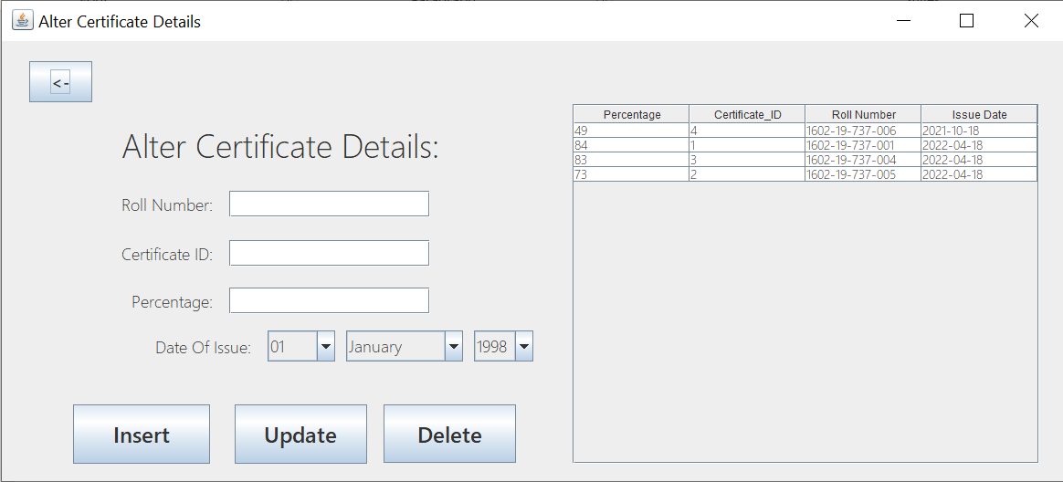

package moocdbase;

import java.sql.Connection;

import java.sql.DriverManager;

import java.sql.ResultSet;

import java.sql.SQLException;

import java.sql.Statement;

import java.util.StringTokenizer;

import javax.swing.JOptionPane;

import javax.swing.table.DefaultTableModel;

public class CertificateModify extends javax.swing.JFrame {

public CertificateModify() {

initComponents();

action();

}

private void initComponents() {

jLabel5 = new javax.swing.JLabel();

day = new javax.swing.JComboBox<>();

month = new javax.swing.JComboBox<>();

year = new javax.swing.JComboBox<>();

jLabel6 = new javax.swing.JLabel();

cid = new javax.swing.JTextField();

jLabel2 = new javax.swing.JLabel();

jLabel3 = new javax.swing.JLabel();

rno = new javax.swing.JTextField();

jLabel4 = new javax.swing.JLabel();

per = new javax.swing.JTextField();

jButton1 = new javax.swing.JButton();

jButton2 = new javax.swing.JButton();

jScrollPane1 = new javax.swing.JScrollPane();

mainTable = new javax.swing.JTable();

jButton3 = new javax.swing.JButton();

jButton4 = new javax.swing.JButton();

setDefaultCloseOperation(javax.swing.WindowConstants.EXIT_ON_CLOSE);

setTitle("Alter Certificate Details");

jLabel5.setFont(new java.awt.Font("Yu Gothic UI Light", 0, 18));

jLabel5.setText("Date Of Issue:");

day.setFont(new java.awt.Font("Yu Gothic UI Light", 0, 18));

day.setModel(new javax.swing.DefaultComboBoxModel<>(new String[] { "01", "02", "03", "04", "05", "06", "07", "08", "09", "10", "11", "12", "13", "14", "15", "16", "17", "18", "19", "20", "21", "22", "23", "24", "25", "26", "27", "28", "29", "30", "31" }));

day.addActionListener(new java.awt.event.ActionListener() {

public void actionPerformed(java.awt.event.ActionEvent evt) {

dayActionPerformed(evt);

}

});

month.setFont(new java.awt.Font("Yu Gothic UI Light", 0, 18));

month.setModel(new javax.swing.DefaultComboBoxModel<>(new String[] { "January", "February", "March", "April", "May", "June", "July", "August", "September", "October", "November", "December" }));

year.setFont(new java.awt.Font("Yu Gothic UI Light", 0, 18));

year.setModel(new javax.swing.DefaultComboBoxModel<>(new String[] { "1998", "1999", "2000", "2001", "2002", "2003", "2004", "2005", "2006", "2007", "2008", "2009", "2010", "2011", "2012", "2013", "2014", "2015", "2016", "2017", "2018", "2019", "2020", "2021", "2022" }));

jLabel6.setFont(new java.awt.Font("Yu Gothic UI Light", 0, 18));

jLabel6.setText("Percentage:");

cid.setFont(new java.awt.Font("Yu Gothic UI Light", 0, 18));

cid.addActionListener(new java.awt.event.ActionListener() {

public void actionPerformed(java.awt.event.ActionEvent evt) {

cidActionPerformed(evt);

}

});

jLabel2.setFont(new java.awt.Font("Yu Gothic UI Light", 0, 36));

jLabel2.setText("Alter Certificate Details:");

jLabel3.setFont(new java.awt.Font("Yu Gothic UI Light", 0, 18));

jLabel3.setText("Roll Number:");

rno.setFont(new java.awt.Font("Yu Gothic UI Light", 0, 18));

rno.addActionListener(new java.awt.event.ActionListener() {

public void actionPerformed(java.awt.event.ActionEvent evt) {

rnoActionPerformed(evt);

}

});

jLabel4.setFont(new java.awt.Font("Yu Gothic UI Light", 0, 18));

jLabel4.setText("Certificate ID:");

per.setFont(new java.awt.Font("Yu Gothic UI Light", 0, 18));

per.addActionListener(new java.awt.event.ActionListener() {

public void actionPerformed(java.awt.event.ActionEvent evt) {

perActionPerformed(evt);

}

});

jButton1.setFont(new java.awt.Font("Yu Gothic UI", 1, 24));

jButton1.setText("Update");

jButton1.addActionListener(new java.awt.event.ActionListener() {

public void actionPerformed(java.awt.event.ActionEvent evt) {

jButton1ActionPerformed(evt);

}

});

jButton2.setFont(new java.awt.Font("Yu Gothic UI", 1, 18));

jButton2.setText("<-");

jButton2.addActionListener(new java.awt.event.ActionListener() {

public void actionPerformed(java.awt.event.ActionEvent evt) {

jButton2ActionPerformed(evt);

}

});

mainTable.setFont(new java.awt.Font("Yu Gothic UI Light", 0, 14));

mainTable.setModel(new javax.swing.table.DefaultTableModel(

new Object [][] {

{null, null, null, null},

{null, null, null, null},

{null, null, null, null},

{null, null, null, null},

{null, null, null, null},

{null, null, null, null},

{null, null, null, null},

{null, null, null, null},

{null, null, null, null},

{null, null, null, null}

},

new String [] {

"Percentage", "Certificate_ID", "Roll Number", "Issue Date"

}

));

mainTable.addMouseListener(new java.awt.event.MouseAdapter() {

public void mouseClicked(java.awt.event.MouseEvent evt) {

mainTableMouseClicked(evt);

}

});

jScrollPane1.setViewportView(mainTable);

jButton3.setFont(new java.awt.Font("Yu Gothic UI", 1, 24));

jButton3.setText("Insert");

jButton3.addActionListener(new java.awt.event.ActionListener() {

public void actionPerformed(java.awt.event.ActionEvent evt) {

jButton3ActionPerformed(evt);

}

});

jButton4.setFont(new java.awt.Font("Yu Gothic UI", 1, 24));

jButton4.setText("Delete");

jButton4.addActionListener(new java.awt.event.ActionListener() {

public void actionPerformed(java.awt.event.ActionEvent evt) {

jButton4ActionPerformed(evt);

}

});

javax.swing.GroupLayout layout = new javax.swing.GroupLayout(getContentPane());

getContentPane().setLayout(layout);

layout.setHorizontalGroup(

layout.createParallelGroup(javax.swing.GroupLayout.Alignment.LEADING)

.addGroup(layout.createSequentialGroup()

.addGap(30, 30, 30)

.addComponent(jButton2, javax.swing.GroupLayout.PREFERRED_SIZE, 69, javax.swing.GroupLayout.PREFERRED_SIZE)

.addGap(0, 0, Short.MAX_VALUE))

.addGroup(layout.createSequentialGroup()

.addContainerGap(78, Short.MAX_VALUE)

.addGroup(layout.createParallelGroup(javax.swing.GroupLayout.Alignment.LEADING)

.addGroup(javax.swing.GroupLayout.Alignment.TRAILING, layout.createSequentialGroup()

.addGroup(layout.createParallelGroup(javax.swing.GroupLayout.Alignment.LEADING)

.addGroup(javax.swing.GroupLayout.Alignment.TRAILING, layout.createSequentialGroup()

.addComponent(jLabel5)

.addPreferredGap(javax.swing.LayoutStyle.ComponentPlacement.UNRELATED)

.addComponent(day, javax.swing.GroupLayout.PREFERRED_SIZE, 74, javax.swing.GroupLayout.PREFERRED_SIZE)

.addPreferredGap(javax.swing.LayoutStyle.ComponentPlacement.UNRELATED)

.addComponent(month, javax.swing.GroupLayout.PREFERRED_SIZE, 128, javax.swing.GroupLayout.PREFERRED_SIZE)

.addPreferredGap(javax.swing.LayoutStyle.ComponentPlacement.UNRELATED)

.addComponent(year, javax.swing.GroupLayout.PREFERRED_SIZE, javax.swing.GroupLayout.DEFAULT_SIZE, javax.swing.GroupLayout.PREFERRED_SIZE))

.addGroup(layout.createSequentialGroup() .addGroup(layout.createParallelGroup(javax.swing.GroupLayout.Alignment.LEADING)

.addGroup(layout.createSequentialGroup() .addGroup(layout.createParallelGroup(javax.swing.GroupLayout.Alignment.TRAILING)

.addComponent(jLabel4)

.addComponent(jLabel3)

.addComponent(jLabel6))

.addGap(18, 18, 18) .addGroup(layout.createParallelGroup(javax.swing.GroupLayout.Alignment.LEADING, false)

.addComponent(per)

.addComponent(rno)

.addComponent(cid, javax.swing.GroupLayout.PREFERRED_SIZE, 220, javax.swing.GroupLayout.PREFERRED_SIZE)))

.addComponent(jLabel2, javax.swing.GroupLayout.PREFERRED_SIZE, 430, javax.swing.GroupLayout.PREFERRED_SIZE))

.addGap(21, 21, 21)))

.addGap(43, 43, 43))

.addGroup(javax.swing.GroupLayout.Alignment.TRAILING, layout.createSequentialGroup()

.addComponent(jButton3, javax.swing.GroupLayout.PREFERRED_SIZE, 150, javax.swing.GroupLayout.PREFERRED_SIZE)

.addGap(27, 27, 27)

.addComponent(jButton1, javax.swing.GroupLayout.PREFERRED_SIZE, 145, javax.swing.GroupLayout.PREFERRED_SIZE)

.addGap(18, 18, 18)

.addComponent(jButton4, javax.swing.GroupLayout.PREFERRED_SIZE, 145, javax.swing.GroupLayout.PREFERRED_SIZE)

.addGap(62, 62, 62)))

.addComponent(jScrollPane1, javax.swing.GroupLayout.PREFERRED_SIZE, 511, javax.swing.GroupLayout.PREFERRED_SIZE)

.addGap(26, 26, 26))

);

layout.setVerticalGroup(

layout.createParallelGroup(javax.swing.GroupLayout.Alignment.LEADING)

.addGroup(layout.createSequentialGroup() .addGroup(layout.createParallelGroup(javax.swing.GroupLayout.Alignment.LEADING)

.addGroup(layout.createSequentialGroup()

.addGap(69, 69, 69) .addGroup(layout.createParallelGroup(javax.swing.GroupLayout.Alignment.LEADING)

.addGroup(layout.createSequentialGroup()

.addGap(11, 11, 11)

.addComponent(jLabel2, javax.swing.GroupLayout.PREFERRED_SIZE, 66, javax.swing.GroupLayout.PREFERRED_SIZE)

.addGap(18, 18, 18) .addGroup(layout.createParallelGroup(javax.swing.GroupLayout.Alignment.BASELINE)

.addComponent(jLabel3)

.addComponent(rno, javax.swing.GroupLayout.PREFERRED_SIZE, javax.swing.GroupLayout.DEFAULT_SIZE, javax.swing.GroupLayout.PREFERRED_SIZE))

.addGap(25, 25, 25) .addGroup(layout.createParallelGroup(javax.swing.GroupLayout.Alignment.BASELINE)

.addComponent(jLabel4)

.addComponent(cid, javax.swing.GroupLayout.PREFERRED_SIZE, javax.swing.GroupLayout.DEFAULT_SIZE, javax.swing.GroupLayout.PREFERRED_SIZE))

.addGap(23, 23, 23) .addGroup(layout.createParallelGroup(javax.swing.GroupLayout.Alignment.BASELINE)

.addComponent(per, javax.swing.GroupLayout.PREFERRED_SIZE, javax.swing.GroupLayout.DEFAULT_SIZE, javax.swing.GroupLayout.PREFERRED_SIZE)

.addComponent(jLabel6))

.addGap(18, 18, 18) .addGroup(layout.createParallelGroup(javax.swing.GroupLayout.Alignment.BASELINE)

.addComponent(jLabel5)

.addComponent(day, javax.swing.GroupLayout.PREFERRED_SIZE, javax.swing.GroupLayout.DEFAULT_SIZE, javax.swing.GroupLayout.PREFERRED_SIZE)

.addComponent(month, javax.swing.GroupLayout.PREFERRED_SIZE, javax.swing.GroupLayout.DEFAULT_SIZE, javax.swing.GroupLayout.PREFERRED_SIZE)

.addComponent(year, javax.swing.GroupLayout.PREFERRED_SIZE, javax.swing.GroupLayout.DEFAULT_SIZE, javax.swing.GroupLayout.PREFERRED_SIZE))

.addGap(47, 47, 47) .addGroup(layout.createParallelGroup(javax.swing.GroupLayout.Alignment.BASELINE)

.addComponent(jButton1, javax.swing.GroupLayout.PREFERRED_SIZE, 65, javax.swing.GroupLayout.PREFERRED_SIZE)

.addComponent(jButton3, javax.swing.GroupLayout.PREFERRED_SIZE, 65, javax.swing.GroupLayout.PREFERRED_SIZE)

.addComponent(jButton4, javax.swing.GroupLayout.PREFERRED_SIZE, 64, javax.swing.GroupLayout.PREFERRED_SIZE)))

.addComponent(jScrollPane1, javax.swing.GroupLayout.PREFERRED_SIZE, 394, javax.swing.GroupLayout.PREFERRED_SIZE)))

.addGroup(layout.createSequentialGroup()

.addGap(22, 22, 22)

.addComponent(jButton2, javax.swing.GroupLayout.PREFERRED_SIZE, 45, javax.swing.GroupLayout.PREFERRED_SIZE)))

.addContainerGap(19, Short.MAX_VALUE))

);

pack();

}

private void dayActionPerformed(java.awt.event.ActionEvent evt) {

}

private void cidActionPerformed(java.awt.event.ActionEvent evt) {

}

private void rnoActionPerformed(java.awt.event.ActionEvent evt) {

}

private void perActionPerformed(java.awt.event.ActionEvent evt) {

}

private void jButton2ActionPerformed(java.awt.event.ActionEvent evt) {

dispose();

MainFrame cf=new MainFrame();

cf.show();

}

private void jButton1ActionPerformed(java.awt.event.ActionEvent evt) {

String roll=rno.getText();

String Cid=cid.getText();

String perc=per.getText();

String d=day.getSelectedItem().toString();

String m=month.getSelectedItem().toString();

String y=year.getSelectedItem().toString();

String nm="";

switch(m){

case "January":nm="JAN";break;

case "February":nm="FEB";break;

case "March":nm="MAR";break;

case "April":nm="APR";break;

case "May":nm="MAY";break;

case "June":nm="JUN";break;

case "July":nm="JUL";break;

case "August":nm="AUG";break;

case "September":nm="SEP";break;

case "October":nm="OCT";break;

case "November":nm="NOV";break;

case "December":nm="DEC";break;

}

String nd=d+"-"+nm+"-"+y;

try{

Class.forName("oracle.jdbc.OracleDriver");

Connection con = DriverManager.getConnection("jdbc:oracle:thin:@localhost:1521:xe","abhiram","iruvanti");

Statement stmt=con.createStatement();

stmt.executeQuery("update certificate set percentage_achieved="+perc+",roll_number='"+roll+"',issue_date='"+nd+"' where certificate_id="+Cid);

JOptionPane.showMessageDialog(this,"Update Successful!");

}

catch(ClassNotFoundException | SQLException e)

{

JOptionPane.showMessageDialog(this,"There must be some problem!");

}

action();

rno.setText("");

cid.setText("");

per.setText("");

day.setSelectedItem("01");

month.setSelectedItem("January");

year.setSelectedItem("1998");

}

public String getName(String roll){

String ans;

try{

Class.forName("oracle.jdbc.OracleDriver");

Connection con=DriverManager.getConnection("jdbc:oracle:thin:@localhost:1521:xe","abhiram","iruvanti");

Statement stmt=con.createStatement();

ResultSet rs=stmt.executeQuery("select student_name from students where roll_number='"+roll+"'");

ans="";

while(rs.next())

ans+=rs.getString(1);

return ans;

}

catch(ClassNotFoundException | SQLException e){

System.out.println(e);

}

return "";

}

private void mainTableMouseClicked(java.awt.event.MouseEvent evt) {

try{

Class.forName("oracle.jdbc.OracleDriver");

Connection con = DriverManager.getConnection("jdbc:oracle:thin:@localhost:1521:xe","abhiram","iruvanti");

Statement stmt=con.createStatement();

int row=mainTable.getSelectedRow();

String Cid=(mainTable.getModel().getValueAt(row,1)).toString(); ResultSet rs=stmt.executeQuery("select * from certificate where certificate_id="+Cid+"");

while(rs.next()){

rno.setText(rs.getString("roll_number"));

cid.setText(rs.getString("certificate_id"));

per.setText(rs.getString("percentage_achieved"));

String nd=rs.getString("issue_date");

nd=nd.substring(0,10);

StringTokenizer st=new StringTokenizer(nd,"-");

String yeare=st.nextToken();

String monthe=st.nextToken();

String daye=st.nextToken();

day.setSelectedItem(daye);

year.setSelectedItem(yeare);

String nm="";

switch(monthe){

case "01":nm="January";break;

case "02":nm="February";break;

case "03":nm="March";break;

case "04":nm="April";break;

case "05":nm="May";break;

case "06":nm="June";break;

case "07":nm="July";break;

case "08":nm="August";break;

case "09":nm="September";break;

case "10":nm="October";break;

case "11":nm="November";break;

case "12":nm="December";break;

}

month.setSelectedItem(nm);

}

con.close();

}

catch(ClassNotFoundException | SQLException e){

JOptionPane.showMessageDialog(this,e);

}

}

private void jButton3ActionPerformed(java.awt.event.ActionEvent evt) {

String roll=rno.getText();

String Cid=cid.getText();

String perc=per.getText();

String d=day.getSelectedItem().toString();

String m=month.getSelectedItem().toString();

String y=year.getSelectedItem().toString();

String nm="";

switch(m){

case "January":nm="JAN";break;

case "February":nm="FEB";break;

case "March":nm="MAR";break;

case "April":nm="APR";break;

case "May":nm="MAY";break;

case "June":nm="JUN";break;

case "July":nm="JUL";break;

case "August":nm="AUG";break;

case "September":nm="SEP";break;

case "October":nm="OCT";break;

case "November":nm="NOV";break;

case "December":nm="DEC";break;

}

String nd=d+"-"+nm+"-"+y;

try{

Class.forName("oracle.jdbc.OracleDriver");

Connection con = DriverManager.getConnection("jdbc:oracle:thin:@localhost:1521:xe","abhiram","iruvanti");

Statement stmt=con.createStatement();

stmt.executeQuery("insert into certificate values("+perc+","+Cid+",'"+roll+"','"+nd+"')");

JOptionPane.showMessageDialog(this,"Insert Successful!");

}

catch(ClassNotFoundException | SQLException e)

{

JOptionPane.showMessageDialog(this,"There must be some problem!");

}

action();

rno.setText("");

cid.setText("");

per.setText("");

day.setSelectedItem("01");

month.setSelectedItem("January");

year.setSelectedItem("1998");

}

private void jButton4ActionPerformed(java.awt.event.ActionEvent evt) {

String roll=rno.getText();

String Cid=cid.getText();

try{

Class.forName("oracle.jdbc.OracleDriver");

Connection con = DriverManager.getConnection("jdbc:oracle:thin:@localhost:1521:xe","abhiram","iruvanti");

Statement stmt=con.createStatement();

stmt.executeQuery("delete from certificate where certificate_id="+Cid+" and roll_number='"+roll+"'");

JOptionPane.showMessageDialog(this,"Delete Successful!");

}

catch(ClassNotFoundException | SQLException e)

{

JOptionPane.showMessageDialog(this,"There seems to be some problem");

}

action();

rno.setText("");

cid.setText("");

}

public void action(){

try{

Class.forName("oracle.jdbc.OracleDriver");

Connection con = DriverManager.getConnection("jdbc:oracle:thin:@localhost:1521:xe","abhiram","iruvanti");

Statement stmt=con.createStatement();

ResultSet rs=stmt.executeQuery("select * from certificate");

DefaultTableModel tm=(DefaultTableModel)mainTable.getModel();

tm.setRowCount(0);

while(rs.next()) {

Object o[]={rs.getInt("percentage_achieved"),rs.getInt("certificate_id"),rs.getString("roll_number"),rs.getDate("issue_date")};

tm.addRow(o);

}

}

catch(ClassNotFoundException | SQLException e)

{

JOptionPane.showMessageDialog(this,e); }

}

public static void main(String args[]) {

java.awt.EventQueue.invokeLater(new Runnable() {

public void run() {

new CertificateModify().setVisible(true);

}

});

}

private javax.swing.JTextField cid;

private javax.swing.JComboBox<String> day;

private javax.swing.JButton jButton1;

private javax.swing.JButton jButton2;

private javax.swing.JButton jButton3;

private javax.swing.JButton jButton4;

private javax.swing.JLabel jLabel2;

private javax.swing.JLabel jLabel3;

private javax.swing.JLabel jLabel4;

private javax.swing.JLabel jLabel5;

private javax.swing.JLabel jLabel6;

private javax.swing.JScrollPane jScrollPane1;

private javax.swing.JTable mainTable;

private javax.swing.JComboBox<String> month;

private javax.swing.JTextField per;

private javax.swing.JTextField rno;

private javax.swing.JComboBox<String> year;

// End of variables declaration

}

**Score Details:**

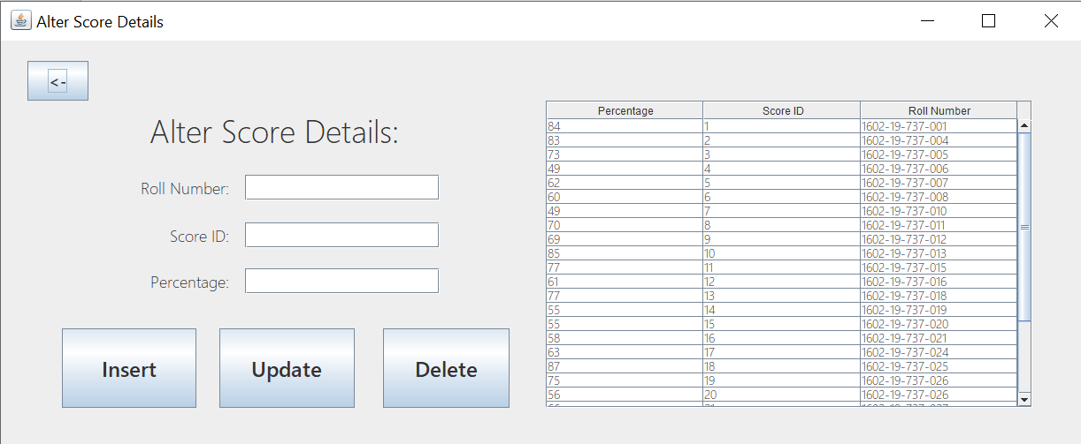

package moocdbase;

import java.sql.*;

import javax.swing.JOptionPane;

import javax.swing.table.DefaultTableModel;

public class ScoreModify extends javax.swing.JFrame {

public ScoreModify() {

initComponents();

action();

}

private void initComponents() {

rno = new javax.swing.JTextField();

jLabel4 = new javax.swing.JLabel();

per = new javax.swing.JTextField();

jLabel6 = new javax.swing.JLabel();

sid = new javax.swing.JTextField();

jLabel2 = new javax.swing.JLabel();

jLabel3 = new javax.swing.JLabel();

jButton2 = new javax.swing.JButton();

NameBox = new javax.swing.JButton();

jScrollPane1 = new javax.swing.JScrollPane();

mainTable = new javax.swing.JTable();

jButton1 = new javax.swing.JButton();

jButton3 = new javax.swing.JButton();

setDefaultCloseOperation(javax.swing.WindowConstants.EXIT_ON_CLOSE);

setTitle("Alter Score Details");

rno.setFont(new java.awt.Font("Yu Gothic UI Light", 0, 18));

rno.addActionListener(new java.awt.event.ActionListener() {

public void actionPerformed(java.awt.event.ActionEvent evt) {

rnoActionPerformed(evt);

}

});

jLabel4.setFont(new java.awt.Font("Yu Gothic UI Light", 0, 18));

jLabel4.setText("Score ID:");

per.setFont(new java.awt.Font("Yu Gothic UI Light", 0, 18));

per.addActionListener(new java.awt.event.ActionListener() {

public void actionPerformed(java.awt.event.ActionEvent evt) {

perActionPerformed(evt);

}

});

jLabel6.setFont(new java.awt.Font("Yu Gothic UI Light", 0, 18));

jLabel6.setText("Percentage:");

sid.setFont(new java.awt.Font("Yu Gothic UI Light", 0, 18));

sid.addActionListener(new java.awt.event.ActionListener() {

public void actionPerformed(java.awt.event.ActionEvent evt) {

sidActionPerformed(evt);

}

});

jLabel2.setFont(new java.awt.Font("Yu Gothic UI Light", 0, 36));

jLabel2.setText("Alter Score Details:");

jLabel3.setFont(new java.awt.Font("Yu Gothic UI Light", 0, 18));

jLabel3.setText("Roll Number:");

jButton2.setFont(new java.awt.Font("Yu Gothic UI", 1, 18));

jButton2.setText("<-");

jButton2.addActionListener(new java.awt.event.ActionListener() {

public void actionPerformed(java.awt.event.ActionEvent evt) {

jButton2ActionPerformed(evt);

}

});

NameBox.setFont(new java.awt.Font("Yu Gothic UI", 1, 24));

NameBox.setText("Update");

NameBox.addActionListener(new java.awt.event.ActionListener() {

public void actionPerformed(java.awt.event.ActionEvent evt) {

NameBoxActionPerformed(evt);

}

});

mainTable.setFont(new java.awt.Font("Yu Gothic UI Light", 0, 14));

mainTable.setModel(new javax.swing.table.DefaultTableModel(

new Object [][] {

{null, null, null},

{null, null, null},

{null, null, null},

{null, null, null},

{null, null, null},

{null, null, null},

{null, null, null},

{null, null, null},

{null, null, null},

{null, null, null}

},

new String [] {

"Percentage", "Score ID", "Roll Number"

}

));

mainTable.addMouseListener(new java.awt.event.MouseAdapter() {

public void mouseClicked(java.awt.event.MouseEvent evt) {

mainTableMouseClicked(evt);

}

});

jScrollPane1.setViewportView(mainTable);

jButton1.setFont(new java.awt.Font("Yu Gothic UI", 1, 24));

jButton1.setText("Insert");

jButton1.addActionListener(new java.awt.event.ActionListener() {

public void actionPerformed(java.awt.event.ActionEvent evt) {

jButton1ActionPerformed(evt);

}

});

jButton3.setFont(new java.awt.Font("Yu Gothic UI", 1, 24));

jButton3.setText("Delete");

jButton3.addActionListener(new java.awt.event.ActionListener() {

public void actionPerformed(java.awt.event.ActionEvent evt) {

jButton3ActionPerformed(evt);

}

});

javax.swing.GroupLayout layout = new javax.swing.GroupLayout(getContentPane());

getContentPane().setLayout(layout);

layout.setHorizontalGroup(

layout.createParallelGroup(javax.swing.GroupLayout.Alignment.LEADING)

.addGroup(layout.createSequentialGroup()

.addGap(30, 30, 30)

.addGroup(layout.createParallelGroup(javax.swing.GroupLayout.Alignment.LEADING)

.addGroup(layout.createSequentialGroup() .addGroup(layout.createParallelGroup(javax.swing.GroupLayout.Alignment.LEADING)

.addGroup(layout.createSequentialGroup()

.addGap(39, 39, 39)

.addComponent(jButton1, javax.swing.GroupLayout.PREFERRED_SIZE, 152, javax.swing.GroupLayout.PREFERRED_SIZE)

.addGap(26, 26, 26)

.addComponent(NameBox, javax.swing.GroupLayout.PREFERRED_SIZE, 153, javax.swing.GroupLayout.PREFERRED_SIZE)

.addGap(32, 32, 32)

.addComponent(jButton3, javax.swing.GroupLayout.PREFERRED_SIZE, 143, javax.swing.GroupLayout.PREFERRED_SIZE)

.addPreferredGap(javax.swing.LayoutStyle.ComponentPlacement.RELATED, 41, Short.MAX_VALUE))

.addGroup(javax.swing.GroupLayout.Alignment.TRAILING, layout.createSequentialGroup()

.addGap(0, 0, Short.MAX_VALUE)

.addGroup(layout.createParallelGroup(javax.swing.GroupLayout.Alignment.TRAILING, false)

.addComponent(jLabel2, javax.swing.GroupLayout.PREFERRED_SIZE, 430, javax.swing.GroupLayout.PREFERRED_SIZE)

.addGroup(layout.createSequentialGroup() .addGroup(layout.createParallelGroup(javax.swing.GroupLayout.Alignment.TRAILING)

.addComponent(jLabel4)

.addComponent(jLabel3)

.addComponent(jLabel6))

.addGap(18, 18, 18) .addGroup(layout.createParallelGroup(javax.swing.GroupLayout.Alignment.LEADING, false)

.addComponent(per)

.addComponent(rno)

.addComponent(sid, javax.swing.GroupLayout.PREFERRED_SIZE, 220, javax.swing.GroupLayout.PREFERRED_SIZE))

.addGap(102, 102, 102)))

.addGap(18, 18, 18)))

.addComponent(jScrollPane1, javax.swing.GroupLayout.PREFERRED_SIZE, 550, javax.swing.GroupLayout.PREFERRED_SIZE)

.addGap(56, 56, 56))

.addGroup(layout.createSequentialGroup()

.addComponent(jButton2, javax.swing.GroupLayout.PREFERRED_SIZE, 69, javax.swing.GroupLayout.PREFERRED_SIZE)

.addContainerGap(javax.swing.GroupLayout.DEFAULT_SIZE, Short.MAX_VALUE))))

);

layout.setVerticalGroup(

layout.createParallelGroup(javax.swing.GroupLayout.Alignment.LEADING)

.addGroup(layout.createSequentialGroup()

.addGroup(layout.createParallelGroup(javax.swing.GroupLayout.Alignment.LEADING)

.addGroup(layout.createSequentialGroup()

.addGap(23, 23, 23)

.addComponent(jButton2, javax.swing.GroupLayout.PREFERRED_SIZE, 45, javax.swing.GroupLayout.PREFERRED_SIZE))

.addGroup(layout.createSequentialGroup()

.addGap(68, 68, 68)

.addGroup(layout.createParallelGroup(javax.swing.GroupLayout.Alignment.LEADING, false)

.addComponent(jScrollPane1, javax.swing.GroupLayout.PREFERRED_SIZE, 348, javax.swing.GroupLayout.PREFERRED_SIZE)

.addGroup(layout.createSequentialGroup()

.addComponent(jLabel2, javax.swing.GroupLayout.PREFERRED_SIZE, 66, javax.swing.GroupLayout.PREFERRED_SIZE)

.addGap(18, 18, 18) .addGroup(layout.createParallelGroup(javax.swing.GroupLayout.Alignment.BASELINE)

.addComponent(jLabel3)

.addComponent(rno, javax.swing.GroupLayout.PREFERRED_SIZE, javax.swing.GroupLayout.DEFAULT_SIZE, javax.swing.GroupLayout.PREFERRED_SIZE))

.addGap(25, 25, 25) .addGroup(layout.createParallelGroup(javax.swing.GroupLayout.Alignment.BASELINE)

.addComponent(jLabel4)

.addComponent(sid, javax.swing.GroupLayout.PREFERRED_SIZE, javax.swing.GroupLayout.DEFAULT_SIZE, javax.swing.GroupLayout.PREFERRED_SIZE))

.addGap(23, 23, 23) .addGroup(layout.createParallelGroup(javax.swing.GroupLayout.Alignment.BASELINE)

.addComponent(per, javax.swing.GroupLayout.PREFERRED_SIZE, javax.swing.GroupLayout.DEFAULT_SIZE, javax.swing.GroupLayout.PREFERRED_SIZE)

.addComponent(jLabel6))

.addGap(39, 39, 39) .addGroup(layout.createParallelGroup(javax.swing.GroupLayout.Alignment.LEADING)

.addComponent(jButton1, javax.swing.GroupLayout.DEFAULT_SIZE, javax.swing.GroupLayout.DEFAULT_SIZE, Short.MAX_VALUE)

.addComponent(NameBox, javax.swing.GroupLayout.Alignment.TRAILING, javax.swing.GroupLayout.DEFAULT_SIZE, javax.swing.GroupLayout.DEFAULT_SIZE, Short.MAX_VALUE)

.addComponent(jButton3, javax.swing.GroupLayout.DEFAULT_SIZE, javax.swing.GroupLayout.DEFAULT_SIZE, Short.MAX_VALUE))))))

.addContainerGap(42, Short.MAX_VALUE))

);

pack();

}// </editor-fold>

private void rnoActionPerformed(java.awt.event.ActionEvent evt) {

}

private void perActionPerformed(java.awt.event.ActionEvent evt) {

}

private void sidActionPerformed(java.awt.event.ActionEvent evt) {

}

private void jButton2ActionPerformed(java.awt.event.ActionEvent evt) {

dispose();

MainFrame cf=new MainFrame();

cf.show();

}

private void NameBoxActionPerformed(java.awt.event.ActionEvent evt) {

String roll=rno.getText();

String Sid=sid.getText();

String perc=per.getText();

try{

Class.forName("oracle.jdbc.OracleDriver");

Connection con = DriverManager.getConnection("jdbc:oracle:thin:@localhost:1521:xe","abhiram","iruvanti");

Statement stmt=con.createStatement();

stmt.executeQuery("update scores set roll_number='"+roll+"',percentage_achieved="+perc+" where score_id="+Sid);

JOptionPane.showMessageDialog(this,"Update Successful!");

}

catch(ClassNotFoundException | SQLException e)

{

JOptionPane.showMessageDialog(this,"There must be some problem!");

}

action();

rno.setText("");

sid.setText("");

per.setText("");

}

private void mainTableMouseClicked(java.awt.event.MouseEvent evt) {

try{

Class.forName("oracle.jdbc.OracleDriver");

Connection con = DriverManager.getConnection("jdbc:oracle:thin:@localhost:1521:xe","abhiram","iruvanti");

Statement stmt=con.createStatement();

int row=mainTable.getSelectedRow();

String Sid=(mainTable.getModel().getValueAt(row,1)).toString();

ResultSet rs=stmt.executeQuery("select * from scores where score_id="+Sid+"");

while(rs.next()){

rno.setText(rs.getString("roll_number"));

sid.setText(rs.getString("score_id"));

per.setText(rs.getString("percentage_achieved"));

}

con.close();

}

catch(ClassNotFoundException | SQLException e){

JOptionPane.showMessageDialog(this,e);

}

}

private void jButton1ActionPerformed(java.awt.event.ActionEvent evt) {

String roll=rno.getText();

String Sid=sid.getText();

String perc=per.getText();

try{

Class.forName("oracle.jdbc.OracleDriver");

Connection con = DriverManager.getConnection("jdbc:oracle:thin:@localhost:1521:xe","abhiram","iruvanti");

Statement stmt=con.createStatement();

stmt.executeQuery("insert into scores values ("+perc+","+Sid+",'"+roll+"')");

JOptionPane.showMessageDialog(this,"Insert Successful!");

}

catch(ClassNotFoundException | SQLException e)

{

JOptionPane.showMessageDialog(this,"There must be some problem!");

}

action();

rno.setText("");

sid.setText("");

per.setText("");

}

private void jButton3ActionPerformed(java.awt.event.ActionEvent evt) {

String roll=rno.getText();

String Sid=sid.getText();

try{

Class.forName("oracle.jdbc.OracleDriver");

Connection con = DriverManager.getConnection("jdbc:oracle:thin:@localhost:1521:xe","abhiram","iruvanti");

Statement stmt=con.createStatement();

stmt.executeQuery("delete from scores where score_id="+Sid+" and roll_number='"+roll+"'");

JOptionPane.showMessageDialog(this,"Delete Successful!");

}

catch(ClassNotFoundException | SQLException e)

{

JOptionPane.showMessageDialog(this,"There must be some problem!");

}

action();

rno.setText("");

sid.setText("");

per.setText("");

}

public void action(){

try{

Class.forName("oracle.jdbc.OracleDriver");

Connection con = DriverManager.getConnection("jdbc:oracle:thin:@localhost:1521:xe","abhiram","iruvanti");

Statement stmt=con.createStatement();

ResultSet rs=stmt.executeQuery("select * from scores");

DefaultTableModel tm=(DefaultTableModel)mainTable.getModel();

tm.setRowCount(0);

while(rs.next()) {

Object o[]={rs.getInt("percentage_achieved"),rs.getInt("score_id"),rs.getString("roll_number")};

tm.addRow(o);

}

}

catch(ClassNotFoundException | SQLException e)

{

JOptionPane.showMessageDialog(this,e);

}

}

public static void main(String args[])

java.awt.EventQueue.invokeLater(new Runnable() {

public void run() {

new ScoreModify().setVisible(true);

}

});

}

private javax.swing.JButton NameBox;

private javax.swing.JButton jButton1;

private javax.swing.JButton jButton2;

private javax.swing.JButton jButton3;

private javax.swing.JLabel jLabel2;

private javax.swing.JLabel jLabel3;

private javax.swing.JLabel jLabel4;

private javax.swing.JLabel jLabel6;

private javax.swing.JScrollPane jScrollPane1;

private javax.swing.JTable mainTable;

private javax.swing.JTextField per;

private javax.swing.JTextField rno;

private javax.swing.JTextField sid;

}

**Enroll:**

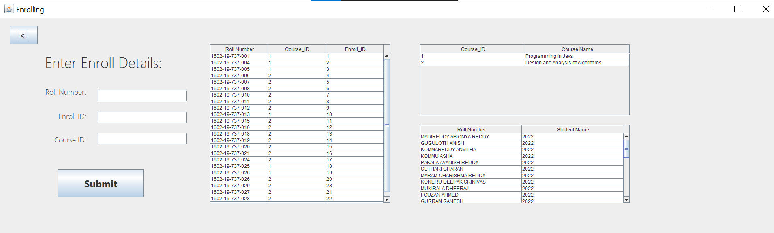

package moocdbase;

import java.sql.*;

import javax.swing.JOptionPane;

import javax.swing.table.DefaultTableModel;

public class enroll extends javax.swing.JFrame {

public enroll() {

initComponents();

action();

action2();

action3();

}

@SuppressWarnings("unchecked")

// <editor-fold defaultstate="collapsed" desc="Generated Code">

private void initComponents() {

jLabel3 = new javax.swing.JLabel();

jButton2 = new javax.swing.JButton();

jScrollPane1 = new javax.swing.JScrollPane();

mainTable = new javax.swing.JTable();

jLabel6 = new javax.swing.JLabel();

eid = new javax.swing.JTextField();

jLabel4 = new javax.swing.JLabel();

rno = new javax.swing.JTextField();

jLabel5 = new javax.swing.JLabel();

cid = new javax.swing.JTextField();

jButton1 = new javax.swing.JButton();

jScrollPane4 = new javax.swing.JScrollPane();

moocTable = new javax.swing.JTable();

jScrollPane5 = new javax.swing.JScrollPane();

studentTable = new javax.swing.JTable();

setDefaultCloseOperation(javax.swing.WindowConstants.EXIT_ON_CLOSE);

setTitle("Enrolling ");

jLabel3.setFont(new java.awt.Font("Yu Gothic UI Light", 0, 36));

jLabel3.setText("Enter Enroll Details:");

jButton2.setFont(new java.awt.Font("Yu Gothic UI", 1, 18));

jButton2.setText("<-");

jButton2.addActionListener(new java.awt.event.ActionListener() {

public void actionPerformed(java.awt.event.ActionEvent evt) {

jButton2ActionPerformed(evt);

}

});

mainTable.setModel(new javax.swing.table.DefaultTableModel(

new Object [][] {

{null, null, null},

{null, null, null},

{null, null, null},

{null, null, null}

},

new String [] {

"Roll Number", "Course_ID", "Enroll_ID"

}

));

jScrollPane1.setViewportView(mainTable);

jLabel6.setFont(new java.awt.Font("Yu Gothic UI Light", 0, 18));

jLabel6.setText("Course ID:");

eid.setFont(new java.awt.Font("Yu Gothic UI Light", 0, 18));

eid.addActionListener(new java.awt.event.ActionListener() {

public void actionPerformed(java.awt.event.ActionEvent evt) {

eidActionPerformed(evt);

}

});

jLabel4.setFont(new java.awt.Font("Yu Gothic UI Light", 0, 18));

jLabel4.setText("Roll Number:");

rno.setFont(new java.awt.Font("Yu Gothic UI Light", 0, 18));

rno.addActionListener(new java.awt.event.ActionListener() {

public void actionPerformed(java.awt.event.ActionEvent evt) {

rnoActionPerformed(evt);

}

});

jLabel5.setFont(new java.awt.Font("Yu Gothic UI Light", 0, 18));

jLabel5.setText("Enroll ID:");

cid.setFont(new java.awt.Font("Yu Gothic UI Light", 0, 18));

cid.addActionListener(new java.awt.event.ActionListener() {

public void actionPerformed(java.awt.event.ActionEvent evt) {

cidActionPerformed(evt);

}

});

jButton1.setFont(new java.awt.Font("Segoe UI", 1, 24));

jButton1.setText("Submit");

jButton1.addActionListener(new java.awt.event.ActionListener() {

public void actionPerformed(java.awt.event.ActionEvent evt) {

jButton1ActionPerformed(evt);

}

});

moocTable.setModel(new javax.swing.table.DefaultTableModel(

new Object [][] {

{null, null},

{null, null},

{null, null},

{null, null}

},

new String [] {

"Course_ID", "Course Name"

}

));

jScrollPane4.setViewportView(moocTable);

studentTable.setModel(new javax.swing.table.DefaultTableModel(

new Object [][] {

{null, null},

{null, null},

{null, null},

{null, null}

},

new String [] {

"Roll Number", "Student Name"

}

));

jScrollPane5.setViewportView(studentTable);

javax.swing.GroupLayout layout = new javax.swing.GroupLayout(getContentPane());

getContentPane().setLayout(layout);

layout.setHorizontalGroup(

layout.createParallelGroup(javax.swing.GroupLayout.Alignment.LEADING)

.addGroup(layout.createSequentialGroup()

.addGroup(layout.createParallelGroup(javax.swing.GroupLayout.Alignment.LEADING)

.addGroup(layout.createSequentialGroup()

.addContainerGap(javax.swing.GroupLayout.DEFAULT_SIZE, Short.MAX_VALUE) .addGroup(layout.createParallelGroup(javax.swing.GroupLayout.Alignment.LEADING)

.addGroup(layout.createSequentialGroup()

.addGap(32, 32, 32)

.addComponent(jButton1, javax.swing.GroupLayout.PREFERRED_SIZE, 211, javax.swing.GroupLayout.PREFERRED_SIZE))

.addComponent(jLabel3, javax.swing.GroupLayout.PREFERRED_SIZE, 350, javax.swing.GroupLayout.PREFERRED_SIZE)))

.addGroup(layout.createSequentialGroup()

.addGap(112, 112, 112) .addGroup(layout.createParallelGroup(javax.swing.GroupLayout.Alignment.TRAILING)

.addComponent(jLabel5)

.addComponent(jLabel4)

.addComponent(jLabel6))

.addGap(29, 29, 29)

.addGroup(layout.createParallelGroup(javax.swing.GroupLayout.Alignment.LEADING, false)

.addComponent(cid)

.addComponent(rno)

.addComponent(eid, javax.swing.GroupLayout.PREFERRED_SIZE, 220, javax.swing.GroupLayout.PREFERRED_SIZE))))

.addGap(57, 57, 57)

.addComponent(jScrollPane1, javax.swing.GroupLayout.PREFERRED_SIZE, 445, javax.swing.GroupLayout.PREFERRED_SIZE)

.addGap(73, 73, 73) .addGroup(layout.createParallelGroup(javax.swing.GroupLayout.Alignment.TRAILING)

.addComponent(jScrollPane4, javax.swing.GroupLayout.PREFERRED_SIZE, 518, javax.swing.GroupLayout.PREFERRED_SIZE)

.addComponent(jScrollPane5, javax.swing.GroupLayout.PREFERRED_SIZE, 518, javax.swing.GroupLayout.PREFERRED_SIZE))

.addGap(1065, 1065, 1065))

.addGroup(layout.createSequentialGroup()

.addGap(24, 24, 24)

.addComponent(jButton2, javax.swing.GroupLayout.PREFERRED_SIZE, 69, javax.swing.GroupLayout.PREFERRED_SIZE)

.addGap(1299, 1299, 1299))

);

layout.setVerticalGroup(

layout.createParallelGroup(javax.swing.GroupLayout.Alignment.LEADING)

.addGroup(layout.createSequentialGroup() .addGroup(layout.createParallelGroup(javax.swing.GroupLayout.Alignment.LEADING)

.addGroup(layout.createSequentialGroup()

.addGap(19, 19, 19)

.addComponent(jButton2, javax.swing.GroupLayout.PREFERRED_SIZE, 45, javax.swing.GroupLayout.PREFERRED_SIZE) .addPreferredGap(javax.swing.LayoutStyle.ComponentPlacement.UNRELATED)

.addComponent(jLabel3, javax.swing.GroupLayout.PREFERRED_SIZE, 65, javax.swing.GroupLayout.PREFERRED_SIZE)

.addGap(28, 28, 28) .addGroup(layout.createParallelGroup(javax.swing.GroupLayout.Alignment.TRAILING)

.addGroup(layout.createSequentialGroup()

.addComponent(rno, javax.swing.GroupLayout.PREFERRED_SIZE, javax.swing.GroupLayout.DEFAULT_SIZE, javax.swing.GroupLayout.PREFERRED_SIZE)

.addGap(25, 25, 25)

.addComponent(eid, javax.swing.GroupLayout.PREFERRED_SIZE, javax.swing.GroupLayout.DEFAULT_SIZE, javax.swing.GroupLayout.PREFERRED_SIZE)

.addGap(23, 23, 23)

.addComponent(cid, javax.swing.GroupLayout.PREFERRED_SIZE, javax.swing.GroupLayout.DEFAULT_SIZE, javax.swing.GroupLayout.PREFERRED_SIZE))

.addGroup(layout.createSequentialGroup()

.addComponent(jLabel4)

.addGap(35, 35, 35)

.addComponent(jLabel5)

.addGap(33, 33, 33)

.addComponent(jLabel6)))

.addGap(62, 62, 62)

.addComponent(jButton1, javax.swing.GroupLayout.PREFERRED_SIZE, 68, javax.swing.GroupLayout.PREFERRED_SIZE)

.addGap(6, 6, 6))

.addGroup(layout.createSequentialGroup()

.addGap(65, 65, 65) .addGroup(layout.createParallelGroup(javax.swing.GroupLayout.Alignment.LEADING)

.addGroup(layout.createSequentialGroup()

.addComponent(jScrollPane1, javax.swing.GroupLayout.PREFERRED_SIZE, 393, javax.swing.GroupLayout.PREFERRED_SIZE)

.addGap(0, 0, Short.MAX_VALUE))

.addGroup(layout.createSequentialGroup()

.addComponent(jScrollPane4, javax.swing.GroupLayout.PREFERRED_SIZE, 176, javax.swing.GroupLayout.PREFERRED_SIZE)

.addGap(23, 23, 23)

.addComponent(jScrollPane5, javax.swing.GroupLayout.PREFERRED_SIZE, 0, Short.MAX_VALUE)))))

.addContainerGap(73, Short.MAX_VALUE))

);

pack();

}

private void jButton2ActionPerformed(java.awt.event.ActionEvent evt) {

dispose();

TheMainPage mp=new TheMainPage();

mp.show();

}

private void eidActionPerformed(java.awt.event.ActionEvent evt) {

}

private void rnoActionPerformed(java.awt.event.ActionEvent evt) {

}

private void cidActionPerformed(java.awt.event.ActionEvent evt) {

}

public void action(){

try{

Class.forName("oracle.jdbc.OracleDriver");

Connection con = DriverManager.getConnection("jdbc:oracle:thin:@localhost:1521:xe","abhiram","iruvanti");

Statement stmt=con.createStatement();

ResultSet rs=stmt.executeQuery("select * from enrolls");

DefaultTableModel tm=(DefaultTableModel)mainTable.getModel();

tm.setRowCount(0);

while(rs.next()) {

Object o[]={rs.getString("roll_number"),rs.getInt("course_id"),rs.getInt("enroll_id")};

tm.addRow(o);

}

}

catch(ClassNotFoundException | SQLException e)

{

JOptionPane.showMessageDialog(this,e);

}

}

public void action2(){

try{

Class.forName("oracle.jdbc.OracleDriver");

Connection con = DriverManager.getConnection("jdbc:oracle:thin:@localhost:1521:xe","abhiram","iruvanti");

Statement stmt=con.createStatement();

ResultSet rs=stmt.executeQuery("select * from moocs");

DefaultTableModel tm=(DefaultTableModel)moocTable.getModel();

tm.setRowCount(0);

while(rs.next()) {

Object o[]={rs.getInt("course_id"),rs.getString("course_name"),rs.getDate("date_of_registration"),rs.getDate("date_of_examination"),rs.getInt("no_of_weeks"),rs.getString("platform_name")};

tm.addRow(o);

}

}

catch(ClassNotFoundException | SQLException e)

{

JOptionPane.showMessageDialog(this,e);

}

}

public void action3(){

try{

Class.forName("oracle.jdbc.OracleDriver");

Connection con = DriverManager.getConnection("jdbc:oracle:thin:@localhost:1521:xe","abhiram","iruvanti");

Statement stmt=con.createStatement();

ResultSet rs=stmt.executeQuery("select * from students");

DefaultTableModel tm=(DefaultTableModel)studentTable.getModel();

tm.setRowCount(0);

while(rs.next()) {

Object o[]={rs.getString("student_name"),rs.getInt("year_of_study"),rs.getString("roll_number")};

tm.addRow(o);

}

}

catch(ClassNotFoundException | SQLException e)

{

JOptionPane.showMessageDialog(this,e);

}

}

private void jButton1ActionPerformed(java.awt.event.ActionEvent evt) {

String roll=rno.getText();

String Eid=eid.getText();

String Cid=cid.getText();

try{

Class.forName("oracle.jdbc.OracleDriver");

Connection con = DriverManager.getConnection("jdbc:oracle:thin:@localhost:1521:xe","abhiram","iruvanti");

Statement stmt=con.createStatement();

stmt.executeQuery("insert into enrolls values ('"+roll+"',"+Cid+","+Eid+")");

JOptionPane.showMessageDialog(this,"Insert Successful!");

}

catch(ClassNotFoundException | SQLException e)

{

JOptionPane.showMessageDialog(this,"There must be some problem!");

}

action();

rno.setText("");

eid.setText("");

cid.setText("");

}

public static void main(String args[]) {

java.awt.EventQueue.invokeLater(new Runnable() {

public void run() {

new enroll().setVisible(true);

}

});

}

private javax.swing.JTextField cid;

private javax.swing.JTextField eid;

private javax.swing.JButton jButton1;

private javax.swing.JButton jButton2;

private javax.swing.JLabel jLabel3;

private javax.swing.JLabel jLabel4;

private javax.swing.JLabel jLabel5;

private javax.swing.JLabel jLabel6;

private javax.swing.JScrollPane jScrollPane1;

private javax.swing.JScrollPane jScrollPane4;

private javax.swing.JScrollPane jScrollPane5;

private javax.swing.JTable mainTable;

private javax.swing.JTable moocTable;

private javax.swing.JTextField rno;

private javax.swing.JTable studentTable;

}

**Retrieve Details:**

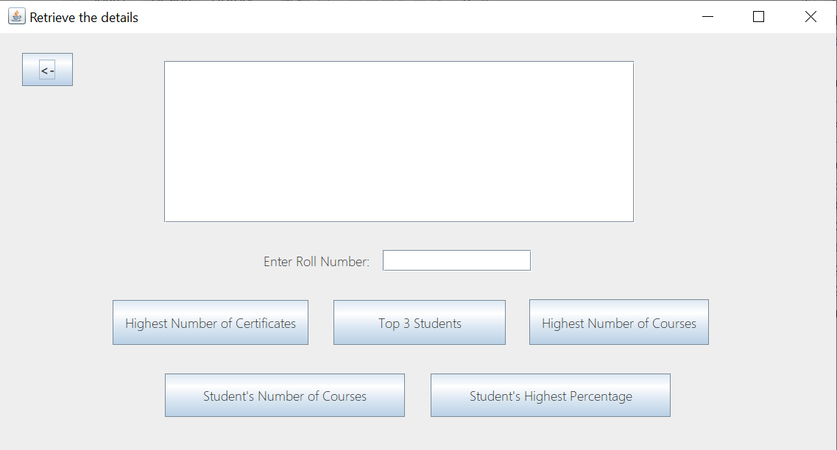

package moocdbase;

import java.sql.Connection;

import java.sql.DriverManager;

import java.sql.ResultSet;

import java.sql.SQLException;

import java.sql.Statement;

import javax.swing.JOptionPane;

public class Retrieval extends javax.swing.JFrame {

public Retrieval() {

initComponents();

}

private void initComponents() {

jScrollPane1 = new javax.swing.JScrollPane();

mainBox = new javax.swing.JTextArea();

jButton1 = new javax.swing.JButton();

jButton2 = new javax.swing.JButton();

jButton3 = new javax.swing.JButton();

jButton4 = new javax.swing.JButton();

jLabel1 = new javax.swing.JLabel();

rno = new javax.swing.JTextField();

jButton7 = new javax.swing.JButton();

jButton5 = new javax.swing.JButton();

setDefaultCloseOperation(javax.swing.WindowConstants.EXIT_ON_CLOSE);

setTitle("Retrieve the details");

mainBox.setColumns(20);

mainBox.setFont(new java.awt.Font("Yu Gothic UI Light", 0, 18));

mainBox.setRows(5);

jScrollPane1.setViewportView(mainBox);

jButton1.setFont(new java.awt.Font("Yu Gothic UI Light", 0, 18));

jButton1.setText("Highest Number of Certificates");

jButton1.addActionListener(new java.awt.event.ActionListener() {

public void actionPerformed(java.awt.event.ActionEvent evt) {

jButton1ActionPerformed(evt);

}

});

jButton2.setFont(new java.awt.Font("Yu Gothic UI Light", 0, 18));

jButton2.setText("Top 3 Students");

jButton2.addActionListener(new java.awt.event.ActionListener() {

public void actionPerformed(java.awt.event.ActionEvent evt) {

jButton2ActionPerformed(evt);

}

});

jButton3.setFont(new java.awt.Font("Yu Gothic UI Light", 0, 18));

jButton3.setText("Highest Number of Courses");

jButton3.setToolTipText("");

jButton3.addActionListener(new java.awt.event.ActionListener() {

public void actionPerformed(java.awt.event.ActionEvent evt) {

jButton3ActionPerformed(evt);

}

});

jButton4.setFont(new java.awt.Font("Yu Gothic UI Light", 0, 18));

jButton4.setText("Student's Highest Percentage");

jButton4.addActionListener(new java.awt.event.ActionListener() {

public void actionPerformed(java.awt.event.ActionEvent evt) {

jButton4ActionPerformed(evt);

}

});

jLabel1.setFont(new java.awt.Font("Yu Gothic UI Light", 0, 18));

jLabel1.setText("Enter Roll Number:");

rno.setFont(new java.awt.Font("Yu Gothic UI", 0, 18));

jButton7.setFont(new java.awt.Font("Yu Gothic UI", 1, 18));

jButton7.setText("<-");

jButton7.addActionListener(new java.awt.event.ActionListener() {

public void actionPerformed(java.awt.event.ActionEvent evt) {

jButton7ActionPerformed(evt);

}

});

jButton5.setFont(new java.awt.Font("Yu Gothic UI Light", 0, 18));

jButton5.setText("Student's Number of Courses");

jButton5.addActionListener(new java.awt.event.ActionListener() {

public void actionPerformed(java.awt.event.ActionEvent evt) {

jButton5ActionPerformed(evt);

}

});

javax.swing.GroupLayout layout = new javax.swing.GroupLayout(getContentPane());

getContentPane().setLayout(layout);

layout.setHorizontalGroup(

layout.createParallelGroup(javax.swing.GroupLayout.Alignment.LEADING)

.addGroup(layout.createSequentialGroup()

.addGroup(layout.createParallelGroup(javax.swing.GroupLayout.Alignment.TRAILING)

.addGroup(layout.createSequentialGroup()

.addComponent(jButton5, javax.swing.GroupLayout.PREFERRED_SIZE, 326, javax.swing.GroupLayout.PREFERRED_SIZE)

.addGap(35, 35, 35)

.addComponent(jButton4, javax.swing.GroupLayout.PREFERRED_SIZE, 326, javax.swing.GroupLayout.PREFERRED_SIZE)

.addGap(52, 52, 52))

.addGroup(layout.createSequentialGroup()

.addGroup(layout.createParallelGroup(javax.swing.GroupLayout.Alignment.LEADING)

.addGroup(layout.createSequentialGroup()

.addGap(30, 30, 30)

.addComponent(jButton7, javax.swing.GroupLayout.PREFERRED_SIZE, 69, javax.swing.GroupLayout.PREFERRED_SIZE)

.addGap(124, 124, 124)

.addComponent(jScrollPane1, javax.swing.GroupLayout.PREFERRED_SIZE, 639, javax.swing.GroupLayout.PREFERRED_SIZE))

.addGroup(layout.createSequentialGroup()

.addGap(358, 358, 358)

.addComponent(jLabel1)

.addGap(18, 18, 18)

.addComponent(rno, javax.swing.GroupLayout.PREFERRED_SIZE, 202, javax.swing.GroupLayout.PREFERRED_SIZE)))

.addGap(101, 101, 101))

.addGroup(layout.createSequentialGroup()

.addComponent(jButton1)

.addGap(34, 34, 34)

.addComponent(jButton2, javax.swing.GroupLayout.PREFERRED_SIZE, 234, javax.swing.GroupLayout.PREFERRED_SIZE)

.addGap(32, 32, 32)

.addComponent(jButton3)))

.addContainerGap(173, Short.MAX_VALUE))

);

layout.setVerticalGroup(

layout.createParallelGroup(javax.swing.GroupLayout.Alignment.LEADING)

.addGroup(layout.createSequentialGroup()

.addGap(27, 27, 27)

.addComponent(jButton7, javax.swing.GroupLayout.PREFERRED_SIZE, 45, javax.swing.GroupLayout.PREFERRED_SIZE)

.addContainerGap(javax.swing.GroupLayout.DEFAULT_SIZE, Short.MAX_VALUE))

.addGroup(javax.swing.GroupLayout.Alignment.TRAILING, layout.createSequentialGroup()

.addContainerGap(38, Short.MAX_VALUE)

.addComponent(jScrollPane1, javax.swing.GroupLayout.PREFERRED_SIZE, 220, javax.swing.GroupLayout.PREFERRED_SIZE)

.addGap(37, 37, 37)

.addGroup(layout.createParallelGroup(javax.swing.GroupLayout.Alignment.BASELINE)

.addComponent(jLabel1)

.addComponent(rno, javax.swing.GroupLayout.PREFERRED_SIZE, javax.swing.GroupLayout.DEFAULT_SIZE, javax.swing.GroupLayout.PREFERRED_SIZE))

.addGap(38, 38, 38) .addGroup(layout.createParallelGroup(javax.swing.GroupLayout.Alignment.BASELINE)

.addComponent(jButton1, javax.swing.GroupLayout.PREFERRED_SIZE, 61, javax.swing.GroupLayout.PREFERRED_SIZE)

.addComponent(jButton2, javax.swing.GroupLayout.PREFERRED_SIZE, 61, javax.swing.GroupLayout.PREFERRED_SIZE)

.addComponent(jButton3, javax.swing.GroupLayout.PREFERRED_SIZE, 62, javax.swing.GroupLayout.PREFERRED_SIZE))

.addGap(39, 39, 39) .addGroup(layout.createParallelGroup(javax.swing.GroupLayout.Alignment.BASELINE)

.addComponent(jButton5, javax.swing.GroupLayout.PREFERRED_SIZE, 59, javax.swing.GroupLayout.PREFERRED_SIZE)

.addComponent(jButton4, javax.swing.GroupLayout.PREFERRED_SIZE, 59, javax.swing.GroupLayout.PREFERRED_SIZE))

.addGap(45, 45, 45))

);

pack();

}// </editor-fold>

private void jButton4ActionPerformed(java.awt.event.ActionEvent evt) {

try{

String roll=rno.getText();

String message="";

if("".equals(roll)){

message+="Roll Number field must not be empty\n";

}

else{

Class.forName("oracle.jdbc.OracleDriver");

Connection con=DriverManager.getConnection("jdbc:oracle:thin:@localhost:1521:xe","abhiram","iruvanti");

Statement stmt=con.createStatement();

ResultSet rs=stmt.executeQuery("select max(percentage_achieved) from scores where roll_number='"+roll+"'");

String name=getName(roll);

if(name.equals("")){

JOptionPane.showMessageDialog(this,"Roll Number does not exist");

}

else{

String ans="";

while(rs.next())

ans+=rs.getString(1);

if(ans.equals("null")){

mainBox.setText("The student seems to have not done any course");

}

else{

mainBox.setText("Highest percentage achieved by "+name+" is "+ans);

}

con.close();

}

}

if(!"".equals(message)){

JOptionPane.showMessageDialog(this,message);

}

}

catch(Exception e){

System.out.println(e);

}

}

private void jButton7ActionPerformed(java.awt.event.ActionEvent evt) {

dispose();

TheMainPage mp=new TheMainPage();

mp.show();

}

private void jButton1ActionPerformed(java.awt.event.ActionEvent evt) {

try{

Class.forName("oracle.jdbc.OracleDriver");

Connection con=DriverManager.getConnection("jdbc:oracle:thin:@localhost:1521:xe","abhiram","iruvanti");

Statement stmt=con.createStatement();

ResultSet rs=stmt.executeQuery("select s.student_name,s.roll_number from students s,(select roll_number,count(roll_number) from certificate group by roll_number having count(roll_number)=(select max(mycount) from(select roll_number,count(roll_number) mycount from certificate group by roll_number)))c where s.roll_number=c.roll_number");

String ans="";

ans+="Student Name \t Roll Number\n\n";

while(rs.next())

ans+=(rs.getString(1)+" \t "+rs.getString(2))+"\n";

mainBox.setText(ans);

con.close();

}

catch(Exception e){

System.out.println(e);

}

}

private void jButton2ActionPerformed(java.awt.event.ActionEvent evt) {

try{

Class.forName("oracle.jdbc.OracleDriver");

Connection con=DriverManager.getConnection("jdbc:oracle:thin:@localhost:1521:xe","abhiram","iruvanti");

Statement stmt=con.createStatement();

ResultSet rs=stmt.executeQuery("select rownum,S.student_name,s.percentage_achieved from students S, (select * from scores order by percentage_achieved desc)s where rownum<=3");

String ans="";

ans+="Rank \t Student Name \t Percentage\n\n";

while(rs.next())

ans+=(rs.getString(1)+" \t "+rs.getString(2)+" \t "+rs.getString(3)+"\n");

mainBox.setText(ans);

con.close();

}

catch(Exception e){

System.out.println(e);

}

}

private void jButton3ActionPerformed(java.awt.event.ActionEvent evt) {

try{

Class.forName("oracle.jdbc.OracleDriver");

Connection con=DriverManager.getConnection("jdbc:oracle:thin:@localhost:1521:xe","abhiram","iruvanti");

Statement stmt=con.createStatement();

ResultSet rs=stmt.executeQuery("select s.student_name,s.roll_number from students s,(select roll_number,count(roll_number) from enrolls group by roll_number having count(roll_number)=(select max(mycount) from(select roll_number,count(roll_number) mycount from enrolls group by roll_number)))c where s.roll_number=c.roll_number");

String ans="";

ans+="Student Name \t Roll Number\n\n";

while(rs.next())

ans+=(rs.getString(1)+" \t "+rs.getString(2))+"\n";

mainBox.setText(ans);

con.close();

}

catch(Exception e){

System.out.println(e);

}

}

public String getName(String roll){

String ans;

try{

Class.forName("oracle.jdbc.OracleDriver");

Connection con=DriverManager.getConnection("jdbc:oracle:thin:@localhost:1521:xe","abhiram","iruvanti");

Statement stmt=con.createStatement();

ResultSet rs=stmt.executeQuery("select student_name from students where roll_number='"+roll+"'");

ans="";

while(rs.next())

ans+=rs.getString(1);

return ans;

}

catch(ClassNotFoundException | SQLException e){

System.out.println(e);

}

return "";

}

private void jButton5ActionPerformed(java.awt.event.ActionEvent evt) {

try{

String roll=rno.getText();

String message="";

if("".equals(roll)){

message+="Roll Number field must not be empty\n";

}

else{

Class.forName("oracle.jdbc.OracleDriver");

Connection con=DriverManager.getConnection("jdbc:oracle:thin:@localhost:1521:xe","abhiram","iruvanti");

Statement stmt=con.createStatement();

ResultSet rs=stmt.executeQuery("select count(roll_number) from enrolls where roll_number='"+roll+"'");

String name=getName(roll);

String ans="";

while(rs.next())

ans+=rs.getString(1);

if("0".equals(ans)){

mainBox.setText("The student seems to have not done any course");

}

else{

mainBox.setText("Number of courses done by "+name+" are "+ans);

con.close();

}

}

if(!"".equals(message)){

JOptionPane.showMessageDialog(this,message);

}

}

catch(Exception e){

System.out.println(e);

}

}

public static void main(String args[]) {

java.awt.EventQueue.invokeLater(new Runnable() {

public void run() {

new Retrieval().setVisible(true);

}

});

}

private javax.swing.JButton jButton1;

private javax.swing.JButton jButton2;

private javax.swing.JButton jButton3;

private javax.swing.JButton jButton4;

private javax.swing.JButton jButton5;

private javax.swing.JButton jButton7;

private javax.swing.JLabel jLabel1;

private javax.swing.JScrollPane jScrollPane1;

private javax.swing.JTextArea mainBox;

private javax.swing.JTextField rno;

}

**GitHub Links and Folder Structure:**

**Link:** <https://github.com/abhiramsreekar/MOOC_Database>

**Folder Structure:**

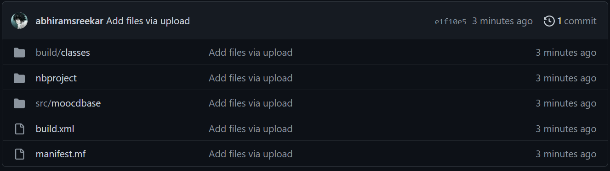

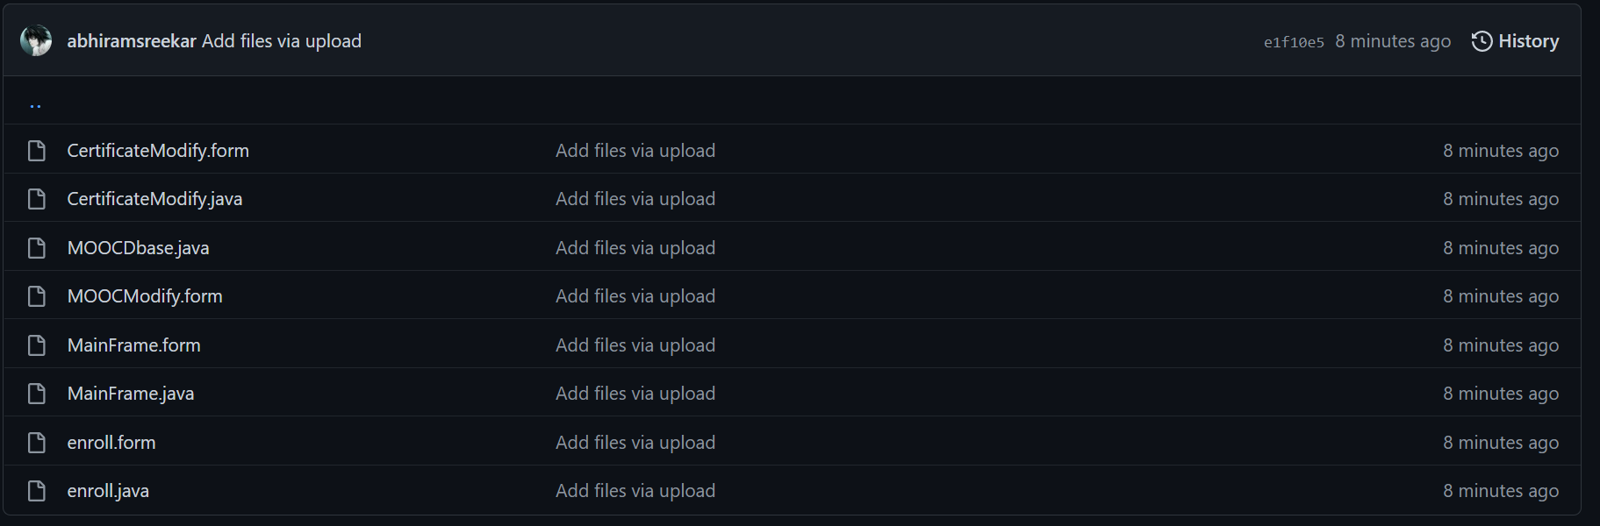

**TESTING:**

**Inserting Student Details:**

Before insertion:

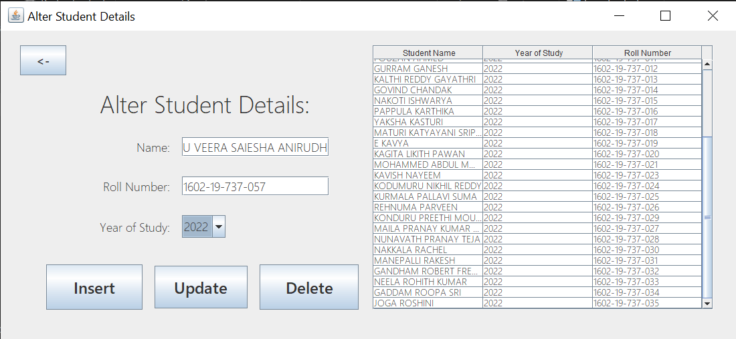

After insertion:

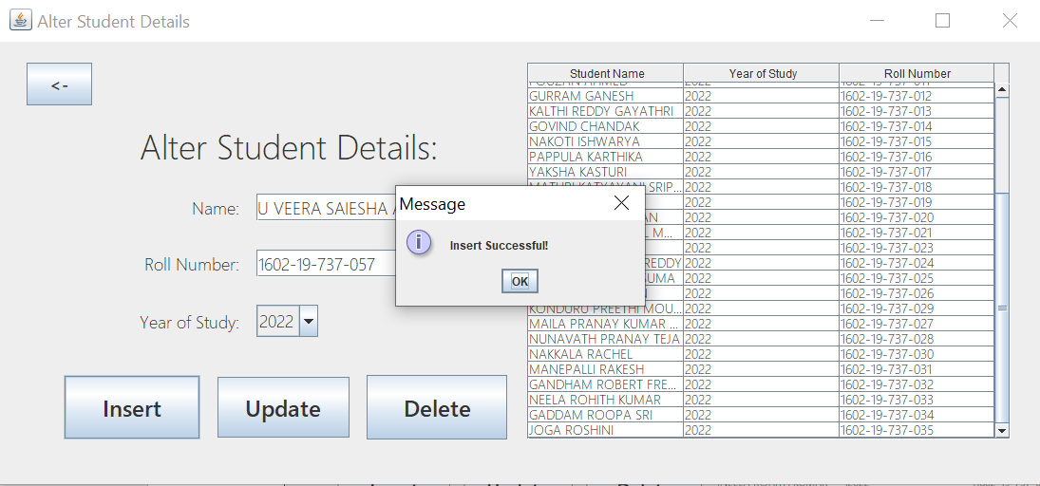

Value gets updated and saved in the table automatically.

**Updating Student Details:**

Before Update:

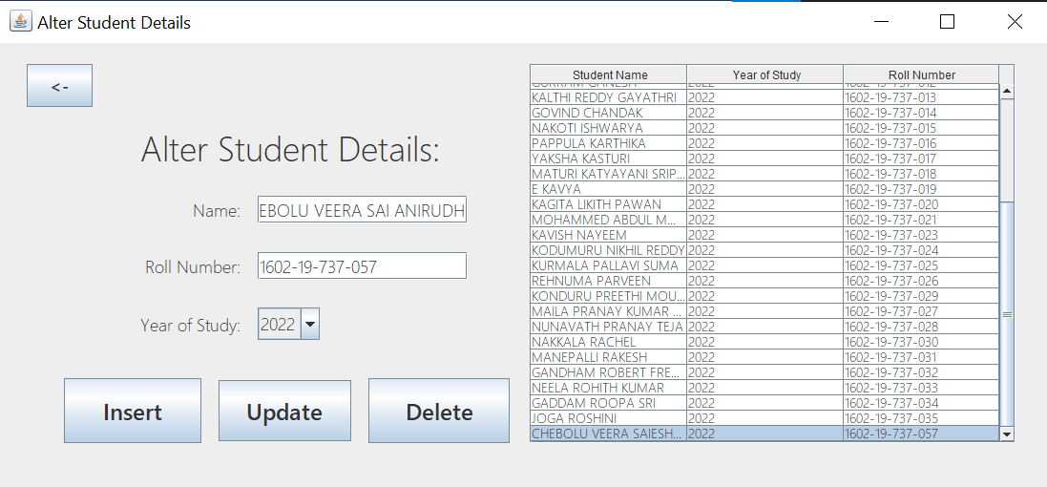

After Update:

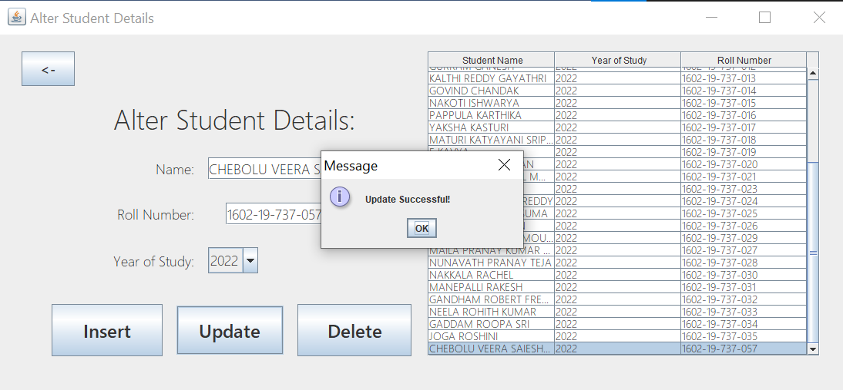

**Deleting Student Details:**

Before Delete:

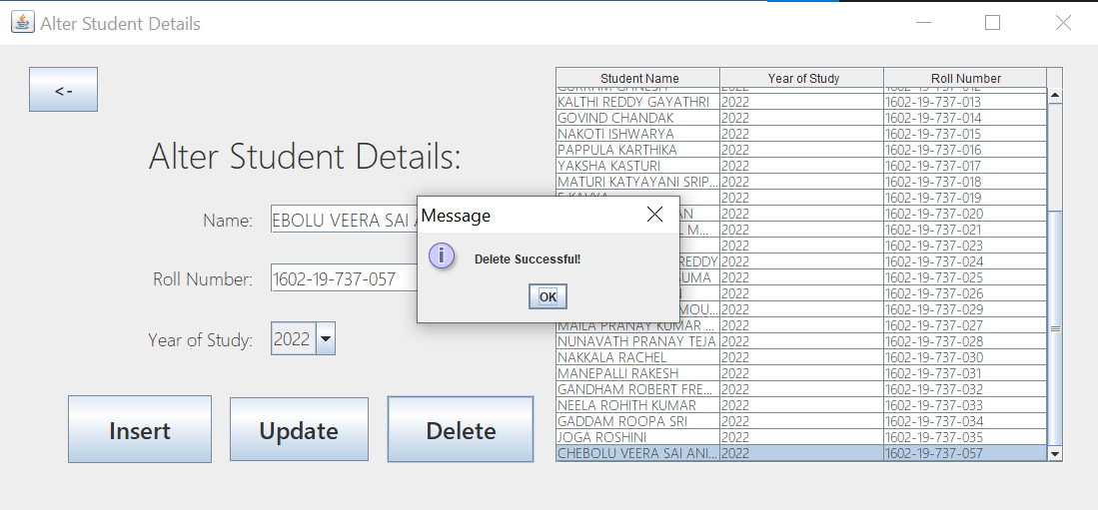

After Delete:



**Inserting MOOC Details:**

Before Insert:

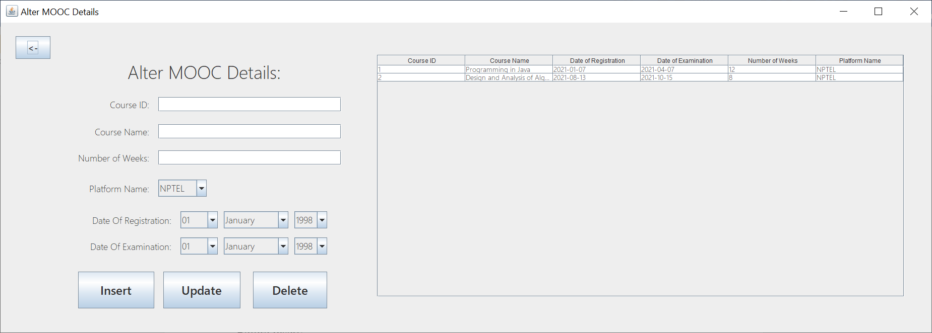

After Insert:

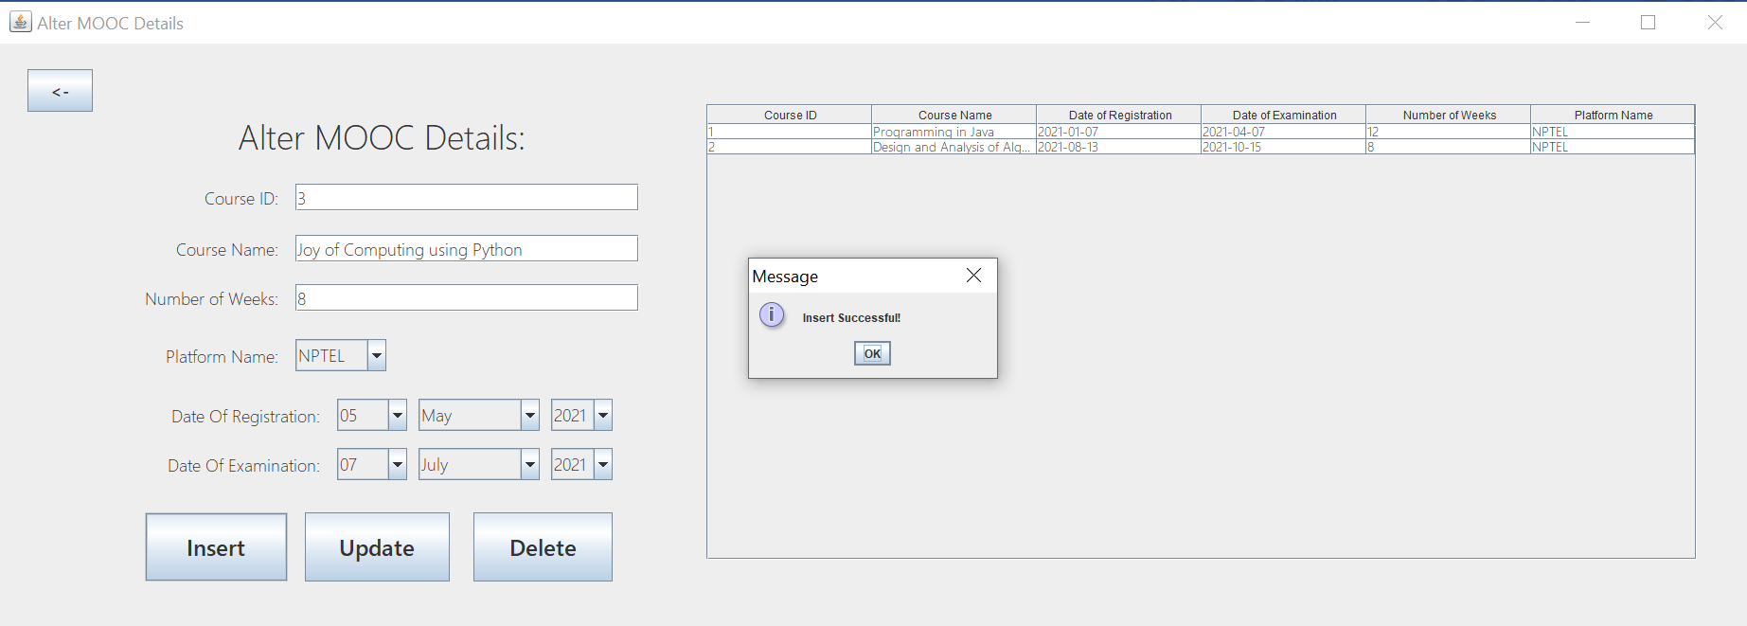

**Updating MOOC Details:**

Before Update:

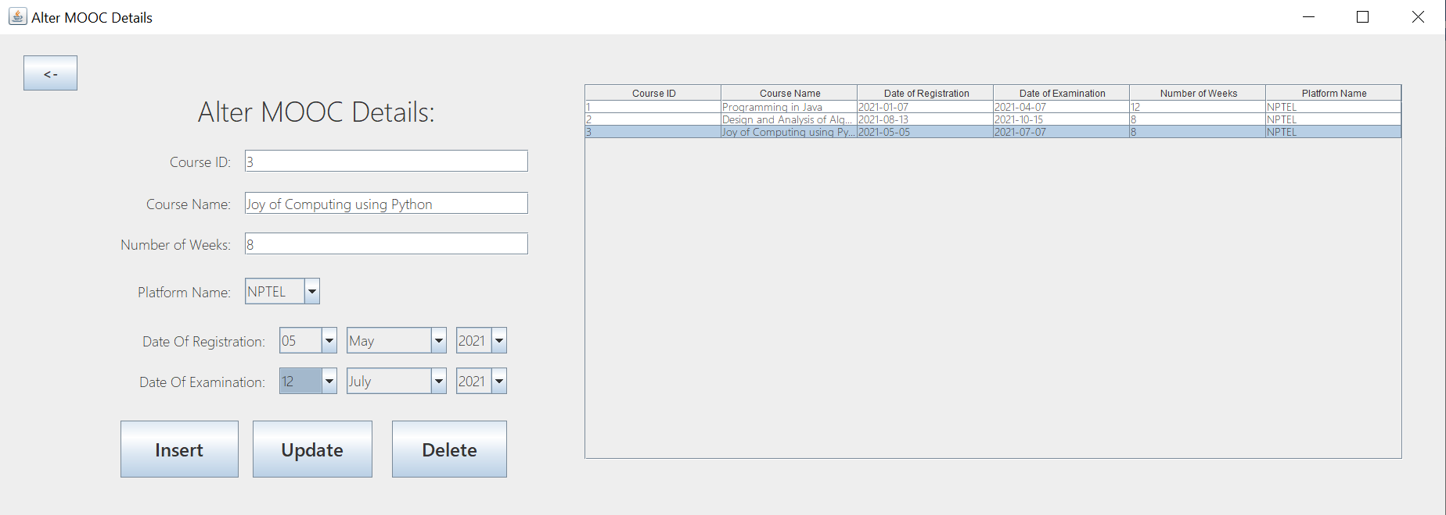

After Update:

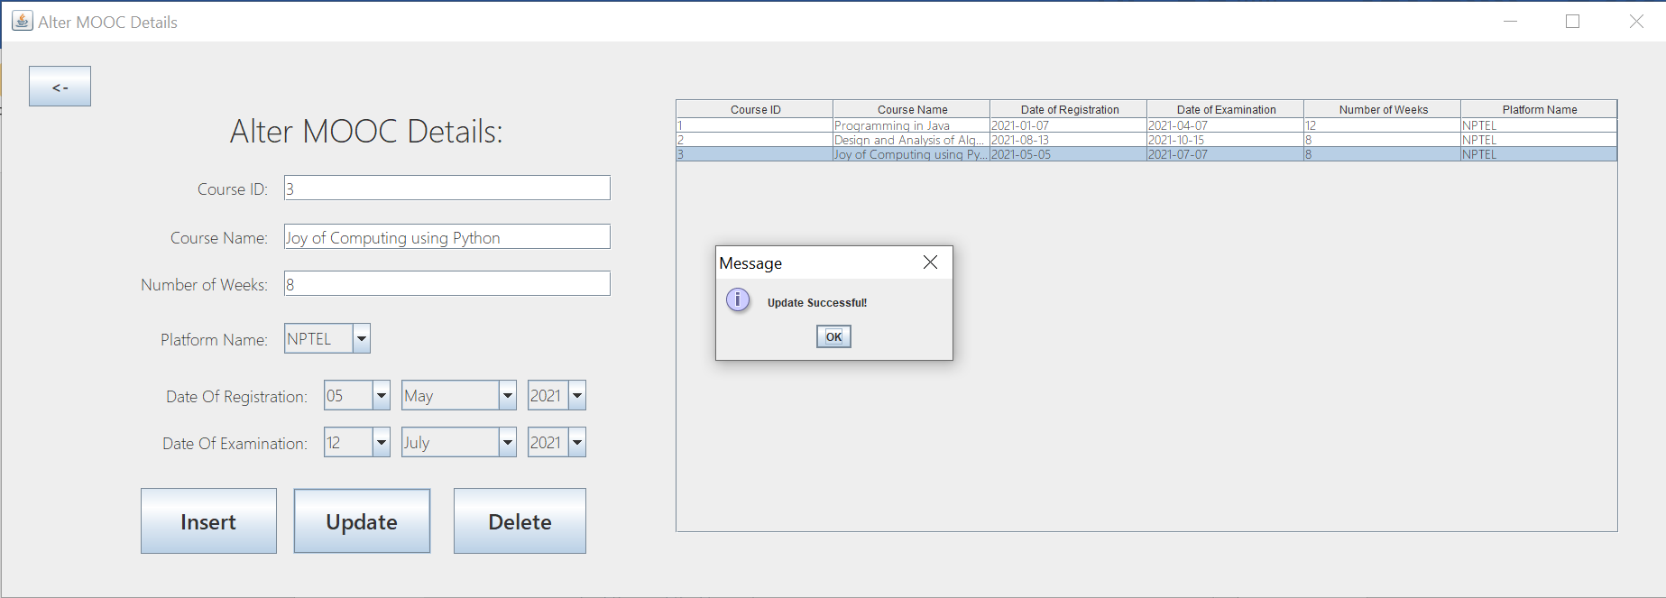

**Deleting MOOC Details:**

Before Delete:



After Delete:

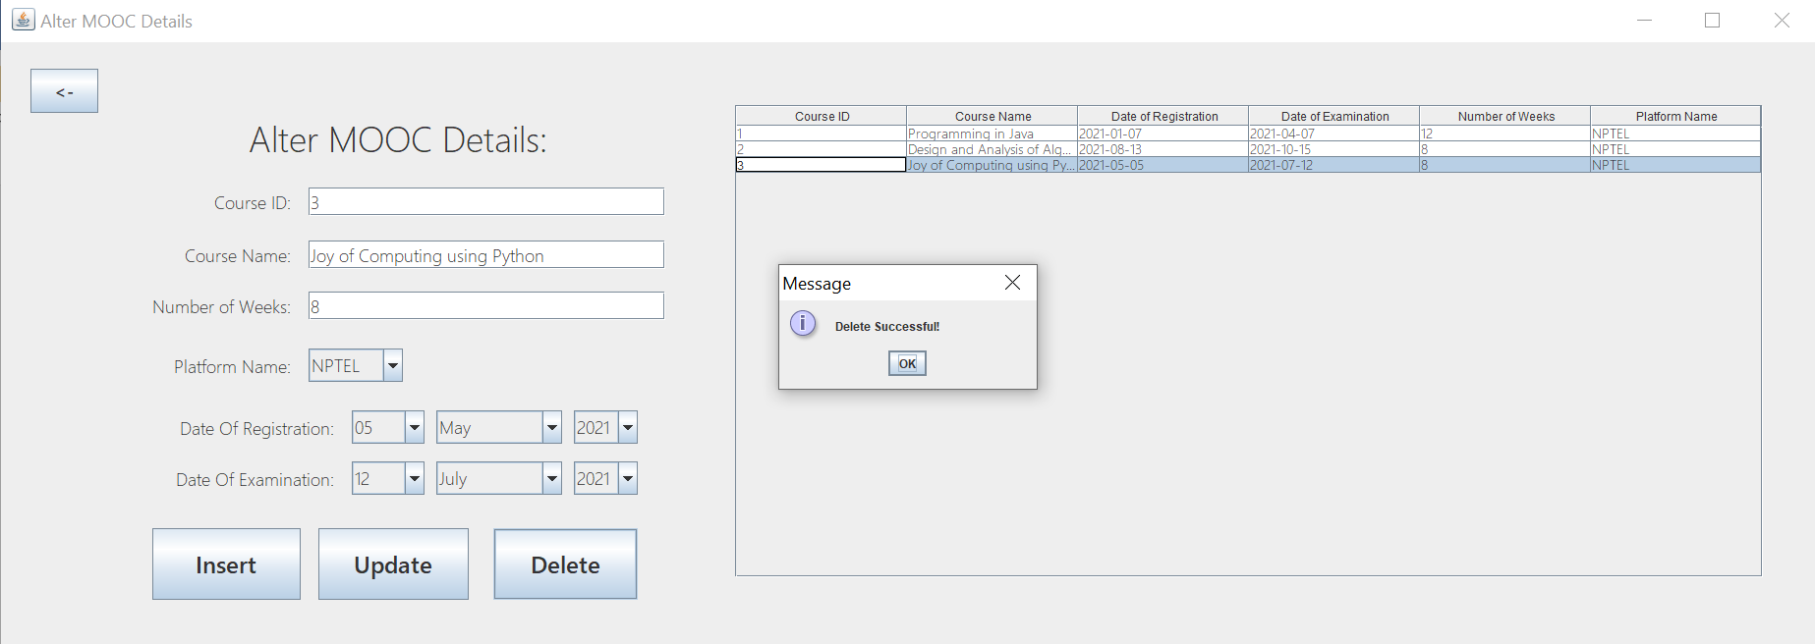

**Inserting Certificate Details:**

Before Insert:

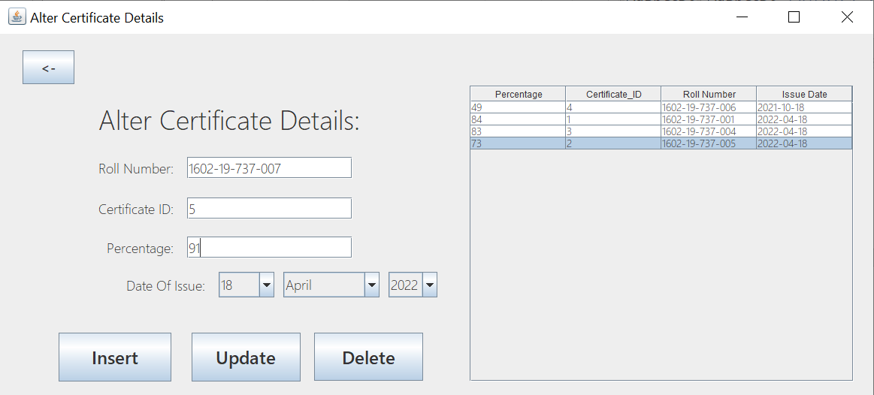

After Insert:

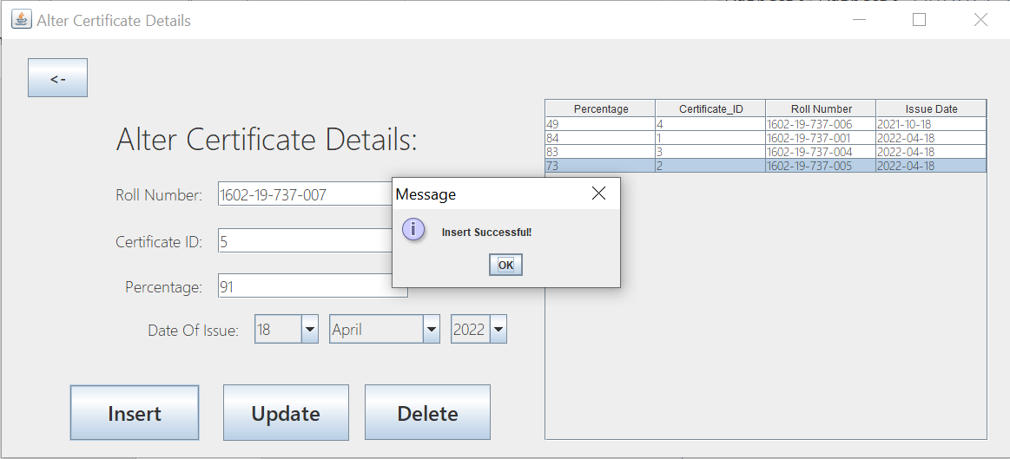

**Updating Certificate Details:**

Before Update:

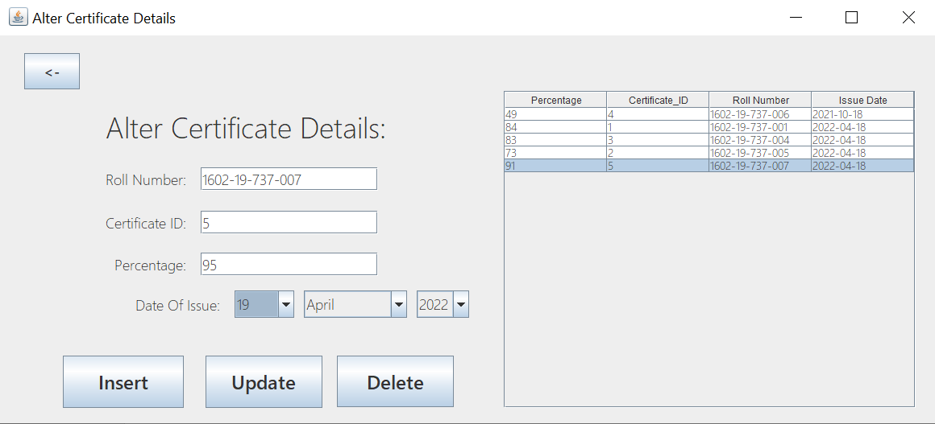

After Update:

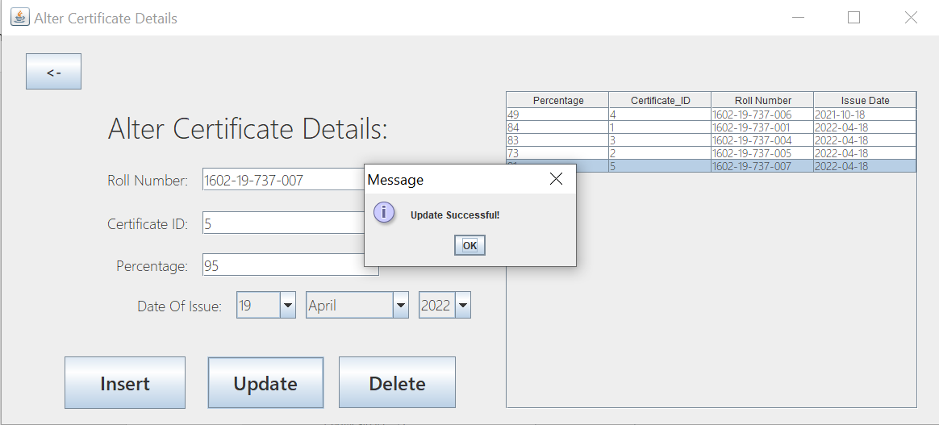

**Delete Certificate Details:**

Before Delete:

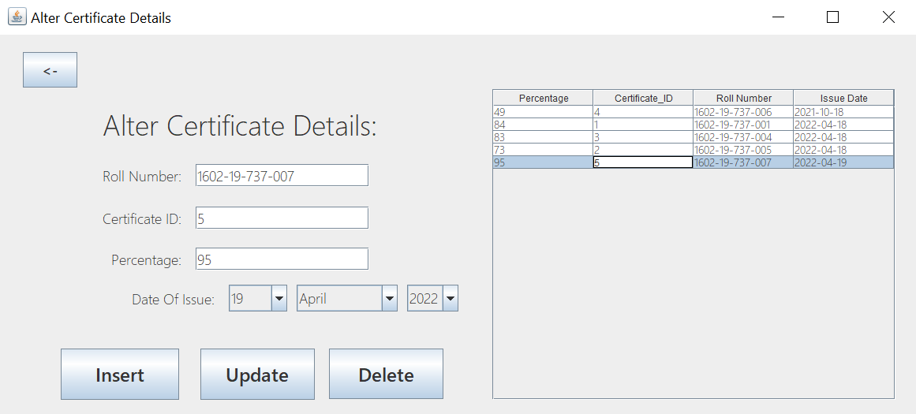

After Delete:

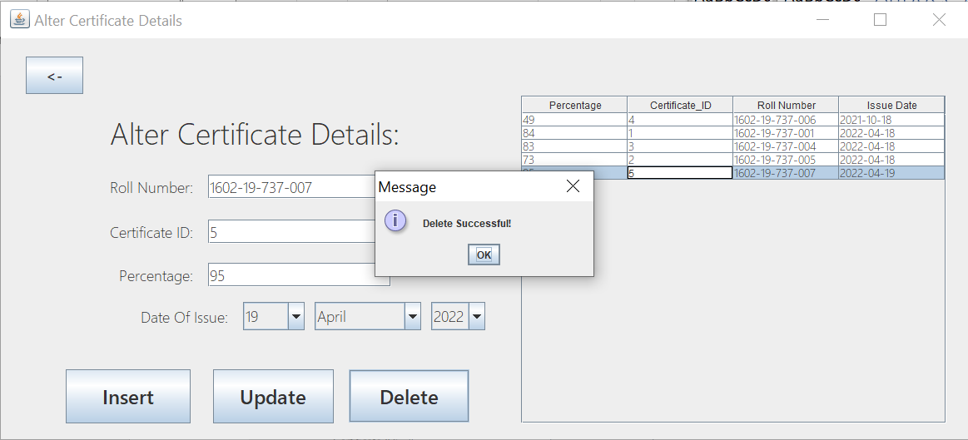

**Insert Score Details:**

Before Score:

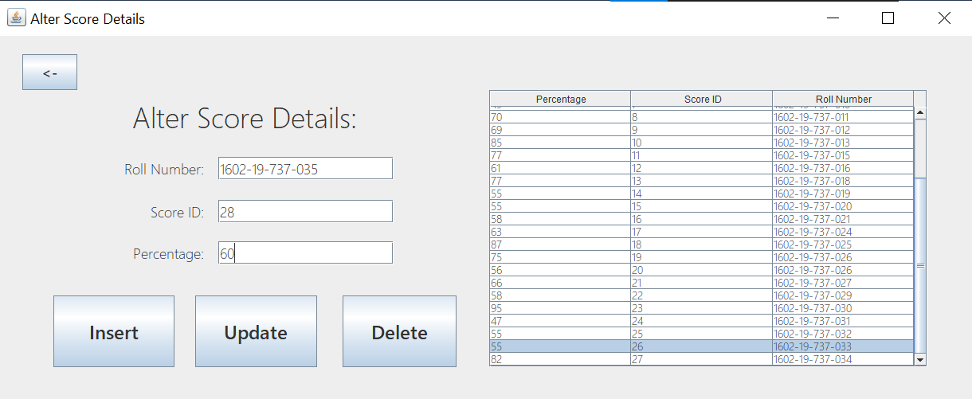

After Score:

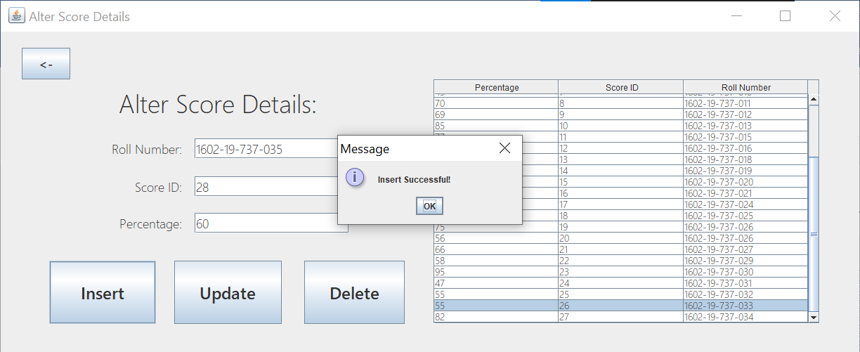

**Update Score Details:**

Before Update:

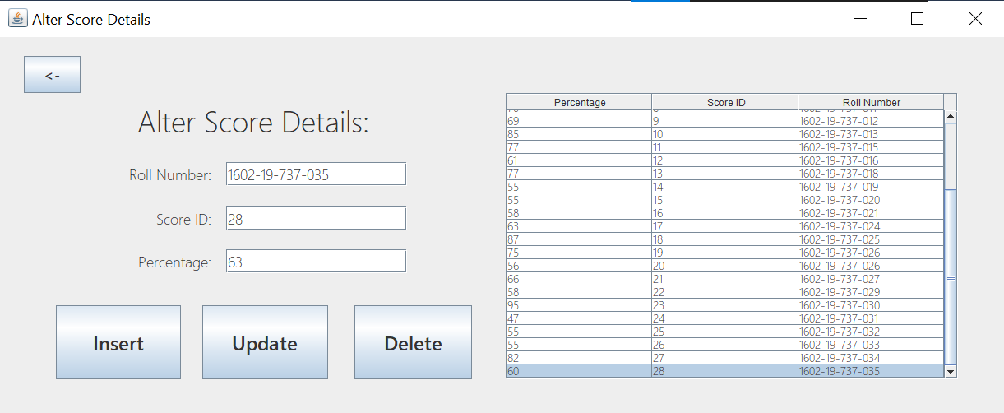

After Update:

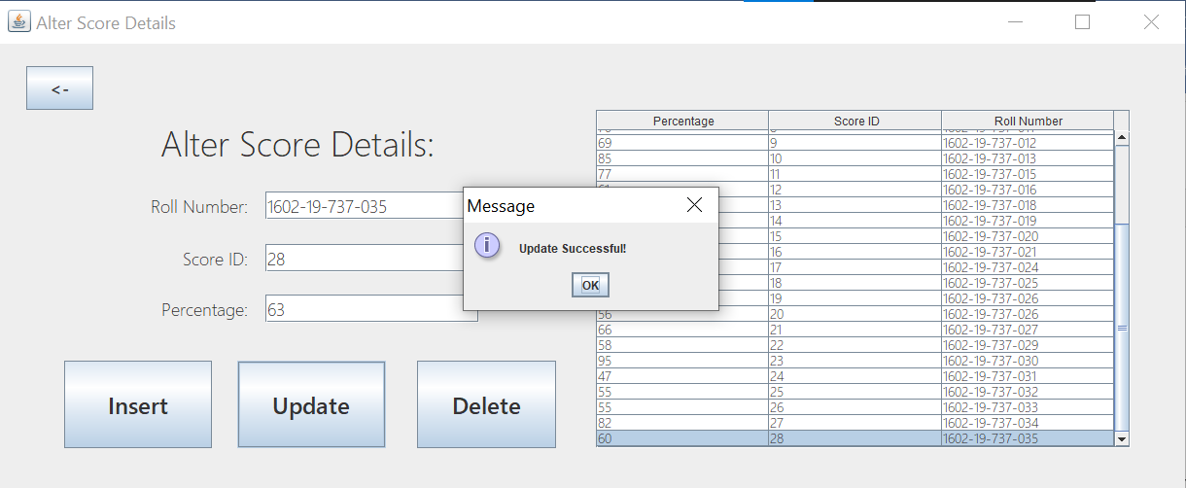

**Delete Score Details:**

Before Delete:

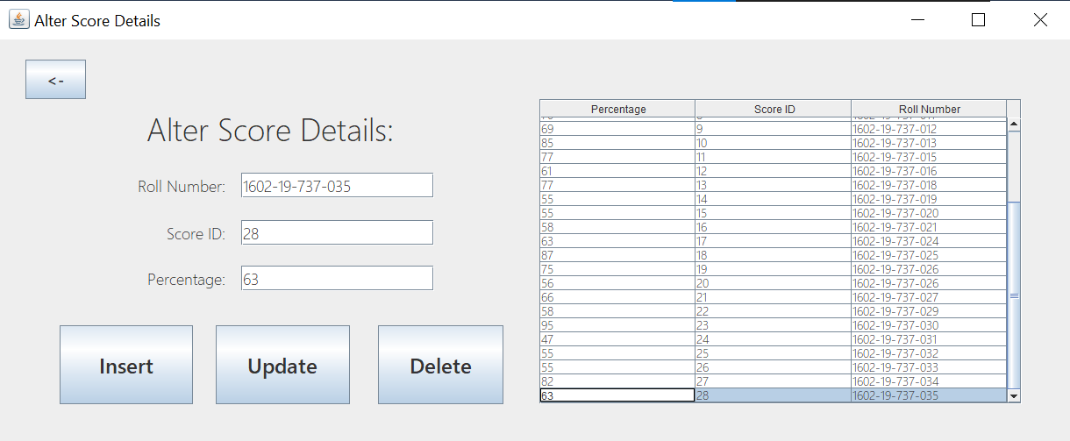

After Delete:

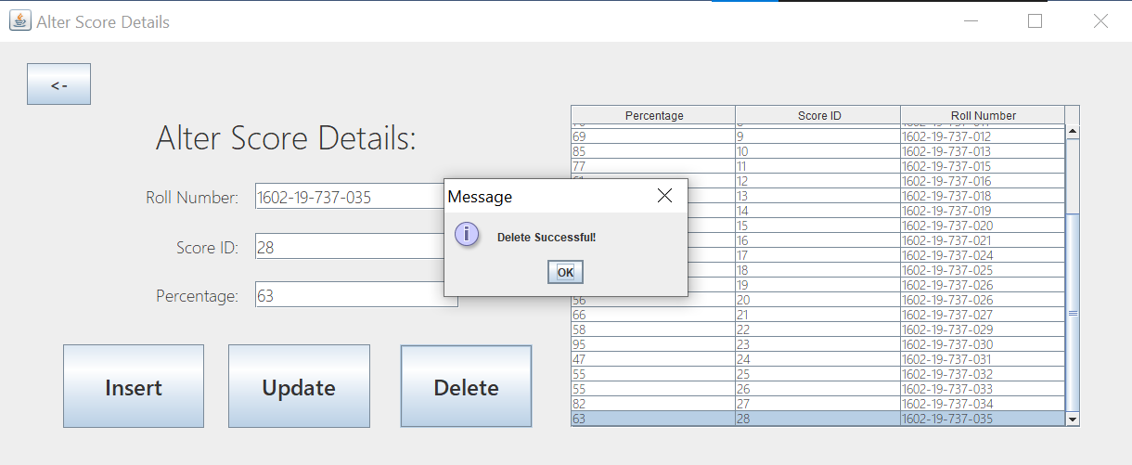

**Insert Enroll Details:**

Before Insert:

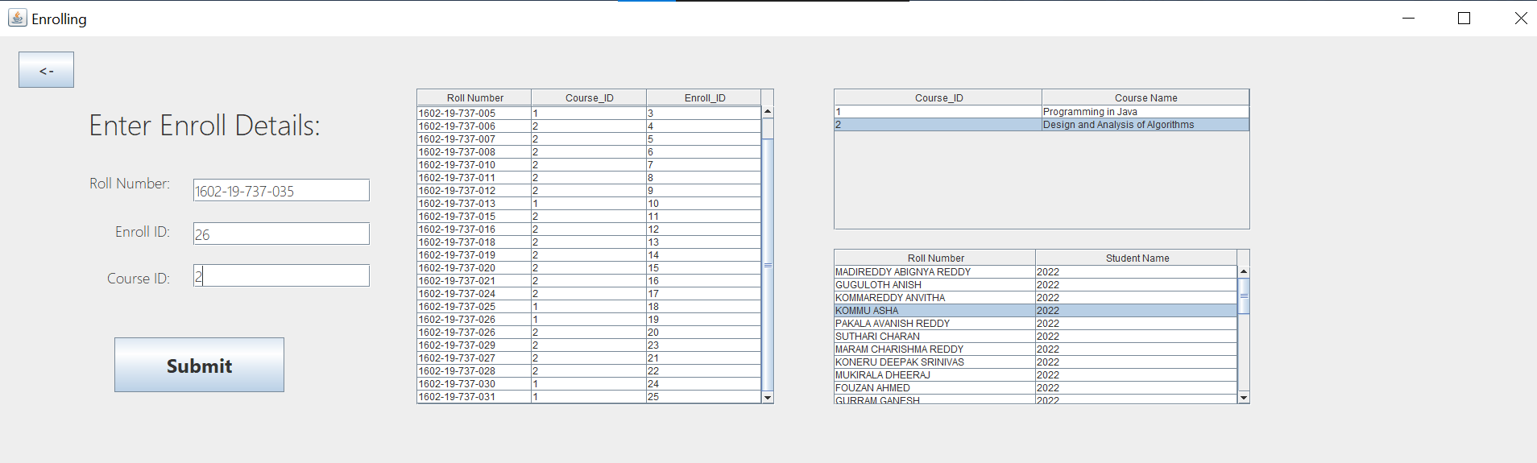

After Insert:

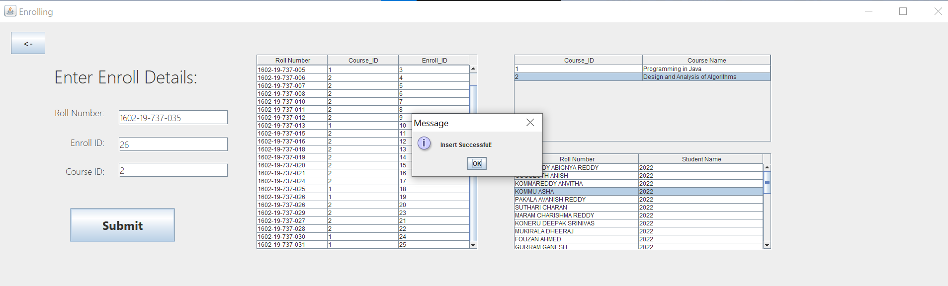

**Check Retrieval Details:**

Highest Number of Certificates:

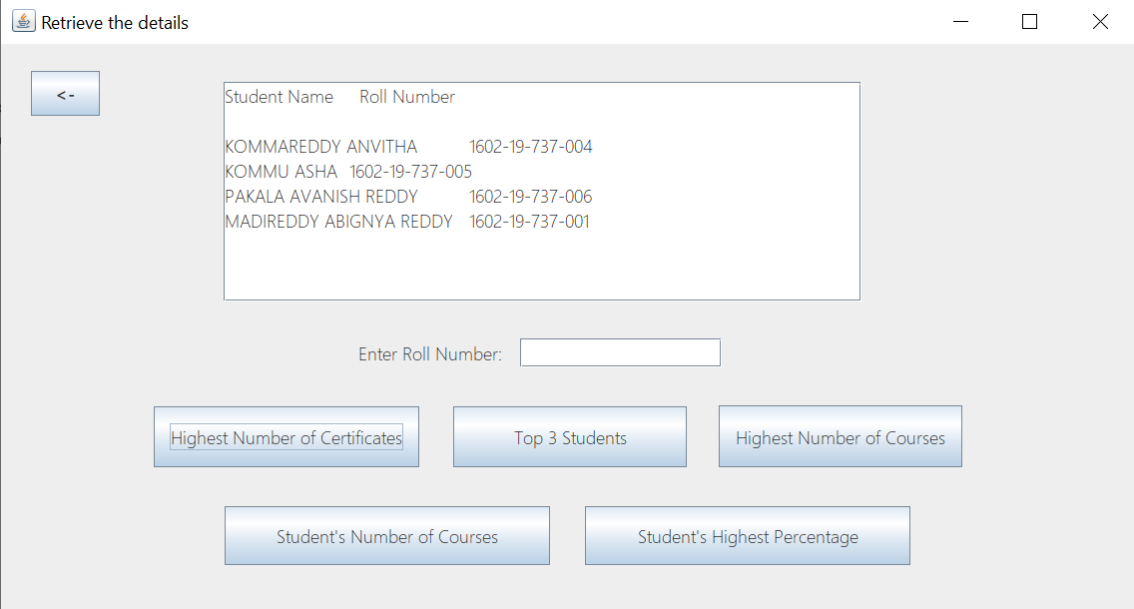

Top 3 students:

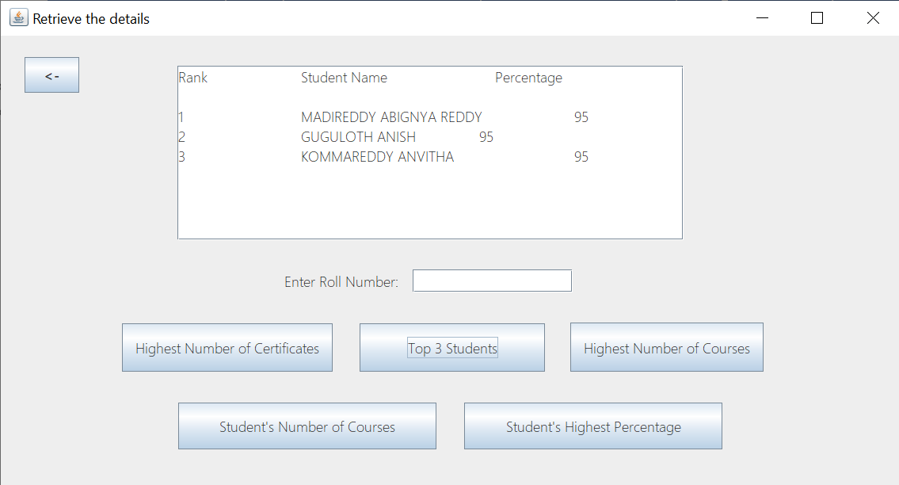

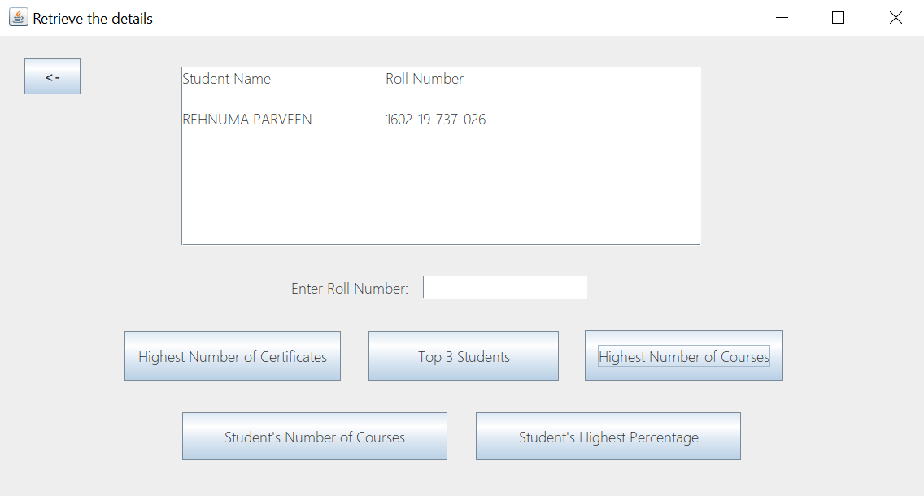Highest Number of Courses:

Student’s Number of Courses:

If roll number not entered:

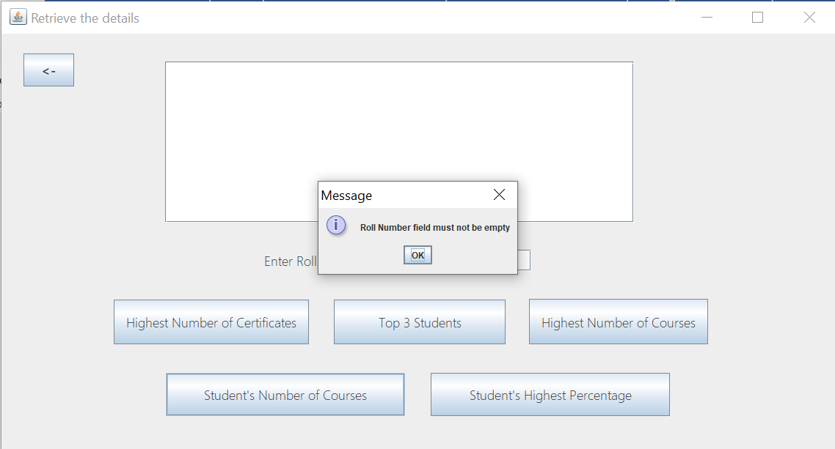

If roll number entered:

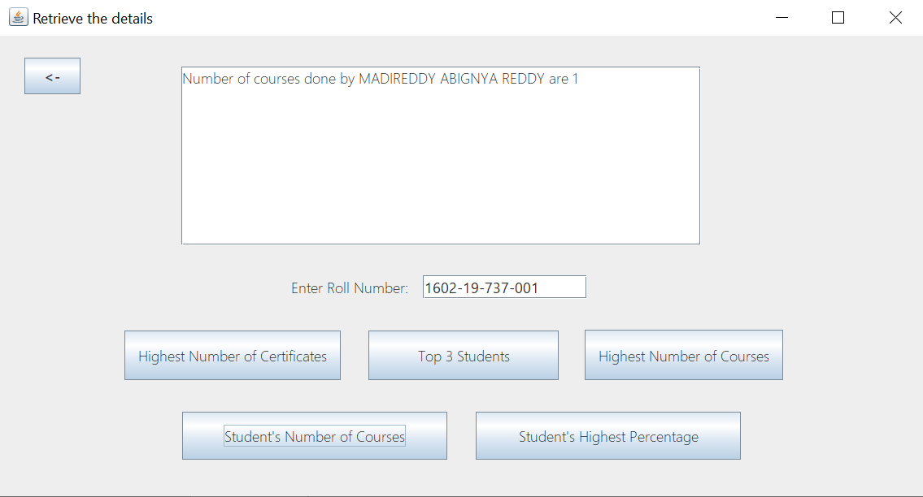

Student’s Highest percentage:

If roll number not entered:

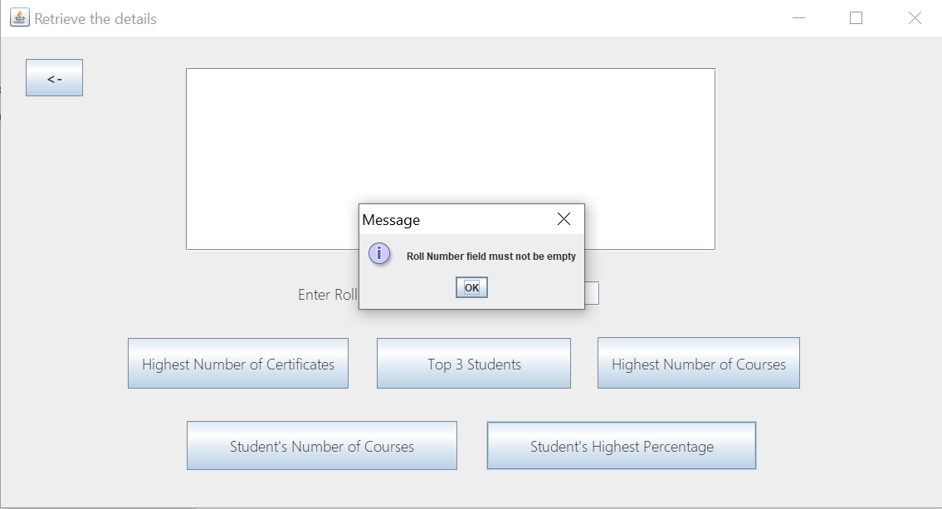

If roll number entered:

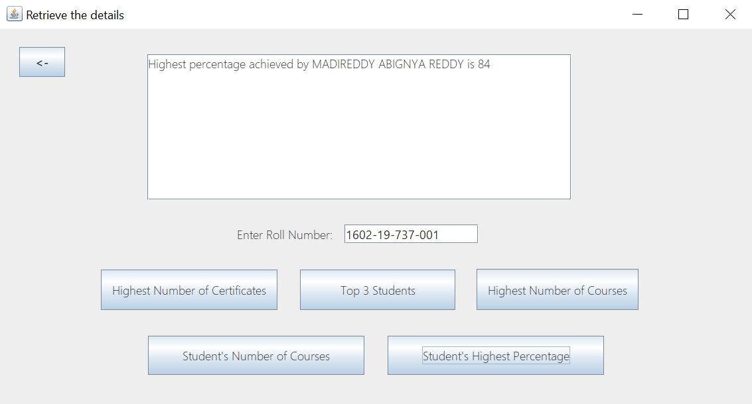

**RESULT**

I have successfully completed my DBMS project ‘***MOOC Database***’

**DISCUSSION AND FUTURE WORK**

This project is an application which helps the students access their highest-grade points from all the courses they have been certified for, contains the basic interaction of applying for internships by students and hiring of interns by project managers. It has a very basic user interface. Future scope would be to make the UI more appealing by using graphics. One more feature would be to allow student-users to upload their resumes and official documents required so that the project managers can take a look while they hire them. We can also think of including a feedback system to allow the users to leave their valuable feedback after using this app. Making this feedback to be publicly viewable, would attract many more users to use this app.

**REFERENCES**

● https://docs.oracle.com/javase/7/docs/api/

● <https://www.javatpoint.com/java-swing>

● https://stackoverflow.com/