The email functionality is done using gmail smtp server. User Name and password for my gmail account is removed for security reasons in the code. This module contains to web pages, one for sending email from the, which resides in EmailList Table and the other one is for verifying the email., that is when the link sent in the email is clicked by the user.

The table scheme for EmailList is depicted in the below image:

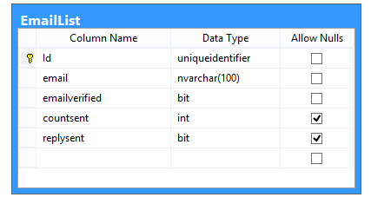

Emailverified: if the user clicks the link in the email, it will be set to true

Countsent: If the user doesn’t click the email link, email will be sent repeatedly for 3 days and if the countsent is 4, sending email will be stopped.

Replysent: if the user clicks the link in email, and the reply email is sent, this field will be set to true.

Default.aspx is the page which will be scheduled to run everyday on 12AM. This page gets the email list whose countsent is lesser than 4 and EmailVerified is false. If the EmailVerified is true, no email will be sent again.

About.aspx is the page which will be sent as a link in the email.if the user clicks it, this page will make emailverified flag to true in EmailList table.

Routine email will be sent using scheduler by using a batch file webpage.cmd. This file will be scheduled using Task Scheduler in windows machine

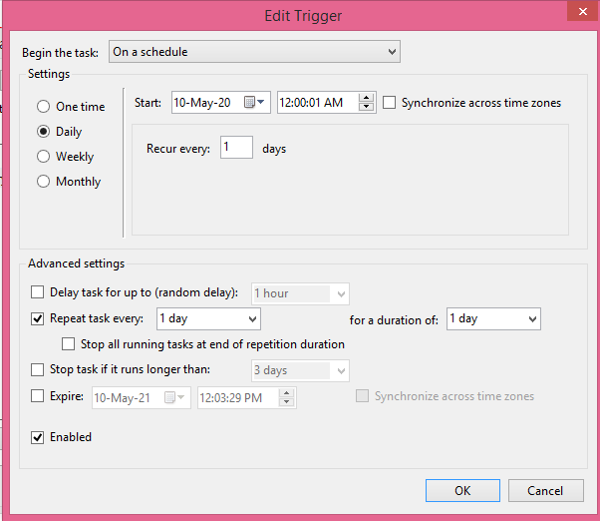

The above screen shot shows that default.aspx page is scheduled in task scheduler. Trigger occur every day and action is where we give the command file or batch file name to trigger.

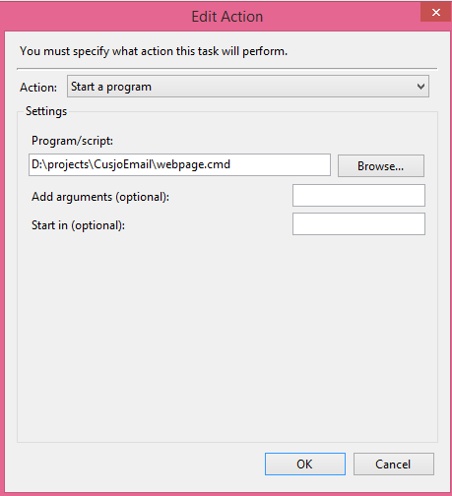

Please note that it is assumed the web application is hosted in IIS server so that it is available all the time and the task scheduler can run the pages and close it immediately when the task is done.

By the way, the cmd file contains only one command and that is given below:

start chrome <https://localhost:44383/default.aspx>