User: [abhiramvikrant@icloud.com](mailto:abhiramvikrant@icloud.com)

Role: user

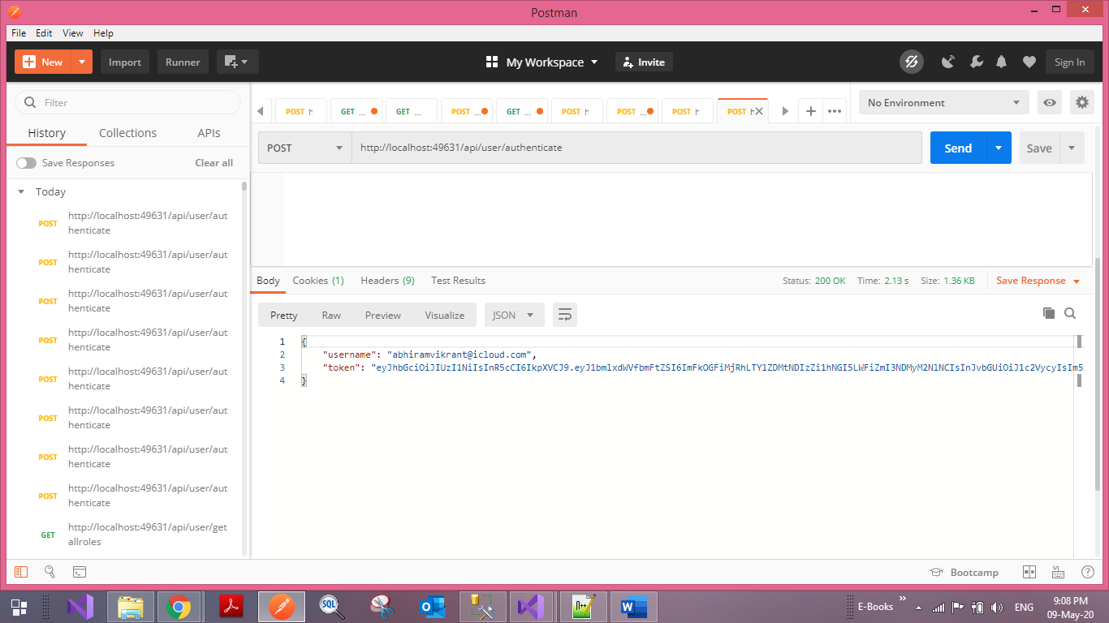

GetAllRoles will respond only to user role as shown below

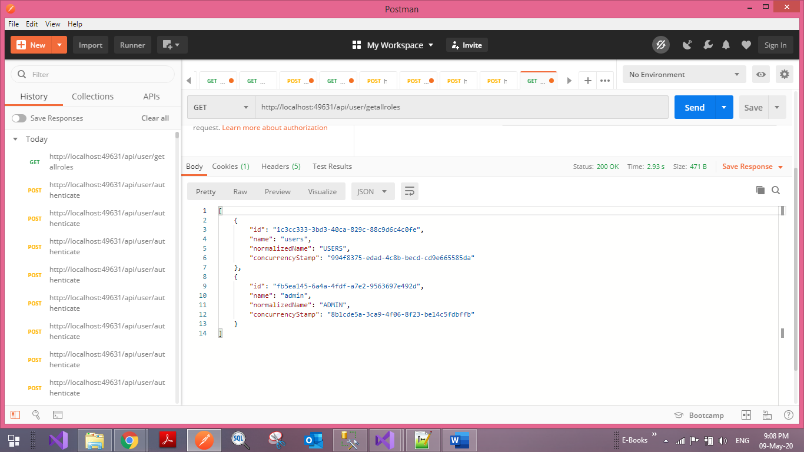

User: [abhiramvikrant@gmail.com](mailto:abhiramvikrant@gmail.com)

Role: admin

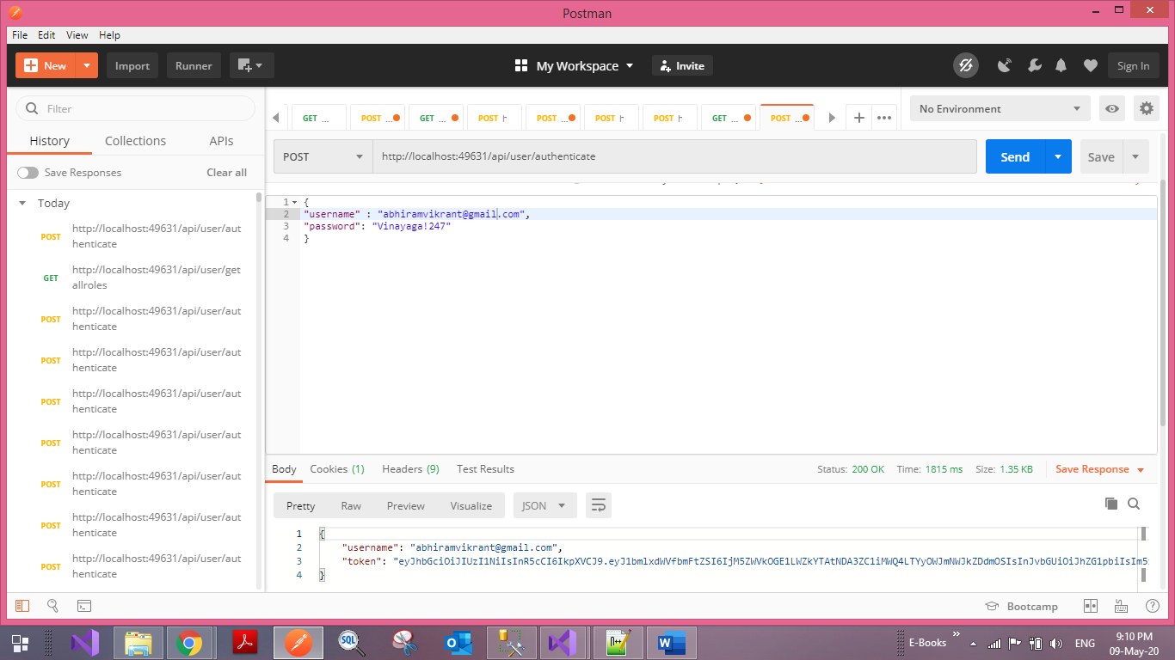

GetAllUsers return json result of all users if the role is admin

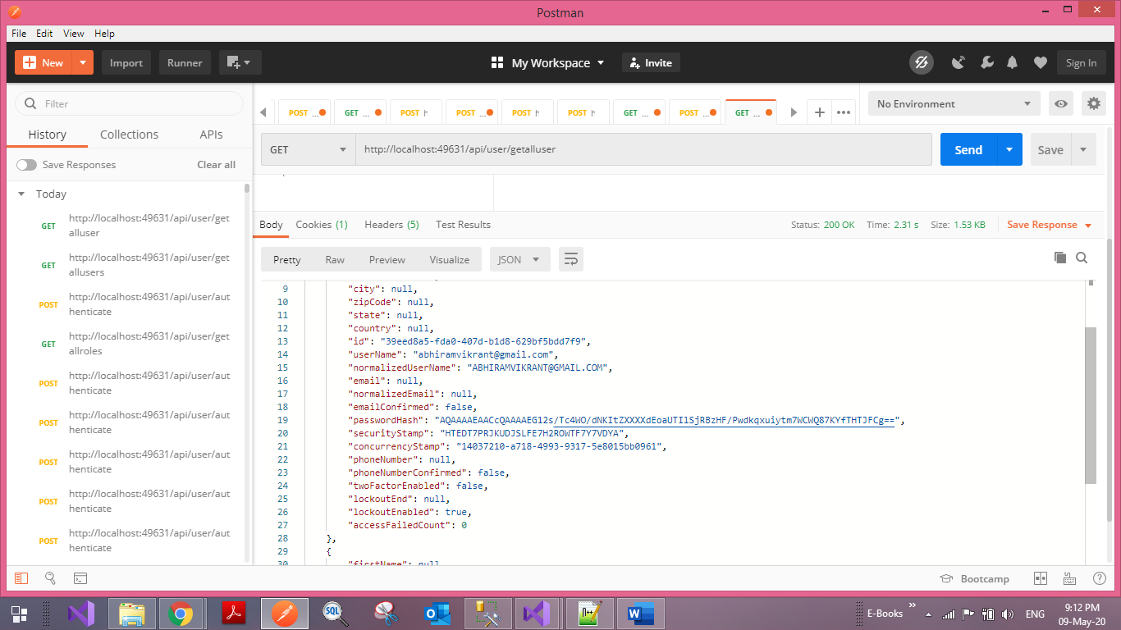

Tables are created using IdentityDBContext in the database by applying EF migrations. Aspnetusers, aspnetroles, aspnetuserroles are the important tables which contains users, roles and user role mappings. Two roles were created namely admin and users. The admin user has permission to get the user list and for the example sake, the user roles can get the role list. Table creation scripts are kept in TableScripts.sql