The front end task is about changing font size, color, styles( like bold, italics and Underline)

A simple asp.net web application is used to achieve it

This application uses no database and sql server is not needed.

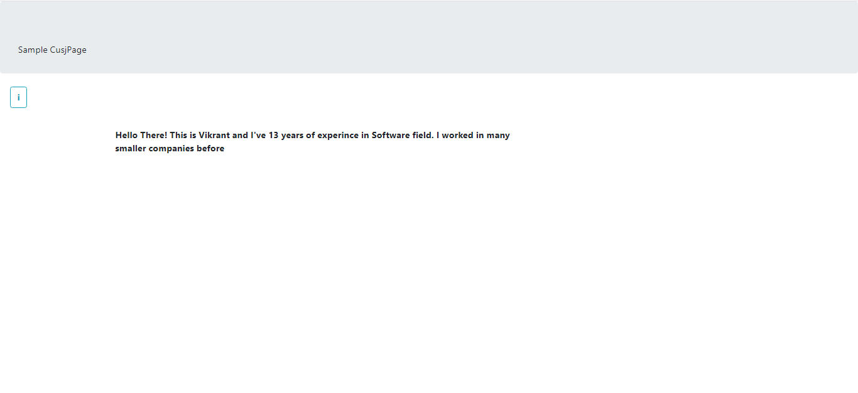

This page contains the header text which can be changed using the tool box , which pops up when you hover the mouser over the alphabet “I”. The features are changing header styles and changing language using the language drop down list in the hover menu

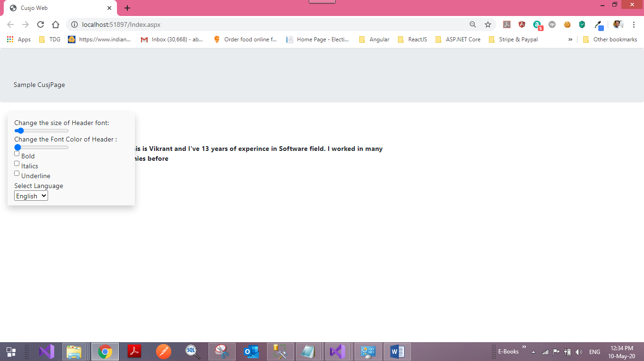

If you use the slider to change the font size, the header font size will change as given below:

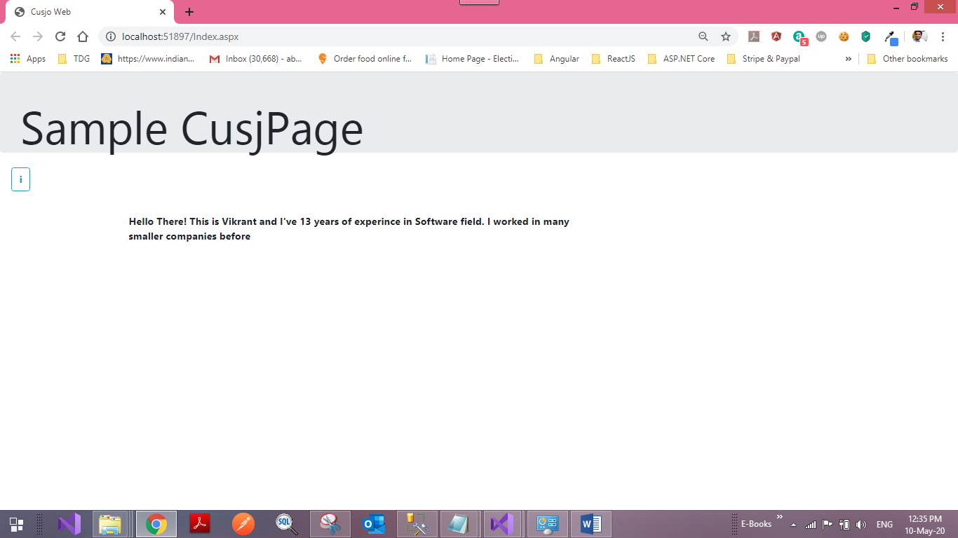

If you change the color slider, the header font color will change as given below:

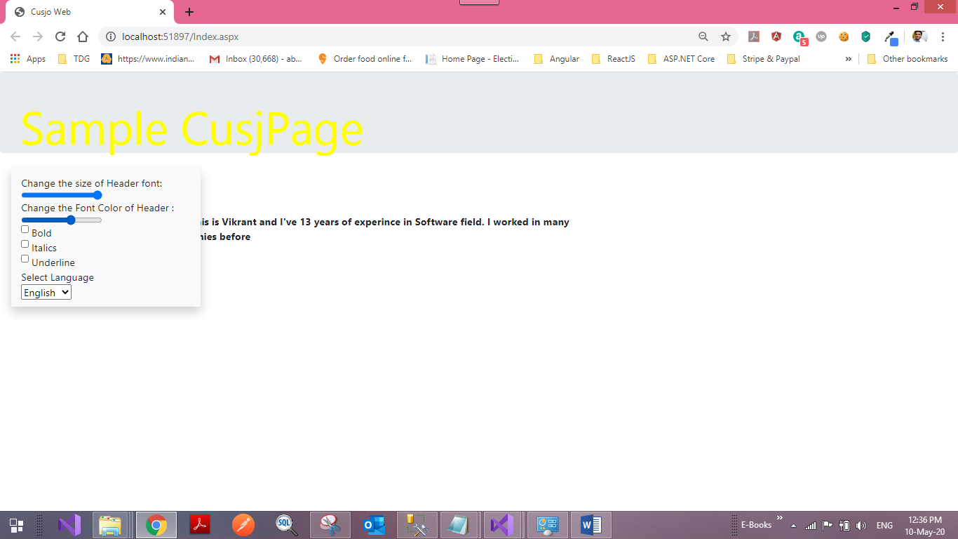

When you click the bold check box, header font will become bold:

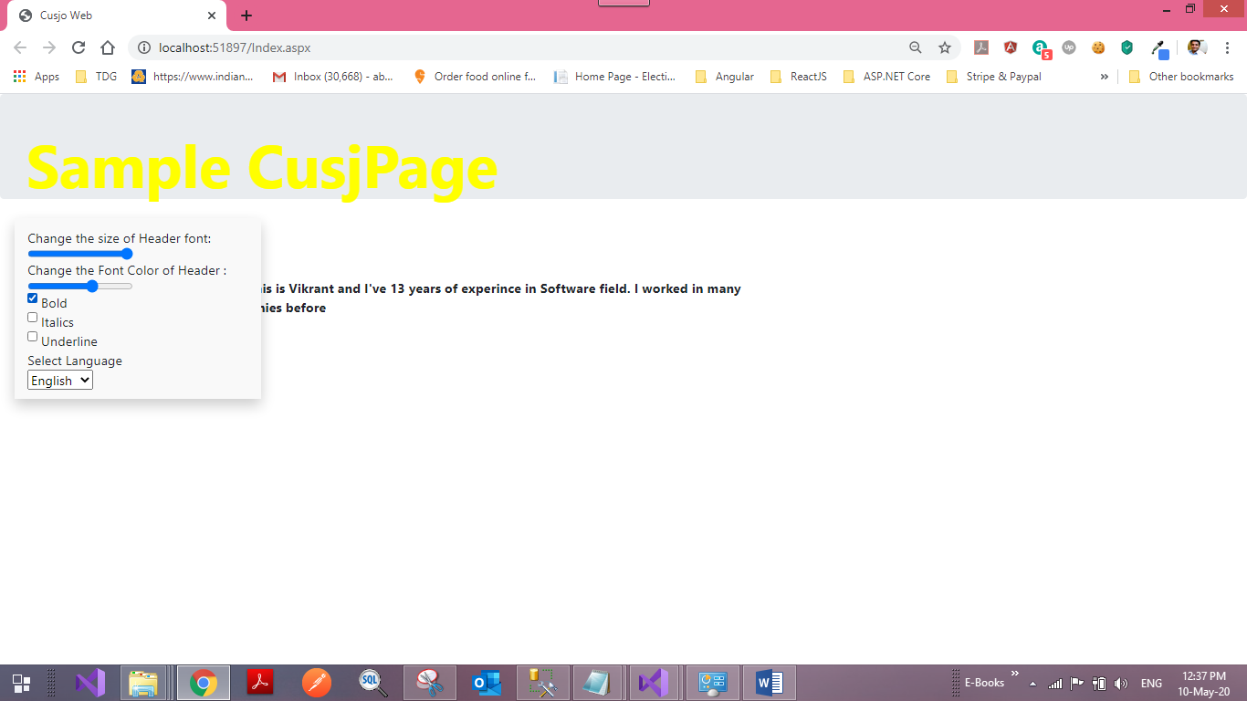

When you check the italics check box, the header font will designed in italics:

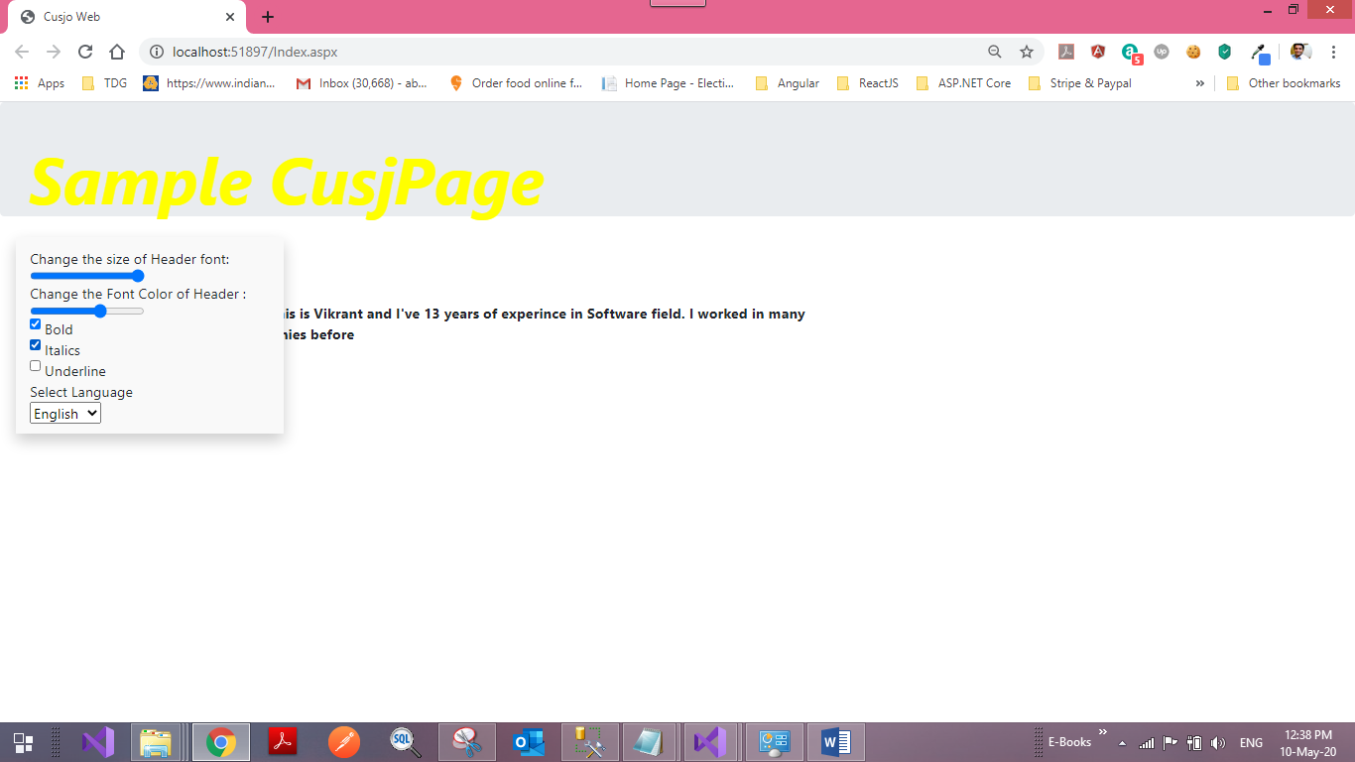

When the underline check box is checked, the header font will be under lined:

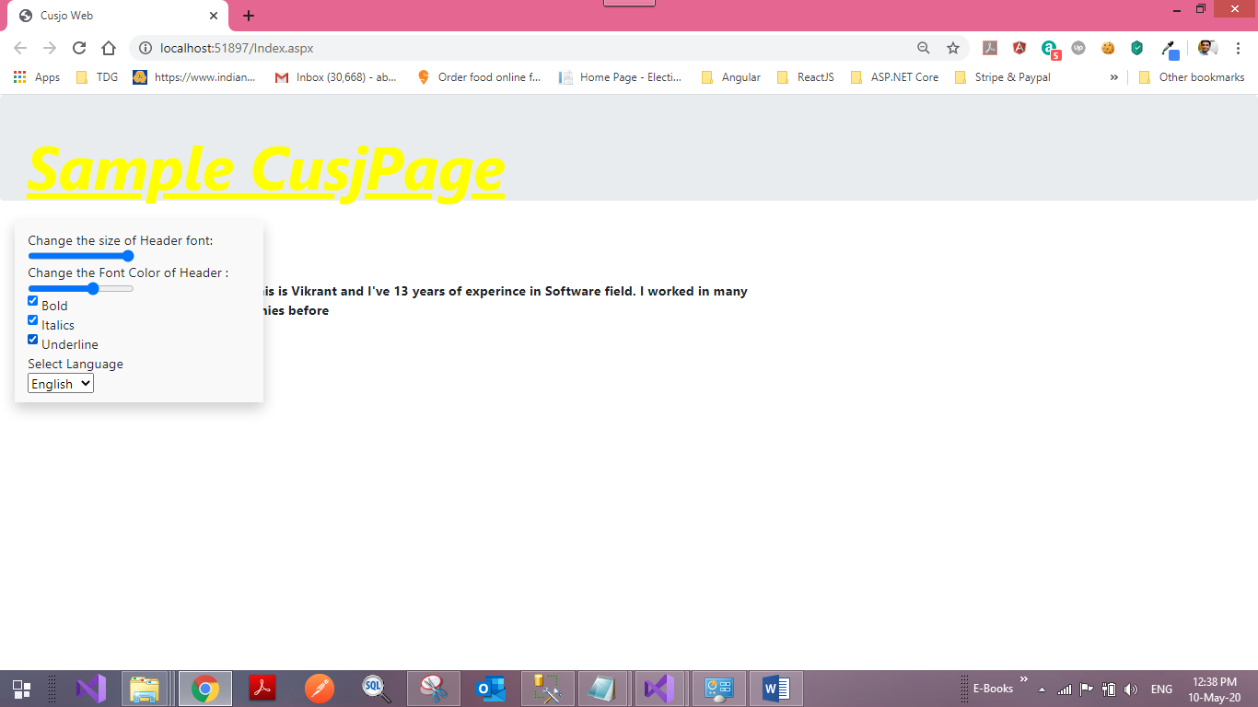

If you select Chinese language, the content will be changed to Chinese:

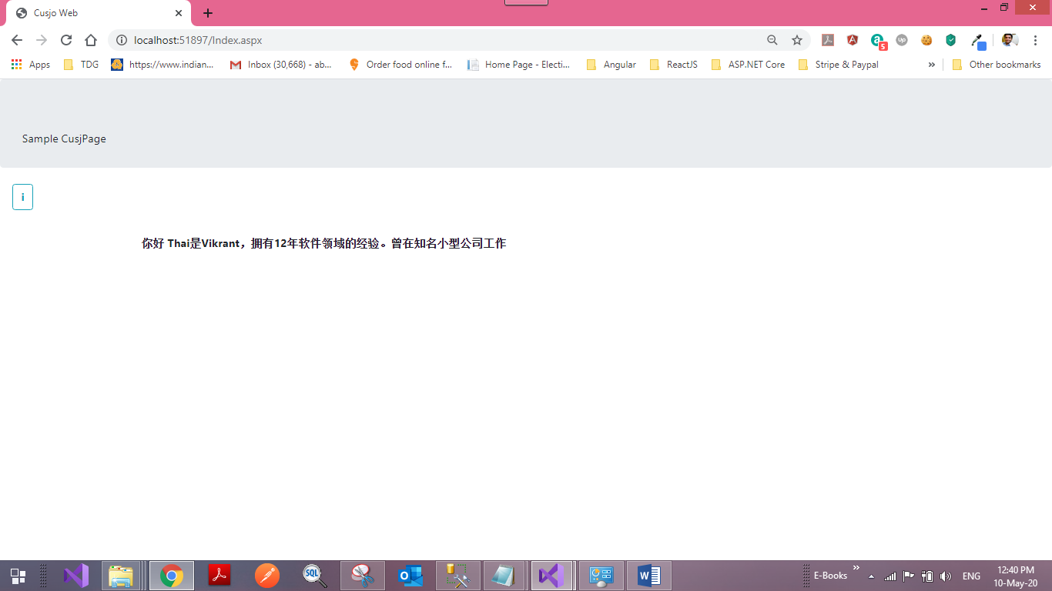

When the hindi language is selected, hindi will be displayed:

