EXPERIMENT NO:3
ARYASREE V K
VML23CS064

1.SHOW DATABASE
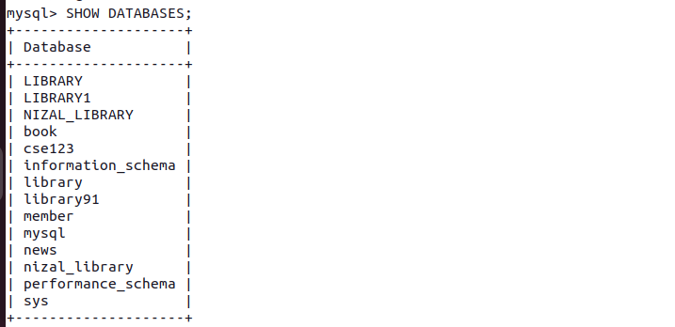
2.CREATE DATABSE

3.USE DATABASE

4.CREATE TABLE PUBLISHER

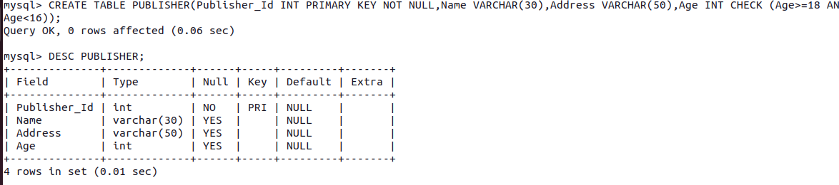

5.CREATE TABLE LANGUAGE
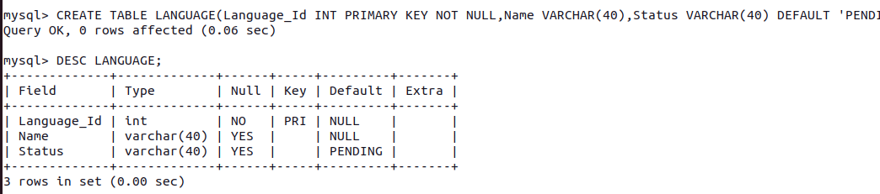
6.CREATE TABLE BOOK

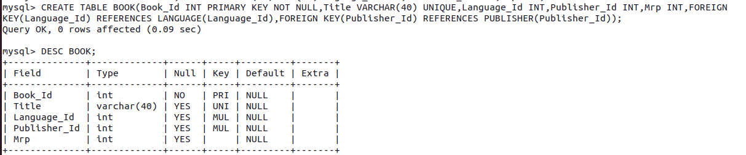
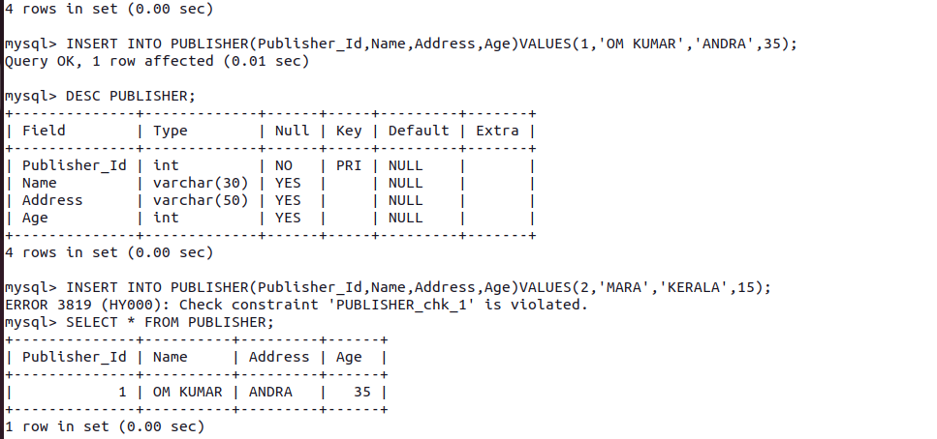
7.INSERT INTO PUBLISHER

8.INSERT INTO LANGUAGE

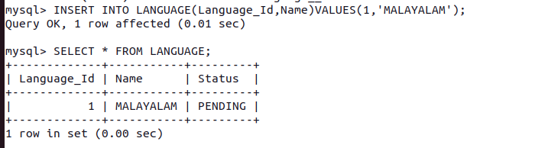

9.INSERT INTO BOOK

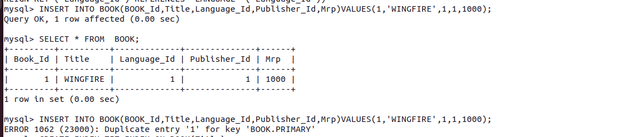

10.CREATE INDEX

