**Chapter 1**

**INTRODUCTION**

A bank is a commercial or state institution that provides financial services, including issuing money in form of coins, bank notes or debit cards, receiving deposits of money, lending money and processing transactions. A commercial bank accepts deposits from customers and in turn makes loans based on those deposits. Some banks (called Banks of issue) issue bank notes as legal tender. Many banks offer ancillary financial services to make additional profit; for example: selling insurance products, investment products or stock broking Currently in most jurisdictions commercial banks are regulated and require permission to operate. Operational authority is granted by bank regulatory authorities and provides right to conduct the most fundamental banking services such as accepting deposits and making loans. A commercial bank is usually defined as an institution that provides selected banking services without meeting the legal definition of bank .Banks have a long history, and have influenced economy and politics for centuries. In history, the primary purpose of a bank was to provide liquidity to trading companies. Banks advanced funds to allow business to purchase inventory, and collected those funds back with interest when the goods are sold. For centuries, the banking industry only dealt with business not customers. Commercial lending today is a very intense activity, with banks carefully analysing the financial condition of its business clients to determine the level of risk in each loan transaction.

In today's world the way of functioning and managing the system has been totally changed. There is a sudden and abrupt change in the structure, maintenance and modification, handling, levelling inside every system. Without managing system through computer applications and programming, the developments of infrastructures are unfinished. There are many errors and drawbacks without use of computer programming and applications.

**1.1 GOALS OF THIS APPLICATION:**

The project that we have undertaken aims to develop a banking system that is clean, user-friendly and multi-functional. Development of this application includes a number of fields such that user feels comfortable and the system appears as dynamic to him. The project "Banking System" includes the following functionalities:

* Transactions can be done with minimum user events.
* All transactional details and accounts are stored in files on stable storage.
* Customers can view their own account details and can use them as necessary
* Customer can inquire an account and can inquire about interest
* All customer's data are stored in files on a stable storage
* Account holders have to pass through a login system to enter their accounts
* This system possess password-protected administrative access; thus preventing the whole management system from unauthorized access
* To provide flexibility for secure and save transaction.
* For better performance.
* Reducing man power.
* For doing work more accurately.
* Faster performance.

**1.2 PROPOSED SYSTEM & OBJECTIVES:**

The application will be extremely beneficial for the Customers intending to use and operate their bank account and will get various benefits in the field of management of accounts on a clean and user-friendly platform.

"Bank Account System", is a simple application, which is especially generated and designed for the bank in order to enter the applicant information about his or her bank account and can perform other function like currency change. It is username and ID protected as well.

Following are the major objectives behind the new proposed system:

* It creates a user friendly environment, where a normal user can access through all the benefits of the system.
* It provides security from unauthorized access, only admin or authorized users are access granted to the system.
* It increases efficiency and saves the time.
* No any danger and obstacles from external entities.
* Easy access of saved data inside the system.
* It is cost effective
* It has ease of use along with complete reference
* It is highly secured and less time consuming; hence time wastage can be avoided.
* Up to date records of the customers are maintained by the authority.

**Chapter 2**

**PROBLEM STATEMENT**

The Bank Management System is an application for maintaining a person's account in a bank. The system provides the access to the costumer to create an account, deposit/withdraw the cash from his account. The following documentation provides the specification of the system.

We are mainly concerned with developing a banking system where a Customer can submit his/her deposit amount to bank if he/she has an account or can withdraw the amount from their account and can create a new account in this bank.

.

**Chapter 3**

**SYSTEM REQUIREMENTS**

**3.1 Software Requirement on each node:**

* Operating system : Windows 10
* Compiler : Dev C++
* Programming Language : C++

**3.2 Hardware requirement on each node:**

* Processor :i3 processor or higher version
* Ram :1 GB or more
* Hard Disk Free Space :5GB

**Chapter 4**

**DESIGN AND IMPLEMENTATION**

**4.1 MODULE DESCRIPTION:**

|  |  |
| --- | --- |
| **MODULE** | **DESCRIPTION** |
| Creating an Account | Creates an account for the user by accepting the input as Account number, deposit money and so on. |
| Updating the existing account | Modifies the Account of the existing user by replacing the old values by new values. |
| Transactions | To credit or debit the money from one’s account. |
| Removing an Account | If the account seems to be worthless, then it can be removed. |
| Displaying the customers list | Displays all the persons existing accounts in the bank. |

**4.2 SCREEN DESIGN:**

WELCOME SCREEN

MAIN MENU:

1 .CREATE AN ACCOUNT

2. UPDATE ACCOUNT

3. TRANSACTION

4. VIEW CUSTOMER

5. REMOVE CUSTOMER

EXIT

EXISTING CUSTOMER

NEW CUSTOMER

C

DEPOSIT AMOUNT NEW BALANCE

NEW

N

1 .DEPOSIT AMOUNT

2 .WITHDRAW AMOUNT

3. VIEW DETAILS

4. EXIT

CREATE ACC:

>NAME

>DOB

>ACC NO

>INITIAL DEPOSIT

WITHDRAW AMOUNT NEW BALANCE

ACCOUNT DETAILS:

>NAME

> ACCOUNT NUMBER

>BALANCE

Figure: 4.2.1 Screen design of the Banking System

**4.3.1 Algorithm for Insert Function**

1. Initialize file record.txt.
2. Print the menu list.
3. Open file in write mode.
4. Print Account number, name, Date of Birth, Initial deposit, Type of account.
5. Copy the content to file.
6. Close the file record.txt.

**4.3.2 Algorithm for modify Function**

1. Initialize file record.txt
2. Print Customer Details.
3. Open file in append mode.
4. Print name, account number, balance, citizenship number, date of birth.
5. Copy the content to buffer.
6. Close the file pointer record.txt.

**4.3.3 Algorithm for Display Function**

1. Initialize file record.txt.
2. Open file in read mode.
3. Print name, account number, balance, date of birth.
4. While not end of the file record then read name, account number.
5. Close the file record.txt.

**4.3.4 Algorithm for Search Function**

1. Initialize file record.txt, i, j, account number, name.
2. Open the file in read mode.
3. While(i<j)

Print name, account number, balance, date of birth, citizenship number.

1. If(i==j)

Print search unsuccessful.

1. Close the file record.txt.

**4.3.5 Algorithm for Update Function**

1. Initialize file record.txt, i, j, account number, name.
2. Open the file in read mode.
3. While(i<j)

Print name, account number.

If ‘successful’

Enter new customer details.

1. If(i==j)

Print search unsuccessful.

1. Close the file record.txt

**4.3.6 Algorithm for Delete Function**

1. Initialize file record.txt
2. Open the file in read mode.
3. if((record.txt)==0)

Print “Deletion Successful”.

1. else

Print “Deletion unsuccessful”.

1. Close the file record.txt.

**Chapter 5**

**RESULTS**

**OUTPUT 1:**

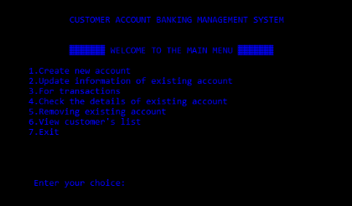

**Figure 5.1: Output of the main menu**

**OUTPUT 2:**

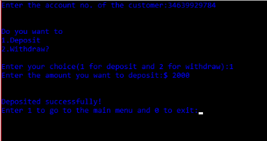

**Figure 5.2: Output of the transaction operation**

**OUTPUT 3:**

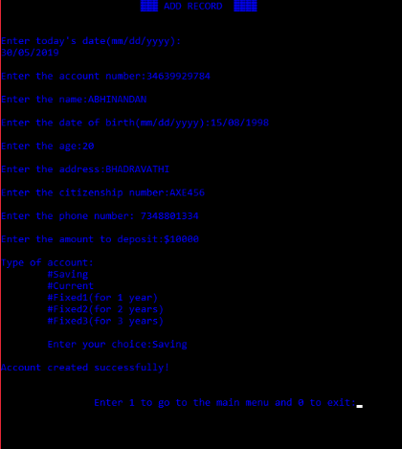

**Figure 5.3: Output of the create account operation**

**OUTPUT 4:**

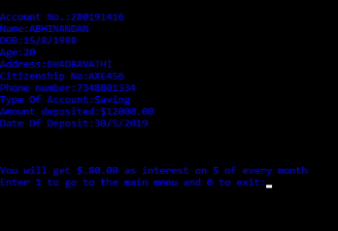

**Figure 5.4: Output of the display operation**

**OUTPUT 5:**

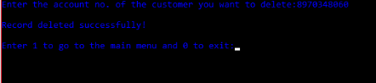

**Figure 5.5: Output of the delete operation**

**OUTPUT 6:**

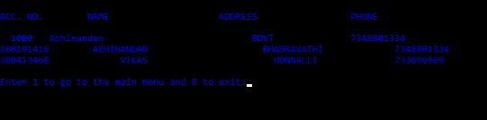

**Figure 5.6: Output of the search operation**

**OUTPUT 7:**

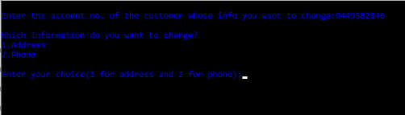

**Figure 5.7: Output of the update operation**

**OUTPUT 8:**

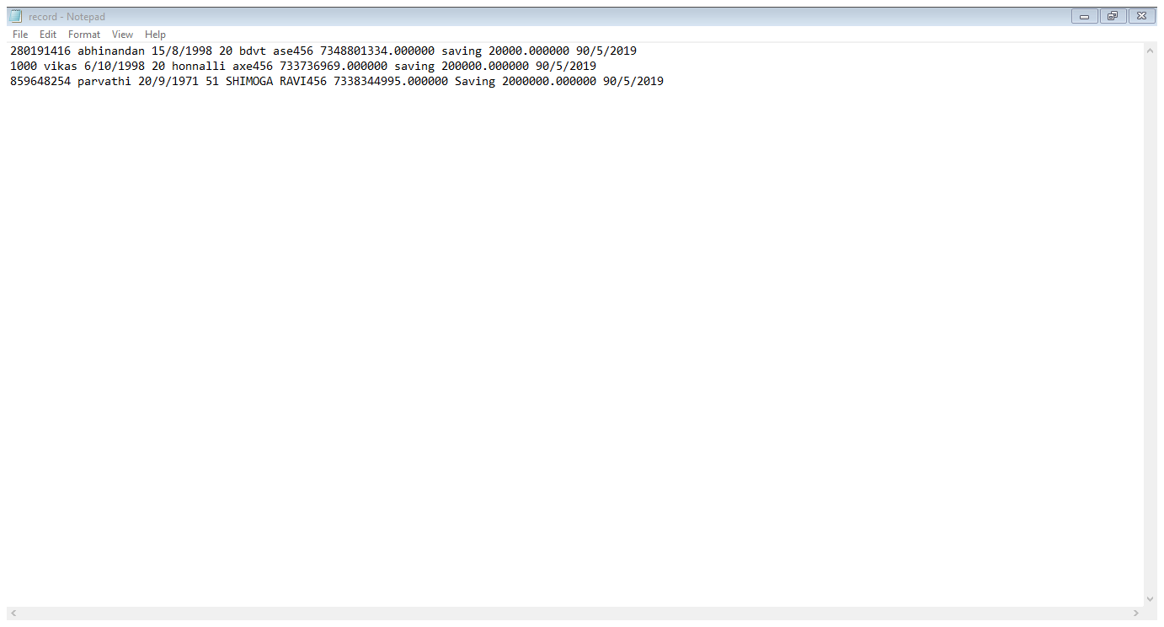

**Figure 5.8: Output after details.txt**

**Chapter 6**

**CONCLUSION**

There are many advantages of using this program as it contains various features like:

* It is actually a user friendly software, as it is just easy to use by just following the instruction which are appeared on the screen.
* This program needs user account number to access user information, so that only authorized users are only allowed to accessed through the internal main system.
* Once a record has been saved, duplicate record can't be made. All the record have different account number so that there will not be any misplace of the records entered.

**REFERENCES**

[1].Text book Michael J.Folk,Bill Zoellick,Greg Riccardi:File Structure-An Obiect Oriented Approach with C++,3rd Edition,Pearson Education,1998.

[2].K.R.Venugopal,K. G.Srinivas,P.M Krishnaraj:File Structures Using C++,Tata McGraw-Hill,2008.