# Answers

1 .val df_rate = spark.read.format("csv").option("header", "true").load("C:/Users/ABHINAV/Desktop/Topgear_ass/spark.txt")

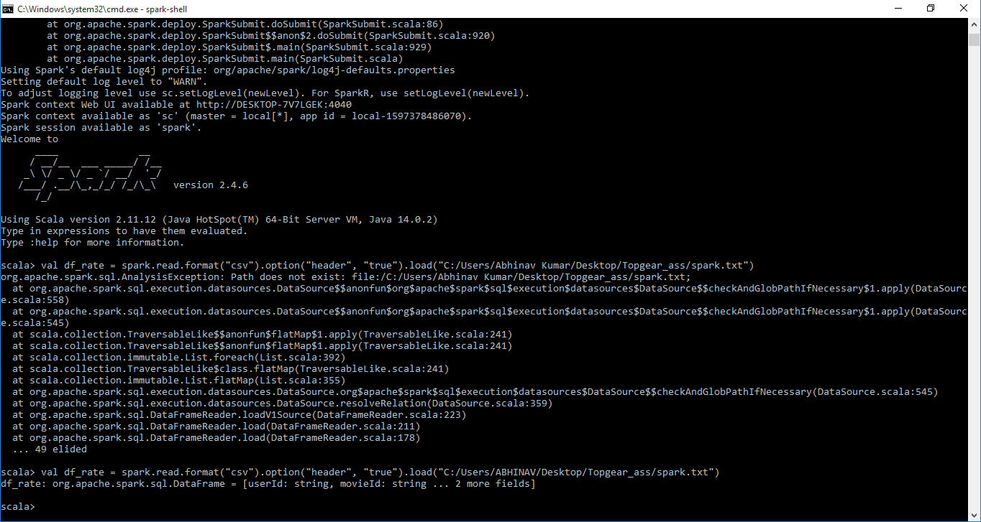

2. df_rate.createOrReplaceTempView("rate")

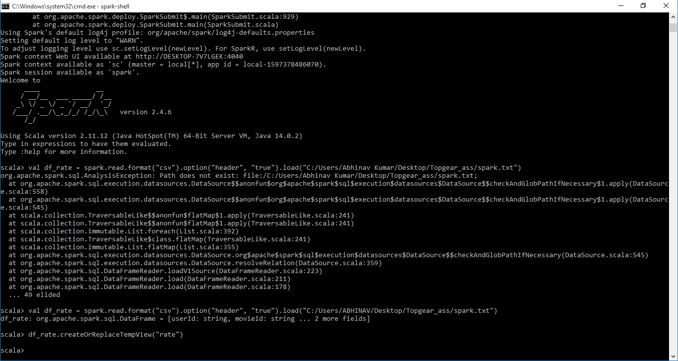

3. val df4 = spark.sql("SELECT INT(userId), INT(movieId), INT(rating), int(timestamp) from Rate")

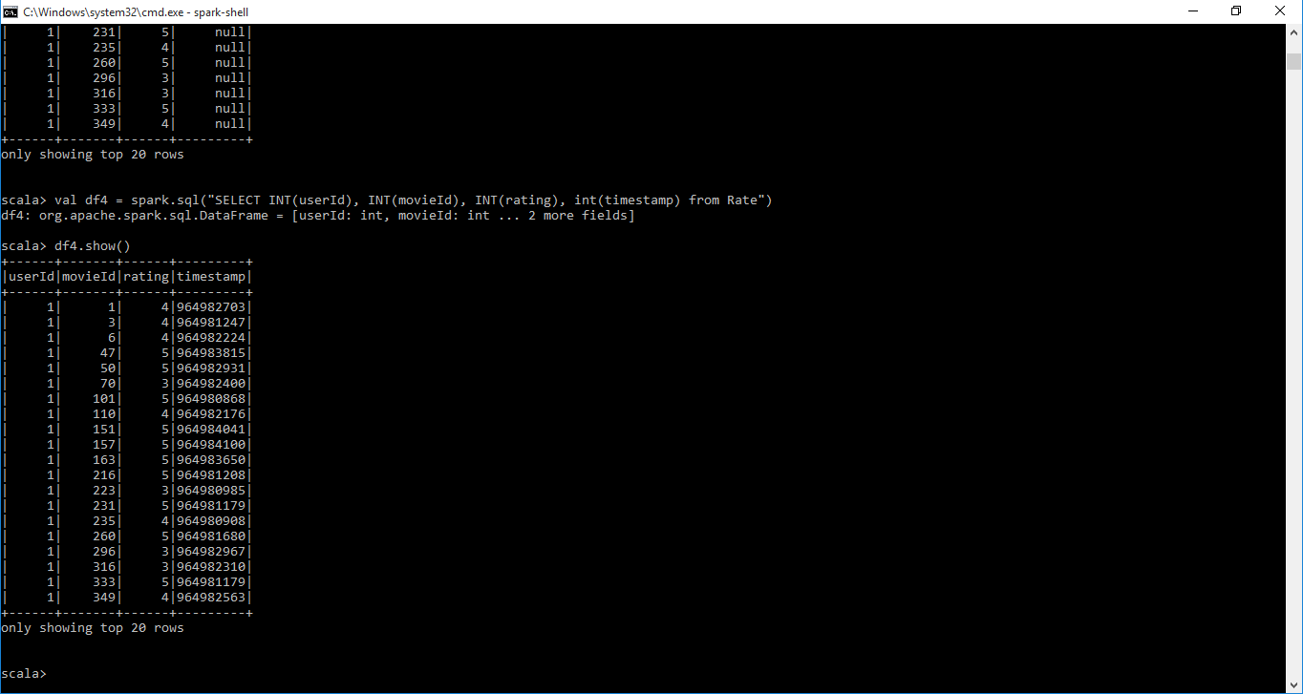

4. val df5 = spark.sql("SELECT movieId, avg(rating) from Rate group by movieId")

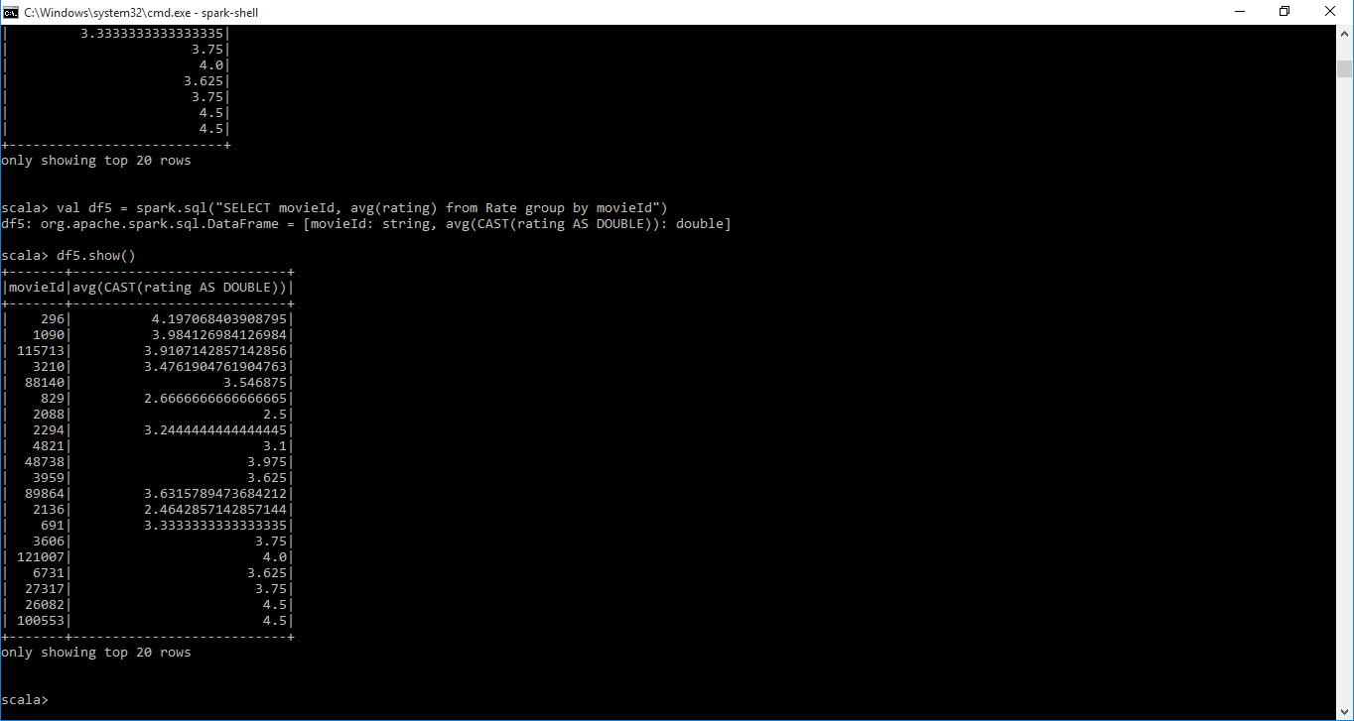

5. val df5 = spark.sql("SELECT movieId, count(movieId) as co from Rate group by movieId order by co desc limit 1 ")

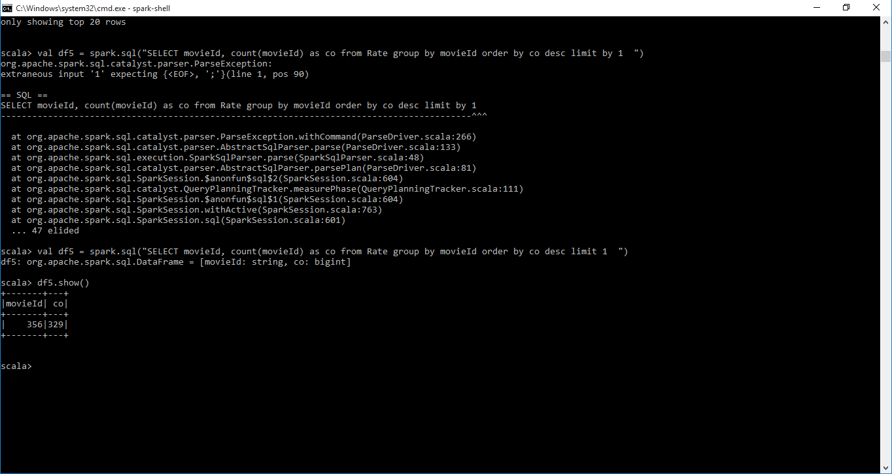

6. val df5 = spark.sql("SELECT userId, avg(rating) as user_rate from Rate group by userId order by user_rate ")

