To,
Editorial Office,
New Journal of Physics.
Institute of Physics, UK. 04 November 2025.

Dear Editors,
We submit the manuscript “Mott Criticality as the Confinement Transition of a Pseudogap-Mott Metal” for consideration as a regular article in New Journal of Physics.
Graphical Abstract of our work
Justification Statement
Understanding the nature and origin of the pseudogap and strange metal phases of hole-doped Mott insulators is a central challenge in strongly correlated quantum matter. The difficulty lies in answering two key questions. First, is the pseudogap related to a precursor in a symmetry-preserved Mott insulator (Taillefer, Annu. Rev. Condens. Matter Phys. 2010.1:51–70)? Second, is the strange metal a novel scale-invariant form of long-range entangled strongly interacting electrons (Phillips et al., Science 377, eabh4273 (2022))? We provide rigorous answers to these questions for the very first time from a new theoretical framework developed here, displaying the origin of the pseudogap in a Mott transition of a particle-hole symmetric model. We offer several rigorous and insightful results (e.g., the electronic DOS, electron lifetime, optical conductivity etc.) that can be tested experimentally. This breakthrough provides a strong foundation for the exploration of the physics of doped Mott insulators, including superconductivity at elevated temperatures, and strange metals that are observed experimentally in a wide variety of correlated quantum materials.

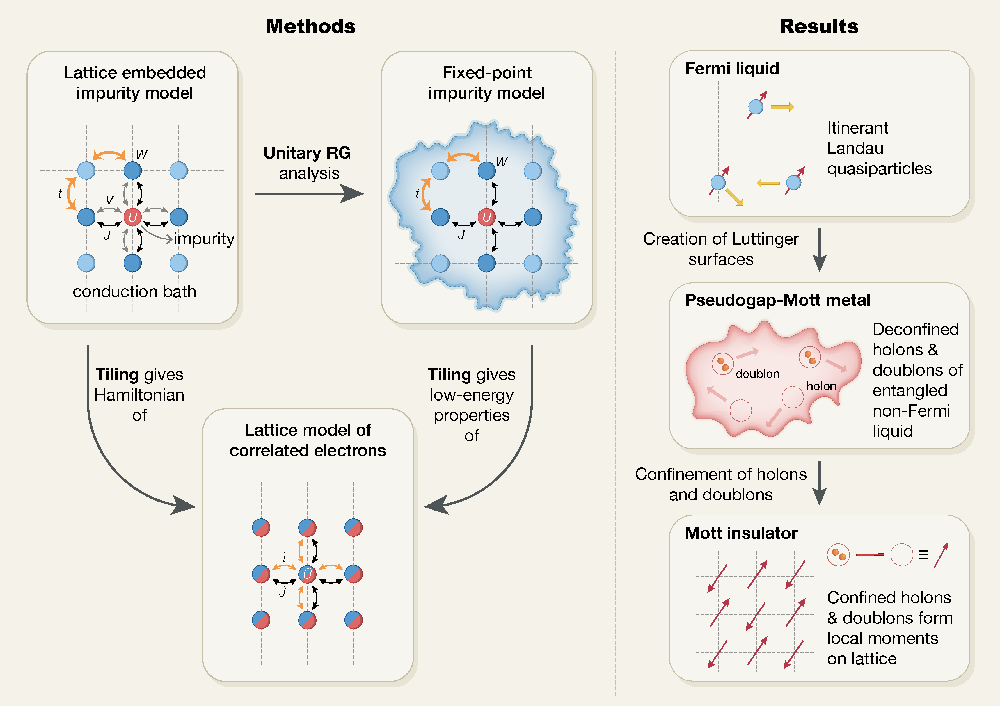
Technical advances (Methods panel of Figure)
- An auxiliary-model strategy that captures both local correlations and non-local interactions: a finite-dimensional lattice embedding of an Anderson impurity augmented with inter-site spin exchange and minimal bath correlations.
- Tiling via a many-body Bloch’s theorem yields an equivalent correlated-electron lattice that inherits all interactions.
- Zero-temperature renormalization-group analysis delivers impurity low-energy physics, then maps it directly onto the lattice—no self-consistency loops needed.
- High-resolution 77 × 77 Brillouin-zone spectra obtained on a desktop workstation already exceed cluster-DMFT resolution; scaling to larger grids on HPC resources is straightforward and does not alter qualitative results.
- Analytically transparent and readily transferable to other correlated systems.
Breakthrough insights (Results panel of Figure)
- Systematic momentum-dependent depletion of Kondo screening suppresses quasiparticle weight and generates antinodal Luttinger surfaces, signalling onset of pseudogap.
- Pseudogap emerges as a long-range-entangled “Mott metal’’ with nodal arcs, Luttinger surfaces and holon-doublon non-Fermi-liquid excitations. A rigorous scaling analysis reveals the universal scaling behaviour of various spectral properties of the Mott metal.
- Continuous confinement of holon-doublon pairs realises Mott’s vision of a repulsion-driven insulator.
- Exactly solvable (Hatsugai–Kohmoto) model describes scale-invariant nodal non-Fermi liquid metal at Mott critical point, displaying features universal throughout the pseudogap phase.
- Unified symmetry principle links Fermi and Luttinger surfaces, providing a clear organisational framework for pseudogap phenomena, strange metals and Mott criticality.
- The continuous Mott transition we uncover differs fundamentally from local quantum-critical scenarios inferred from other auxiliary-model methods.
We expect these results to interest a broad readership in the condensed matter and quantum materials communities, and to inspire new experimental and theoretical studies. We confirm that this manuscript has not been published elsewhere and is not under consideration by another journal. All authors have approved the manuscript and agree with its submission to New Journal of Physics. The manuscript is self-contained, and presents detailed derivations in the appendices.

Thank you for considering our manuscript for publication in New Journal of Physics. We welcome the opportunity to provide further information or revisions.

Sincerely,
SIDDHARTHA LAL
Professor
Department of Physical Sciences, IISER Kolkata, India
Email: slal@iiserkol.ac.in

(On behalf of all authors: Abhirup Mukherjee, S. R. Hassan, Anamitra Mukherjee, N. S. Vidhyadhiraja, A. Taraphder, and Siddhartha Lal)

