**RESUME**

***NAME*:-**Abhishek kumar 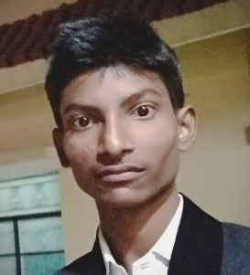

***EMAIL ADDRESS*:-**abhishekkumar880247@gmail.com

***PHONE NO*:-**8799714607

**OBJECTIVE**:-Seeking for experience in your company.

**ACADEMIC QUALIFICATION**

|  |  |  |  |
| --- | --- | --- | --- |
| **COURSE** | **INSTITUTION** | **BOARD** | **PERCENTAGE** |
| B.TECH  (2018-2022) | NETAJI SUBHASH ENGINEERING COLLEGE  (KOLKATA) | WEST  BENGAL UNIVERSITY OF TECHNOLOGY | PERSUING |
| XII(SENIOR SECONDARY),  SCIENCE  (2016-2018) | NALANDA COLLEGE  (BIHAR SHARIF) | BIHAR SECONDARY EDUCATION BOARD | 63.4% |
| X(SECONDARY)  (2015-2016) | EAST DELHI PUBLIC SENIOR SECONDARY SCHOOL,  GHAZIABAD | CENTRAL BOARD OF SECONDARY EDUCATION  (DELHI) | 87.4%  (CGPA:-9.2) |

**PROJECT:-** Presently , I am working on a website.

**PROJECT OUTLINE:** One can learn about programming language.

**ADDITIONAL DETAILS**

1. I has successfully completed the **soft skill** course held by **NATIONAL PROGRAMME ON TECHNOLOGY ENHANCED LEARNING** (course certified from **IIT ROORKEE**).
2. In 10th STD , I got **best student of the year award Dec 2015** on behalf of my school (EAST DELHI PUBLIC SENIOR SECONDARY SCHOOL).
3. In 10th STD I again I got **1st prize in GK & English competition** held by ABCL INSTITUTE Ghaziabad.