INDEX
S. No | Contents | Page. no
1 | Lab Objective | 3
2 | Introduction About Lab | 4
3 | Standard Operating Procedure – SOP | 6
3 | HelloWorld | 7
4 | MenuCreation | 8
5 | Menu Events Handling | 9
6 | SlideShow | 14
7 | Image Slide Show | 20
8 | Quiz & RMS | 50
9 | InputChecking
10 | Bar Graph
11 | PieChart
12 | Client Server App using Datagram
13 | Login using HttpConnection
14 | Additional Viva Question | 88
15 | References | 94

LAB OBJECTIVE
In this lab, a student is expected to design, implement, document and present a mobile client/server system using standard Java and Java 2 Micro Edition (J2ME) platform. Specifically it is required to design and implement a system that consists mainly of a mobile client (MC) and a Proxy Server (PS). MC will be written in J2ME, MIDP 2.0, while PS will be written in standard Java. It is necessary to use a mobile phone emulator to develop and demonstrate the experiments.
It may be necessary to use other components or existing resources (servers) as needed. For instance a database local to PS or a web service available on the Internet that can be invoked by the PS.

Standard Operating Procedure – SOP
1) If the Java Development Kit (JDK) is not there or only having the Java Runtime Environment (JRE) installed, install the latest JDK from http://java.sun.com/javase/downloads/index.jsp. Current stable release of Java is JDK 6 Update 7 but check the web page in case there are newer non-beta releases available.
2) Next, download the Java Wireless Toolkit (formerly called J2ME Wireless Toolkit) from: http://java.sun.com/products/sjwtoolkit/download.html.
3) Run the installer (for example, for Windows it is: sun_java_wireless_toolkit- 2_5_2 windows.exe). The installer checks whether a compatible Java environment has been pre-installed. If not, it is necessary to uninstall old versions of Java and perform Step 1 again.
Once after successful installation of Java and the tool kit compile this program and run the following program in the toolkit.
Steps to run this program in toolkit:
- Start -> All Programs -> Sun Java Tool Kit -> Wireless Tool Kit
- Click New Project – Enter Project Name -> Enter Class Name -> Click on Create Project.
- Choose appropriate API Selection and Configurations.
- Place Java Source file in WTK2.1 / WTK2.2\apps\projectname\src
- Build the Project.
- Run the Project

Experiment 1 : Printing HelloWorld program
Step-1:-Start ->AllPrograms->Sun Java Tool Kit->Wireless Tool Kit
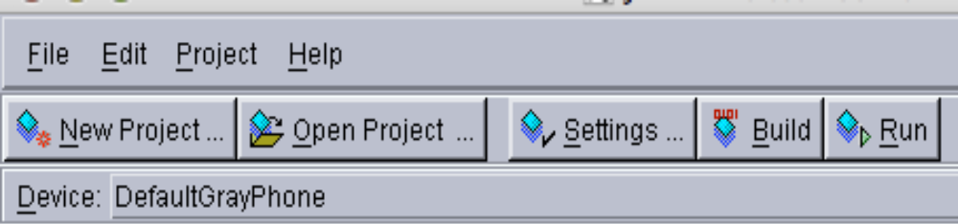
Step-2:-Click New Project –Enter project Name as FirstMidlet -> Enter ClassName as HelloMidlet->click on Create Project
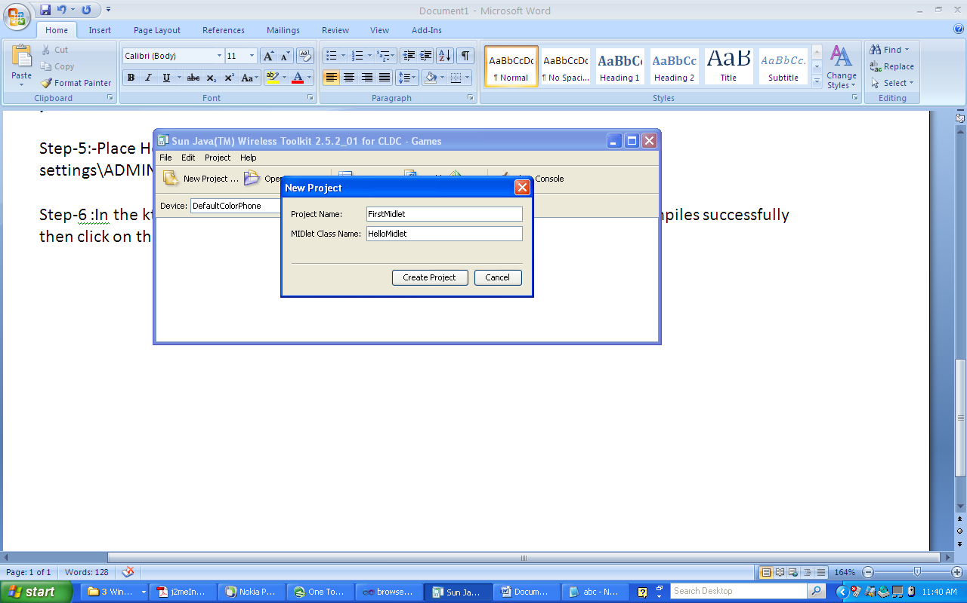
Step-3:- A setting window will open up. Accept the defaults by clicking ok in that window.
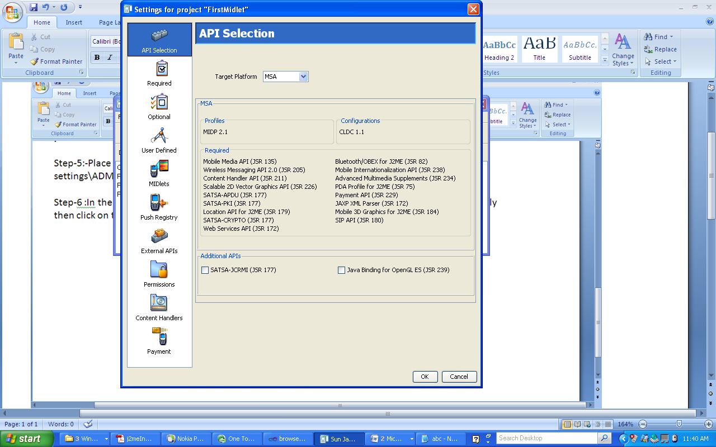

Step-4:-Write Following Code in Notepad and save it as HelloMidlet.java

import javax.microedition.midlet.*;
import javax.microedition.lcdui.*;
public class HelloMidlet extends MIDlet
{
public HelloMidlet()
{
}
public void startApp()
{
Form form = new Form( "First Program" );
form.append( "Hello World" );
Display.getDisplay(this).setCurrent( form );
}
public void pauseApp()
{
}
public void destroyApp( boolean unconditional )
{
}
}

Step-5:-Place HelloMidlet.java in C:\Documents and settings\ADMIN\j2mewtk\2.5.2\apps\FirstMidlet\src\

Step-6 :In the ktoolbar main window click on the “Build” button. When the build compiles successfully then click on the “Run” button.

OUTPUT:
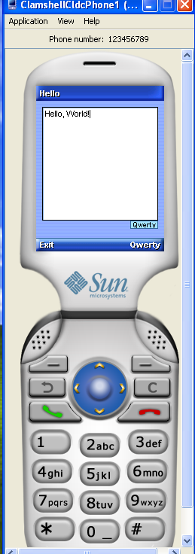

Experiment 2: Create a program which creates to following kind of menu.
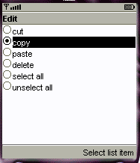
* cut
* copy
* past
* delete
* select all
* unselect all

import javax.microedition.midlet.*;
import javax.microedition.lcdui.*;
public class MenuCreation extends MIDlet implements CommandListener
{
public ChoiceGroup ch;
public Form form;
public Display display;
public Command cmd;
public StringItem st;
public MenuCreation()
{
display=Display.getDisplay(this);
ch=new ChoiceGroup("Edit",Choice.EXCLUSIVE);
ch.append("cut",null);
ch.append("copy",null);
ch.append("paste",null);
ch.append("delete",null);
ch.append("select all",null);
ch.append("unselect all",null);
ch.setSelectedIndex(1, true);
cmd=new Command("Select list item",Command.OK,1);
form=new Form("");
form.append(ch);
form.addCommand(cmd);
form.setCommandListener(this);
st=new StringItem("","");
}
public void startApp()
{
display.setCurrent(form);
}
public void pauseApp()
{
}
public void destroyApp(boolean unconditional)
{
}
public void commandAction(Command command,Displayable displayable)
{
if(command==cmd)
{
st.setText("");
st.setText("your selected option is "+ch.getString(ch.getSelectedIndex()));
form.append(st);
}
}
}
Output:
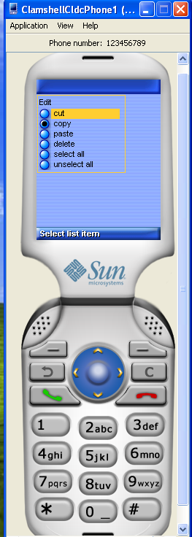

Experiment 3: Create a menu which has the following options:
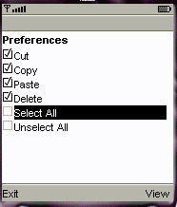
* cut - can be on/off
* copy - can be on/off
* paste - can be on/off
* delete - can be on/off
* select all - put all 4 options on
* unselect all - put all 4 options off

import javax.microedition.midlet.*;
import javax.microedition.lcdui.*;
public class MenuEvents extends MIDlet implements CommandListener,ItemStateListener
{

public ChoiceGroup ch;
public ChoiceGroup ch1;
public Form form;
public Form form1;
public Display display;
public Command View;
public Command Exit;
public Command Back;
public StringItem options;
public Item item;
public MenuEvents()
{
display=Display.getDisplay(this);
form=new Form("");
form1=new Form("Selcted Options are");
ch=new ChoiceGroup("Preferences",Choice.MULTIPLE);
ch.append("cut",null);
ch.append("copy",null);
ch.append("paste",null);
ch.append("delete",null);
ch.setSelectedIndex(1, true);
form.append(ch);
ch1=new ChoiceGroup("",Choice.EXCLUSIVE);
ch1.append("select all",null);
ch1.append("unselect all",null);
ch1.setSelectedIndex(1, true);
form.append(ch1);
View=new Command("View",Command.OK,1);
Exit =new Command("Exit",Command.EXIT,1);
Back=new Command("Back",Command.BACK,1);
form.addCommand(View);
form.addCommand(Exit);
form1.addCommand(Back);
form.setCommandListener(this);
form1.setCommandListener(this);
form.setItemStateListener(this);
}
public void startApp()
{
display.setCurrent(form);
}
public void pauseApp()
{
}
public void destroyApp(boolean unconditional)
{
}
public void commandAction(Command command,Displayable displayable)
{
if(displayable==form)
{
if(command==View)
{
boolean opt[]=new boolean[ch.size()];
options=new StringItem("","");
String values="";
ch.getSelectedFlags(opt);
options.setText("");
for(int i=0;i<opt.length;i++)
{
if(opt[i])
{
values+=ch.getString(i)+"\n";
}
}
options.setText(values);
form1.append(options);
display.setCurrent(form1);
}
else if(command==Exit)
{
destroyApp(true);
notifyDestroyed();
}
}
else if(displayable==form1)
{
if(command==Back)
{
display.setCurrent(form);
options.setText("");
}
}

}
public void itemStateChanged(Item item)
{
if(item==ch1)
{
int i=0;
int size=ch.size();
while(i<size)
{
if(ch1.getSelectedIndex()==0)
ch.setSelectedIndex(i, true);
else
ch.setSelectedIndex(i, false);
i++;
}
}
}
}
OUTPUT:
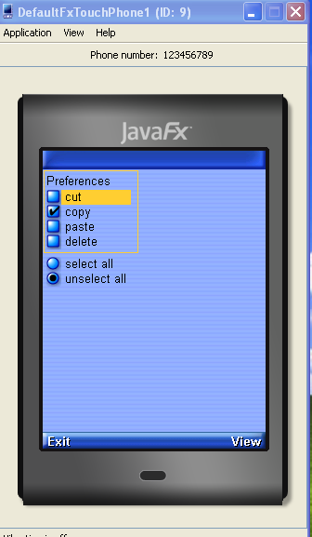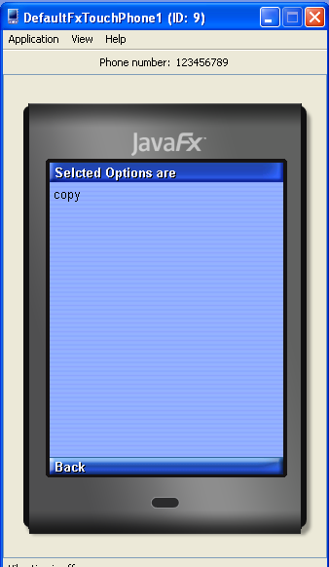
Experiment 4: Create a slide show which has three slides, which includes only text. Program should change to the new slide after 5 seconds. After the third slide program returns to the first slide.
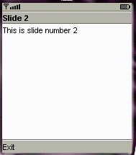
import javax.microedition.midlet.*;
import javax.microedition.lcdui.*;
public class SlideShow extends MIDlet implements CommandListener {

public Form slide1;
public Form slide2;
public Form slide3;
public Command Exit;
public Display display;
public SlideShow()
{
display=Display.getDisplay(this);
Exit=new Command("Exit",Command.EXIT,1);
slide1=new Form("Slide1");
slide1.append("This is Slide number 1");
slide1.addCommand(Exit);
slide2=new Form("Slide2");
slide2.append("This is Slide number 2");
slide2.addCommand(Exit);
slide3=new Form("Slide3");
slide3.append("This is Slide number 3");
slide3.addCommand(Exit);
slide1.setCommandListener(this);
slide2.setCommandListener(this);
slide3.setCommandListener(this);
}
public void startApp() {
Thread runner = new Thread(new ThreadRunner(display,slide1,slide2,slide3));
runner.start();
}
public void pauseApp() {
}
public void destroyApp(boolean unconditional) {
}
public void commandAction(Command command,Displayable displayable)
{
if(displayable==slide1)
{
if(command==Exit)
notifyDestroyed();

}
else if(displayable==slide2)
{
if(command==Exit)
notifyDestroyed();

}
else if(displayable==slide3)
{
if(command==Exit)
notifyDestroyed();

}
}
}

class ThreadRunner implements Runnable {
Display display;
public int c=0;
public Form slide1;
public Form slide2;
public Form slide3;
public ThreadRunner(Display display,Form slide1,Form slide2,Form slide3) {
this.display = display;
this.slide1=slide1;
this.slide2=slide2;
this.slide3=slide3;
}

public void run() {
while(true)
{
c++;
if(c==1)
display.setCurrent(slide1);
else if(c==2)
display.setCurrent(slide2);
else if(c==3)
display.setCurrent(slide3);
else if(c==4)
c=0;

try
{
Thread.sleep(1500);
}
catch(Exception ex)
{
}
}
}
}

Output:
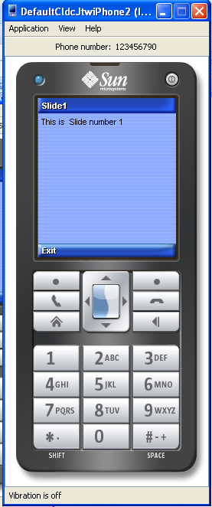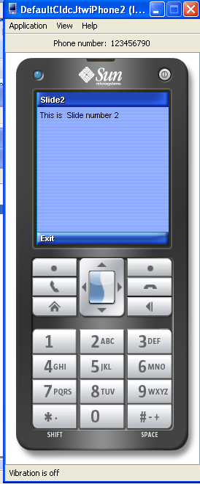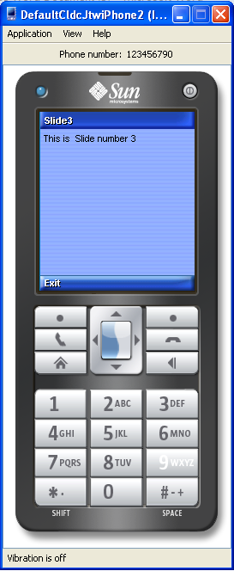

Experiment 5: Create a slide show which has three slides, which includes pictures at PNG format. Program should change to the new slide other 5 seconds.
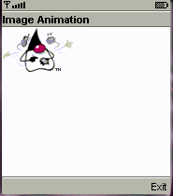
import javax.microedition.midlet.*;
import javax.microedition.lcdui.*;
public class imageSlideShow extends MIDlet implements CommandListener {
public Form slide1;
public Form slide2;
public Form slide3;
public Command Exit;
public Display display;
public Image image1;
public Image image2;
public Image image3;
public ImageItem imageitem1;
public ImageItem imageitem2;
public ImageItem imageitem3;
public imageSlideShow()
{
display=Display.getDisplay(this);
try
{
image1=Image.createImage("/1.png");
image2=Image.createImage("/2.png");
image3=Image.createImage("/3.png");
imageitem1=new ImageItem(null,image1,ImageItem.LAYOUT_CENTER,"image1");
imageitem2=new ImageItem(null,image2,ImageItem.LAYOUT_CENTER,"image2");
imageitem3=new ImageItem(null,image3,ImageItem.LAYOUT_CENTER,"image3");
}
catch(Exception ex)
{

}

Exit=new Command("Exit",Command.EXIT,1);
slide1=new Form("Slide1");

slide1.append(imageitem1);
slide1.addCommand(Exit);
slide2=new Form("Slide2");
slide2.append(imageitem2);
slide2.addCommand(Exit);
slide3=new Form("Slide3");
slide3.append(imageitem3);
slide3.addCommand(Exit);
slide1.setCommandListener(this);
slide2.setCommandListener(this);
slide3.setCommandListener(this);
}
public void startApp() {
Thread runner = new Thread(new ThreadRunner(display,slide1,slide2,slide3));
runner.start();
}

public void pauseApp() {
}

public void destroyApp(boolean unconditional) {
}
public void commandAction(Command command,Displayable displayable)
{
if(displayable==slide1)
{
if(command==Exit)
notifyDestroyed();

}
else if(displayable==slide2)
{
if(command==Exit)
notifyDestroyed();

}
else if(displayable==slide3)
{
if(command==Exit)
notifyDestroyed();

}
}
}

class ThreadRunner implements Runnable {
Display display;
public int c=0;
public Form slide1;
public Form slide2;
public Form slide3;
public ThreadRunner(Display display,Form slide1,Form slide2,Form slide3) {
this.display = display;
this.slide1=slide1;
this.slide2=slide2;
this.slide3=slide3;
}

public void run() {
while(true)
{
c++;
if(c==1)
display.setCurrent(slide1);
else if(c==2)
display.setCurrent(slide2);
else if(c==3)
display.setCurrent(slide3);
else if(c==4)
c=0;

try
{
Thread.sleep(1500);
}
catch(Exception ex)
{
}
}
}
}

Output:
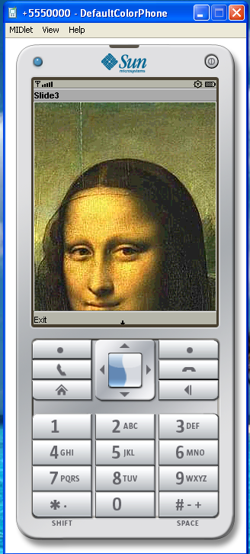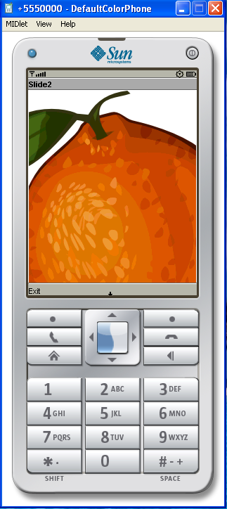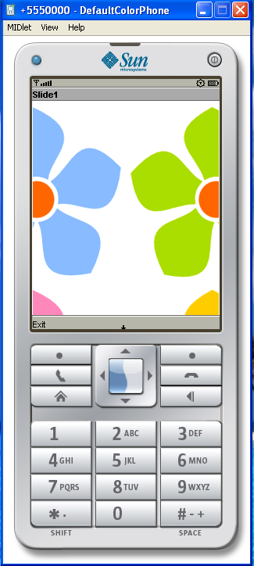

Experiment 6: Create a MIDP application, which show to the user 5-10 quiz questions. All questions have 4 possible options and one right option exactly. Application counts and shows to the user how many right answers were right and shows them to user.
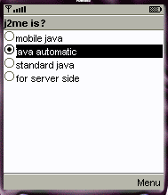

i mport javax.microedition.midlet.*;
import javax.microedition.lcdui.*;
import javax.microedition.rms.*;
import java.io.*;
public class QuizMidlet extends MIDlet implements CommandListener {

public Form form1;
public Form form2;
public Form form3;
public Form form4;
public Form form5;
public Form form6;
public Form form7;
public ChoiceGroup ch1;
public ChoiceGroup ch2;
public ChoiceGroup ch3;;
public ChoiceGroup ch4;;
public ChoiceGroup ch5;;
public Command nextCommand;
public Command backCommand;
public Command MenuCommand;
public Command OkCommand;
public Command ExitCommand;
public Command sCommand;
public Display display;
public StringItem st;
public TextField textfield;
public int count;
public RecordStore recordstore=null;
public RecordEnumeration re=null;
public Alert alert;
public Compare comp;
public StringItem st1;
public QuizMidlet()
{
count=0;
display=Display.getDisplay(this);
nextCommand=new Command("Next",Command.OK,1);
backCommand=new Command("Back",Command.BACK,1);
OkCommand=new Command("Save",Command.SCREEN,1);
ExitCommand=new Command("Exit",Command.SCREEN,1);
sCommand=new Command("TopScores",Command.SCREEN,1);
st=new StringItem("TotalPoints","0");
st1=new StringItem("","");
textfield=new TextField("EnterName","",20,TextField.ANY);
form1=new Form("J2ME Stands for");
form2=new Form("a+b=");
form3=new Form("5*5");
form4=new Form("Who is AP CM");
form5=new Form("How many Districts in AP");
form6=new Form("Score");
form7=new Form("Top Scoreers");
ch1=new ChoiceGroup("",Choice.EXCLUSIVE);
ch1.append("Java 2 Mobile Edition", null);
ch1.append("Java 2 Macro Edition", null);
ch1.append("Java 2 Micro Edition", null);
ch1.append("Java 2 Music Edition", null);
form1.append(ch1);
form1.addCommand(nextCommand);
form1.setCommandListener(this);

ch2=new ChoiceGroup("",Choice.EXCLUSIVE);
ch2.append("b+a", null);
ch2.append("b*a", null);
ch2.append("b/a", null);
ch2.append("b-a", null);
form2.append(ch2);
form2.addCommand(nextCommand);
form2.addCommand(backCommand);
form2.setCommandListener(this);

ch3=new ChoiceGroup("",Choice.EXCLUSIVE);
ch3.append("20", null);
ch3.append("30", null);
ch3.append("10", null);
ch3.append("25", null);
form3.append(ch3);
form3.addCommand(nextCommand);
form3.addCommand(backCommand);
form3.setCommandListener(this);

ch4=new ChoiceGroup("",Choice.EXCLUSIVE);
ch4.append("Rosiah", null);
ch4.append("Jagan", null);
ch4.append("ChandaBabu", null);
ch4.append("Kiran", null);
form4.append(ch4);
form4.addCommand(nextCommand);
form4.addCommand(backCommand);
form4.setCommandListener(this);

ch5=new ChoiceGroup("",Choice.EXCLUSIVE);
ch5.append("8", null);
ch5.append("4", null);
ch5.append("11", null);
ch5.append("23", null);
form5.append(ch5);
form5.addCommand(backCommand);
form5.addCommand(nextCommand);
form5.setCommandListener(this);
form6.addCommand(OkCommand);
form6.addCommand(ExitCommand);
form6.addCommand(sCommand);
form6.setCommandListener(this);
form7.addCommand(backCommand);
form7.setCommandListener(this);
try
{
recordstore=RecordStore.openRecordStore("Quiz", true);
}
catch(Exception ex)
{

}
}
public void startApp() {
display.setCurrent(form1);
}

public void pauseApp() {
}

public void destroyApp(boolean unconditional) {
}
public void commandAction(Command cmd,Displayable displayable)
{

if(displayable==form1)
{
if(cmd==nextCommand)
display.setCurrent(form2);

}
else if(displayable==form2)
{

if(cmd==nextCommand)
display.setCurrent(form3);
else if(cmd==backCommand)
display.setCurrent(form1);
}
else if(displayable==form3)
{
if(cmd==nextCommand)
display.setCurrent(form4);
else if(cmd==backCommand)
display.setCurrent(form2);
}
else if(displayable==form4)
{
if(cmd==nextCommand)
display.setCurrent(form5);
else if(cmd==backCommand)
display.setCurrent(form3);
}
else if(displayable==form5)
{
if(cmd==nextCommand)
{

if(ch1.getSelectedIndex()==2)
count++;
if(ch2.getSelectedIndex()==0)
count++;
if(ch3.getSelectedIndex()==3)
count++;
if(ch4.getSelectedIndex()==3)
count++;
if(ch5.getSelectedIndex()==3)
count++;

st.setText(String.valueOf(count));

form6.append(st);
form6.append(textfield);
display.setCurrent(form6);
}
else if(cmd==backCommand)
display.setCurrent(form4);
}
else if(displayable==form6)
{
if(cmd==OkCommand)
{
try
{
String Pname=textfield.getString();
int Points=Integer.parseInt(st.getText());
byte[] bytes;
ByteArrayOutputStream ostream=new ByteArrayOutputStream();
DataOutputStream dstream =new DataOutputStream(ostream);
dstream.writeUTF(Pname);
dstream.writeInt(Points);
dstream.flush();
bytes=ostream.toByteArray();
recordstore.addRecord(bytes, 0,bytes.length );
ostream.reset();
ostream.close();
dstream.close();
alert =new Alert("Message","Saved",null,AlertType.INFO);
alert.setTimeout(Alert.FOREVER);
display.setCurrent(alert);
}
catch(Exception ex)
{
alert =new Alert("Message",ex.toString(),null,AlertType.INFO);
alert.setTimeout(Alert.FOREVER);
display.setCurrent(alert);
}

}
else if(cmd==ExitCommand)
{
try
{
recordstore.closeRecordStore();
notifyDestroyed();
}
catch(Exception ex)
{

}
}
else if(cmd==sCommand)
{
try
{
byte[] bytes=new byte[300];
ByteArrayInputStream bstream=new ByteArrayInputStream(bytes);
DataInputStream dstream=new DataInputStream(bstream);
StringBuffer sb=new StringBuffer();
comp=new Compare();
re=recordstore.enumerateRecords(null, comp,false);
st1.setText("");
while(re.hasNextElement())
{
recordstore.getRecord(re.nextRecordId(), bytes, 0);
sb.append(dstream.readUTF()+"|"+dstream.readInt());
sb.append("\n");
dstream.reset();
}
bstream.close();
dstream.close();

st1.setText(sb.toString());
form7.append(st1);
}
catch(Exception ex)
{
alert =new Alert("Msg",ex.toString(),null,AlertType.INFO);
alert.setTimeout(Alert.FOREVER);
display.setCurrent(alert);
}
display.setCurrent(form7);
}

}
else if(displayable==form7)
{
if(cmd==backCommand)
display.setCurrent(form6);
}
}
}

class Compare implements RecordComparator
{
public byte[] bytedata=new byte[300];
public ByteArrayInputStream bstream=null;
public DataInputStream dstream=null;
public int compare(byte[] r1,byte[] r2)
{
int r1int,r2int;
int or=0;
try
{

int maxlen=Math.max(r1.length, r2.length);
if(maxlen>bytedata.length)
{
bytedata=new byte[maxlen];
}
bstream=new ByteArrayInputStream(r1);
dstream=new DataInputStream(bstream);
dstream.readUTF();
r1int=dstream.readInt();
bstream=new ByteArrayInputStream(r2);
dstream=new DataInputStream(bstream);
dstream.readUTF();
r2int=dstream.readInt();
if(r1int==r2int)
{
or= RecordComparator.EQUIVALENT;
}
else if(r1int>r2int)
{
or= RecordComparator.PRECEDES;
}
else if(r1int<r2int)
{
or= RecordComparator.FOLLOWS;
}
return or;
}
catch(Exception ex)
{
return RecordComparator.EQUIVALENT;
}
}

public void compareClose()
{
try
{
if(bstream!=null)
{
bstream.close();
}
if(dstream!=null)
{
dstream.close();
}
}
catch(Exception ex)
{

}
}
}
OUTPUT:
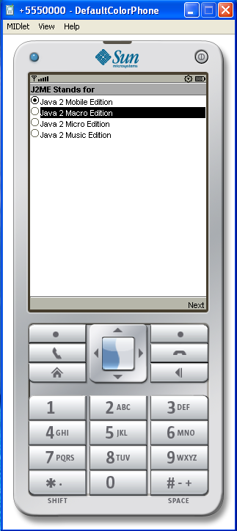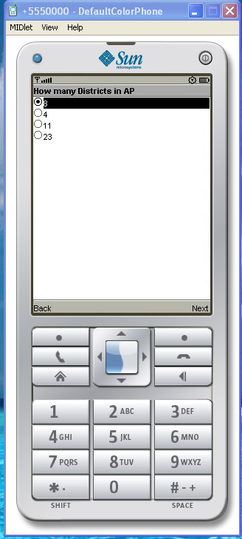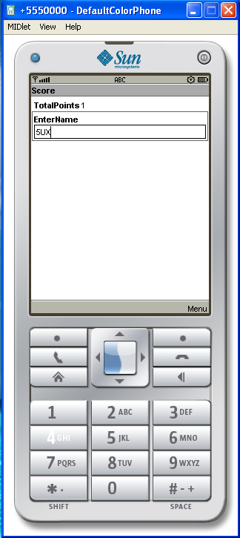

Experiment 7:Create a MIDP application which Examine ,that a phone number,which a user entered in given format.

import javax.microedition.midlet.*;
import javax.microedition.lcdui.*;

public class InputChecking extends MIDlet implements CommandListener {

public Form form1;
public TextField textfield1;
public Command exitCommand;
public Command okCommand;
public StringItem st;
public Display display;

public InputChecking()
{

display=Display.getDisplay(this);
form1=new Form("Insert the Phone number");
exitCommand=new Command("Exit",Command.EXIT,1);
okCommand=new Command("Ok",Command.OK,1);
st=new StringItem("Phone Number is ","");
textfield1=new TextField("Phone;","",30,TextField.ANY);
form1.append(textfield1);
form1.addCommand(okCommand);
form1.addCommand(exitCommand);
form1.setCommandListener(this);

}
public void startApp() {
display.setCurrent(form1);
}

public void pauseApp() {
}

public void destroyApp(boolean unconditional) {
}

public void commandAction(Command cmd,Displayable displayable)
{
if(cmd==exitCommand)
notifyDestroyed();
else if(cmd==okCommand)
{

String s=textfield1.getString();
s=s.replace(' ', '.');

int len=s.length();
int i=0;
int c=0;
String s1="";
while(i<len)
{
if(s.charAt(i)=='.')
{

if(c==0)
{

if(s1.equals("040") || s1.equals("041") || s1.equals("050") || s1.equals("0400") || s1.equals("044"))
{
c++;

s1="";
}
}
if(c==1)
{

if(s1.length()-1==3)
{
c++;
s1="";
}

}
}
s1=s1+s.charAt(i);
i++;

}

if(s1.length()-1==3 || s1.length()-1==4 || s1.length()-1==5)
c++;

if(c==3)
st.setText("OK");
else
{

st.setText("wrong\n Phone Number Format is xxx xxx xxxx\nArea code must be 040|050|041|0400|044");

}
form1.append(st);

}

}
}

OUTPUT:
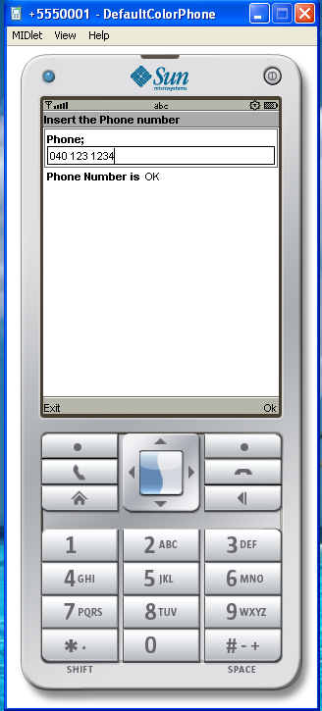

Experiment 8: Create a MIDP application, which draws a bar graph to the display. Data values can be given at int[] array.
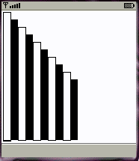
import javax.microedition.midlet.*;
import javax.microedition.lcdui.*;
public class BarGraphMIDlet extends MIDlet implements CommandListener{
public Form form;
public Command exitCommand;
public Command OkCommand;
public Command backCommand;
public Displayable d;
public Display display;
public TextField textfield1;
public TextField textfield2;
public TextField textfield3;
public TextField textfield4;
public TextField textfield5;

public BarGraphMIDlet()
{
display=Display.getDisplay(this);
form=new Form("BarGraph");
textfield1=new TextField("Value1:-","",30,TextField.ANY);
textfield2=new TextField("Value2:-","",30,TextField.ANY);
textfield3=new TextField("Value3:-","",30,TextField.ANY);
textfield4=new TextField("Value4:-","",30,TextField.ANY);
textfield5=new TextField("Value5:-","",30,TextField.ANY);
form.append(textfield1);
form.append(textfield2);
form.append(textfield3);
form.append(textfield4);
form.append(textfield5);
OkCommand=new Command("Ok",Command.OK,1);
exitCommand=new Command("Exit",Command.EXIT,1);
backCommand=new Command("Back",Command.BACK,1);
form.addCommand(OkCommand);
form.addCommand(exitCommand);
form.setCommandListener(this);

}
public void startApp() {
display.setCurrent(form);
}

public void pauseApp() {
}

public void destroyApp(boolean unconditional) {
}
public void commandAction(Command command,Displayable displayable)
{
if(displayable==form)
{
if(command==OkCommand)
{
int[] data=new int[5];
data[0]=Integer.parseInt(textfield1.getString());
data[1]=Integer.parseInt(textfield2.getString());
data[2]=Integer.parseInt(textfield3.getString());
data[3]=Integer.parseInt(textfield4.getString());
data[4]=Integer.parseInt(textfield5.getString());
d=new BarCanvas(data);
d.addCommand(backCommand);
d.setCommandListener(this);
display.setCurrent(d);
}
else if(command==exitCommand)
notifyDestroyed();
}
else if(displayable==d)
{
if(command==backCommand)
display.setCurrent(form);
}
}
}

class BarCanvas extends Canvas{

int[] data;
public int x;
public int y;
public int y1;
public int h;
public BarCanvas(int[] data)
{
this.data=data;
x=10;
}
public void paint(Graphics g)
{
g.setColor(255, 255, 255);
g.fillRect(0, 0, this.getWidth(), this.getHeight());
g.setColor(255, 125, 100);
int i=0;
y1=data[0];
h=200;
while(i<data.length)
{
y=data[i];
h=200+y1-y;
g.fillRect(x, y,25 , h);
x+=30;
i++;
}
}
}

OUTPUT:
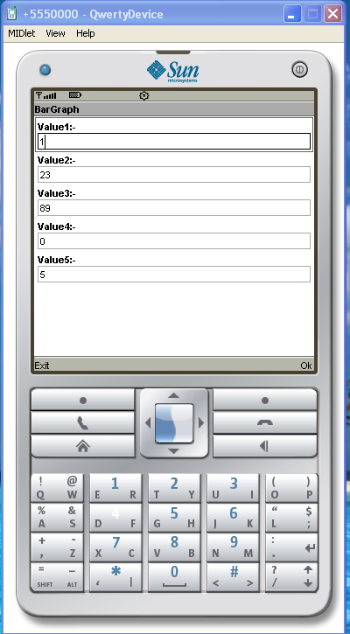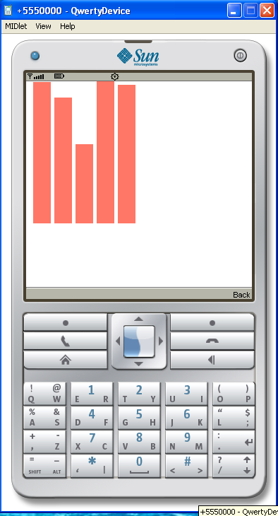

Experiment 9:Create a MIDP application, which draws a bar graph to the display. Data values can be given at int[] array. You can enter four data (integer) values to the input text field.
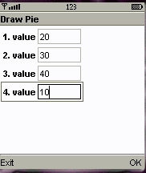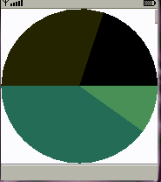
import javax.microedition.midlet.MIDlet;
import javax.microedition.lcdui.*;
public class PieChartMIDlet extends MIDlet implements CommandListener {
public Form form;
public Command exitCommand;
public Command OkCommand;
public Display display;
public TextField textfield1;
public TextField textfield2;
public TextField textfield3;
public TextField textfield4;
public TextField textfield5;
public Displayable d;
public void startApp() {
display = Display.getDisplay(this);
form=new Form("Draw Pie");
textfield1=new TextField("Value1:-","",30,TextField.ANY);
textfield2=new TextField("Value2:-","",30,TextField.ANY);
textfield3=new TextField("Value3:-","",30,TextField.ANY);
textfield4=new TextField("Value4:-","",30,TextField.ANY);
textfield5=new TextField("Value5:-","",30,TextField.ANY);
form.append(textfield1);
form.append(textfield2);
form.append(textfield3);
form.append(textfield4);
form.append(textfield5);
exitCommand = new Command("exit", Command.EXIT, 1);
OkCommand=new Command("Ok",Command.OK,1);
form.addCommand(OkCommand);
form.addCommand(exitCommand);
form.setCommandListener(this);
display.setCurrent(form);
}
public void pauseApp() {
}
public void destroyApp(boolean unconditional) {
}
public void commandAction(Command c, Displayable s) {
if(s==form)
{
if(c==exitCommand)
notifyDestroyed();
else if(c==OkCommand)
{
int[] data = new int[5];

data[0]=Integer.parseInt(textfield1.getString());
data[1]=Integer.parseInt(textfield2.getString());
data[2]=Integer.parseInt(textfield3.getString());
data[3]=Integer.parseInt(textfield4.getString());
data[4]=Integer.parseInt(textfield5.getString());
d = new PieChartCanvas(data);
d.addCommand(exitCommand);
d.setCommandListener(this);
display.setCurrent(d);
}
}
else if(s==d)
{
if(c==exitCommand)
display.setCurrent(form);
}
}
}

class PieChartCanvas extends Canvas {
int[] data;

int colors[] = { 0xFF0000, 0xA9E969, 0x00FFFF, 0xC675EC, 0x008800, 0x00C400 };

public PieChartCanvas(int[] data) {
this.data = data;
}

public void paint(Graphics g) {
int width = this.getWidth();
int height = this.getHeight();
g.setColor(255, 255, 255);
g.fillRect(0, 0, width, height);
int sum = 0;
for (int i = 0; i < data.length; i++) {
sum += data[i];
}
int deltaAngle = 360 * 100 / sum / 100;
int x = 4;
int y = 4;
int diameter;
if (width > height)
diameter = height - y * 2;
else
diameter = width - x * 2;
int startAngle = 0;
for (int i = 0; i < data.length; i++) {
g.setColor(colors[i]);
g.fillArc(x, y, diameter, diameter, startAngle, deltaAngle * data[i]);
startAngle += deltaAngle * data[i];
}
}
}

OUTPUT:
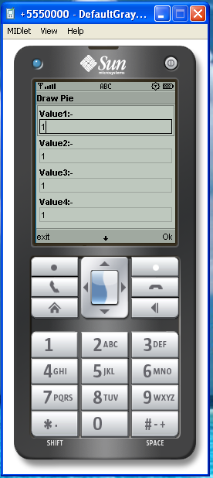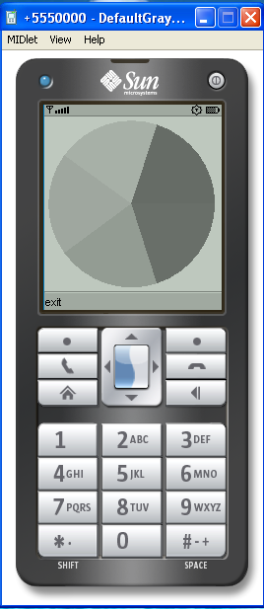

6.2 Login to HTTP Server from a J2ME Program
Experiment 10: This J2ME sample program shows how to display a simple LOGIN SCREEN on the J2ME phone and how to authenticate to a HTTP server. Many J2ME applications for security reasons require the authentication of the user. This free J2ME sample program, shows how a J2ME application can do authentication to the backend server.
Note: Use Apache Tomcat Server as Web Server and Mysql as Database Server.

import javax.microedition.midlet.*;
import javax.microedition.lcdui.*;
import javax.microedition.io.*;
import java.io.*;
public class login extends MIDlet implements CommandListener {
public Form form1;
public Command okCommand;
public Display display;
public HttpConnection ht=null;
public InputStream ist=null;
public StringItem st;
public TextField t1;
public TextField t2;
public Alert alert;
public Form form2;
public login()
{
display=Display.getDisplay(this);
st=new StringItem(" "," Welcome");
alert =new Alert(" ","Wrong UserName or Password",null,AlertType.INFO);

t1=new TextField("UserName"," ",30,TextField.ANY);
t2=new TextField("Password"," ",30,TextField.PASSWORD);
form1=new Form("Login Here");
form2=new Form("Welcome");
okCommand=new Command("Login",Command.OK,1);
form1.addCommand(okCommand);
form1.setCommandListener(this);

form1.append(t1);
form1.append(t2);
form2.append(st);
}

public void startApp() {
display.setCurrent(form1);
}

public void pauseApp() {
}

public void destroyApp(boolean unconditional) {
notifyDestroyed();
}
public void commandAction(Command cmd,Displayable d)
{
if(cmd==okCommand)
{
try
{

// String url="http://192.168.5.19:8080/WebApplication7/index.jsp?t1=101&t2=aaa";
String url="http://192.168.5.19:8080/WebApplication7/index.jsp?t1="+t1.getString().trim()+"&t2="+t2.getString().trim();
//ht=(HttpConnection)Connector.open("http://192.168.5.19:8080/WebApplication7/index.jsp");
ht=(HttpConnection)Connector.open(url);
ist=ht.openInputStream();
byte[] b=new byte[900];
ist.read(b);
String s=new String(b);
s=s.trim();
if(s.equals("ok"))
display.setCurrent(form2);
else
{

alert.setTimeout(Alert.FOREVER);
display.setCurrent(alert);
}
}
catch(Exception ex)
{
form1.append(ex.toString());
}
}
}
}

OUTPUT:
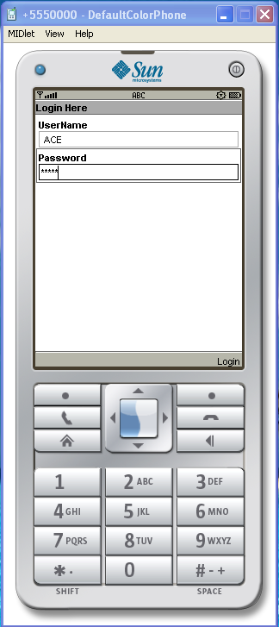

Experiment 11:

import javax.microedition.midlet.*;
import javax.microedition.lcdui.*;
import javax.microedition.io.*;

public class DatagramServer extends MIDlet implements CommandListener{
public Form form1;
public Form form2;
public Command startCommand;
public Command refreshCommand;
public Command exitCommand;
public Display display;
public StringItem st;
public DatagramServer()
{
display=Display.getDisplay(this);
startCommand=new Command("Start",Command.OK,1);
refreshCommand=new Command("Refresh",Command.OK,1);
exitCommand=new Command("Exit",Command.EXIT,1);
st=new StringItem(" "," ");
form1 =new Form("DataGramserver");
form2=new Form("Ready to receive Messages");
form1.addCommand(startCommand);
form1.setCommandListener(this);
form2.addCommand(refreshCommand);
form2.addCommand(exitCommand);
form2.setCommandListener(this);
}
public void startApp() {
display.setCurrent(form1);
}

public void pauseApp() {
}

public void destroyApp(boolean unconditional) {
}

public void commandAction(Command cmd,Displayable displayable)
{
if(displayable==form1)
{
if(cmd==startCommand)
{
try {
DatagramConnection dgc = (DatagramConnection)
Connector.open("datagram://:9001");
try {
int size = 100;
Datagram datagram = dgc.newDatagram(size);
dgc.receive(datagram);

form2.append(datagram.getData().toString());
} finally {
dgc.close();
}
} catch (Exception x){
x.printStackTrace();
}
display.setCurrent(form2);
}
}
else if(displayable==form2)
{
if(cmd==exitCommand)
{
notifyDestroyed();
}
else if(cmd==refreshCommand)
{
st.setText(" ");
}
}
}
}

Client

import javax.microedition.midlet.*;
import javax.microedition.lcdui.*;
import javax.microedition.io.*;
public class DatagramClient extends MIDlet implements CommandListener{
public Form form1;
public Display display;
public TextField textfield;
public Command sendCommand;
public DatagramClient()
{
display=Display.getDisplay(this);
form1=new Form("Datagram Client");
sendCommand=new Command("send",Command.OK,1);
textfield=new TextField("Enter Text",null,30,TextField.ANY);
form1.append(textfield);
form1.addCommand(sendCommand);
form1.setCommandListener(this);
}
public void startApp() {
display.setCurrent(form1);
}

public void pauseApp() {
}

public void destroyApp(boolean unconditional) {
}
public void commandAction(Command cmd,Displayable d)
{
if(cmd==sendCommand)
{
try {
DatagramConnection dgc = (DatagramConnection)
Connector.open("datagram://localhost:9001");
try {
while(true)
{
byte[] payload = textfield.getString().getBytes();
Datagram datagram = dgc.newDatagram(payload, payload.length);
dgc.send(datagram);
}
} finally {
dgc.close();
}
} catch (Exception x) {
x.printStackTrace();
}

}
}
}

