TIC-TAC-TOE

**A Reinforcement Learning Application**

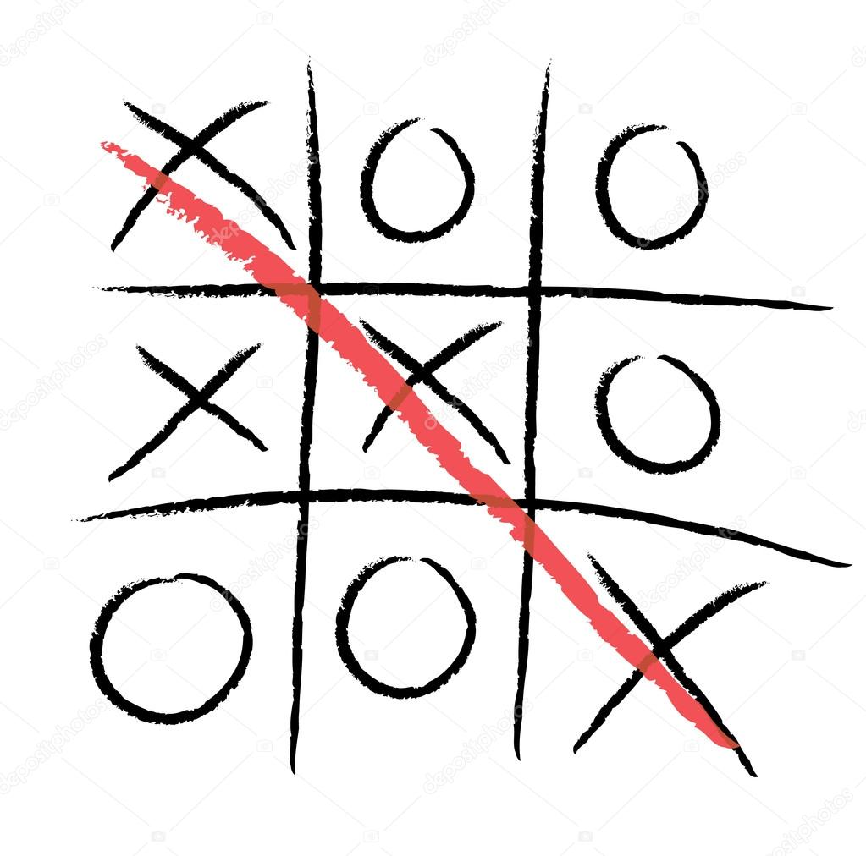

**AKASH KUMAR SINGH**

**ABHISHEK SAINI**

**Procedure**

* Tried to implement Reinforcement Learning Algorithm on tic tac toe Game.
* Recorded several graphs after varying some variables.

**Variables**

* **Epsilon :** No of exploratory moves to be played per 100 moves.
* **Gridsize** : Size of tic-tac-toe Arena
* **Alpha** : Step Size Parameter
* **Trains** : Total No of Trainings(Value Functions For States Updated)
* **CheckCount** : Total no of games played to calculate probablity after each training.(Value Functions For States not updated)
* **Win** **Percent** : Percentage of winning after each training
* **Graph was plotted between the variables Percent and Trains .**

**Results**

**1 .Graph for Certain Fixed Parameters:**

# -For Grid-3 Arena

* For Alpha= 0.99 , Epsilon = 0.1 , Total Trainings = 1000, Games Played After Each Trainings =1000

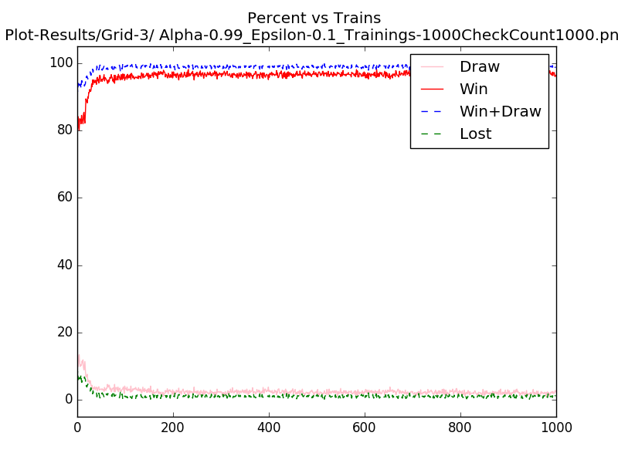

# -For Grid-4 Arena

* For Alpha= 0.91 , Epsilon = 0. 1 , Total Trainings = 100, Games Played After Each Trainings =100

# 

**2 .Graph for varied Epsilons:**

# -For Grid-3 Arena

* For Alpha= 0.92 , Epsilon1 = 0.6 ,Epsilon1 = 0.01, Total Trainings = 1000, Games Played After Each Trainings =1000

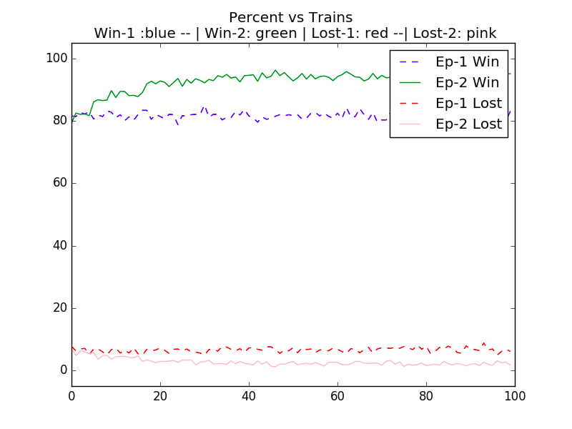

* For Alpha= 0.75 , Epsilon1 = 0. 1 , Epsilon2==1;Total Trainings = 100, Games Played After Each Trainings =1000

# 

# 

# -For Grid-4 Arena

* For Alpha= 0.95 , Epsilon1 = 0.001 ,Epsilon2=.4, Total Trainings = 50, Games Played After Each Trainings =500

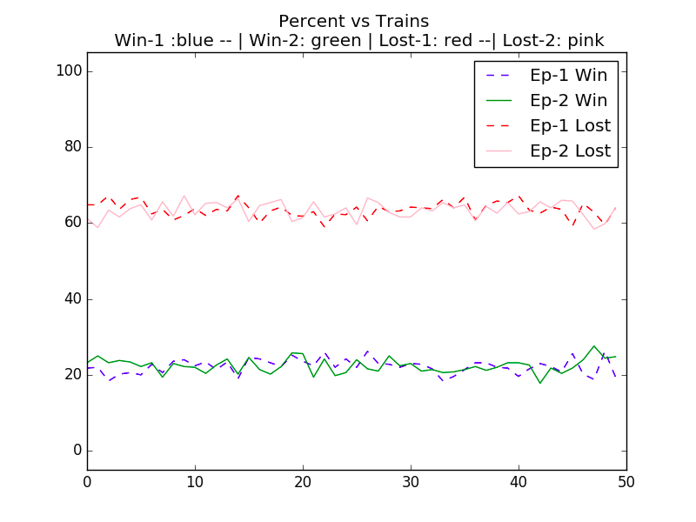

* For Alpha= 0.9 , Epsilon1 = 0.01 ,Epsilon2=0.7, Total Trainings = 100, Games Played After Each Trainings =100

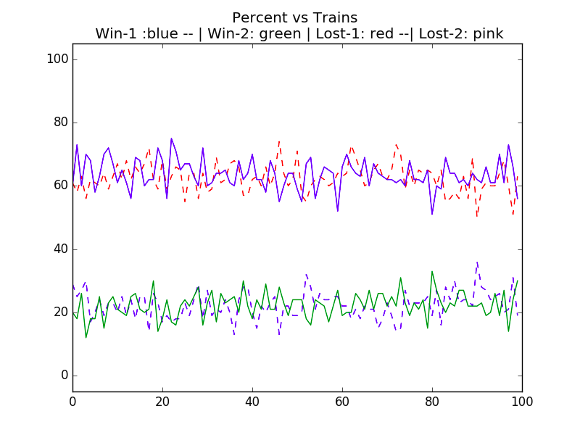

# 

**Conclusion**

# **Trainings**: For 3x3 grid Arena if we increase the no of trains then the Win Percent increases(For Epsilon<1).So we can conclude that the higher we train our game,higher its win percent will be.

# **On varying Epsilon** : For 3x3 grid Arena if we increase Epsilon the Win Percent increases slowly and we will require more trainings to get good results.So we can conclude that in 3x3 arena precision decreases with exploration.

# **Rate of percentage increase :** For initial trains Win Percent increases rapidly but later the rate decreases(for 3x3 grid tic tac toe)

# 