-------------------------------------------------------------------------------------------------------------------------------------

Example question of fork
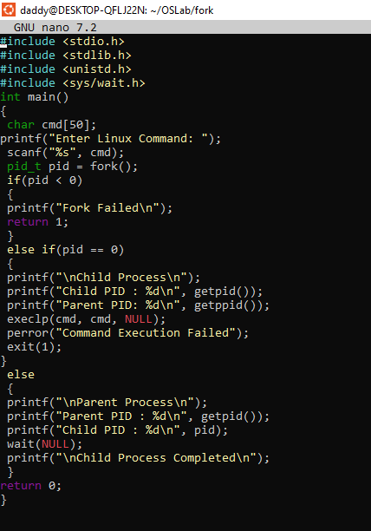

Terminal and output:-

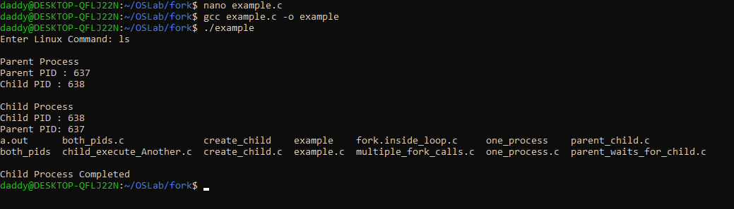
-------------------------------------------------------------------------------------------------------------------------------------
-------------------------------------------------------------------------------------------------------------------------------------
Program 1: One Process (Before fork())
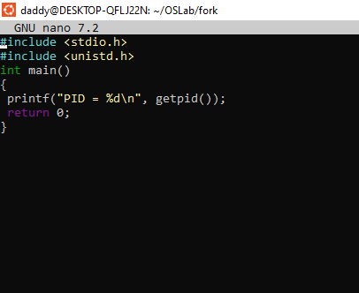
Terminal and Output
------------------------------------------------------------------------------------------------------------------------------------
-------------------------------------------------------------------------------------------------------------------------------------
Program 2: fork() Creates a Child
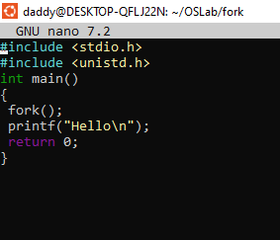
Terminal and Output
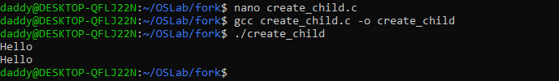
------------------------------------------------------------------------------------------------------------------------------------
Program 3: Parent vs Child
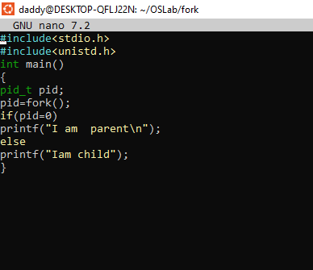
Terminal and Output
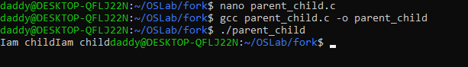

Program 4: Display Both PIDs
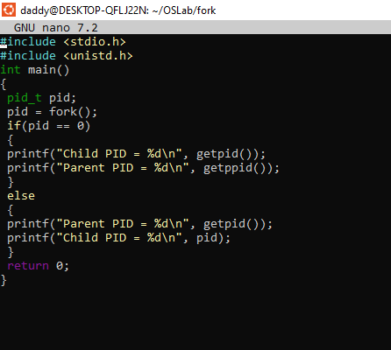
Terminal and Output
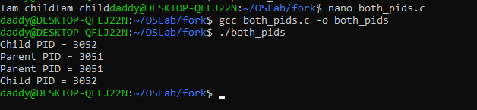
-------------------------------------------------------------------------------------------------------------------------------------
Program 5: Parent Waits for Child
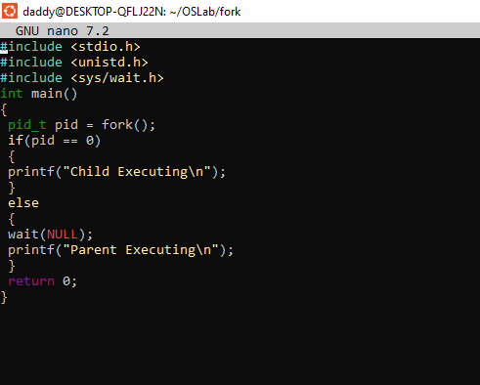
Terminal and Output
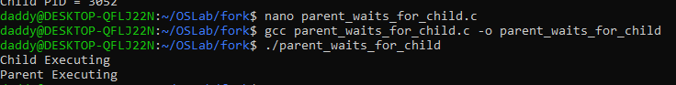

-------------------------------------------------------------------------------------------------------------------------------------
Program 6: Multiple fork() Calls
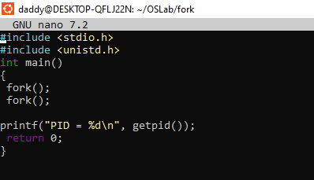
Terminal and Output
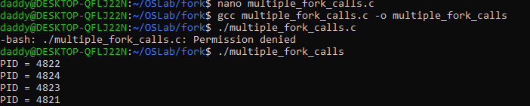

-------------------------------------------------------------------------------------------------------------------------------------
----------------------------------------------------------------------------------------------------------------------------------
Program 7: Child Executes Another Program (exec())
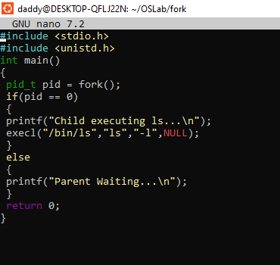
Terminal and Output
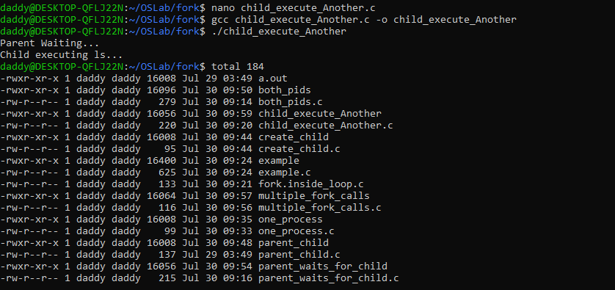
-------------------------------------------------------------------------------------------------------------------------------------
----------------------------------------------------------------------------------------------------------------------------------
Program 8: fork() Inside a Loop (Fun)
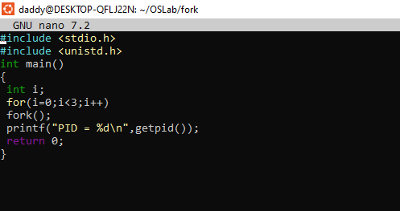
Terminal and Output
