signal1 Program 1 — SIGINT Handler

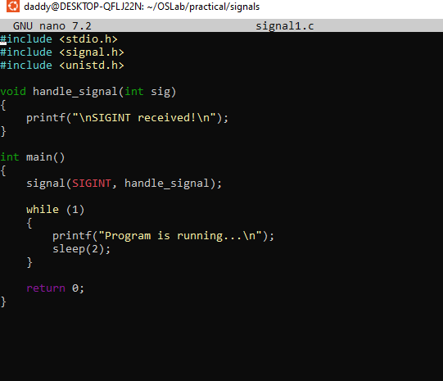

output

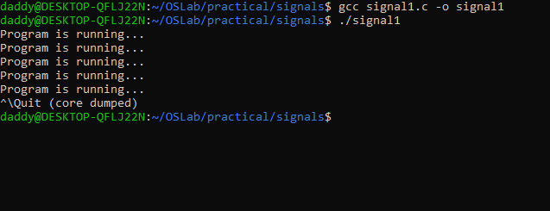

Program 2 — SIGINT Without Handler
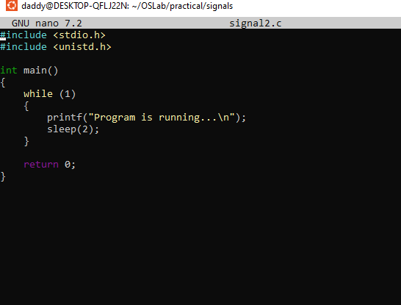
Output
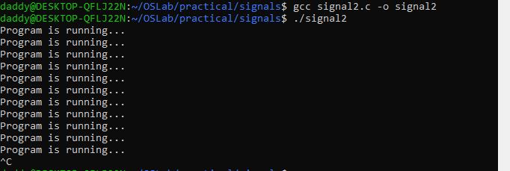

Program 3 — SIGCHLD
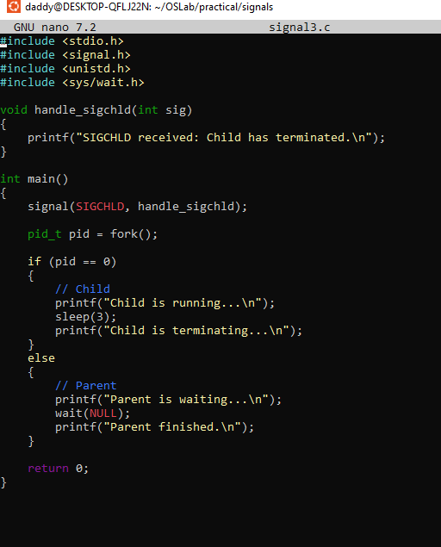
Output
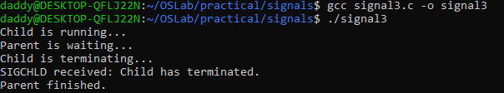

Program 4 — SIGPIPE
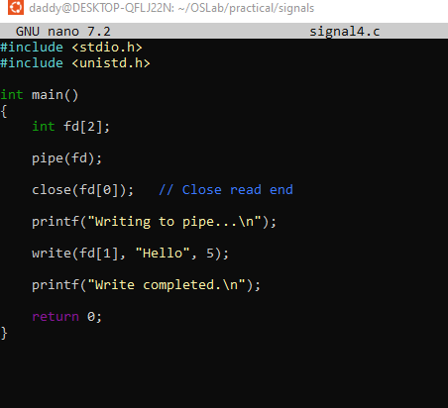

Output

Program 5 — kill() and SIGUSR1
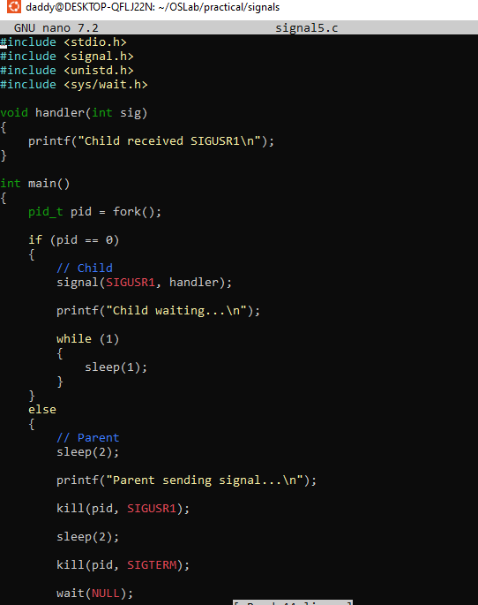
Out put
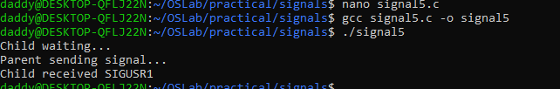

Program 6 — SIGABRT
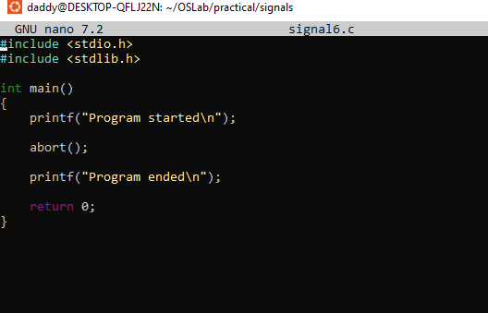
Output
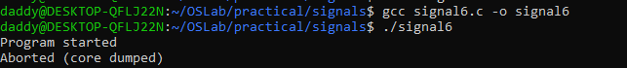

Program 7 — SIGSEGV
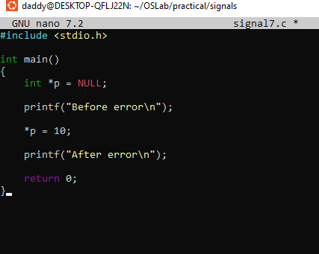
Output
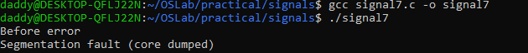

Create README.md

