Practical6:-
Code:

server.c
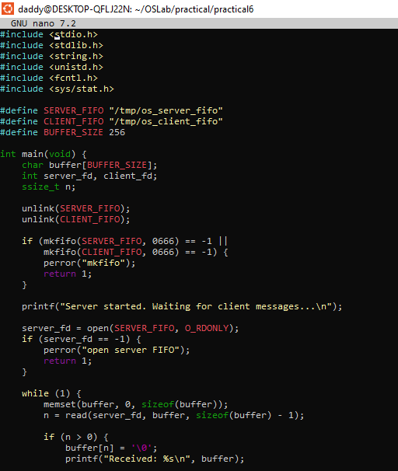

Client.c
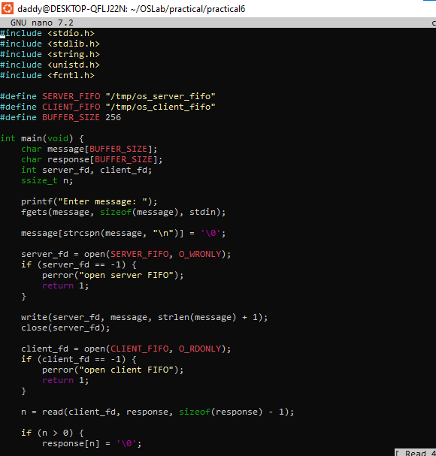

While running the programing

\

Open a second terminal
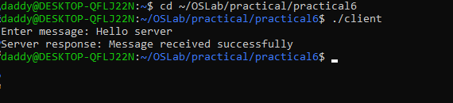
output Check in server
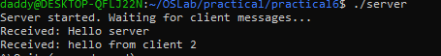

Then in 3rd terminal
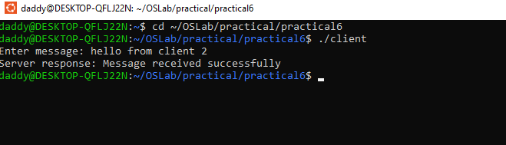
Output in server
