Practical 10:-

- Investigate inode structures using commands such as ls -i, stat, and find. Create hard links and symbolic links and explain their impact on inode allocation.

Design a program using mmap() to perform file reading and writing. Compare memory-mapped I/O with traditional read/write operations in terms of efficiency and implementation complexity.

Code :-

Output :-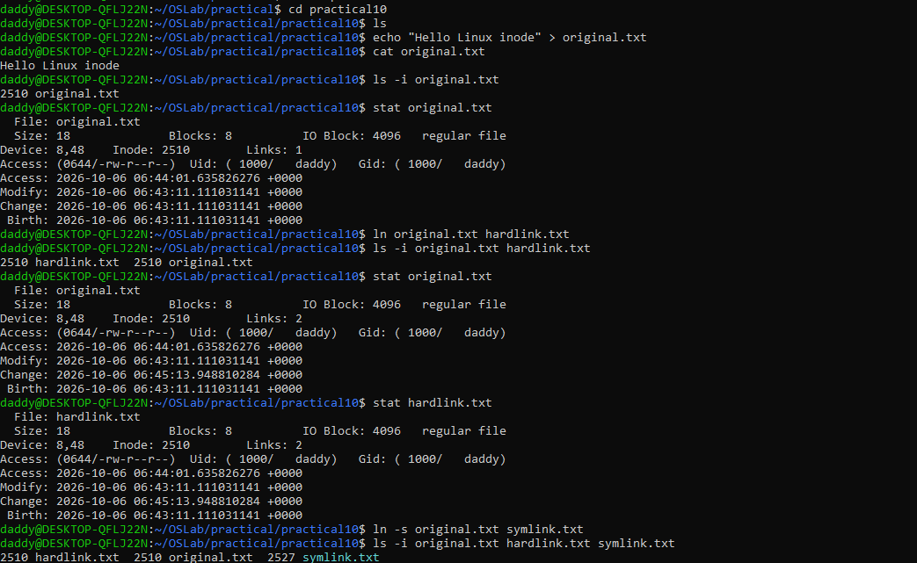
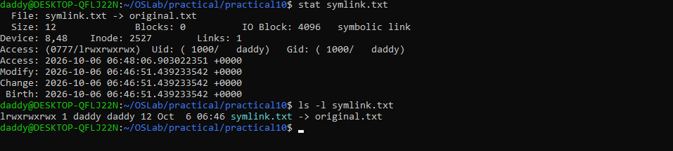

Program 2

Code:-
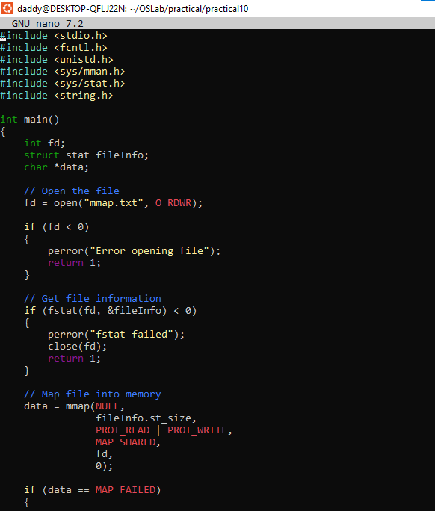

Output:-

