Skill 11

- To Store Commands, Maintain History Buffer, Handle Capacity Limits, Retrieve Entries, Display History, Validate Consistency.

To Create Pipeline Structures, Store Commands, Maintain Execution Order, Connect Processes, Validate Pipeline Layout, Test Configurations.

Code:-

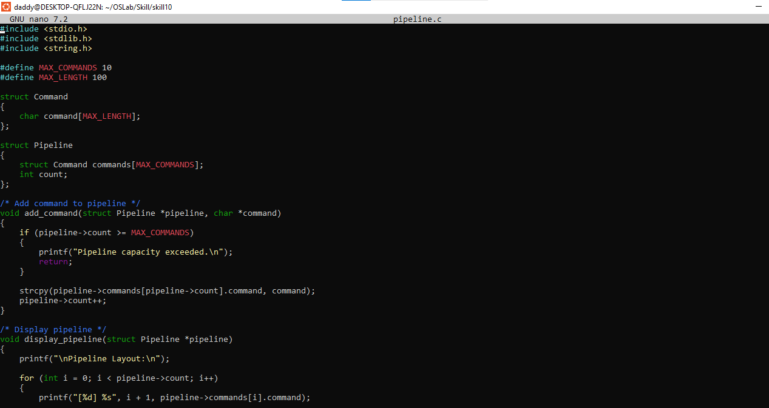
Output
