-- 1. Create
Table


-- 2. Insert Data
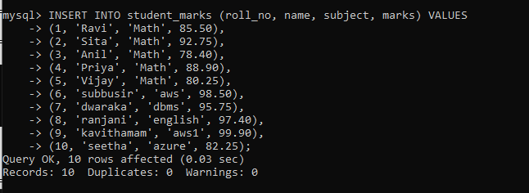
-- 3. Simple Select
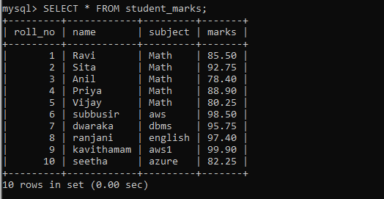
-- 4. Aggregate Functions
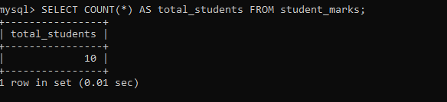
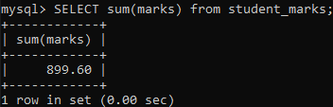


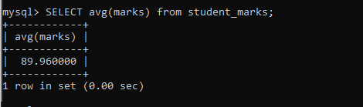
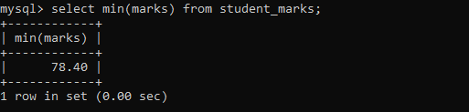
-- 5. Filtering with WHERE
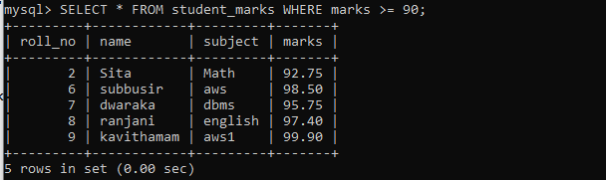

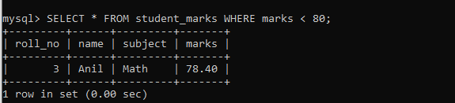

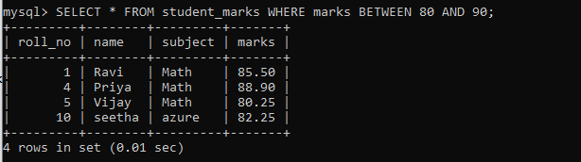

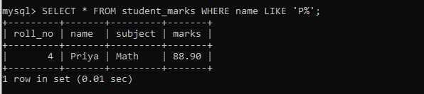

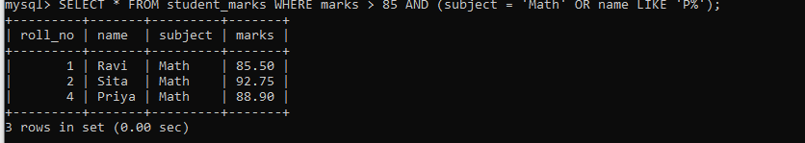
-- 6. Update Queries

