=========================================================

TOPIC: JOINS AND SET OPERATIONS
=========================================================
PART 1: CROSS JOIN
STEP 1: CREATE TABLES
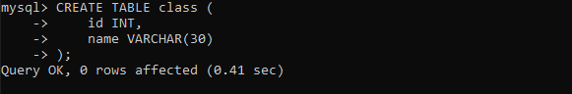
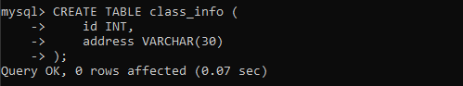
=========================================================
STEP 2: INSERT DATA
=========================================================
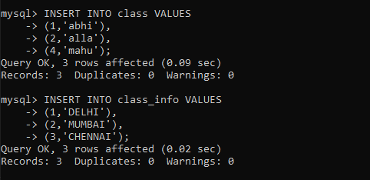
=========================================================
QUESTION 1 - CROSS JOIN
=========================================================
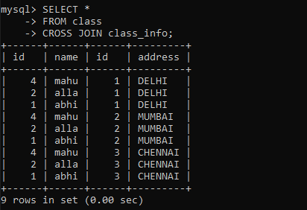
=========================================================
PART 2: INNER JOIN
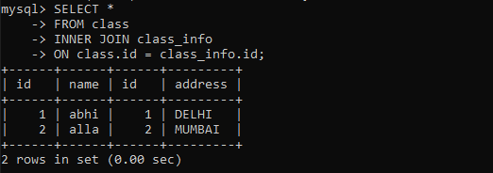

=========================================================
PART 3: NATURAL JOIN
=========================================================

QUESTION 4 - NATURAL JOIN
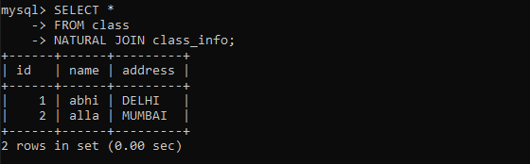
=========================================================
PART 4: LEFT OUTER JOIN
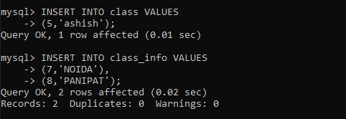
=========================================================
QUESTION 5 - LEFT JOIN
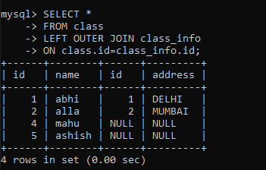
=========================================================
QUESTION 6 - LEFT JOIN
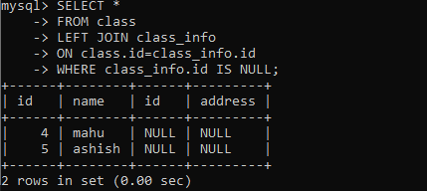
=========================================================
PART 5: RIGHT OUTER JOIN
=========================================================

QUESTION 7 - RIGHT JOIN
=========================================================

