Week 1 Project Report
Traffic Volume Prediction and Analysis Using Machine Learning
Submitted by: Abhishek

1. Introduction
Traffic congestion has become one of the major urban challenges in modern cities. Traffic patterns are influenced by several factors such as office timings, weather conditions, holidays, humidity, temperature, and road activity. Understanding and predicting traffic behavior can help in better transportation planning, congestion management, and resource allocation.
In this project, traffic data was analyzed using Python, Pandas, NumPy, Matplotlib, and Scikit-learn. Different data analysis and machine learning techniques were applied to identify important traffic patterns and predict traffic volume.

The project focused on:
- Data cleaning and preprocessing
- Exploratory Data Analysis (EDA) with visual insights
- Feature Engineering from datetime
- Machine Learning Modeling (Linear Regression & Random Forest)
- Model Comparison and error analysis

2. Objectives
- To understand real-world traffic datasets.
- To perform data preprocessing and handle missing values.
- To analyze traffic trends using visualization techniques.
- To extract meaningful features from datetime information.
- To build and compare ML models for traffic prediction.
- To identify the most influential factors affecting traffic volume.

3. Tools and Technologies Used
Tool / Library | Purpose
Python | Programming language
Pandas | Data manipulation and analysis
NumPy | Numerical operations
Matplotlib | Data visualization
Scikit-learn | Machine Learning
Google Colab | Development environment

4. Dataset Description
The dataset contains hourly traffic information along with environmental and weather-related parameters. Total rows: 33,750.

Column Name | Description
date_time | Date and time of observation
is_holiday | Holiday information
air_pollution_index | Air pollution level
humidity | Humidity percentage
wind_speed | Speed of wind
temperature | Atmospheric temperature
rain_p_h | Rainfall per hour
snow_p_h | Snowfall per hour
weather_type | Weather category
traffic_volume | Number of vehicles observed (Target)

5. Data Preprocessing

5.1 Handling Missing Values
The is_holiday column contained many missing values representing non-holiday days. These were replaced with the label 'No holiday':
df["is_holiday"] = df["is_holiday"].fillna("No holiday")

5.2 Datetime Conversion
The date_time column was converted to datetime format to enable feature extraction:
df["date_time"] = pd.to_datetime(df["date_time"])

6. Feature Engineering
New time-based features were extracted from the datetime column to improve model performance:
Feature | Meaning
hour | Hour of the day (0–23)
day_of_week | Day number in the week
month | Month number (1–12)

7. Exploratory Data Analysis (EDA)

7.1 Hour-wise Traffic Analysis
Traffic volume was grouped by hour of day to observe daily patterns.
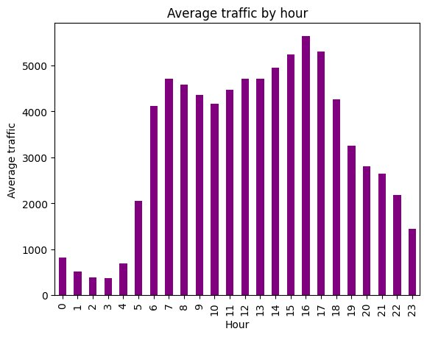
Figure 1: Average Traffic Volume by Hour of Day
- Very low traffic during late-night hours (12 AM – 4 AM)
- Sharp increase from 5 AM; morning peak around 7–8 AM (~4,700 vehicles/hr)
- Afternoon/evening peak at 4–5 PM (~5,500+ vehicles/hr)
- Traffic reduces significantly after 8 PM

7.2 Holiday-wise Traffic Analysis
Average traffic volume was compared across different holidays.
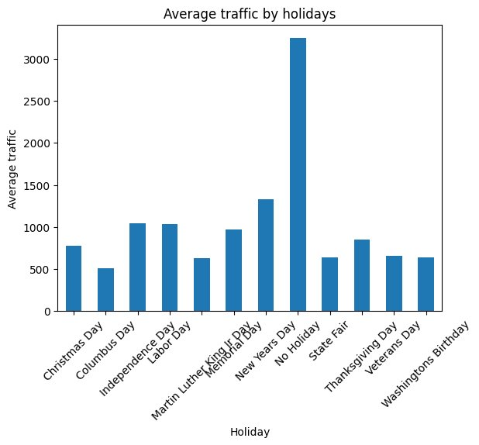
Figure 2: Average Traffic Volume by Holiday (All Holidays Including Non-Holiday)
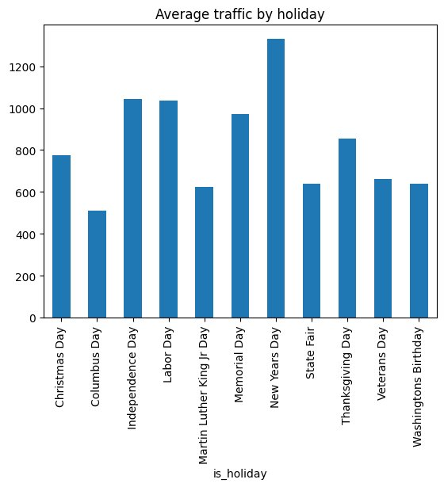
Figure 3: Average Traffic Volume by Holiday (Holidays Only)
- Non-holiday days show the highest average traffic (~3,250 vehicles/hr)
- New Year's Day shows unusually high traffic among holidays
- Columbus Day shows the lowest holiday traffic (~510 vehicles/hr)
- Independence Day and Labor Day remain relatively high (~1,050 vehicles/hr)

7.3 Hourly Traffic Pattern by Holiday
Hourly traffic patterns were visualized for each holiday type.
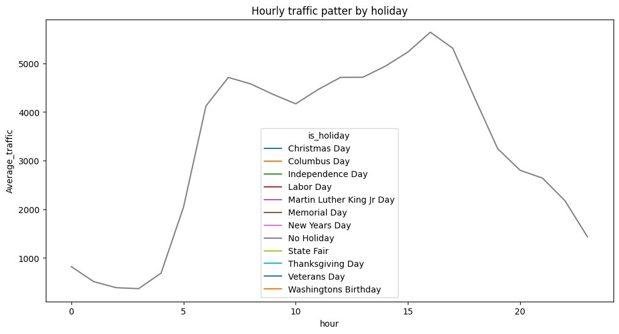
Figure 4: Hourly Traffic Pattern by Holiday (All categories)
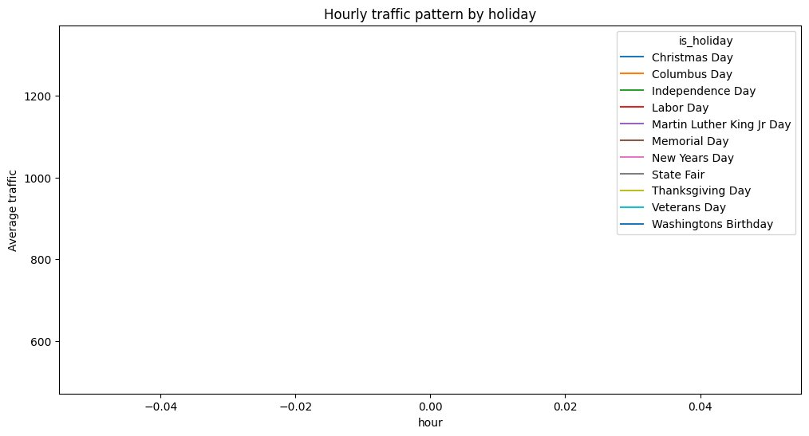
Figure 5: Hourly Traffic Pattern by Holiday (Holiday categories only)
Note: The second chart (Figure 5) shows a known bug — the hour axis shows fractional values near 0 instead of 0-23. This occurred because the holiday subset had very few data points for most hours, causing incorrect grouping. This is identified as an area for future fix.

7.4 Weather-type Traffic Analysis
Average traffic volume was analyzed across different weather conditions.
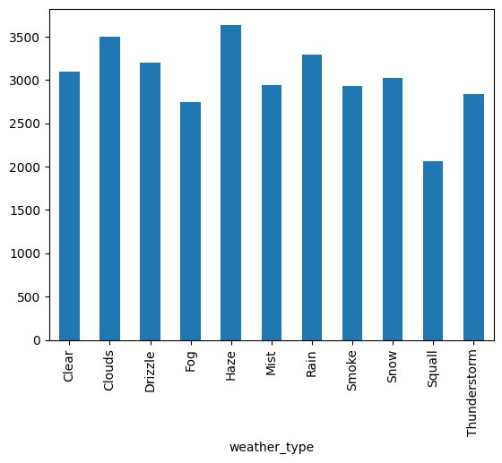
Figure 6: Average Traffic Volume by Weather Type
- Haze conditions show the highest traffic (~3,650 vehicles/hr)
- Thunderstorm and squall show notably lower traffic (~2,050–2,850 vehicles/hr)
- Most weather conditions (Clear, Clouds, Rain, Snow) show similar traffic (~2,900–3,500 vehicles/hr)
- Weather impact is minimal compared to time-based factors — a key finding

7.5 Boxplot Analysis
Boxplots were used to understand traffic distribution and variability across holidays.
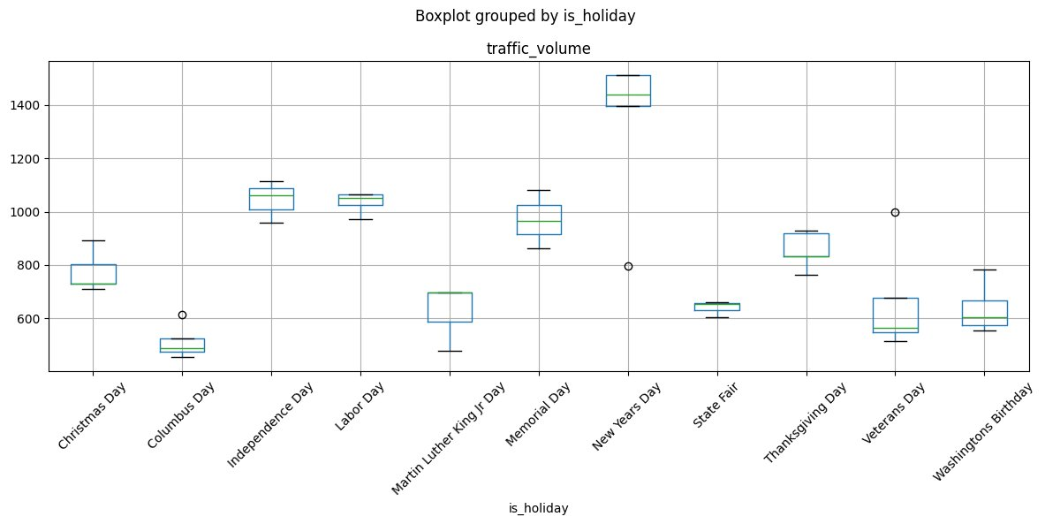
Figure 7: Boxplot of Traffic Volume Grouped by Holiday
- New Year's Day shows the widest spread — high variability in traffic
- State Fair and Columbus Day show tight, low distributions
- Most holidays show limited outliers, except Veterans Day (one high outlier at ~1,000)
- Non-holiday data (not shown here) would dominate with a wide distribution

8. Machine Learning Models

8.1 Features Used
The following features were used as input to both models:
- hour, day_of_week, month (time-based features)
- temperature, humidity, air_pollution_index
- wind_speed, wind_direction, visibility_in_miles
- dew_point, rain_p_h, snow_p_h, clouds_all

8.2 Linear Regression
Linear Regression assumes a linear relationship between features and the target variable.
Result:
Metric | Value
Mean Absolute Error (MAE) | 1607.06 vehicles/hr

Interpretation: High error because traffic patterns are nonlinear and linear regression cannot capture complex interactions between features.

8.3 Random Forest Regressor
Random Forest is an ensemble algorithm that combines 100 decision trees to capture nonlinear patterns. Parameters: n_estimators=100, random_state=42.
Result:
Metric | Value
Mean Absolute Error (MAE) | 259.50 vehicles/hr

9. Model Comparison
Model | MAE (vehicles/hr)
Linear Regression | 1607.06
Random Forest Regressor | 259.50

Random Forest achieved 83.8% reduction in MAE compared to Linear Regression. This demonstrates the importance of using nonlinear models for complex real-world data.

10. Model Interpretation & Insights

10.1 Practical Accuracy of the Random Forest Model
With an MAE of 259.5 vehicles/hr against an average traffic of several thousand vehicles/hr, the prediction error is a small fraction of total volume. This accuracy is suitable for:
- Weekly traffic planning
- Route capacity analysis and peak-hour identification
- Resource allocation and congestion trend monitoring

However, this accuracy is NOT sufficient for:
- Real-time traffic signal control
- Minute-by-minute emergency deployment
- Autonomous traffic regulation systems

10.2 Feature Importance Analysis
The Random Forest model's feature importance revealed a striking pattern: time-based features dominate the prediction.
Feature | Importance (%)
Hour of the day | ~82.49%
Day of week | ~10.87%
Weather features (all combined) | <7%

Key Insight: Traffic volume is a time-driven phenomenon, not weather-driven. Office schedules, human routines, and daily activity cycles dominate. A simplified model using only hour + day_of_week may achieve similar performance while reducing data collection complexity.

10.3 Error Analysis by Hour
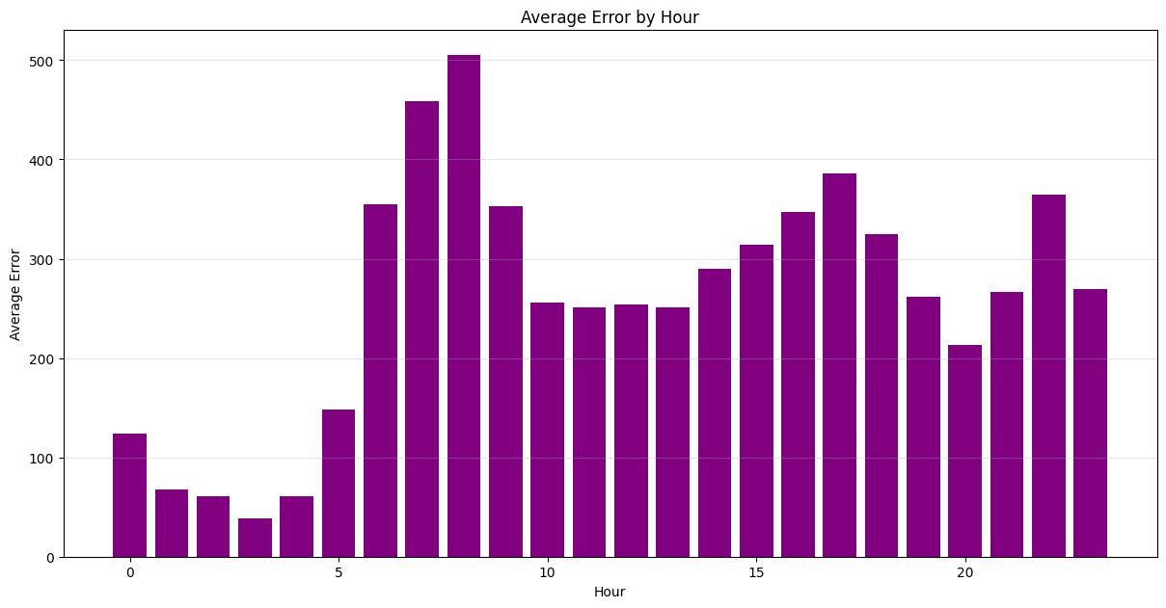
Figure 8: Average Prediction Error by Hour of Day
The error analysis graph reveals an important pattern:
Period | Hours | Average Error
Late night (low error) | 1 AM – 4 AM | ~38–67 vehicles/hr
Morning rush (high error) | 7 AM – 8 AM | ~458–505 vehicles/hr
Afternoon peak | 5 PM | ~385 vehicles/hr
Late night irregular | 10 PM, 11 PM | ~364 vehicles/hr

The model performs best during stable late-night periods and struggles during rapid transition periods (rush hours) where small events can cause large traffic swings. Predictions during rush hours should include safety buffers in practical deployment.

11. Key Learnings

Python & Libraries
- Functions, file handling, exception handling, loops, and dictionaries
- NumPy arrays and numerical operations
- Pandas DataFrames, groupby, null handling, and feature extraction
- Matplotlib bar plots, line plots, and box plots

Machine Learning
- Train-test split and model evaluation using MAE
- Linear Regression vs. ensemble methods (Random Forest)
- Feature importance extraction and interpretation

12. Challenges Faced
- Handling missing values in the is_holiday column
- Understanding datetime feature extraction
- Debugging the hourly traffic pattern by holiday plot (axis bug identified)
- Interpreting machine learning evaluation metrics
- Understanding why Random Forest significantly outperforms Linear Regression

13. Future Improvements
- Add lag-based features (previous hour traffic) to capture traffic momentum
- Include R² score and RMSE alongside MAE for fuller evaluation
- Apply K-fold cross-validation for more reliable performance estimates
- Test a simplified model using only hour + day_of_week
- Hyperparameter tuning (n_estimators, max_depth) for better accuracy
- Deployment using Flask or Streamlit
- SQL database integration and real-time prediction pipeline

14. Conclusion
This project successfully analyzed and predicted traffic volume using machine learning. The key findings are:
- Traffic volume is overwhelmingly driven by time (hour: 82.49%, day_of_week: 10.87%)
- Weather conditions have minimal impact on traffic compared to time-based patterns
- Random Forest (MAE: 259.50) vastly outperforms Linear Regression (MAE: 1607.06)
- The model is best suited for strategic planning, not real-time control
- Prediction errors are highest during rush hours — appropriate buffers needed

The project provided practical exposure to the complete data science pipeline: preprocessing, EDA, visualization, feature engineering, ML modeling, and result interpretation.

15. References
- Scikit-learn Documentation — scikit-learn.org
- Pandas Documentation — pandas.pydata.org
- NumPy Documentation — numpy.org
- Matplotlib Documentation — matplotlib.org
- Dataset Source — Kaggle

