Assignment 5: Diffusion Models

Name(s): Abhinav Sasikumar, Khushi Kalra
NetID(s): as263, khushik3

Part 1: Single-Step Denoising UNet

- A visualization of the noising process using 𝜎 = [0.0, 0.2, 0.4, 0.5, 0.6, 0.8, 1.0] (Figure 3)
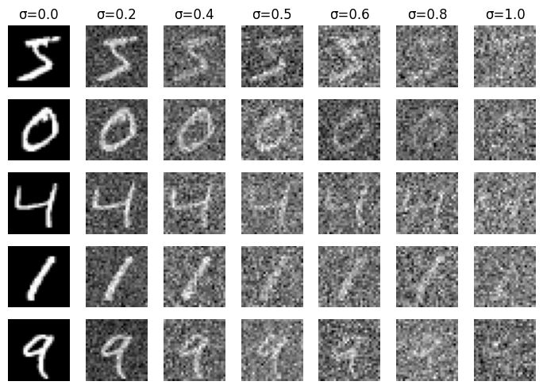

- A training loss curve plot every few iterations during the whole training process (Figure 4)
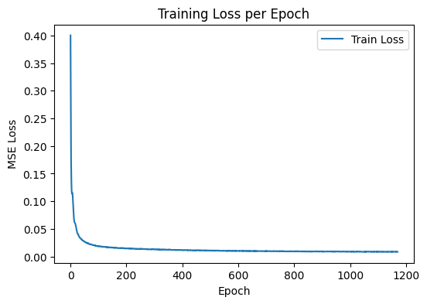

- Sample results on the test set after the first and the 5th epoch. (Figures 5 and 6)

After Epoch 1:
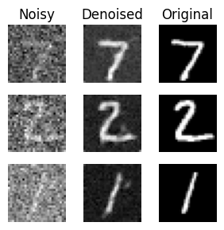
After Epoch 5:
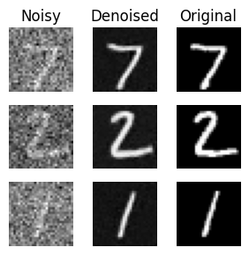

- Sample results on the test set with out-of-distribution noise levels after the model is trained. Keep the same image and vary 𝜎 = [0.0, 0.2, 0.4, 0.5, 0.6, 0.8, 1.0] (Figure 7)
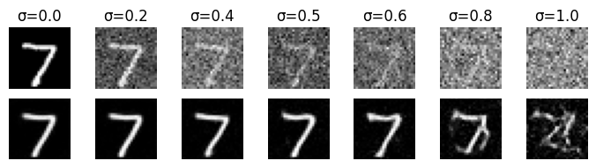

Part 2.1-2.3: Time-conditioned UNet

- A training loss curve plot for the time-conditioned UNet over the whole training process (Figure 10).

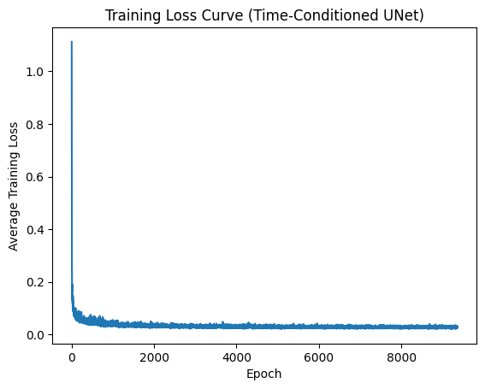

- Sampling results for the class-conditioned UNet after the 5th and the 20th epoch. Providing a GIF is optional and can be done as extra credit.

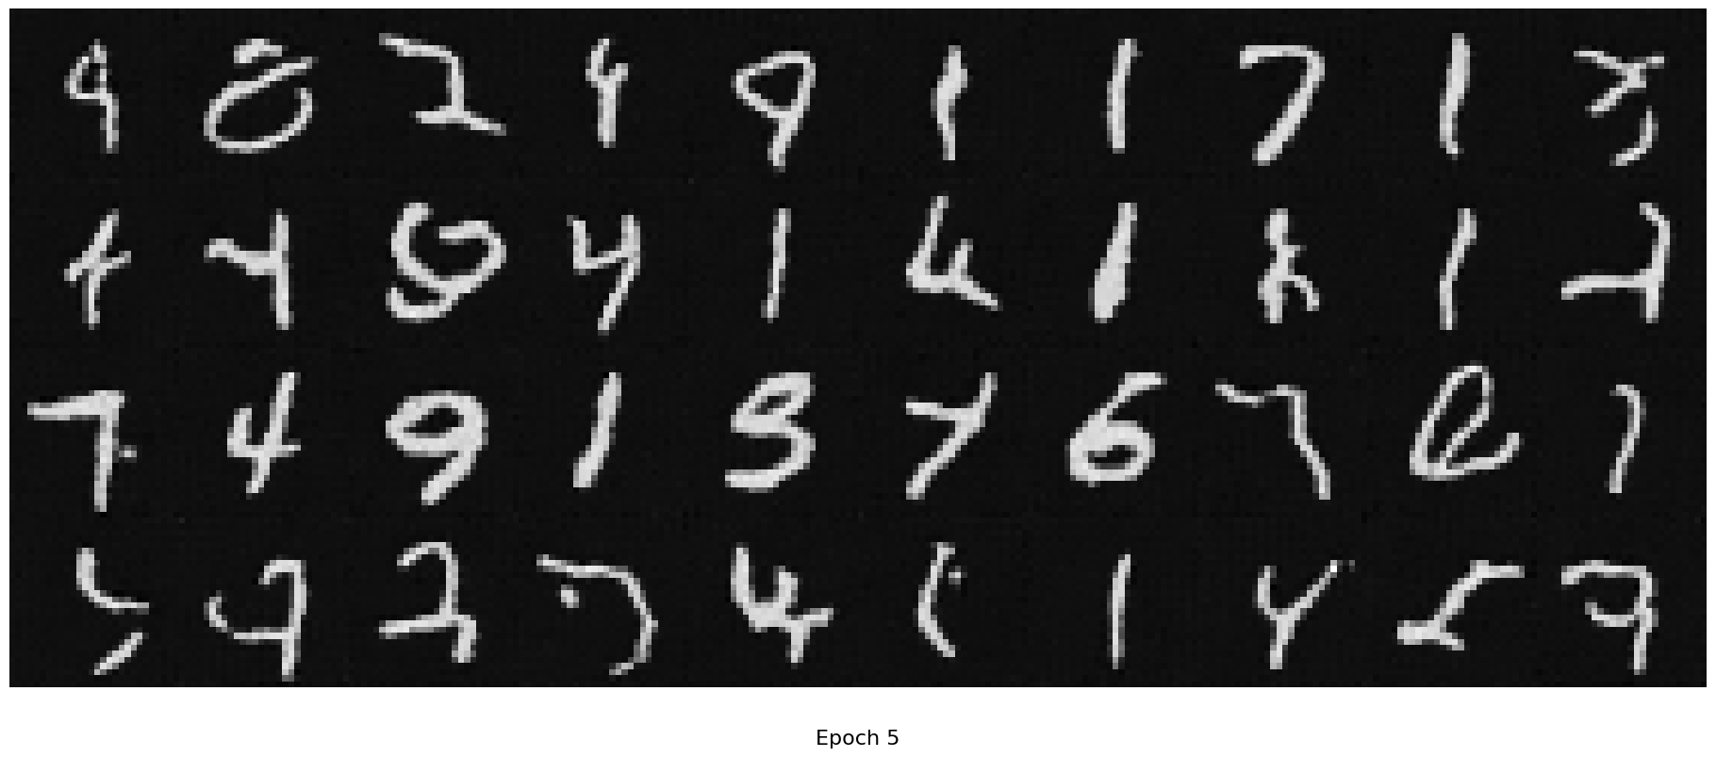

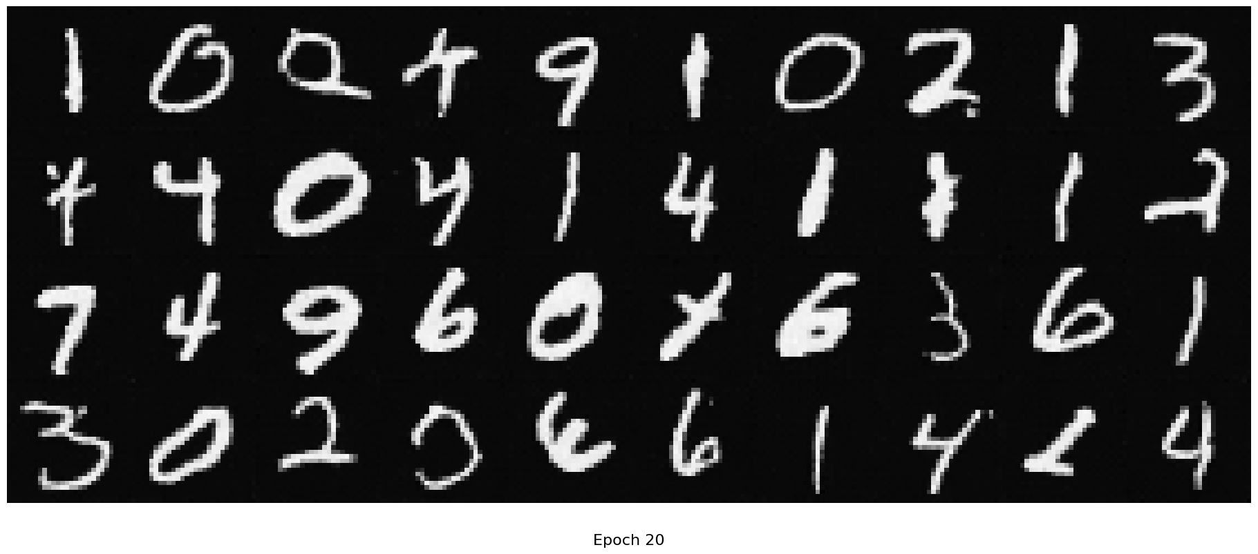

Part 2.4-2.5: Class-conditioned UNet

- A training loss curve plot for the class-conditioned UNet over the whole training process
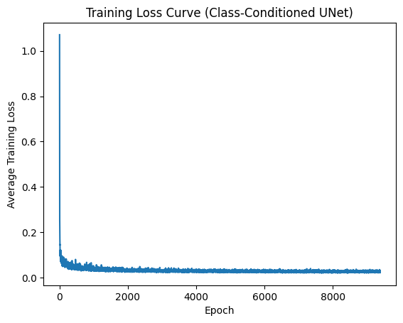

- Sampling results for the class-conditioned UNet after the 5th and the 20th epoch. Generate 4 instances of each digit as shown on the assignment page. Providing a GIF is optional and can be done as extra credit.

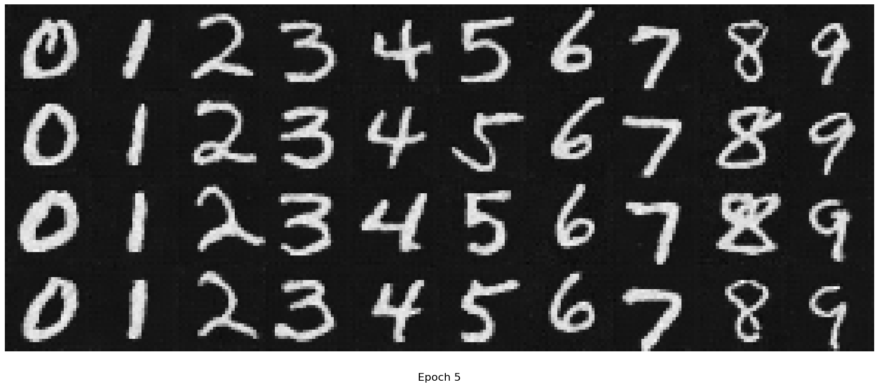
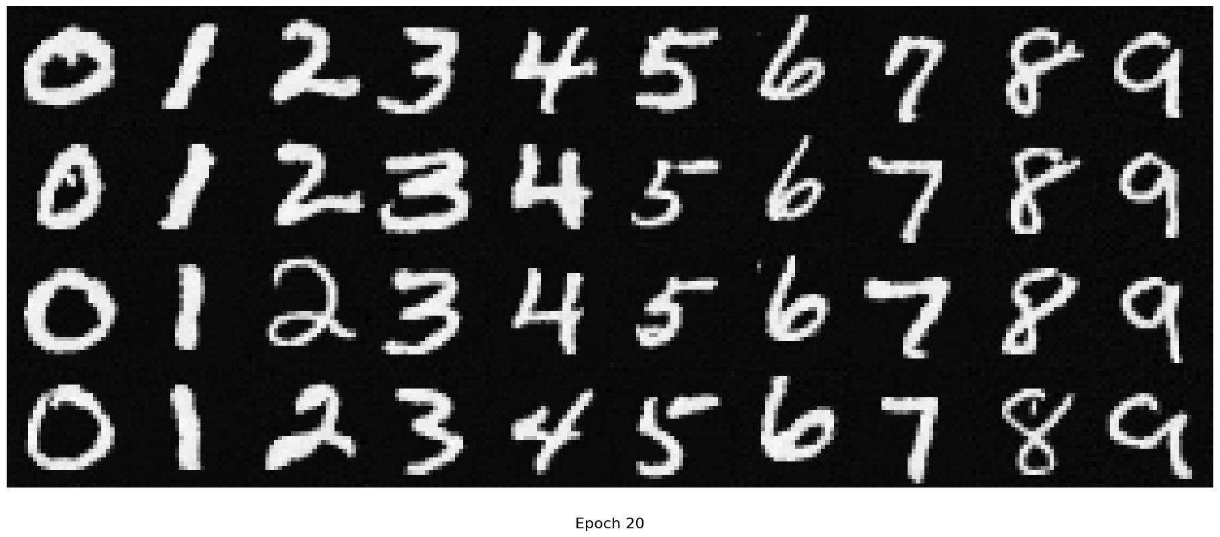

Extra credit:

