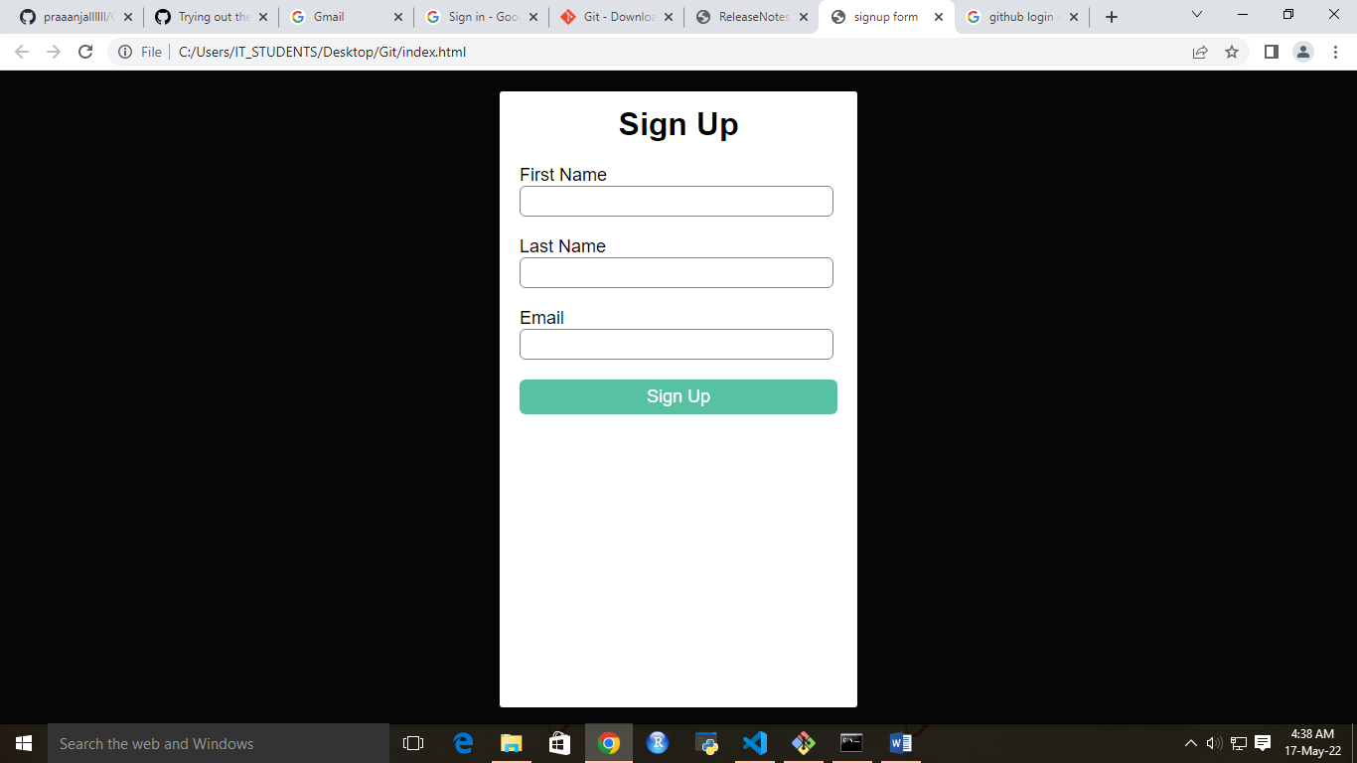

steps for uploading files to repositories

git init

git add README.md

git commit -m "first commit"

git branch -M main

git remote add origin https://github.com/praaanjallllll/github.git

git push -u origin main

