CarePlix Voice Final Architecture
  - Version 1.0 | Proposed implementation baseline | 31 October 2026
A selected architecture for the complete demo and its production evolution. This document establishes what CarePlix operates, what providers process and how inbound and outbound channels connect.

Selected architecture
ADR01 selects a managed demo: CarePlix application services and durable records run on Google Cloud; LiveKit Cloud operates media, SIP connectivity and hosted CarePlix agent workers; the worker calls Gemini Live directly through the Google plugin. A separately configured SIP carrier supports outbound calls. This arrangement uses the existing LiveKit account without assuming its enabled features [L2, L3, L4].
The AI Control Studio is a CarePlix application, not a reskinned vendor console. Operators never need vendor credentials. A reusable worker loads a signed or authenticated reference to a published configuration and fetches only the task context it is allowed to access.
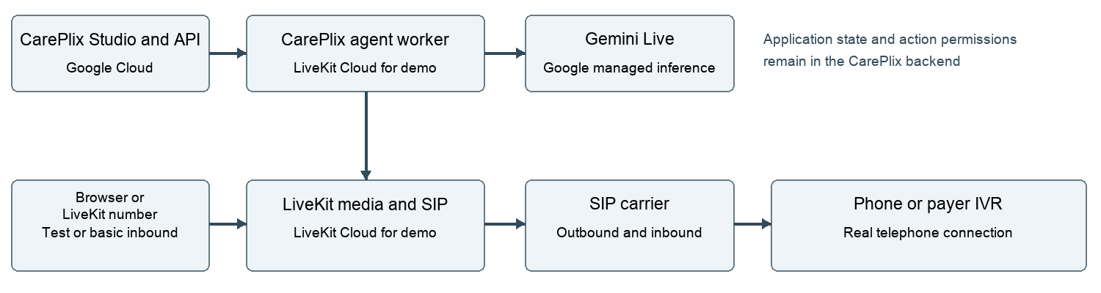

Three execution boundaries
The control plane stores agent versions, tasks, permissions, routes and audit events. It runs on Google Cloud and remains authoritative across calls. The live conversation plane handles media, model sessions and rapid tools. The business workflow plane performs scheduling, external writes, reconciliation and review outside the audio loop.
Do not place patient information in room names, dispatch metadata, metric labels or general logs. Pass opaque task and attempt identifiers. Agent workers fetch scoped context from the CarePlix API after authentication.

Deployment evolution
Mode | Voice infrastructure | Agent workers | Trade-off
Managed demo selected | LiveKit Cloud | LiveKit Cloud | Least initial voice operations work
Hybrid option | LiveKit Cloud | CarePlix GCP workers | Worker control with an external media boundary
Self hosted option | CarePlix media and SIP services | CarePlix workers | Full operational responsibility for voice services
Self-hosting changes infrastructure ownership, not the fact that Gemini and the telephone carrier process data. Keep provider adapters, configurations and export formats portable; do not describe migration as a configuration-only change. Network, recording, monitoring and capacity tests must be repeated [L5].

Inbound and outbound channel decisions
ADR02 selects one external SIP carrier for outbound calling. Prefer the same carrier for a pilot inbound number when transfers or unified number management are required. A LiveKit-purchased US number is an optional fast inbound demonstration route.
As verified on 31 October 2026, LiveKit documents its purchased numbers as inbound-only and does not support TransferSIPParticipant forwarding for those numbers [L1]. Recheck before purchase and release. Do not imply that owning a LiveKit number enables outbound calling or every transfer feature.
Route | Call initiation | Routing | Release condition
Browser | Short-lived CarePlix token | LiveKit room and explicit agent dispatch | D microphone and permissions tests
LiveKit inbound number | External caller dials number | Number dispatch rule selects agent | D basic inbound; transfer unavailable until qualified
Carrier inbound number | Carrier receives PSTN call | Authenticated inbound SIP trunk and dispatch | P preferred for transfer-dependent workflows
Carrier outbound | CarePlix initiates attempt | Outbound trunk creates SIP participant | D approved number and destination policy

Call transfer policy
Blind transfer, warm transfer and adding a human to an existing session are different capabilities. Record supported capabilities per number route. If a route cannot support the required handoff, do not expose a transfer button or promise a transfer; create a callback task and explain the next step. Production transfer qualification must confirm who owns each call leg and when billing stops.

Component responsibility
Component | Responsibility | Default location
CarePlix UI and API | Identity, tasks, studio, results | GCP application services
PostgreSQL | Configuration, permissions, attempts, events | GCP managed database
Secret manager | Provider keys and connection secrets | GCP secret storage
LiveKit media and SIP | Transport and telephony bridge | LiveKit Cloud for demo
Agent worker | Conversation and scoped tools | LiveKit Cloud for demo
Gemini Live endpoint | Native audio inference | Approved Google managed endpoint
Carrier | PSTN reachability and caller number | Selected provider
Object storage | Approved recordings and artifacts | CarePlix controlled bucket

Network and data flow
Use HTTPS/WSS for application and model traffic. Configure encrypted SIP/media segments where supported and verify the carrier boundary; do not claim PSTN end-to-end encryption. Cloud region selections are constrained by each provider's actual supported regions and contractual data terms.

Architecture decisions and capacity
ADR03 uses Gemini native audio initially. No separate STT or TTS service is required in the conversation path. A modular STT to text LLM to TTS adapter remains an extension point. Native transcriptions are not guaranteed verbatim evidence; critical facts require confirmation and review.
ADR04 makes published agent configurations immutable. Runtime releases and configuration releases are separate. Every attempt stores runtime build, agent version, tool schema version, model identifier and policy version. A rollback changes new dispatches, not conversations already running.
ADR05 uses an explicit case state machine and a transactional outbox. Queue delivery may repeat; dial and write actions are idempotent. Ambiguous external operations enter reconciliation rather than automatic retry.
ADR06 starts with one workspace and one active synthetic-data call. Pilot capacity begins with a load-tested target of ten concurrent calls, subject to quota and carrier approval. These are proposed application limits, not vendor capacity claims.

Isolation and credentials
The backend resolves workspace and user identity from authentication, not browser-supplied tenant identifiers. Mint room-specific participant tokens with minimal privileges. Worker-to-backend authorization is short-lived and restricted to assigned attempts. Direct Google access from hosted workers needs an approved credential method; do not assume GCP instance identity exists outside GCP. Prefer supported federation, otherwise use a rotated managed secret with limited permissions.

Availability and recovery
A worker or media failure can interrupt an active call. Persist facts and action receipts incrementally, mark the attempt as interrupted, and offer an authorized retry. Do not promise transparent failover of a live telephone conversation. Gracefully drain workers during runtime updates and reject new sessions if prerequisites are unhealthy.

Self hosting migration checklist
Export agent and tool versions; deploy media, SIP, Redis coordination and workers; configure TLS, firewall and TURN requirements; replace cloud-only plugins; deploy recording Egress if needed; reconnect carrier trunks; rehearse key rotation, capacity, backup and recovery. Run the same inbound, outbound and transfer qualification suite before moving traffic. A separate GCP infrastructure design is needed for the selected production scale.

Known constraints
LiveKit account access, production region, carrier contract, enabled model, number inventory and quotas remain unverified. This document does not assert compliance or readiness. Human-versus-AI voice detection is never an identity control. Carrier caller ID is a routing signal rather than proof of the caller's authority.

Sources and verification
Vendor documentation checked on 31 October 2026. Provider capabilities and account entitlements must be rechecked before implementation. Uncited implementation details are CarePlix design proposals.
L1 LiveKit phone numbers and limitations
L2 LiveKit SIP trunk setup
L3 LiveKit managed agent deployment
L4 LiveKit Gemini Live integration
L5 LiveKit self hosted deployment
G4 Cloud Tasks delivery and idempotency

