1. echo "Hello Bas";

name='Abhisek Roy'

echo $name;



1. #echo $BASH_VERSION

#echo $PWD

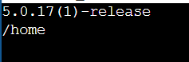

1. echo "Please Enter your name"

read name

echo "Hi ${name}"

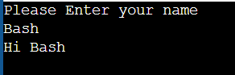

1. echo "Enter a no"

read

echo $REPLY

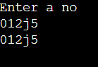

1. a=100

b=12

echo $((a+b))

echo $((a-b))

echo $((a*b))

echo $((a/b))

echo $((a%b))

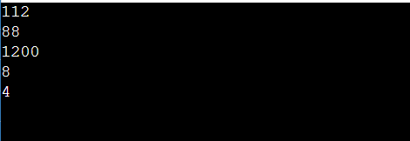

1. a=100

b=12

echo $(expr $a + $b)

echo $(expr $a - $b)

echo $(expr $a / $b)

echo $(expr $a \* $b)

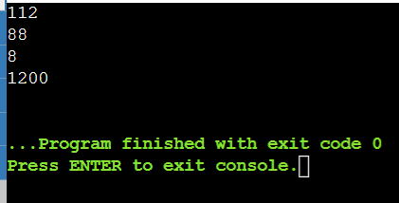

a=20

b=21

if [ $a == $b ]

then

echo "Equal"

else

echo "Not Equal"

fi

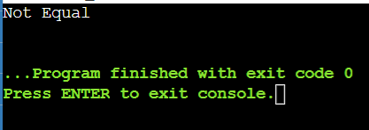

echo "Enter The NUmber"

read no

if [ $(expr $no % 2) == 0 ]

then

echo "Even"

else

echo "odd"

fi

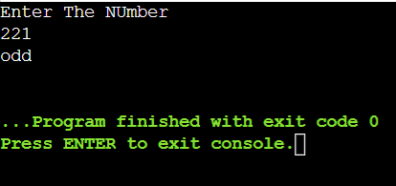

echo "Enter The age"

read age

if [ "$age" -lt 18 ]

then

echo "eligible"

else

echo "not"

fi

