Name-Abhisek Roy

Department- B.Tech in Information Technology

Year-3rd

Semester-5th

Roll No-10000219062

Registration No-042888

Paper code :PCCIT591

1. **Write a recursive function to compute Max and Min of n elements.**

**Algorithm:**

Get a array of numbers

Define a recursive function:

Base Case: if n==1, return arr[0]

Recursive Case: return max(arr[n-1], findMax(arr,n-1))

For minimum:

Recursive Case: return min(arr[n-1], findMin(arr,n-1)

**Code:**

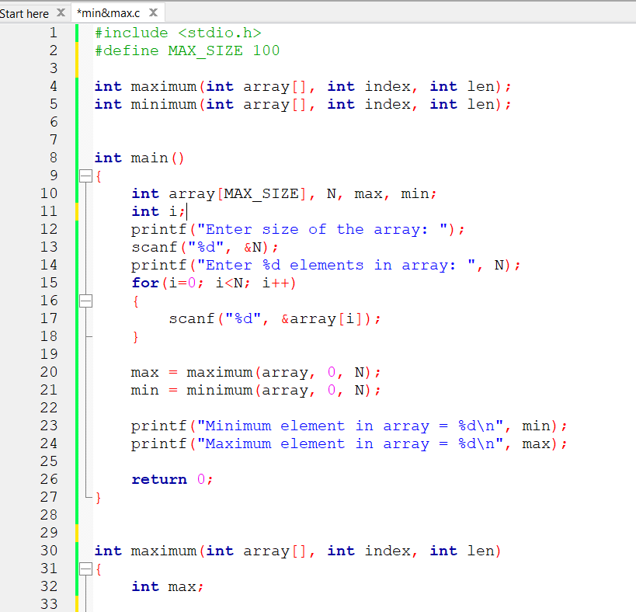

*-+

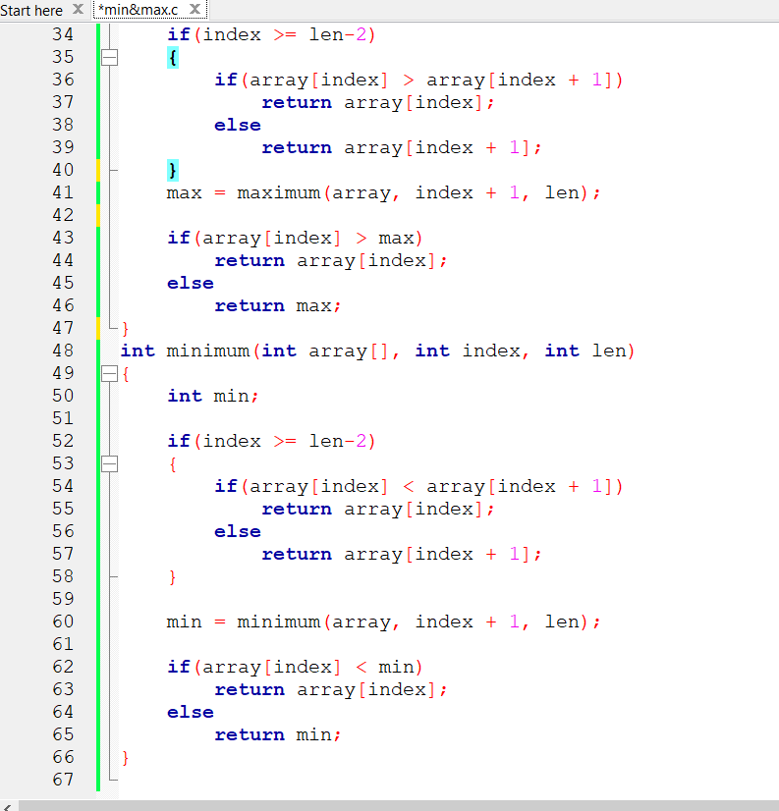

**Output**

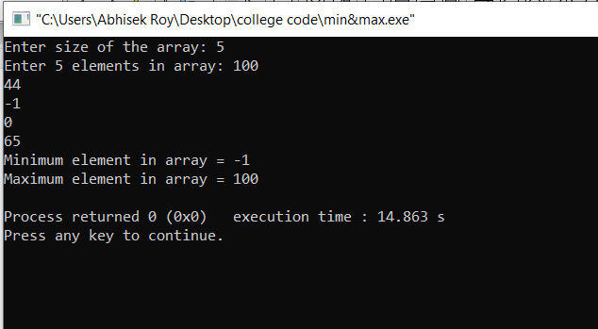

1. **write a recursive function to find the binary equivalent of a positive integer number.**

**Algorithm:**

int deci_bin(int num)

if(num==0)

return 0;

else

return ((num%2)+10*deci_bin(num/2));

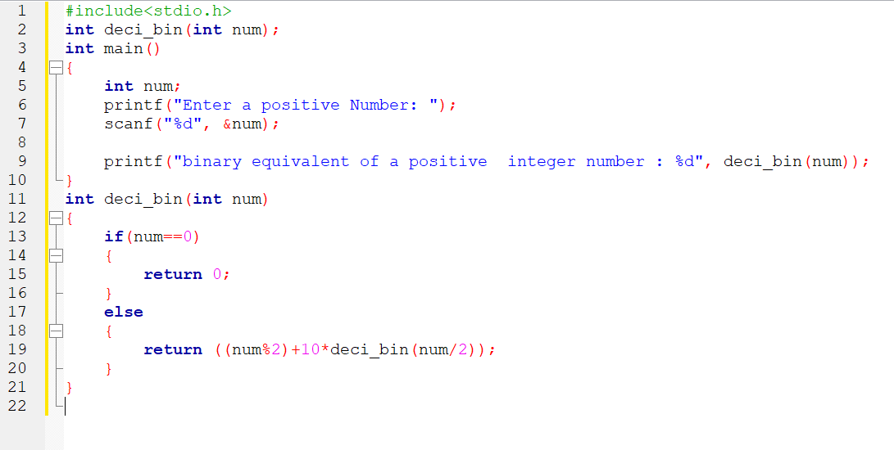

**Output**

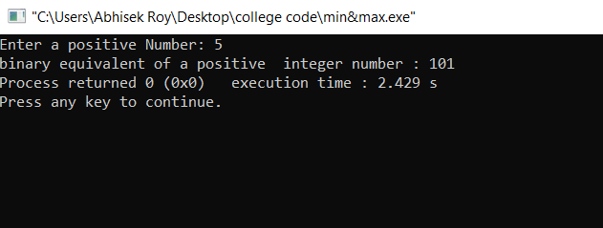

1. **Write a recursive function that adds up the numbers present within an array.**

**Algorithm :**

int sum( int arr[], int n )

{

int sum = 0;

//base case:

if (n < 0) {

return sum;

} else{

sum = sum + arr[n];

}

sum(arr,n-1);

}

**code**

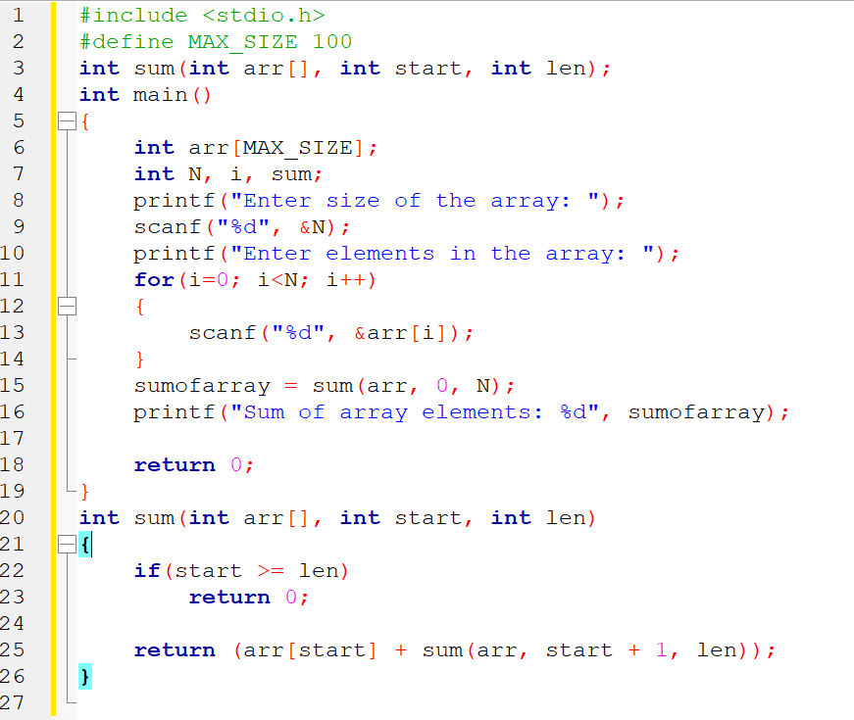

**Output**

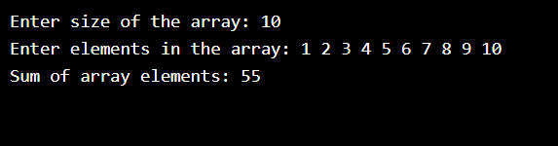

1. **Write a recursive function to compute the binomial coefficients.**

**Algorithm:**

int BIN_COF(int n, int k)

if (k==0 || k==n)

return 1;

return BIN_COF(n-1, k-1) + BIN_COF(n-1, k);

**code :**

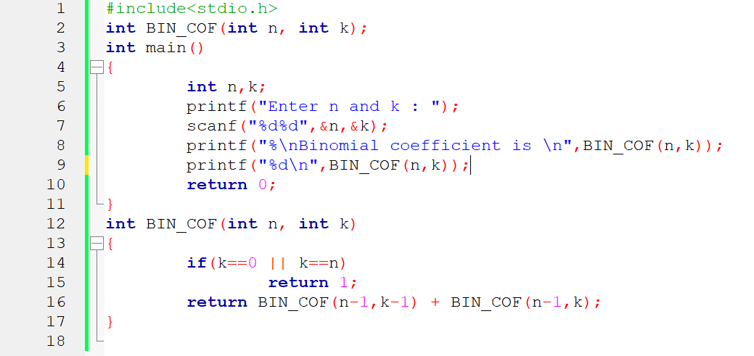

**Output**

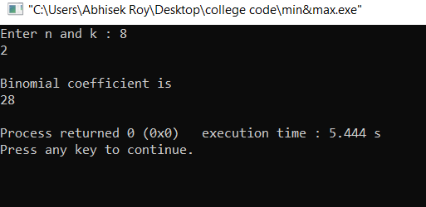

1. **Write a program that reads number and outputs all the possible sums that can be formed by digits of the number.**

**Algorithm:**

int sum_digits(int n)

if (n == 0)

return 0;

return (n%10 + sum_digits(n/10));

**Code:**

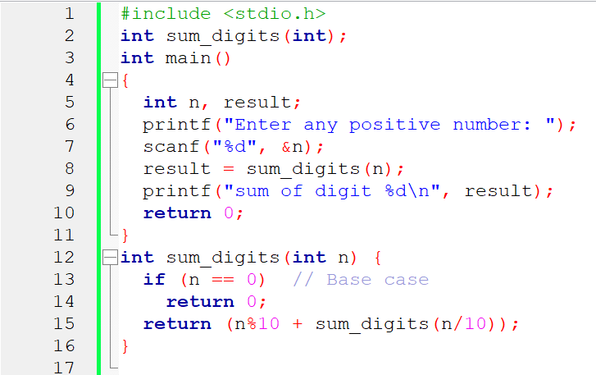

**Output**

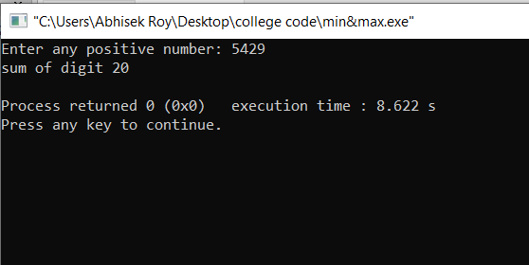

1. **Consider a binary tree and write recursive functions to compute the no. of nodes present in the tree.**

**Algorithm :**

if(root != NULL)

{

countnodes(root->left);

count++;

countnodes(root->right);

}

return count;

**Code:**

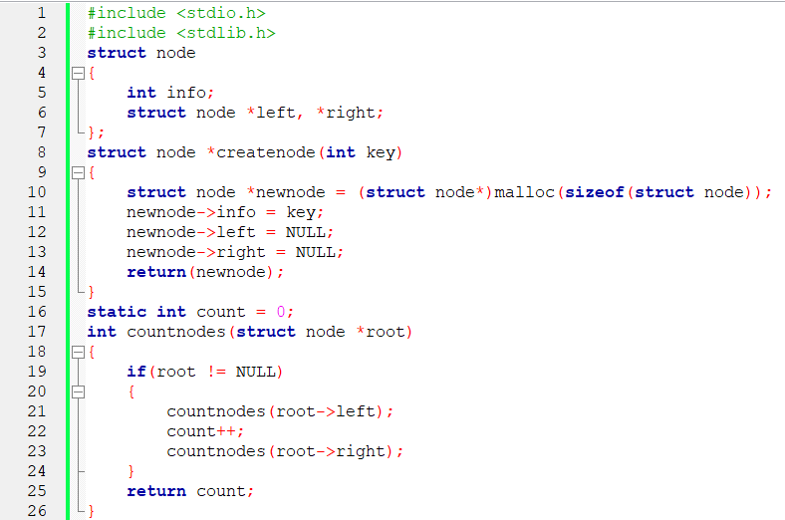

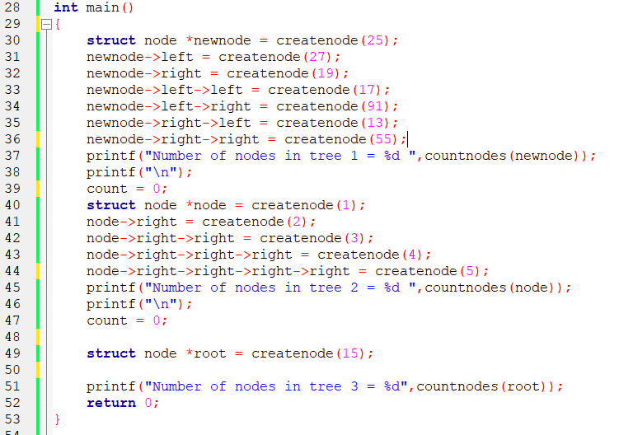

**Output**

