

**Calendar V1.0**

**Name Roll No.**

Abhisek Roy 10000219062

Adarsh Gupta 10000219061

Kushal Mitra 10000219008

Animesh Alok 10000219006

Roni Sikder 10000219077

***by Team AAKAR***



Source Code:

#include<stdio.h>

#include<string.h>

#include<conio.h>

#include<windows.h>

//For changing color of fonts

#define ANSI_COLOR_RED    "\x1b[31m"

#define ANSI_COLOR_RESET   "\x1b[0m"

#define ANSI_COLOR_YELLOW "\x1b[33m"

//For finding first day of the month.

int startingday(int year,int month){

    static int t[] = { 0, 3, 2, 5, 0, 3, 5, 1, 4, 6, 2, 4 };

    year -= month < 3;

    return ( year + year/4 - year/100 + year/400 + t[month-1] + 1) % 7;

}

//Will return total number of days in a month

int mounth(int month){

    switch(month){

        case 1:

            return(31);

        case 2:

            return(28);

        case 3:

            return(31);

        case 4:

            return(30);

        case 5:

            return(31);

        case 6:

            return(30);

        case 7:

            return(31);

        case 8:

            return(31);

        case 9:

            return(30);

        case 10:

            return(31);

        case 11:

            return(30);

        case 12:

            return(31);

    }

}

//For adding event/to do in the calendar

void addevent(int val1,int val2){

    int i,val3;

    char f1[6];

    char arr[20];

    FILE *fp;

    system("cls");

    printf("Enter the date in which event is to be added: ");

    scanf("%d",&val3);

    i=val3;

    sprintf(f1,"%d.txt",val1);

    printf("Enter the event name : ");

    fgets(arr, sizeof(arr), stdin);

    fgets(arr, sizeof(arr), stdin);

    fp=fopen(("%s",f1),"a+");

    fprintf(fp,"%d/%d/%d   ",i,val2,val1);

    for(i=0;i<strlen(arr);i++){

        fputc(arr[i],fp);

    }

    fclose(fp);

    printf("Event is Successfully Saved\n");

}

//To delete a saved event in a date

void delete_event(){

    int i,val1,val2,val3;

    char c;

    char f1[10],f2[40],temp[20],arr[20];

    FILE *fp,*fptr;

    printf("Enter the year : ");

    scanf("%d",&val1);

    printf("Enter the month number : ");

    scanf("%d",&val2);

    printf("Enter the date : ");

    scanf("%d",&val3);

    i=val3;

    printf("Enter The Event Name : ");

    fgets(arr,19,stdin);

    fgets(arr,19,stdin);

    sprintf(f1,"%d.txt",val1);

    fp=fopen(("%s",f1),"r");

    fptr=fopen("temp.txt","w");

    sprintf(f2,"%d/%d/%d",i,val2,val1);

    while(fgets(temp,19,fp)!=NULL){

        if(strcmp(temp,strcat(f2,arr))!=0)

        {

            fputs(temp,fptr);

        }

    }

    fclose(fp);

    fclose(fptr);

    remove(f1);

    rename("temp.txt",f1);

}

void view_event(){

    //To see the saved events

    int val5;

    char ch;

    char f10[10];

    FILE *fps;

    printf("Enter the year to see the events of that year : ");

    scanf("%d",&val5);

    sprintf(f10,"%d.txt",val5);

    fps=fopen(("%s",f10),"r");

    if(fps==NULL){

        printf("No event has been added in this year!!!\n");

        printf("Press any key to continue..");

        return;

    }

    //printf("*\n");

    rewind(fps);

    while(1){

        ch=fgetc(fps);

        if(ch==EOF){

            break;

        }

        printf("%c",ch);

    }

}

void c_month(char *month_name[], int month, int day1, int year){

    //Main UI

    int loop1=0, choice, temp, date;

    char ch;

    SYSTEMTIME stime;

    GetSystemTime(&stime);

    temp=startingday(year,month);

    date=mounth(month);

    printf("--------------------------------------------------------\n");

    printf("|                CALENDAR by Team AAKAR                |\n");

    printf("--------------------------------------------------------\n");

    printf("\nCurrent year :  %d\n\n",stime.wYear);

    printf("Today is : %s",month_name[stime.wMonth-1]);

    printf(" %d %d\n\n",day1,stime.wYear);

    printf("---------------------------------------------------\n");

    printf("                    %s %d\n",month_name[month-1],year);

    printf("---------------------------------------------------\n");

    printf("Sun\tMon\tTue\tWed\tThur\tFri\tSat \n\n");

for(int i=0;i<temp;i++){

        printf("\t");

        loop1++;

    }

 int sun = (8-temp+7)%7;

    for(int loop=1;loop<=date;loop++)

    {

        if((loop-sun+7)%7 == 0){

            printf(ANSI_COLOR_RED "%d\t" ANSI_COLOR_RESET,loop);

        }

        else printf("%d\t",loop);

        if(++loop1>6)

        {

            printf("\n\n");

            loop1=0;

        }

        temp=(temp+date)%7;

    }

    while(1){

    printf("\n\n1. Change month\n");

    printf("2. Change year \n");

    printf("3. Add Event in %s %d\n", month_name[month-1],year);

    printf("4. Delete Event\n");

    printf("5. View Event \n");

    printf("6. Who We Are?\n");

    printf("7. Quit\n\n");

    printf("Enter your choice : ");

    scanf("%d",&choice);

        switch(choice){

            case 1: {

                    printf("Enter P for previous month or Enter N for next: ");

                    ch=getch();

                    if(ch=='p' || ch=='P'){

                        system("cls");

                        c_month(month_name,month-1,day1,year);

                    }

                    else if(ch=='n' || ch=='N'){

                        system("cls");

                        c_month(month_name,month+1,day1,year);

                    }

                    break;

            }

            case 2: {

                    printf("Enter P for previous year or Enter N for next: ");

                    ch=getch();

                    if(ch=='p' || ch=='P'){

                        system("cls");

                        c_month(month_name,month,day1,year-1);

                    }

                    else if(ch=='n' || ch=='N'){

                        system("cls");

                        c_month(month_name,month,day1,year+1);

                    }

                    break;

            }

            case 3: {

                    addevent(year,month);

                    printf("Press any key to continue...");

                    getch();

                    system("cls");

                    c_month(month_name,month,day1,year);

                    break;

            }

            case 4: {

                    delete_event();

                    c_month(month_name,month,day1,year);

                    break;

            }

            case 5: {

                    system("cls");

                    view_event();

                    printf("Press any key to continue...");

                    getch();

                    system("cls");

                    c_month(month_name,month,day1,year);

                    break;

            }

            case 6: {

                    printf("We are Team " ANSI_COLOR_YELLOW "AAKAR" ANSI_COLOR_RESET " from B.tech[IT] 2nd year of MAKAUT, WB.\n\n");

                    printf(ANSI_COLOR_YELLOW "\t\tA" ANSI_COLOR_RESET "bhisek Roy Roll No: 10000219062\n");

                    printf(ANSI_COLOR_YELLOW "\t\tA" ANSI_COLOR_RESET "darsh Gupta Roll No: 10000219061\n");

                    printf(ANSI_COLOR_YELLOW "\t\tK" ANSI_COLOR_RESET "ushal Mitra Roll No: 10000219008\n");

                    printf(ANSI_COLOR_YELLOW "\t\tA" ANSI_COLOR_RESET "nimesh Alok Roll No: 10000219006\n");

                    printf(ANSI_COLOR_YELLOW "\t\tR" ANSI_COLOR_RESET "oni Sikdar  Roll No: 10000219077\n");

                    printf("\nPress any key to continue...");

                    getch();

                    // system("cls");

                    // c_month(month_name,month,day1,year);

                    break;

            }

            case 7: {

                    system("cls");

                    exit(1);

            }

            default: {

                    printf("Wrong Choice!!!");

                    exit(0);

            }

        }

    }

}

int main(){

    //To set the title of console

    SetConsoleTitleA("Calendar by Team AAKAR");

    char *month_name[]={"January","February","March","April","May","June","July","August","September","October","November","December"};

    int day1,month,year;

    SYSTEMTIME stime;

    GetSystemTime(&stime);

    day1=stime.wDay;

    year=stime.wYear;

    month=stime.wMonth;

    system("cls");

    c_month(month_name,month,day1,year);

    return 0;

}

***Output:***

Starting Screen.

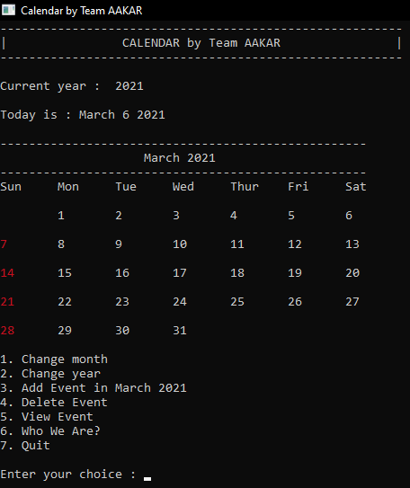

This will be the first screen that will appear after executing the above code.

Here we will enter the value given in menu to perform that particular action like for changing the month, we’ll be pressing 1.

1. Changing month

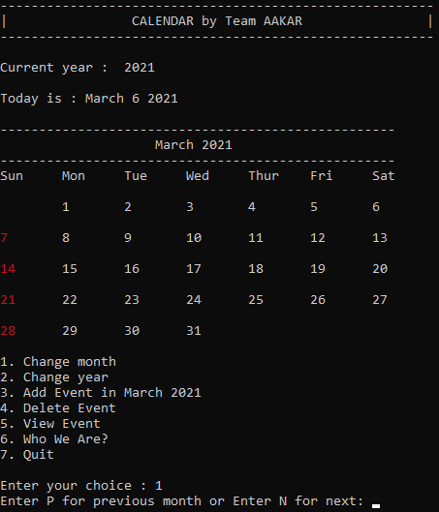

After pressing 1, program will prompt for another user input. If we want to switch to previous month, we’ll be pressing P or for switching to next month, it’ll be N.

The moment we’ll press P/N month will get changed accordingly.

Below pic shows the output, when we pressed P.

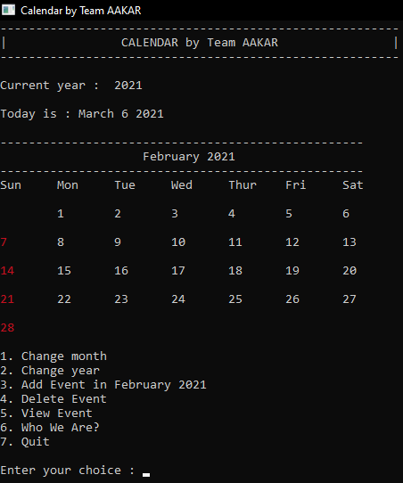

1. Changing Year.

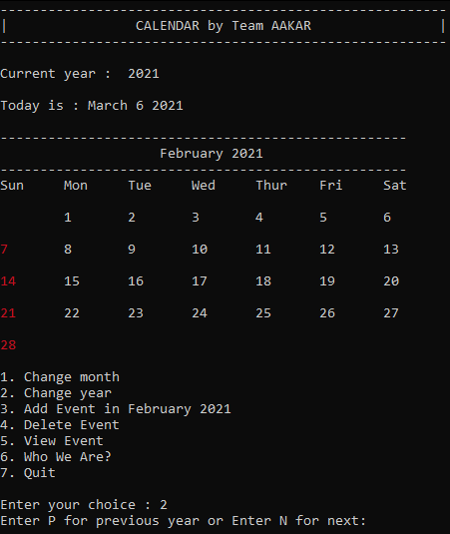

After pressing 2, program will prompt for another user input. If we want to switch to previous year, we’ll be pressing P or for switching to next year, it’ll be N.

The moment we’ll press P/N, year will get changed accordingly.

Below pic shows the output, when we pressed N.

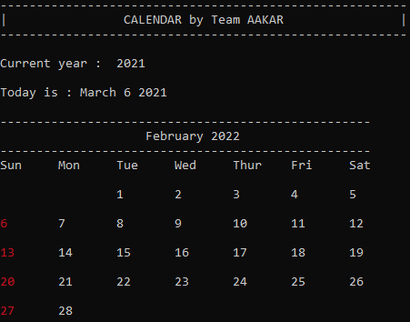

1. Adding an Event.

To add an event first we’ll go to that month, then we’ll be pressing 3 to add event.

After pressing 3, a window like this will appear, where we’ll just put the date in dd format, in which event is to be added.

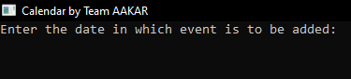

After putting the date, program will prompt for enterring event name, here we’ll be adding the name and details regarding the event.

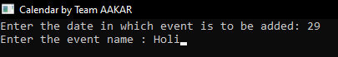

After enterring the event details, program will show a message saying Event is Successfully Saved. After pressing any key from keyboard it’ll take us to the home page of our program.

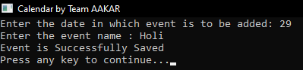

1. View Event

Using this we can see all our saved events in that particular year at once.

After pressing 4, it’ll ask us to enter the year for which we wish to see the events.

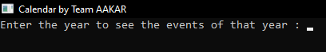

After enterring the year, if there’ll be any event saved for that year it’ll show them all at once like this:

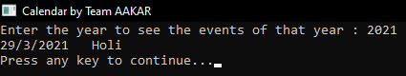

In case, there will not be any events saved for that year then it’ll show a message like this:

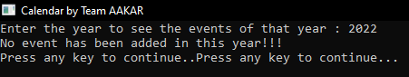

1. Delete Event.

To delete a saved event, first we’ll press 5 to enter the delete function mode.

After pressing 5, it’ll prompt for year.

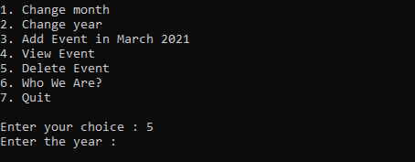

We’ll enter the year for which the event is to be deleted.



Then it’ll prompt for month, date and event name, we’ll be enterring the details in respective prompts and ultimately that event will get deleted.

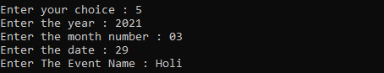

1. Who We Are?

Menu number 6 will show our details in this way:

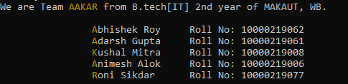

1. Quit.

Menu no. 7 will simply end the program.