- GIT Hub Directory Structure:
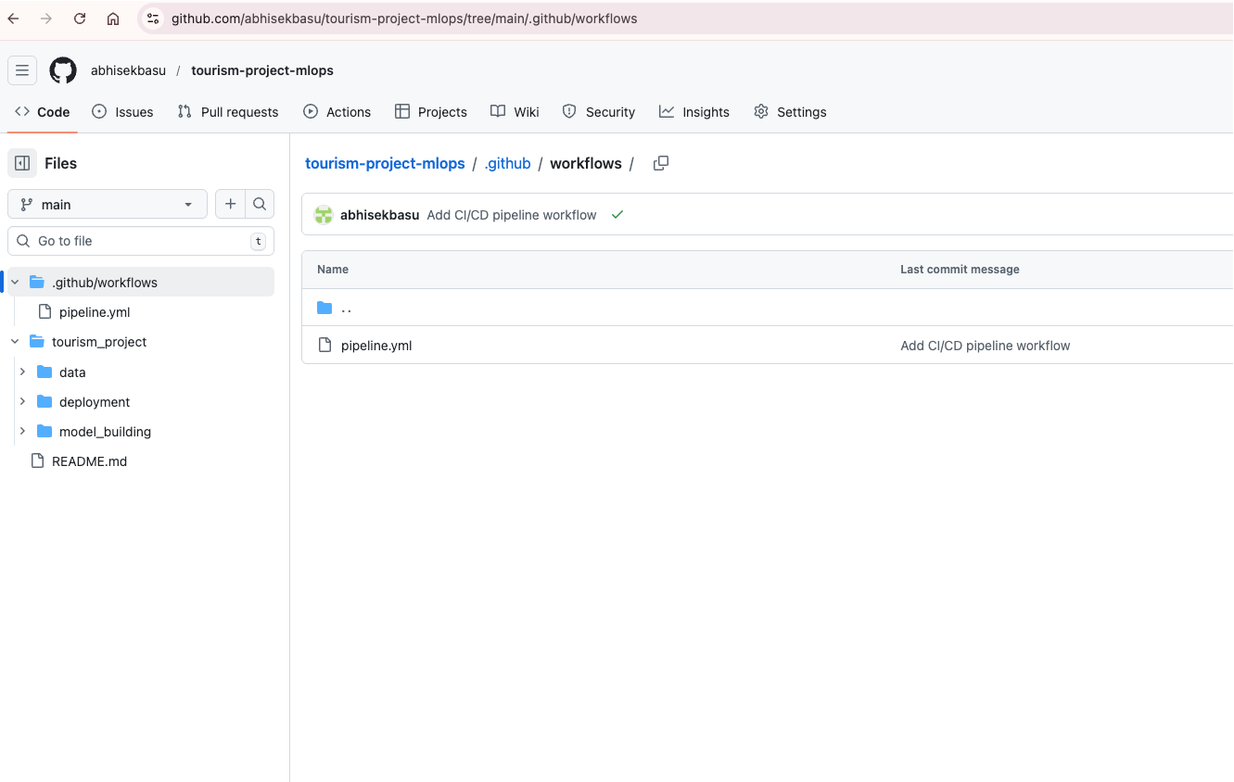
- Workflow completed Successfully:
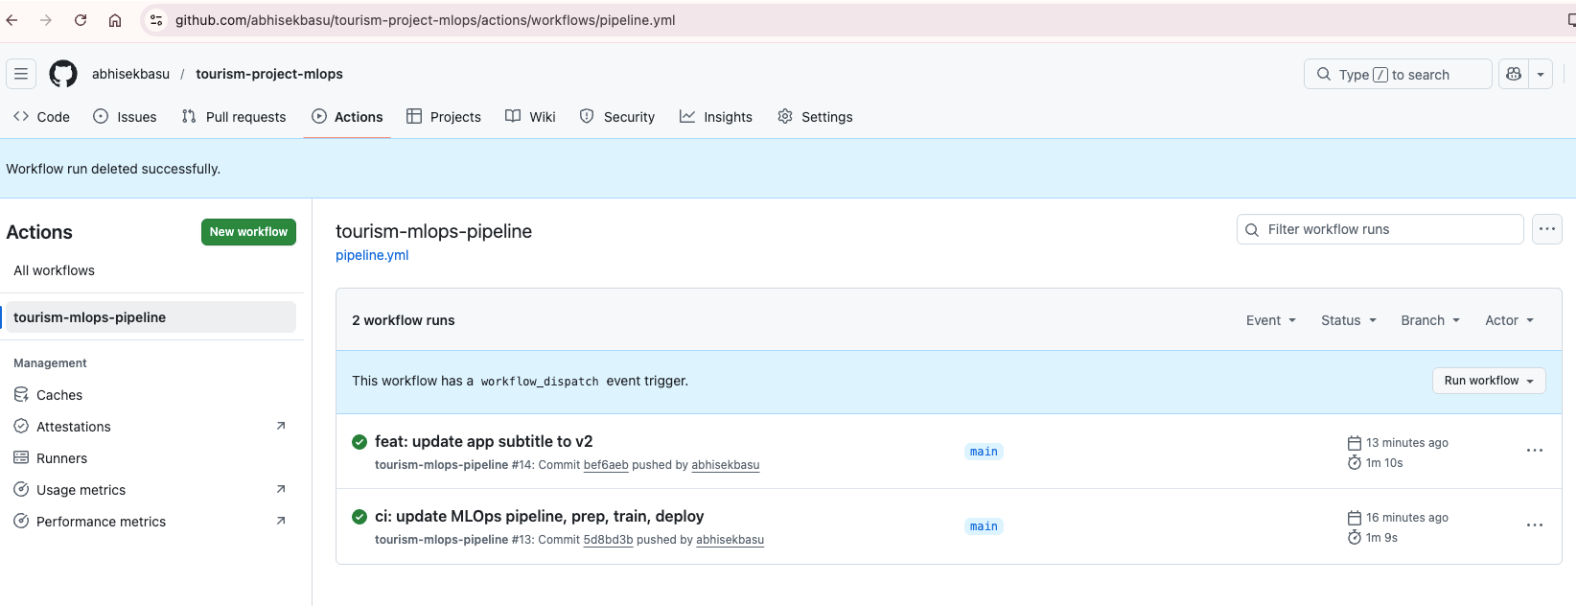

- Code Change Triggered Workflow and Successful:
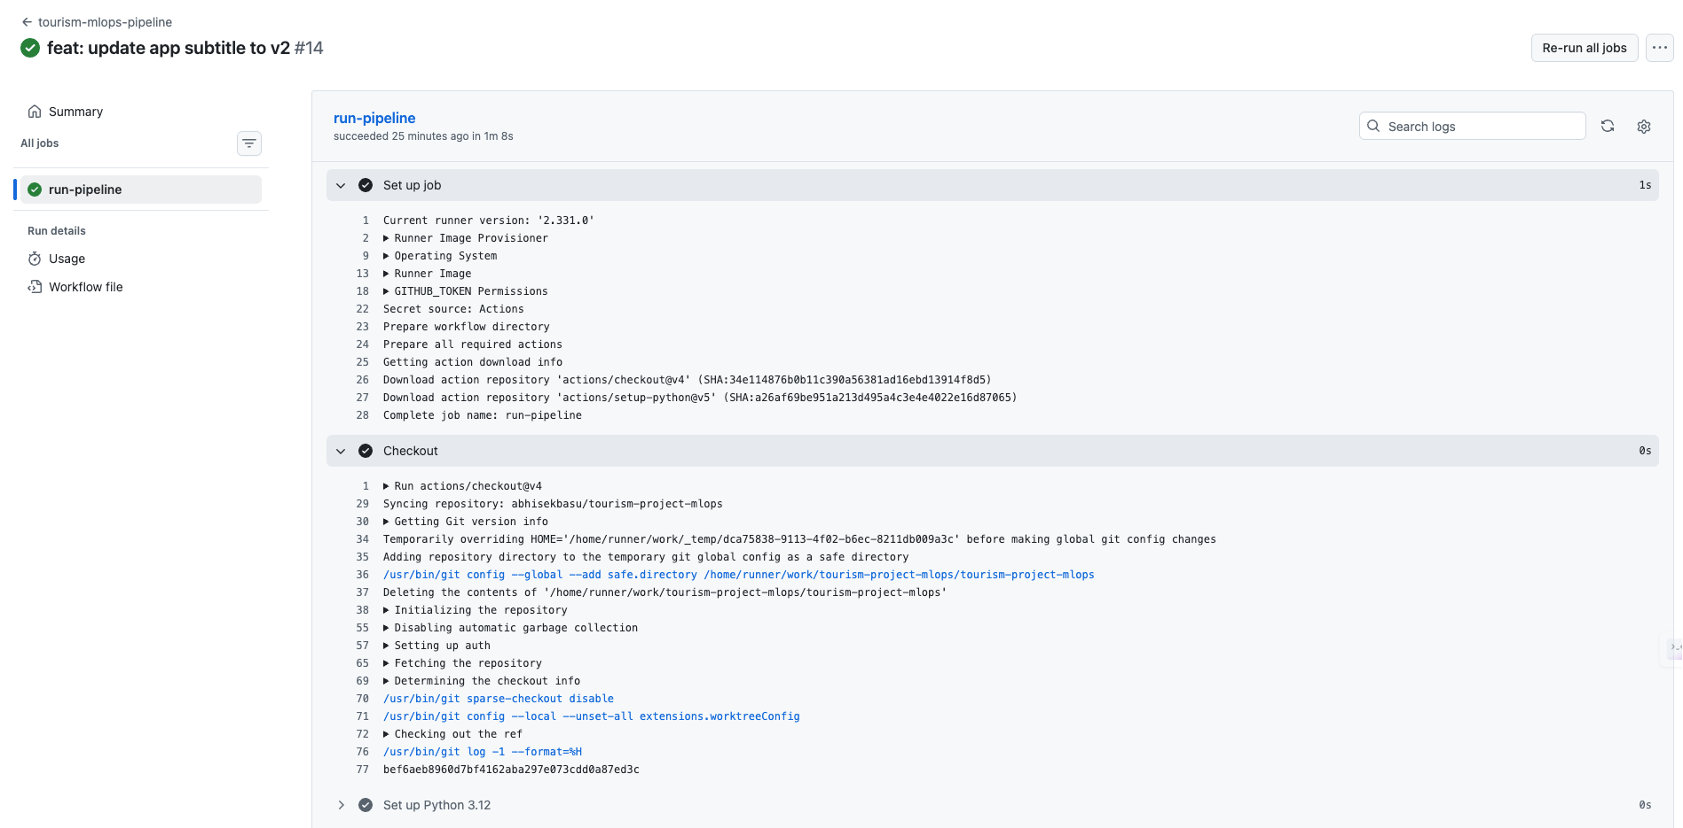

- Hugging Face Dataset repo showing raw/tourism.csv, processed/train.csv, processed/test.csv
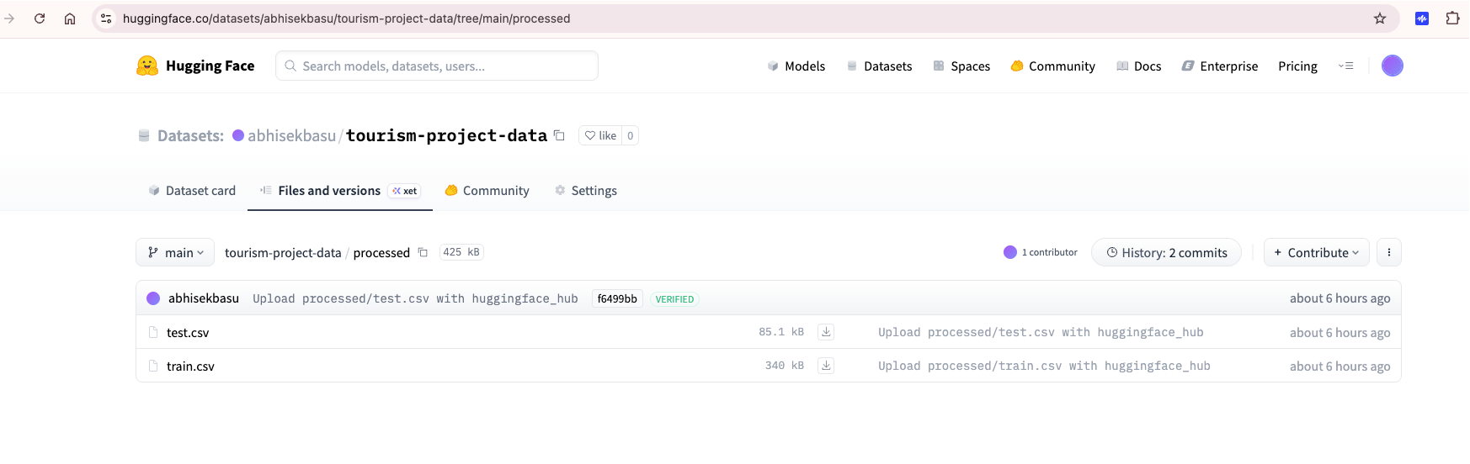
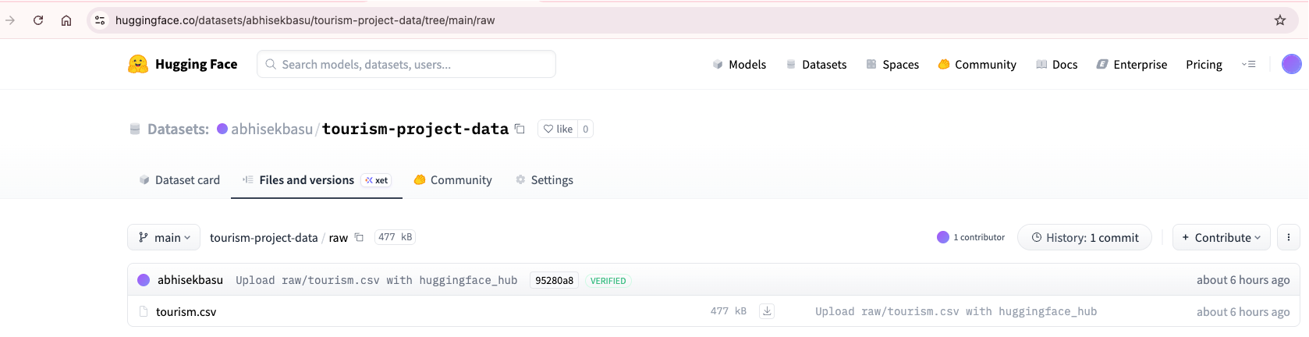
- Hugging Face Model Hub showing best_tourism_model_v1.joblib and model_summary.json
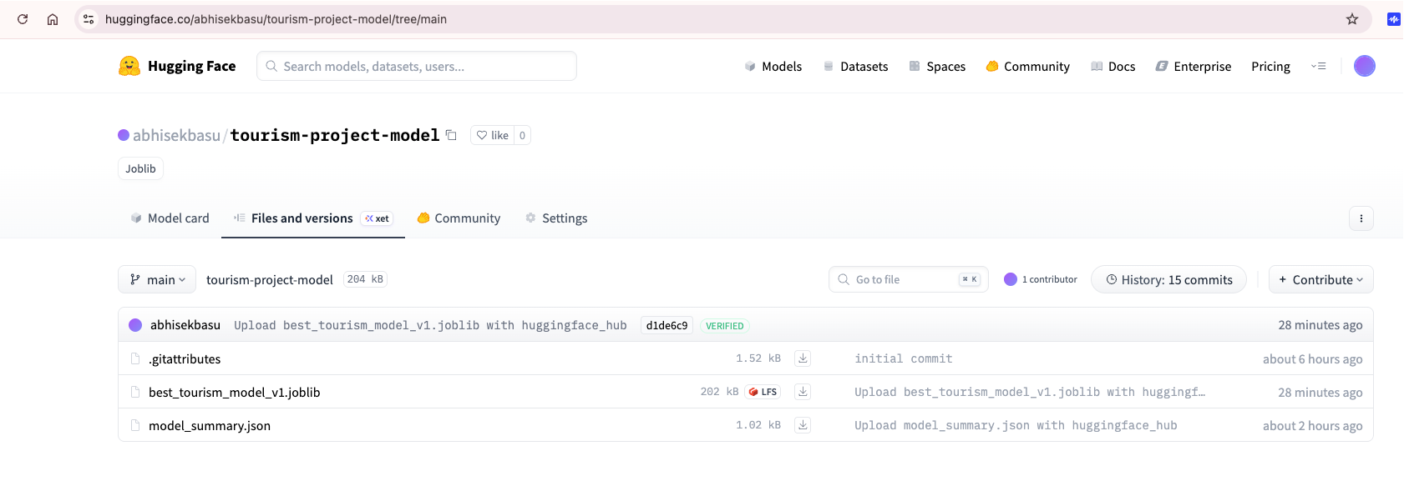
- Hugging Face Space showing the running Streamlit app with a sample prediction:
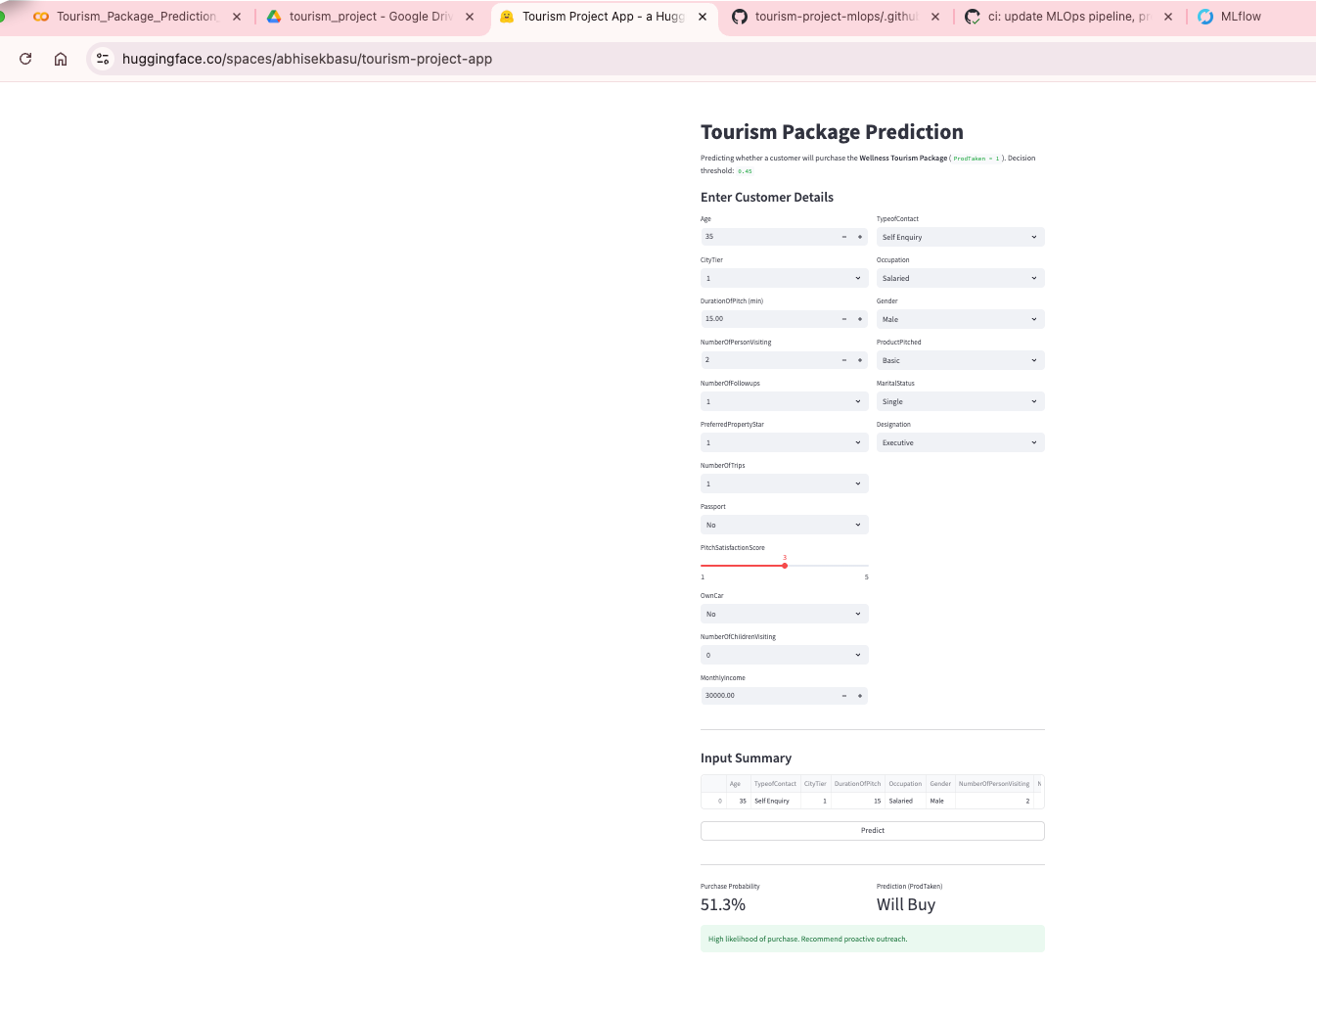

  - Updated Running App
