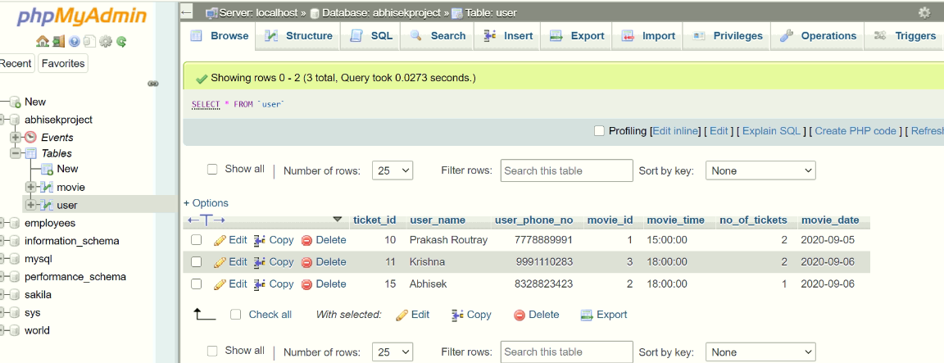

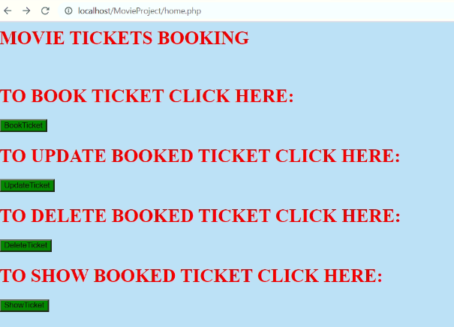

**Point-1:**

An endpoint to book a ticket using a user’s name, phone number, and timings. Screenshot attached below

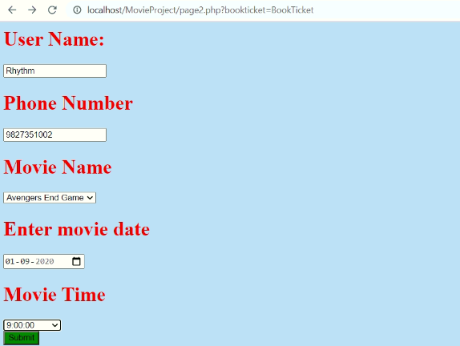

**Point-2:**

An endpoint to view all the tickets for a particular time.

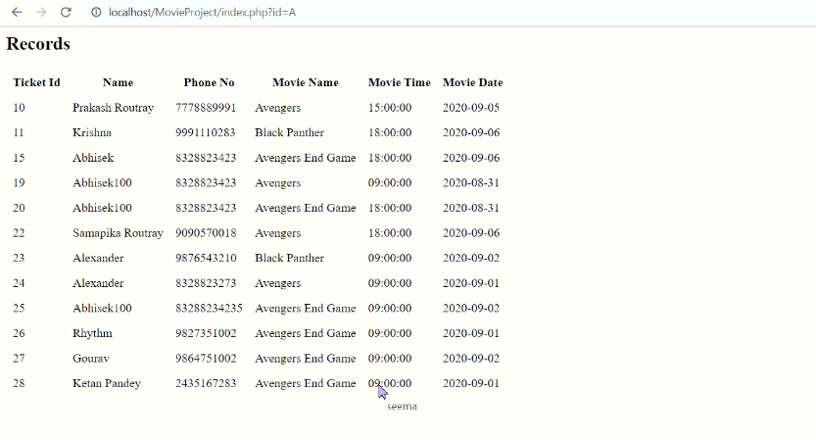

**Point-3:**

An endpoint to update a ticket timing.

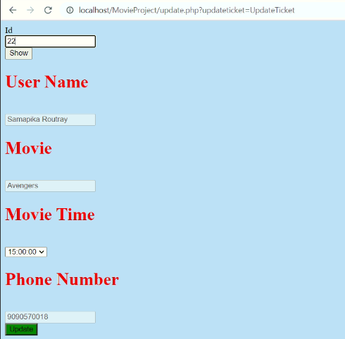

**Point-4:**

If the ticket is Expired.

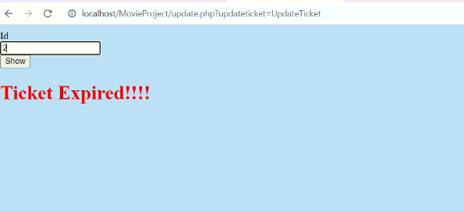

**Point-5:**

An endpoint to delete a particular ticket.

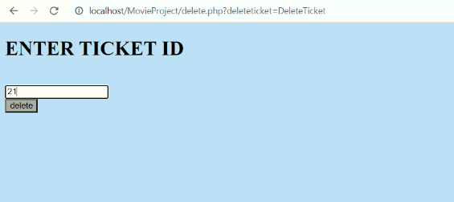

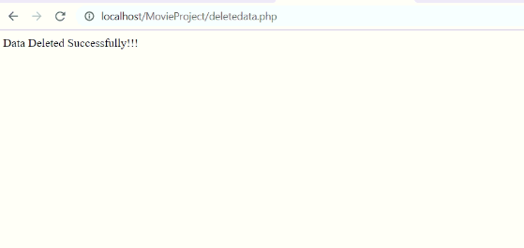

**Point-6:**

An endpoint to view the user’s details based on the ticket id.

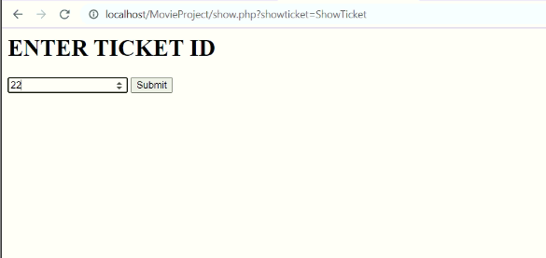

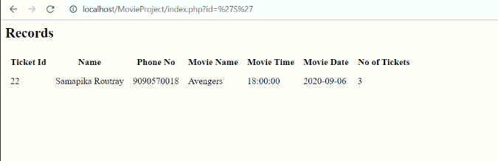

**Point-7:**

For a particular timing, a maximum of 20 tickets can be booked.

If number of tickets exceed 20 tickets it show message “HOUSE FULL”

