**Organization Blindspot:**

**Assessing Implicit Race and Gender Biases in the US Coast Guard**

*Hanyu Dai,* [Abhi Sharma](mailto:abhisha@berkeley.edu)*, and* [Brendan Mattina](mailto:bcmatt20@berkeley.edu)

*W241, Section 5, Thursdays - 630p*

**Research Question:**

##### The US Coast Guard has experienced an organizational reckoning over the last ten years. Spurred in part by a parallel societal reckoning and several high profile and embarrassing incidents at the US Coast Guard Academy (USCGA), the US Coast Guard (USCG) has confronted the reality that as a service, it’s simply not diverse, nor inclusive enough. Several high-profile studies recommended strategies to cultivate a more inclusive workforce, which the USCG implemented or is in the process of implementing. But have those strategies impacted the mindsets of the rank-and-file USCG Officer Corps? We propose an experimental study to answer the following question: Do implicit race and gender biases impact how Coast Guard officers regard fellow officers?

**Introduction:**

Each branch of the US military is composed of enlisted personnel and commissioned officers. Commissioned officers comprise approximately 25% of the total force and are charged, by oath, to faithfully lead and serve their subordinates, who are primarily enlisted personnel. Half of USCG officers that enter the service do so by graduating from the US Coast Guard Academy. Unfortunately, from 2008 to 2019, the US Coast Guard Academy suffered a series of embarrassing and high profile racially motivated incidents that stimulated overdue conversations throughout the Officer Corps [OIG-20-36]. Were officers doing enough to effectively lead an ever more diverse workforce?

Two high profile reports, one by the US Department of Homeland Security (DHS) Inspector General (IG) and another by RAND suggested that they were not. The DHS IG report detailed recent and persistent examples of failed leadership in dealing with recent racially motivated hate incidents and subsequent whistle-blower retaliation [OIG-20-36]. Furthermore, the RAND study illuminated how poor leadership was among the primary factors, if not the primary factor, in higher attrition rates among females, when compared with males [Hall].

###### The RAND study also highlighted organizational frustrations with the opaque officer assignment and promotion processes. Officers are selected for future positions by either one assignment officer, or a small panel of officers who have served in similar positions before. Furthermore, officers are promoted by a small panel of higher ranked officers that evaluate member service records before deciding who to promote. Both processes (assignments and promotions) are conducted secretly, without ex-post-facto explanations detailing how assignment officers or panels came to their decisions.

One can easily associate this lack of transparency with documented poor leadership and fairly conclude that the service is at the very least unconsciously biased against women and minorities. Regardless of whether that is a valid induction, the unfortunate reality is that white males comprise a disproportionate amount of the Officer Corps, especially at the highest ranks of Captain and Admiral, and hold a disproportionate number of the most coveted assignments.

**Experiment Design:**

To assess gender and race based implicit bias amongst the CG Officer Corps, we developed an experiment that emulated part of the USCG special assignment process. USCG officers can compete for two different types of assignments, general, and special. Competition for a general assignment is dictated by regimented processes and controlled by individual assignment officers. The USCG is currently opposed to any experiment involving the general assignment process, although this would be an excellent opportunity for future work.

Special assignment processes vary by position. In some cases, a small panel of officers currently holding one of the advertised positions will solicit a pool of qualified candidates, pre-selected by an assignment officer, for a civilian style resume and a writing sample. Importantly, resumes and writing samples include candidate names. The officer panel collectively reviews the writing samples and resumes, before selecting some candidates from the pool for phone interviews. The panel then selects from among interviewed candidates to fill the available positions. This is the process that we emulate in our experiment.

Conceivably, any officer could find themselves on a special assignment panel, so we intend to build our sample by randomly selecting from the entire USCG Active Duty officer population. We will conduct our experiment via online survey. To build our sample, we will randomly select 2500 officers from across the service and email them our survey. We are particularly concerned about survey participation and anticipate a 5-10% response rate, meaning anywhere from 125 to 250 responses. Our experiment will be double blinded; therefore, we will rely on the online survey platform, likely Survey Monkey, to assign respondents randomly to treatment and control groups. The experimenters themselves would not be aware of which participants are in treatment or control, as would be the case with the survey participants.

Before conducting the experiment in the USCG, we conducted a pilot experiment in Berkeley Xlab. In this pilot experiment, to assess bias, we asked participants to read a description for a position on the fictitious “Strategic Vision Task Force”, and consider a table describing preferred and minimum position requisites. Participants then considered two resumes and used a slider bar to indicate which resume they prefered and the intensity of their preference (7 step Likert scale). Participants repeated this step 5 more times, comparing a total of six unique resume pairs (Table 1). Participants in treatment and control compared the same resume pairs. Participants in control did not see candidate names. Participants in treatment saw candidate names that suggested different race/gender combinations (Black Female (BF), Black Male (BM), White Female (WF), White Male (WM)).

|  |  |  |
| --- | --- | --- |
|  | Control (Redacted Names) | Treatment (Full Names) |
| Resume Pair 1 | WM Resume / BM Resume | WM Resume / BM Resume |
| Resume Pair 2 | WM Resume / WF Resume | WM Resume / WF Resume |
| Resume Pair 3 | WM Resume / BF Resume | BM Resume / BF Resume |
| Resume Pair 4 | BM Resume / WF Resume | BM Resume / WF Resume |
| Resume Pair 5 | BM Resume / BF Resume | BM Resume / BF Resume |
| Resume Pair 6 | WF Resume / BF Resume | WF Resume / BF Resume |

*Table 1: Experimental Design*

We provided a 7-step Likert scale (visualized as a slider bar) for participants to use to express their preference because it was intuitive to understand and explain. A value of 1 on our Likert scale meant that a participant strongly preferred the candidate resume on the left of their screen. A value of 7 on our Likert scale meant a participant strongly preferred the candidate resume on the right of their screen. A value of 4 on our Likert scale meant a participant had no preference.

We also considered forcing participants to demonstrate their resume preference on a binary scale (winning resume = 1, losing resume = 0). However, the binary scale lacked two key elements. First, the binary scale removed any possibility of a ‘tie’ between resumes. Second, the binary scale sacrificed any chance at understanding how much participants preferred one resume over another.

Our outcome metric is the average difference in a preference score for a resume pair in treatment and control, which ostensibly demonstrated how candidate names changed participant preference for one candidate resume over another. For example, per Table 1, say participants in control scored Resume Pair 1 as a 4, indicating no preference, whereas participants in treatment scored Resume Pair 1 as a 6, suggesting preference for the BM candidate resume. The average treatment effect (ATE) of 2 (Treatment - Control, 6 - 4) suggests that our sample has moderate implicit bias favoring black males over white males. In another example, again referring to Table 1, say Resume Pair 2 scored 4 and 1 respectively, yielding an ATE of -3. An ATE of -3 for Resume Pair 2 would suggest our sample has strong implicit bias favoring white males over white females.

Importantly, while manipulating names forces us to change two levels of treatment simultaneously, (suggested race and gender), our design still allows us to isolate differences driven by individual race or gender. Per Table 1, ATE for Resume Pair 1 affords us the effect of race on preference for male candidates. Similarly, ATE for Resume Pair 6 affords us the effect of race on preference for the female candidates. If we average the ATE from Resume Pairs 1 and 6 collectively then we can obtain the effect of race on preference.

**Survey Design:**

We will begin our USCG survey by asking a limited set of demographic questions. We designed the set to maximize participant privacy. We do not ask USCG participants for their name or age (whereas we did ask Pilot Study participants for their ages). We ask participants for race and rank as literature suggests both (with rank as proxy for age) are correlated with bias intensity [Banaji]. To further protect USCG officer privacy, particularly for officers of color who’ve achieved higher rank, we ask participants to identify a rank range, leading to aggregated data. These covariates will help us block as appropriate and will also help execute covariate balance checks.

We asked participants “How much [they] like [their] coworkers?” as a pre-treatment placebo question. This question served two purposes. First, a pre-treatment measure with which to assess randomization. Second, to assess any inadvertent treatment effect.

To reduce the length of the survey, we presented condensed resumes that participants could digest quickly. To improve authenticity and further distract participants from our experimental intent, we explained to participants that the USCG was experimenting with restricted, or shortened, resumes to expand candidate pools for special assignments. Furthermore we explained that the USCG wanted to examine how different restricted resume (RR) formats would influence resume reviewers. We hoped our instructions created the requisite space for participants’ implicit bias to fully influence their decision making.

Creating names suggesting different genders and races was potentially problematic. To mitigate the impact of our biases, we leveraged US Commerce and Census Departments data to create candidate names. For first names we used a US Commerce data set which compiled mortgage applicants’ first name and race from all applications in 2010 [Tzioumis]. Each row of this dataset included the actual name, as well as observation count, and then the frequency with which each first name was associated with a particular race (Table 2 and 3; ‘pctwhite’, ‘pctblack’, etc.). Per the first row of Table 2, the first name ‘Willie’ was observed 901 times in the dataset, and in ~76% of those observations, the applicant was a black person. We extracted the top 25% of names by observation count, and then calculated percent differential between white and black percentage and the sum of all other percentages. Per the first row of Table 2, the column ‘black_diff’ suggests that the frequency margin for black people and people of all other races named ‘Willie’ was 52%. We used ‘black_diff’ and ‘white_diff’ to assess how exclusively white and black each first name in the dataset was. To determine experimental first names, we sorted the dataset by ‘black_diff’ and ‘white_diff’ (Tables 2 and 3 respectively), discarded the first names with the highest ‘diff’ scores (Salvatore and Willie) then selected the next highest male/female names by ‘diff’ score.

|  |  |  |  |  |  |  |  |  |  |
| --- | --- | --- | --- | --- | --- | --- | --- | --- | --- |
| **firstname** | **obs** | **pcthispanic** | **pctwhite** | **pctblack** | **pctapi** | **pctaian** | **pct2prace** | **white_diff** | **black_diff** |
| WILLIE | 901 | 2.22 | 18.868 | 75.916 | 2.553 | 0.111 | 0.333 | -62.154 | 51.942 |
| REGINALD | 487 | 1.848 | 31.417 | 63.655 | 2.669 | 0 | 0.411 | -37.166 | 27.31 |
| TYRONE | 262 | 3.817 | 32.061 | 59.542 | 4.198 | 0 | 0.382 | -35.878 | 19.084 |
| GWENDOLYN | 622 | 1.125 | 54.18 | 43.087 | 1.125 | 0 | 0.482 | 8.361 | -13.825 |
| KELVIN | 232 | 5.172 | 28.448 | 40.517 | 25.431 | 0.431 | 0 | -42.672 | -18.534 |
| JOHNNIE | 304 | 3.289 | 59.211 | 36.184 | 0.329 | 0.658 | 0.329 | 19.08 | -26.974 |
| FREDDIE | 214 | 12.617 | 44.393 | 36.449 | 5.607 | 0 | 0.935 | -11.215 | -27.103 |
| DERRICK | 598 | 3.01 | 55.351 | 35.117 | 5.686 | 0.502 | 0.334 | 11.204 | -29.264 |
| ANDRE | 599 | 5.509 | 56.928 | 33.723 | 3.339 | 0.167 | 0.334 | 14.023 | -32.387 |
| FELICIA | 448 | 7.589 | 56.027 | 33.259 | 2.455 | 0.446 | 0.223 | 12.501 | -33.035 |

*Table 2: Top 10 Black First Names*

|  |  |  |  |  |  |  |  |  |  |
| --- | --- | --- | --- | --- | --- | --- | --- | --- | --- |
| **firstname** | **obs** | **pcthispanic** | **pctwhite** | **pctblack** | **pctapi** | **pctaian** | **pct2prace** | **white_diff** | **black_diff** |
| SALVATORE | 665 | 0.752 | 98.947 | 0 | 0.15 | 0 | 0.15 | 97.895 | -99.999 |
| BRADLEY | 3619 | 0.221 | 98.867 | 0.193 | 0.525 | 0.138 | 0.055 | 97.873 | -99.475 |
| KIRSTEN | 511 | 0.587 | 98.63 | 0.196 | 0.391 | 0.196 | 0 | 97.456 | -99.412 |
| SVETLANA | 210 | 0 | 98.571 | 0 | 1.429 | 0 | 0 | 97.142 | -100 |
| BETH | 2511 | 0.518 | 98.566 | 0.358 | 0.438 | 0 | 0.119 | 97.133 | -99.283 |
| SERGEY | 208 | 0 | 98.558 | 0 | 1.442 | 0 | 0 | 97.116 | -100 |
| LAURI | 207 | 0.966 | 98.551 | 0.483 | 0 | 0 | 0 | 97.102 | -99.034 |
| BRET | 417 | 0.24 | 98.321 | 1.199 | 0 | 0.24 | 0 | 96.882 | -97.362 |
| BRETT | 1951 | 0.359 | 98.36 | 0.871 | 0.256 | 0.103 | 0.051 | 96.823 | -98.155 |
| MEGHAN | 565 | 1.239 | 98.407 | 0 | 0.354 | 0 | 0 | 96.814 | -100 |

*Table 3: Top 10 White First Names*

|  |  |  |  |  |
| --- | --- | --- | --- | --- |
| **LAST NAME** | **PCTWHITE** | **PCTBLACK** | **COUNT** | **RANK** |
| WASHINGTON | 5.16 | 89.87 | 163036 | 138 |
| JACKSON | 41.93 | 53.02 | 666125 | 18 |
| WILLIAMS | 48.52 | 46.72 | 1534042 | 3 |
| ROBINSON | 51.34 | 44.1 | 503028 | 27 |
| COLEMAN | 52.04 | 43.83 | 208624 | 102 |
| HARRIS | 53.88 | 41.63 | 593542 | 24 |
| DIXON | 57.05 | 38.21 | 152015 | 156 |
| THOMAS | 55.53 | 38.17 | 710696 | 14 |
| JAMES | 54.45 | 38.09 | 233224 | 80 |
| DANIELS | 57.17 | 37.83 | 138776 | 180 |

*Table 4: Top Ten Black Last Names*

|  |  |  |  |  |
| --- | --- | --- | --- | --- |
| **LAST NAME** | **PCTWHITE** | **PCTBLACK** | **COUNT** | **RANK** |
| SCHMIDT | 96.48 | 0.28 | 145565 | 171 |
| MEYER | 96.07 | 0.45 | 149664 | 163 |
| OLSON | 96.03 | 0.36 | 163502 | 136 |
| HANSEN | 95.64 | 0.4 | 133474 | 193 |
| HOFFMAN | 95.45 | 1.11 | 132645 | 195 |
| SNYDER | 95.37 | 1.28 | 159363 | 144 |
| WAGNER | 93.97 | 2.5 | 154516 | 152 |
| RYAN | 93.33 | 2.82 | 139335 | 177 |
| WOOD | 90.06 | 5.61 | 247299 | 75 |
| FOX | 89.82 | 5.68 | 147357 | 167 |

*Table 5: Top Ten White Last Names*

We used US Census data from the year 2000 to select racially suggestive last names. Each row of the Census dataset that we extracted (Tables 4 and 5) included a surname, dataset observation count for said surname, rank of the surname in the dataset based on observation count, then finally the frequency with which the surname was associated with a black person or a white person (‘PCTBLACK’ and ‘PCTWHITE’ respectively). We sorted the dataset by ‘PCTBLACK’ and ‘PCTWHITE’ to generate two subsets (Tables 4 and 5 respectively) before extracting the top two surnames from each subset for our black male and female; and white male and female last names, which we assigned to each randomly.

The resumes that we show to survey participants are intentionally made to be similar to each other so that we can measure the effect of the treatment in isolation. We constructed as many resumes as there were treatments (four), so that we could uniquely assign each resume to a derived name. This strategy ideally further disguised our true intention from the participants.

|  |  |  |
| --- | --- | --- |
| **Area** | **Preferred** | **Minimum** |
| Recent Professional Experience | 2 Operational Tours (OT) with Medals | 1 Operational Tour (OT) with Medal and 1 Staff Tour (ST) with Medal |
| Leadership Experience | Commanding Officer | Executive Officer  -or-  Department Head |
| Highest Level of Education | Master’s of Business Administration -or- Public Policy/Public Administration | Master’s Degree (Any) |
| Professional Development | Leadership Role in an Association | Demonstrated Participation in an Association |

*Table 6: Stated Preferred and Minimum Prerequisites*

|  |  |  |
| --- | --- | --- |
| Area | Preferred | Minimum |
| Recent Professional Experience  (Chose 1 Set) | Set 1 (A):   * Blank 1 on 110 ft warship, received the CG Achievement Medal (OT) * Operations Department Head on 210 ft warship, received the CG Commendation Medal (OT)   Set 2 (B):   * Division Chief - Sector Response, received Coast Guard Achievement Medal (OT) * Blank 2 at Station Medium, received CG Commendation Medal (OT) | Set 1 (A):   * Blank 1 on 110 ft warship, received the CG Achievement Medal (OT) * Department Head, Sector Logistics, received the CG Commendation Medal (ST)   Set 2 (B):   * Maritime Enforcement Policy Advisor at CG Head Quarters, received the CG Achievement Medal (ST) * Blank 2 at Station Medium, received CG Commendation Medal (OT) |
| Leadership Experience | Blank 1/2 : Commanding Officer | Blank 1/2 : Executive Officer |
| Highest Level of Education  (Chose 1) | * (A) Master’s of Business Administration, University of Michigan, Ross School of Business * (B) Master’s of Science in Public Policy and Management, Carnegie Mellon University | * (A) Master’s of Science in Naval Architecture and Marine Engineering, University of Michigan * (B) Master’s of Science in Computer Engineering, Carnegie Mellon University |
| Professional Development  (Choose 1) | * (A) Vice-President, Regional Chapter, CG Officers’ Association * (B) Vice-Chairman, Regional Chapter, National Naval Officers’ Association | * (A) Member at Large, Regional Chapter, CG Officers’ Association * (B) Member at Large, Regional Chapter, National Naval Officers’ Association |

*Table 7: Prerequisite Sets*

To build four resumes, we started by composing sets of perquisites for each resume “area” (Table 6) : Professional Experience, Leadership Experience, Education, and Professional Development. Resume areas correspond roughly to CG Officer Evaluation forms. Different sets of prerequisites actualized preferred and minimum requirements (Table 7). We kept the relative strength of each resume constant by ensuring that each resume contained 2 sets of preferred prerequisites and 2 sets of minimum prerequisites (Table 6, Resume Structure). To build out each resume (Table 8), we randomly assigned preferred and minimum prerequisites to areas in each resume, randomly assigned each resume one of four major Coast Guard hub cities, and assigned each resume to be single or double column format. Finally, we assigned one of four names to each resume, so that each resume suggests a candidate of different race or gender.

|  |  |  |  |  |
| --- | --- | --- | --- | --- |
|  | Resume 1 | Resume 2 | Resume 3 | Resume 4 |
| Race/Gender | White Male | Black Male | White Female | Black Female |
| First Name | Bradley | Reginald | Kirsten | Gwendolyn |
| Last Name | Meyer | Washington | Schmidt | Jackson |
| Address | Alameda, CA | Boston, MA | Boston, MA | New Orleans, LA |
| Resume Format | Single Column | Double Column | Single Column | Double Column |
| Prereq Structure | Min, Prf, Min, Prf | Prf, Prf, Min, Min | Prf, Min, Min, Prf | Min, Prf, Prf, Min |
| Prereq Sets | BAB | BBB | BAB | ABA |

*Table 8: Resume Randomization*

We used all four resumes to create 6 unique pairs. Using Qualtrics, we randomized the order of resume pairs for every participant to mitigate any order bias. Unfortunately, we did not randomize inter-pair order, meaning that certain surveys were always shown on the left of the screen, and others to the right, whenever they were part of the displayed pair. This almost assuredly introduced bias in our Pilot Study and must be corrected for the actual experiment. Final surveys are included as Appendix 1 and 2.

**Pilot Study:**

To prepare for our actual experiment, we conducted a Pilot Study with the University of California Berkeley XLab. Our sample population consisted of approximately 300 Berkeley students who volunteered as subjects to take the survey online. Said volunteers were compensated for their time. All procedures discussed above remained the same. Unfortunately, the Pilot sample only included a very limited number of former service members, so we cannot use this population to predict treatment effects from the actual USCG population. The data itself did not include participants’ choices to all questions due to a flaw in the questionnaire, so that we can not measure the actual treatment effects. Instead, we randomly assigned preference for all participants, and used the data to demonstrate how we will use the real data that will be collected from USCG in the future.

**Pre-Processing Exploratory Data Analysis (EDA):**

In total, 314 people participated in the survey. First of all, we checked for non-compliance and attrition. In our data, we noticed only a single attritor, who is defined as a person who answers a partial set of questions out of the total set that are shown (for example, if the participant answered 3 out of 6 questions, they attrited). In actuality, attrition wasn’t really a problem for us, which was expected since we were running our survey as part of a larger survey pool organized at Berkeley XLab, which had overall low levels of attrition. Non Compliance seemed to be a surprisingly significant problem in our survey, where we observed over 30 participants who were non compliant. They appeared in the dataset as never-takers where we observed all their responses to be NA for all questions they were shown. To keep things simple, we ignored attritors and non-compliers, thus one should be mindful when interpreting the results.

We further filtered data with how long people took on average to answer each question in the control/treatment group. From Figure 1, we can see that people generally spent 15 to 40 seconds on each question. We considered all records that have an average answering time less than 10 seconds of low quality, and removed these records from further processing.

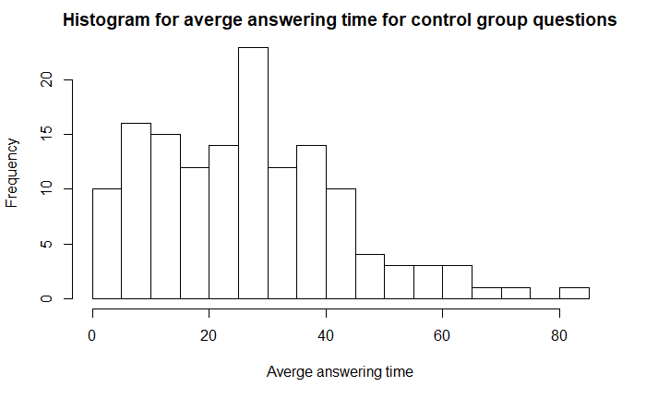a)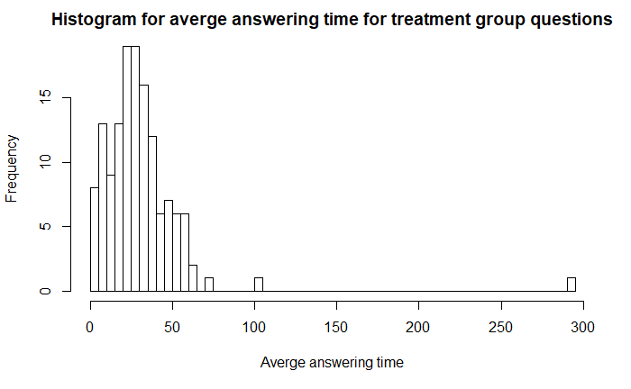b)

*Figure 1: Average time people spent on questions in a) Control group, and b) Treatment group*

Then, we further trimmed the dataset by removing records containing null values and abnormal values in variable YearOfBirth, because we wanted to simulate the real experiment, in which we planned to collect and use information about age groups. After checking values in variables YearOfBirth, we realized that there were country names (introduced because someone modified the survey midway) and some abnormal values such as 2020. After removing these records, we have 227 records in total (115 records in treatment group and 112 records in control group).

After removing low-quality records, we proceeded to perform EDA on the dataset. First of all, we checked the missing value percentage of all covariates we had.

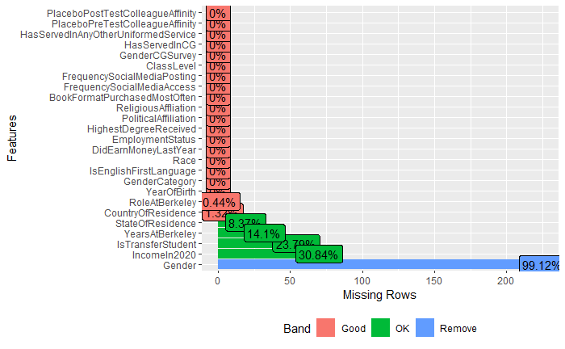

*Figure 2: Missing value percentage of all covariates*

The last 5 covariates (StateOfResidence, YearsAtBerkeley, IsTransferStudent, IncomeIn2020, Gender) had a comparatively large proportion of missing values and were not related to the topic we were investigating. We kept them as covariates, but didn’t attempt to impute missing values as these covariates are not very relevant in terms of informing gender and racial bias in the US Coast Guard setting. Note that “Gender” was a variable that had mostly missing data. Fortunately, we had collected another variable “GenderCGSurvey” that had the right values, so gender information was available for analysis.

Then, we checked the distribution of all covariates. For the only continuous variable YearOfBirth, we created a density plot (Figure 3). It turned out that most of our respondents were around 20 years old, which was expected since the primary respondents were Berkeley students.

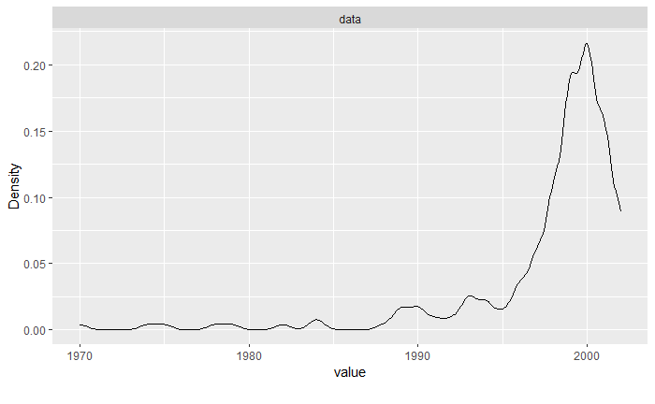

*Figure 3: Density plot of variable YearOfBirth*

As for the distribution of categorical variables, please refer to the Appendix 3 for a full set of distribution graphs. Here are the graphs for 2 key covariates (gender and race) we are going to use in the real experiment.

a)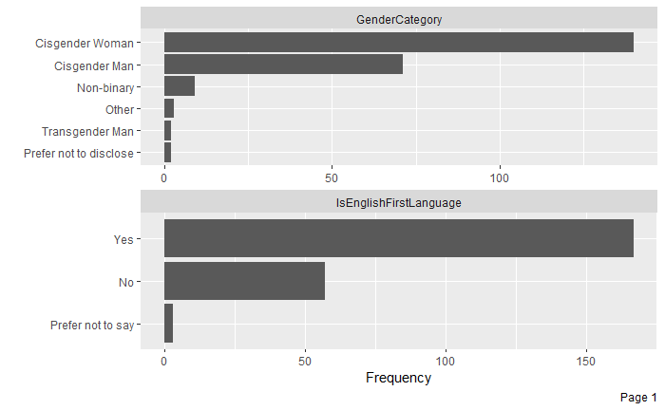

b)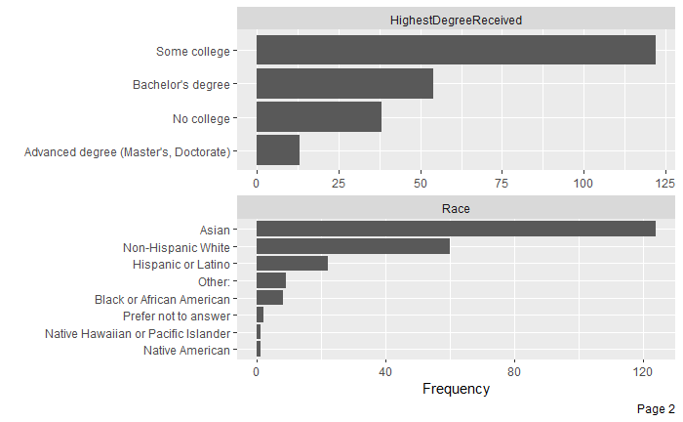

*Figure 4: Distribution of variable a) Gender, and b) Race*

From all distribution graphs, we could tell that most of the respondents have never served in uniformed service before, so it is hard to say that their responses would reflect the actual situation in the USCG. Almost all respondents are living in the United States. Around 66% of the respondents are female, half of them are Asian. Roughly half of them are democrats, and only 5.3% of them are republicans. These facts were understandable because the main source of data is Xlab (most subjects were undergraduate Berkeley students).

We also conducted the covariate balance check by creating love plots. From Figure 5, we could confirm that the random assignment was working because standardized mean difference for all categorical covariates were less than 0.3.

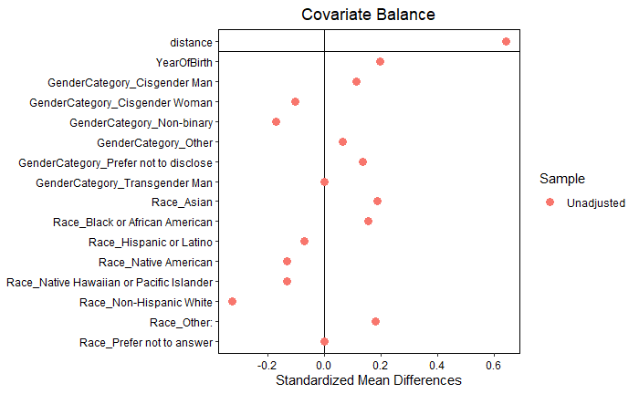

*Figure 5: Covariate balance check with love plot*

We also compared distributions of race, gender, and year of birth in both control and treatment groups to make sure that subjects were evenly distributed (Figure 6).

a)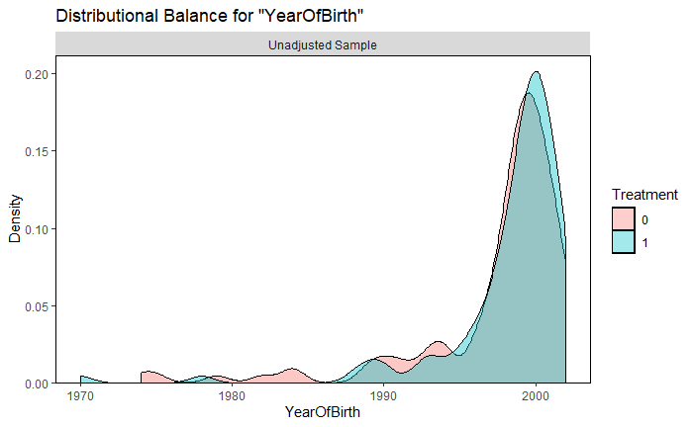

b)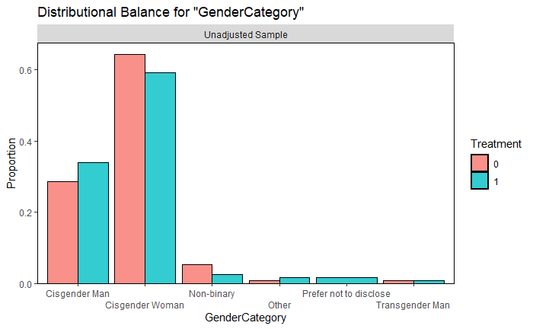

c)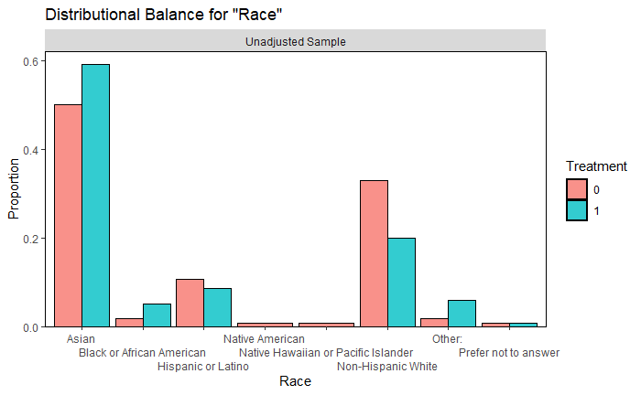

*Figure 6: Covariate balance check for a) YearOfBirth, b) Gender, and c) Race*

**Data Preparation and Feature Engineering:**

Part of the work in this project was setting up our data set such that we could partition the treatment and control groups on a “per question” basis. This involved some feature engineering where we had to convert our data from “column major” responses to “row major” responses. Here, “column major” refers to the fact that originally, each participant had several columns representing their demographic, profession related and behavioral covariates, followed by a response to each of the resume comparisons they had witnessed. “Row major” refers to the transformation of the column major format, where we created new datasets for each question - with rows representing the covariates followed by a single resume question’s response (for both treatment and control participants).

After we had the data formatted in its desired state, we looked at adding a few more metadata columns that helped us identify which resumes were being compared in the treatment group, along with identifying information of the resume persons (WM vs BF etc.).

We further grouped up age into the following age groups to better emulate the real experiment (for example, we plan to use strata instead of specific ranking): 6~12 is child; 13~25 is student; 26~40 is adult; 41~60 is middle-age; 61+ is senior. We considered all records with age less than 6 as invalid data records.

**Models and Analysis:**

As discussed above, we used a “differences in difference” design for obtaining our treatment effect. The first difference was the “difference in resume pair score” that was obtained from the participant for a resume pair. The second difference was the average difference between the treatment and control group outcomes, which is obtained naturally via a regression. This second difference was our treatment effect.

Due to a bug in the Qualtrics survey implementation, we were unfortunately unable to obtain the true “difference in resume pair scores” for our survey population. We only noticed this toward the end of the survey data collection, when we noticed a score of 0 being applied to each question, for both treatment and control groups. Notwithstanding this setback and for the sake of continuing our analysis to prove our methodology, we obtained the scores for our questions synthetically, ie, we obtained these via a random number generator that generated a distribution of integer scores with a predetermined mean and standard deviation (see image below). These values varied between 1-7, representing the likert scale described in the above sections. Thus, our goal from our modeling exercise was to ensure that our methodology is sound and reproducible, which will allow us to rerun the analysis as and when we obtain the right data from the right audience.

We obtained the data to perform our regression analysis in the following way:

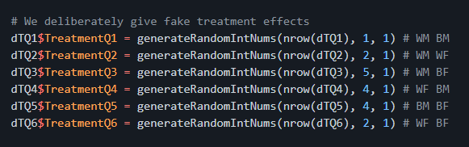

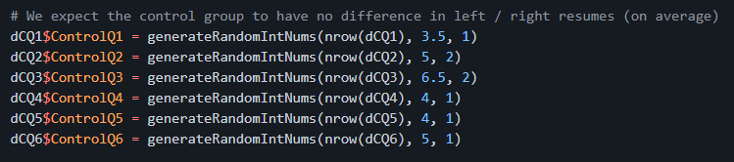

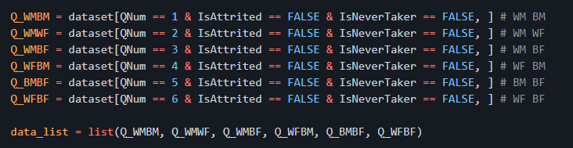

*Figure 7: Dataset being used for each Question: The first 2 images represent the mean and standard deviation of the responses to the “resume comparison” questions for the treatment and control group.*

In the above figure, each dataset corresponds to a comparison question. Before we get into the regression analysis, let’s briefly discuss the placebo test that was conducted to ensure we have not inadvertently changed the characteristics / affinity of our participants by treating them with resume comparison questions. We also will get insight on any differences between the treatment and control groups by performing this test. We conducted a pre-post placebo test where we asked a related question whose responses should NOT have changed per participant (within subject). The question asked was *"How much do you like your coworkers?"*. This question was posed to the participant:

1. Before they started answering the resume comparison questions and
2. After they had finished answering the resume comparison questions

We hypothesized that the participants (on average) should not have had a change in response to this question throughout the survey. We were successful in validating this hypothesis after looking at the distribution of the change in response values:

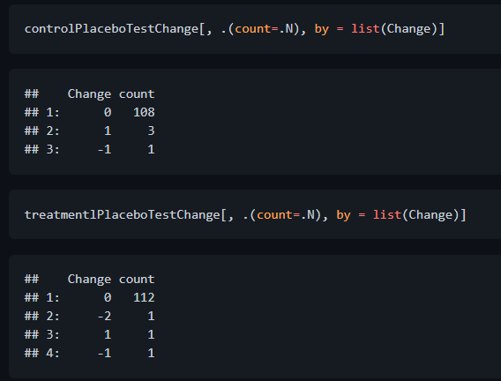

*Figure 8: Placebo test in action*

As we observe above, the change for most participants in both treatment and control groups seems to be around 0. This is sufficient proof that the audience had not been influenced by the survey itself (in terms of their affinity to judge others’ resumes).

Next, we decided to run the regression for 5 different models:

1. Vanilla Model (Without covariates)
2. Core Model (With core covariates)
3. Covariate Model 1 (with Demographic covariates)
4. Covariate Model 2 (with Profession related covariates)
5. Covariate Model 3 (with Behavior related covariates)

The vanilla model had no covariates associated with it and gave an all up analysis of the treatment effect. This allowed us to establish a baseline and perform some sanity checks around obtaining the treatment effect via regression.

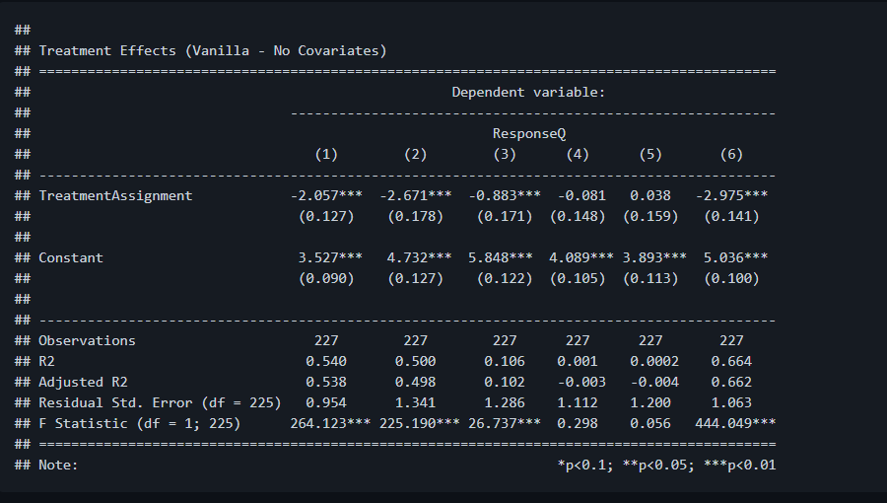

*Figure 9: Regression results from vanilla model*

From the above, we notice a series of 6 regressions - which are corresponding to the 6 questions that participants were asked in the survey. Note that both treatment and control participants were each asked 6 questions. The mapping of the questions was as follows:

|  |  |
| --- | --- |
| Question Number | Comparison |
| 1 | WM vs BM |
| 2 | WM vs WF |
| 3 | WM vs BF |
| 4 | WF vs BM |
| 5 | BM vs BF |
| 6 | WF vs BF |

*Figure 10: Question to Resume Comparison mapping*

Thus model (1) above is referring to a significant treatment effect of -2.057 which is the comparison between WM and BM candidates. In this case, we observe from the data that the average treatment effect when comparing white males and black males is favored toward white males with an affinity score of -2.057. We can draw similar conclusions with the other models.

We also cross validated the above treatment coefficient values obtained from regression by manually performing the treatment calculations (difference in means between treatment and control groups on the outcome “difference in scores” variable). We indeed observed that these values matched for all 6 models. For code and more details, please take a look at Appendix 4.

From the hypothetical regression run above, we observed that white males are typically favored against other race gender combinations. In models (1) to (3), white males are compared against black males, white females and black females - In each of these models, white male resumes seem to pick up favorable treatment outcomes. In models (4) to (5), we observe an insignificant treatment effect - ie, we observe no affinity when comparing black males to white females or when comparing black males to black females. In model (6), when comparing white females to black females, we observe a strong affinity toward white females, with a treatment effect of almost 3 units.

Note that each of the above treatment effects are “made up” based on the response data that was provided by the random number generator. Mathematically, we observe that the treatment effects line up as they should. For example, looking at Q6 (WF vs BF) in Figure 7 - we observe that we had instructed our random number generator to generate data resulting in a mean score of 5 for the control group (with standard deviation 1), and to generate data resulting in a mean score of 2 for the treatment group (with standard deviation 1). The difference between these means is -3 which is represented by the regression results shown in Column 6 of Figure 9. Note that these data assignments are not the views and representations of the team members and are purely exaggerated for demonstration purposes. In reality, we will have to rerun the survey with the correct data collection processes to measure the biases of participants.

Next, we move to the analysis of the remaining models. The core model consisted of the “core” covariates - something that we believe should be meaningful in supporting the treatment effect (as a pre-experimental hypothesis). These covariates consist of the survey participant’s *“Race”, “Gender” and “AgeBin”*. AgeBin is just an age group variable that classifies the participant to be within an age category (middle aged vs adult vs senior etc.). Note that when we do conduct the regressions with the USCG audience, these are primarily the covariates that would be accessible by us (due to privacy protection policies in place). This is another reason as to why we are relying on these covariates in our primary model. Upon running this regression, we observed similar results that we obtain from our vanilla model.

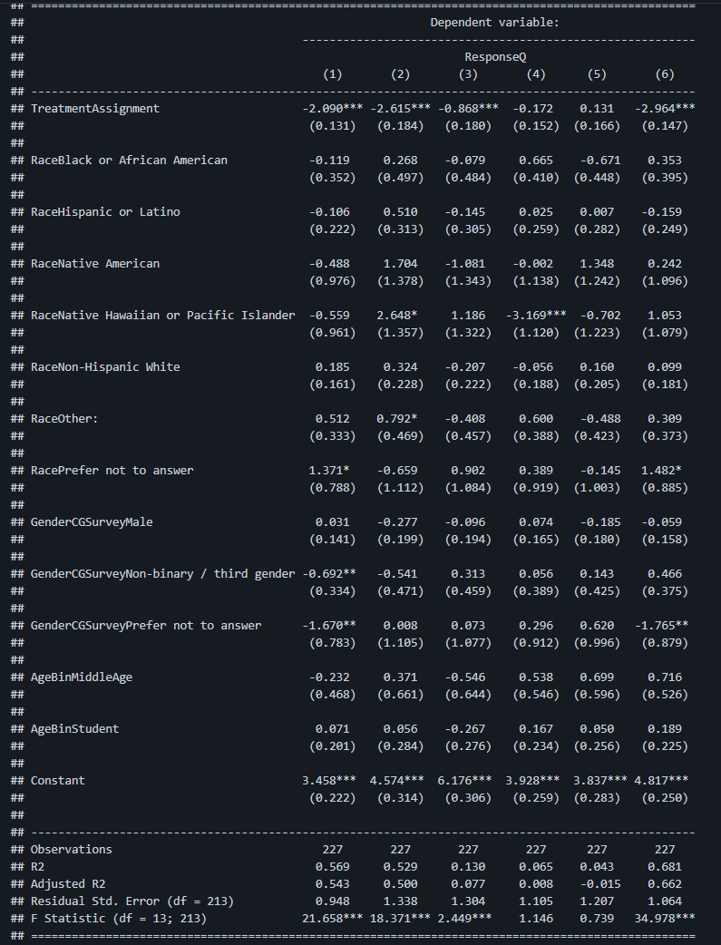

*Figure 11: Regression with Covariates*

Unfortunately, from observing the covariates, it does not seem as if any of the covariates are significant across multiple models. This is slightly discouraging as we expected some of these covariates to be associated with our outcome scores, as one would typically imagine that race or gender or age may play at least some implicit role when determining preference in candidacy. Again, we have to remember that this analysis is being done on made up response data, and against a non-ideal audience (XLab vs USCG). It is entirely possible that when we rerun this survey against the USCG, we will expect to obtain significant coefficients across these dimensions.

We do observe, however, that there are some covariates that do seem significant in some models. For example, we notice that *“Race Native Hawaiin or Pacific Islander”* is significant as a covariate in models (2) and (4). This may seem encouraging at first glance, however, we have to be careful in understanding if this coefficient is truly showing a significant effect or not. From our data, we observe only a single observation where the race matches this criteria. In that case, we cannot posit with high confidence that the covariate is giving us any true significant effects (as it may be noise in the data that is making the covariate significant by chance - we should aim to get a larger sample with this set of covariates to confirm). One last observation from the “core” model was that the magnitude and sign of the treatment effects were similar to the vanilla model. This shows that by adding covariates, we do not influence the treatment coefficients, which is expected. All in all, we observe that no single covariate seems to be largely significant in determining affinity on the resumes, across all models.

Next, we ran a model with demographic covariates - *“Race”, “GenderCGSurvey”, “PoliticalAffiliation”, “ReligiousAffliation”, “ClassLevel”, “AgeBin”, “IsEnglishFirstLanguage”, “CountryOfResidence”, “StateOfResidence”*. Again, as was the case with the “core” model, we didn’t observe any one single covariate that was significant across multiple models. The treatment effect and signs remained intact, which was expected. We have omitted pasting the output of the regression here since it is fairly large and may be difficult to read. For the code and associated output, please refer to Appendix 4.

Next, we ran a model with profession related covariates - *“HasServedInCG”, “HasServedInAnyOtherUniformedService”, “HighestDegreeReceived”, “EmploymentStatus”, “RoleAtBerkeley”, “YearsAtBerkeley”, “IncomeIn2020”*. As expected, the magnitude and sign of treatment effects remained similar as the previous models. Interestingly, we did notice that there were some covariates that seemed significant across some models. For example, *“EmploymentStatus”* covariate with level value *“Employed part time”* was significant in model (2) and (5). The covariate *“HighestDegreeReceived”* with level value *“No college”* was significant across models (2), (4) and (5). Each of these variables - *EmploymentStatus:EmployedPartTime* and *HighestDegreeReceived:NoCollege* had several observations within them - 44 and 38 respectively, which makes us feel more confident that there truly is a significant association of these coefficients in their respective models. Note that unlike the above regressions which had over 220 observations, the profession related model had only 130 observations when running the model (because of multiple NA values in coefficient observations).

Last, we ran the model with behavior related covariates - *“FrequencySocialMediaAccess”, “FrequencySocialMediaPosting”, “BookFormatPurchasedMostOften”*. As expected, the magnitude and sign of treatment effects remained similar as the previous models. This model was of least interest to us, since we don’t expect any of these covariates to immediately influence the gender or race bias in USCG candidacy selection. The only reason we ran this was because we had access to these covariates as a part of the XLab survey run. We did not find any special significant covariates that displayed persistent significance across models.

The only other insight to share from a modeling perspective is that our unique design allowed us to retrieve effects of only gender or only race, even though the treatment was administered in a compounded fashion (a combination of race and gender, *example - Bradley Meyer*). For example, in our vanilla model, if we average the treatment coefficient across model (1) and model (6) - ie, WM vs BM and WF vs BF, we get the treatment effect across the race dimension (marginalized by gender). We see that the result is *(-2.057 + -2.975) / 2 = -2.516*. Thus, we observe that we can get the preferential affinity for being white (as opposed to black), quantifying it with a value of -2.516. The same can be done to obtain the exclusive treatment effect across the gender dimension. If the model gets expanded to include more races in the future, we can extend this technique to obtain the ATE across any race we choose.

**Future Work:**

We plan on tweaking our experiment design to improve complexity in our analysis and a richer experience for our participants. Initially, the position description must include more details for a USCG audience. They will be less inclined to accept the basic position description which could manifest itself into frustration which would distract participants from making an focused candidate assessment. Adding more information for the position would allow us to ask additional questions about how well each candidate resume met each prerequisite. We could use this data to explore the impact of bias on specific areas i.e. leadership and professional experience, education, or professional development.

Additionally, we’d like to expand experiment design to include distributions from which to draw different elements. The distributions, created for all resume areas and for each race/gender name combination, would allow us to create more unique resumes, all with roughly the same strength. We are particularly concerned about spill over when testing the entire USCG Officer Corps, especially if we used the same four resumes with the same four names. Distributions would mitigate the spillover risk without proportionally increasing risk of bias, as we’d continue to construct resumes by randomly drawing elements from area distributions.

We would also like to expand our treatment matrix to include a new level. Our 3x2 design would feature resumes with names of matching race/gender, names with different race/gender, and resumes with redacted names. This design could allow us to assess how officers regard race/gender combinations generally and by proposing a solution, redacted names, could also generate a more positive reception for the experiment within the USCG.

Unfortunately, we expect a low participation rate of 10% or less. With such a low participation rate, the enhancements discussed above could lead to meaninglessly small samples in each treatment level. To alleviate those concerns, we propose running an engagement pilot study to explore different email engagement strategies and how each strategy impacts participation rate. Participation rate would also dictate how we block our treatment and control groups, ideally by rank which we suspect would be strongly correlated with implicit bias intensity.

**Summary and Conclusions:**

With an opportunity to assess implicit bias within the USCG, we can provide the organization a path to truly understand why race and gender assignment disparities exist. Our Pilot Study demonstrated that we have a methodology in place to isolate and assess the impact of race and gender on how study participants regard candidate resumes from candidates of different gender and race. While not exact, applying these same methodologies, with some modifications, to the USCG Officer Corps will reveal organizational biases (or lack thereof) inherent to some assignment processes. With the right context, the USCG can work to design proactive solutions to combat racial and gender assignment disparity and become a service that faithfully represents the people it serves.

**References:**

1. OIG-20-36. <https://www.oig.dhs.gov/sites/default/files/assets/2020-06/OIG-20-36-Jun20.pdf>
2. Kimberly Curry Hall, Kirsten M. Keller, David Schulker, Sarah Weilant, Katherine L. Kidder, and Nelson Lim. Improving Gender Diversity in the U.S. Coast Guard: Identifying Barriers to Female Retention. Homeland Security Operational Analysis Center operated by the RAND Corporation, 2019.
3. Konstantinos Tzioumis. Demographic aspects of first names. *Sci Data* 5, 180025 (2018). https://doi.org/10.1038/sdata.2018.25
4. Mahzarin R. Banaji and Anthony G. Greenwald. Blindspot: HIdden Biases of Good People. New York: Random House Publishing Group. 2013.
5. Marianne Bertrand and Sendhil Mullainathan, “Are Emily and Greg More Employable Than Lakisha and Jamal? A Field Experiment on Labor Market Discrimination.” American Economic Review 94, no. 4. September 2004.

**Appendix 1: Treatment Survey**

**Section 1 (UCB): Demographic Information and Placebo Question (both Control and Treatment Surveys)**

|  |  |
| --- | --- |
| **Radio Button Questions** | **Radio Button Choices** |
| What is your class? | [Fresh/Soph]; [Jr/Sr]; [Grad/Post-Grad] |
| What gender do you identify with? | [M]; [F]; [T]; [Other]; [Prefer not to answer] |
| What races or ethnicities do you identify with? Please choose all that apply. | [White];[Hispanic, Latinex, or Spanish Origin]; [Black or African American]; [American Indian or Alaska Native]; [Asian]; [Native Hawaiian and Pacific Islander];[Other] |
| Have you ever served in the US Coast Guard? | [Y]; [N]; [Prefer not to answer] |
| Have you ever served in any US uniformed service? | [Y]; [N]; [Prefer not to answer] |

|  |  |
| --- | --- |
| **Slider Question** | **Slider Choices** |
| How much do you like your coworkers? | [Strongly Dislike];[Dislike];[Neutral];[Like];[Strongly Like] |

**Section 1 (CG): Demographic Information and Placebo Question (both Control and Treatment Surveys)**

|  |  |
| --- | --- |
| **Question** | **Drop Down Menu Choices** |
| What is your rank? | [ENS/LTJG]; [LT/LCDR]; [CDR/CAPT/ADM] |
| What gender do you identify with? | [M]; [F]; [T]; [Other]; [Prefer not to answer] |
| What races or ethnicities do you identify with? Please choose all that apply. | [White];[Hispanic, Latinex, or Spanish Origin]; [Black or African American]; [American Indian or Alaska Native]; [Asian]; [Native Hawaiian and Pacific Islander];[Other]; |

|  |  |
| --- | --- |
| **Question** | **Slider Choices** |
| How much do you like your coworkers? | [Strongly Dislike];[Dislike];[Neutral];[Like];[Strongly Like] |

**Section 2: Position Description and Resumes - Control (UCB)**

Page 1:

Directions: In the US Coast Guard (USCG), certain Offices will ask candidates applying to the most competitive positions for a full length, civilian style resume. Usually, a very small group of reviewers will evaluate the resumes, spending only a short amount of time with each, before choosing who to interview. To streamline the resume review process and allow for expanded candidate pools, the USCG Human Resources directorate is experimenting with different formats for “restricted resumes” (RR). The USCG is particularly concerned with how different RR formats may influence resume reviewers and consequently has commissioned a study to address those format concerns.

We are about to show you a position description, a table of preferred and minimum prerequisites for the position, and then a series of six candidate RR pairs that may feature different RR formats. We are asking you to use the provided slider bar to indicate the candidate you’d prefer to interview, and how strongly you prefer said candidate. While understanding you may have limited understanding of the USCG, we ask that you use the table of preferred and minimum prerequisites to develop your candidate preference as best you can.

Please review the above instructions as necessary. When you are ready, please click Next to proceed.

Page 2 (practice):

-This is a practice question to acquaint you with survey procedures.-

**Directions:** Please read the following position description and the table of preferred and minimum position prerequisites. Then, use the provided slider bar to indicate which candidate you’d prefer and the strength of your preference.

**Position:** Member of the Strategic Vision Task Force

**Description:** The Strategic Vision Task Force is charged with developing the framework for organizational growth over the next 30 years. It’s chartered goals are to ensure the USCG maintains its operational relevance, can adequately compete for Federal resources, and can attract the best talent from both private industry and the Federal government. Prerequisites for assignment to the Task Force are as follows:

**Position prerequisites:**

|  |  |  |
| --- | --- | --- |
| Area | Preferred | Minimum |
| Recent Professional Experience | 2 Operational Tours (OT) with Medals | 1 Operational Tour (OT) with Medal and 1 Staff Tour (ST) with Medal |
| Leadership Experience | Commanding Officer | Executive Officer  -or-  Department Head |
| Highest Level of Education | Master’s of Business Administration -or- Master’s of Public Policy/Administration | Master’s Degree (Any) |
| Professional Development | Leadership Role in an Association | Demonstrated Participation in an Association |

**Please use the provided slider bar to indicate which candidate you’d prefer to interview and how strongly you prefer said candidate.**

RR-A

RR-B

Slider Bar: [Strongly Prefer][Prefer][Slightly Prefer][No Preference][Slightly Prefer][Prefer][Strongly Prefer]

Please click ‘Next’ to proceed.

Page 3: Resume Pair 1 (Randomize Pair Order via Qualtrics)

**Directions:** Please read the following position description and the table of preferred and minimum position prerequisites. Then, use the provided slider bar to indicate which candidate you’d prefer and the strength of your preference.

**Position:** Member of the Strategic Vision Task Force

**Description:** The Strategic Vision Task Force is charged with developing the framework for organizational growth over the next 30 years. It’s chartered goals are to ensure the USCG maintains its operational relevance, can adequately compete for Federal resources, and can attract the best talent from both private industry and the Federal government. Prerequisites for assignment to the Task Force are as follows:

**Position prerequisites:**

|  |  |  |
| --- | --- | --- |
| Area | Preferred | Minimum |
| Recent Professional Experience | 2 Operational Tours (OT) with Medals | 1 Operational Tour (OT) with Medal and 1 Staff Tour (ST) with Medal |
| Leadership Experience | Commanding Officer | Executive Officer  -or-  Department Head |
| Highest Level of Education | Master’s of Business Administration -or- Master’s of Public Policy/Administration | Master’s Degree (Any) |
| Professional Development | Leadership Role in an Association | Demonstrated Participation in an Association |

**Please use the provided slider bar to indicate which candidate you’d prefer to interview and how strongly you prefer said candidate.**



Slider Bar: [Strongly Prefer][Prefer][Slightly Prefer][No Preference][Slightly Prefer][Prefer][Strongly Prefer]

Please click ‘Next’ to proceed

Page 4: Resume Pair 2 (Randomize Pair Order via Qualtrics

**Directions:** Please read the following position description and the table of preferred and minimum position prerequisites. Then, use the provided slider bar to indicate which candidate you’d prefer and the strength of your preference.

**Position:** Member of the Strategic Vision Task Force

**Description:** The Strategic Vision Task Force is charged with developing the framework for organizational growth over the next 30 years. It’s chartered goals are to ensure the USCG maintains its operational relevance, can adequately compete for Federal resources, and can attract the best talent from both private industry and the Federal government. Prerequisites for assignment to the Task Force are as follows:

**Position prerequisites:**

|  |  |  |
| --- | --- | --- |
| Area | Preferred | Minimum |
| Recent Professional Experience | 2 Operational Tours (OT) with Medals | 1 Operational Tour (OT) with Medal and 1 Staff Tour (ST) with Medal |
| Leadership Experience | Commanding Officer | Executive Officer  -or-  Department Head |
| Highest Level of Education | Master’s of Business Administration -or- Master’s of Public Policy/Administration | Master’s Degree (Any) |
| Professional Development | Leadership Role in an Association | Demonstrated Participation in an Association |

**Please use the provided slider bar to indicate which candidate you’d prefer to interview and how strongly you prefer said candidate.**



Slider Bar: [Strongly Prefer][Prefer][Slightly Prefer][No Preference][Slightly Prefer][Prefer][Strongly Prefer]

Please click ‘Next’ to proceed

Page 5: Resume Pair 3 (Randomize Pair Order via Qualtrics

**Directions:** Please read the following position description and the table of preferred and minimum position prerequisites. Then, use the provided slider bar to indicate which candidate you’d prefer and the strength of your preference.

**Position:** Member of the Strategic Vision Task Force

**Description:** The Strategic Vision Task Force is charged with developing the framework for organizational growth over the next 30 years. It’s chartered goals are to ensure the USCG maintains its operational relevance, can adequately compete for Federal resources, and can attract the best talent from both private industry and the Federal government. Prerequisites for assignment to the Task Force are as follows:

**Position prerequisites:**

|  |  |  |
| --- | --- | --- |
| Area | Preferred | Minimum |
| Recent Professional Experience | 2 Operational Tours (OT) with Medals | 1 Operational Tour (OT) with Medal and 1 Staff Tour (ST) with Medal |
| Leadership Experience | Commanding Officer | Executive Officer  -or-  Department Head |
| Highest Level of Education | Master’s of Business Administration -or- Master’s of Public Policy/Administration | Master’s Degree (Any) |
| Professional Development | Leadership Role in an Association | Demonstrated Participation in an Association |

**Please use the provided slider bar to indicate which candidate you’d prefer to interview and how strongly you prefer said candidate.**



Slider Bar: [Strongly Prefer][Prefer][Slightly Prefer][No Preference][Slightly Prefer][Prefer][Strongly Prefer]

Please click ‘Next’ to proceed

Page 6: Resume Pair 4 (Randomize Pair Order via Qualtrics)

**Directions:** Please read the following position description and the table of preferred and minimum position prerequisites. Then, use the provided slider bar to indicate which candidate you’d prefer and the strength of your preference.

**Position:** Member of the Strategic Vision Task Force

**Description:** The Strategic Vision Task Force is charged with developing the framework for organizational growth over the next 30 years. It’s chartered goals are to ensure the USCG maintains its operational relevance, can adequately compete for Federal resources, and can attract the best talent from both private industry and the Federal government. Prerequisites for assignment to the Task Force are as follows:

**Position prerequisites:**

|  |  |  |
| --- | --- | --- |
| Area | Preferred | Minimum |
| Recent Professional Experience | 2 Operational Tours (OT) with Medals | 1 Operational Tour (OT) with Medal and 1 Staff Tour (ST) with Medal |
| Leadership Experience | Commanding Officer | Executive Officer  -or-  Department Head |
| Highest Level of Education | Master’s of Business Administration -or- Master’s of Public Policy/Administration | Master’s Degree (Any) |
| Professional Development | Leadership Role in an Association | Demonstrated Participation in an Association |

**Please use the provided slider bar to indicate which candidate you’d prefer to interview and how strongly you prefer said candidate.**



Slider Bar: [Strongly Prefer][Prefer][Slightly Prefer][No Preference][Slightly Prefer][Prefer][Strongly Prefer]

Please click ‘Next’ to proceed

Page 7: Resume Pair 5 (Randomize Pair Order via Qualtrics

**Directions:** Please read the following position description and the table of preferred and minimum position prerequisites. Then, use the provided slider bar to indicate which candidate you’d prefer and the strength of your preference.

**Position:** Member of the Strategic Vision Task Force

**Description:** The Strategic Vision Task Force is charged with developing the framework for organizational growth over the next 30 years. It’s chartered goals are to ensure the USCG maintains its operational relevance, can adequately compete for Federal resources, and can attract the best talent from both private industry and the Federal government. Prerequisites for assignment to the Task Force are as follows:

**Position prerequisites:**

|  |  |  |
| --- | --- | --- |
| Area | Preferred | Minimum |
| Recent Professional Experience | 2 Operational Tours (OT) with Medals | 1 Operational Tour (OT) with Medal and 1 Staff Tour (ST) with Medal |
| Leadership Experience | Commanding Officer | Executive Officer  -or-  Department Head |
| Highest Level of Education | Master’s of Business Administration -or- Master’s of Public Policy/Administration | Master’s Degree (Any) |
| Professional Development | Leadership Role in an Association | Demonstrated Participation in an Association |

**Please use the provided slider bar to indicate which candidate you’d prefer to interview and how strongly you prefer said candidate.**



Slider Bar: [Strongly Prefer][Prefer][Slightly Prefer][No Preference][Slightly Prefer][Prefer][Strongly Prefer]

Please click ‘Next’ to proceed

Page 8: Resume Pair 6 (Randomize Pair Order via Qualtrics

**Directions:** Please read the following position description and the table of preferred and minimum position prerequisites. Then, use the provided slider bar to indicate which candidate you’d prefer and the strength of your preference.

**Position:** Member of the Strategic Vision Task Force

**Description:** The Strategic Vision Task Force is charged with developing the framework for organizational growth over the next 30 years. It’s chartered goals are to ensure the USCG maintains its operational relevance, can adequately compete for Federal resources, and can attract the best talent from both private industry and the Federal government. Prerequisites for assignment to the Task Force are as follows:

**Position prerequisites:**

|  |  |  |
| --- | --- | --- |
| Area | Preferred | Minimum |
| Recent Professional Experience | 2 Operational Tours (OT) with Medals | 1 Operational Tour (OT) with Medal and 1 Staff Tour (ST) with Medal |
| Leadership Experience | Commanding Officer | Executive Officer  -or-  Department Head |
| Highest Level of Education | Master’s of Business Administration -or- Master’s of Public Policy/Administration | Master’s Degree (Any) |
| Professional Development | Leadership Role in an Association | Demonstrated Participation in an Association |

**Please use the provided slider bar to indicate which candidate you’d prefer to interview and how strongly you prefer said candidate.**



Slider Bar: [Strongly Prefer][Prefer][Slightly Prefer][No Preference][Slightly Prefer][Prefer][Strongly Prefer]

Please click ‘Next’ to proceed

Page 9: Exit Survey:

Thank you for completing our survey! Please take a moment on your way out to answer one last question!

|  |  |
| --- | --- |
| **Question** | **Slider Choices** |
| How much do you like your coworkers? | [Strongly Dislike];[Dislike];[Neutral];[Like];[Strongly Like] |

Please click Finish to submit your survey and thanks again! Go Bears!

**Appendix 2: Control Survey**

**Section 1 (UCB): Demographic Information and Placebo Question (both Control and Treatment Surveys)**

|  |  |
| --- | --- |
| **Radio Button Question** | **Radio Button Choices** |
| What is your class? | [Fresh/Soph]; [Jr/Sr]; [Grad/Post-Grad]; [Prefer not to answer] |
| What gender do you identify with? | [M]; [F]; [T]; [Other]; [Prefer not to answer] |
| What races or ethnicities do you identify with? Please choose all that apply. | [White];[Hispanic, Latinex, or Spanish Origin]; [Black or African American]; [American Indian or Alaska Native]; [Asian]; [Native Hawaiian and Pacific Islander];[Other] |
| Have you ever served in the US Coast Guard? | [Y]; [N]; [Prefer not to answer] |
| Have you ever served in any US uniformed service? | [Y]; [N]; [Prefer not to answer] |

|  |  |
| --- | --- |
| **Slider Question** | **Slider Choices** |
| How much do you like your coworkers? | [Strongly Dislike];[Dislike];[Neutral];[Like];[Strongly Like] |

**Section 1 (CG): Demographic Information and Placebo Question (both Control and Treatment Surveys)**

|  |  |
| --- | --- |
| **Question** | **Drop Down Menu Choices** |
| What is your rank? | [ENS/LTJG]; [LT/LCDR]; [CDR/CAPT/ADM] |
| What gender do you identify with? | [M]; [F]; [T]; [Other]; [Prefer not to answer] |
| What races or ethnicities do you identify with? Please choose all that apply. | [White];[Hispanic, Latinex, or Spanish Origin]; [Black or African American]; [American Indian or Alaska Native]; [Asian]; [Native Hawaiian and Pacific Islander];[Other]; |

|  |  |
| --- | --- |
| **Question** | **Slider Choices** |
| How much do you like your coworkers? | [Strongly Dislike];[Dislike];[Neutral];[Like];[Strongly Like] |

**Section 2: Position Description and Resumes - Control (UCB)**

Page 1:

Directions: In the US Coast Guard (USCG), certain Offices will ask candidates applying to the most competitive positions for a full length, civilian style resume. Usually, a very small group of reviewers will evaluate the resumes, spending only a short amount of time with each, before choosing who to interview. To streamline the resume review process and allow for expanded candidate pools, the USCG Human Resources directorate is experimenting with different formats for “restricted resumes” (RR). The USCG is particularly concerned with how different RR formats may influence resume reviewers and consequently has commissioned a study to address those format concerns.

We are about to show you a position description, a table of preferred and minimum prerequisites for the position, and then a series of six candidate RR pairs that may feature different RR formats. We are asking you to use the provided slider bar to indicate the candidate you’d prefer to interview, and how strongly you prefer said candidate. While understanding you may have limited understanding of the USCG, we ask that you use the table of preferred and minimum prerequisites to develop your candidate preference as best you can.

Please review the above instructions as necessary. When you are ready, please click Next to proceed.

Page 2 (practice):

-This is a practice question to acquaint you with survey procedures.-

**Directions:** Please read the following position description and the table of preferred and minimum position prerequisites . Then, use the provided slider bar to indicate which candidate you’d prefer and the strength of your preference.

**Position:** Member of the Strategic Vision Task Force

**Description:** The Strategic Vision Task Force is charged with developing the framework for organizational growth over the next 30 years. It’s chartered goals are to ensure the USCG maintains its operational relevance, can adequately compete for Federal resources, and can attract the best talent from both private industry and the Federal government. Prerequisites for assignment to the Task Force are as follows:

**Position prerequisites:**

|  |  |  |
| --- | --- | --- |
| Area | Preferred | Minimum |
| Recent Professional Experience | 2 Operational Tours (OT) with Medals | 1 Operational Tour (OT) with Medal and 1 Staff Tour (ST) with Medal |
| Leadership Experience | Commanding Officer | Executive Officer  -or-  Department Head |
| Highest Level of Education | Master’s of Business Administration -or- Master’s of Public Policy/Administration | Master’s Degree (Any) |
| Professional Development | Leadership Role in an Association | Demonstrated Participation in an Association |

**Please use the provided slider bar to indicate which candidate you’d prefer to interview and how strongly you prefer said candidate.**

RR-A

RR-B

Slider Bar: [Strongly Prefer][Prefer][Slightly Prefer][No Preference][Slightly Prefer][Prefer][Strongly Prefer]

Please click ‘Next’ to proceed.

Page 3: Resume Pair 1 (Randomize Pair Order via Qualtrics)

**Directions:** Please read the following position description and the table of preferred and minimum position prerequisites . Then, use the provided slider bar to indicate which candidate you’d prefer and the strength of your preference.

**Position:** Member of the Strategic Vision Task Force

**Description:** The Strategic Vision Task Force is charged with developing the framework for organizational growth over the next 30 years. It’s chartered goals are to ensure the USCG maintains its operational relevance, can adequately compete for Federal resources, and can attract the best talent from both private industry and the Federal government. Prerequisites for assignment to the Task Force are as follows:

**Position prerequisites:**

|  |  |  |
| --- | --- | --- |
| Area | Preferred | Minimum |
| Recent Professional Experience | 2 Operational Tours (OT) with Medals | 1 Operational Tour (OT) with Medal and 1 Staff Tour (ST) with Medal |
| Leadership Experience | Commanding Officer | Executive Officer  -or-  Department Head |
| Highest Level of Education | Master’s of Business Administration -or- Master’s of Public Policy/Administration | Master’s Degree (Any) |
| Professional Development | Leadership Role in an Association | Demonstrated Participation in an Association |

**Please use the provided slider bar to indicate which candidate you’d prefer to interview and how strongly you prefer said candidate.**



Slider Bar: [Strongly Prefer][Prefer][Slightly Prefer][No Preference][Slightly Prefer][Prefer][Strongly Prefer]

Please click ‘Next’ to proceed

Page 4: Resume Pair 2 (Randomize Pair Order via Qualtrics)

**Directions:** Please read the following position description and the table of preferred and minimum position prerequisites . Then, use the provided slider bar to indicate which candidate you’d prefer and the strength of your preference.

**Position:** Member of the Strategic Vision Task Force

**Description:** The Strategic Vision Task Force is charged with developing the framework for organizational growth over the next 30 years. It’s chartered goals are to ensure the USCG maintains its operational relevance, can adequately compete for Federal resources, and can attract the best talent from both private industry and the Federal government. Prerequisites for assignment to the Task Force are as follows:

**Position prerequisites:**

|  |  |  |
| --- | --- | --- |
| Area | Preferred | Minimum |
| Recent Professional Experience | 2 Operational Tours (OT) with Medals | 1 Operational Tour (OT) with Medal and 1 Staff Tour (ST) with Medal |
| Leadership Experience | Commanding Officer | Executive Officer  -or-  Department Head |
| Highest Level of Education | Master’s of Business Administration -or- Master’s of Public Policy/Administration | Master’s Degree (Any) |
| Professional Development | Leadership Role in an Association | Demonstrated Participation in an Association |

**Please use the provided slider bar to indicate which candidate you’d prefer to interview and how strongly you prefer said candidate.**



Slider Bar: [Strongly Prefer][Prefer][Slightly Prefer][No Preference][Slightly Prefer][Prefer][Strongly Prefer]

Please click ‘Next’ to proceed

Page 5: Resume Pair 3 (Randomize Pair Order via Qualtrics)

**Directions:** Please read the following position description and the table of preferred and minimum position prerequisites . Then, use the provided slider bar to indicate which candidate you’d prefer and the strength of your preference.

**Position:** Member of the Strategic Vision Task Force

**Description:** The Strategic Vision Task Force is charged with developing the framework for organizational growth over the next 30 years. It’s chartered goals are to ensure the USCG maintains its operational relevance, can adequately compete for Federal resources, and can attract the best talent from both private industry and the Federal government. Prerequisites for assignment to the Task Force are as follows:

**Position prerequisites:**

|  |  |  |
| --- | --- | --- |
| Area | Preferred | Minimum |
| Recent Professional Experience | 2 Operational Tours (OT) with Medals | 1 Operational Tour (OT) with Medal and 1 Staff Tour (ST) with Medal |
| Leadership Experience | Commanding Officer | Executive Officer  -or-  Department Head |
| Highest Level of Education | Master’s of Business Administration -or- Master’s of Public Policy/Administration | Master’s Degree (Any) |
| Professional Development | Leadership Role in an Association | Demonstrated Participation in an Association |

**Please use the provided slider bar to indicate which candidate you’d prefer to interview and how strongly you prefer said candidate.**



Slider Bar: [Strongly Prefer][Prefer][Slightly Prefer][No Preference][Slightly Prefer][Prefer][Strongly Prefer]

Please click ‘Next’ to proceed

Page 6: Resume Pair 4 (Randomize Pair Order via Qualtrics)

**Directions:** Please read the following position description and the table of preferred and minimum position prerequisites . Then, use the provided slider bar to indicate which candidate you’d prefer and the strength of your preference.

**Position:** Member of the Strategic Vision Task Force

**Description:** The Strategic Vision Task Force is charged with developing the framework for organizational growth over the next 30 years. It’s chartered goals are to ensure the USCG maintains its operational relevance, can adequately compete for Federal resources, and can attract the best talent from both private industry and the Federal government. Prerequisites for assignment to the Task Force are as follows:

**Position prerequisites:**

|  |  |  |
| --- | --- | --- |
| Area | Preferred | Minimum |
| Recent Professional Experience | 2 Operational Tours (OT) with Medals | 1 Operational Tour (OT) with Medal and 1 Staff Tour (ST) with Medal |
| Leadership Experience | Commanding Officer | Executive Officer  -or-  Department Head |
| Highest Level of Education | Master’s of Business Administration -or- Master’s of Public Policy/Administration | Master’s Degree (Any) |
| Professional Development | Leadership Role in an Association | Demonstrated Participation in an Association |

**Please use the provided slider bar to indicate which candidate you’d prefer to interview and how strongly you prefer said candidate.**



Slider Bar: [Strongly Prefer][Prefer][Slightly Prefer][No Preference][Slightly Prefer][Prefer][Strongly Prefer]

Please click ‘Next’ to proceed

Page 7: Resume Pair 5 (Randomize Pair Order via Qualtrics)

**Directions:** Please read the following position description and the table of preferred and minimum position prerequisites . Then, use the provided slider bar to indicate which candidate you’d prefer and the strength of your preference.

**Position:** Member of the Strategic Vision Task Force

**Description:** The Strategic Vision Task Force is charged with developing the framework for organizational growth over the next 30 years. It’s chartered goals are to ensure the USCG maintains its operational relevance, can adequately compete for Federal resources, and can attract the best talent from both private industry and the Federal government. Prerequisites for assignment to the Task Force are as follows:

**Position prerequisites:**

|  |  |  |
| --- | --- | --- |
| Area | Preferred | Minimum |
| Recent Professional Experience | 2 Operational Tours (OT) with Medals | 1 Operational Tour (OT) with Medal and 1 Staff Tour (ST) with Medal |
| Leadership Experience | Commanding Officer | Executive Officer  -or-  Department Head |
| Highest Level of Education | Master’s of Business Administration -or- Master’s of Public Policy/Administration | Master’s Degree (Any) |
| Professional Development | Leadership Role in an Association | Demonstrated Participation in an Association |

**Please use the provided slider bar to indicate which candidate you’d prefer to interview and how strongly you prefer said candidate.**



Slider Bar: [Strongly Prefer][Prefer][Slightly Prefer][No Preference][Slightly Prefer][Prefer][Strongly Prefer]

Please click ‘Next’ to proceed

Page 8: Resume Pair 6 (Randomize Pair Order via Qualtrics)

**Directions:** Please read the following position description and the table of preferred and minimum position prerequisites . Then, use the provided slider bar to indicate which candidate you’d prefer and the strength of your preference.

**Position:** Member of the Strategic Vision Task Force

**Description:** The Strategic Vision Task Force is charged with developing the framework for organizational growth over the next 30 years. It’s chartered goals are to ensure the USCG maintains its operational relevance, can adequately compete for Federal resources, and can attract the best talent from both private industry and the Federal government. Prerequisites for assignment to the Task Force are as follows:

**Position prerequisites:**

|  |  |  |
| --- | --- | --- |
| Area | Preferred | Minimum |
| Recent Professional Experience | 2 Operational Tours (OT) with Medals | 1 Operational Tour (OT) with Medal and 1 Staff Tour (ST) with Medal |
| Leadership Experience | Commanding Officer | Executive Officer  -or-  Department Head |
| Highest Level of Education | Master’s of Business Administration -or- Master’s of Public Policy/Administration | Master’s Degree (Any) |
| Professional Development | Leadership Role in an Association | Demonstrated Participation in an Association |

**Please use the provided slider bar to indicate which candidate you’d prefer to interview and how strongly you prefer said candidate.**



Slider Bar: [Strongly Prefer][Prefer][Slightly Prefer][No Preference][Slightly Prefer][Prefer][Strongly Prefer]

Please click ‘Next’ to proceed

Page 9: Exit Survey:

Thank you for completing our survey! Please take a moment on your way out to answer one last question!

|  |  |
| --- | --- |
| **Question** | **Slider Choices** |
| How much do you like your coworkers? | [Strongly Dislike];[Dislike];[Neutral];[Like];[Strongly Like] |

Please click Finish to submit your survey and thanks again! Go Bears!

**Appendix 3: Distribution of categorical variables**





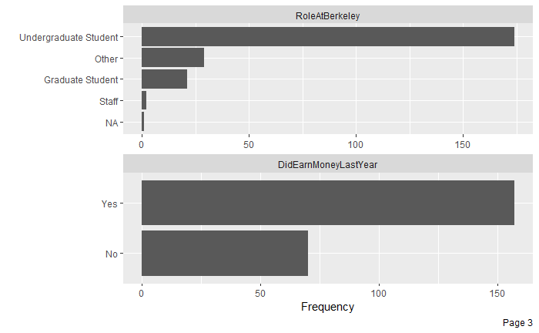

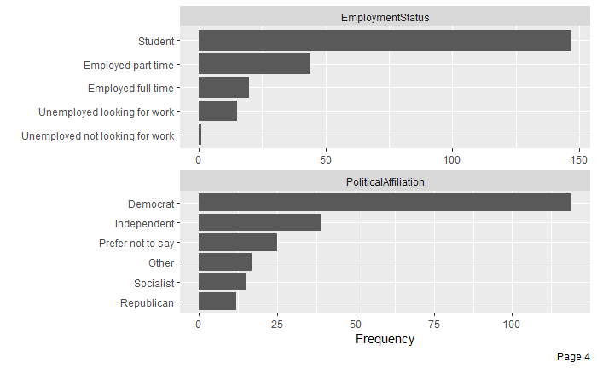

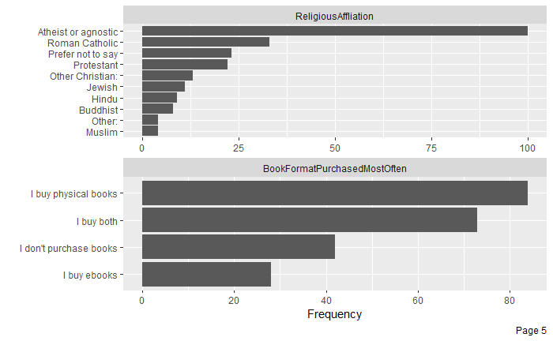

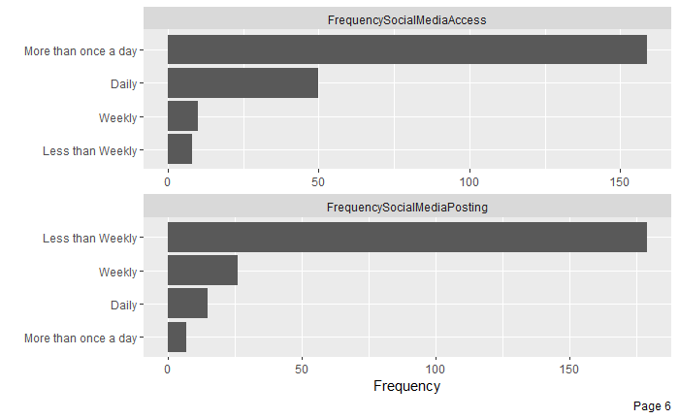

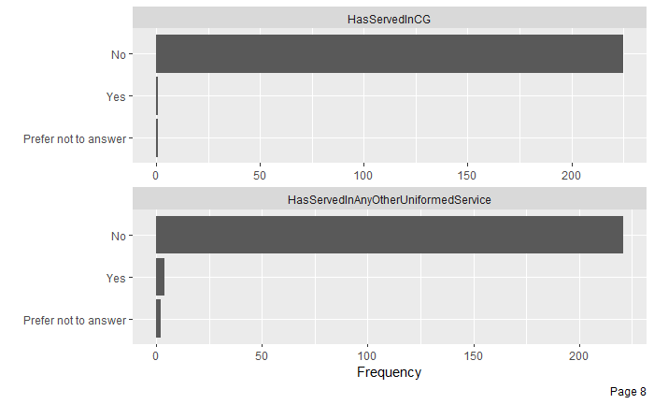

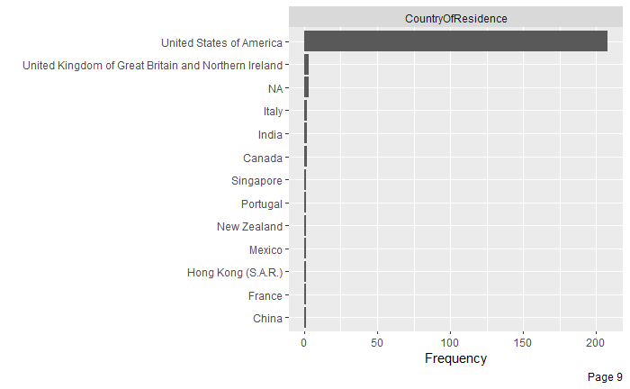

**Appendix 4: Regression Analysis**

This section covers regression analysis that was performed on the xLab survey data. For full description and code, please refer to this [github](https://github.com/abhisha1991/W241_Project/blob/master/CG.md) page. The repository is private since the survey data is sensitive to the public. Please email [abhisha@berkeley.edu](mailto:abhisha@berkeley.edu) for access.



Vanilla Model without any covariates