HW4 – W251 – Submitted by abhisha@berkeley.edu
1. Name all the layers in the network, describe what they do.
There are 2 layers of convolution and pooling. Convolution layer helps in extracting the relevant features of the image based on a “filter” - things like edges and lines. Pooling helps in size reduction of the output which goes into the next layer’s input. The idea of max pooling is to extract the max value from the convolved matrix – this will indicate a strong signal if the features in the image overlapped well with the filters and will indicate a weak signal if the features in the image didnt overlap well with the filter. The last layer Is a softmax layer which helps in assigning probabilities to each of the 10 digit classes. The class with the highest probability is chosen.

Baseline model from https://cs.stanford.edu/people/karpathy/convnetjs/demo/mnist.html
layer_defs = [];
layer_defs.push({type:'input', out_sx:24, out_sy:24, out_depth:1});
layer_defs.push({type:'conv', sx:5, filters:8, stride:1, pad:2, activation:'relu'});
layer_defs.push({type:'pool', sx:2, stride:2});
layer_defs.push({type:'conv', sx:5, filters:16, stride:1, pad:2, activation:'relu'});
layer_defs.push({type:'pool', sx:3, stride:3});
layer_defs.push({type:'softmax', num_classes:10});

net = new convnetjs.Net();
net.makeLayers(layer_defs);

trainer = new convnetjs.SGDTrainer(net, {method:'adadelta', batch_size:20, l2_decay:0.001});
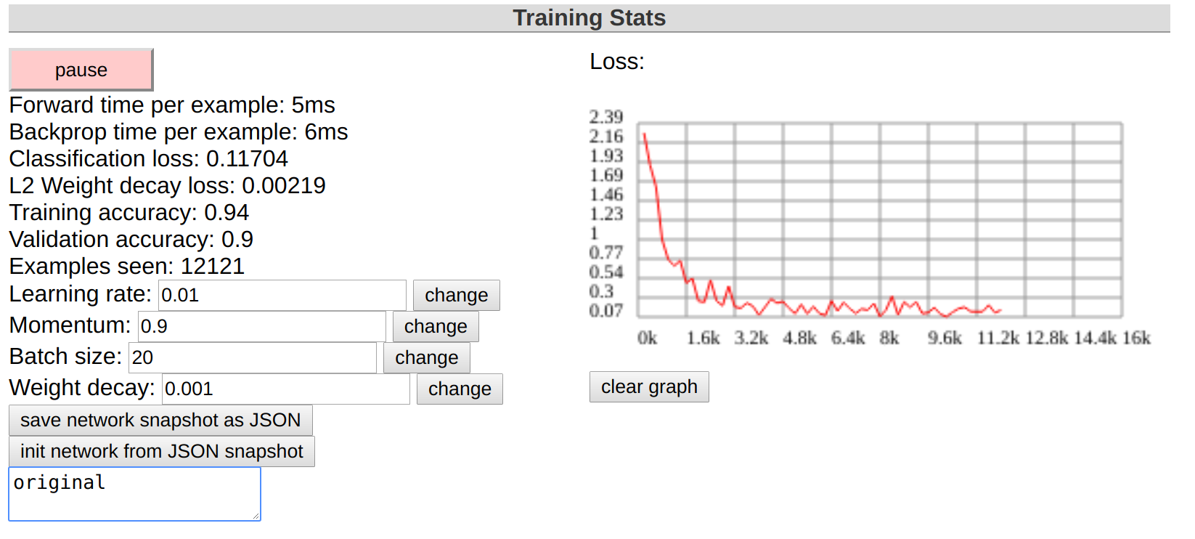
2. Experiment with the number and size of filters in each layer. Does it improve the accuracy?
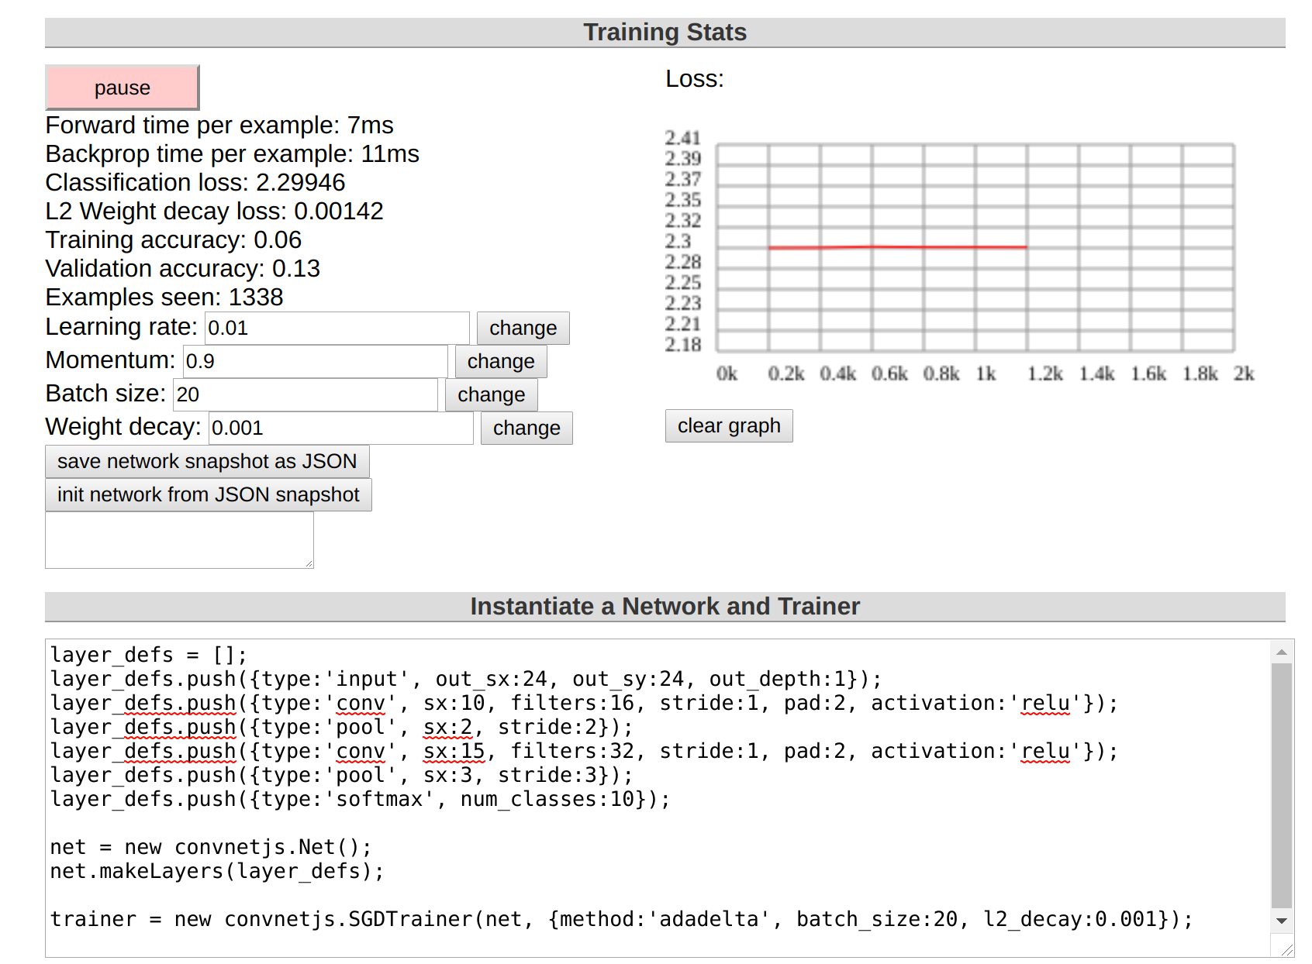
In this case, we increased the size of filters and number of filters in both layers. We see the model has performed very badly. There is likely some error in the model because the error didnt even go down. One possibility is lack of training examples – we only saw 1338 examples.
Another try gives us the following
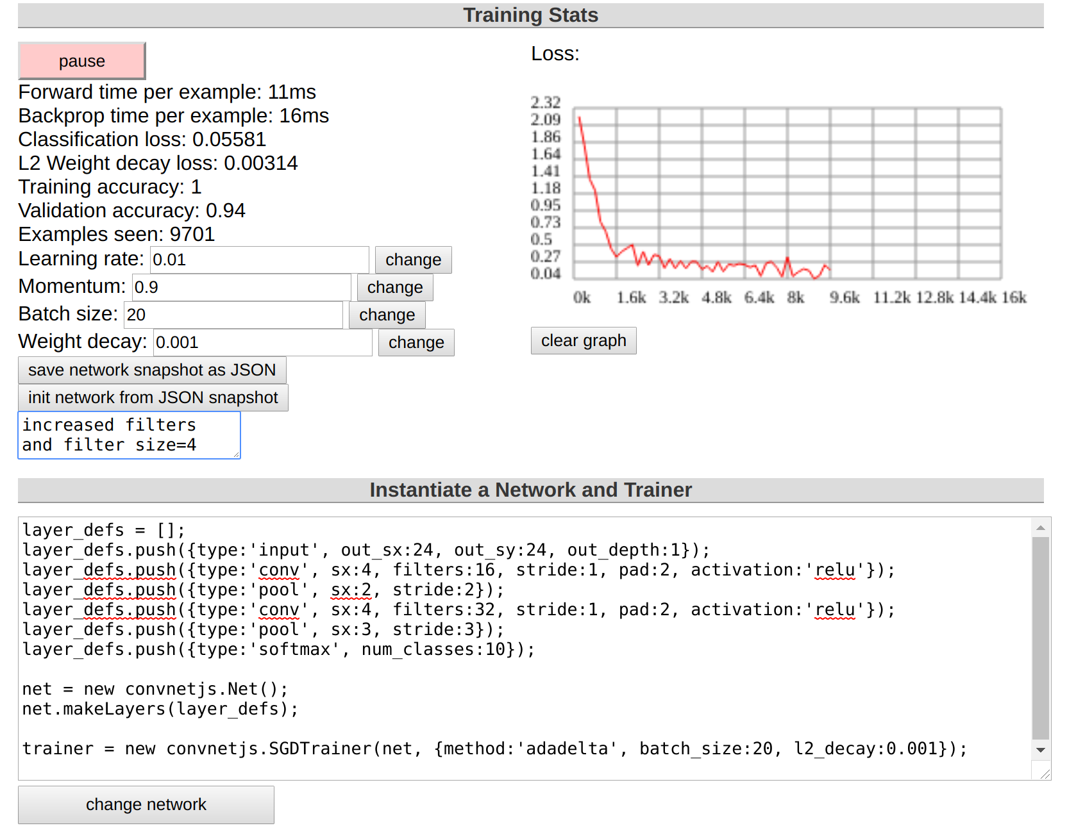
This is more reasonable, for the above, we increased filters and we changed the filter size to 4 in both layers.
3. Remove the pooling layers. Does it impact the accuracy?
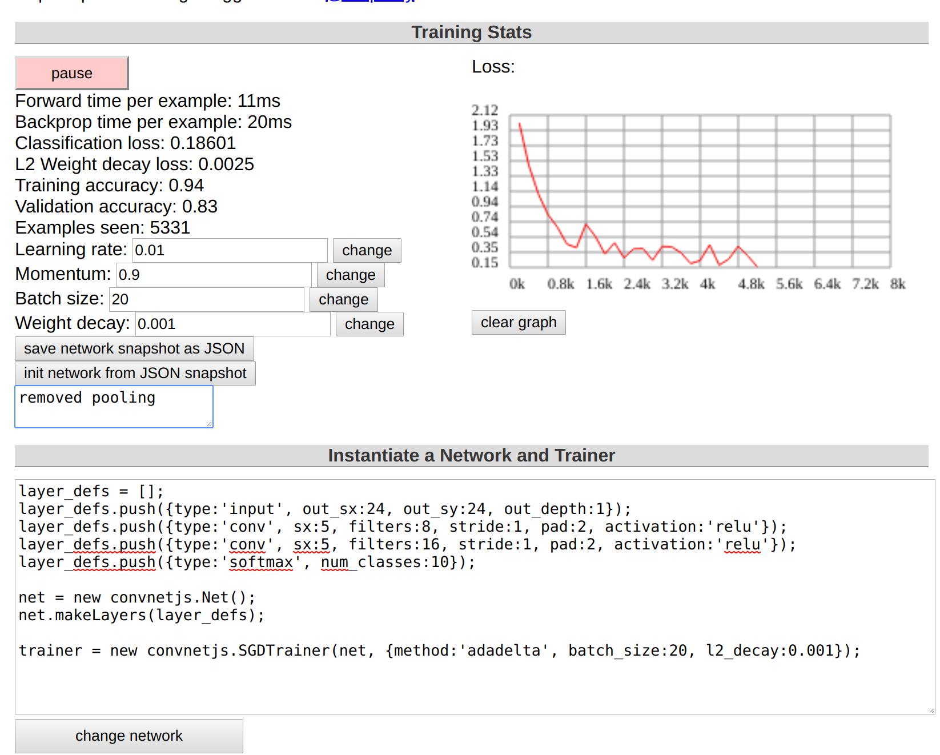
Accuracy decreases when we remove pooling, which is interesting
4. Add one more conv layer. Does it help with accuracy?
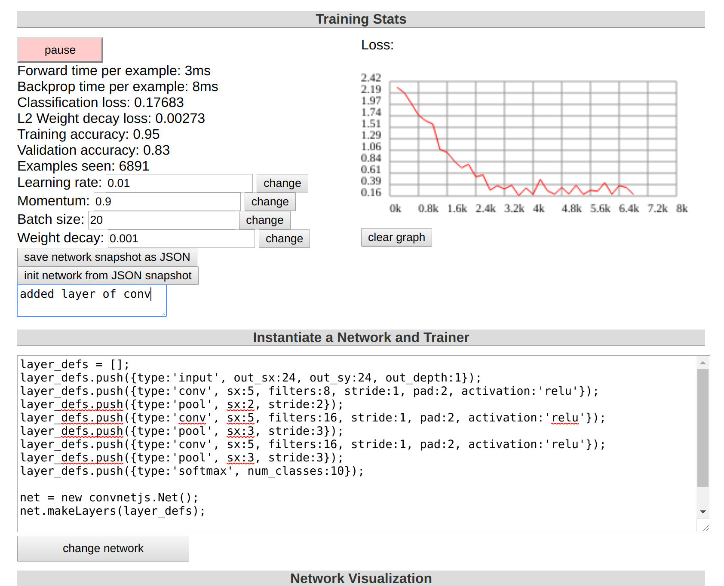
Adding a new layer probably leads to some form of overfitting where we see high training accuracy but low test accuracy
5. Increase the batch size. What impact does it have?
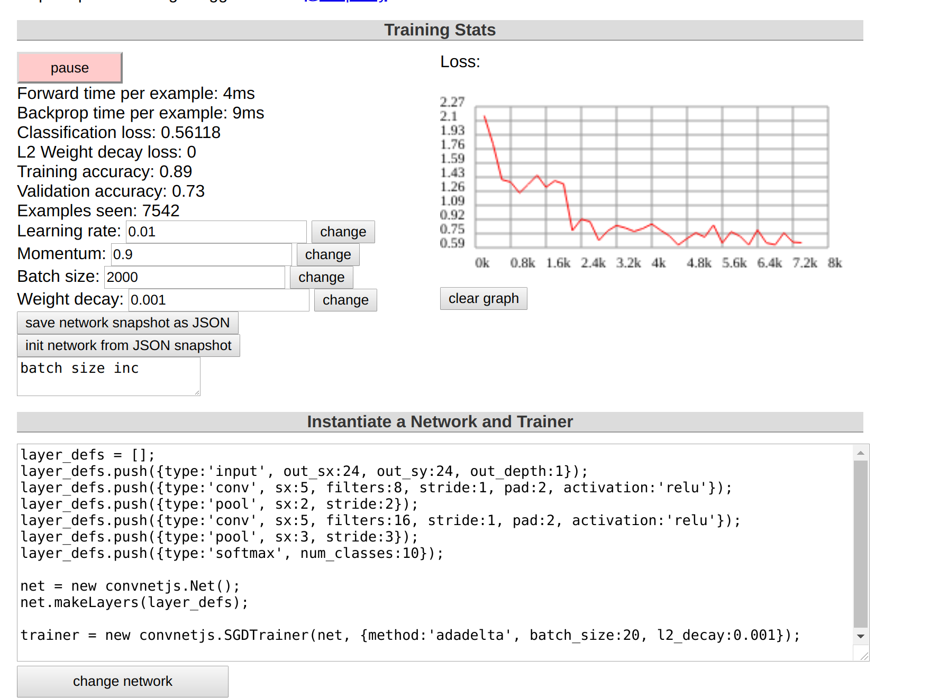
Increasing batch size from 20 to 2000 leads to a very low validation accuracy relative to the other models.
6. What is the best accuracy you can achieve? Are you over 99%? 99.5%?
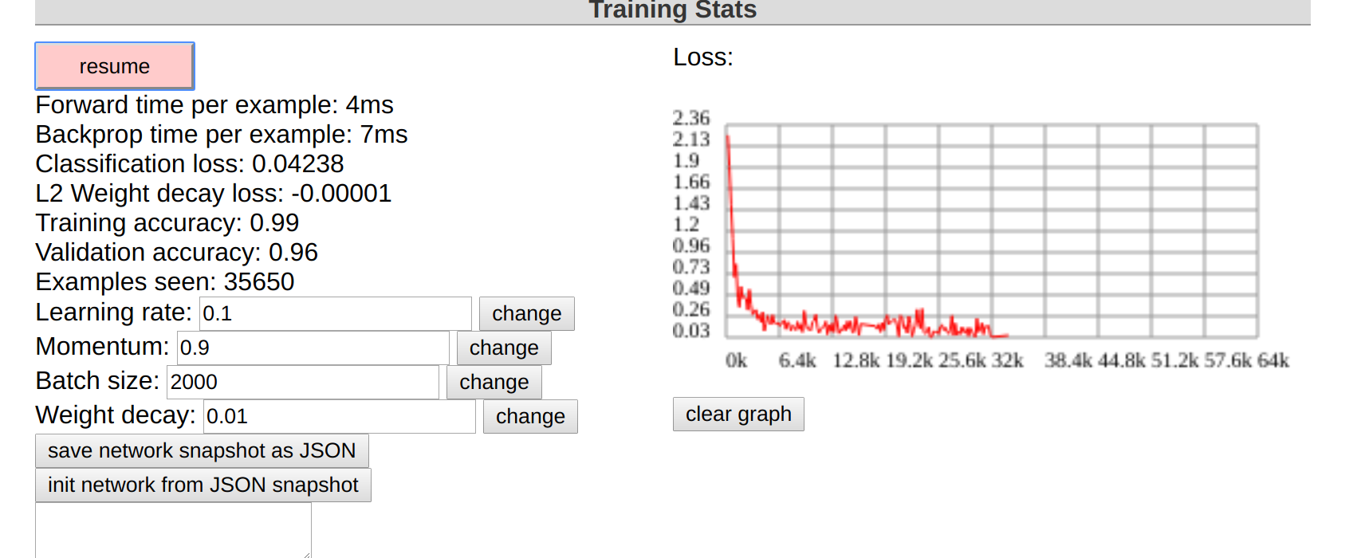
No unfortunately my network only had a validation accuracy of 96% with the default network

