ASSISSMENT YEAR 2013-2014

ACKNOWLEDGEMENT FROM AO WARD 4(1)

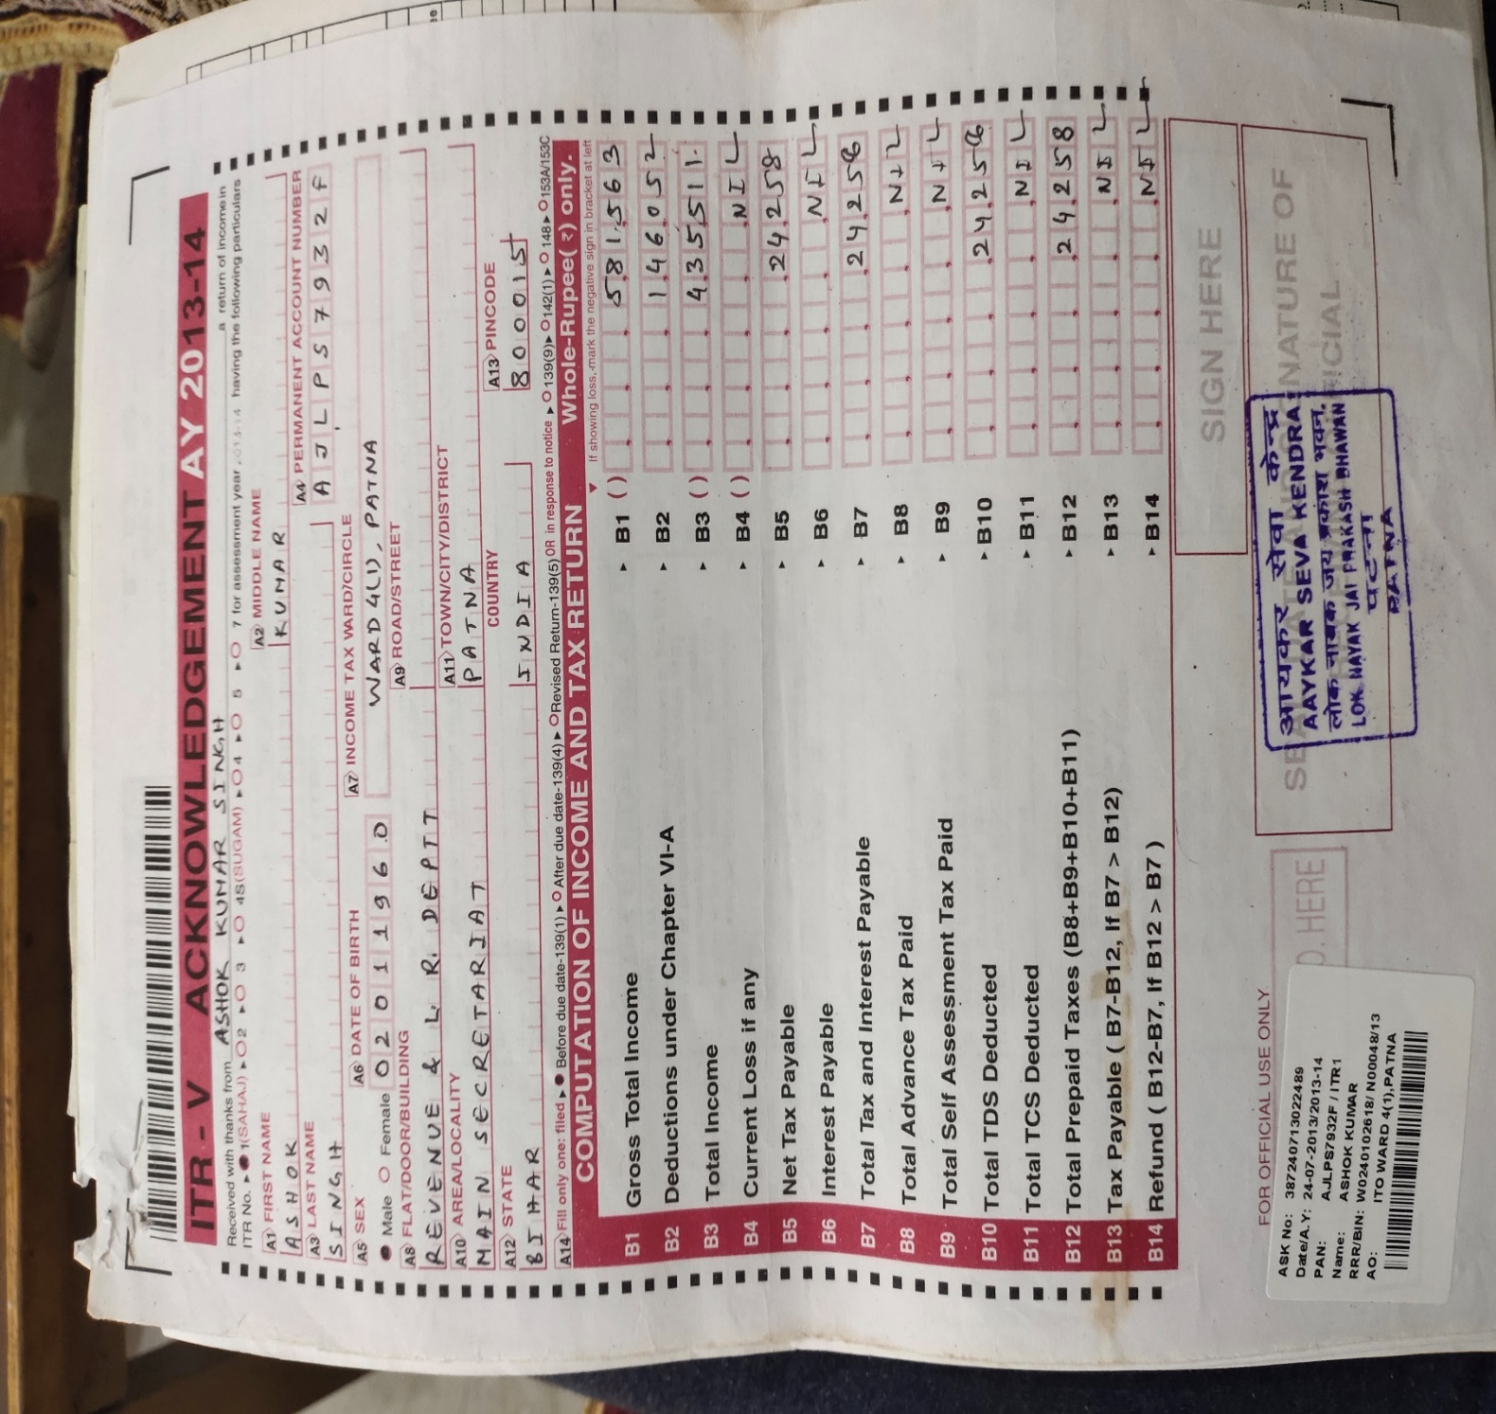

FORM 16

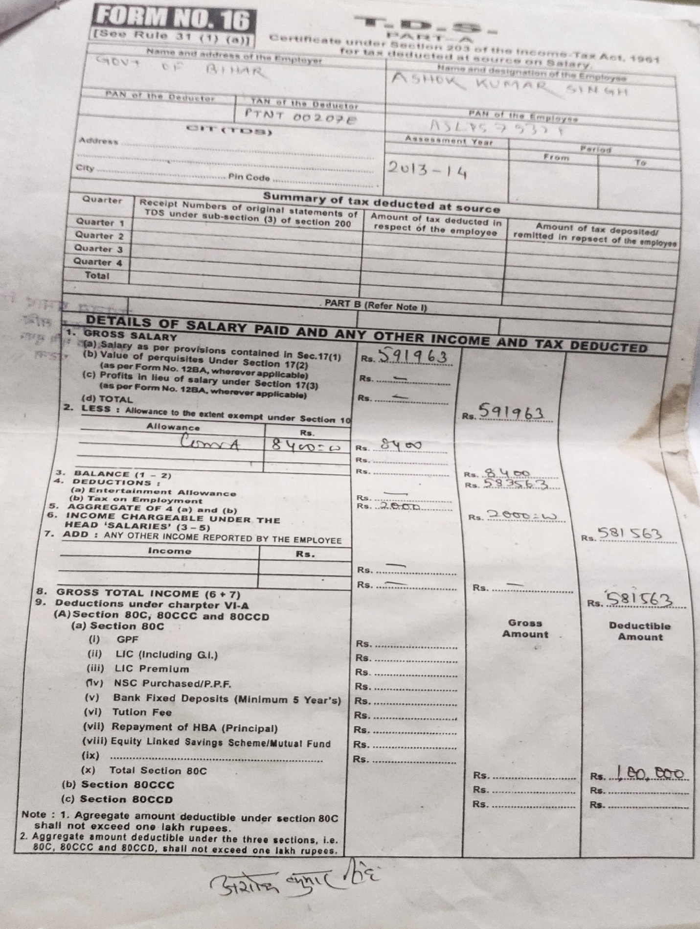

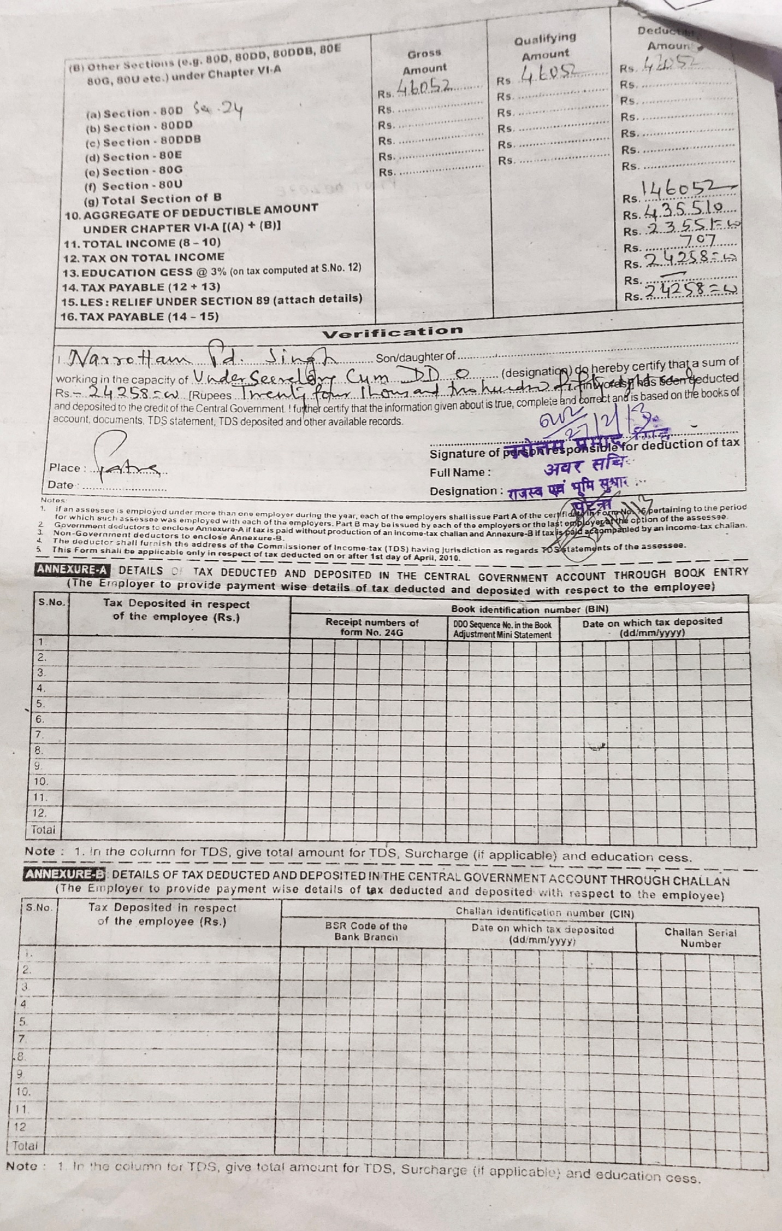

FORM 26AS (TRACES)

